AWS IAM PROJECT

1. Project Overview
This project demonstrates how to create an AWS IAM user, provide the user with Amazon S3 permissions, sign in using the IAM credentials, create an S3 bucket, keep public access blocked, configure bucket settings, and upload a file.

Project Objectives
- Create an IAM user named sakshi.
- Provide Amazon S3 access to the IAM user.
- Review and create the IAM user securely.
- Use the IAM user to sign in to the AWS Management Console.
- Create an Amazon S3 bucket named sakshi-1122.
- Keep Block Public Access enabled.
- Review bucket versioning and encryption settings.
- Upload a demo.txt file successfully to the bucket.

Tools / AWS Services Used
- AWS Identity and Access Management (IAM)
- AWS Management Console
- Amazon S3

Step 1 — Open IAM Users
Open the AWS Management Console and go to Identity and Access Management (IAM). Select IAM users. This page is used to create and manage IAM identities.
Action: Click “Create user” to start creating the new IAM user.
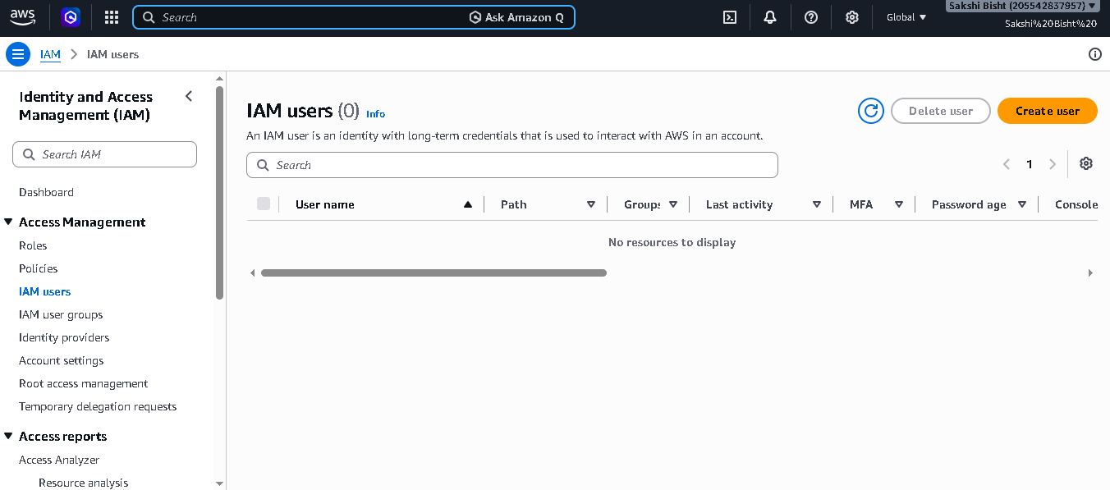

Step 2 — Specify the IAM User
In the Create user wizard, enter the user name as “sakshi”. The reference shows console access being configured for this user.
Action: Enter the username carefully and continue to the permissions step.
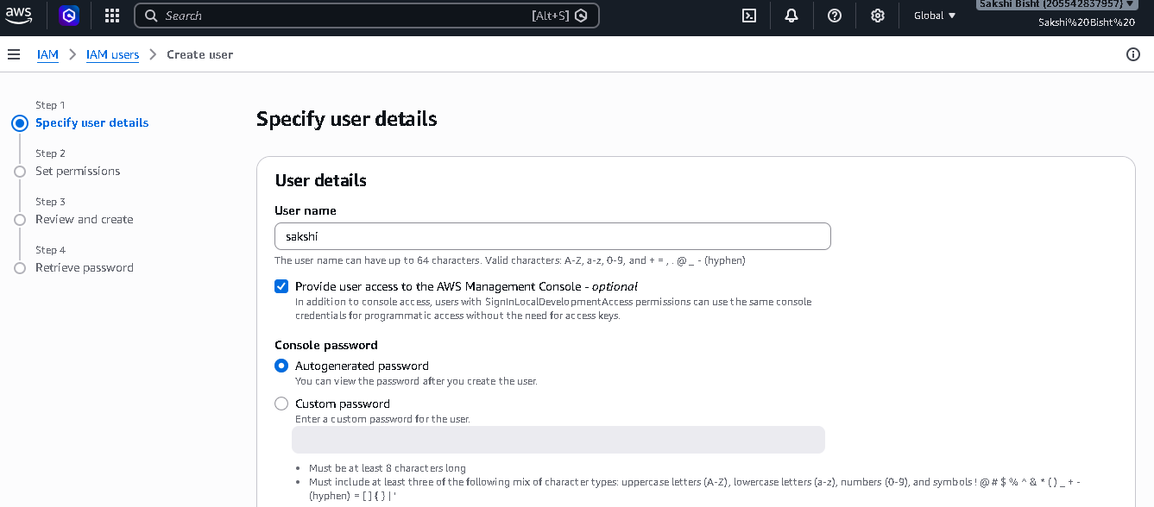

Step 3 — Configure Console Password
Choose the console password option. The reference demonstrates an automatically generated password and the option to use a custom password.
Action: For a real project, use a strong password and require the user to change it at first sign-in when appropriate.
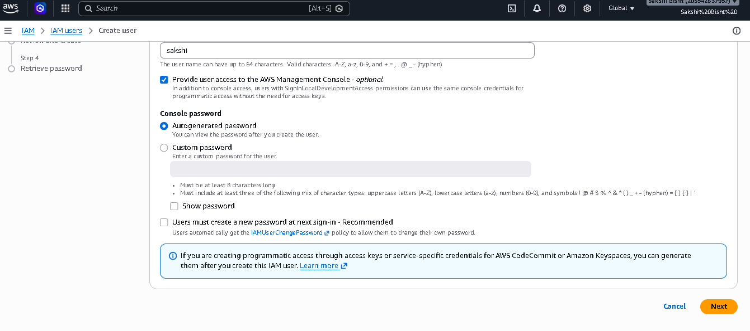

Step 4 — Set Permissions
On the Set permissions page, choose how permissions will be assigned. The reference uses direct policy attachment and selects an AWS managed S3 policy.
Action: For this project, select the S3 permission required for the practical task. The supplied reference shows AmazonS3FullAccess.
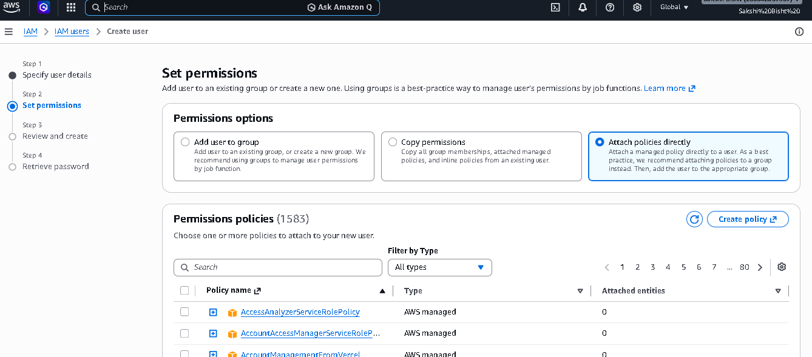

Step 5 — Select Amazon S3 Full Access
Search the policy list for “AmazonS3FullAccess” and select it. This gives the IAM user broad access to Amazon S3.
Action: For production environments, prefer the minimum permissions required for the task instead of broad full access.
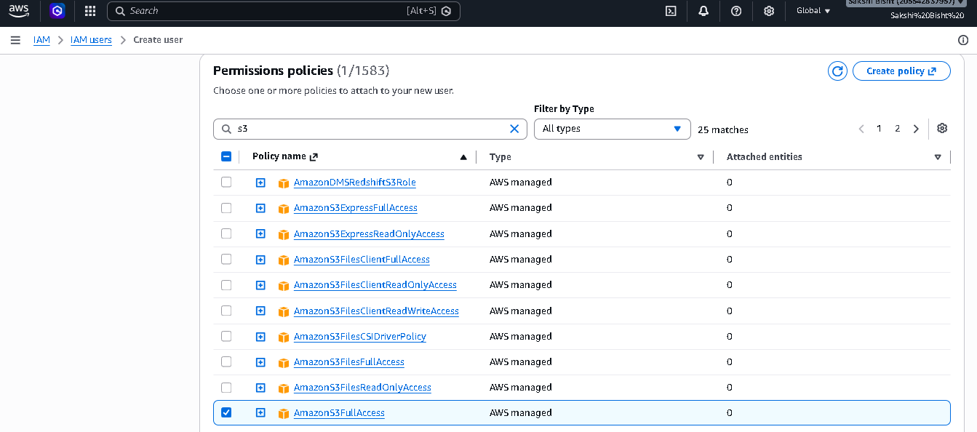

Step 6 — Review and Create
Review the IAM username and permissions summary. The reference shows user “sakshi”, the AmazonS3FullAccess policy, an autogenerated console password, and no tags.
Action: Check the details before clicking “Create user”.
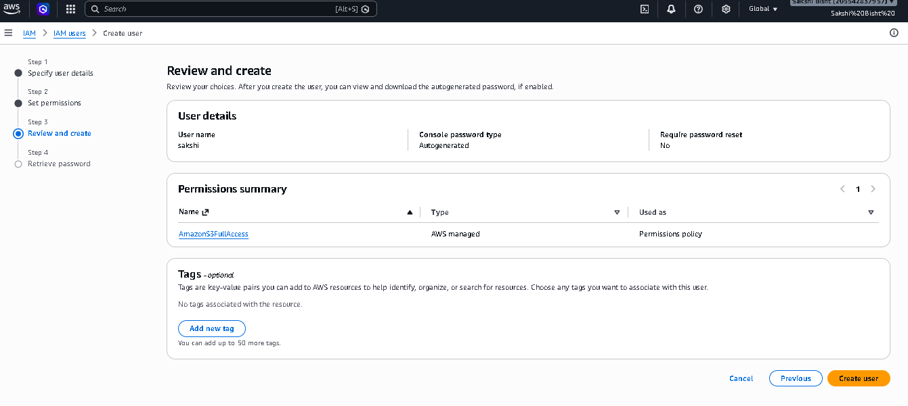

Step 7 — User Created Successfully
After creation, AWS displays the console sign-in details. The reference shows the username and a console sign-in URL, along with the generated password.
Action: Save the credentials securely. AWS provides the generated password for retrieval at this stage.
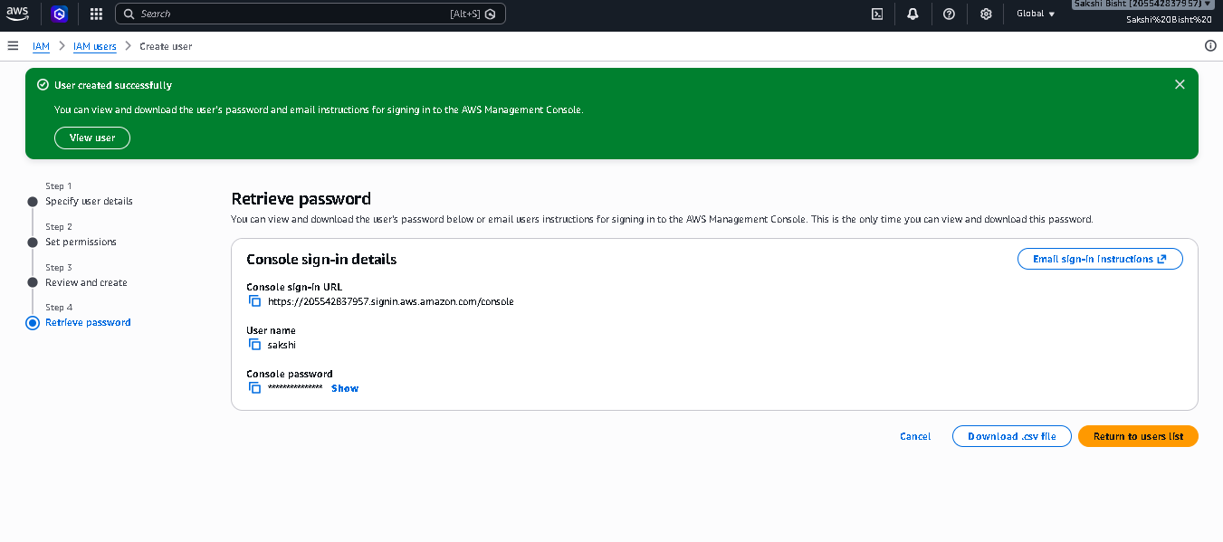

Step 8 — IAM User Sign-In
Open the IAM user sign-in page and enter the AWS account ID or alias, IAM username, and password.
Action: Use the newly created IAM user rather than the AWS root user for normal project work.
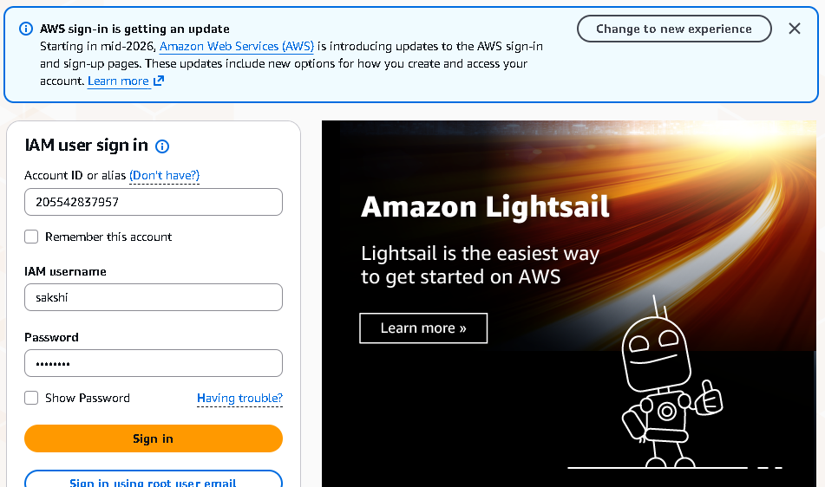

Step 9 — Open Amazon S3
After signing in, open Amazon S3 from the AWS console. S3 is the storage service used in this project.
Action: Choose the option to create a new bucket.
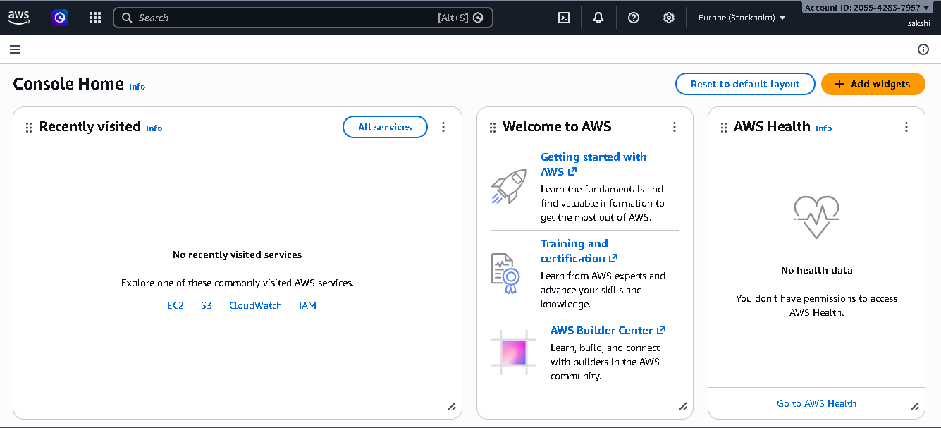

Step 10 — Start Creating the S3 Bucket
On the Create bucket page, select the required AWS Region and choose the General purpose bucket type shown in the reference.
Action: The reference uses the Europe (Stockholm) region, eu-north-1.
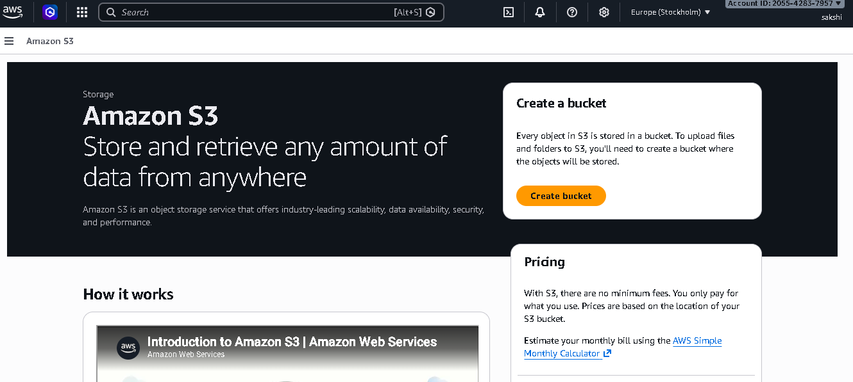

Step 11 — Enter the Bucket Name
Enter the bucket name “sakshi-1122”. S3 bucket names must follow AWS naming rules and must be unique within the applicable namespace.
Action: Use a unique bucket name if AWS reports that the name is already taken.
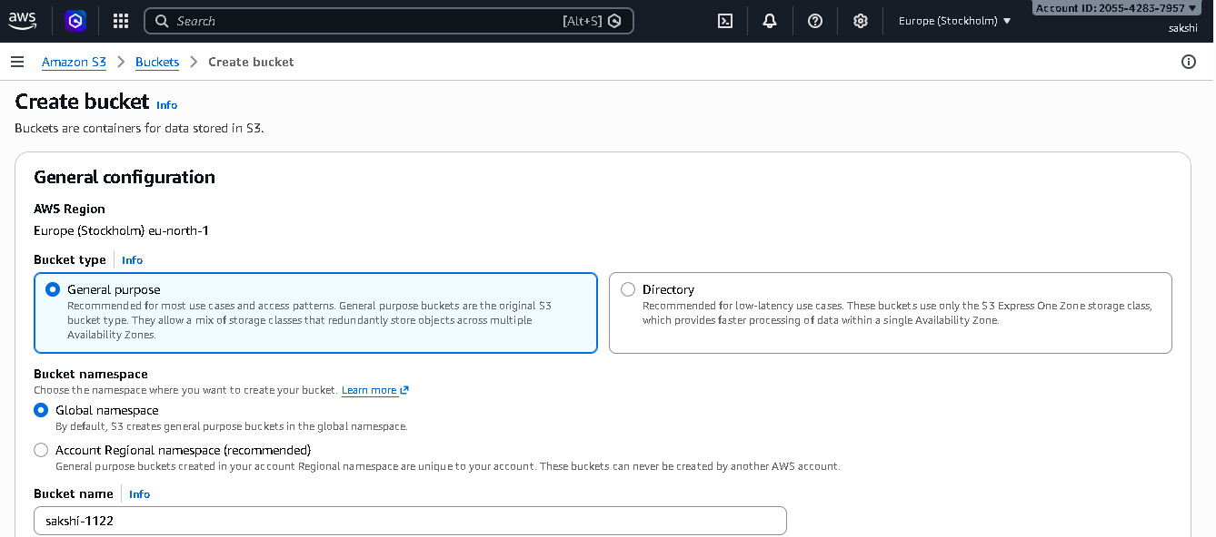

Step 12 — Object Ownership
In Object Ownership, keep “Bucket owner enforced” / ACLs disabled as shown in the reference. This keeps ownership controlled through the bucket owner and policies rather than ACLs.
Action: This is the recommended configuration for many standard S3 use cases.
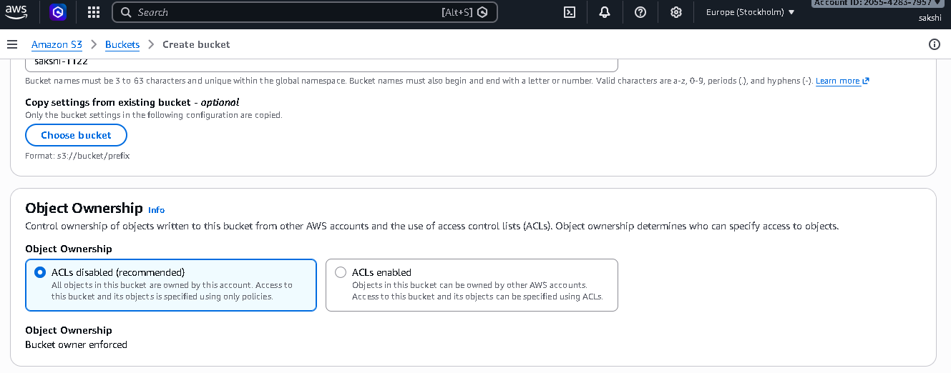

Step 13 — Block Public Access
Keep all Block Public Access settings enabled. The reference explicitly shows the four public-access blocking controls.
Action: Do not disable these settings unless the project specifically requires public access and the security implications are understood.
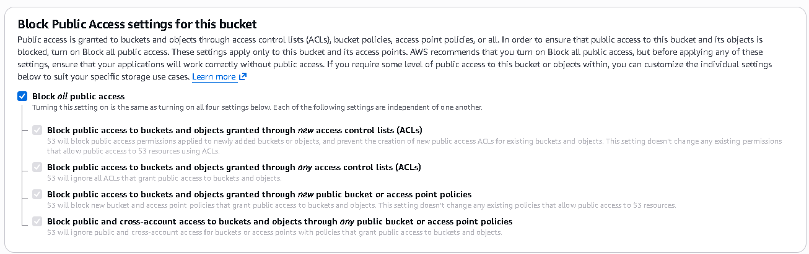

Step 14 — Bucket Versioning
Review Bucket Versioning. The reference shows the option to enable or disable versioning.
Action: Versioning can help recover previous object versions after accidental changes or deletions.
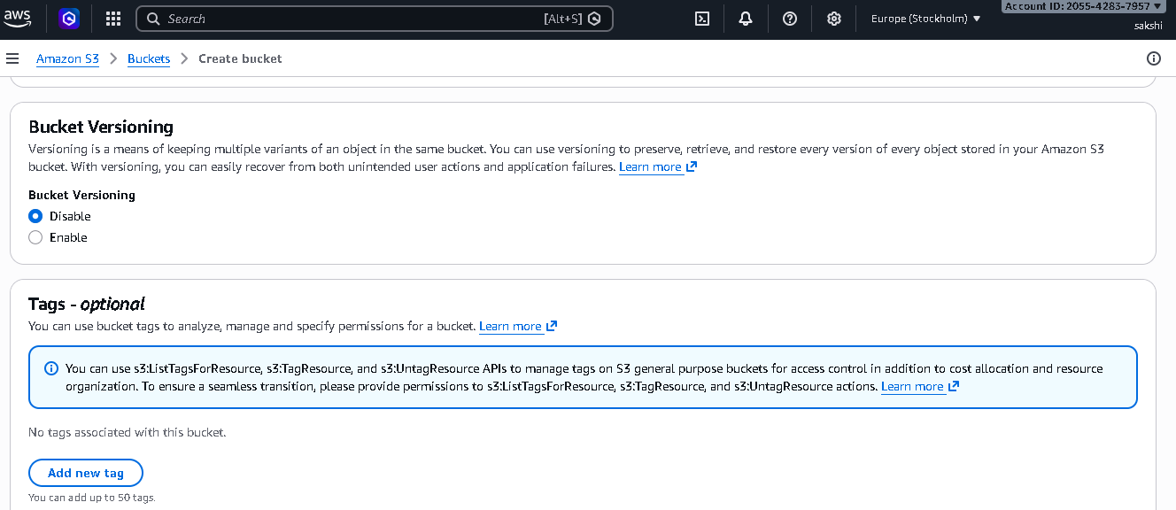

Step 15 — Default Encryption
Review the Default encryption section. The reference shows server-side encryption options including S3 managed keys (SSE-S3) and AWS KMS keys (SSE-KMS).
Action: Use the encryption option required by your project or organization. The reference presents SSE-S3 as an available option.
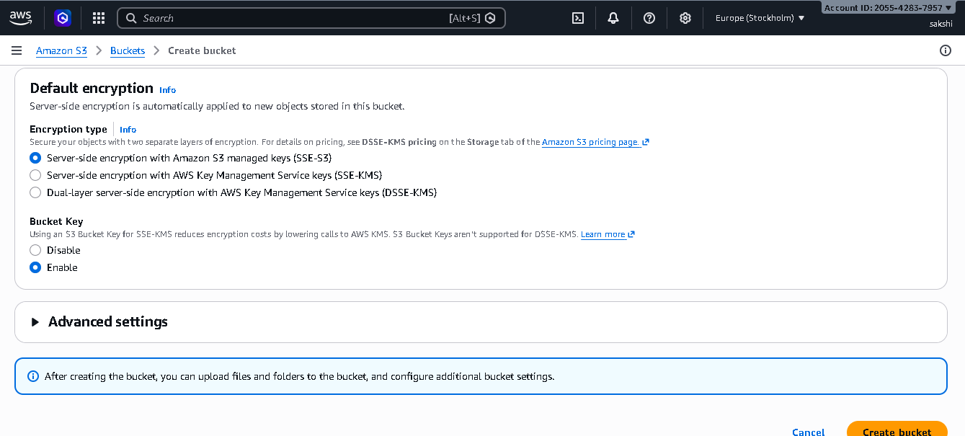

Step 16 — Bucket Created
After the bucket is created, open the bucket. The reference shows “sakshi-1122” with zero objects initially.
Action: The bucket is now ready for file upload.
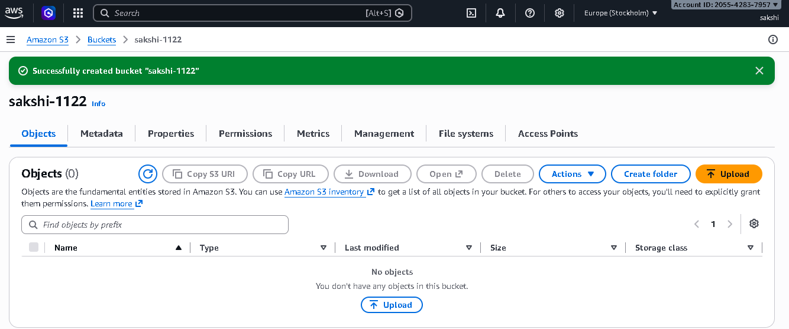

Step 17 — Upload a File
Select Upload and add the demo.txt file. The reference shows the upload completing successfully with one file stored in the bucket.
Action: Confirm that the object appears in the bucket after the upload.
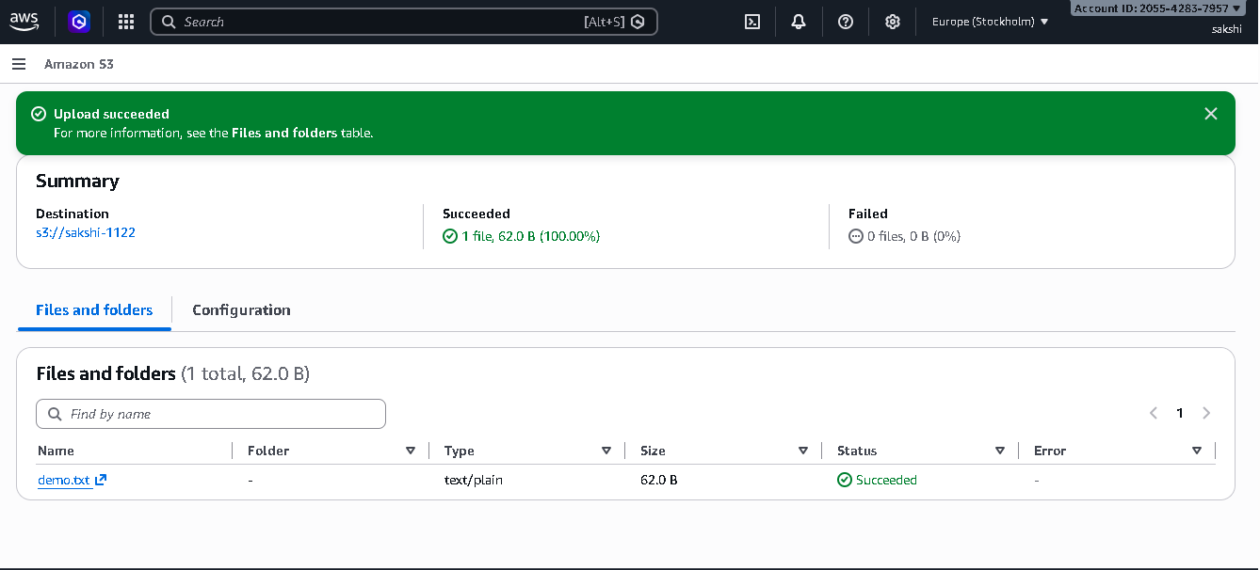

2. Project Result
The practical workflow is completed when the IAM user can sign in to AWS, access Amazon S3 according to the assigned permissions, create the sakshi-1122 bucket, and upload demo.txt successfully.

3. Security Points
- Avoid using the AWS root account for routine work.
- Use IAM users, groups, or roles with only the permissions required.
- Keep S3 Block Public Access enabled unless public access is intentionally required.
- Use strong passwords and MFA where possible.
- Do not share IAM passwords or access keys.
- Review and remove unused permissions regularly.

4. Conclusion
This project demonstrates a basic AWS Identity and Access Management workflow combined with Amazon S3. An IAM user was created, S3 permissions were assigned, the user signed in to the AWS console, an S3 bucket was created with security-focused settings, and a file was uploaded successfully.

