AWS S3 PUBLIC BUCKET PROJECT

1. Project Objective
The objective of this project is to create an Amazon S3 bucket, configure the bucket so that public access can be granted, upload a file/object, and verify the resulting bucket and upload status. The steps below follow the sequence and settings visible in the supplied reference screenshots.

2. Prerequisites
- An active AWS account with permission to use Amazon S3.
- A file ready to upload to the bucket.
- A unique S3 bucket name.
- Basic familiarity with the AWS Management Console.

Step 1: Open Amazon S3 and start creating a bucket
Sign in to the AWS Management Console. Open Amazon S3, select Buckets, and choose Create bucket. On the Create bucket page, enter a globally unique bucket name and select the required AWS Region.
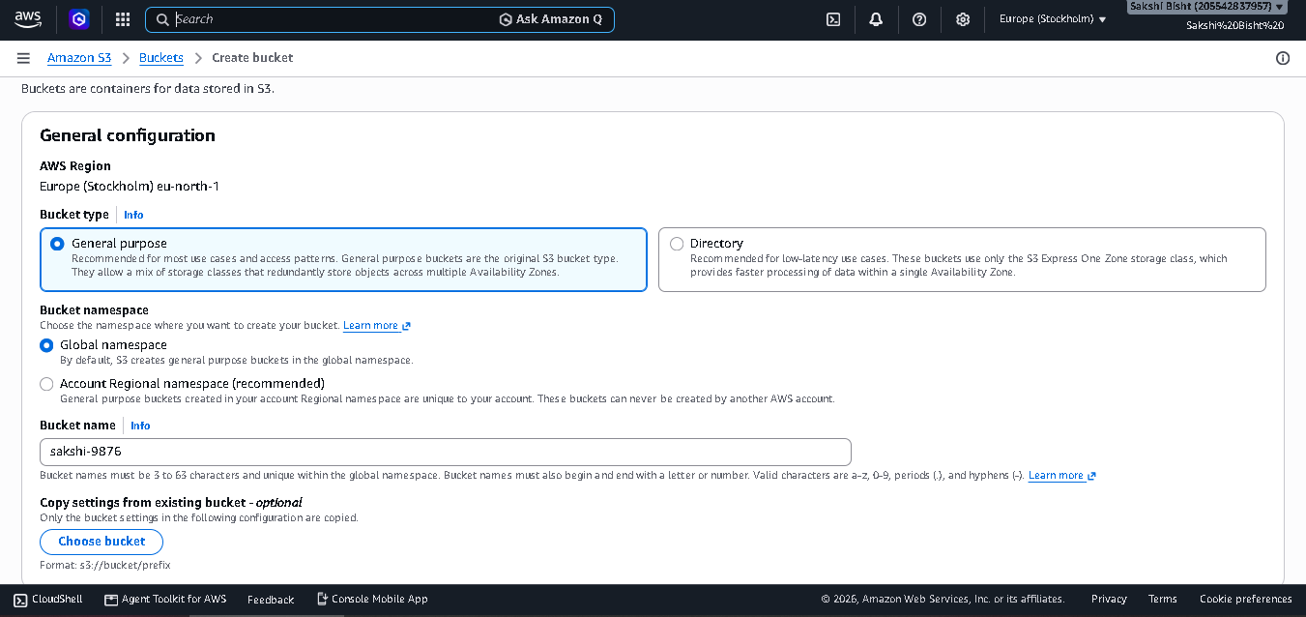

Step 2: Configure Block Public Access
In the Block Public Access settings, clear the option that blocks all public access if the purpose of the project is to make the bucket publicly accessible. The reference screenshot shows the four public-access blocking settings unchecked and the acknowledgement box selected. Read the warning and select the acknowledgement only when you understand that the bucket and its objects may become public.
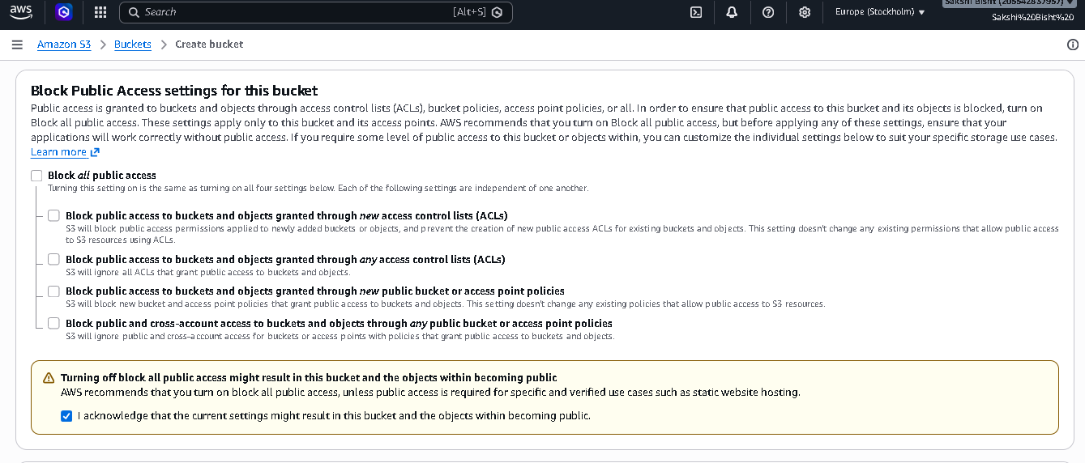

Step 3: Review Object Ownership
In Object Ownership, review the ownership setting shown by the AWS console. The reference screenshot shows the ACLs-enabled option selected. Keep the setting consistent with the access-control approach being demonstrated in the project.
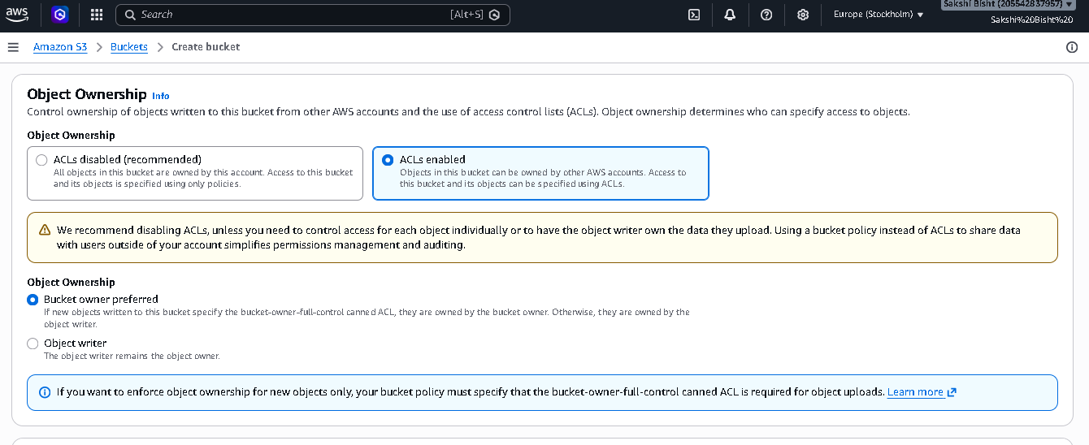

Step 4: Review bucket configuration / versioning
Open the bucket's Properties or relevant configuration section and review Bucket Versioning and Tags. The reference screenshot shows Bucket Versioning as disabled and Tags as optional. These settings can be left as shown in the reference unless your project requires versioning or tagging.

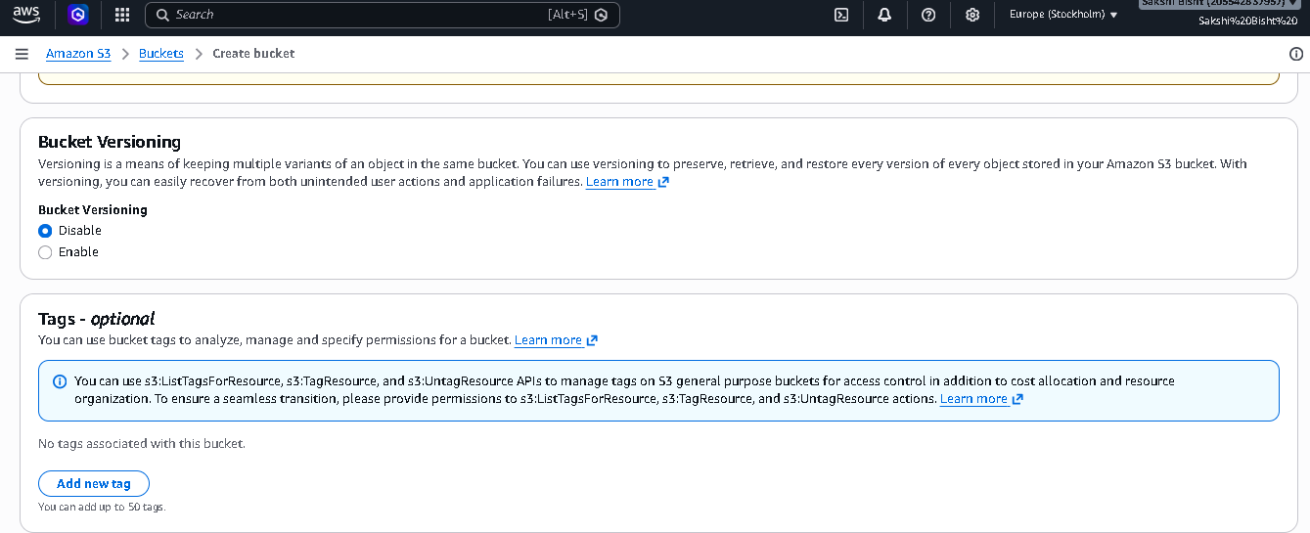

Step 5: Review encryption and advanced settings
Scroll to Default encryption and review the encryption configuration. The reference screenshot shows server-side encryption using an S3-managed key (SSE-S3). Review the remaining advanced settings and continue to bucket creation.
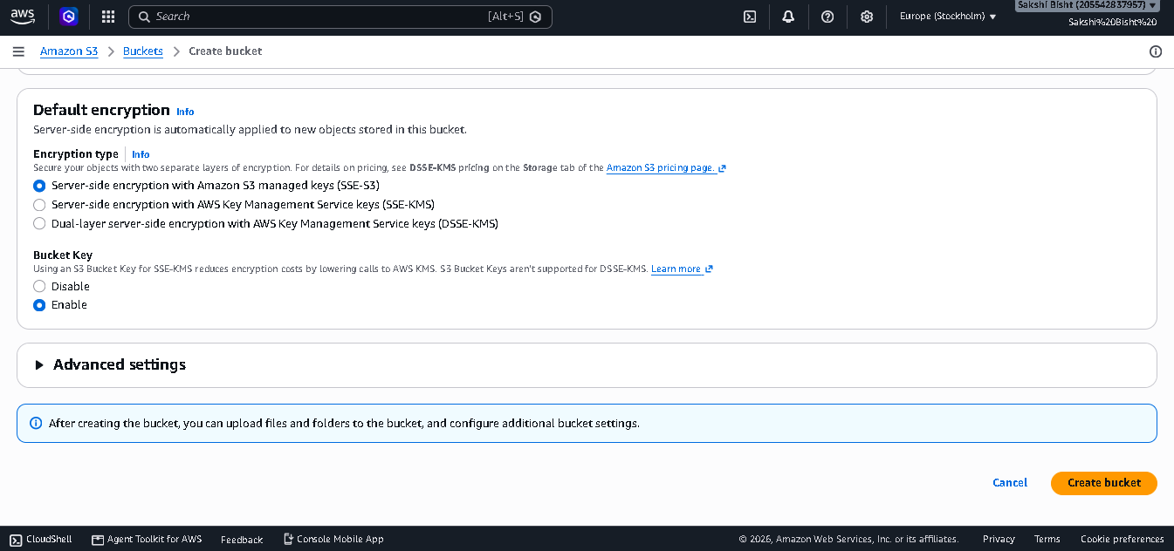

Step 6: Create the bucket
After reviewing the configuration, select Create bucket. AWS should return to the bucket list and display the newly created bucket. The reference document shows a bucket named similar to 'sakshi-S3-7' in the bucket list.
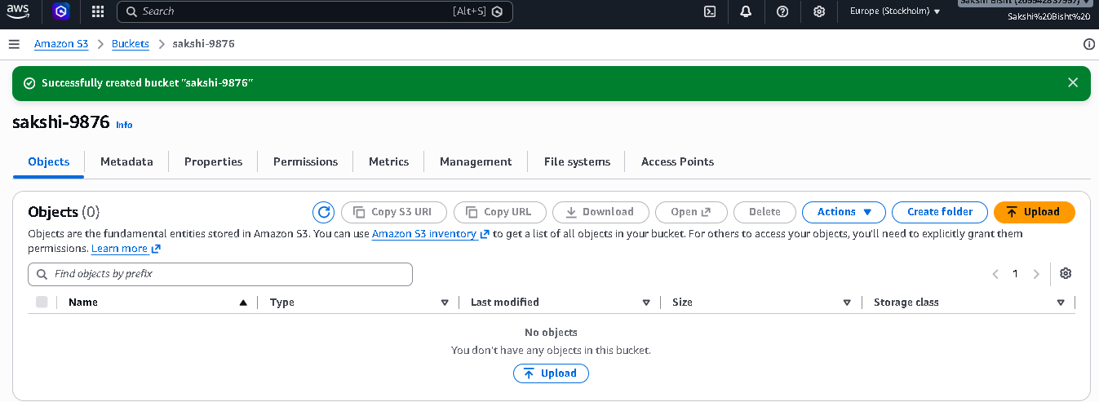

Step 7: Open the bucket and upload a file
Open the newly created bucket. From the Objects tab, choose Upload, add the required file, and start the upload. Wait for the upload to finish successfully.
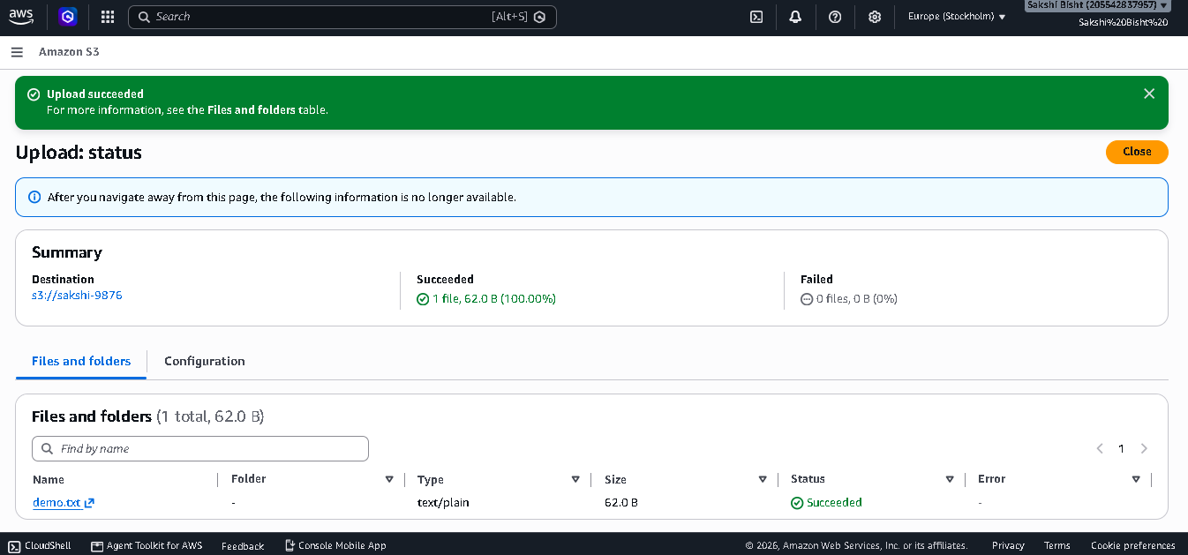

Step 8: Verify upload status
After the upload completes, confirm that AWS reports the upload as successful and that the file appears in the bucket's object list. The reference screenshot shows a successful upload status and the uploaded object in the list.

3. Final Verification Checklist
- ✓ The S3 bucket was created successfully.
- ✓ The bucket name is unique and visible in the S3 bucket list.
- ✓ The public-access blocking configuration matches the project requirement.
- ✓ Object ownership/access-control settings were reviewed.
- ✓ Default encryption was reviewed.
- ✓ A file was uploaded successfully.
- ✓ The uploaded object is visible in the bucket.
- ✓ Versioning and tags were reviewed.

4. Expected Result
At the end of the project, an Amazon S3 bucket should exist in the selected AWS Region, contain the uploaded object, and have the public-access configuration demonstrated in the reference document. The AWS console should show successful bucket creation and successful object upload.

5. Conclusion
This project demonstrates the basic workflow of Amazon S3: creating a bucket, configuring access settings, reviewing ownership and encryption options, uploading an object, and verifying the result. It provides practical experience with object storage and S3 bucket configuration in the AWS Management Console.

