ADIDAS US SALES PERFORMANCE
Professional Business Intelligence & Exploratory Data Analysis Report
Prepared from EDA notebook + Excel + Power BI + Tableau dashboards

Total Orders  9,637 | Total Units  2,475,611 | Total Sales  119,996,275 | Operating Profit  33,158,084 | Profit Margin  27.63%

1. Executive Summary
The analysis covers 9,637 sales records across 13 fields. The dataset contains retailer, geography, product, pricing, units sold, sales, operating profit, invoice date, and sales-method information.
Financial performance: Total sales are 119.996M with operating profit of 33.158M, producing a dashboard profit margin of 27.63%.
Retailers: West Gear is the largest sales contributor in the dashboards, followed by Foot Locker and Sports Direct.
Regional performance: The West is the strongest region, contributing about 30.29% of sales in the Tableau view.
Product performance: Men's Street Footwear is the leading product category by sales and also shows the strongest product-level sales contribution.
Sales methods: In-store is the largest channel at 37.47%, followed by Outlet at 32.81% and Online at 29.72%.
Geographic concentration: New York is the leading city in the displayed top-city analysis, with Charleston and San Francisco also among the strongest cities.

2. Dataset Overview
Records: 9,637
Columns: 13
Numeric fields: 6
Categorical/date fields: 7
Cities: 52 unique cities
Product categories: 6
Retailers: 6
Sales methods: 3

3. Data Quality & Preparation
Missing values — 0 across all 13 columns — Clean
Duplicate rows — 0 — Clean
Data structure — 9,637 × 13 — Consistent
Date handling — invoice_date converted to datetime in EDA — Ready for time analysis
City cardinality — 52 unique cities — Good geographic coverage
The EDA notebook reports zero missing values and zero duplicate rows. invoice_date was converted to datetime for monthly analysis.

4. Descriptive Statistical Profile
Price per unit | $45.22 | $45 | $7 | $110
Units sold | 256.89 | 176 | 6 | 1,275
Total sales / record | $12,451.62 | $7,805 | $160 | $82,500
Operating profit / record | $3,440.71 | $437 | $8 | $39,000

5. Exploratory Data Analysis Findings
Retailer analysis
The EDA frequency analysis shows Foot Locker with 2,630 records, West Gear with 2,372, Sports Direct with 2,030, Kohl's with 1,030, Amazon with 949, and Walmart with 626. The dashboards separately show that West Gear generates the highest sales value, followed by Foot Locker and Sports Direct. Record count and sales value therefore should not be treated as the same metric.
Product analysis
The six product categories have very similar record counts: Men's Street Footwear 1,610; Men's Athletic Footwear 1,608; Women's Apparel 1,607; Men's Apparel 1,605; Women's Street Footwear 1,606; and Women's Athletic Footwear 1,601. Despite similar record volumes, the dashboards show meaningful differences in sales value, with Men's Street Footwear leading.
Regional analysis
The Tableau dashboard shows the West at 30.29% of sales, Northeast at 20.90%, South at 17.81%, Midwest at 17.12%, and Southeast at 13.88%. The West is therefore the largest regional sales contributor in the displayed dashboard.
Sales-method analysis
The dashboard distribution is In-store 37.47%, Outlet 32.81%, and Online 29.72%. The mix is relatively balanced, while In-store has the largest share.
City analysis
The top-city dashboard identifies New York, San Francisco, Charleston, Portland, and Orlando among the leading cities. New York is the highest displayed city at approximately 5.76M in sales.
Monthly trend
The monthly dashboard shows clear variation across the year, with stronger sales in the middle-to-late part of the year and a visible dip around early autumn before recovery toward year-end. The exact monthly totals are dashboard-derived and should be read together with the filters applied.

6. Correlation & Relationship Analysis
The EDA notebook includes a correlation heatmap for price_per_unit, units_sold, total_sales and operating_profit, plus a scatter plot of total_sales versus operating_profit. These visuals support assessment of the relationship between transaction scale and operating profit. This report keeps the interpretation directional because exact correlation coefficients were not explicitly documented in the supplied materials.

7. Dashboard Review Across Excel, Power BI & Tableau
Excel: Detailed KPI cards, monthly trend, regional split, product sales vs profit, retailer ranking, top cities, and interactive filters.
Power BI: Clean executive layout with KPI cards, monthly trend, retailer and product comparisons, regional and city visuals, and slicers.
Tableau: Strong comparative storytelling using trend, product sales vs profit, retailer bars, regional treemap, and sales-method view.
The KPI values are consistent across the dashboards, with Power BI and Tableau using rounded presentation values while Excel shows detailed figures.

8. Dashboard Screenshots
Excel Dashboard
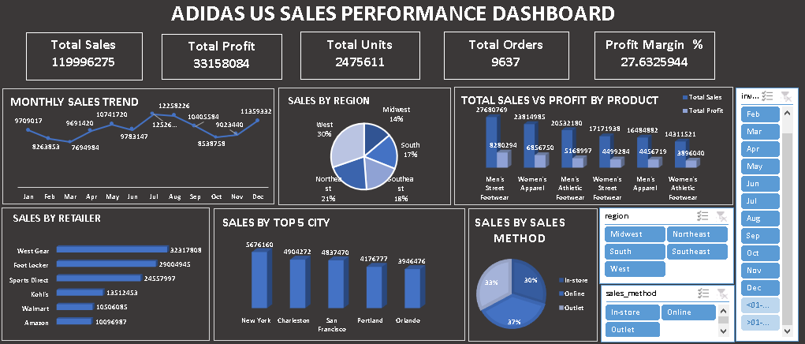

Power BI Dashboard
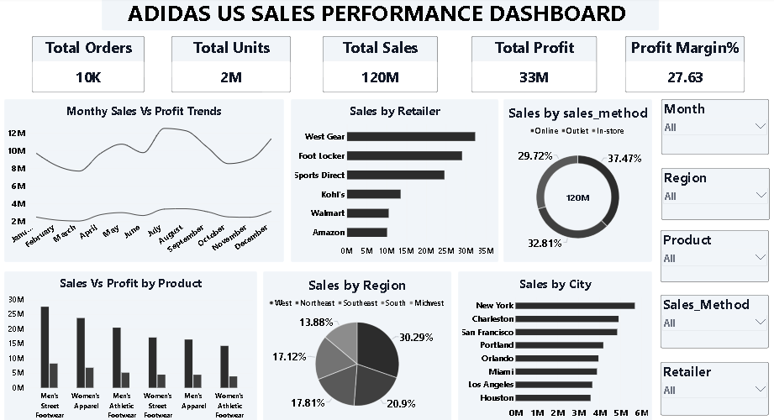

Tableau Dashboard
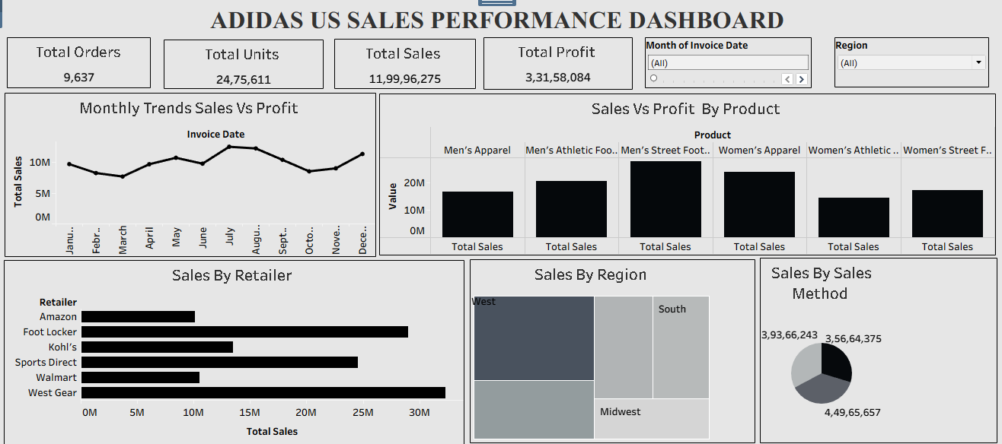

9. Key Business Insights
West-led performance — The West region is the largest regional contributor in the Tableau dashboard at 30.29%.
Retailer concentration — West Gear and Foot Locker account for the two largest sales positions in the dashboard, making them strategically important retail partners.
Product opportunity — Men's Street Footwear is the strongest displayed product category by sales, making it a key category for inventory and promotion planning.
Balanced channel mix — In-store, Outlet and Online are all material channels. The largest, In-store, is only moderately ahead of the other two.
High-performing cities — New York leads the displayed top-city ranking, while San Francisco, Charleston, Portland and Orlando also contribute strongly.
Profitability matters alongside sales — The dashboards compare sales with operating profit by product, supporting decisions based on both revenue scale and profitability rather than sales alone.

10. Recommendations
Prioritize inventory availability and promotional planning for Men's Street Footwear and other high-sales product categories.
Develop retailer-specific strategies for West Gear and Foot Locker because they are the strongest sales contributors in the dashboards.
Protect and expand the West region while investigating the drivers behind its stronger performance.
Maintain an omnichannel strategy: In-store leads, but Outlet and Online together represent a large share of sales.
Use city-level dashboards to localize inventory and campaigns, especially in New York and other high-performing cities.
Track operating profit together with sales for every product and retailer so growth is evaluated on quality of revenue, not volume alone.
For future analysis, add year-over-year growth, average order value, profit margin by product/region/retailer, and channel profitability if the underlying data supports them.

11. Conclusion
The Adidas US sales analysis presents a strong, multi-dimensional view of business performance. The dataset is structurally clean, contains no reported missing values or duplicate rows, and supports analysis across time, geography, products, retailers and sales methods. The dashboards consistently identify West Gear, the West region, Men's Street Footwear, and New York among important high-performing segments. The combined EDA and BI dashboards provide a solid foundation for management reporting and can be extended into predictive and prescriptive analysis.
Source note: Findings are based only on the supplied EDA notebook and the three dashboard images. Where a value was not explicitly available in the supplied materials, it has not been invented.

