PIZZA SALES
DATA ANALYSIS REPORT
Integrated Analysis using EDA, Microsoft Excel, Power BI & Tableau

1. Executive Summary
This project presents an end-to-end pizza sales analysis using exploratory data analysis (EDA), Excel, Power BI and Tableau. The underlying dataset contains 48,620 sales-line records across 13 fields. The analysis establishes data quality, summarizes sales behavior, and converts the findings into interactive and presentation-ready dashboards.
The dashboards consistently report total revenue of approximately 817.86K and 21,350 distinct orders. The EDA notebook also reports 48,620 rows, 13 columns, 32 unique pizza names, no duplicate rows and no missing values. The analysis identifies Friday as the strongest ordering day, with Saturday and Thursday next, while Sunday is the weakest among the seven days.

Project Objectives
- Understand the structure and quality of the pizza sales dataset.
- Measure revenue, orders and pizza volume using clear KPIs.
- Identify monthly, daily and hourly ordering patterns.
- Compare revenue contribution by pizza category and pizza size.
- Identify the top-performing pizza products.
- Build decision-ready dashboards in Excel, Power BI and Tableau.
- Compare the three BI/reporting approaches and document improvement opportunities.

2. Dataset Overview
The EDA notebook shows a dataset of 48,620 records and 13 columns. The fields cover transaction identifiers, quantity, date/time, pricing, pizza size, category, ingredients and pizza name.
Metric | Value
Rows / sales-line records | 48,620
Columns | 13
Distinct pizza names | 32
Duplicate rows | 0
Missing values | 0 across all columns
Distinct orders | 21,350 (dashboard KPI)
Total revenue | 817,860 / 817.86K (dashboard KPI)
Total pizza quantity | 49,574 (Excel dashboard KPI)

Main Variables
Field | Role in Analysis
pizza_id | Unique pizza-line identifier
order_id | Order identifier; used for distinct order counts
pizza_name_id | Product-level identifier
quantity | Number of pizzas in a sales line
order_date | Date used for monthly/time analysis
order_day | Day-of-week analysis
order_time | Time-of-day / hourly analysis
unit_price | Price per pizza
total_price | Transaction-line revenue
pizza_size | L, M, S, XL and XXL size analysis
pizza_category | Chicken, Classic, Supreme and Veggie
pizza_ingredients | Ingredient description
pizza_name | Product name

Data Quality Assessment
- The notebook reports zero missing values in all 13 columns.
- The notebook reports zero duplicated rows.
- Numeric fields include quantity, unit_price and total_price, while identifiers/date/category/product fields are also present.
- The notebook converts order_date to datetime for monthly analysis and derives an hour field from order_time.

3. Exploratory Data Analysis (EDA)
The supplied notebook follows a practical EDA workflow: library import, data loading, record inspection, shape and data-type checks, descriptive statistics, missing-value checks, frequency analysis, sorting, uniqueness/duplicate checks, grouping and visualization.

3.1 Descriptive Statistics
Variable | Mean | Minimum | Maximum
Quantity | 1.02 | 1 | 4
Unit Price | 16.49 | 9.75 | 35.95
Total Price | 16.82 | 9.75 | 83.00

The descriptive statistics indicate that most sales lines contain one pizza, while the maximum recorded quantity is four. Average line revenue is about 16.82.

3.2 Orders by Day
Day | Sales-line Count
Friday | 8,106
Saturday | 7,355
Thursday | 7,323
Wednesday | 6,797
Tuesday | 6,753
Monday | 6,369
Sunday | 5,917

3.3 Category Distribution
Pizza Category | Sales-line Count
Classic | 14,579
Supreme | 11,777
Veggie | 11,449
Chicken | 10,815

3.4 Product and Revenue Visualizations
- Revenue by Pizza Category — compares category-level contribution.
- Revenue by Pizza Size — compares the revenue generated by L, M, S, XL and XXL.
- Top 10 Pizzas by Sales — ranks pizza products by total_price.
- Orders by Hour — shows demand throughout the day.
- Monthly Sales Trend — tracks revenue movement across the year.
- Correlation Heatmap — examines relationships among quantity, unit_price and total_price.
The notebook is therefore not limited to descriptive tables; it also translates the dataset into visual patterns that can be reused in the BI dashboards.

4. Microsoft Excel Dashboard
The supplied Excel dashboard presents the analysis in a compact, filter-oriented format. It uses KPI cards for headline performance and slicer-style filters for pizza size, pizza category and months.
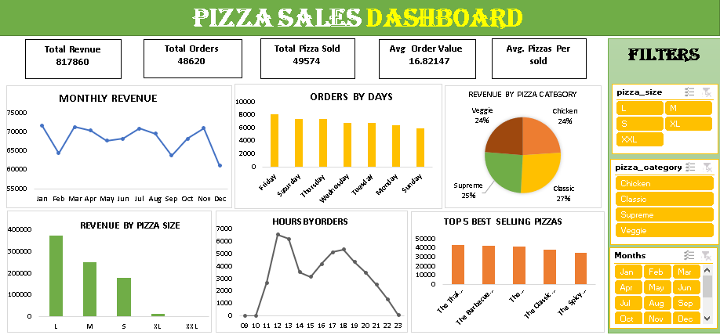
Figure 1. Supplied Excel Pizza Sales Dashboard

Key Excel Dashboard Components
- KPI cards: Total Revenue, Total Orders, Total Pizza Sold and Average Order Value.
- Monthly Revenue line chart for seasonality/trend monitoring.
- Orders by Days bar chart for weekday demand comparison.
- Revenue by Pizza Category pie chart.
- Revenue by Pizza Size column chart.
- Hours by Orders line chart.
- Top 5 Best Selling Pizzas ranking.
- Interactive filters for pizza size, pizza category and months.

Excel Metric Snapshot
KPI | Dashboard Value
Total Revenue | 817,860
Total Orders / sales lines shown | 48,620
Total Pizza Sold | 49,574
Avg. Order Value | 16.82

5. Power BI Dashboard
The Power BI version is designed as a management-style interactive dashboard. It combines KPI cards, slicers and multiple visuals into a single analytical page.
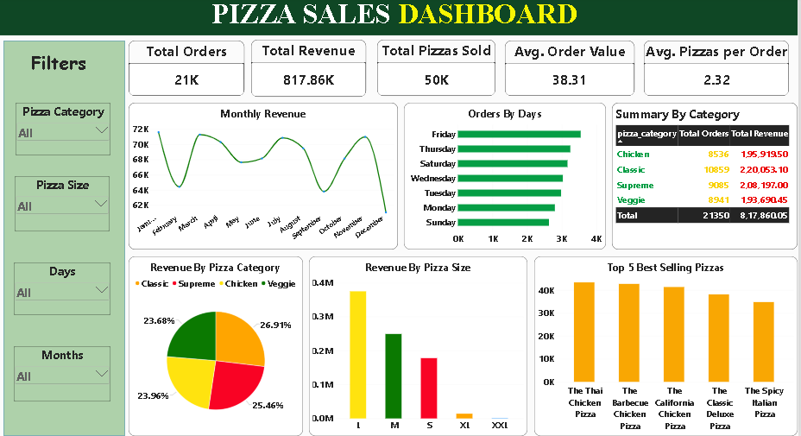
Figure 2. Supplied Power BI Pizza Sales Dashboard

Key Power BI Components
- KPI cards: Total Orders, Total Revenue, Total Pizzas Sold, Average Order Value and Average Pizzas per Order.
- Filters for Pizza Category, Pizza Size, Days and Months.
- Monthly Revenue trend chart.
- Orders by Days horizontal bar chart.
- Category summary table containing order and revenue measures.
- Revenue by Pizza Category pie chart.
- Revenue by Pizza Size column chart.
- Top 5 Best Selling Pizzas ranking.

Power BI Metric Snapshot
KPI | Displayed Value
Total Orders | 21K (dashboard display)
Total Revenue | 817.86K
Total Pizzas Sold | 50K (dashboard display)
Avg. Order Value | 38.31
Avg. Pizzas per Order | 2.32

6. Tableau Dashboard
The Tableau version emphasizes clean analytical views and direct comparison of revenue and order behavior. Its visuals include monthly revenue, orders by day, revenue by category, revenue by size, hourly/order behavior and top-selling pizzas.
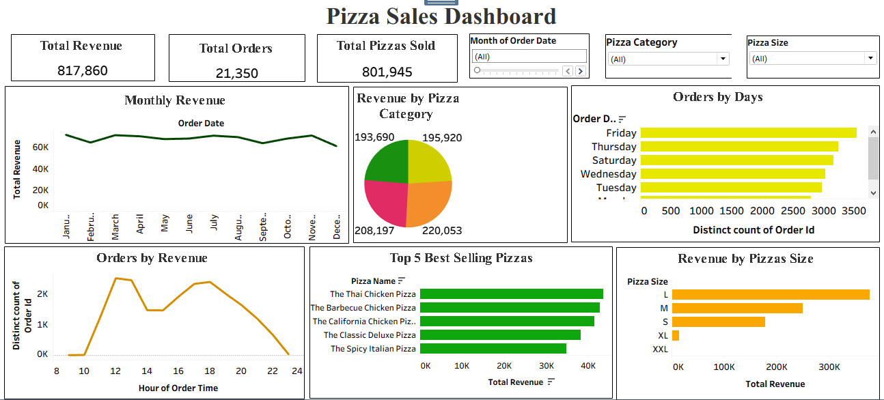
Figure 3. Supplied Tableau Pizza Sales Dashboard

Key Tableau Components
- Headline KPI cards for total revenue, total orders and total pizzas sold.
- Monthly Revenue trend.
- Orders by Days horizontal bars.
- Revenue by Pizza Category pie chart.
- Orders by Revenue / hourly pattern view.
- Top 5 Best Selling Pizzas horizontal ranking.
- Revenue by Pizza Size horizontal bars.

Tableau Metric Snapshot
KPI | Displayed Value
Total Revenue | 817,860
Total Orders | 21,350
Total Pizzas Sold | 801,945*

*The Tableau screenshot displays 801,945 for Total Pizzas Sold. This value is inconsistent with the supplied Excel KPI of 49,574 and the Power BI display of approximately 50K, so the Tableau measure should be validated before final submission. The report does not silently replace the displayed value.

7. Cross-Platform Comparison
All three dashboards communicate the same broad business story, but they differ in interaction, metric display and presentation style.
Dimension | Excel | Power BI | Tableau
Primary strength | Familiar spreadsheet workflow | Interactive BI reporting | Visual analytical storytelling
Filters | Strong slicer-style filtering | Strong interactive slicers | More visualization-focused
KPI presentation | Clear | Most comprehensive | Clear
Trend analysis | Good | Very good | Very good
Ranking analysis | Good | Good | Very good
Ease for beginners | Very high | High | Moderate–high
Presentation readiness | Good | Excellent | Excellent

Recommended Positioning
- Use EDA to demonstrate technical data understanding and analytical reasoning.
- Use Excel to demonstrate spreadsheet, pivot/slicer and dashboard skills.
- Use Power BI as the primary business dashboard because it combines KPI cards, filters and multiple business views effectively.
- Use Tableau as a complementary visualization platform demonstrating cross-tool BI capability.

8. Key Business Insights
Based on the supplied EDA outputs and dashboard views, the following insights can be stated with confidence:
- The dataset contains 48,620 sales-line records and 32 distinct pizza names, providing sufficient product-level detail for dashboard analysis.
- Data quality is strong in the notebook: there are no missing values and no duplicated rows.
- Friday is the busiest day by sales-line count, while Sunday is the least busy.
- Classic is the largest category by sales-line count in the EDA output, followed by Supreme, Veggie and Chicken.
- Large (L) pizzas are the dominant revenue-producing size in the supplied dashboards, followed by Medium (M) and Small (S).
- The dashboards consistently show total revenue of about 817.86K.
- The top-selling product views consistently highlight The Thai Chicken Pizza, The Barbecue Chicken Pizza, The California Chicken Pizza, The Classic Deluxe Pizza and The Spicy Italian Pizza.
- Demand is concentrated in the daytime and early evening hours, with the hourly visual showing clear peaks rather than uniform demand across 24 hours.
- Monthly revenue fluctuates across the year, indicating that sales performance should be monitored by month rather than assuming a constant baseline.

Business Recommendations
- Increase staffing and preparation capacity around the strongest ordering periods, particularly Friday and the major hourly peaks.
- Promote high-performing pizzas through combo offers, add-ons and featured placements rather than relying only on broad discounts.
- Use size-level revenue analysis to optimize inventory and ingredient planning, especially for the dominant L and M sizes.
- Investigate lower-performing days such as Sunday with targeted offers, family deals or time-specific promotions.
- Track category and product performance monthly to identify shifts in customer preferences.
- Standardize KPI definitions across Excel, Power BI and Tableau before presenting the project to evaluators.

9. Technical Review & Improvement Opportunities
The supplied EDA notebook is a useful foundation, but several technical improvements would make the project more robust and professional.
Area | Current Project | Recommended Improvement
Date parsing | order_date is converted during analysis | Parse date once during preprocessing and create a proper calendar/month field.
Time parsing | Hour is derived from order_time | Use an explicit time format to avoid parser warnings.
Plot labels | Several title/label lines use assignment syntax | Use plt.title(...), plt.xlabel(...) and plt.ylabel(...).
Category grouping | Groupby is demonstrated | Create named summary tables/aggregations for reuse.
KPI definitions | Different dashboards show different order/pizza totals | Document exact formulas and keep them identical across tools.
Visualization consistency | Different colors/layouts across tools | Use a shared theme and standardized KPI definitions.
Validation | Dashboard values are visually reported | Add a KPI reconciliation table before final submission.

Most important correction
Before submitting the project, reconcile Total Orders, Total Pizza Sold and Average Order Value across all three dashboards. The same dataset should produce the same KPI definitions unless the dashboard explicitly states that a different measure is being used.

Suggested Standard KPI Definitions
KPI | Recommended Definition
Total Revenue | SUM(total_price)
Total Orders | DISTINCTCOUNT(order_id)
Total Pizzas Sold | SUM(quantity)
Average Order Value | Total Revenue / Total Orders
Average Pizzas per Order | Total Pizzas Sold / Total Orders

10. Conclusion
The Pizza Sales Analytics project demonstrates a complete data-analysis workflow from raw transaction data to business dashboards. The EDA stage establishes data quality and reveals important patterns in time, category, size and product performance. Excel provides an accessible dashboarding layer, while Power BI and Tableau provide stronger BI-oriented presentation and analytical storytelling.
The overall result is a practical portfolio project that demonstrates skills in Python-based EDA, data validation, aggregation, visualization, KPI design and business intelligence. The next priority should be KPI reconciliation and formula standardization so that all tools tell exactly the same numerical story.

Final Deliverables Covered
Component | Purpose | Status in Supplied Files
EDA | Data understanding, quality checks and exploratory visuals | Completed
Excel | Spreadsheet dashboard with filters and KPIs | Completed
Power BI | Interactive business intelligence dashboard | Completed
Tableau | Visual analytics dashboard | Completed

