HEALTHCARE ANALYTICS
EDA, Excel, Power BI & Tableau

1. Executive Summary
This report presents a healthcare analytics project based on exploratory data analysis and dashboard visualization. The supplied dataset contains 55,500 patient records and 15 attributes. The workflow moves from data inspection and quality validation to clinical, demographic, admission and billing analysis, followed by dashboard reporting in Excel, Power BI and Tableau.

Objectives
- Understand dataset structure and descriptive statistics.
- Validate missing values, duplicates and unusual numerical values.
- Analyze age, gender, medical condition, admission type, medication, insurance and test results.
- Create meaningful visualizations and KPI-style summaries.
- Compare Excel, Power BI and Tableau as reporting and visualization tools.

2. Dataset Overview
The dataset fields include Name, Age, Gender, Blood Type, Medical Condition, Date of Admission, Doctor, Hospital, Insurance Provider, Billing Amount, Room Number, Admission Type, Discharge Date, Medication and Test Results.
Metric | Result
Total records | 55,500
Columns | 15
Missing values | 0
Duplicate rows | 534
Average age | 51.54 years
Age range | 13–89 years
Average billing | 25,539.32
Billing range | -2,008.49 to 52,764.28

3. Exploratory Data Analysis
EDA was used as the foundation before dashboard development. The supplied analysis covers dataset inspection, data types, missing values, duplicates, unique values, descriptive statistics, sorting, grouping and categorical frequency analysis.

3.1 Data Quality
Check | Finding | Interpretation
Missing values | 0 | Fields are complete in the supplied analysis.
Duplicates | 534 | Should be reviewed during cleaning.
Minimum billing | -2,008.49 | Potential anomaly; validate before financial reporting.
Test results | Normal / Inconclusive / Abnormal | Three categories are present.

3.2 Medical Condition
Condition | Patients
Arthritis | 9,308
Diabetes | 9,304
Hypertension | 9,245
Obesity | 9,231
Cancer | 9,227
Asthma | 9,185

Arthritis is the highest recorded condition and Asthma is the lowest. The six counts are relatively close, so the condition mix is fairly evenly represented.

3.3 Admission Type
Admission | Patients
Elective | 18,655
Urgent | 18,576
Emergency | 18,269

Elective admissions are the largest category, followed by Urgent and Emergency. The three categories are close in volume.

3.4 Year-wise Patient Trend
Year | Patients
2019 | 7,387
2020 | 11,285
2021 | 10,931
2022 | 11,017
2023 | 11,026
2024 | 3,854

The supplied EDA shows the highest annual count in 2020 and a sharp decrease in 2024. The 2024 result should be checked against the underlying date coverage and dashboard context.

4. Dashboard Framework
The dashboards consolidate the EDA into KPI cards, trend charts, categorical comparisons and interactive filters. The supplied views cover yearly patient trends, medical condition and test results, age group, gender, admission type, medication and insurance provider.
Dashboard element | Purpose
KPI cards | Total Patients and Average Billing Amount
Year trend | Patient counts from 2019–2024
Clinical views | Medical conditions and test results
Demographics | Age group and gender
Operations | Admission type and medication
Insurance | Provider comparison
Filters | Gender, Test Results, Year and Age Group

5. Excel Dashboard
The supplied Excel dashboard is titled “HEALTH ANALYTICS DASHBOARD”. It uses Pivot-style summaries, charts, KPI cards and slicers for quick reporting and interactive filtering.
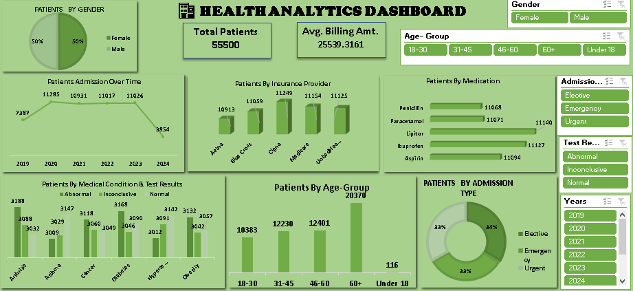
Figure 1. Supplied Excel dashboard.
Component | Output
KPIs | Total Patients = 55,500; Avg. Billing ≈ 25,539.3161
Views | Gender, admission over time, insurance, medication, condition/test results, age group, admission type
Slicers | Gender, Age Group, Admission Type, Test Results, Years
Role | Quick, familiar Pivot-based reporting

6. Power BI Dashboard
The supplied Power BI dashboard is titled “Healthcare Analytics Dashboard”. It combines KPI cards, yearly trends and multiple clinical, demographic and operational visuals.
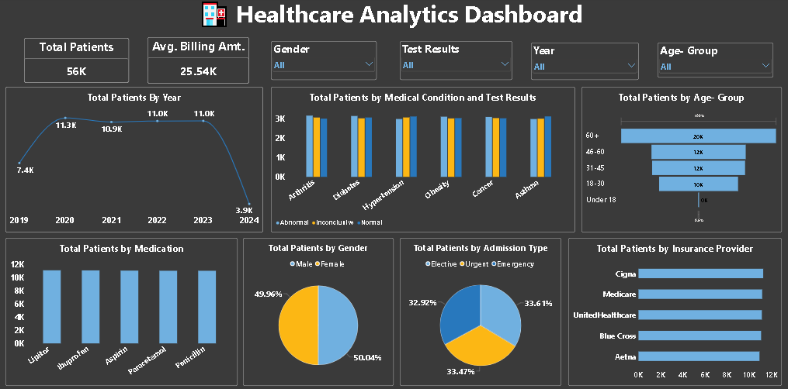
Figure 2. Supplied Power BI dashboard.
Component | Output
KPIs | Total Patients and Average Billing
Trend | 2019–2024 patient trend
Clinical | Medical Condition vs. Test Results
Other views | Admission, medication, insurance, age group, gender
Displayed screenshot state | 11,026 patients; Avg. Billing ≈ 25,574

7. Tableau Dashboard
The supplied Tableau dashboard is titled “Healthcare Analytics Dashboard”. It emphasizes interactive filtering and visual comparison across the same major healthcare dimensions.
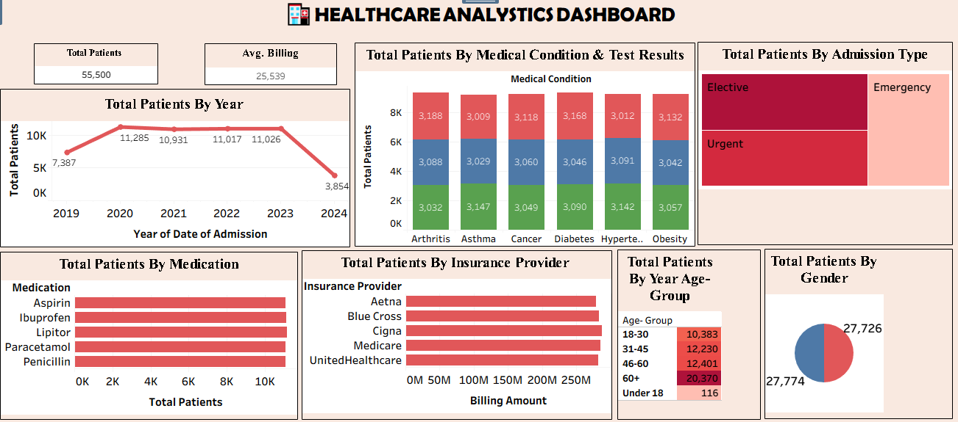
Figure 3. Supplied Tableau dashboard.
Component | Output
KPIs | Total Patients and Average Billing Amount
Filters | Gender, Test Results, Year, Age Group
Views | Year trend, condition/test results, age group, medication, gender, admission, insurance
Displayed state | Approximately 56K patients; Avg. Billing ≈ 25.54K
Gender | Approximately 50.04% Male and 49.96% Female

8. Tool-wise Comparison
Area | Python EDA | Excel | Power BI | Tableau
Data cleaning / quality | Excellent | Good | Good | Good
Statistical EDA | Excellent | Moderate | Moderate | Moderate
Pivot / quick analysis | Moderate | Excellent | Excellent | Excellent
Interactive dashboard | Limited | Good | Excellent | Excellent
Advanced visualization | Excellent | Good | Excellent | Excellent
Ease for beginners | Moderate | Excellent | Good | Good
Best use | Deep EDA | Quick reporting | Business BI | Interactive visual analytics

9. Key Insights
- 55,500 patient records support multi-dimensional analysis.
- Average patient age is approximately 51.54 years.
- Arthritis is the most frequent listed condition; Asthma is the least frequent.
- Elective, Urgent and Emergency admissions are relatively balanced.
- No missing values were found, but 534 duplicate records require review.
- The negative minimum billing value is a notable anomaly requiring investigation.
- Dashboards make demographic, clinical, admission and financial patterns easier to compare than raw tables alone.

10. Limitations & Validation
- The reason for the 534 duplicate records is not established in the supplied materials.
- The meaning of the negative billing value is not established and should be validated.
- Dashboard totals may represent filtered states and therefore should not automatically be compared with the overall EDA total.
- Final dashboard values should be checked against the underlying data and filter configuration.
- The supplied materials support descriptive analytics; they do not establish clinical causation.

11. Future Scope
- Investigate and resolve duplicate records and negative billing values.
- Analyze relationships among age, billing, medical condition and admission type.
- Add deeper time-based analysis using admission and discharge dates.
- Introduce advanced BI measures and drill-down analysis.
- Extend the dashboard with hospital, doctor and room-level analysis where appropriate.

12. Conclusion
The Healthcare Analytics project demonstrates a complete workflow from raw patient data to visual reporting. EDA establishes data quality and reveals clinical, demographic, admission and time-based patterns. Excel provides a practical Pivot-based reporting layer, while Power BI and Tableau provide strong interactive dashboard experiences. The recommended workflow is: Clean & Validate → EDA → KPI/Summary Calculations → Dashboard → Insights → Validation.

13. Source Basis
This report is based on the supplied project materials: the healthcare EDA notebook, Excel dashboard screenshot, Power BI dashboard screenshot, Tableau dashboard screenshot, and the supplied Healthcare Analytics EDA Report/Synopsis. Dashboard values are preserved as displayed; no unsupported reconciliation has been added.

