Name: Sakshi Rajendra Chaudhari

Roll No.:39

Assignment No.: 01

Assignment Title: Develop programs to understand the control structures of python

Code:

**1.1 Continue statement:**

# Program to find out even and odd number in between given range using for loop:

for num in range(10):  
 if num % 2 == 0:  
 print(num, "is even number")  
 continue  
 print(num, "is odd number")

**Output:**

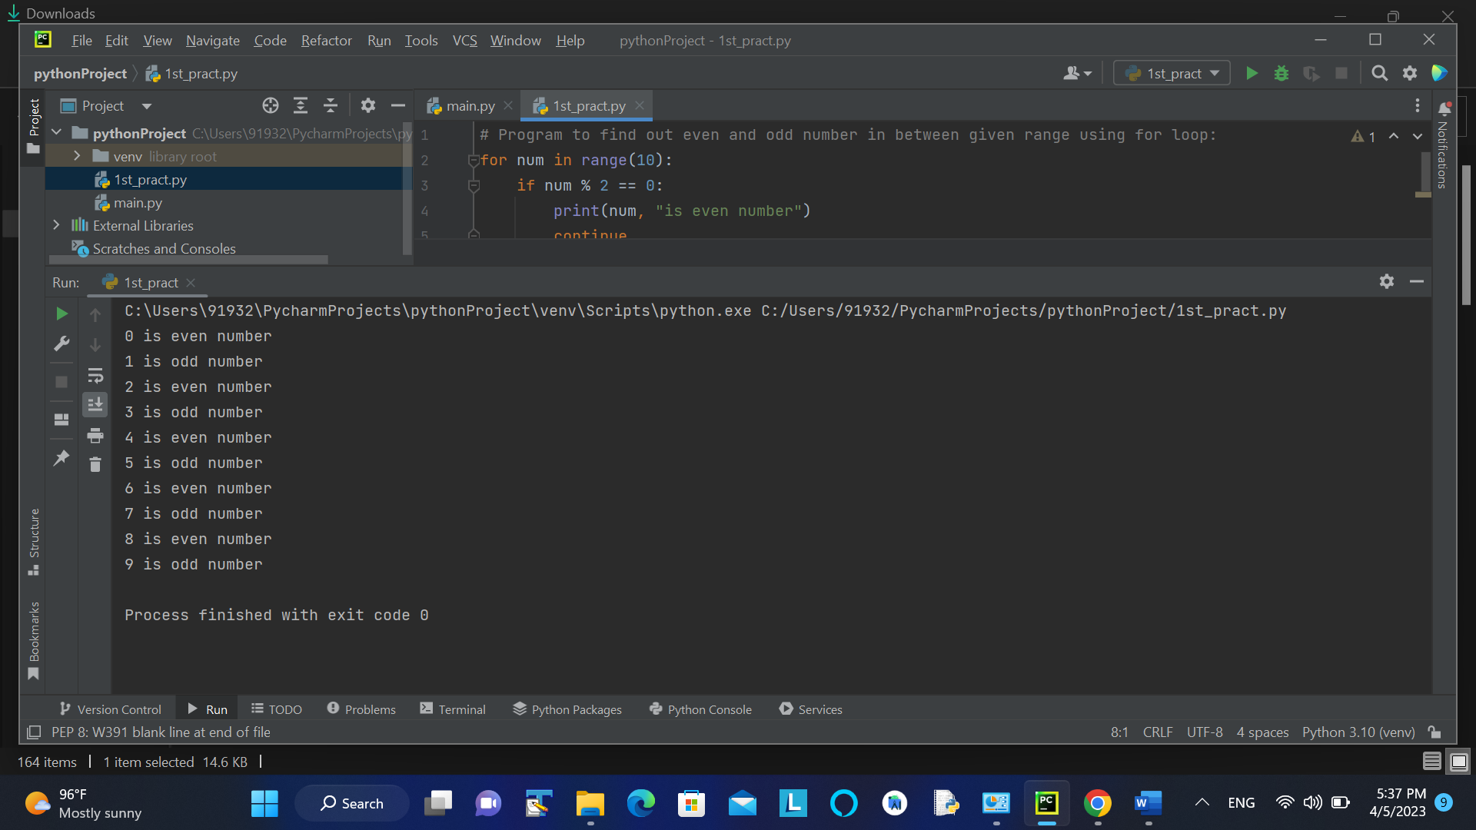

# program to print odd numbers from 1 to 10 using while loop:

num = 0  
n = int(input("Enter a number in between 1 to 10: "))  
if n > 10:  
 print("please enter a number in between 1 to 10")  
else:  
 while num < n:  
 num += 1  
 if (num % 2) == 0:  
 continue  
 print(num)

**Output**

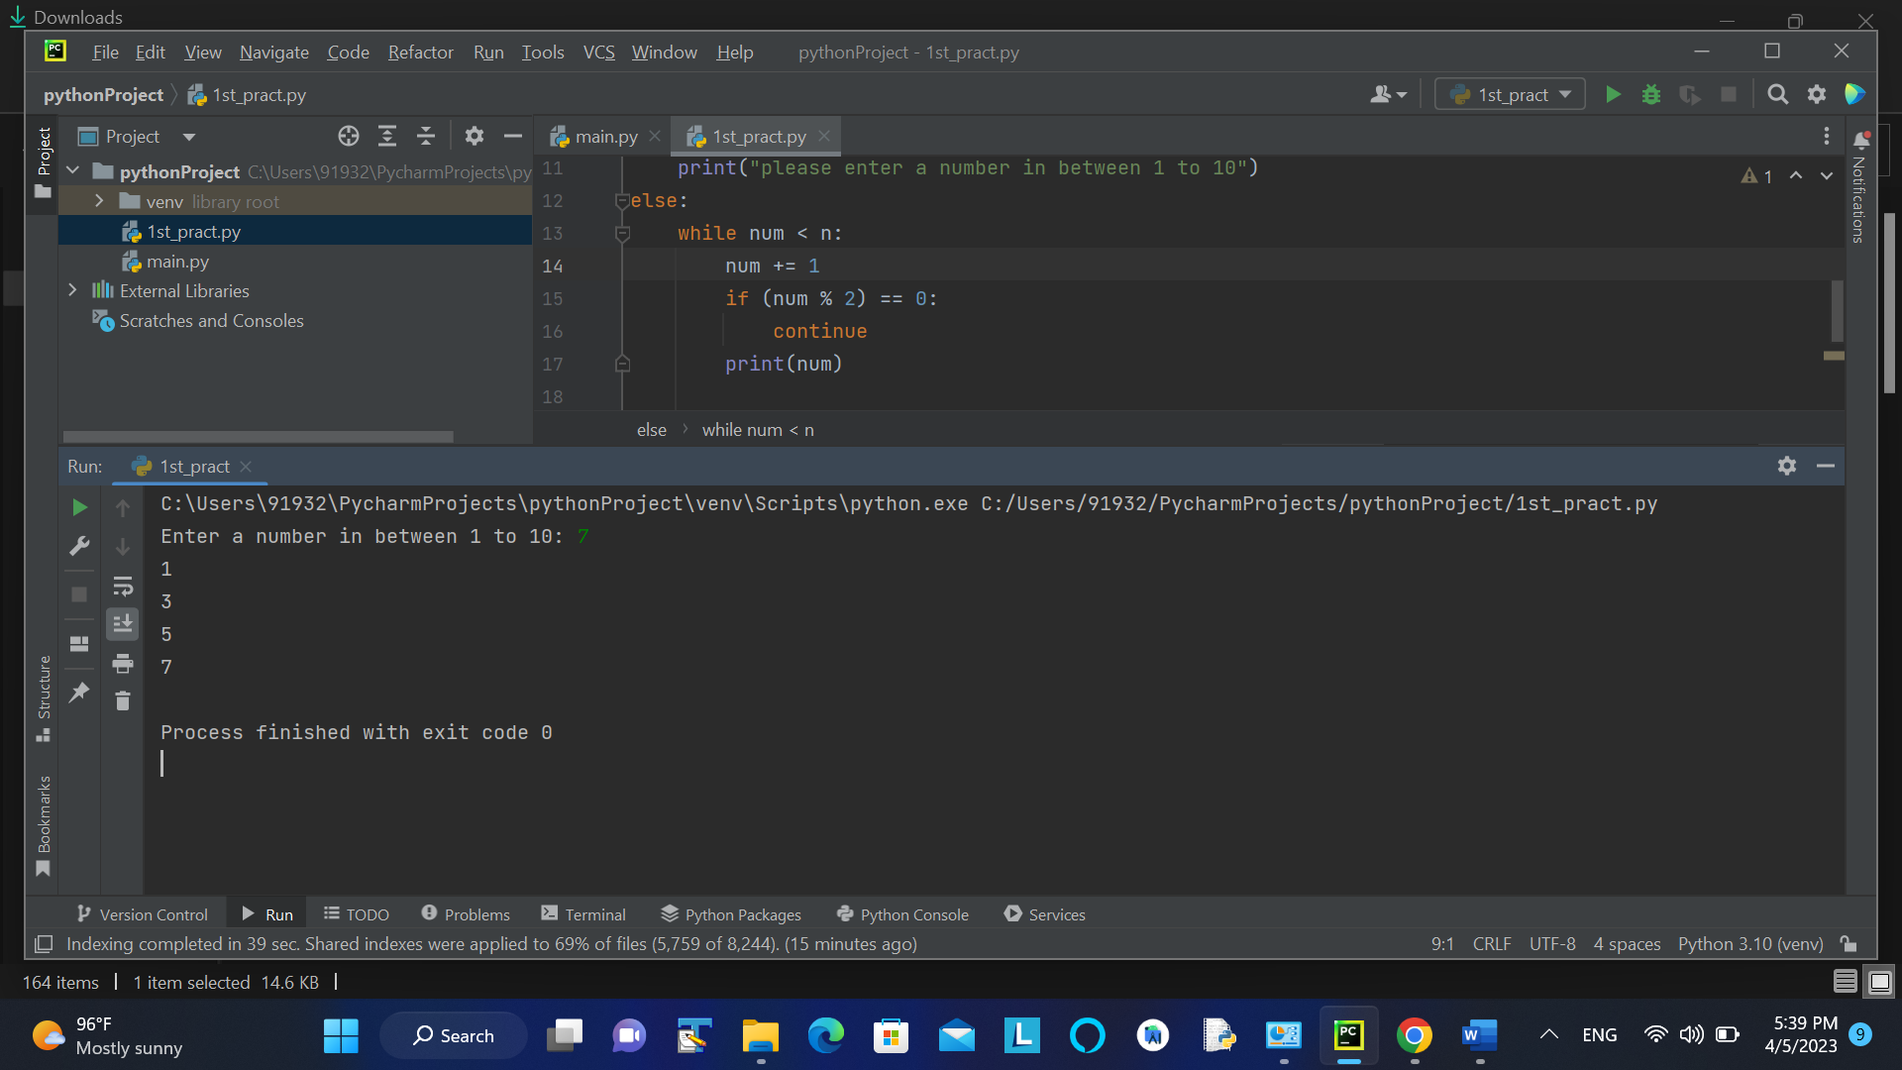

**1.2 Break Statement:**

# program to find first 5 multiples of 6

i = 1  
n = int(input("Enter a number in between 1 to 10: "))  
if n > 10:  
 print("please enter a number in between 1 to 10")  
else:  
 while i <= 10:  
 print('6 * ', (i), '=',6 * i)  
 if i >= n:  
 break  
 i = i + 1

**Output:**

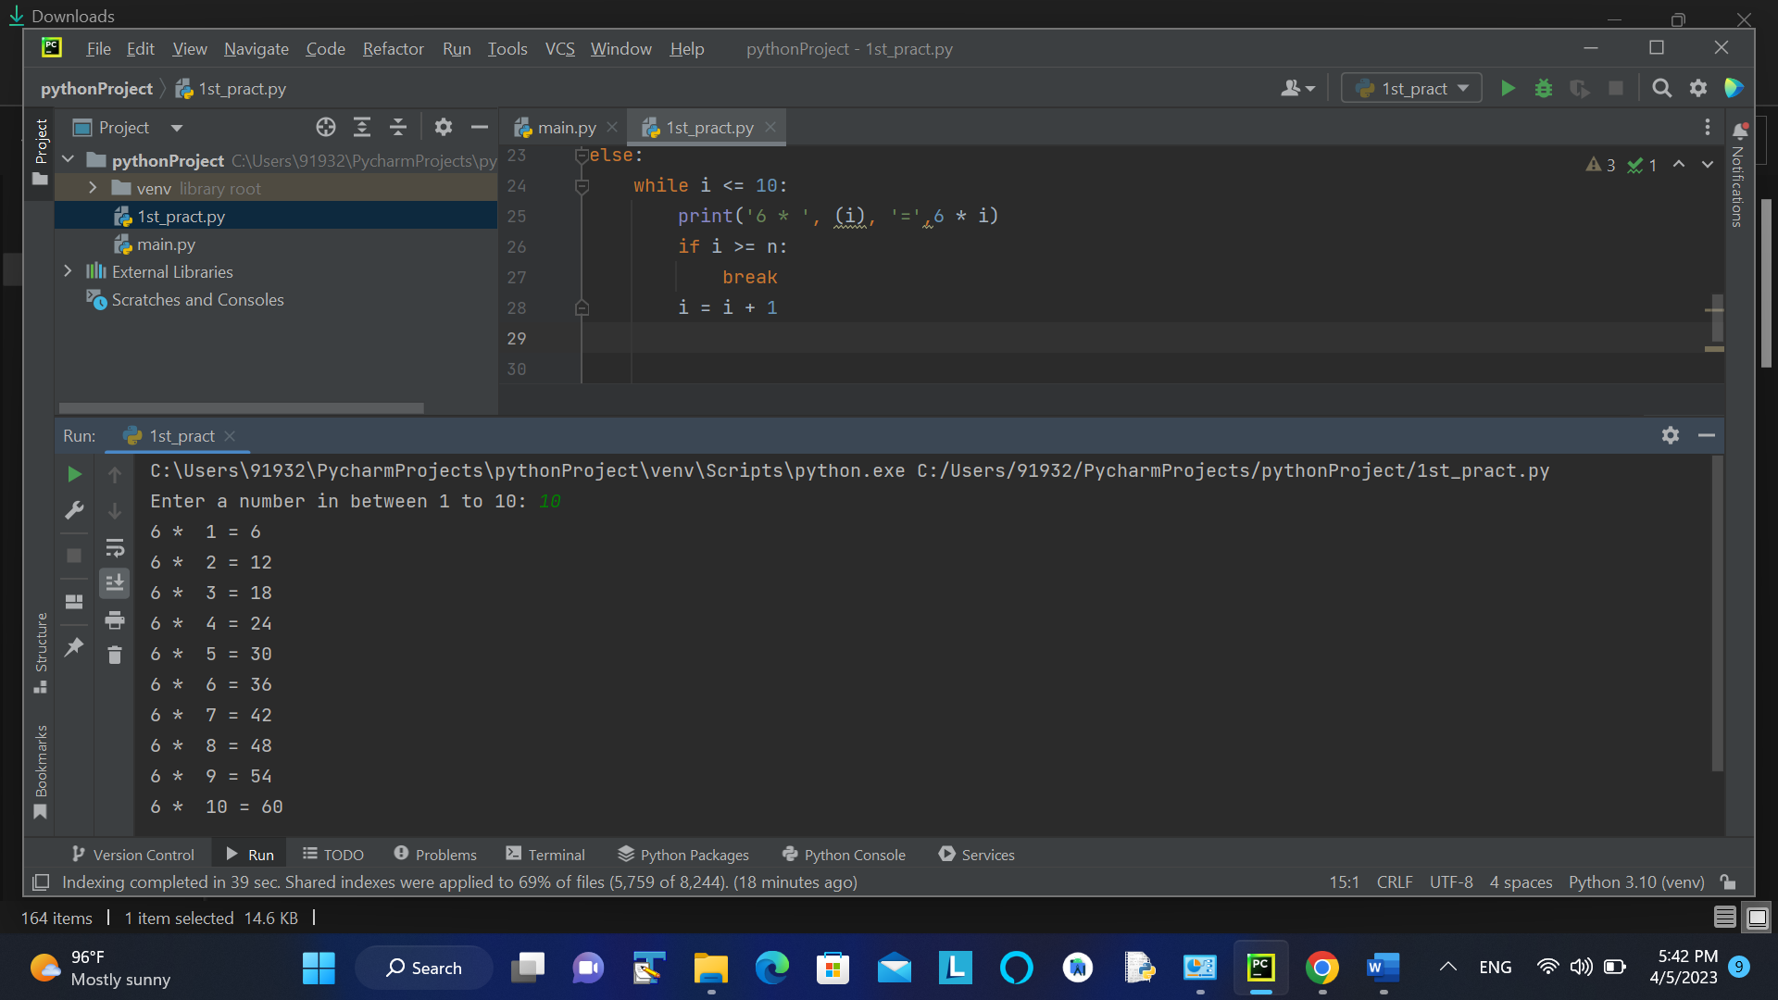

**1.3 Pass Statement:**

#Program to find out odd number in given list

num = [1, 3, 6, 33, 76, 29, 17, 60, 47, 53, 88, 10, 2, 3, 100]  
  
print('Odd numbers are: ')  
for i in num:  
 # check if the number is even  
 if i % 2 == 0:  
 # if even, then pass  
 pass  
 # print the odd numbers  
 else:  
 print (i)

**Output:**

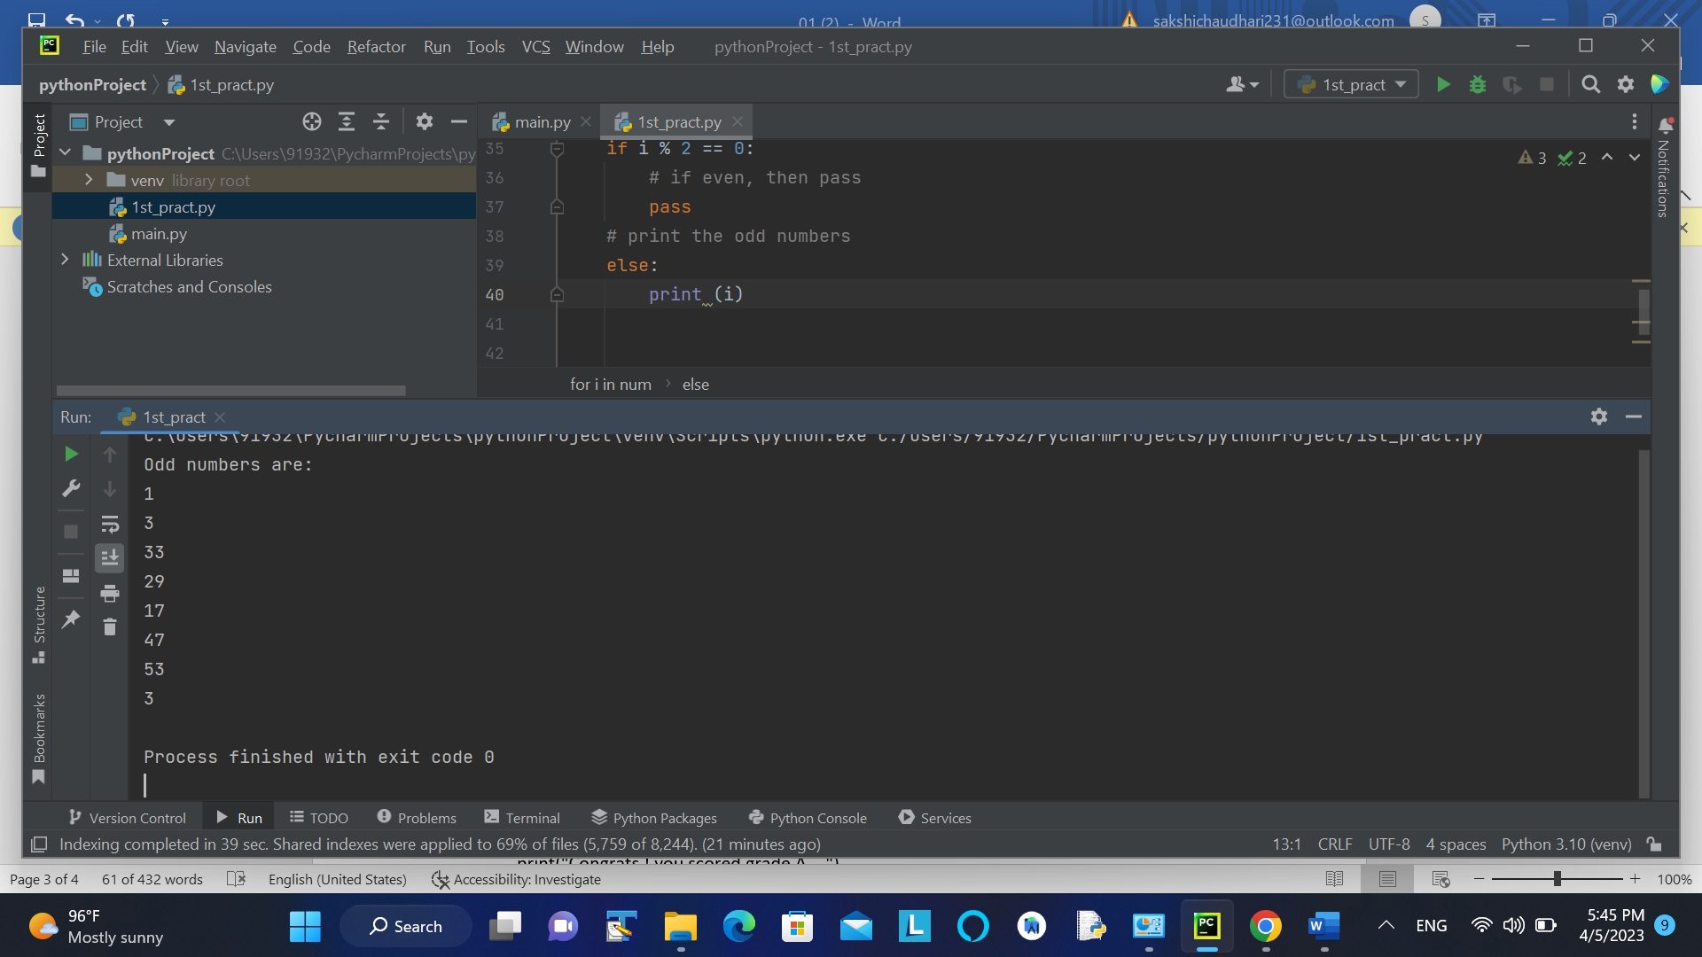

**1.4 Conditional Statement (Chained if):**

#program to find out Grade of student:

marks = int(input("Enter the marks: "))  
if marks>100:  
 print("Please enter proper marks!")  
elif marks > 85 and marks <= 100:  
 print("Congrats ! you scored grade A ...")  
elif marks > 60 and marks <= 85:  
 print("You scored grade B + ...")  
elif marks > 40 and marks <= 60:  
 print("You scored grade B ...")  
elif (marks > 30 and marks <= 40):  
 print("You scored grade C ...")  
else:  
 print("Sorry you are fail")

**Output:**

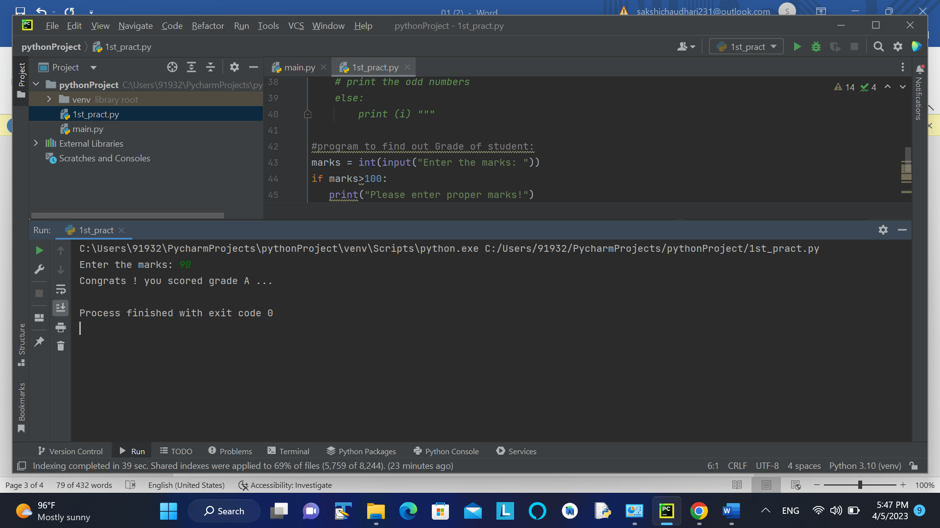

**1.5 Nested Loop:**

#program to print Multiplication table up to given number:

n = int(input("Enter any number up to 100:"))  
  
# Iterating over numbers in the range 1 to n  
for row in range(1,n+1):  
 # Iterating over numbers in the range 1 to n  
 for col in range(1,n+1):  
 # Printing the product of row and col  
 print(row*col, end="\t")  
 print()

**Output:**

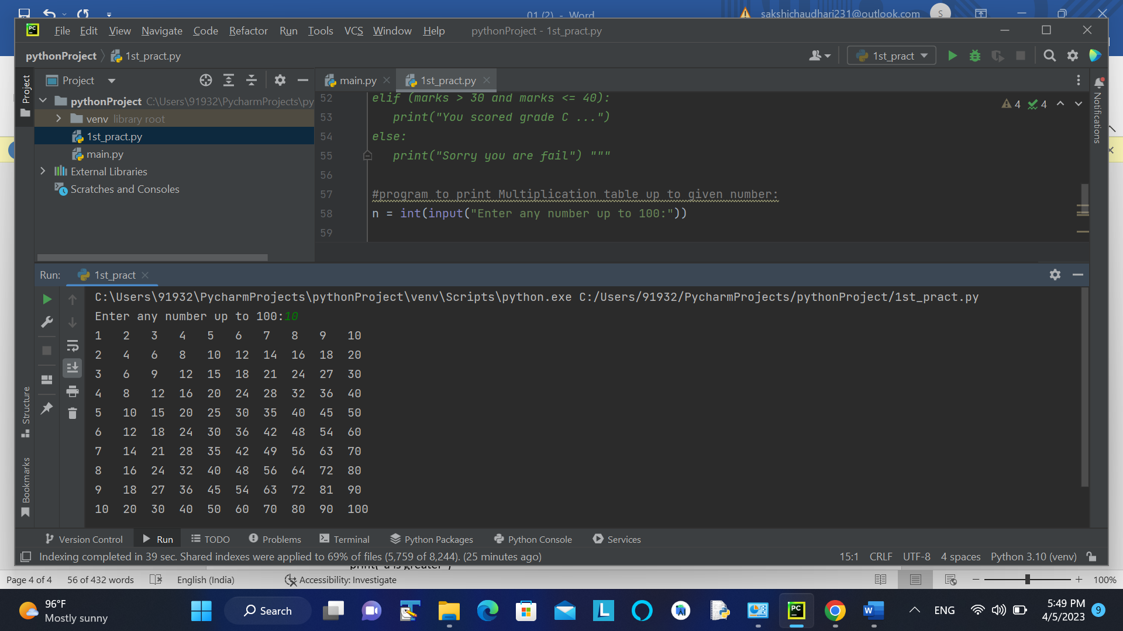

**1.6 Nested Condition:**

a = int(input("Enter 1st number: "))  
b = int(input("Enter 2nd number: "))  
c = int(input("Enter 3rd number: "))  
if(a>b):  
 if(a>c):  
 print("1st No is greater")  
  
if(b>a):  
 if(b>c):  
 print("2nd No is greatest")  
  
if(c>a):  
 if(c>b):  
 print("3rd No is greatest")  
  
if(a == b and b == c):  
 print("all are equal")

**Output:**

