ADVANCE JAVA COURSE CONTENT

# 

**Our Strength**

**Duration: 30 Hours Vivek Sir**

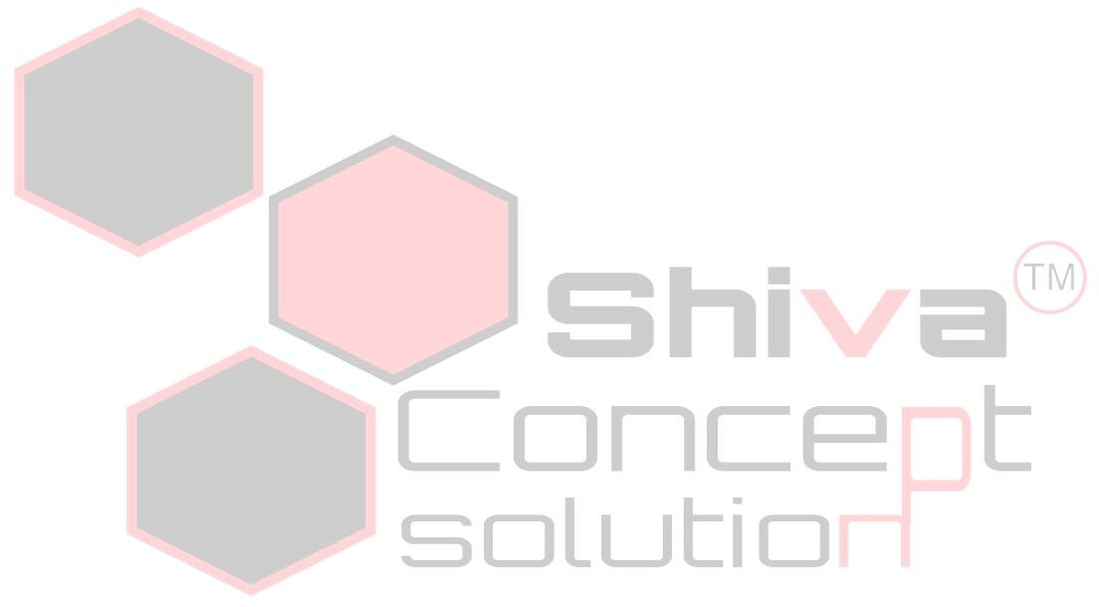**Prerequisite: C++ 0939-9126229**

|  |  |
| --- | --- |
| **ADVANCE JAVA**  **Syllabus** | * Collection Framework in depth(LIST, MAP, TREE, QUEUE, DEQUEUE, MAP), Comparable, Comparator, Legacy Classes. * SQL QUERY. * JDBC (type1,type2,type3,type4) using Swing Interface(Statement, Prepared Statement). * Create Stored Procedure and call from JSP or Servlet. * Servlet , Custom Servlet, Servlet life cycle. * Create Design and Code in servlet. * Servlet Redirection using Request dispatcher . * JSP Overview. * Create Dynamic Web template using JSP. * Create Form using JSP and Get data by Servlet. * Redirection from JSP. * JSP Directive elements(Include, Forward) etc. * JSP Scriptlet block expression, Declaration etc. * JSP Custom tag. * JSTL * Create Login ,Registration and Explain Session and Cookies . * File uploading and Downloading. * Filter in Servlet. * Report using JSP and Servlet. * Pagination using JSP and Servlet. * Use Jquery and Ajax in JSP. * Validation using JQUERY and JAVASCRIPT. * HTML/HTML5 Introduction. * CSS/CSS3 Introduction. * JAVA Beans Class. * Explain Project practically One-tier, Two-Tier and Three Tier (MVC) using JSP, Servlet and Bean class. * Servlet to bean and JSP to bean. * Use Stored Procedure using Callable Statement. * Create one minor project using User panel and Admin panel. * RMI Introduction.   **Note:** Project is mandatory it will be completed by Current Faculty.  You can check Syllabus if any topic not covers then you can Direct contact to management. |



Visit us:- H.O. M-6, 1ST Floor Kanchan Sagar Near Industry House 0731-4069788, 7805063968

B.O. GH 45 1ST Floor Sch. No.54 Near Perfect Bakery Vijay Nagar Indore. 0731 4906788

B.O. 160/4 Pipliyarao Bhawarkua Above Panjabi Tadka Restaurant Opp. TVS Showroom A.B. Road