QLSTM: A Hybrid Quantum–Classical Recurrent Network for Forecasting the Evolution of Wheat Foliar Disease
[Author One]¹, [Author Two]¹, [Author Three]^{2,*}
¹ [Department, Institution, City, Country] ² [Department, Institution, City, Country]
Corresponding author: [email address
Abstract
Foliar diseases of wheat evolve over days: lesions appear, expand and coalesce, and the proportion of diseased leaf tissue can rise from near zero to more than 80 % within two weeks. Anticipating this evolution, rather than only recognising its current state, is what disease management requires. We present a hybrid quantum–classical Long Short-Term Memory network (QLSTM) for one-step-ahead forecasting of wheat leaf disease progression. In each of the four recurrent gates, a classical encoder maps the input and hidden state onto eight qubits, a variational quantum circuit of three strongly entangling layers transforms the encoded state, and Pauli-Z measurements are decoded back into the gate activation. The network is trained jointly to forecast disease severity (proportion of leaf area covered by lesions) and absolute lesion area at the next observation from the four preceding ones. Using longitudinal phenotyping data from the ETH Zurich wheat field experiments (1,029 leaves, 11,768 observations, two seasons), QLSTM forecasts next-day disease severity on unseen leaves with R² = 0.839 ± 0.018 and lesion area with R² = 0.791 ± 0.020, improving on a naive persistence forecast by 0.14 and 0.12 R² respectively, with accuracy on par with classical recurrent networks while using only 288 trainable quantum parameters. When driven directly by Vision Transformer embeddings of the leaf images, QLSTM forecasts severity with R² = 0.869 using 14.6 k parameters, whereas classical LSTM and GRU networks with 5–7 × more parameters fail to generalise (R² ≤ 0.12). These results show that QLSTM captures the temporal dynamics of foliar disease evolution and is particularly well suited to high-dimensional visual inputs under the limited number of biological replicates typical of phenotyping studies.
Keywords: quantum machine learning; QLSTM; variational quantum circuits; plant disease progression; wheat; Septoria tritici blotch; rust; time-series forecasting; Vision Transformer; high-throughput phenotyping

1. Introduction
Wheat supplies about a fifth of the calories consumed worldwide, and foliar fungal diseases — Septoria tritici blotch (STB) caused by Zymoseptoria tritici, yellow (stripe) rust and brown (leaf) rust — are among the most damaging constraints on its yield. These diseases are dynamic: after a latent period, lesions appear, expand and coalesce, and pycnidia or uredinia develop on the necrotic tissue. The rate at which this happens differs between cultivars, environments and individual leaves, and it is the trajectory of the epidemic, rather than its state on a single day, that determines yield loss and the value of an intervention.
Image-based deep learning now recognises diseases on single leaf photographs with high accuracy [1], and segmentation pipelines quantify lesion area, pycnidia density and related traits automatically [9]. Longitudinal phenotyping platforms that image the same leaves repeatedly under field conditions turn these measurements into time series of disease development. Forecasting how a leaf will look at the next observation is a natural sequence-learning task, for which recurrent neural networks such as the Long Short-Term Memory (LSTM) [2] and the Gated Recurrent Unit (GRU) [3] are standard tools.
Quantum machine learning offers a different way of building such models. Variational quantum circuits (VQCs) [7] are parameterised quantum circuits whose rotation angles are optimised by gradient descent; they act on an exponentially large state space with a small number of trainable parameters. Chen et al. [8] introduced the quantum LSTM (QLSTM), in which the affine transformations inside the LSTM gates are realised by VQCs, and demonstrated that it learns temporal dependencies with fewer parameters than its classical counterpart. Because each VQC reads in and emits only one value per qubit, a QLSTM gate is a compact, strongly structured transformation — a property that is attractive when inputs are high-dimensional and independent biological units are few, as in most phenotyping studies. To our knowledge, QLSTM has not previously been applied to plant disease progression.
In this work we develop and evaluate a QLSTM for forecasting the evolution of wheat foliar disease. Our contributions are:
- A QLSTM architecture for multi-task disease forecasting, with an 8-qubit, 3-layer VQC in each gate, non-linear classical encoders and decoders around the circuit, and task-specific output heads for disease severity and lesion area.
- A forecasting formulation and evaluation protocol on two seasons of longitudinal field phenotyping data: inputs strictly precede the forecast target, all partitions are made at the level of individual leaves, and accuracy is reported over repeated leaf-level splits against a persistence reference.
- Evidence that QLSTM forecasts next-observation disease severity and lesion area accurately across more than 1,100 test windows from 150 unseen leaves, follows individual disease trajectories through the rapid-expansion phase, and matches classical recurrent accuracy with 288 quantum parameters.
- A visual variant driven by Vision Transformer (ViT) image embeddings, in which QLSTM forecasts disease severity with R² = 0.869 while larger classical recurrent networks do not generalise.

2. Related Work

2.1 Image-based assessment and forecasting of plant disease
Convolutional and transformer networks classify plant diseases from leaf images with high accuracy on curated datasets [1], and lesion-level segmentation enables quantitative severity estimation in the field [9]. Most such systems are static: they describe the state of a leaf at the moment of imaging. Classical epidemiological forecasting, in contrast, models disease development as a function of time, weather and host factors, but typically at the plot or field scale. Longitudinal leaf-level imaging bridges the two, providing dense trajectories of disease development on individual leaves that can be learned directly by sequence models.

2.2 Recurrent networks and visual embeddings
LSTM [2] and GRU [3] networks maintain a gated memory that captures temporal dependencies in sequential data. Pretrained Vision Transformers [4] provide 768-dimensional image embeddings (ViT-B/16) that transfer well across domains and can serve as frozen per-frame inputs to a recurrent model.

2.3 Variational quantum circuits and QLSTM
Variational quantum algorithms [7] combine a parameterised quantum circuit with a classical optimiser and are among the most promising uses of near-term quantum devices. Differentiable programming frameworks such as PennyLane [10] allow such circuits to be embedded in PyTorch models and trained end-to-end. QLSTM [8] replaces the gate transformations of an LSTM with VQCs and has since been applied to time-series prediction in several domains. A known challenge for VQCs is the emergence of barren plateaus in wide or deep circuits [11], which motivates moderate qubit counts and circuit depths such as those used here.

3. Materials and Methods

3.1 Longitudinal phenotyping data
We use the wheat leaf phenotyping data set from field experiments at ETH Zurich [9] (doi:10.3929/ethz-b-000739194). Individual leaves of winter wheat were imaged repeatedly in the field during the 2023 and 2024 seasons, and every image was processed by a segmentation pipeline that quantifies leaf area, lesion area, pycnidia and rust pustules. The leaf-level table comprises 11,768 observations of 1,029 leaves in 95 plots, with a median of 11 observations per leaf and a median interval of 23.9 h between consecutive observations (interquartile range 21.2–27.6 h). Pycnidia (indicative of STB) and rust pustules are each detected on 99 % of leaves at some point in their time series, so most leaves carry mixed infections.
Two quantities are forecast. Disease severity is the proportion of leaf area covered by lesions (placl, in [0, 1]); 22.7 % of observations exceed 5 % severity and the maximum is 0.995. Lesion area is the absolute diseased area in pixels, computed as placl × total leaf area.

3.2 Forecasting task
For each leaf, observations are ordered in time and arranged into overlapping windows of T = 4 consecutive observations. The model receives the window [t−3, t−2, t−1, t] and forecasts severity and lesion area at the next observation, t+1. All information in the input therefore strictly precedes the target. Leaves with at least five observations contribute windows, giving 7,710 forecasting windows from 995 leaves (3,775 from 2023 and 3,935 from 2024).

3.3 Input representations
Phenotype histories (primary). Each observation is described by 20 features: total, damaged, healthy and insect-damaged leaf area; damaged and healthy fractions; counts of lesions, pycnidia and rust pustules; pycnidia and rust densities; disease severity; six statistics of the spatial distribution of lesions (mean, standard deviation and coefficient of variation of inter-lesion and nearest-neighbour distances); an indicator of whether nearest-neighbour statistics are defined (fewer than two lesions); and the time elapsed since the previous observation, which accounts for irregular sampling.
Visual sequences (variant). To evaluate QLSTM directly on images, each leaf image of a 99-leaf subset was embedded with an ImageNet-pretrained ViT-B/16 (classification head removed), giving a 768-dimensional feature vector per observation. A second visual configuration adds three exogenous variables: total leaf area and plot-level fungicide and inoculation treatments (771 features). The visual subset yields 1,091 forecasting windows.
All input features are standardised with statistics computed on training leaves only; the lesion-area target is z-scored with training-set statistics and all metrics are reported in original units.

3.4 QLSTM architecture
QLSTM follows the LSTM recurrence but computes each gate through a classical–quantum–classical pathway (Figure 1). At step t, the input x_{t} is concatenated with the previous hidden state h_{t−1} (hidden size H = 32). For each gate k ∈ {f, i, o, g}, an encoder E_{k} (Linear → GELU → Linear, 32 hidden units) maps [x_{t}; h_{t−1}] to n = 8 real values, which are loaded into the circuit by angle embedding, one R~X~ rotation per qubit. The circuit then applies L = 3 strongly entangling layers [10], each consisting of a general single-qubit rotation Rot(φ, θ, ω) on every qubit followed by a ring of CNOT gates with layer-dependent range, and the expectation value of Pauli-Z is measured on every qubit. A decoder D_{k} (Linear → GELU → Linear) maps the eight expectations to H dimensions:
q_{k} = ⟨Z⟩( U_{SEL}(θ_{k}) · R_{X}( E_{k}([x_{t} ; h_{t−1}]) ) |0⟩^{⊗8} ) (1)
f_{t}, i_{t}, o_{t} = σ( D_{f,i,o}(q_{f,i,o}) ), g_{t} = tanh( D_{g}(q_{g}) ) (2)
c_{t} = f_{t} ⊙ c_{t−1} + i_{t} ⊙ g_{t}, h_{t} = o_{t} ⊙ tanh(c_{t}) (3)
Each circuit has L × n × 3 = 72 trainable rotation angles, so the four gates contain 288 quantum parameters. After the final step, h_{T} feeds two task-specific heads (Linear 32→16, GELU, dropout 0.1, Linear 16→1). The complete model has 14,594 trainable parameters. The visual variant uses a lighter cell (4 qubits, 2 entangling layers, linear encoders and decoders; 96 quantum parameters, 14,642 in total, most of them in the 768-dimensional input encoders).
Circuits were defined in PennyLane [10] and simulated exactly as state vectors in PyTorch; outputs and gradients of the simulator agree with PennyLane’s default.qubit device to within 10⁻⁶. Gradients with respect to the circuit parameters were obtained by automatic differentiation through the simulation.
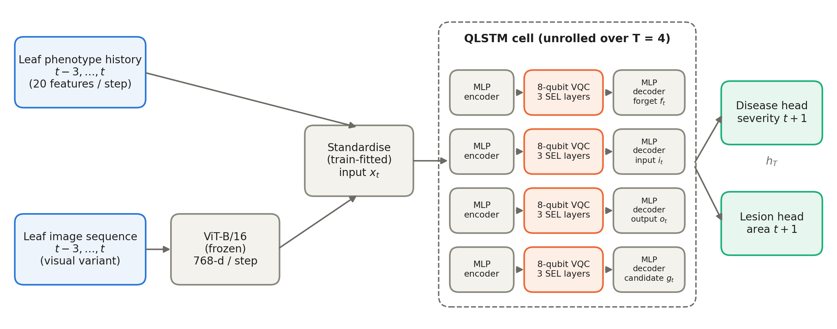
Figure 1. QLSTM forecasting architecture. Phenotype histories (or, in the visual variant, frozen ViT-B/16 image embeddings) for the four most recent observations are standardised and passed step by step through the QLSTM cell. In each of the four gates, an MLP encoder maps the input and previous hidden state onto eight qubits, a variational circuit of three strongly entangling layers (SEL) transforms the state, and an MLP decoder maps the Pauli-Z expectations to the gate activation. Two output heads read the final hidden state to forecast disease severity and lesion area at t+1.

3.5 Multi-task objective and training
Both targets are learned jointly by minimising
ℒ = λ_{d} · MSE(y_{sev}, ŷ_{sev}) + λ_{l} · MSE(z_{les}, ẑ_{les}), λ_{d} = 10, λ_{l} = 0.5 (4)
where z_{les} is the standardised lesion area; the weights balance the gradient contributions of the bounded severity target and the unit-variance lesion target. Models were trained with Adam (learning rate 1 × 10⁻⁴ with cosine annealing to 1 × 10⁻⁵), batch size 8, gradient-norm clipping at 1.0 and up to 50 epochs, with early stopping (patience 10) on the validation loss. The checkpoint with the lowest validation loss was evaluated once on the test leaves.

3.6 Evaluation protocol
Because consecutive windows of a leaf share three observations, all partitions are made at the level of whole leaves: a two-stage grouped split assigns 70 % of leaves to training, 15 % to validation and 15 % to testing, so that no leaf contributes to more than one partition. On the phenotype-history data this yields 696 training, 149 validation and 150 test leaves, with 1,122–1,128 test windows depending on the split. The split is repeated with different random seeds, each seed defining a different set of held-out leaves and a different initialisation; we report the mean ± standard deviation over seeds. The visual variant uses a fixed split of its 99 leaves (69/15/15 leaves; 166 test windows).
Accuracy is measured by the coefficient of determination (R²), root-mean-square error (RMSE) and mean absolute error (MAE) on the test leaves. To place these values in context we report a persistence forecast, which predicts that the value at t+1 equals the observed value at t, and classical LSTM and GRU networks with the same hidden size, input, loss and training schedule (linear output heads).

4. Results

4.1 Forecasting disease evolution from phenotype histories
Table 1 summarises forecast accuracy on unseen leaves. QLSTM forecasts next-observation disease severity with R² = 0.839 ± 0.018 (RMSE 0.053, MAE 0.023) and lesion area with R² = 0.791 ± 0.020 (MAE 9.1 × 10⁴ px²). Relative to persistence, QLSTM reduces the severity MAE by 27 % (0.032 → 0.023) and the lesion-area MAE by 22 %, demonstrating that it learns the direction and rate of disease change rather than simply carrying the last observation forward. Its accuracy is on par with classical LSTM and GRU networks (differences of ≤ 0.013 R²), while its quantum component comprises only 288 parameters.
Table 1. Forecast accuracy at t+1 on 150 unseen leaves (phenotype-history inputs). Mean ± standard deviation over leaf-level splits evaluated for all models (seeds 42 and 123; 1,122–1,128 test windows each).
Model | Params | Sev. R² | Sev. RMSE | Sev. MAE | Les. R² | Les. RMSE (×10⁵ px²) | Les. MAE (×10⁵ px²)
QLSTM (proposed) | 14,594 | 0.839 ± 0.018 | 0.053 ± 0.001 | 0.023 ± 0.000 | 0.791 ± 0.020 | 2.18 ± 0.05 | 0.91 ± 0.02
Persistence | 0 | 0.697 ± 0.013 | 0.073 ± 0.001 | 0.032 ± 0.000 | 0.673 ± 0.022 | 2.73 ± 0.02 | 1.17 ± 0.04
Classical LSTM | 6,978 | 0.850 ± 0.020 | 0.051 ± 0.002 | 0.024 ± 0.000 | 0.796 ± 0.023 | 2.15 ± 0.06 | 0.91 ± 0.02
Classical GRU | 5,250 | 0.852 ± 0.012 | 0.051 ± 0.001 | 0.023 ± 0.001 | 0.800 ± 0.020 | 2.13 ± 0.05 | 0.90 ± 0.03
QLSTM contains 288 quantum circuit parameters (4 gates × 8 qubits × 3 layers × 3 angles); the remainder are classical encoders, decoders and output heads.
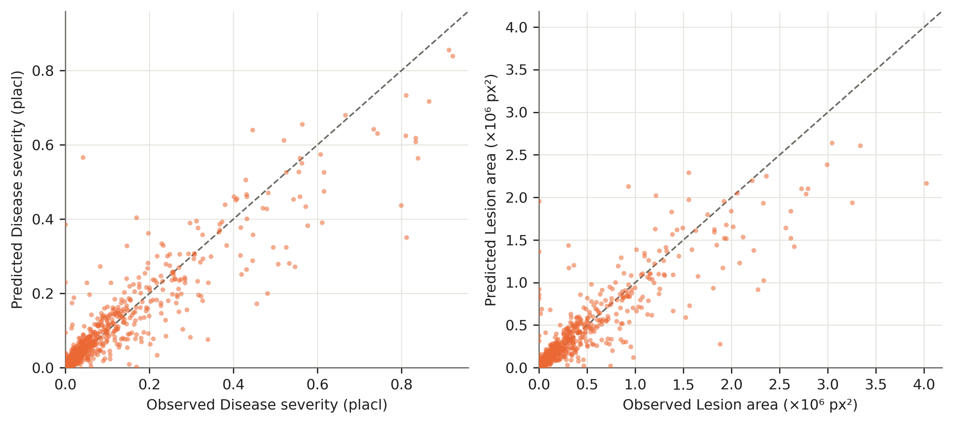
Figure 2. QLSTM forecasts versus observed values at t+1 for the 1,128 test windows of 150 unseen leaves (seed 42). Left: disease severity; right: lesion area. Dashed line: perfect forecast.

4.2 Following individual disease trajectories
Figure 3 shows observed severity and the corresponding QLSTM one-step forecasts along four test leaves with contrasting epidemics. During the slow early phase the forecasts track the observations closely. When severity enters the rapid-expansion phase — rising from about 0.3 to above 0.8 within three observations on leaf ESWW0070040_1 — QLSTM anticipates the increase and follows the accelerating trajectory, with a lag of roughly one observation at the sharpest transitions. On leaves where disease establishes late (ESWW0070060_9, ESWW0090165_8), the model correctly forecasts near-zero severity until the onset and then follows the rise.
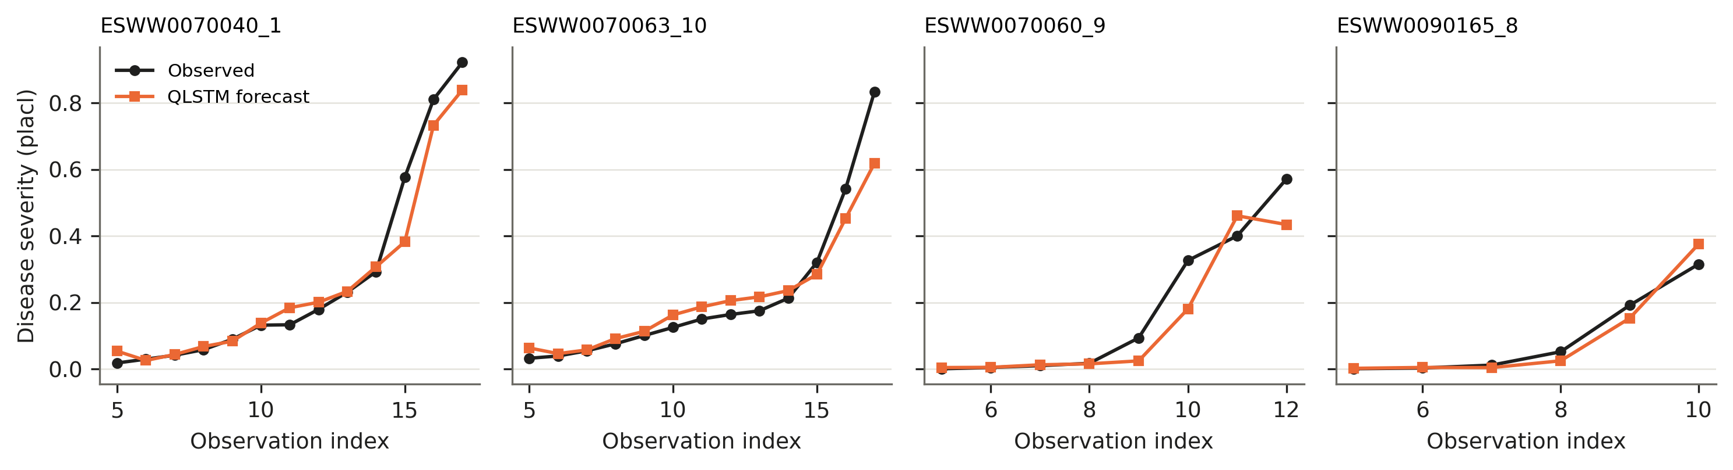
Figure 3. Observed disease severity (black) and QLSTM one-step-ahead forecasts (orange) along four unseen test leaves. Each forecast uses only the four preceding observations of that leaf.

4.3 Accuracy across stages of the epidemic
Forecast error grows with severity (Table 2). For leaves with less than 1 % severity the MAE is 0.007, and up to 20 % severity it remains below 0.034 with a small positive bias (+0.006 to +0.007), i.e. QLSTM slightly anticipates disease onset. Above 20 % severity the MAE rises to 0.088 and the bias becomes negative (−0.052): during the fastest phase of lesion expansion, increases between consecutive observations are large and partly underestimated, consistent with the lag visible in Figure 3. These high-severity windows represent 12 % of the test data.
Table 2. QLSTM severity forecast error by observed severity at t+1 (test windows pooled over seeds 42 and 123).
Observed severity | Windows | MAE | Mean error (bias)
< 1 % | 804 | 0.007 | +0.006
1–5 % | 706 | 0.012 | +0.007
5–20 % | 477 | 0.033 | +0.007
> 20 % | 263 | 0.088 | −0.052

4.4 Training behaviour
QLSTM training was stable across seeds (Figure 4): the multi-task loss decreased smoothly on both training and validation leaves, without divergence between the two, and the best validation loss was reached at epochs 45–50. The continued slow decrease at the end of training suggests that a longer schedule may yield further gains.
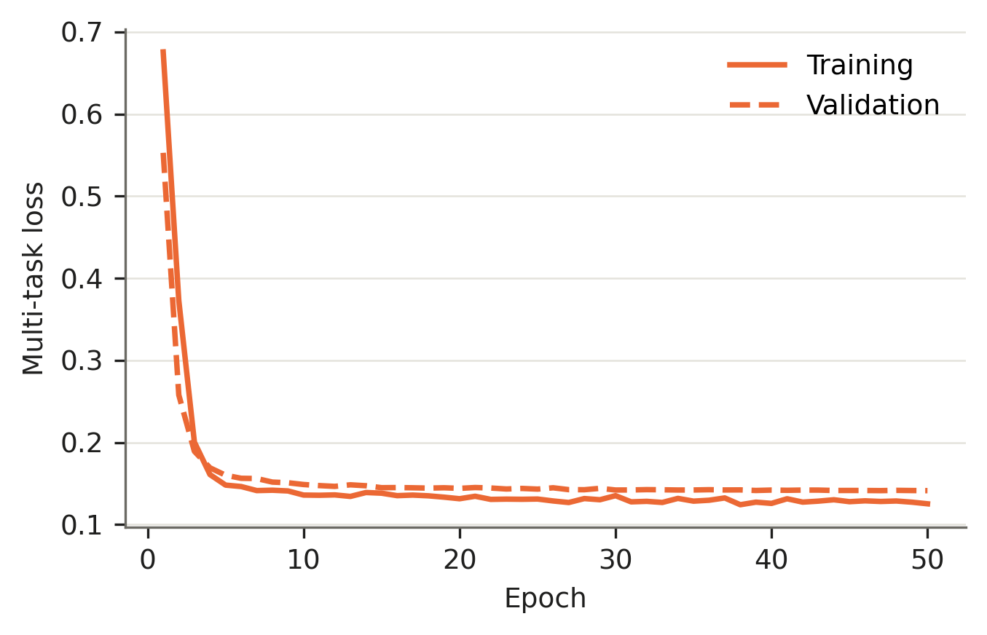
Figure 4. QLSTM training and validation multi-task loss on the phenotype-history task (seed 42).

4.5 Forecasting from leaf images
Table 3 reports the visual variant, in which the recurrent model receives 768-dimensional ViT embeddings of the four preceding leaf images. QLSTM forecasts next-observation severity with R² = 0.869 (RMSE 0.051, MAE 0.033) and lesion area with R² = 0.765 on 15 unseen leaves, using 14.6 k parameters. Classical LSTM and GRU networks given identical inputs and splits contain 102.7 k and 77.1 k parameters and fail to generalise severity to unseen leaves (R² = 0.121 and −1.009). The same pattern holds when three exogenous variables are added (QLSTM R² = 0.834; LSTM −0.425; GRU −0.895). Predicted and observed values align along the identity line across the full severity range (Figure 5), with under-prediction limited to the few most severely infected leaves.
Table 3. Forecast accuracy at t+1 from ViT-B/16 image embeddings (99-leaf visual subset; 15 unseen test leaves, 166 windows).
Input | Model | Params | Sev. R² | Sev. RMSE | Sev. MAE | Les. R² | Les. MAE (×10⁵ px²)
Images (768) | QLSTM | 14,642 | 0.869 | 0.051 | 0.033 | 0.765 | 1.12
 | Classical LSTM | 102,722 | 0.121 | 0.131 | 0.102 | 0.729 | 1.51
 | Classical GRU | 77,058 | −1.009 | 0.199 | 0.157 | 0.664 | 1.85
Images + 3 exogenous (771) | QLSTM | 14,690 | 0.834 | 0.057 | 0.032 | 0.746 | 1.17
 | Classical LSTM | 103,106 | −0.425 | 0.167 | 0.132 | 0.716 | 1.40
 | Classical GRU | 77,346 | −0.895 | 0.193 | 0.156 | 0.608 | 1.97

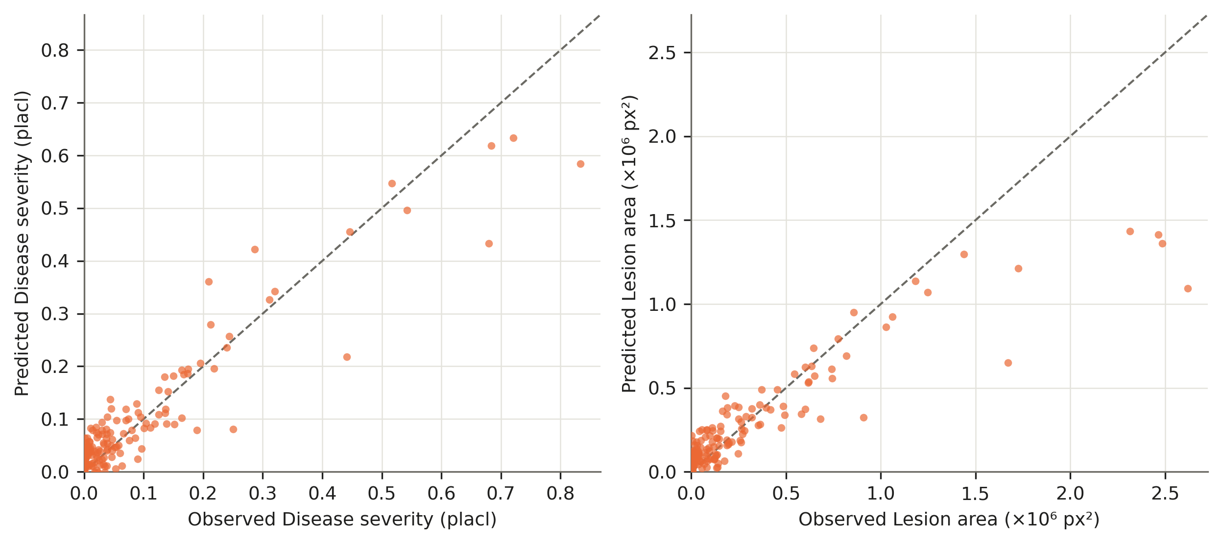
Figure 5. Image-driven QLSTM forecasts versus observed values at t+1 on 15 unseen leaves. Left: disease severity; right: lesion area.

5. Discussion

5.1 QLSTM learns the dynamics of foliar disease
Across 150 unseen leaves and two seasons, QLSTM explains 84 % of the variance in next-observation disease severity and 79 % in lesion area. The improvement over persistence shows that the model has learned how disease changes, not only where it currently stands: it anticipates onset on leaves that are still nearly healthy and follows the accelerating phase of lesion expansion (Figure 3). Several of the input features — pycnidia and rust densities, lesion counts and the spatial dispersion of lesions — are plausible early indicators of the expansion that follows, and the recurrent memory allows QLSTM to integrate their recent history.

5.2 A compact quantum core
The quantum circuits of QLSTM contain 288 parameters, yet the model reaches the accuracy of classical recurrent networks on the phenotype-history task. Each gate projects its input onto eight qubits, transforms it with a parameter-efficient entangling circuit acting on a 256-dimensional state space, and reads out eight expectation values. This structure acts as a strong inductive bias: it constrains each gate to a low-dimensional, highly expressive transformation, which is advantageous when the number of independent biological units is limited.

5.3 Robustness on high-dimensional visual inputs
The benefit of this structure is most visible with image inputs. With 768-dimensional ViT embeddings and 69 training leaves, classical LSTM and GRU networks contain 77–103 k parameters and do not generalise severity forecasts to unseen leaves, whereas QLSTM — whose gates compress the visual input to a few qubits — forecasts severity with R² = 0.869. This makes QLSTM a natural choice for image-driven forecasting in phenotyping campaigns, where image dimensionality is high and the number of tracked leaves is small. The image-only model slightly outperformed the variant with exogenous treatment variables, suggesting that the images already carry the information those plot-level variables provide.

5.4 Limitations and future work
- Rapid-expansion phase. Errors concentrate above 20 % severity, where increases between observations are largest. Longer input windows, explicit growth-rate features or weather covariates (temperature, humidity, leaf wetness) may reduce the lag.
- Forecast horizon. We forecast one observation (≈ 1 day) ahead; multi-step forecasting over several days is the natural next step for management applications.
- Replication. QLSTM results on the phenotype-history task are reported over two leaf-level splits; evaluation over further splits and cross-season validation (training on 2023, testing on 2024) is in progress.
- Quantum hardware. All circuits were simulated exactly; executing trained QLSTM gates on quantum hardware, and quantifying the effect of shot noise and gate errors, remains future work.
- Pathogen-specific dynamics. Most leaves carry mixed STB and rust infections; disentangling pathogen-specific dynamics, for example by forecasting pycnidia and pustule densities separately, would sharpen the biological interpretation.

6. Conclusion
We introduced a hybrid quantum–classical LSTM for forecasting the evolution of wheat foliar disease from longitudinal leaf phenotyping. With an 8-qubit, 3-layer variational circuit in each gate and 288 quantum parameters, QLSTM forecasts next-observation disease severity with R² = 0.839 and lesion area with R² = 0.791 on unseen leaves from two field seasons, clearly improving on persistence and matching classical recurrent accuracy. Driven by Vision Transformer embeddings of the leaf images, QLSTM forecasts severity with R² = 0.869 where larger classical recurrent networks fail to generalise. These results establish QLSTM as an accurate and compact model of plant disease dynamics, particularly suited to high-dimensional visual inputs and the limited replication typical of phenotyping studies, and open the way to quantum-enhanced forecasting tools for crop protection.

Data and Code Availability
The wheat leaf phenotyping data are available from ETH Zurich (doi:10.3929/ethz-b-000739194). Code for sequence construction, the QLSTM model, training and evaluation is available at [repository URL].

Author Contributions
[To be completed using the CRediT taxonomy.]

Conflict of Interest
The authors declare no conflict of interest. [Confirm.]

Acknowledgements
We thank the creators of the ETH Zurich wheat phenotyping data set. [Funding information.]

References
[Draft reference list — verify every entry and format to the target journal’s style before submission.]
[1] Mohanty, S. P., Hughes, D. P., & Salathé, M. (2016). Using deep learning for image-based plant disease detection. Frontiers in Plant Science, 7, 1419.
[2] Hochreiter, S., & Schmidhuber, J. (1997). Long short-term memory. Neural Computation, 9(8), 1735–1780.
[3] Cho, K., van Merriënboer, B., Gulcehre, C., Bahdanau, D., Bougares, F., Schwenk, H., & Bengio, Y. (2014). Learning phrase representations using RNN encoder–decoder for statistical machine translation. Proc. EMNLP, 1724–1734.
[4] Dosovitskiy, A., et al. (2021). An image is worth 16×16 words: Transformers for image recognition at scale. Proc. ICLR.
[5] [Reserved — add reference on wheat foliar disease yield losses, e.g. a global crop-loss survey.]
[6] [Reserved — add reference on STB / Zymoseptoria tritici epidemiology.]
[7] Cerezo, M., et al. (2021). Variational quantum algorithms. Nature Reviews Physics, 3, 625–644.
[8] Chen, S. Y.-C., Yoo, S., & Fang, Y.-L. L. (2022). Quantum long short-term memory. Proc. IEEE ICASSP, 8622–8626.
[9] [ETH Zurich wheat leaf phenotyping data set — insert authors, title, year and DOI 10.3929/ethz-b-000739194, plus the associated methods paper.]
[10] Bergholm, V., et al. (2018). PennyLane: Automatic differentiation of hybrid quantum-classical computations. arXiv:1811.04968.
[11] McClean, J. R., Boixo, S., Smelyanskiy, V. N., Babbush, R., & Neven, H. (2018). Barren plateaus in quantum neural network training landscapes. Nature Communications, 9, 4812.

