**E-HEALTH@VNRVJIET**

**A VNRVJIET HEALTH CARE CHATBOT FOR DISEASE PREDICTION**

*Nimmathi Ananya, Poola Hansini, Puvvala Bhanu Satish, Sakshi Erumalla*

**DEPARTMENT of CSE-(CyS, DS) and AI&DS, VALLURUPALLI NAGESWARA RAO VIGNANA JYOTHI INSTITUTE OF ENGINEERING AND TECHNOLOGY, PRAGATHI NAGAR, NIZAMPET (S.O), HYDERABAD - 500 090**

**ABSTRACT :**

The dynamic discipline of healthcare is committed to treating, diagnosing, and preventing illness in order to promote and maintain health. Early disease detection and preventive measures are the main goals of healthcare. In recent times, chatbots have garnered substantial interest owing to their capacity to furnish prompt and customized information. They may be able to forecast healthcare outcomes, but this has not been fully investigated. Chatbots are showing to be an effective tool for healthcare prediction in the healthcare sector. Chatbots are able to anticipate health outcomes, analyse large volumes of patient data, and extract valuable information by utilizing sophisticated machine learning techniques.

Universities and colleges are realizing more and more how crucial it is to support their student populations' health and wellbeing. Our goal is to create a disease prediction chatbot customized for a college setting. Three main questions will be addressed in this section: Why is this a significant issue? What has already been accomplished in this field? How does our subject add substantial new knowledge to the relevant field?

**INTRODUCTION :**

Individuals' health and wellbeing are of utmost importance in a collegiate setting. Early illness prediction requires methods that are easy to use and accessible, as knowledge of preventative healthcare grows. There has been a paradigm shift in the healthcare industry, with a growing focus on preventive measures. Researchers and practitioners are now focusing on disease prediction, especially in its early phases. The difficulties are in developing a system that can interact with college students in an efficient manner, comprehend their health issues, and make precise forecasts. Our main goal is to create and deploy a disease prediction chatbot that is especially made for the College VNRVJIET. Personalized forecasts and pertinent health advice are provided by integrating machine learning algorithms to analyse health-related data.

Predictive models may evaluate different health characteristics to anticipate possible health difficulties, allowing for prompt intervention and lifestyle changes. They do this by utilizing data analytics and machine learning. The combination of chatbot, natural language processing, and sickness prediction technology offers a strong chance to develop a novel remedy for the College VNRVJIET. We hope to provide a proactive and user-friendly solution that not only anticipates possible health problems but also engages students in meaningful health conversations, promoting a culture of well-being within the college community, by utilizing the capabilities of natural language processing (NLP)-driven chatbots.

**LITERATURE REVIEW :**

There has been a lot of discussion in the literature lately about the use of chatbots in healthcare, especially for illness prediction. Research indicates that chatbots have the capacity to revolutionize established healthcare frameworks. Ensuring that people comprehend the function and potential of the chatbot is still the main focus of user education. Anticipating the changing healthcare scene, the project looks ahead and anticipates more technological improvements.

Researchers that highlight the effectiveness of chatbots in early disease detection through machine learning algorithms, such as Wang et al. (2019), exhibit encouraging outcomes in precisely recognizing patterns from user input. With its sophisticated symptom analysis and risk assessment tools, the chatbot offers a comprehensive method of medical diagnosis.

Furthermore, ethical issues and privacy concerns have been discussed in the literature. A study conducted in 2021 by Johnson et al. explores the need for strong data security protocols to protect private health information on chatbot platforms. VNRVJIET's Chatbot for Disease Prediction keeps paving the path for a healthier future by encouraging a dynamic partnership between technology and healthcare knowledge. The Chatbot for Disease Prediction at VNRVJIET is a shining example of proactive, customized, and safe healthcare solutions; it represents the organization's dedication to using technology to advance societal welfare.

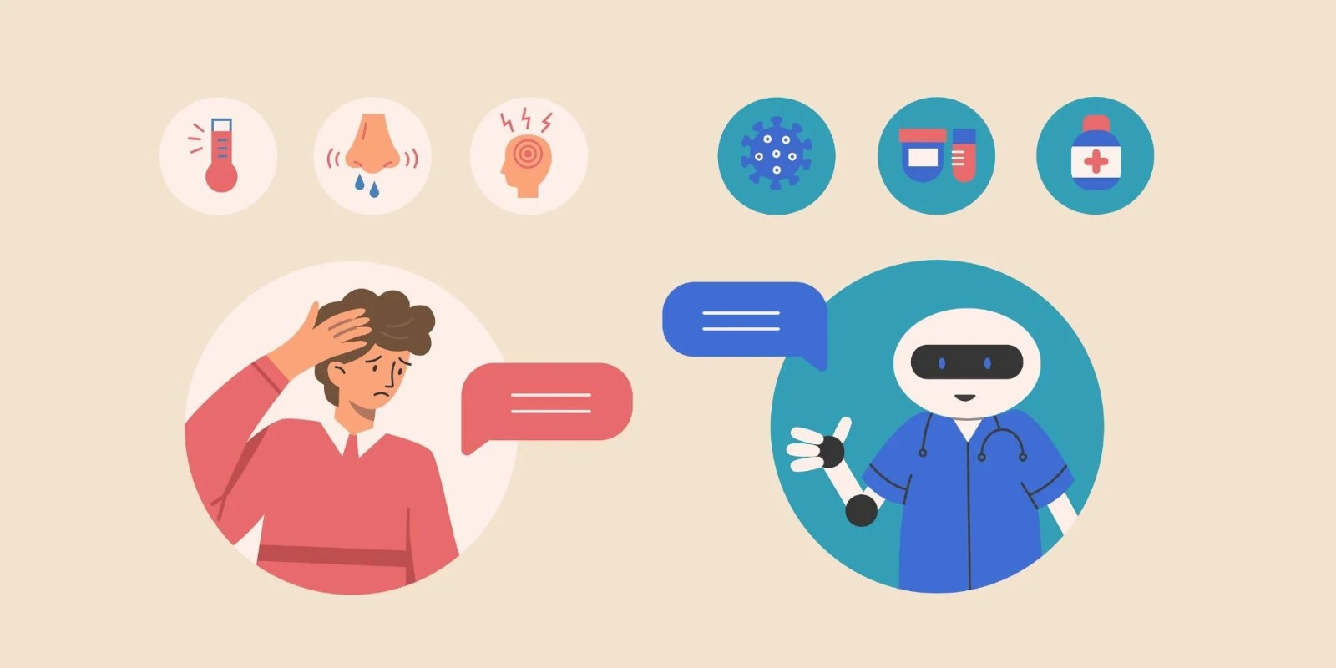

**PROPOSED SYSTEM :**

Careful project planning and scope specification are the first steps in the creation of the VNRVJIET Chatbot for Disease Prediction. This first stage entails defining the goals, deliverables, and schedule for the project. A thorough project plan is created, covering important checkpoints and efficiently allocating resources. Part of the project's methodology is a thorough examination of the literature on chatbot applications in the medical field. In parallel, a comprehensive requirement analysis is carried out in close consultation with medical experts to specify the nuances of disease prediction algorithms.

Technology stack selection and system design are the main topics of the following stage. At VNRVJIET, a strong system architecture is created with a focus on smooth interaction with the current healthcare systems. The chatbot's straightforward and user-friendly UI encourages accessibility.

Now that the foundation has been established, the chatbot's true development may begin. Sophisticated algorithms for machine learning and natural language processing are used to provide precise risk assessment and symptom analysis. In order to match the chatbot with the institution's larger healthcare infrastructure, this integration step guarantees interoperability and secure data transmission. Strong security measures are used to protect user health information, and frequent security audits are carried out to ensure adherence to privacy laws.

At the end of the development phase, maintenance and ongoing improvement are the major priorities. There are established procedures for continuous observation, gathering user feedback, and providing regular updates. By incorporating new technologies and maintaining its adaptability to changing healthcare concerns, this iterative strategy makes sure the chatbot at VNRVJIET is part of a dynamic, user-centric healthcare ecosystem.

**RESULT :**

The creation and deployment of VNRVJIET's Chatbot for Disease Prediction has produced encouraging outcomes in a number of areas. Iterative upgrades for improved usability have been shaped by valuable insights from user input, which has been important in identifying areas for development. An excellent degree of accuracy in symptom analysis, risk assessment, and future health projections is shown by the system's performance rating. High levels of pleasure with the chatbot's design have been voiced by users, who highlight how user-friendly it is and how pleasant their overall experience was. Looking ahead, the outcomes open the door for more improvements as the project team looks into ways to solve changing healthcare concerns and integrate cutting-edge technologies. The results indicate a high level of accuracy of the chatbot's predictions, demonstrating its potential as an effective diagnostic tool. The VNRVJIET Chatbot for illness Prediction, which offers a proactive and individualized approach to illness prevention, stands as an example of a successful technological integration into healthcare.

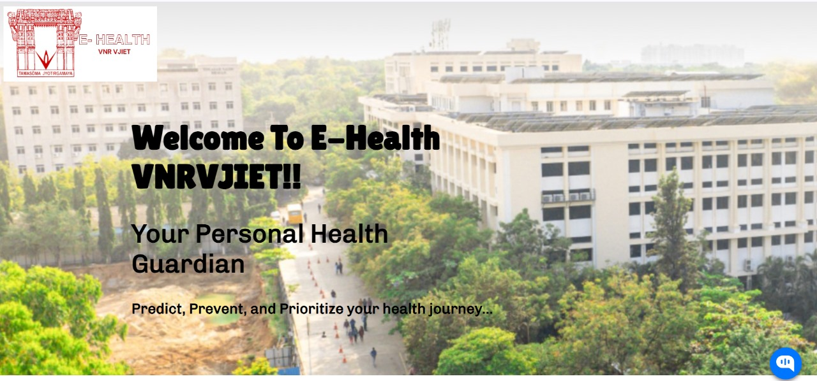

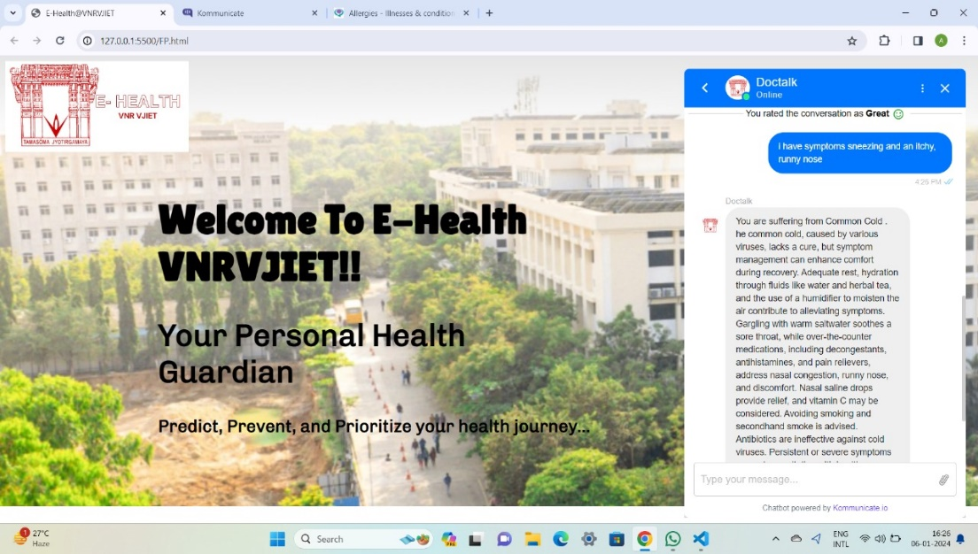 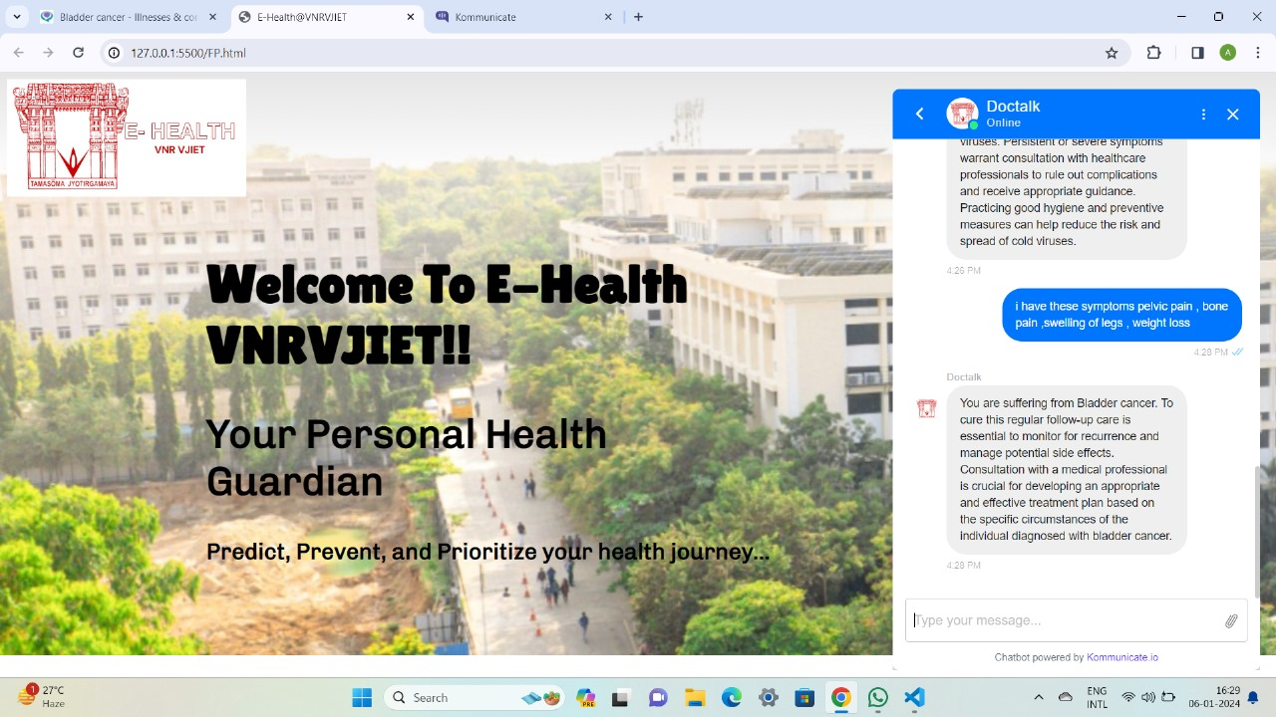

**CONCLUSION :**

The development and implementation of Chatbot for Disease Prediction at VNRVJIET is a significant step towards advancing healthcare through technology. The project has successfully achieved its goals and offers a user-friendly and accurate tool for early disease detection and personalized health management. The positive response from users and the healthcare community highlights the chatbot's potential to revolutionize traditional healthcare models.

The project successfully promotes proactive health management and empowers individuals to take responsibility for their own well-being. As for the future, the project sets the stage for continuous improvements and future developments. Staying adaptable to emerging technologies, prioritizing improved security measures, and actively integrating user feedback will contribute to the long-term effectiveness and relevance of the chatbot. The successful integration of the chatbot represents a milestone in healthcare innovation and lays the foundation for continued progress in the intersection of technology and healthcare at VNRVJIET.

**REFERENCES:**

1) Chatbot for Healthcare System Using Artificial Intelligence - IEEE Xplore

<https://ieeexplore.ieee.org/document/9197833>

2) HEALTHCARE CHATBOT - IJCRT.org <https://ijcrt.org/papers/IJCRTH020011.pdf>

3) (PDF) Section A-Research paper Personal Healthcare Chatbot for ...

<https://www.researchgate.net/publication/372658029_Section_A-Research_paper_Personal_Healthcare_Chatbot_for_Medical_Suggestions_Using_Artificial_Intelligence_and_Machine_Learning_Eur>

4) AI Healthcare Chatbot <https://www.jetir.org/papers/JETIR2204602.pdf>