Name : Sakshi Dhamapurkar

PRN : 21510073

Batch : B4

Packet Captured of handshaking :

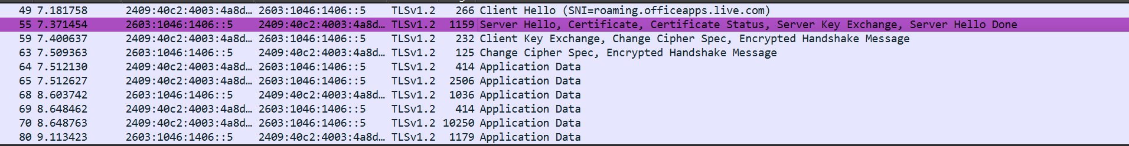

Client side Hello TLS :

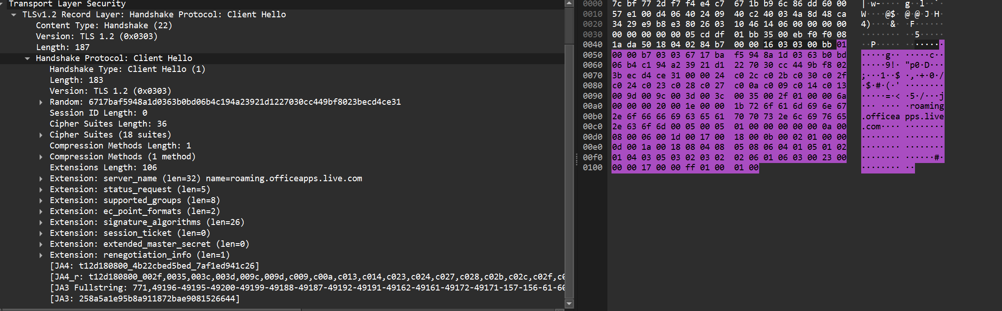

Server side Hello TLS :

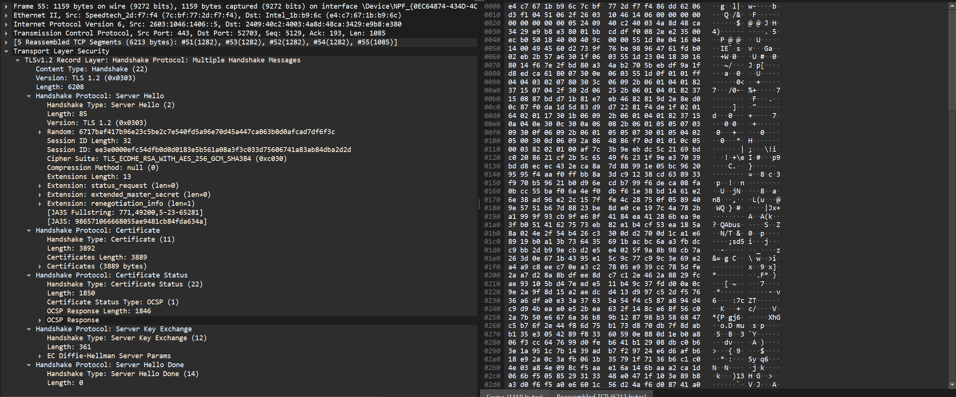

Client Key Exchange :

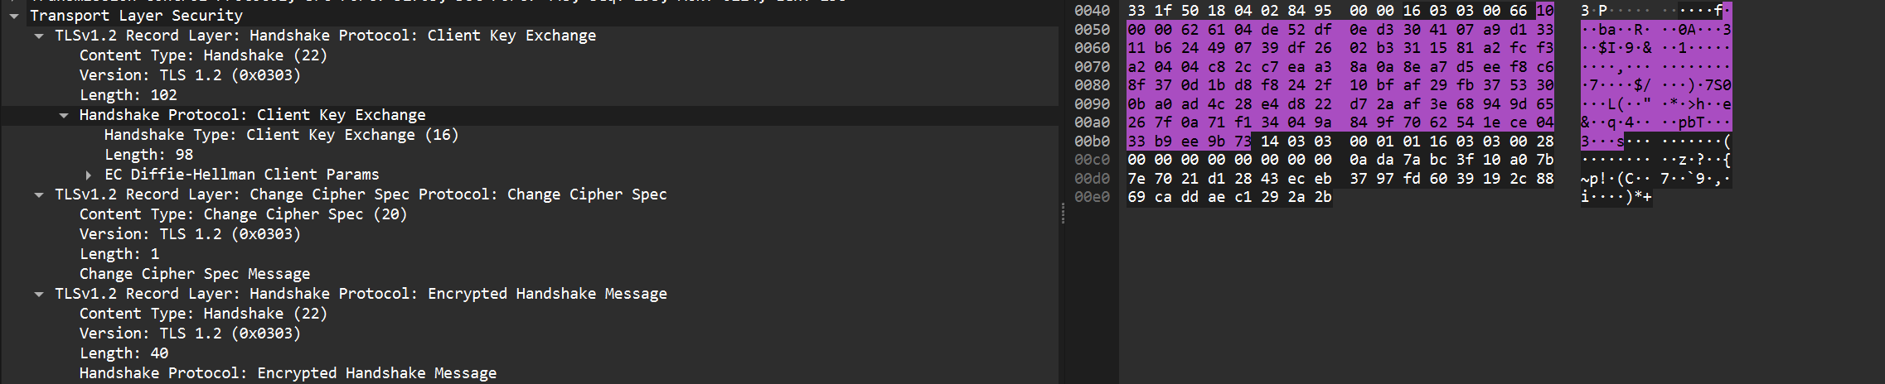

Application Data :

