Sakshi Dhamapurkar

21510073

Batch-T3

**Assignment No.6**

**Greedy method**

To apply Greedy method to solve problems of

1) Job sequencing with deadlines

1.A) Generate table of feasible,proceesing sequencing , profit .

1.B) What is the solution generated by the function JS when n=7, (*p1,p2,...,p7*) = (3,5,20,18,1,6,30), and (*d1,d2,d3,...,d7*) = (1,3,4,3,2,1,2)?

1.C) **Input**: Five Jobs with following deadlines and profits

|  |  |  |
| --- | --- | --- |
| JobID | Deadline | Profit |
| a | 2 | 100 |
| b | 1 | 19 |
| c | 2 | 27 |
| d | 1 | 25 |
| e | 3 | 15 |

**Output**: Following is maximum profit sequence of jobs:

c, a, e

1.D) Study and implement Disjoint set algorithm to reduce time complexity of JS from O() to nearly O(*n*)

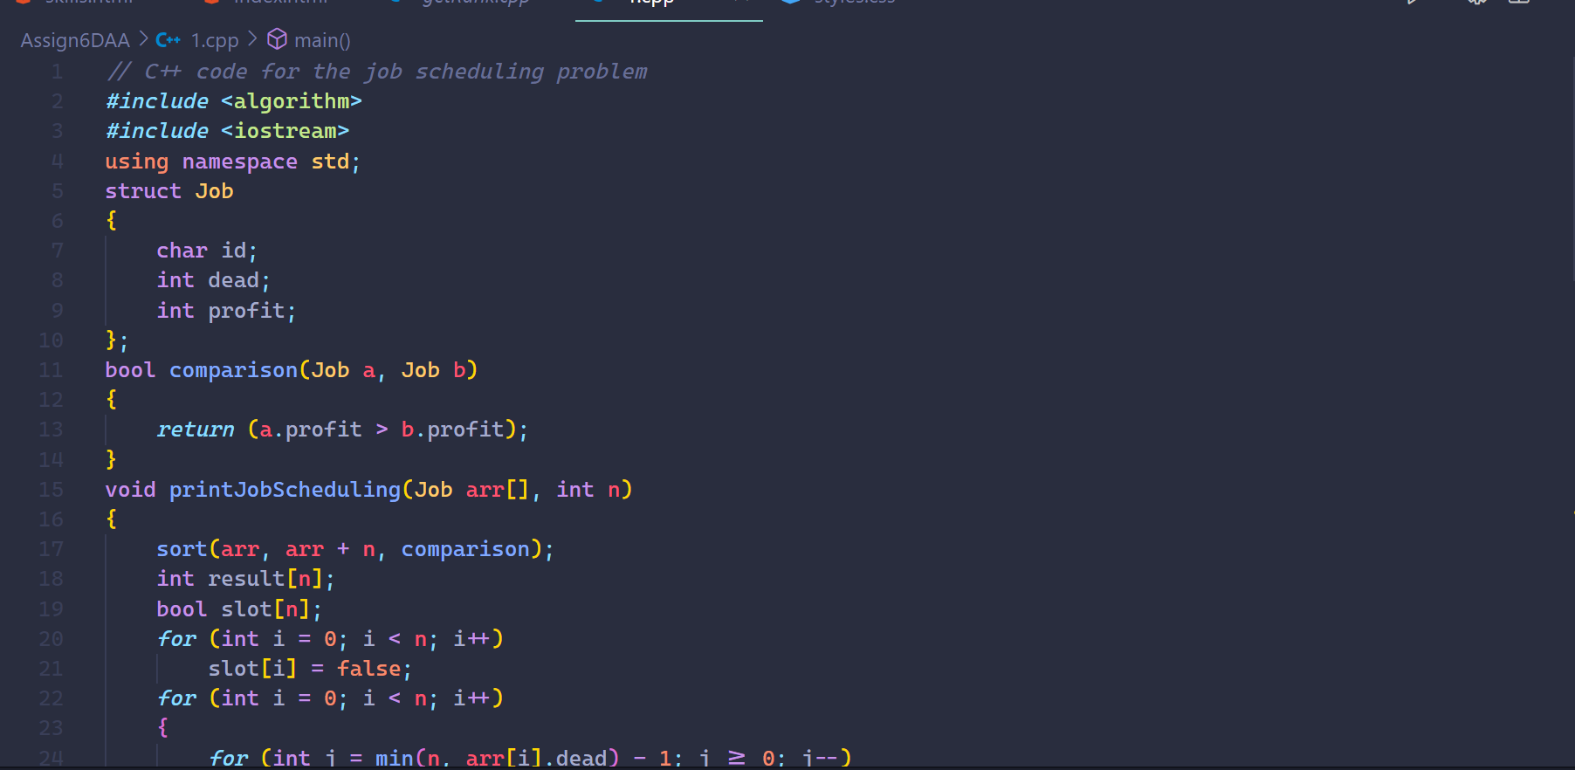

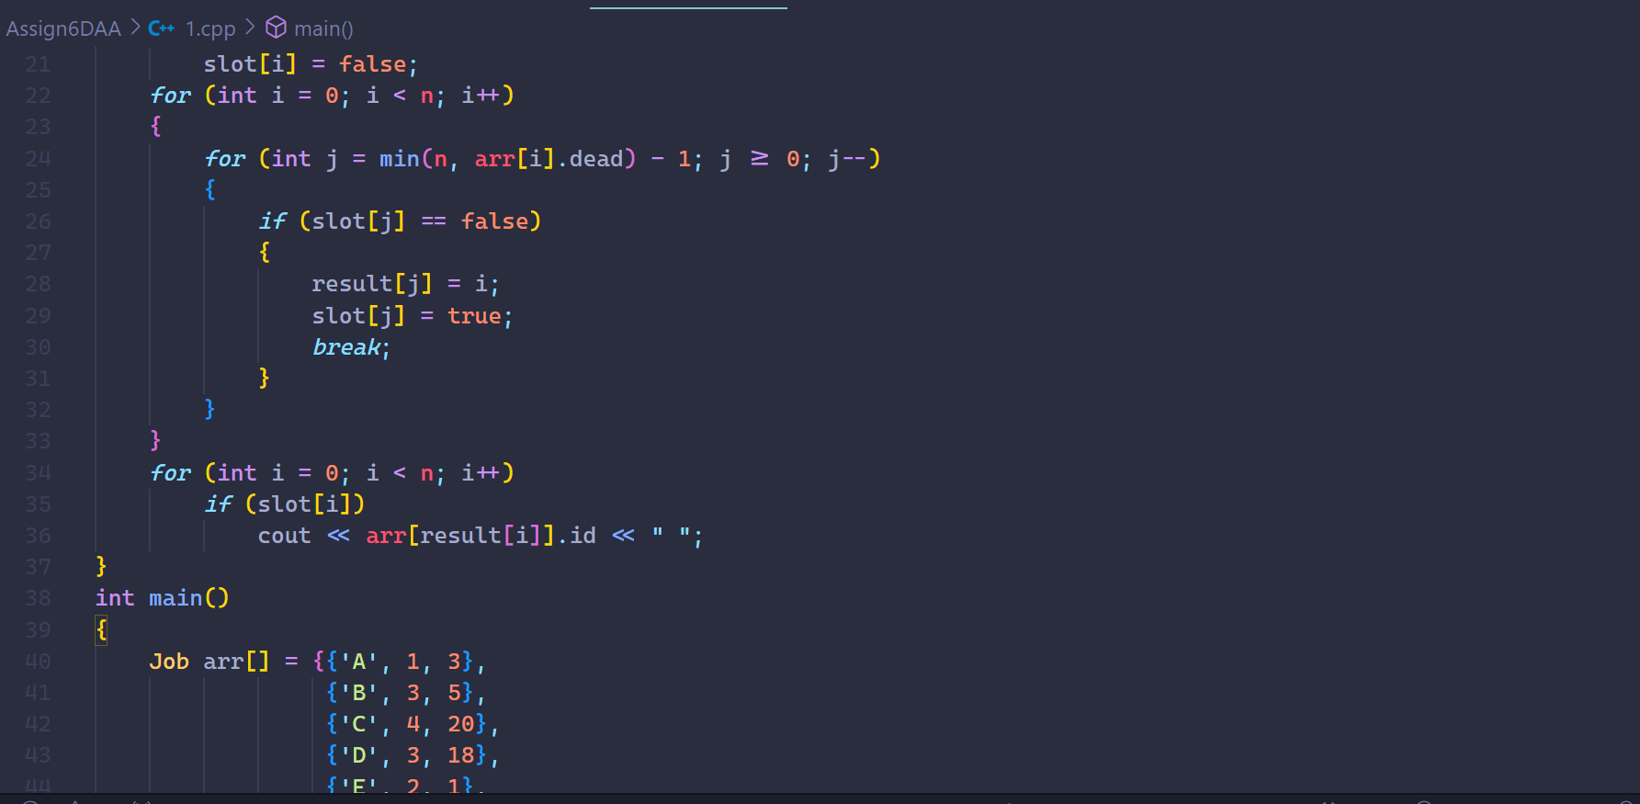

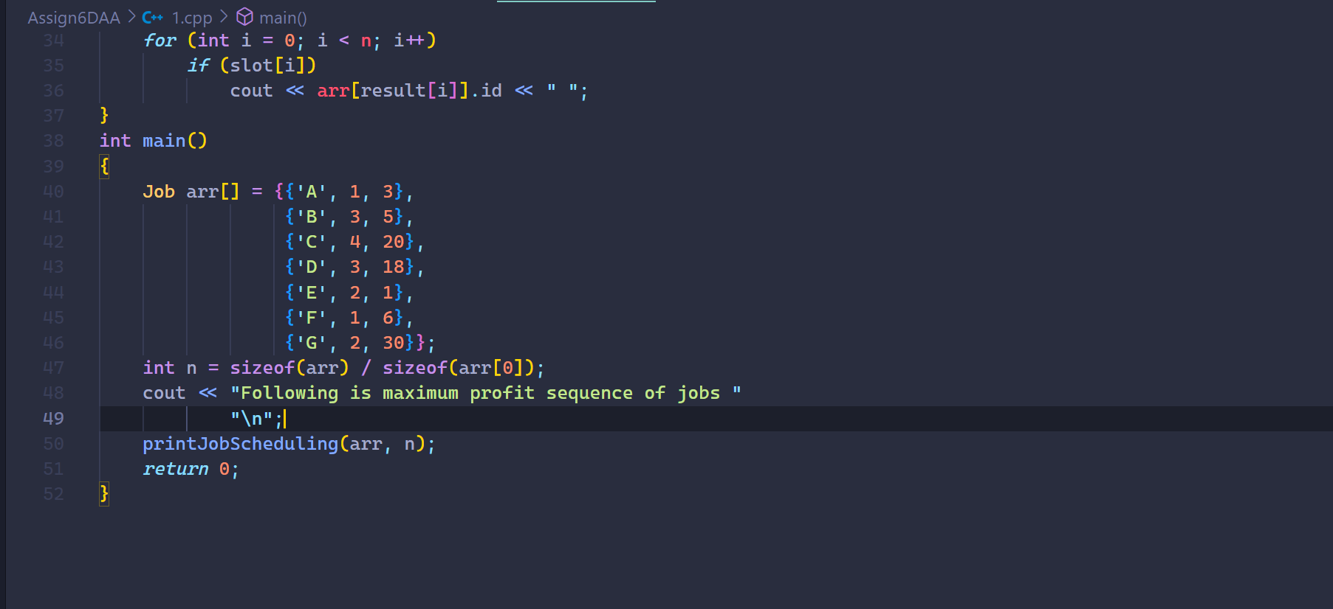

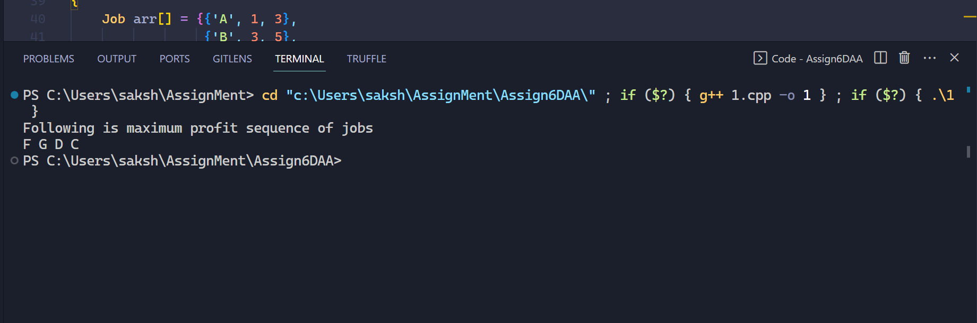

2) To implement Fractional Knapsack problem 3 objects (n=3).

(w1,w2,w3) = (18,15,10)

(p1,p2,p3) = (25,24,15)

M=20

With strategy

a) Largest-profit strategy

b) Smallest-weight strategy

c) Largest profit-weight ratio strategy

