Name : Narule Shreyas Vaibhavkumar
PRN : 21510077
Roll No :
Programming Lab
Assignment 03

Que 1:
Make a class named Fruit with a data member to calculate the number of fruits in a basket. Create two other class named Apples and Mangoes to calculate the number of apples and mangoes in the basket. Print the number of fruits of each type and the total number of fruits in the basket.
#include<iostream>
using namespace std;

class Mangoe
{public:
int num;

Mangoe(int data)
{
this->num=data;
cout<<"The total number of Mangoes in basket is :"<<num<<endl;
}
};
class Apple
{
public:
int num;

Apple(int data)
{
this->num=data;
cout<<"The total number of Apples in basket is :"<<num<<endl;
}
};

class Fruits
{
public:
int total;
Fruits(Mangoe obj1,Apple obj2)
{this->total=obj1.num+obj2.num;
cout<<"The total number of fruits in the basket is :"<<this->total<<endl;
}
};

int main()
{Apple obj1(5);
Mangoe obj2(5);
Fruits(obj2,obj3);

return 0;
}

Output:
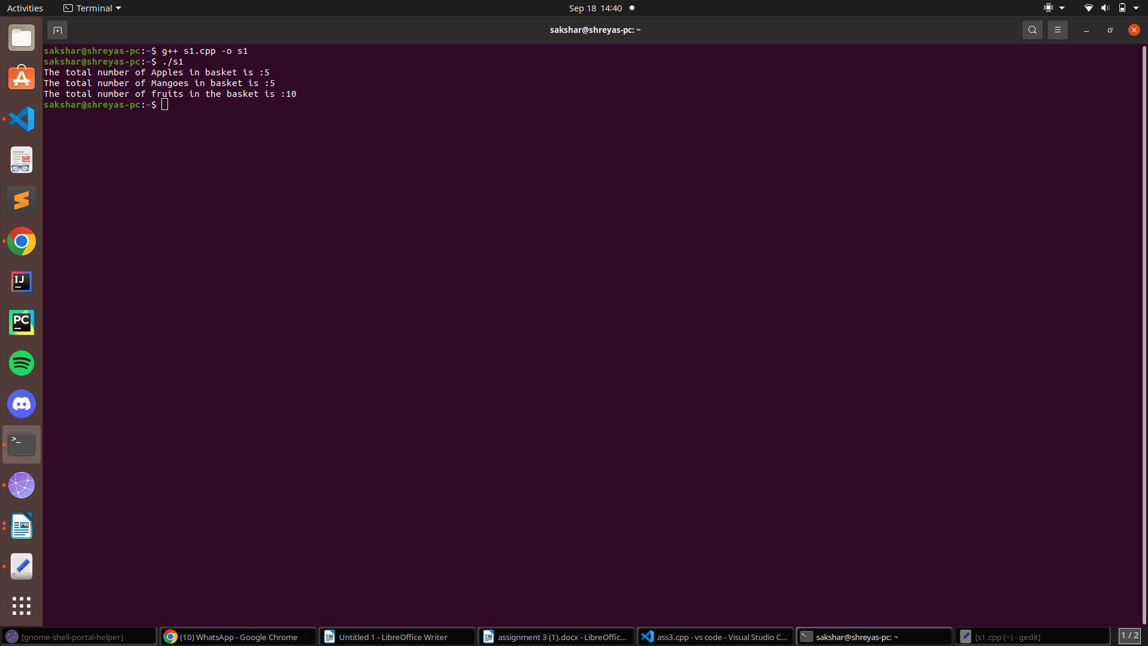
Que 2:
Create a class named Shape with a function that prints "This is a shape". Create another class named Polygon inheriting the Shape class with the same function that prints "Polygon is a shape". Create two other classes named Rectangle and Triangle having the same function which prints "Rectangle is a polygon" and "Triangle is a polygon" respectively. Again, make another class named Square having the same function which prints "Square is a rectangle". Now, try calling the function by the object of each of these classes.
#include<iostream>
using namespace std;

class Shape
{
public:
void display()
{cout<<"This is Shape."<<endl;
}
};

class Polygon : public Shape
{
public:
void display()
{
cout<<"Polygon is a Shape."<<endl;
}
};

class Rectangle : public Polygon
{
public:
void display()
{
cout<<"Rectangle is a polygon."<<endl;
}
};

class Triangle : public Polygon
{
public:
void display()
{
cout<<"Triangle is a polygon."<<endl;
}
};

class Square : public Rectangle
{
public:
void display()
{
cout<<"Square is a Rectangle."<<endl;
}
};

int main()
{hape o1;
obj1.Shape::display();

Polygon obj2;
obj2.Polygon::display();

Rectangle obj3;
obj3.Rectangle::display();

Triangle obj4;
obj4.Triangle::display();

Square obj5;
obj5.Square::display();
return 0;
}

Output:
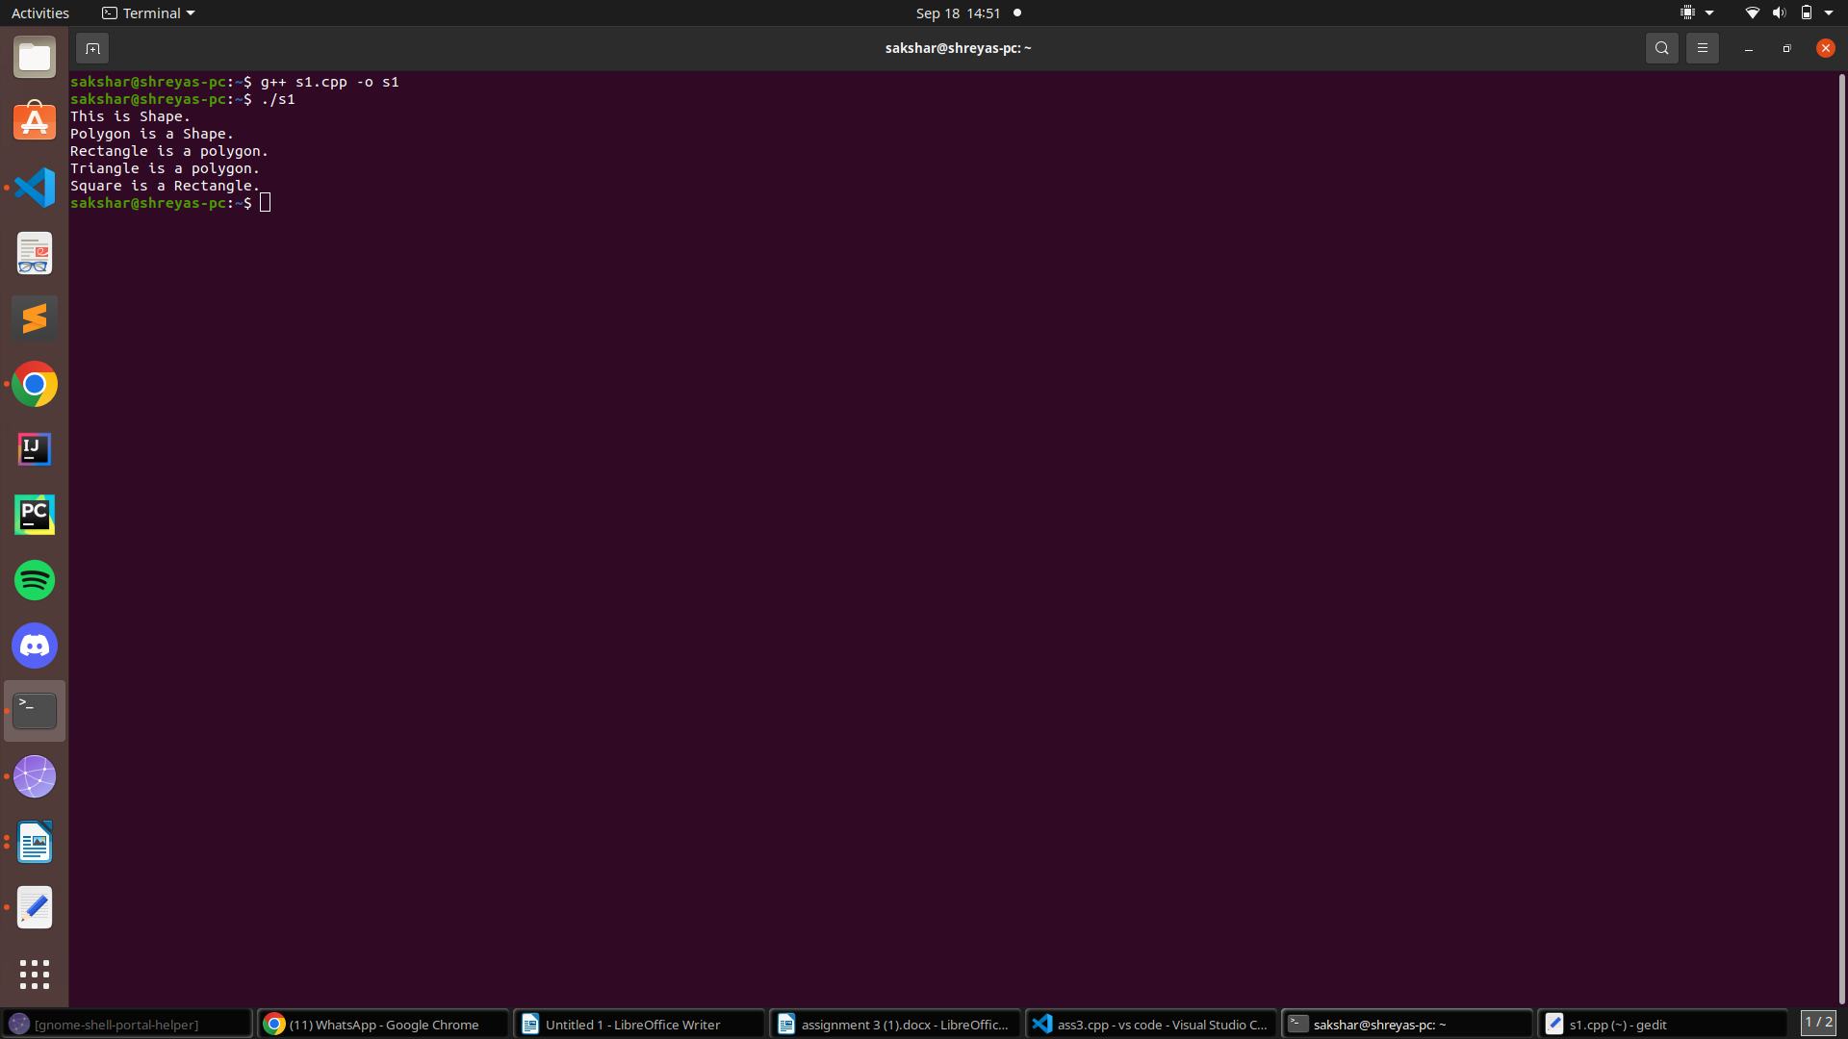
Que 3:
An educational institution wishes to maintain a database of its employees. The database is divided into a number of classes whose hierarchical relationships are shown in below Fig. The figure also shows the minimum information required for each class. Specify all the classes and define functions to create the database and retrieve individual information as and when required.

#include<iostream>
using namespace std;

class Staff
{
public:

string code;

void setstaff()
{
cout<<"Enter staff code-name:"<<endl;
cin>>this->code;
}
};

class Teacher: public Staff
{
public:
string book,pub;

void setteacher()
{
setstaff();
cout<<"Enter the name of book and it publication:"<<endl;
cin>>this->book;
cin>>this->pub;
}

void display(){
cout<<"Staff code-name is :"<<this->code<<endl;
cout<<"Staff book name is :"<<this->book<<endl;
cout<<"Staff book's publication is :"<<this->pub<<endl;
}
};

class Typist : public Staff
{public:
int speed;

void settypist()
{
setstaff();cout<<"Enter your typing speed :"<<endl;
cin>>this->speed;
}

void display()
{
cout<<"Staff code-name is :"<<this->code<<endl;;
cout<<"Staff typing speed is :"<<this->speed<<" wpm."<<endl;;
}
};

class Officer: public Staff
{
public:

char grade;
void setofficer()
{
setstaff();
cout<<"Enter your grade :"<<endl;
cin>>this->grade;
}
void display()
{
cout<<"Staff code-name is :"<<this->code<<endl;
cout<<"Staff Grade is :"<<this->grade<<endl;
}
};

int main()
{ class Teacher obj1;
obj1.setteacher();
obj1.display();

class Typist obj2;
obj2.settypist();
obj2.display();

class Officer obj3;
obj3.setofficer();
obj3.display();
return 0;
}

Output:
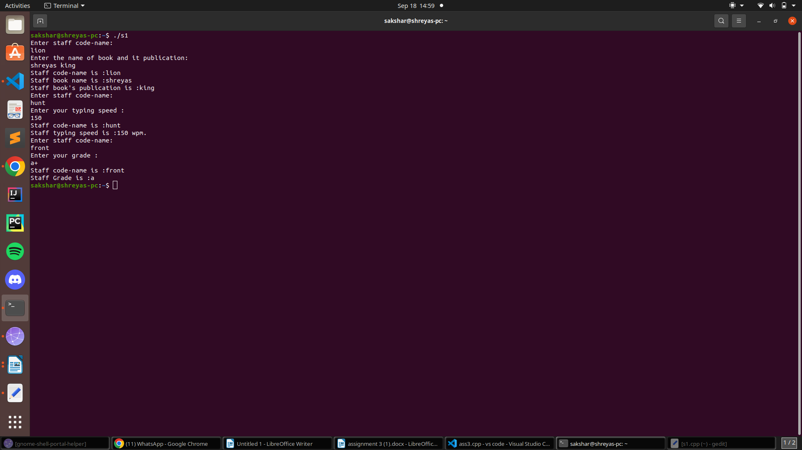
Que 4:
The database created in above example does not include educational information of the staff. It has been decided to add this information to teachers and officers (and not for typists) which will help the management in decision making with regard to training, promotion, etc. Add another data class called education that holds two pieces of educational information, namely, highest qualification in general education and highest professional qualification. This class should be inherited by the classes teacher and officer. Modify the above program to incorporate these additions.

#include<iostream>
using namespace std;

class Education
{
public:
string qedu,pedu;

void seteduction()
{
cout<<"Enter your highest General Qualification:"<<endl;
cin>>this->qedu;
cout<<"Enter your highest Professional Qualification:"<<endl;
cin>>this->pedu;
}
};

class Staff
{
public:

string code;

void setstaff()
{
cout<<"Enter staff code-name:"<<endl;
cin>>this->code;
}
};

class Teacher: public Staff,public Education
{
public:
string book,pub;

void setteacher()
{
setstaff();
seteduction();
cout<<"Enter the name of book and it publication:"<<endl;
cin>>this->book;
cin>>this->pub;
}

void display()
{
cout<<"Staff code-name is :"<<this->code<<endl;
cout<<"Staff book name is :"<<this->book<<endl;
cout<<"Staff book's publication is :"<<this->pub<<endl;
cout<<"Staff General Qualification is :"<<this->qedu<<endl;
cout<<"Staff Professional Qualification is :"<<this->pedu<<endl;
}
};

class Typist : public Staff
{
public:
int speed;

void settypist()
{
setstaff();
cout<<"Enter your typing speed :"<<endl;
cin>>this->speed;
}

void display()
{
cout<<"Staff code-name is :"<<this->code<<endl;;
cout<<"Staff typing speed is :"<<this->speed<<" wpm."<<endl;;
}
};

class Officer: public Staff,public Education
{
public:

char grade;

void setofficer(){
setstaff();
seteduction();
cout<<"Enter your grade :"<<endl;
cin>>this->grade;
}
void display()
{
cout<<"Staff code-name is :"<<this->code<<endl;
cout<<"Staff Grade is :"<<this->grade<<endl;
cout<<"Staff General Qualification is :"<<this->qedu<<endl;
cout<<"Staff Professional Qualification is :"<<this->pedu<<endl;
}
};

int main()
{ class Teacher obj1;
obj1.setteacher();
obj1.display();
class Typist obj2;
obj2.settypist();
obj2.display();
class Officer obj3;
obj3.setofficer();
obj3.display();
return 0;
}

Output:
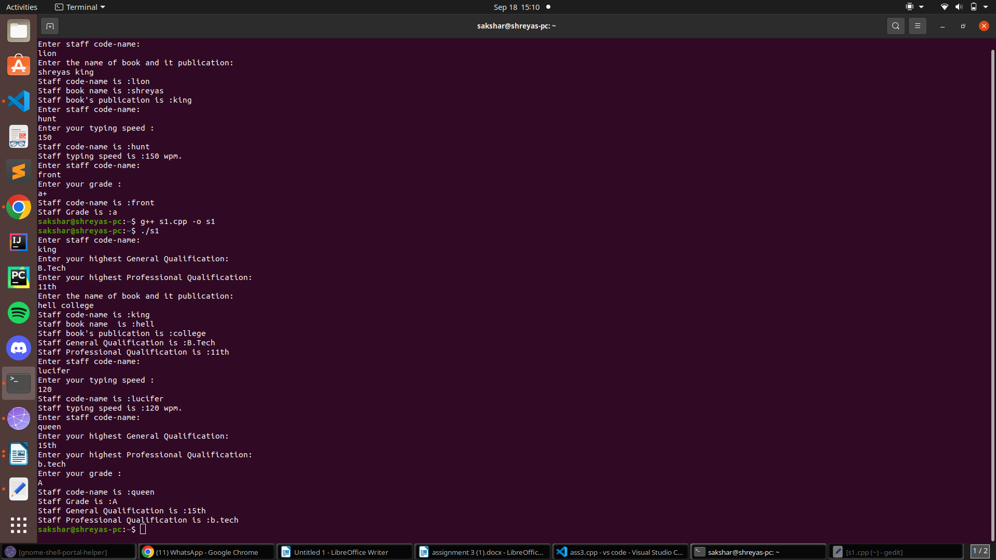
Que 5:
. Using Hybrid inheritance, design a program which will solve real life problem.
#include <iostream>
using namespace std;

class A
{
public:
int x;
};
class B : public A
{
public:
B()
{
x = 10;
}
};
class C
{
public:
int y;
C()
{
y = 4;
}
};
class D : public B, public C
{
public:
void sum()
{
cout << "Sum= " << x + y;
}
};

int main()
{
D obj1;
obj1.sum();
return 0;
}

Output:
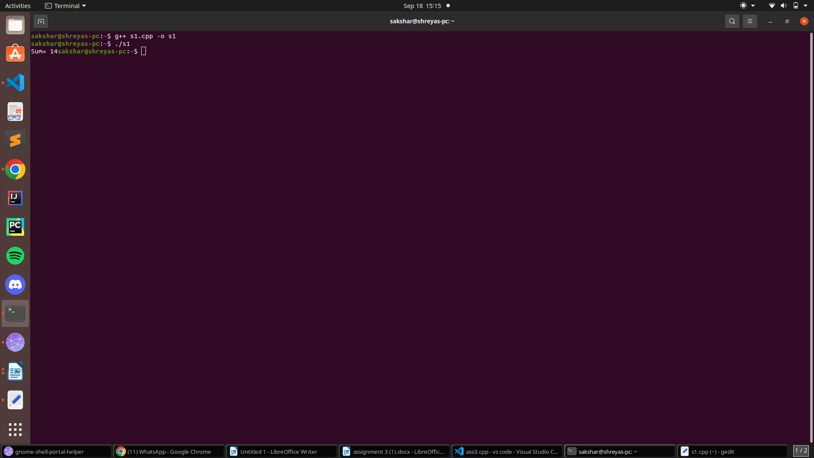
Que 6:
Design a class Polar which describes a point in the plane using polar coordinates radius and angle. A point in polar coordinates is shown in below Fig. Use the overloaded + operator to add two objects of Polar. Note that we cannot add polar values of two points directly. This requires first the conversion of points into rectangular co-ordinates, then adding the corresponding rectangular co-ordinates and finally convening the result back into polar co-ordinates. You need to use the following trigonometric formulae: x = r * cos(a); y = r * sin(a); a =a tan(y/x); // arc tangent r =sqrt(x*x + y*y);

#include<iostream>
#include<cmath>
using namespace std;

class Polar
{
public:
float r;
float a;

Polar(float a=0,float r=0)
{
this->a=a;
this->r=r;
}

Polar operator + (Polar const &obj) {
Polar res;
float x1=r*cos(a),y1=r*sin(a),x2=obj.r*cos(a),y2=obj.r*sin(a);
x1+=x2;
y1+=y2;

if(x1==0)
a=90.00;

else
a=atan(float(y1/x1));

r=sqrt(((x1*x1)+(y1*y1)));

res.a=a;
res.r=r;

return res;
}
void display()
{
cout<<"The radius is :"<<this->r<<endl;
cout<<"The angle is :"<<this->a<<endl;
}
};

int main()
{
Polar p1(90.00,10),p2(0.00,20);
Polar p3=p1+p2;
p3.display();
return 0;
}

Output:
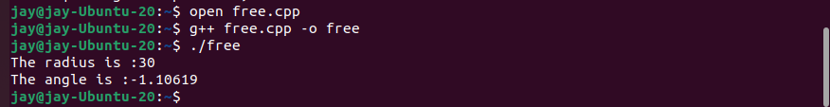

Que 7:
Create a class INTEGER that contains one float data member. Overload all the four arithmetic operators so that they operate on the objects of INTEGER.
#include<iostream>
using namespace std;

class Integer
{
public:
float a;

Integer(int k){this->a=k;}
Integer operator + (Integer const &o)
{
Integer temp(200);
temp.a=a+ o.a;

return temp;
}

Integer operator - (Integer const &o)
{
Integer temp(200);
temp.a=a - o.a;
return temp;
}

Integer operator / (Integer const &o)
{
Integer temp(200);
temp.a=float(a)/float(o.a);

return temp;
}

void display()
{
cout<<"The value of data is :"<<this->a<<endl;
}

};

int main()
{ class Integer int1(200),int2(200);
Integer int3=int1+int2;
int3.display();

int3=int1-int2;
int3.display();

int3=int1/int2;
int3.display();
return 0;
}

Output:
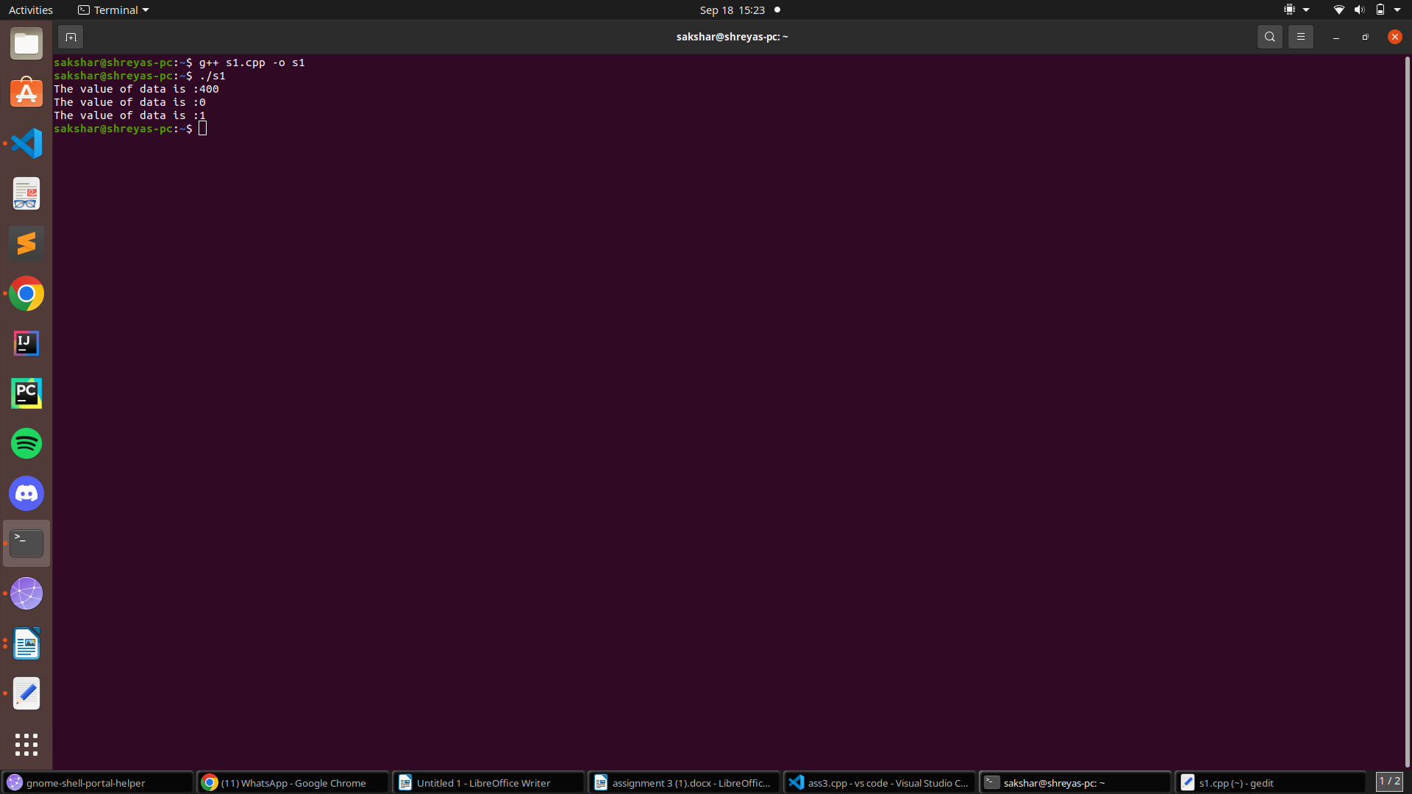
Que 8:
Create a class MAT of type m*n. Define all possible matrix operations for MAT type objects.
#include<iostream>
using namespace std;

class Mat
{
public:
int m,n;

void setdata1()
{
cout<<"Enter the no. of rows and columns of the matrix:"<<endl;
cin>>m>>n;
}

int arr[10][10];

void setdata2()
{
cout<<"Enter the elements in the matrix :"<<endl;

for(int i=0;i<m;i++)
{
for(int j=0;j<n;j++)
cin>>arr[i][j];
}
}

void display()
{
cout<<"Displaying the elements in the matrix:"<<endl;
for(int i=0;i<m;i++)
{
for(int j=0;j<n;j++)
cout<<arr[i][j]<<" ";

cout<<endl;
}
}

};

int main()
{
Mat m;
m.setdata1();
m.setdata2();
m.display();
return 0;
}

Output:

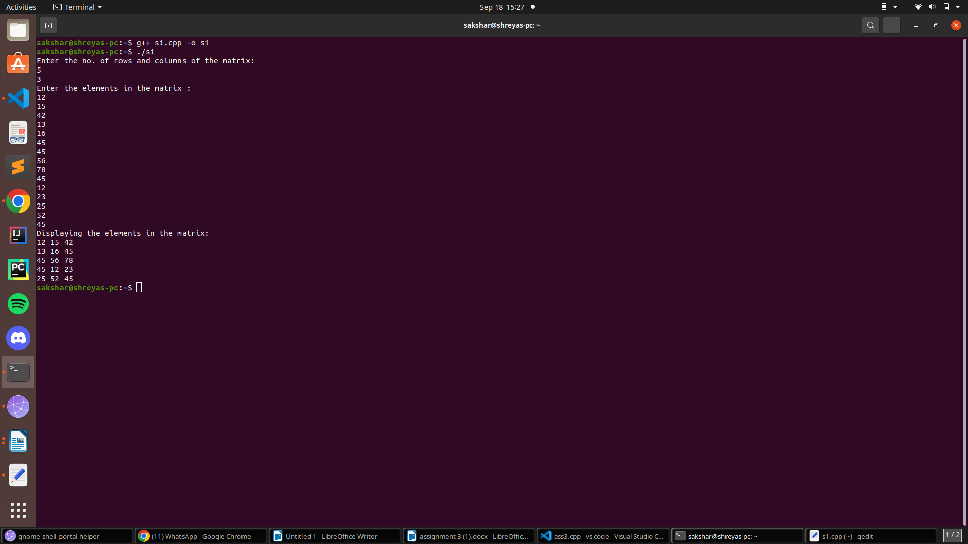
Que 9:
Define a class String. Use overloaded = = operator to compare two strings.
#include<iostream>
using namespace std;

class String
{
public:
string s;

String(string s=NULL)
{
this->s=s;
}

bool operator ==(String& o)
{
bool flag=true;

for(int i=0;i<o.s.length();i++)
{
if(s[i]!=o.s[i])
{
flag=false;
break;
}
}

return flag;
}
};

int main()
{
String s1("abcde"),s2("abcde");

bool b1=s1==s2;

String s3("JAY"),s4("jay");

bool b2=s3==s4;

cout<<b1<<endl;
cout<<b2<<endl;
return 0;
}

Output:
