Sakshi Dhamapurkar
21510073
Batch-T3
Assignment No.6
Greedy method
To apply Greedy method to solve problems of
1) Job sequencing with deadlines
1.A) Generate table of feasible,proceesing sequencing , profit .
1.B) What is the solution generated by the function JS when n=7, (p1,p2,...,p7) = (3,5,20,18,1,6,30), and (d1,d2,d3,...,d7) = (1,3,4,3,2,1,2)?
1.C) Input: Five Jobs with following deadlines and profits

JobID | Deadline | Profit
a | 2 | 100
b | 1 | 19
c | 2 | 27
d | 1 | 25
e | 3 | 15
Output: Following is maximum profit sequence of jobs:
c, a, e
1.D) Study and implement Disjoint set algorithm to reduce time complexity of JS from O($n^{2}$) to nearly O(n)

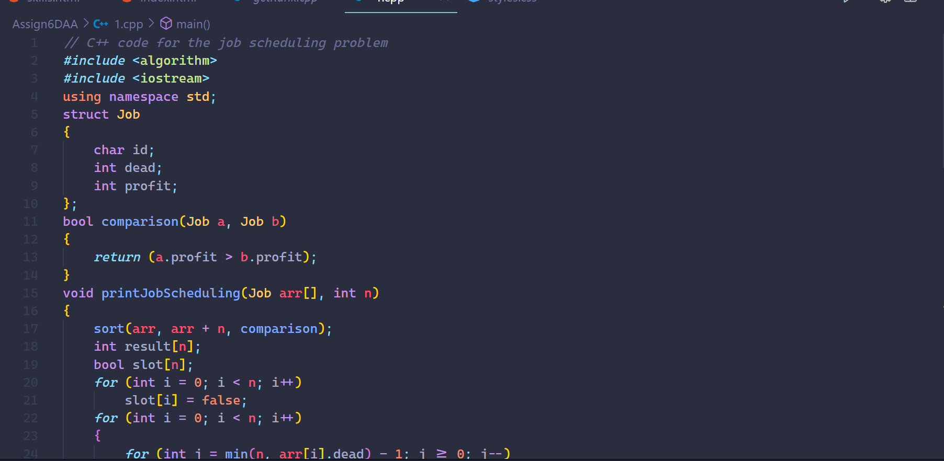
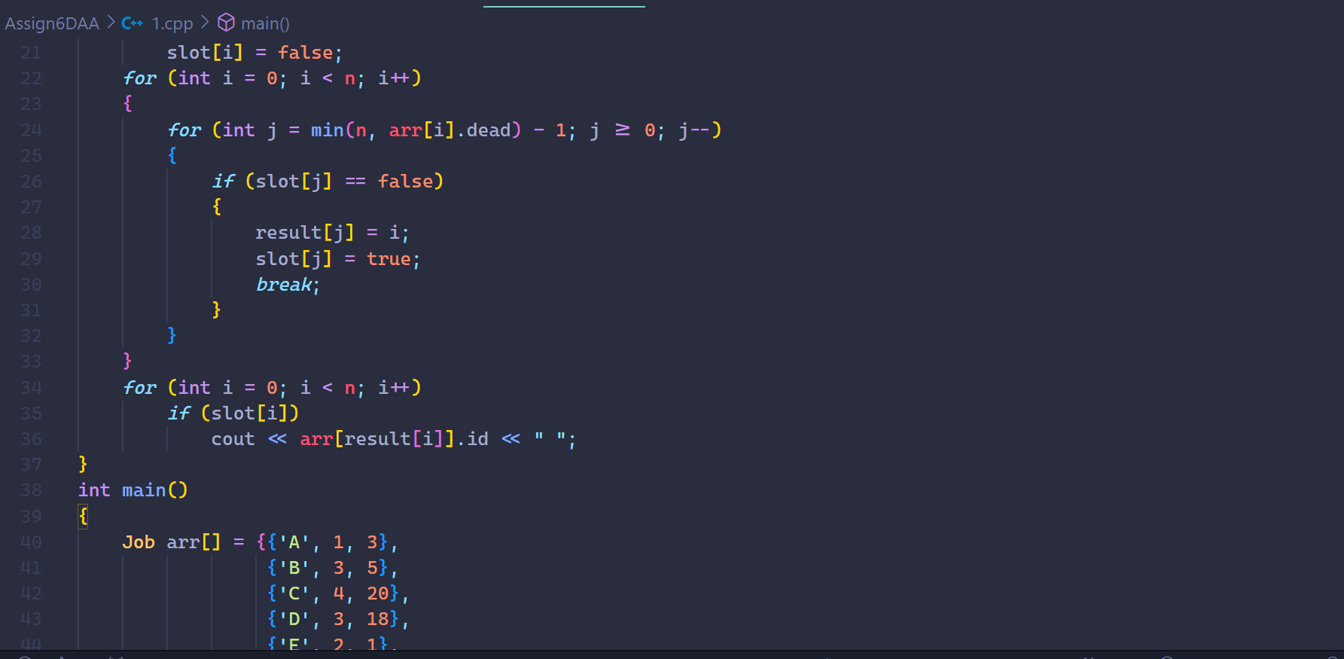

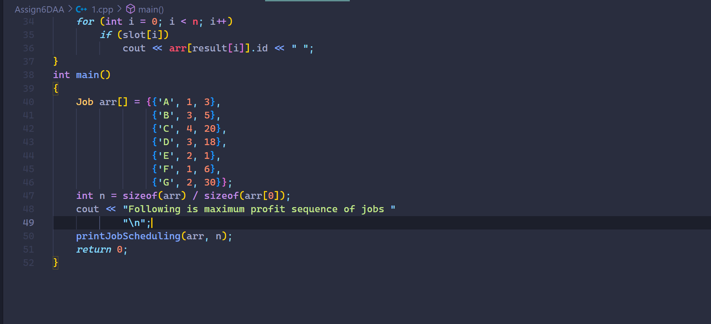

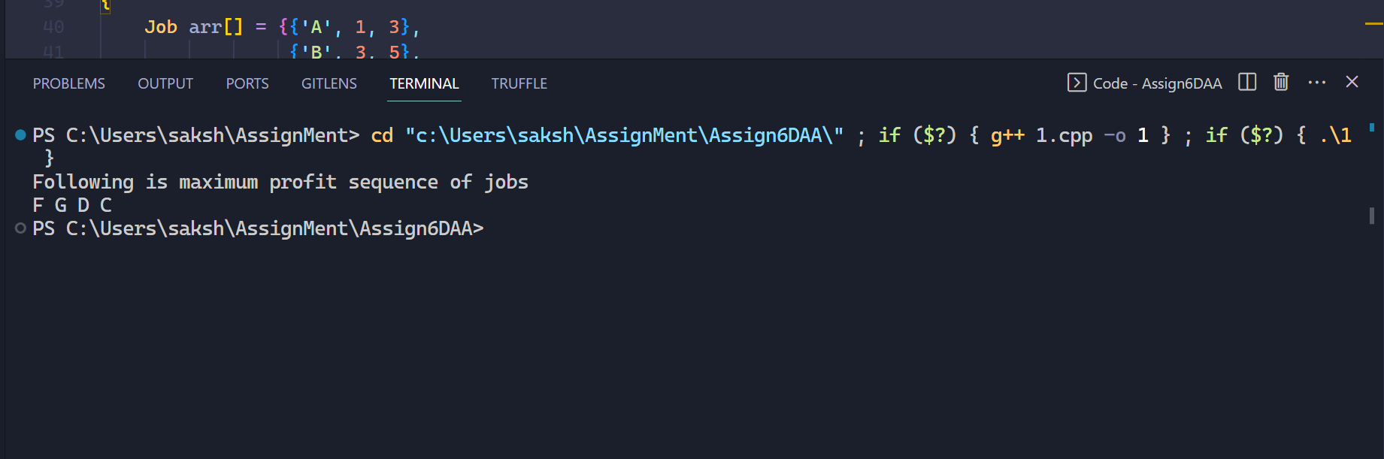

2) To implement Fractional Knapsack problem 3 objects (n=3).
(w1,w2,w3) = (18,15,10)
(p1,p2,p3) = (25,24,15)
M=20
With strategy
a) Largest-profit strategy
b) Smallest-weight strategy
c) Largest profit-weight ratio strategy

