**Note**: On command prompt,

Use command : ‘npm i’ to install all the necessary packages for running the project.

Then use command ‘npm install -xml-reader’

And then ‘npm install -xml-query’

**Step 1:** start the .js file from command prompt using command ‘node filename.js’.

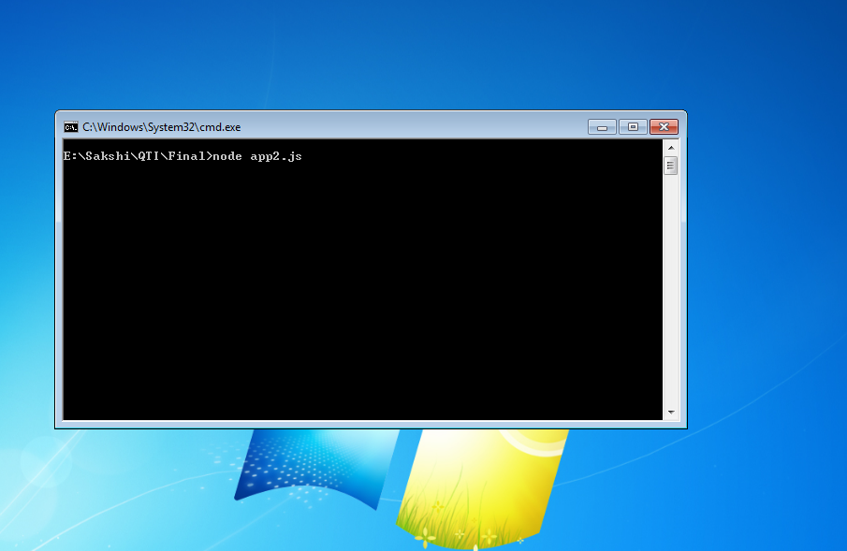

**Step 2:** Server starts on click of Enter key.

Message displays on console ‘Server running in port8080’

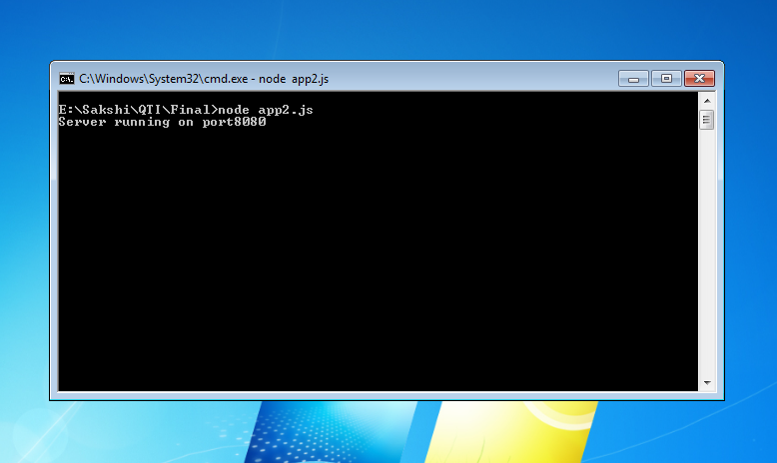

**Step 3:** Open the ‘main.html’ file locally from system into browser. Basic layout will be displayed.

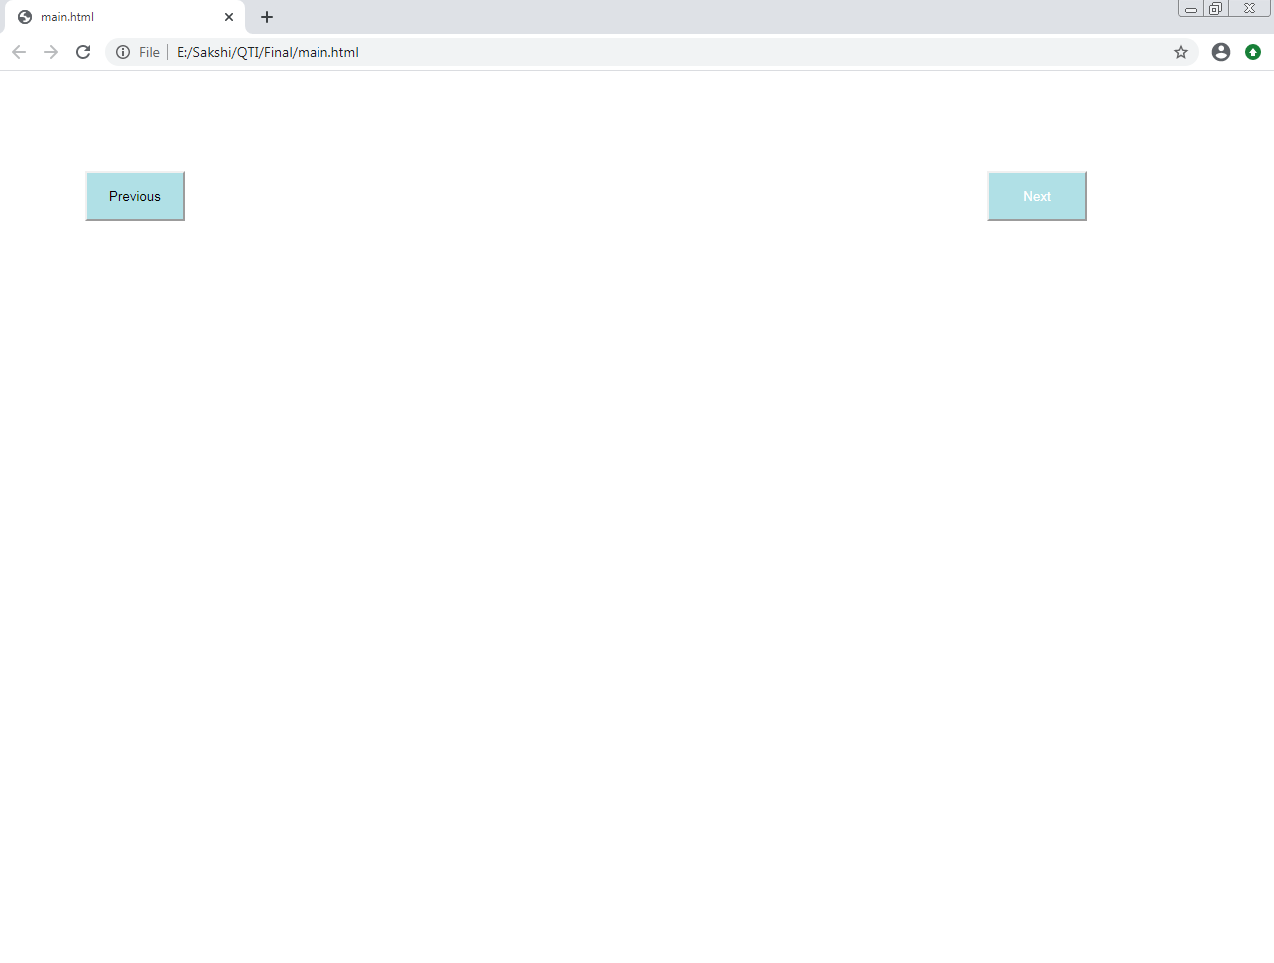

**Step 4:** For connecting to the local server, click on Next or Previous buttons.

**Steps 5:** XML Title will be displayed on top, Question and Answer choices will be displayed too.