Experiment No. 10

Version Control using Git & GitHub

Name: | Sakshi Himpalnerkar | Class: | SY-B
Roll No: | 71

Aim
To understand and implement Version Control using Git and GitHub by creating repositories, committing changes, and pushing code to a remote repository.

Theory
Git is a distributed version control system that tracks changes in source code during software development. It allows multiple developers to work together on non-linear development.
GitHub is a cloud-based hosting service that lets you manage Git repositories. It provides a web interface for collaboration, code review, and project management.
Key concepts include: Working Directory, Staging Area (Index), Local Repository, and Remote Repository. Changes flow from working directory → staging area → local repository → remote repository.

Step by Step Procedure

Sr. | Step Description
1. | Installation of Git
2. | Configure username & email
3. | Create local repository
4. | Create files
5. | Add files to staging
6. | Commit changes
7. | Create GitHub repository
8. | Link local repo to GitHub
9. | Push files

Screenshots
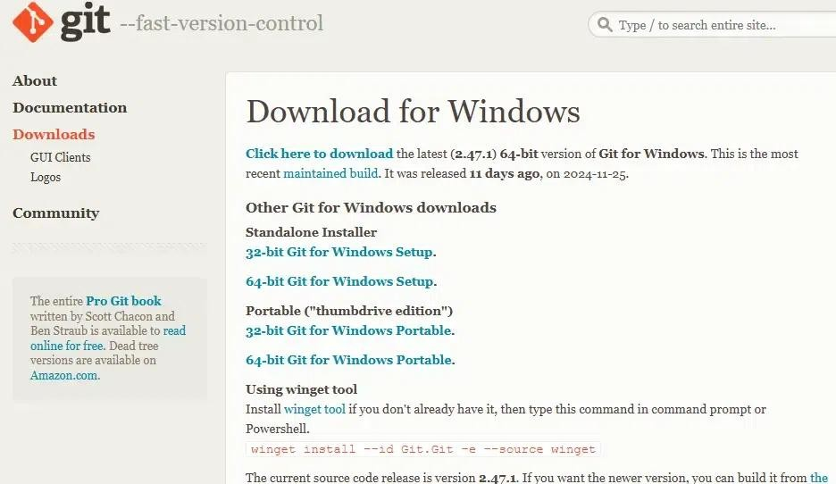
- installation verification (git version)

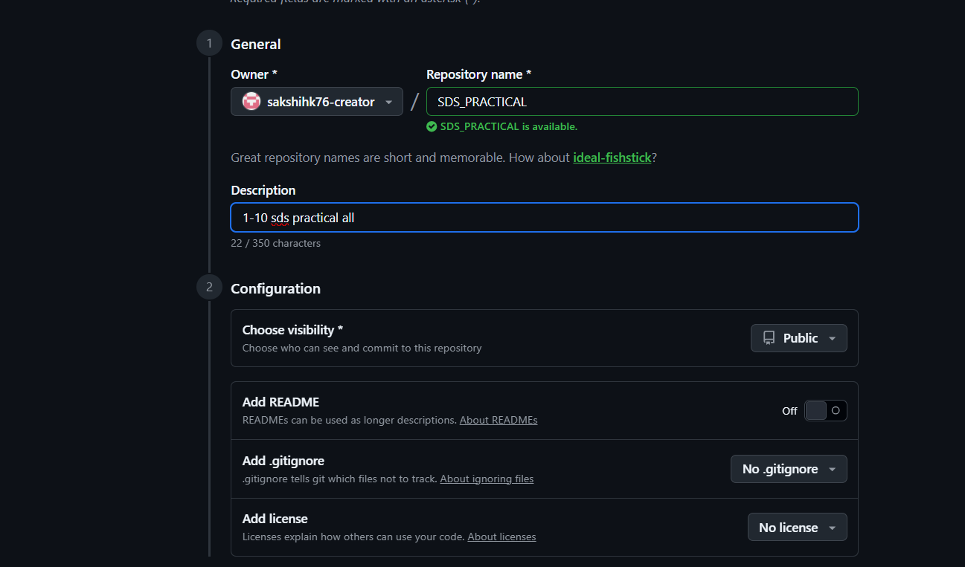
- Repository creation

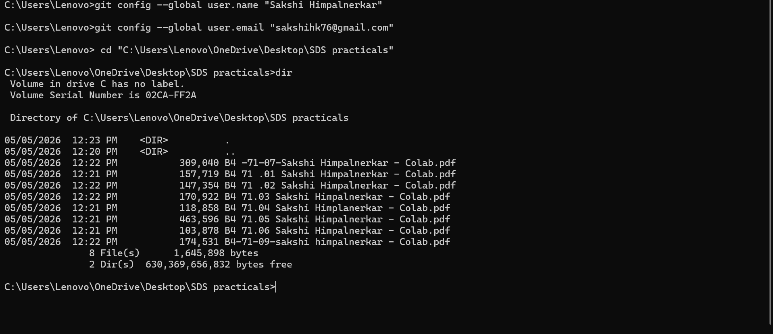

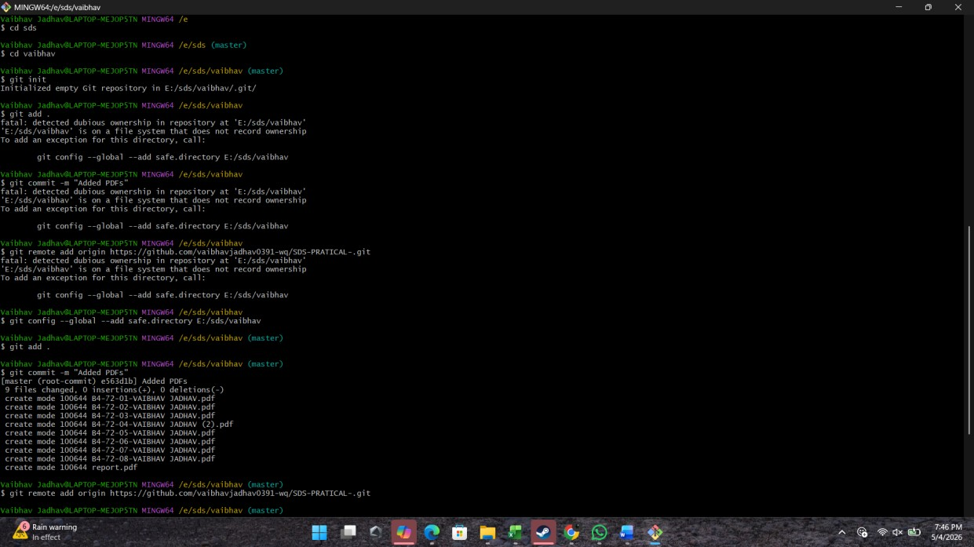

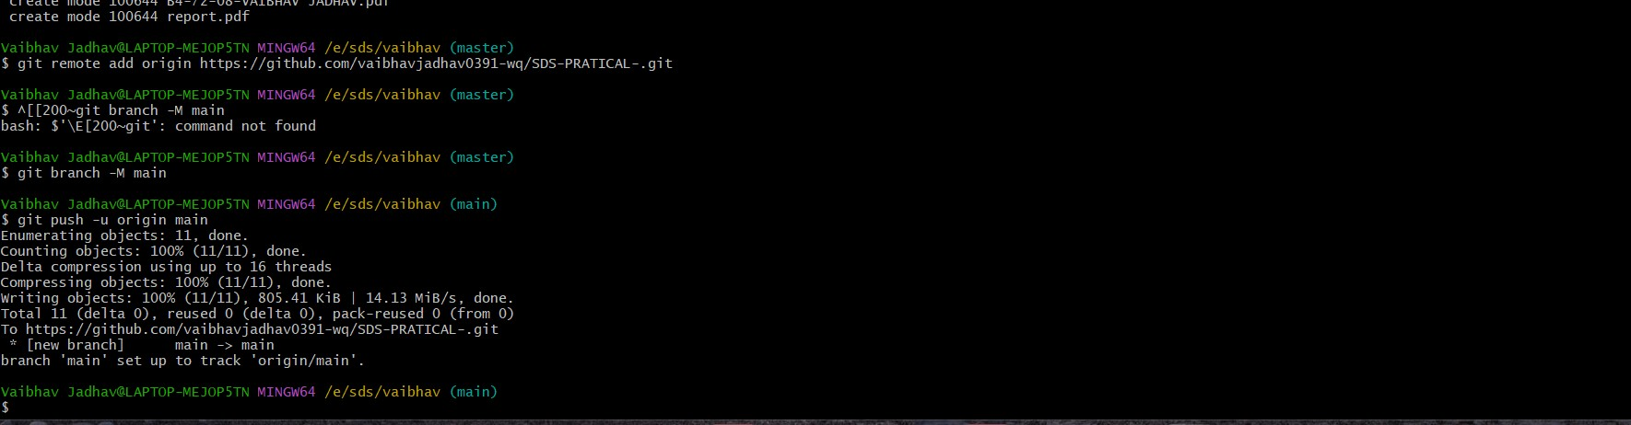
- Successful push

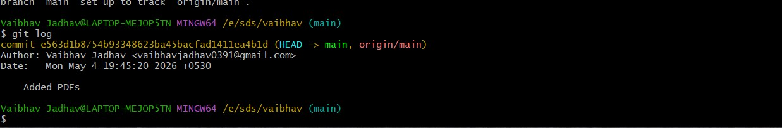
- Display commit logs (git log)

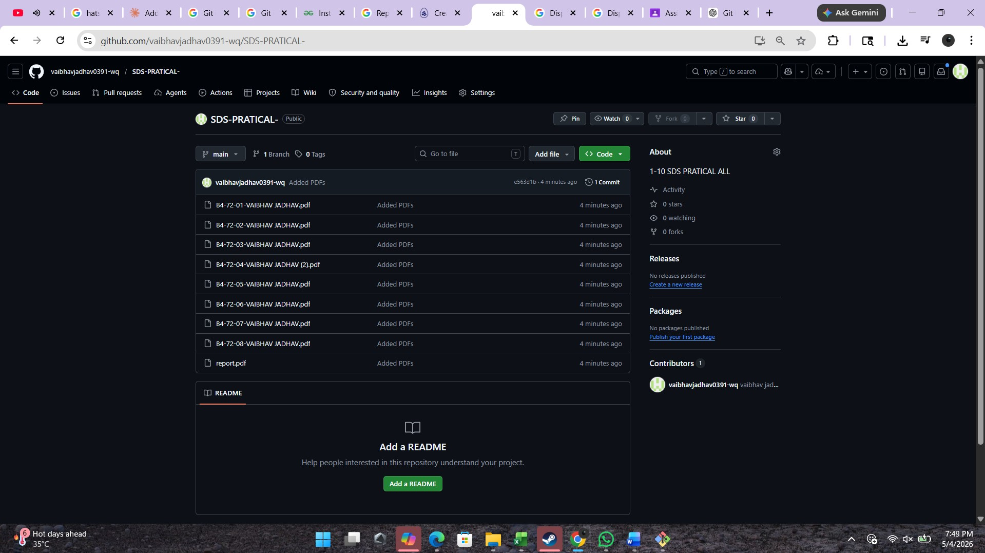
- Show files on GitHub repo

Questions
- What is the difference between Git and GitHub?
Git and GitHub are related but different tools used in software development.
  - Git is a distributed version control system. It is used to track changes in files and manage different versions of a project locally on a computer. It allows developers to work offline and maintain history of changes.
  - GitHub is a cloud-based platform that hosts Git repositories. It provides features like collaboration, sharing code, issue tracking, and version management over the internet.

- Explain the difference between git add and git commit
  - git add:
This command is used to move changes from the working directory to the staging area. It prepares the files for saving but does not actually save them.
  - git commit:
This command saves the staged changes permanently in the repository. Each commit creates a snapshot of the project with a message describing the changes.

- What is the staging area in Git?
The staging area is an intermediate area in Git where changes are stored before they are committed.
  - It allows the user to select specific changes to include in the next commit
  - It acts as a buffer between working directory and repository
  - It helps in organizing commits properly

- What happens if you modify a file after committing it?
If a file is modified after committing:
  - The new changes are not automatically saved in the repository
  - Git marks the file as “modified”
  - You must again use git add and git commit to save the new changes

- Difference between git push and git pull
  - git push:
It is used to upload local commits from your system to a remote repository like GitHub. It updates the online repository.
  - git pull:
It is used to fetch and download changes from the remote repository to your local system. It keeps your project updated.
.

- What is Version Control? Differentiate between Centralized and Distributed VCS
Version Control is a system that records changes made to files over time so that previous versions can be restored when needed.
Centralized Version Control System (CVCS):
  - Has a single central server
  - All users connect to this server
  - Requires internet connection
  - If server fails, data may be lost
  - Example: SVN
Distributed Version Control System (DVCS):
  - Every user has a complete copy of the repository
  - Works offline
  - Faster and more secure
  - No single point of failure
  - Example: Git

Conclusion
Git and GitHub are powerful tools used for managing and sharing projects. Git helps in tracking changes and maintaining version history, while GitHub allows collaboration and remote storage. Version control systems improve productivity, ensure data safety, and make teamwork easier in sof

