Experiment no 3

**Topic: Inheritance and method overriding:**

1. **Single**
2. **Multilevel**
3. **Hybrid**
4. **Hierarchical**

**Access modifiers : Private, Public, Protected, Default**

**Method overriding**

1. **Implement following Inheritance**

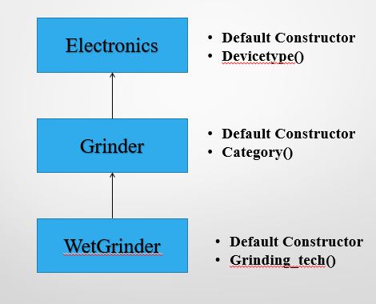

public class Electronics

{

public Electronics(){

System.out.println("class electronics");

}

public void Devicetype(){

System.out.println("it is electronics");

}

}

class Grinder extends Electronics

{

public Grinder(){

System.out.println("class grinder");

}

public void Category(){

System.out.println("it is grinder");

}

}

class WetGrinder extends Grinder

{ public WetGrinder(){

System.out.println("class wetgrinder");

}

public void Grinding_tecgh(){

System.out.println("it is wetgrinder");

}

} class TestInheritance {

public static void main(String [] args){

WetGrinder w=new WetGrinder();

w.Category();

w.Grinding_tecgh();

w.Devicetype();

}

}

Output: class electronics

class grinder

class wetgrinder

it is grinder

it is wetgrinder

it is electronics

1. **Implement following Inheritance**

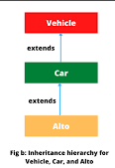

public class Vehicle

{ public void get_vehicle(){

System.out.println("class vehicle");

}

}

class Car extends Vehicle

{ public void get_car(){

System.out.println("class car");

}

}

class Alto extends Car

{ public void get_alto(){

System.out.println("class alto");

}

public static void main(String [] args)

{

Alto a=new Alto();

a.get_alto();

a.get_vehicle();

a.get_car();

}

}

Output:

class alto

class vehicle

class car

1. **Implement following Inheritance**

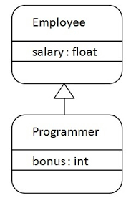

public class Employee {

float salary=30000;

public void get_salary()

{

System.out.println("Salary="+salary);

}

}

class Programmer extends Employee

{

int bonus=10000;

public void get_bonus()

{

System.out.println("Bonus="+bonus);

}

public static void main(String[] args)

{

Programmer p=new Programmer();

p.get_bonus();

p.get_salary();

}

}

Output:

Bonus=10000

Salary=30000.0

1. **Implement following Inheritance**

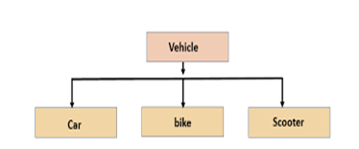

public class Vehicle1

{ public void get_vehicle()

{

System.out.println("class vehicle");

}

}

class Car extends Vehicle1

{ public void get_car()

{

System.out.println("class car");

}

}

class Bike extends Vehicle1

{

public void get_bike()

{

System.out.println("class bike");

}

}

class Scooter extends Vehicle1

{ public void get_scooter()

{

System.out.println("class scooter");

}

public static void main(String [] args)

{

Car c=new Car();

Bike b=new Bike();

Scooter s=new Scooter();

b.get_vehicle();

c.get_car();

b.get_bike();

s.get_scooter();

}

}

Output: class vehicle class car class bike class scooter

1. Implement concept of Method Overridding.