INDIAN TECH JOB MARKET
ANALYSIS REPORT — 2026
A Data Analytics Project
Prepared by: Sakshi
Tools: Python · Pandas · Matplotlib/Seaborn · Plotly · Streamlit

1. Executive Summary
This report presents an end-to-end analysis of the Indian technology job market using a dataset of 23,201 job postings scraped from online job platforms in 2026. The project covers data cleaning, exploratory data analysis, and the development of an interactive Streamlit dashboard to help job seekers, recruiters, and analysts understand hiring trends, salary benchmarks, in-demand skills, and company activity across India's technology sector.
Key headline figures from the cleaned dataset:
Total Postings | Companies | Cities Covered
23,201 | 6,992 | 198
Avg. Company Rating | Salary Disclosed | Avg. Disclosed Salary
3.59 / 5 | 11.9% | ₹15.3 LPA

Note on salary figures: only about 12% of postings in this dataset disclose a salary range. All salary statistics in this report are computed using disclosed postings only — undisclosed postings are excluded rather than treated as zero, since including them would understate true market salaries substantially (an early, uncorrected pass of this analysis produced an average of ₹2.27 LPA, which is not representative of the market).

2. Project Objective
The goal of this project was to analyze the Indian technology job market to answer practical, business-relevant questions:
- Which cities and companies are hiring the most for tech roles?
- What is the salary landscape across roles, cities, and experience levels?
- Which technical skills are most in demand?
- How prevalent is remote/hybrid work versus on-site roles?
- Can these insights be delivered through an interactive, filterable dashboard rather than a static report?

3. Data Source & Description
The raw dataset (indian_tech_jobs_2026.csv) contains 23,201 job postings with 32 attributes per posting, including job title, company name, company rating, location, experience range, salary range, required skills, work mode, and posting date. The data was scraped from Indian job listing platforms and required substantial cleaning before analysis, described in the next section.

4. Methodology

4.1 Data Cleaning
Data cleaning was performed in Python using Pandas, and included:
- Replacing placeholder text (e.g. “Not Available”, “Not Disclosed”) with proper null values
- Correcting salary fields so undisclosed postings are treated as missing rather than zero, preventing salary averages from being artificially deflated
- Removing 90 postings with logically invalid experience ranges (minimum experience greater than maximum experience)
- Standardizing categorical fields such as work mode, salary tier, and experience tier
- Deriving helper fields such as salary midpoint, primary city, and skill domain for downstream analysis

4.2 Exploratory Data Analysis
EDA was performed using Pandas, Matplotlib, and Seaborn to answer the business questions above, covering distributions, group comparisons (by city, company, role, and experience), and correlation analysis between salary and experience.

4.3 Interactive Dashboard
A multi-page Streamlit dashboard was built on top of the cleaned dataset, using Plotly for interactive charts. The dashboard includes dedicated pages for Salary Analysis, Skills Analysis, Company Insights, Location Analysis, Market Trends, and a Job Explorer with search and filtering.

5. Key Findings

5.1 Hiring Hotspots — Cities
Mumbai leads hiring activity with 3,276 postings, followed closely by Bangalore, Chennai, Pune, and Noida — together these five cities account for a large share of all listings, reflecting India's established technology hub geography.
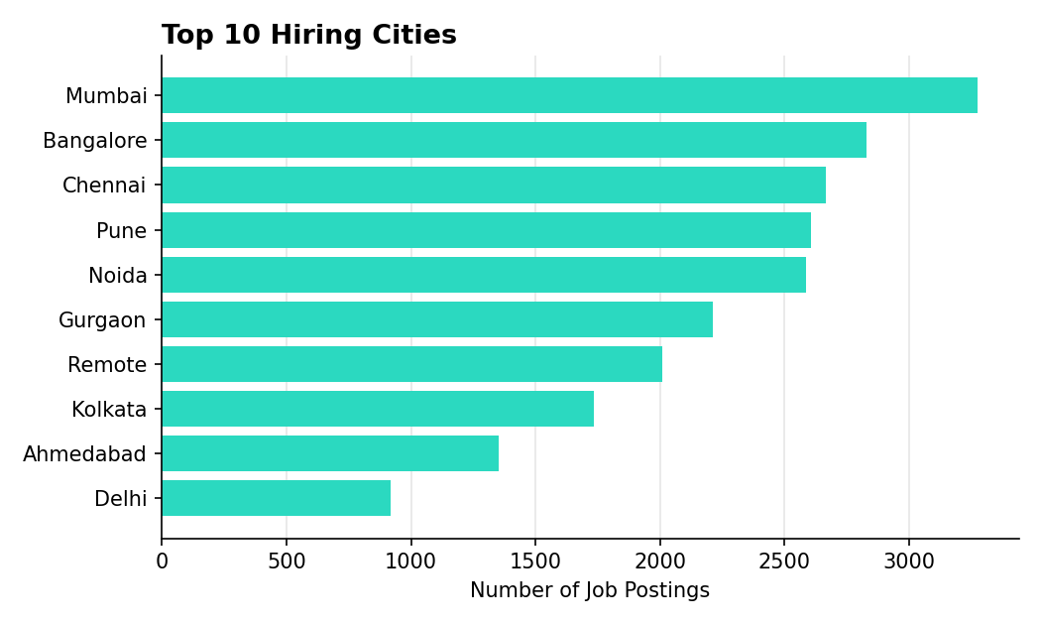
Figure 1: Top 10 hiring cities by number of postings

5.2 Hiring Hotspots — Companies
Tata Consultancy Services is the single largest poster of tech jobs in the dataset (653 postings), followed by Accenture and EY — consistent with the dominance of large IT services firms in India's tech employment market.
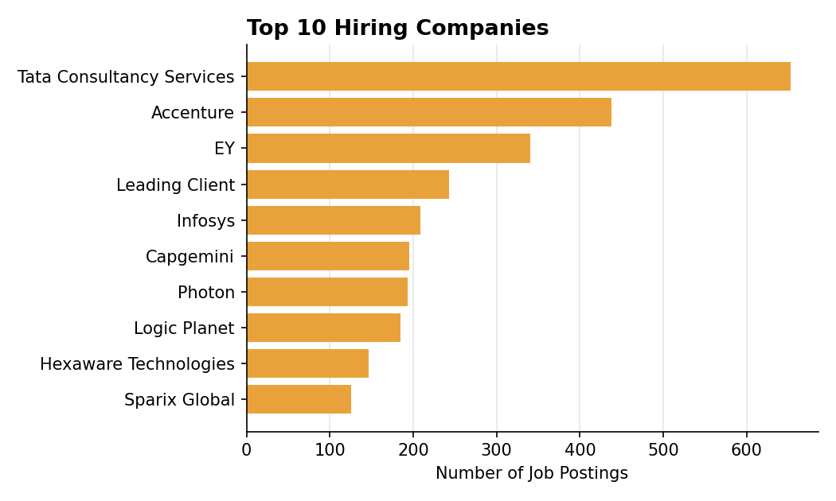
Figure 2: Top 10 hiring companies by number of postings

5.3 Role Demand
Data Scientist is the most commonly posted role category (6,455 postings), ahead of Data Analyst and Business Analyst — suggesting particularly strong demand for data-focused roles relative to more traditional software engineering titles in this dataset.
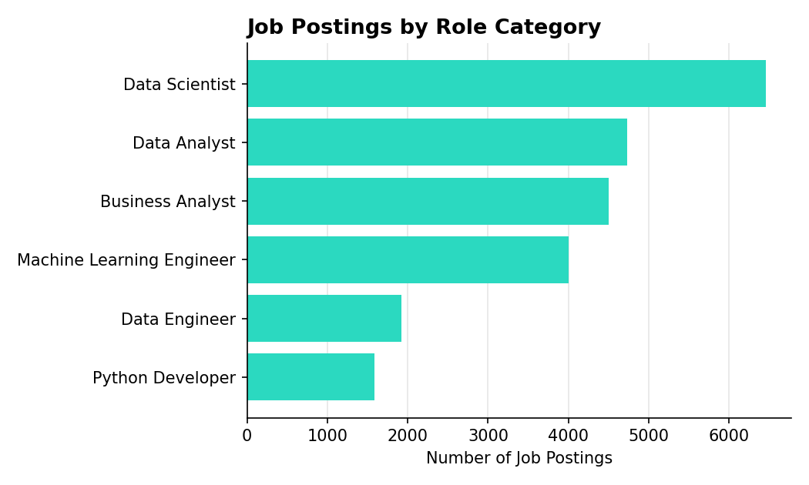
Figure 3: Job postings by role category

5.4 Salary Landscape
Among postings that disclose salary, the distribution is right-skewed — most disclosed roles cluster between ₹8–25 LPA, with a long tail of higher-paying senior and specialist roles.
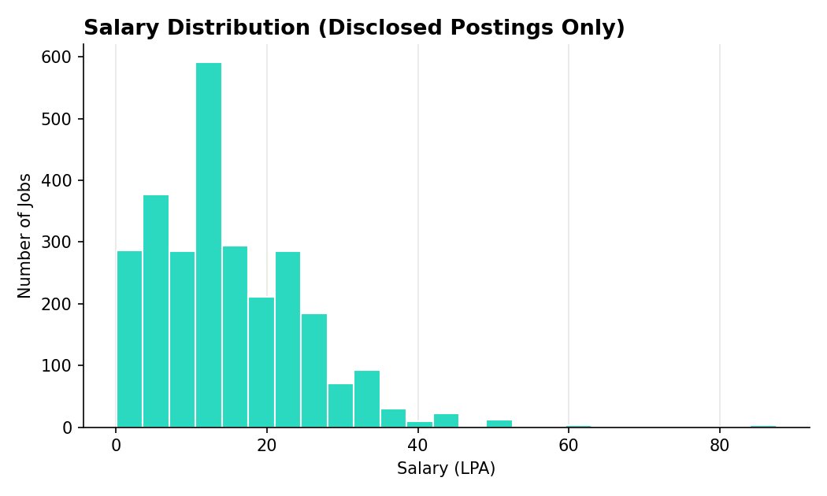
Figure 4: Salary distribution (disclosed postings only)
Data Scientist roles command the highest average disclosed salary among the major role categories, consistent with elevated demand for that role shown in Section 5.3.
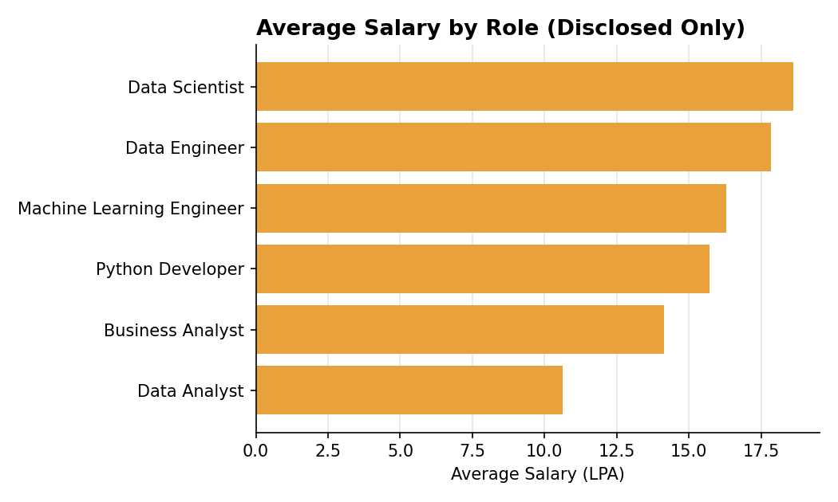
Figure 5: Average disclosed salary by role category
Among the top 10 hiring cities, Pune shows the highest average disclosed salary, narrowly ahead of Bangalore — both cities are established hubs for specialized and senior technology roles.
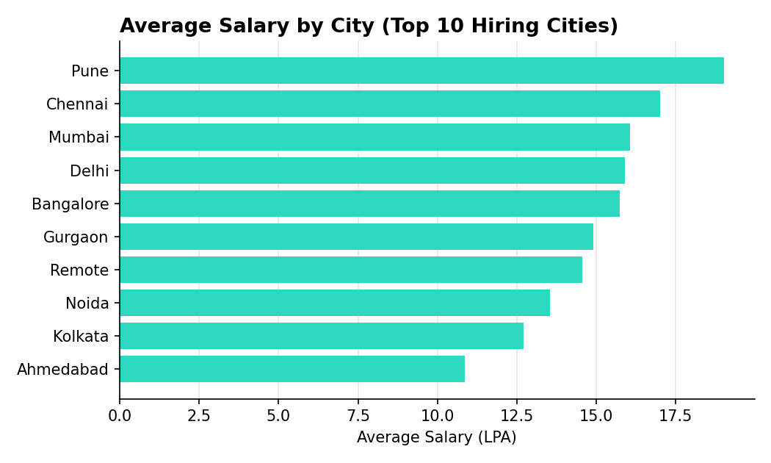
Figure 6: Average disclosed salary by city (top 10 hiring cities)

5.5 Experience Profile
The market is dominated by mid-level roles (3–5 years of experience), which make up nearly half of all postings, followed by junior and senior roles in roughly similar proportion. Entry-level (fresher) and lead/architect-level postings are comparatively rare.
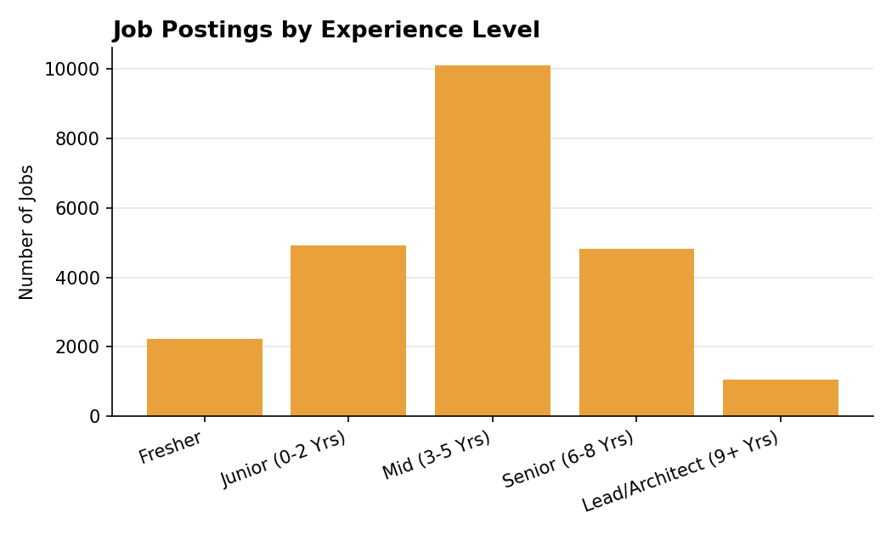
Figure 7: Job postings by experience level

5.6 Work Mode
On-site remains the dominant work mode at roughly 81% of postings, with hybrid and fully remote roles each accounting for around 9–10%. This suggests remote work, while present, is still the exception rather than the norm in Indian tech hiring as reflected in this dataset.
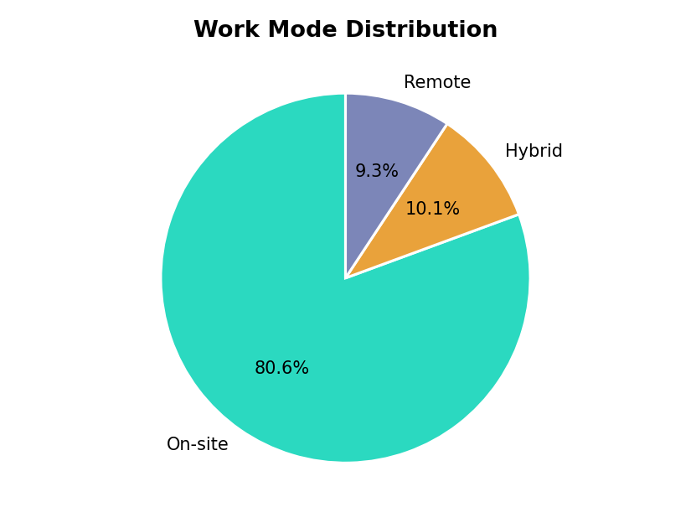
Figure 8: Work mode distribution

5.7 In-Demand Skills
Python, data analysis, and machine learning are the most frequently mentioned skills across postings, reflecting the strong data-and-analytics tilt of demand already visible in the role distribution.
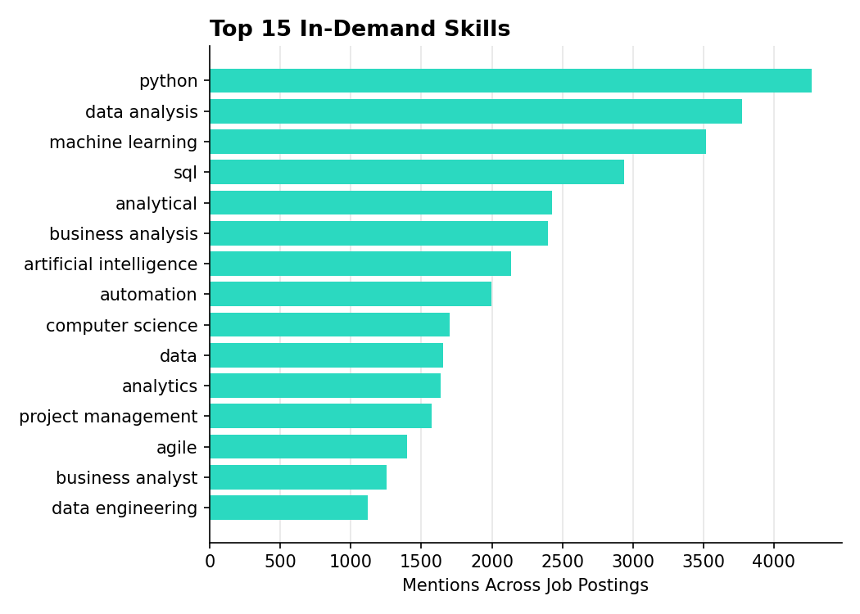
Figure 9: Top 15 most frequently mentioned skills

6. Data Quality Notes & Limitations
- Salary disclosure rate is low (≈12%), so salary insights, while directionally useful, are based on a non-random subset of postings and may not perfectly represent the full market.
- 90 postings (about 0.4% of the raw data) had internally inconsistent experience ranges and were excluded from the cleaned dataset.
- Company and city names were scraped as free text and standardized where possible, but some long-tail inconsistencies may remain (e.g. city names with area-level detail).
- The dataset reflects postings visible on job platforms at time of scraping and is not a complete census of the Indian tech job market.

7. Interactive Dashboard
All findings in this report can be explored interactively in the accompanying Streamlit dashboard, which allows filtering by city, experience level, salary tier, and work mode across the following pages:
- 📊 Salary Analysis — distribution, highest-paying cities and companies
- 🧠 Skills Analysis — in-demand skills by domain, experience, and city
- 🏢 Company Insights — top hirers, ratings, company size
- 📍 Location Analysis — hiring by city and state, work mode
- 📈 Market Trends — experience and hiring trends over time
- 🔍 Job Explorer — searchable, filterable job listing table

8. Conclusion & Recommendations
The Indian tech job market, as reflected in this dataset, is concentrated in a handful of major cities and large IT services companies, with strong demand for data-oriented roles and skills. On-site work remains dominant, and disclosed salaries — while representing a minority of postings — suggest meaningfully higher compensation than a naive read of the raw data would imply.
For job seekers: Python, data analysis, and machine learning skills align with the highest-demand roles. For recruiters and analysts: improving salary disclosure rates in future postings would substantially improve the reliability of compensation benchmarking.

9. Future Scope
- AI-based salary prediction model trained on disclosed postings
- Resume-to-job matching and skill-gap analysis
- Live job API integration for real-time updates
- Company comparison and benchmarking tool
- Conversational AI assistant for career guidance

