

Table Of Contents

1.Abstract **3**

**2.Introduction** **4**

3.Current System **5**

4.Proposed System **6**

4.1. Employee 6

4.2. Admin 7

**5.Technical Details** **8**

5.1. Technology stack 8

5.2. Important points and Assumptions 11

6.Data Flow **12**

7.System Flow **16**

8.ER Diagram **23**

9.Conclusion **24**

# 1.Abstract

Now a day’s vehicle parking is an important issue and day by day its necessity is increasing. We are still using the manual vehicle parking system and that is why we are facing problems like wastage of time and fuel finding free space around the parking lot when we need to park our car. Another issue is the chaos that happens while parking because there is no particular system, anyone can park anywhere that sometimes causes damage to the vehicles while moving out or in the parking lot.

So, there is a need for a proper Parking management system for managing the records of the incoming and outgoing vehicles in a parking house. Using the proposed system, it becomes easy as the system will automatically allot a specified slot to an employee and also retrieving parking data becomes easy about number of vehicle parked becomes

The vehicle parking area has many slots for vehicle parking. So, to park a vehicle one has to just swipe a card at the entrance of the building and a particular slot will be allotted to the employee. Also, the employee will be able to see whether empty slots are there in the particular building or not as display will be present at the entrance of every building.

The main objective of the project is to build a Vehicle Parking management system that will make parking an activity of 5 minutes rather than that of half hour. Our system will track the entry and exit of vehicles, maintain a listing of vehicles within the parking lot, and determine if the parking lot is full or not and will also notify users if there is something related to parking.

# 2.Introduction

This project was developed for making parking management easy to use without much manual work to be done by people working in managing parking.While parking the vehicle in parking space we realized various things that can be changed for better .

In this project we have developed a parking system which will make vehicle parking organised and we will have details of all the available parking in parking lots. The proposed system will have two logins ie. an Admin and Employee login. Admin will be the one who will have overall view of parking in the campus.He will decide how much slots to allot for parking for a particular day.And system will allocate a parking slot to an employee when the employee swipes his/her card at the main gate. As soon as the card is swiped the first available slot will be given. And the admin will be able to change the parking allotting if some maintenance activity is going on in that building. An employee will be able to see this message on the bulletin board that employees have access to.

Admin will have many other functionalities which will enable him to maintain a stable system.Admin will also be able to download multiple records about vehicles parked in parking slots and also exceptional records.He can even modify the details of the vehicles and can also add someone as admin to make work easy. This system will surely solve all the issues that the current system is facing.

# 3.Current System

The current system totally depends on manual work to be done by the parking management team for finding the vacancies in parking lot. And an employee entering the campus will park the vehicle in the place told by the employee.Sometimes it becomes a very annoying thing to do ,if we have urgent meetings to join or are already very late. So that is why we realised a need for making a system that will provide next available to the employee at the entrance itself. Thus making our work easy.

Some of the reasons why we need a new vehicle management system is:

1.For keeping the track of vehicles in the premises someone has to go and check manually that certain vehicle is present or not.

2.Finding total number of vehicles parked and available parking slots for parking becomes difficult too as we have to manually check for that as well.

3.In case of maintenance activity or any other issue with availability of parking.We had to keep no entry boards at entrance for people to know that this parking is not available.Employee will come to know about this only after he enters the building.No prior notice about this is given .

Due to all the above problems we tried to provide solutions to them using the proposed system .In the proposed system we can easily make things more easy for administration thus decreasing human intervention.We will just need an admin at the get to proceed with our developed system.

# 4.Proposed System

This system works as follows-

* A monitor is kept at the entrance gate which shows availability of parking in the building.
* Employees need to swipe their card and then a slot for parking is allocated to them.
* Also while exiting they have to swipe the card again.
* Admins (who are employees with admin rights) can view the data of all parkings, vehicles registered by employees, locations, slots etc and can also change the data as and when required.

Our proposed system’s functionalities are explained below.

## 4.1. Employee

After authentication the employee is let in

1. In the Employee Page, an employee is allowed to register a vehicle he would be bringing to campus.
2. If an Employee wants to modify the details of a vehicle already registered by himself/herself he can do that by clicking on Update vehicle details button.
3. He can also send a message to Admin in case of any query by using the Query Details tab.

## 4.2. Admin

Admin(who are employees with admin rights) can login with his credentials and after authentication he is let in.

1. In the My Details Page he is allowed to register a vehicle he would be bringing to campus.
2. If an Admin wants to modify the details of a vehicle already registered by himself/herself or by other members he can do it in the Update Details page in Modify Vehicle Tab.
3. Also Admin can add someone as admin or remove someone from admin in Update Details Page
4. In the Dashboard he can view live updates of Available and Allocated Slots in Buildings.
5. In the Modify Location page, Admin can add a new building and can also modify the allocated slots of a specific building.
6. In the Update Slots page, Admin can Enable/Disable a specific slot if required. He/She can also add a message for reference in front of that slot.
7. In Message Center Admin can add a bulletin board for employees to see, for a given time period. Also he can send messages to employees.
8. In the Report page, data of vehicle in and out can be monitored. In daily In/Out tab admin can view current date’s parking data. Also if Admin wants to get a report of specific dates data or add some other filters on the report he can do that. The data will be downloaded in Excel Format.
9. The data of vehicles which are on campus from more than 12hrs is recorded in the Exception Report in Report Page.

# 5.Technical Details

## 5.1. Technology stack

This project is built with quite new and popular open source technologies. This web application is built using one of web services called Flask module. Different technologies are involved for the frontend and backend. They are as follows.

1. **FrontEnd**-

All the webpages of web applications are made by using HTML,CSS, JS and Bootstrap.We tried to make interactive and impressive UI using these technologies.

**HTML**

HTML was used mostly for designing purposes in UI.

**CSS**

CSS made the UI more lively with all the features we used eg. ICONS

**Javascript**

Used where explicit functions were required in UI like Validations.

**Bootstrap**

Bootstrap made the UI more lively with all the features we used eg. ICONS, but it’s use was limited to few features only.

1. **Backend**-

**Flask**

Flask is a web framework, it’s a Python module that lets you develop web applications easily. In the case of Flask, its dependencies are:

* [Werkzeug](http://werkzeug.pocoo.org/) a WSGI utility library
* [jinja2](http://jinja.pocoo.org/) which is its template engine
* Few more modules needed to be installed using pip commands

1. **Database**-

MYSQL

MySQL is a relational database management system based on the Structured Query Language, which is the popular language for accessing and managing the records in the database. MySQL is open-source and free software under the GNU license. It is supported by **Oracle Company**.

It supports the following Operating System:

* Windows
* Mac OS X
* Linux
* UNIX
* z/OS
* BSD
* Symbian
* AmigaOS

In this web application parking database includes following schemas:

|  |  |  |  |
| --- | --- | --- | --- |
| Table Name | Attributes | Description | Connected Web pages |
| Bulletin_Board | Message,Start_Time_Date,End_Time_Date | Bulletin board shows the news related to parking | Message Center,  EmployeePage,  Inputpage |
| Emp_details | Emp_ID,Emp_Name,Emp_Contact,Gender,Emp_Password,isAdmin,AccessCard_No | Emp_details contains information employees as well as admin. | EmployeePage,  MyDetailsAdmin,  Login,  Update_Details,  Modify_Location,  ModifyVehicalEmployee_Search,Inputpage |
| Emp_Vehicle_Report | Emp_ID,Emp_Name,Veh_NO,In_Time_Date,Out_Time_date,Veh_Type,Updated_Date,Building,City,Slot_No | This table gives daily in/out vehicle information | Reports,  Download,  Inputpage,  remove |
| History_Vehicle_Details | Emp_ID,Emp_Name,Veh_NO,Vehicle_Company_Name,Vehicle_Model,Vehicle_Type,Updated_Time,Updated_By | This table is about the history of vehicle details. | MyDetailsAdmin,  EmployeePage |
| Location_Details | City,Building | This table is used to insert locations | Report |
| real_time | Building,City,Specially_Abled_Two_Wheeler,Specially_Abled_Two_Wheeler,Two_Wheeler,Four_Wheeler | Real time data is tested from a real_time table. | Dashboard,  DisplayPagePune,  DisplayPageHyderabad |
| total_slots | City,Building,Veh_Type,Total_Allocated,Total_Available,Updated_Time,Updated_by | This table used to modify real time data of dashboard and Modify_Location page | Modify_Location,  Dashboard |
| Vehicle_entry | City,Building,Veh_Type,Slot_No,Veh_No,Status,Msg,PSID | This table is used for real time purposes. | Dashboard,  Modify_Location,  Update_slots,  DisplayPagePune,  remove  Inputpage  DisplayPageHyderabad |
| vehicle_details | Emp_ID,Emp_Name,Veh_No,Veh_Company_Name,Veh_Model,Veh_Type,Updated_Date,Updated_By | This page is used for storing data of all vehicle registered | EmployeePage,MyDetailsAdmin,UpdateDetails,ModifyVehicalEmployee_Search,ModifyVehicalEmployee |

## 5.2. Important points and Assumptions

1. All information of vehicle registration and any modification done in vehicle details is stored in a table in the database(history_vehicle_details table).
2. The real time monitor is refreshed after 1sec.
3. Refresh button is recommended to use to reflect the changes done.
4. Before making any changes in the modified location it is recommended to see if any vehicle is already parked in it or not.

# 6.Data Flow

Level 0-

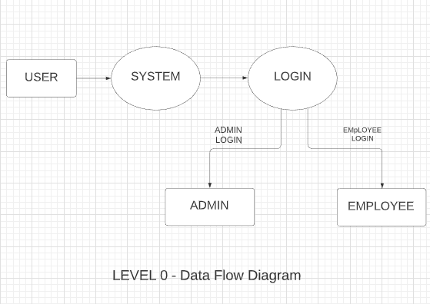

LEVEL 1 - Employee Module

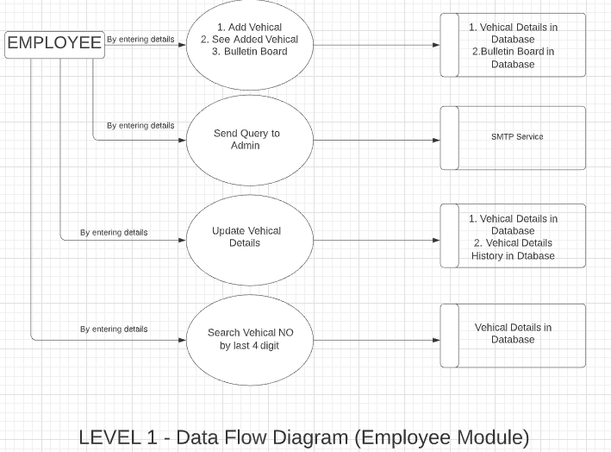

LEVEL 1 - Admin Module

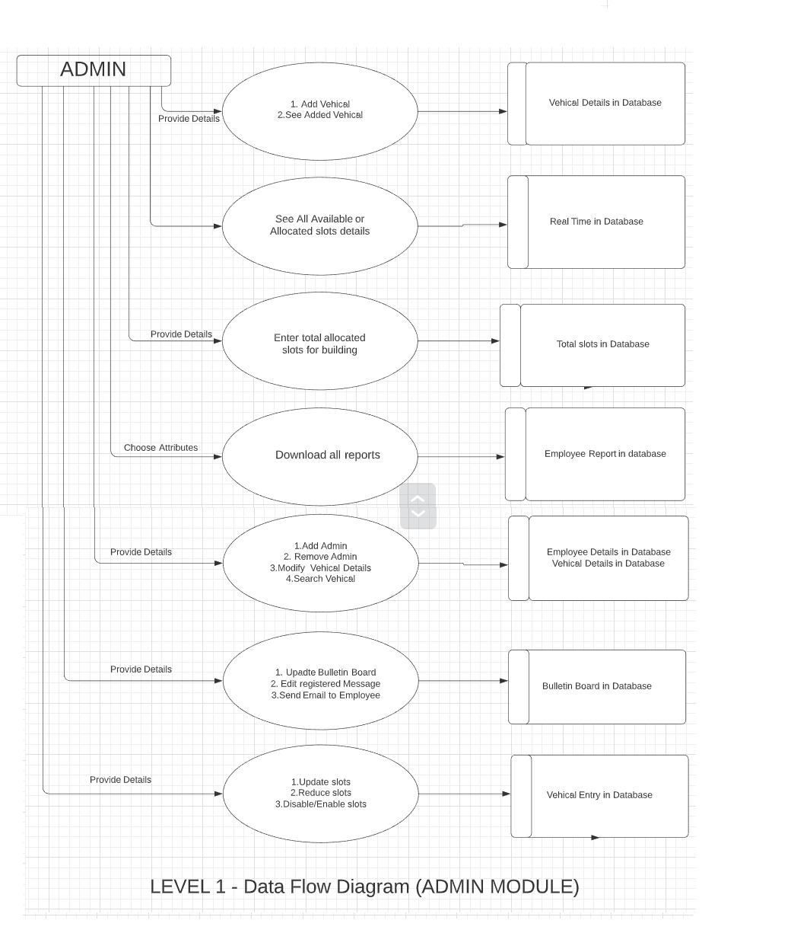

# 7.System Flow

Step 1: Firstly Employee(User) will login using ID and Password in the system.

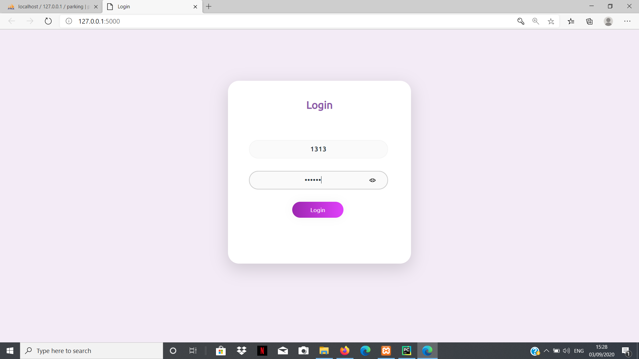

Step 2:After login there is two ways like depending on User is Employee or Admin.If user is just a employee then it will be redirected to Employee Page or If user is Admin the it will be redirected to Admin Page.

1. Employee Page:

I)My Details Page:This page shows the basic information about employee like id ,name,her/his vehicle details,query details etc.Also the employee can add vehicles and If the employee has query like Registration issue and Parking issue etc.

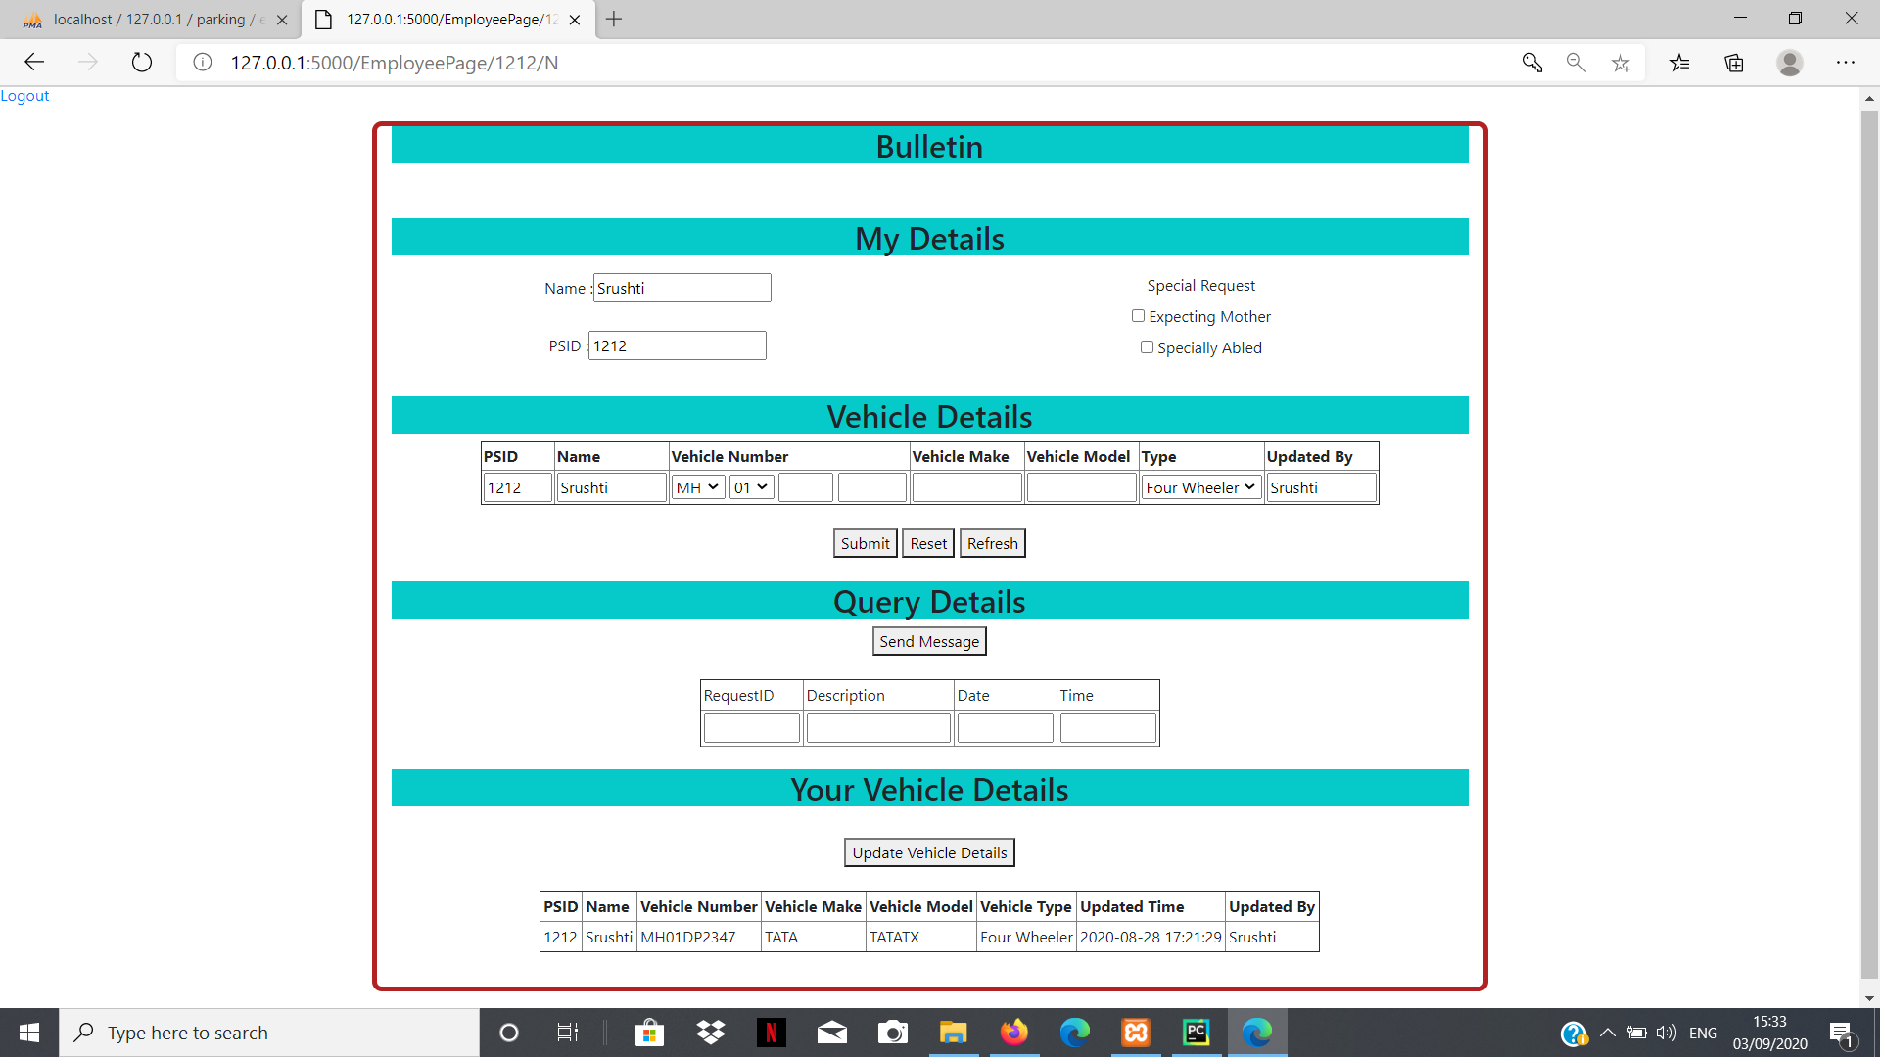

II)Send Message:After clicking on send message it will redirected to this page.Using this we can send email to admin if the employee have query.

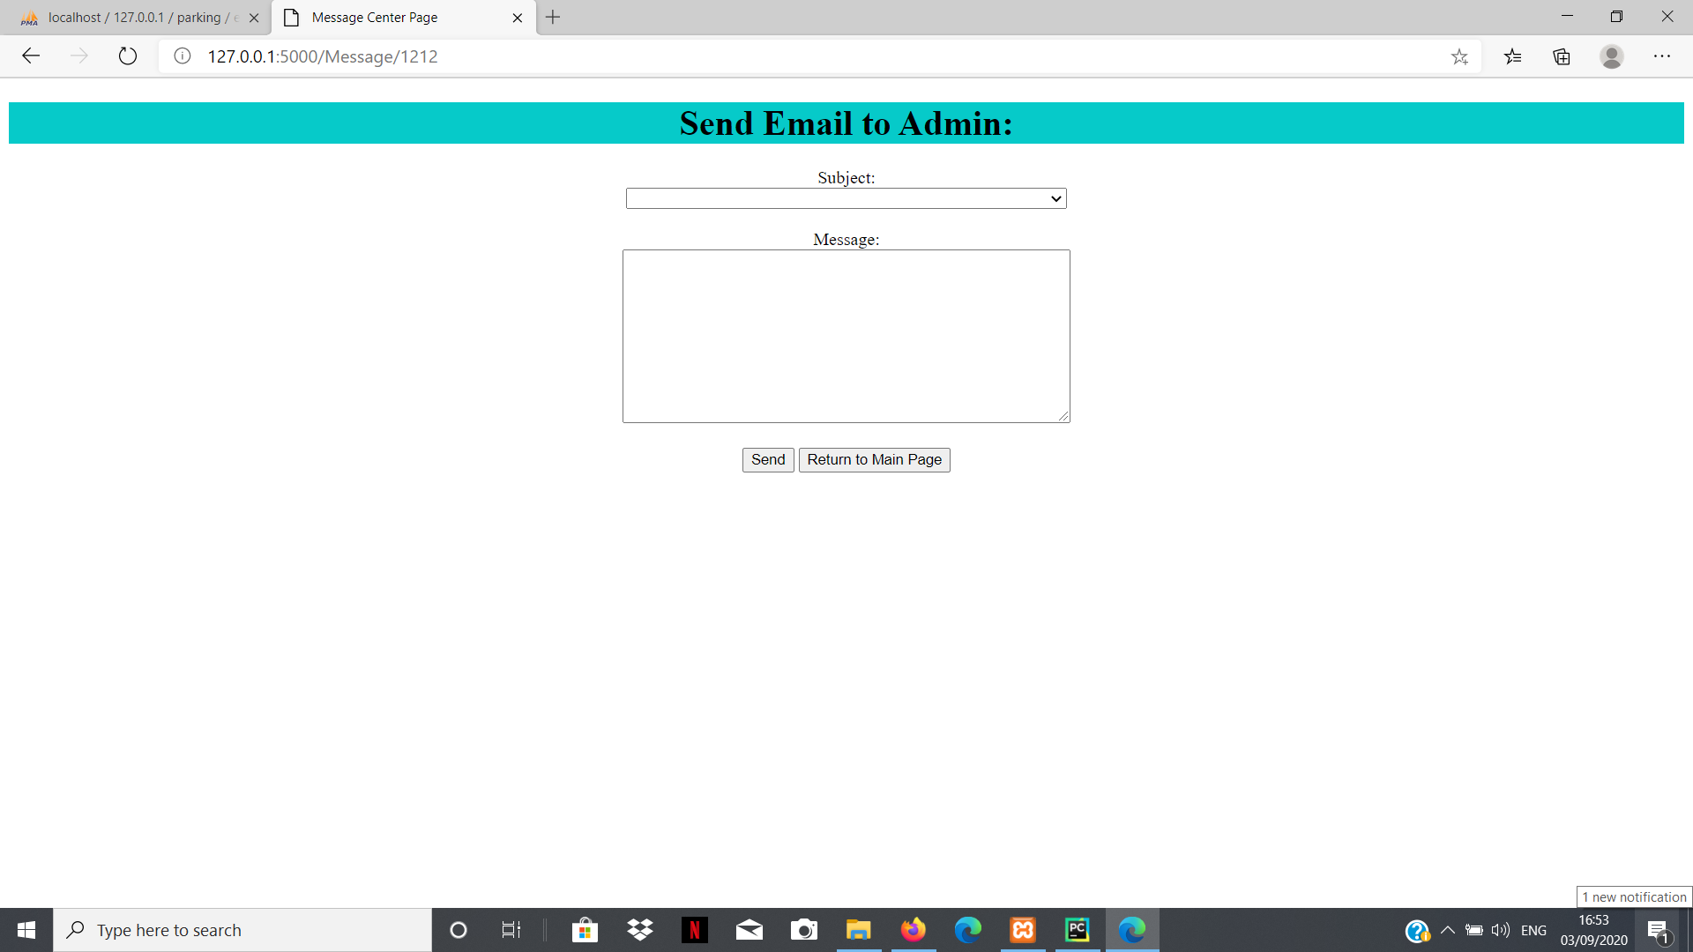

2. Admin :The Admin has authority to manage the whole parking system.

I)My Details Page:This page shows the basic information about Admin(Employee) like id ,name,her/his vehicle details.Also the employee can add vehicles.

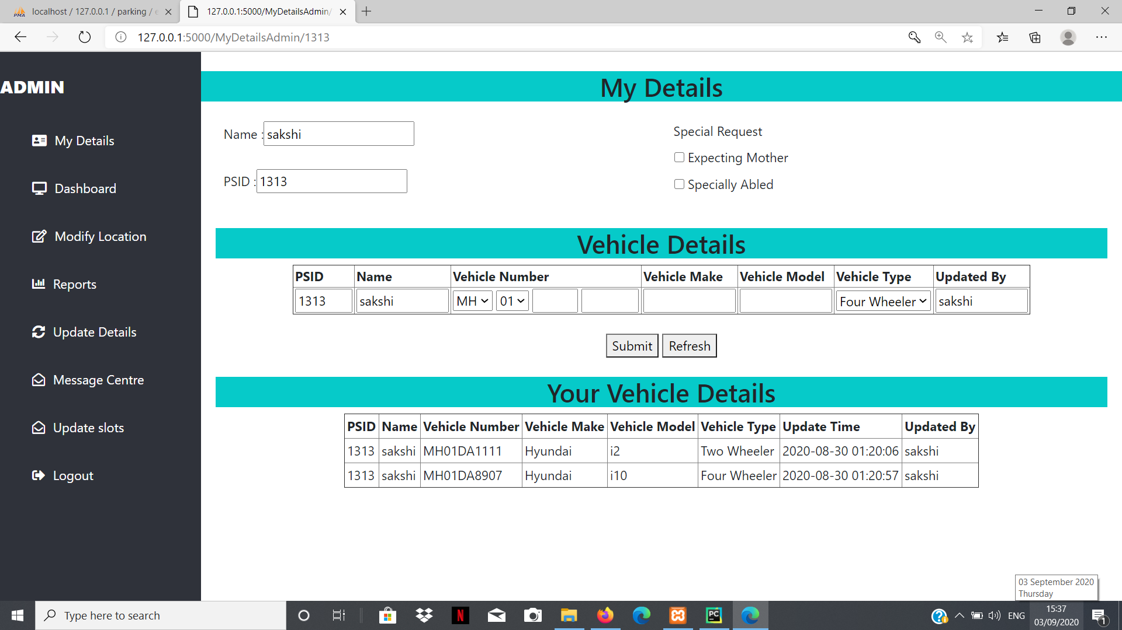

II)Dashboard Page:This page shows Allocated slots for all building with the vehicle types for two locations i.e Pune and Hyderabad.

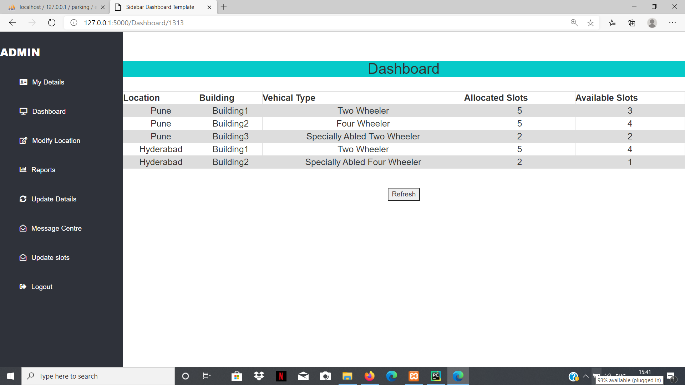

III)Modify Location Page:Using this page admin can create location with capacity for the vehicle parking for both city like Pune and Hyderabad.

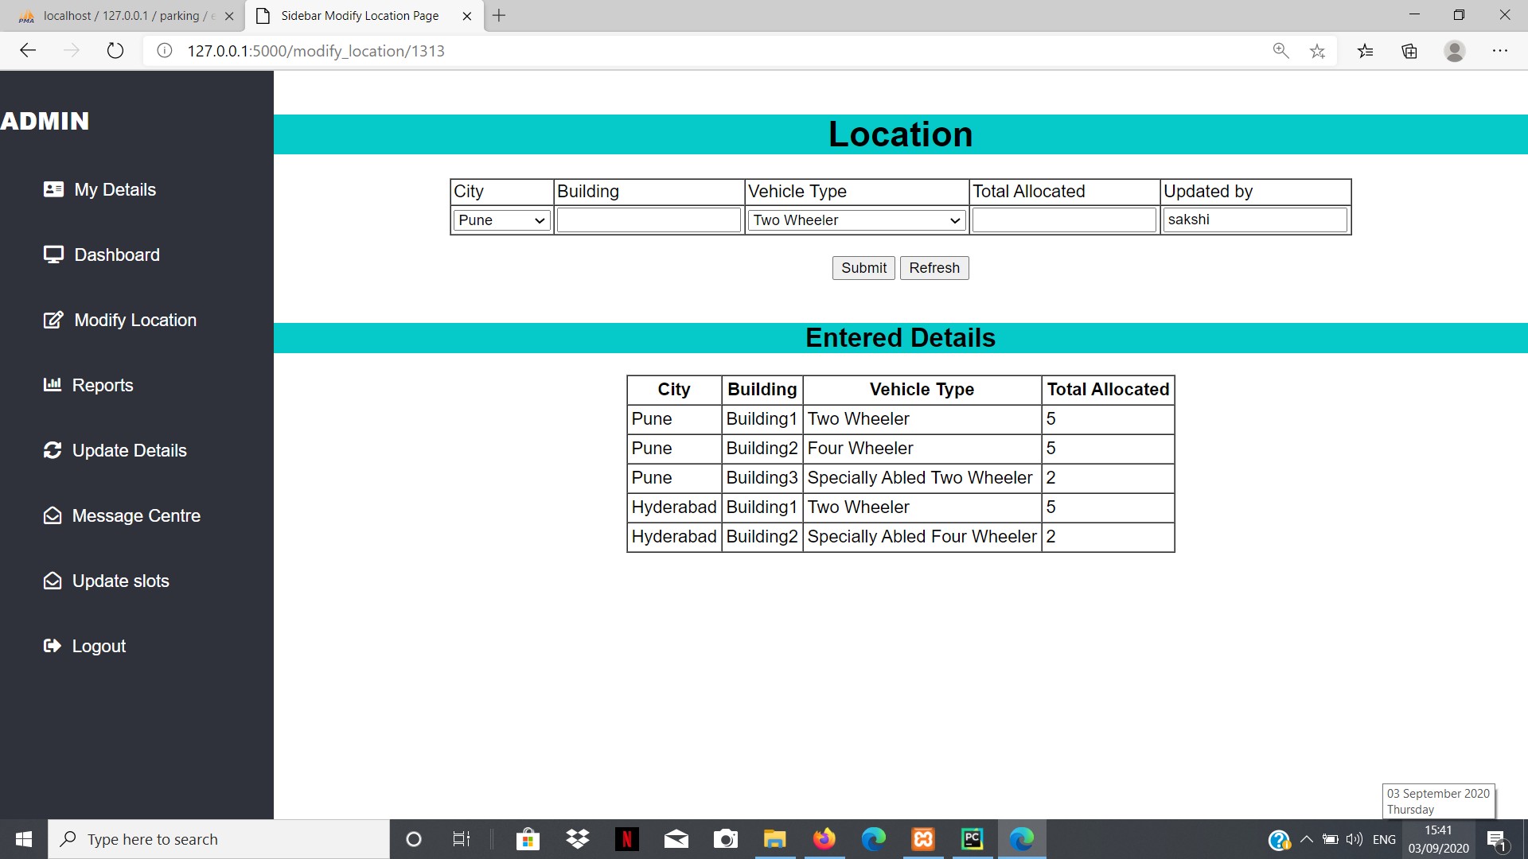

IV)Report Page:This page basically shows daily in out vehicles with the details and where admin can download the report based on the attributed like Name,Type,Vehicle no,ID etc. and the buildings by selecting start date and end date.And also we can directly download the report of Yesterday,Last week,Last month,last 6 month by clicking on button.

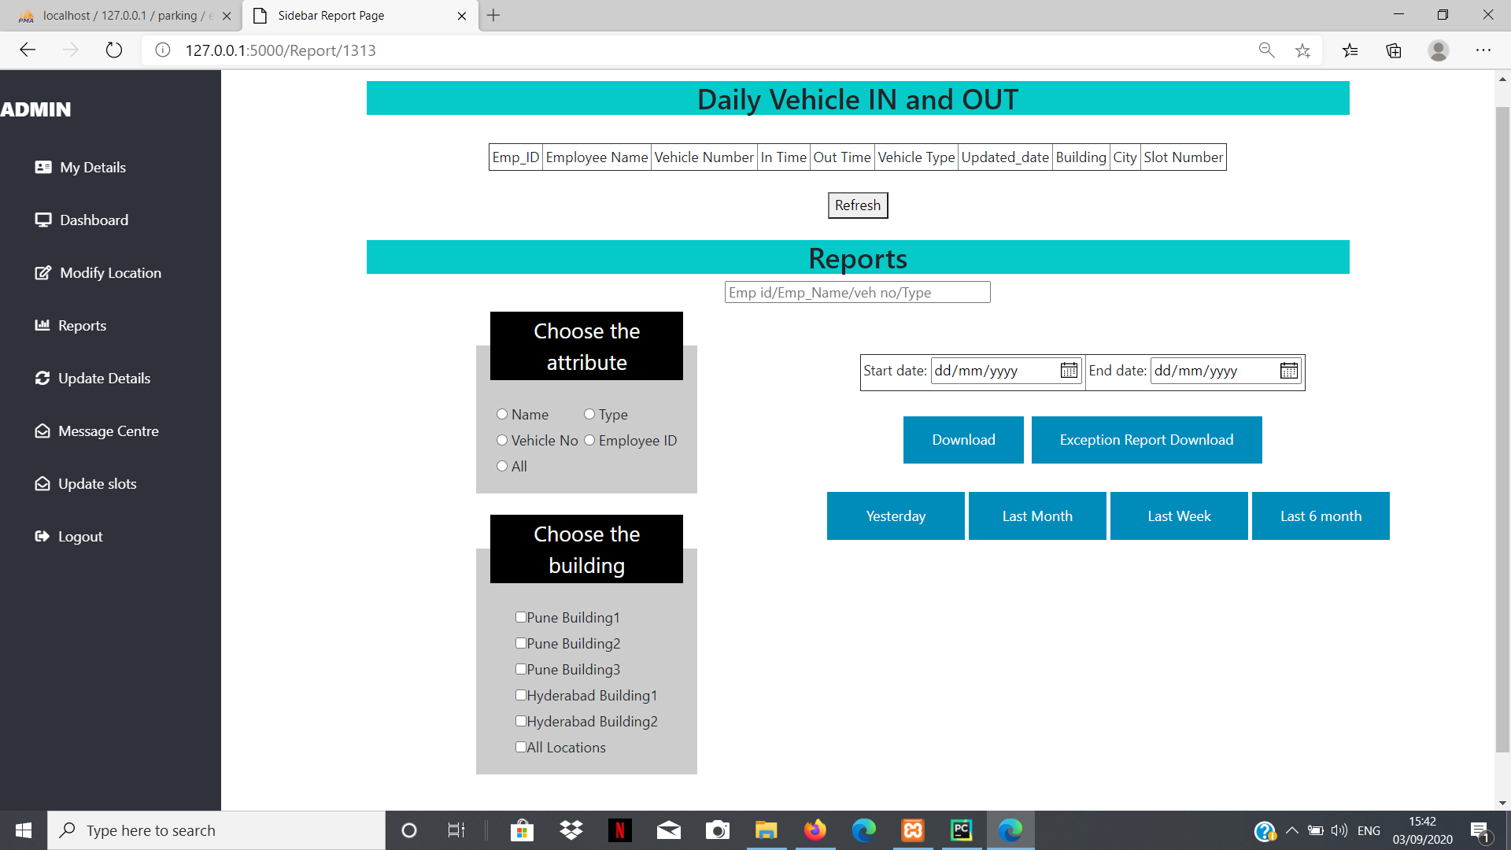

V)Update Details Page:This page show the list of Admin and any admin can add a new admin and remove the admin and we can search the details of the employee using last four digit of vehicle no.

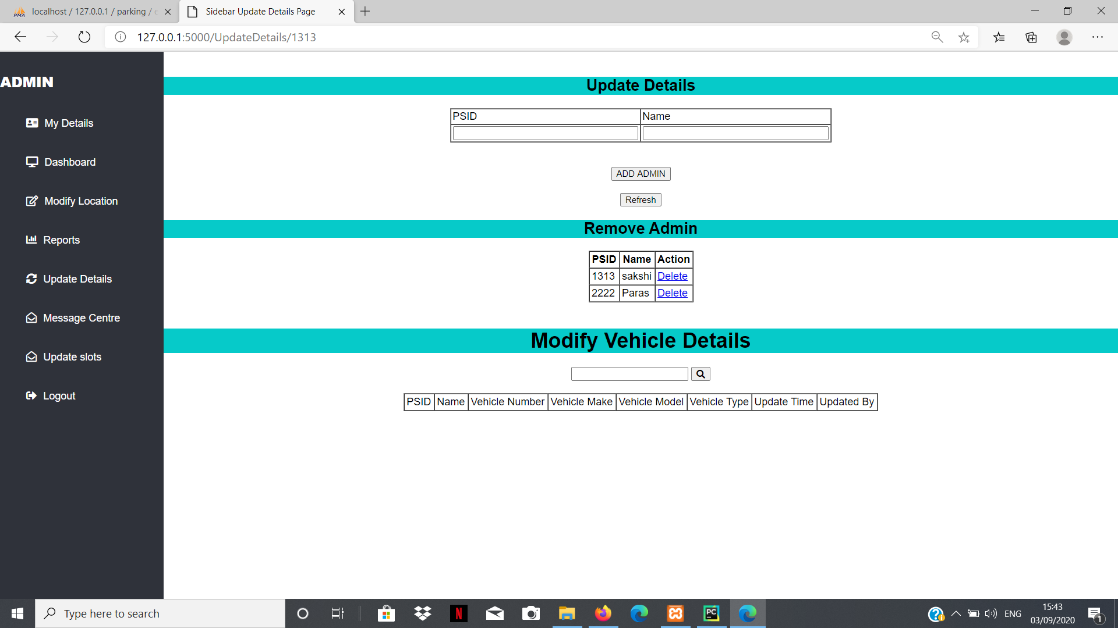

VI)Message Centre Page:It shows the details of all the messages and admin can add new messages with start and end (date and time).And aslo admin can send email to the employee.

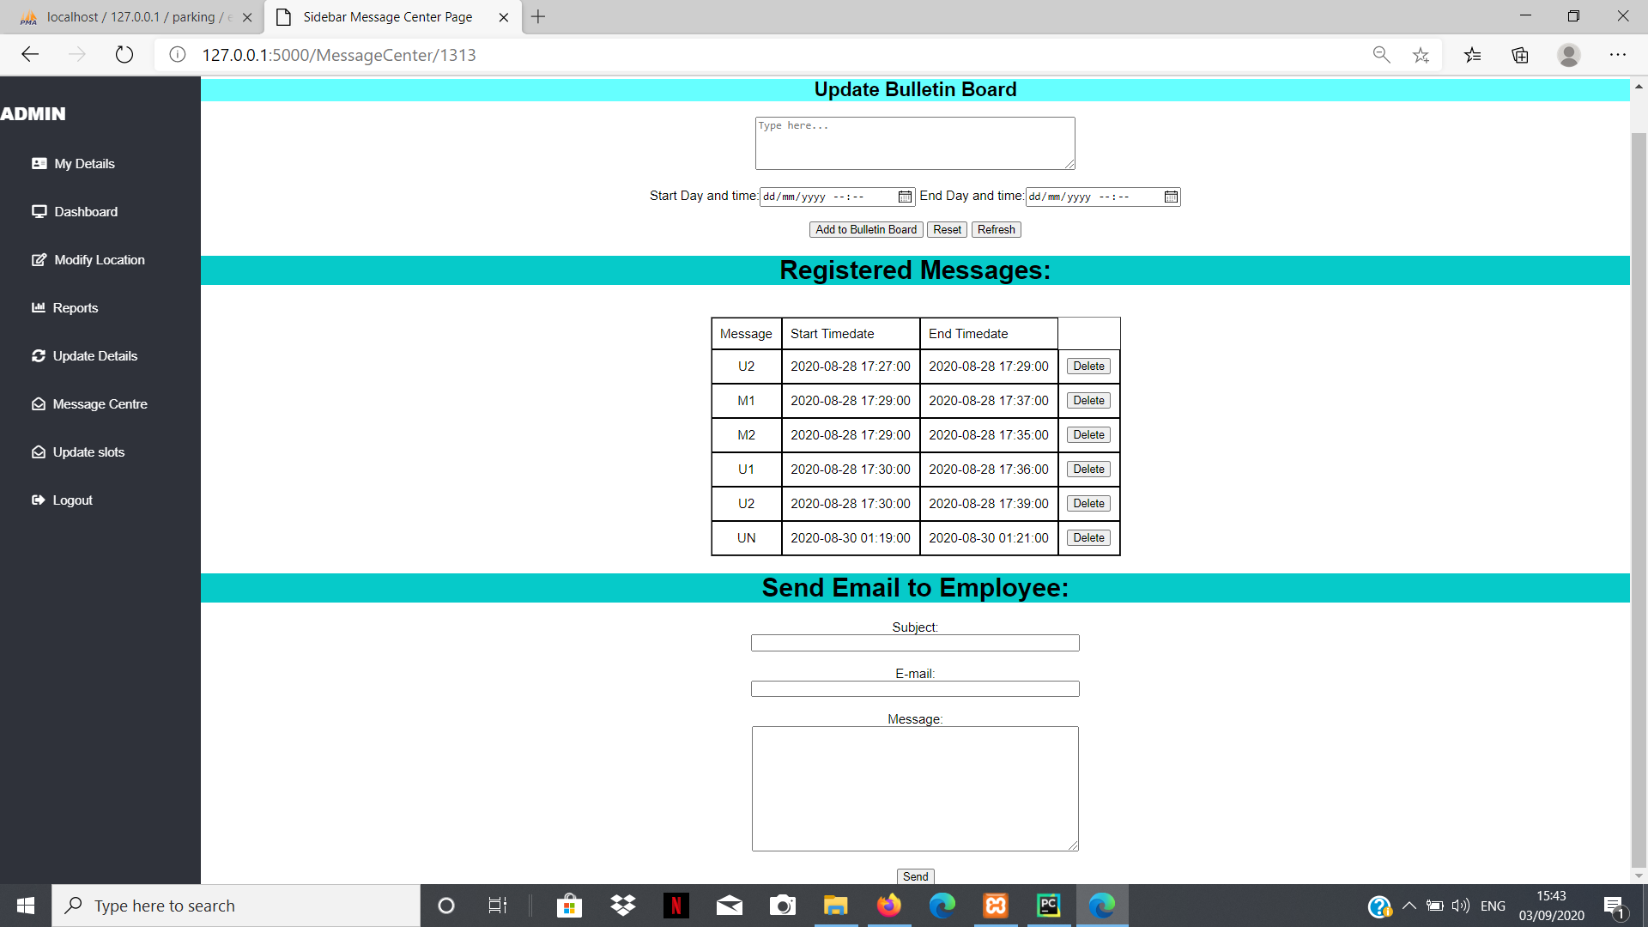

VII)Update Slot Page:This page shows all slots for each building and admin can modify existing slots and can also add new slots.

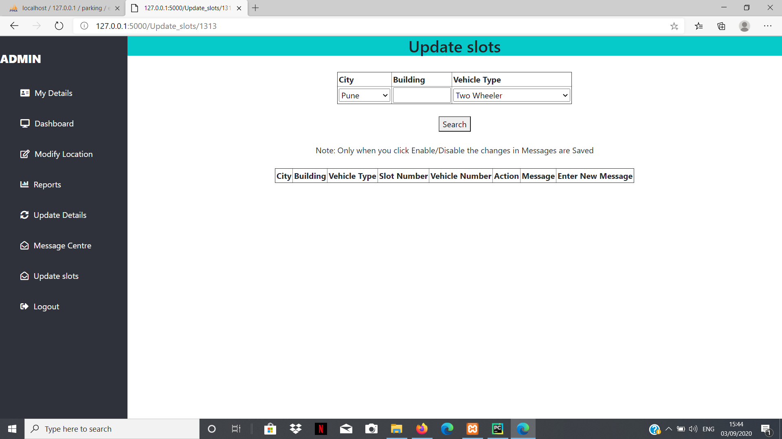

VIII)Logout: After clicking on logout it will again return on login page.

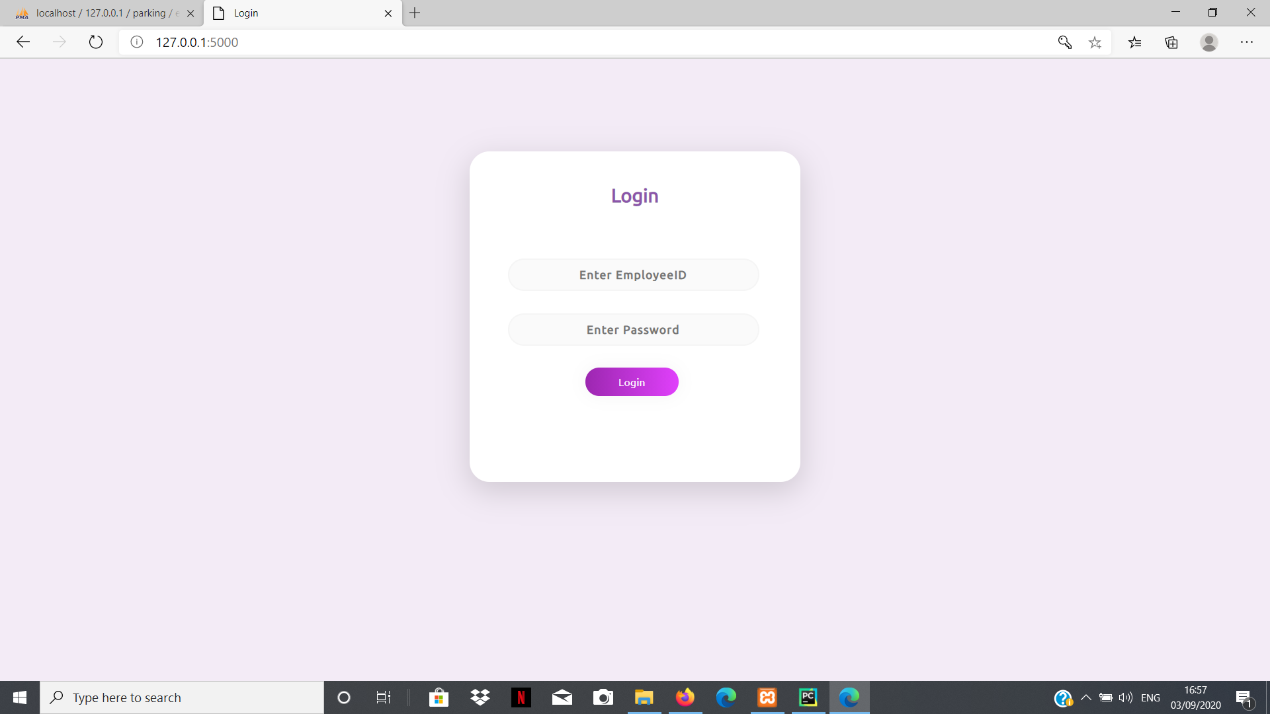

# 8.ER Diagram

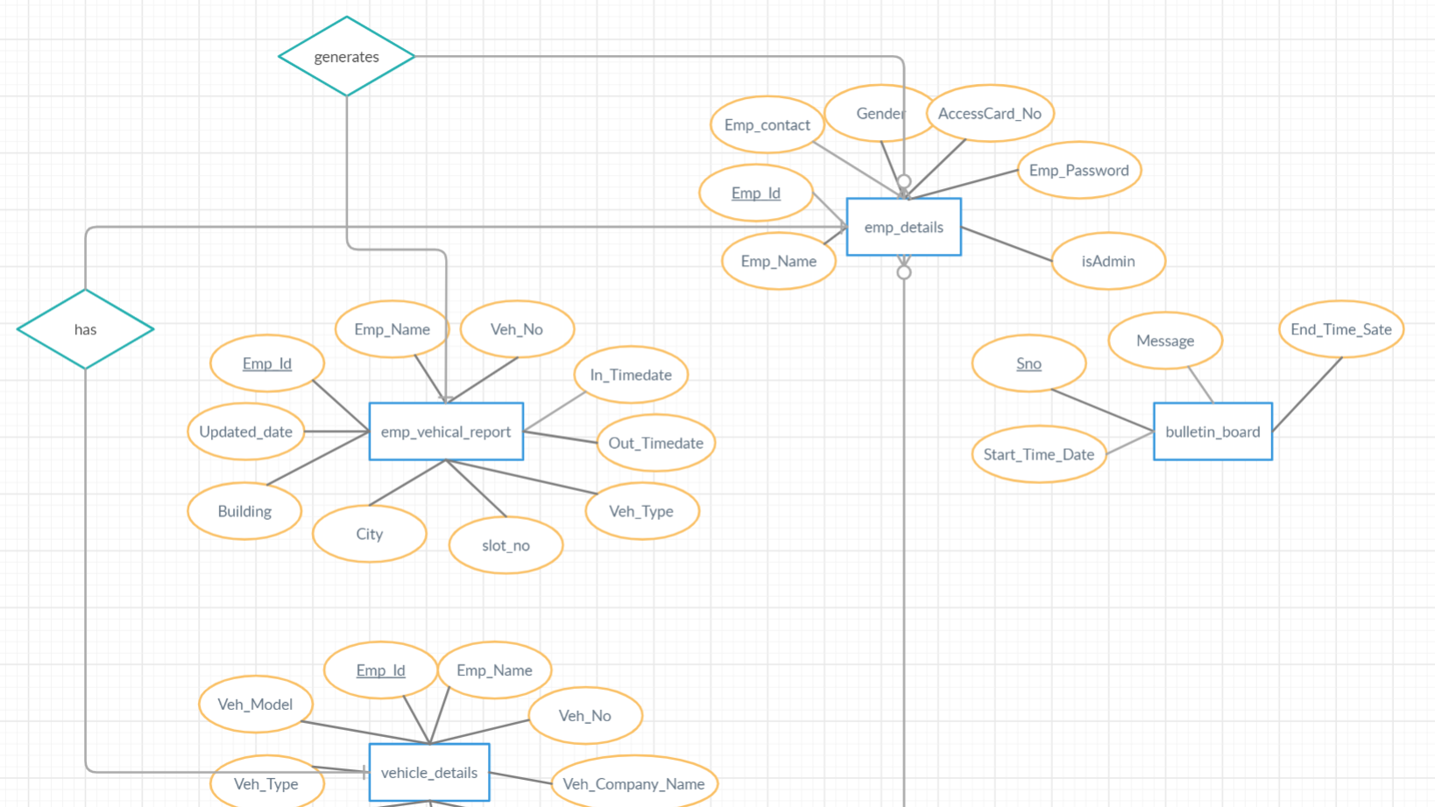

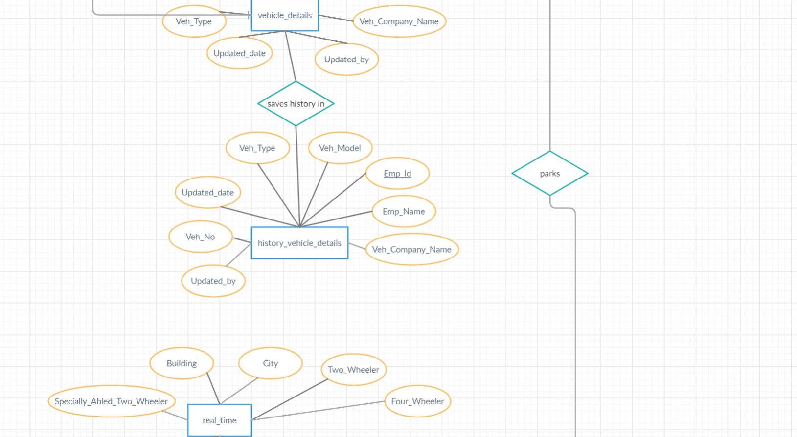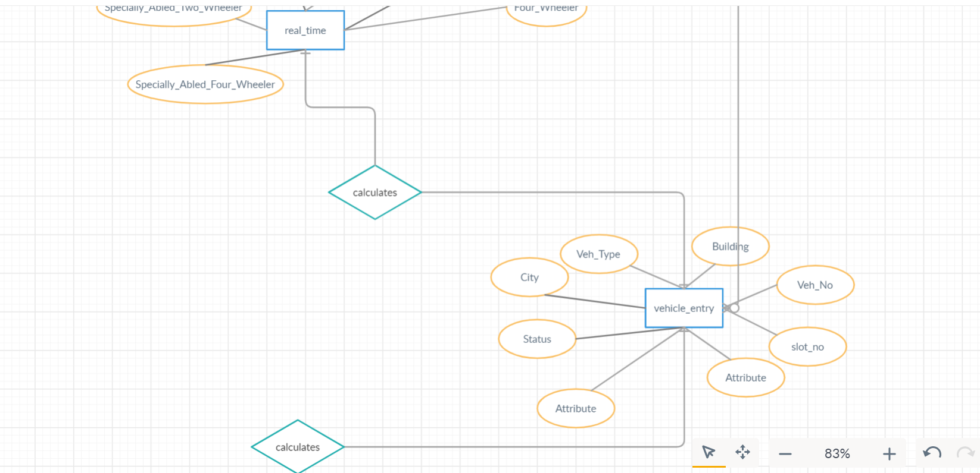

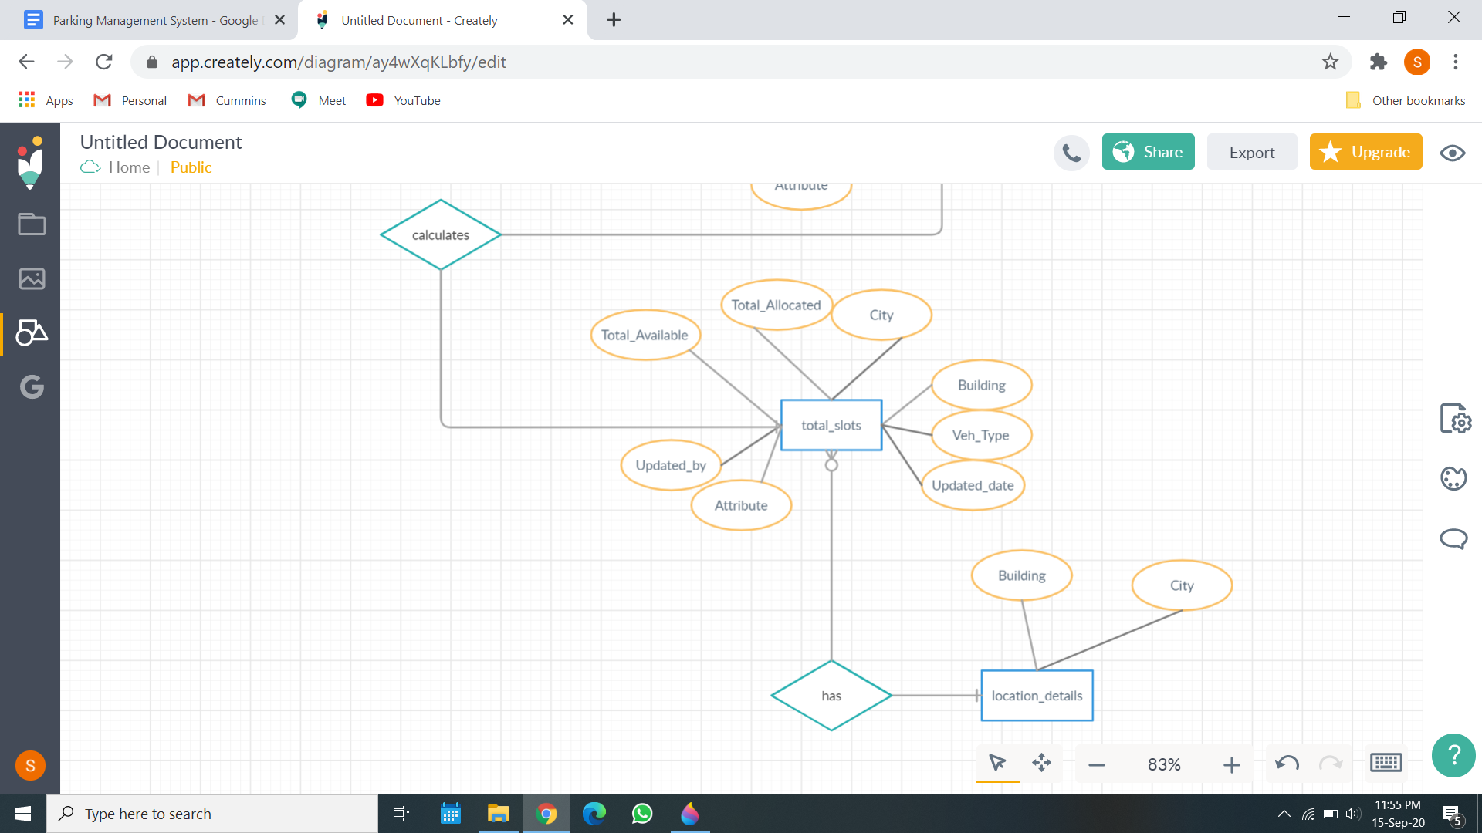

# 9.Conclusion

After doing study of the project it is found that systems can be introduced in HSBC and it will be beneficial for parking system management.The main benefits are time and fuel saving. It can also provide sustainable parking management in an eco-friendly manner. As the Greenhouse gases emission will be less in amount and the surroundings will be clean. There is less maintenance cost for this system so it helps the property developer in cost saving. It provides security to the parking ground. Our systems reduce the hassle in parking grounds.

Therefore we should introduce the system will beneifit in many ways.Also we can measure the carbon footprint if we use the system as we will have the data of all the vehicles coming into the premises so we can do the calculations to obtain it.