- What is bug In Software Testing?

Sol:When the expected and actual behavior is not matching, an incident needs to be raised. An incident may be a Bug. It is a programmer's fault where a programmer intended to implement a certain behavior, but the code fails to correctly conform to this behavior because of incorrect implementation in coding. It is also known as Defect.

- Differentiate Error, Defect, And Failure?
Sol:
Error-The incorrect human action that produces incorrect result is called an error or mistake.
Defect-A flaw in a component or system that can cause the component or system to fail to perform its required function.
Faliure-Deviation from expected behavior to actual behavior by end user in operations is failure.

- What Are The Different Types Of Status Of Defects?
Sol:
New: Tester provides new status while Reporting (for the first time)
Open: Developer / Dev lead /DTT opens the Defect
Rejected: Developer / Dev lead /DTT rejects if the defect is invalid or defect is duplicate.
Fixed: Developer provides fixed status after fixing the defect
Deferred: Developer provides this status due to time etc...
Closed: Tester provides closed status after performing confirmation Testing
Re-open: Tester Re-opens the defect with valid reasons and proofs

- Explain About Defect/Bug Life Cycle?
Sol:
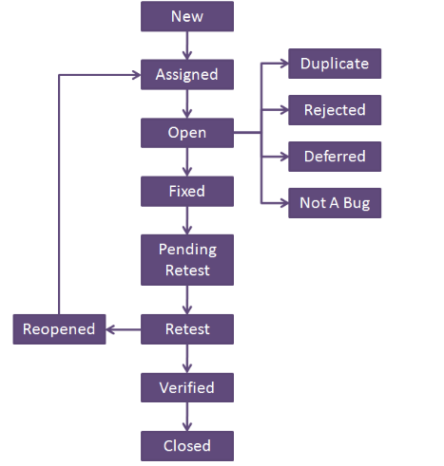

- A bug is identified by the tester it is assigned to whom?
Sol:Developer

- Why is JIRA used? Explain step by step how an issue is created in JIRA.
Sol: JIRA is a tool developed by Australian Company Atlassian. It is used for bug tracking, issue tracking, and project management.
Steps to create an issue in JIRA

- Click Create at the top of the screen to open the Create Issue dialog box.
- Select the relevant Project and Issue Type in the Create Issue dialog box.
- Type a Summary for the issue and complete any appropriate fields — at least the required ones that are marked by an asterisk.
If you want to access fields that are not shown in this dialog box, or you want to hide existing fields:
  - Click the Configure Fields button at the top right of the screen.
  - Click Custom and select the fields you want to show or hide by selecting or clearing the relevant check boxes respectively, or click All to show all fields.
When you next create an issue, these selected fields will be displayed.
- When you are satisfied with the content of your issue, click the Create button.

- What is Defect Density?
Sol:Defect Density is the number of confirmed defects detected in software/component during a defined period of development/operation divided by the size of the software/component.

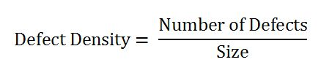

- What is the difference between defect density and defect triage?
Sol:Defect Density is the number of confirmed defects detected in software/component during a defined period of development/operation divided by the size of the software/component.

Defect triage is a process where each bug is prioritized based on its severity, frequency, risk, etc. Triage term is used in the Software testing / QA to define the severity and priority of new defects.

- Explain Bug reporting and parameters of bug?
Sol:
A bugs report or defects report is a list of bugs found out by testers while testing a software product in testing phase under a testing environment. The test environment is created at development site similar to the actual environment in which the software is supposed to work or run in live situation at customer site. Environment built for testing is supposed to be an independent entity meant only for testing team to perform testing without any development changes happening on it.

Parameters of a bug
- Defect Id- Id provided by testing team for the bug reported.
- Priority – business or development team can decide
- Severity – Testing team can decide
- Created by – Tester Name
- Created Date – Date of created defect
- Assigned to – Developer Name
- Resolved Date – This Date decided by developer
- Resolved By – Developer Name
- Status – New, IT Committed, Development, Ready for QA, In-Testing, Testing Successfully Completed.
- Project name – Current module or project Name
- Product name – Main Product Name
- Release Version (e.g. 1.2.3)
- Module – Module Name
- Detected Build Version – 1.1.1, 1.1.2

- What is defect management? Explain the defect management process.
Sol:
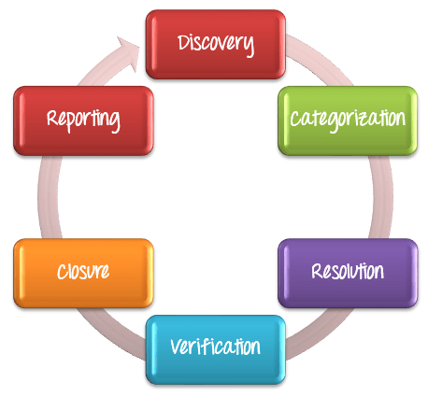

- Discovery:In the discovery phase, team have to discover as many defects as possible, before the Release/Go live of project. A defect is said to be discovered and change to status accepted when it is acknowledged and accepted by the developers.

- Categorization:
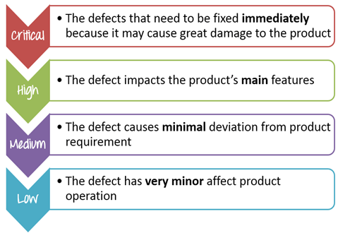

- Resolution:Once the defects are accepted and categorized they are fixed by the developer.
- Verification:After the development team fixed the reported issues, the testing team verifies them.
- Closure:Once a defect has been resolved and verified, the defect is closed.
- Reporting:Current defect situation is reported.

- What is Test estimation? Explain Work Breakdown Structure test estimation technique with an example?
Sol:
Test Estimation is a management activity which approximates how long a Task would take to complete.
Estimating effort for the test is one of the major and important tasks in Test Management.
Work Breakdown Structure (WBS)
- Divide the whole project task into subtasks
- Use the Work BreakDown structure to break out the project into 5 smaller tasks
- After that, you can break out each task to the subtask. The purpose of this activity is create task as detailed as possible.

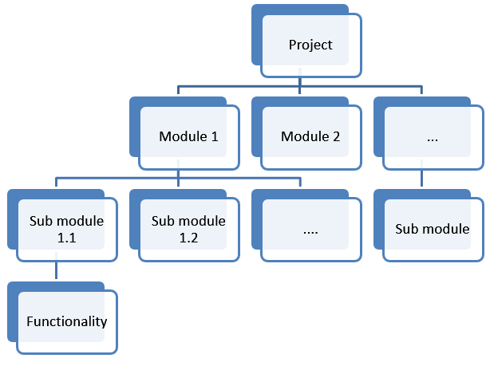

- What is test reports? What parameters are used in test reports?
Sol:
Test summary report /Quality Reports is a document which contains summary of test activities and final test results.
An assessment of how well the Testing is performed.Based on the test report, the stakeholders can Evaluate the quality of the tested product.
Parameters used in test reports are :
TestCase ID
TestCase Name
Actual result
Expected result
Status

- What are the test management tools?
Sol:
TestLink:
- Test-link is most widely used web based open source test management tool.
- It synchronizes both requirements specification and test specification together.
- User can create test project and document test cases using this tool.
- With Test-Link you can create an account for multiple users and assign different user roles.
JIRA
- Jira is a proprietary issue tracking product developed by Atlassian which allows bug tracking and agile project management.
- It is used for bug tracking, issue tracking, and project management.

- What is a test link? How do you write test cases in TestLink?
Sol:
- Test-link is most widely used web based open source test management tool.
- It synchronizes both requirements specification and test specification together.
- User can create test project and document test cases using this tool.
- With Test-Link you can create an account for multiple users and assign different user roles.

To write test cases in TestLink

Creating a Test Project
Click on the tab "create" to create a new project.
Enter all the required fields in the window like a category for a test project, name of the project, prefix, description, etc. After filling all necessary details, click on tab "Create" at the end of the window.

Creating a Test Plan
From the home-page, click on Test Plan Management from home-page
It will open another page, at the bottom of the page click on a tab "Create".
Fill out all the necessary information like name, description, create from existing test plan, etc. in the open window, and click on "create tab"

Build Creation
Click on Builds/Releases under Test Plan from the home page

Creating Testsuite
Click on test specification option from the home page.
On the right-hand side of the panel, click on the setting. It will display a series of test operation.
Click on the "create" tab for the test suite
Fill-up all the details for test-suite and click on save it tab.
- Enter the test suite name
- Enter the details about your test suite
- Click on save button to save the details of test-suite

Creating a Testcase
Click on the test suite folder on the left side of the panel under a folder tree structure.
Click on the setting icon in the right side panel. List of test case operations will be displayed on the right side panel.
New window will open, to create test cases click on create a button in test-case operations.

- Explain steps how to upload Test case sheet on TestLink?
Sol:Step 1 − To import test cases, go to Test Specifications → Test Specification from the dashboard.
Step 2 − Select the nearest test suite folders, where the test cases should be imported.
Step 3 − Click the Actions icon on the right pane.
It displays Test Case Operations.
Step 4 − Click the Import icon
Step 5 - Select the file and upload it.
Step 6 - Click the Upload file button.

- What is severity and priority in bug/defect?
Sol:Severity is defined as the degree of impact a Defect has on the development or operation of a component application being tested.
Higher effect on the system functionality will lead to the assignment of higher severity to the bug.
Priority is defined as the order in which a defect should be fixed.
Higher the priority the sooner the defect should be resolved.
Defects that leave the software system unusable are given higher priority over defects that cause a small functionality of the software to fail.

- While placing an order for clothing website, in order confirmation page there is a logo error. It is a?
  - a)High priority, high severity
  - b)Low severity low priority
  - c)Low severity, high priority (of low severity as it not going to affect the functionality of the website but can be of high priority as you don't want any further shipment to proceed with the wrong logo.)
  - d)High severity low priority
Sol: c

- Website home page failed to load.
  - a)High priority, high severity (Major functionality failure like log in is not working, crashes in the basic workflow of the software are the best example of High Priority and High Severity)
  - b) Low severity low priority
  - c) Low severity, high priority
  - d) High severity low priority
Sol: a

- The application works perfectly for 50k sessions but beings to crash after a higher number of sessions.
  - a)Low severity low priority
  - b)High priority, high severity
  - c)Low severity, high priority
  - d)High severity low priority (This problem needs to be fixed but not immediately.)
Sol: d

- An application (web) is made up of 20 pages. On one of the pages, there is a sentence with a grammatical error.
  - a)Low severity low priority - This bug may go unnoticed to the eyes of many and won't affect any functionality or the credibility of the company.
  - b)High priority, high severity
  - c) Low severity, high priority
  - d) High severity low priority
Sol: a
- Find bugs and report the same on JIRA for below-mentioned modules in the website: URL :http://www.rushplace.com/ Testwebsite1
  - 1.My Account
Sol:
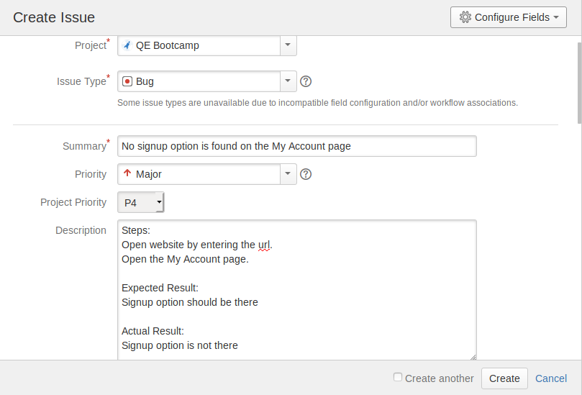
2. Add to basket
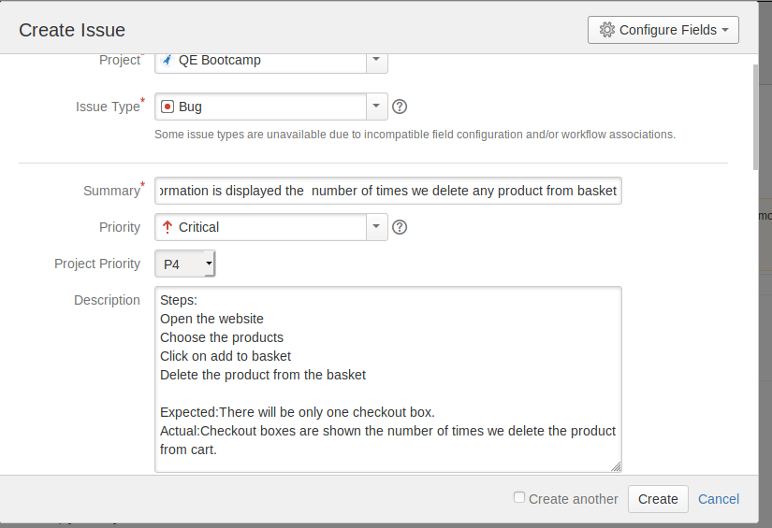

3.Search
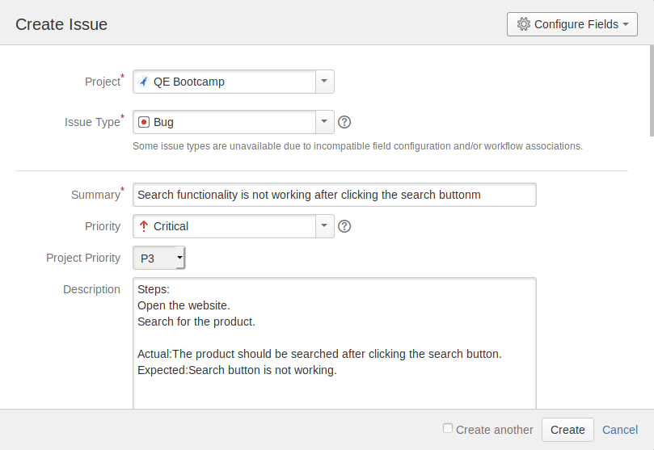
4.Homepage
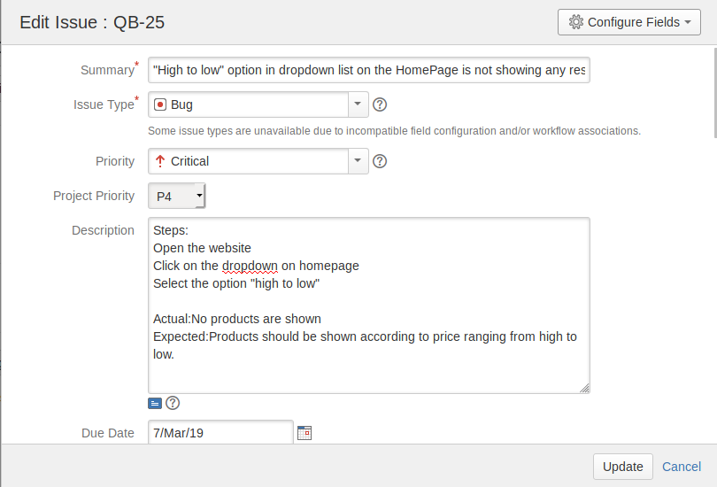
- Find bugs and report the same on JIRA for below-mentioned modules in the website: URL:http://newtours.demoaut.com/mercurywelcome.php :Testwebsite2 .
1.Register Here
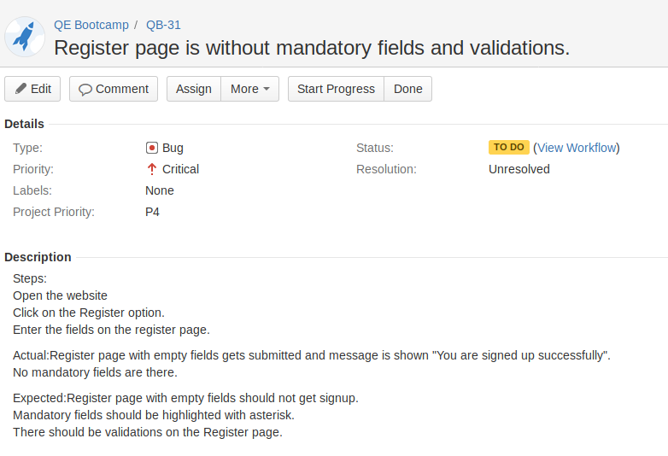
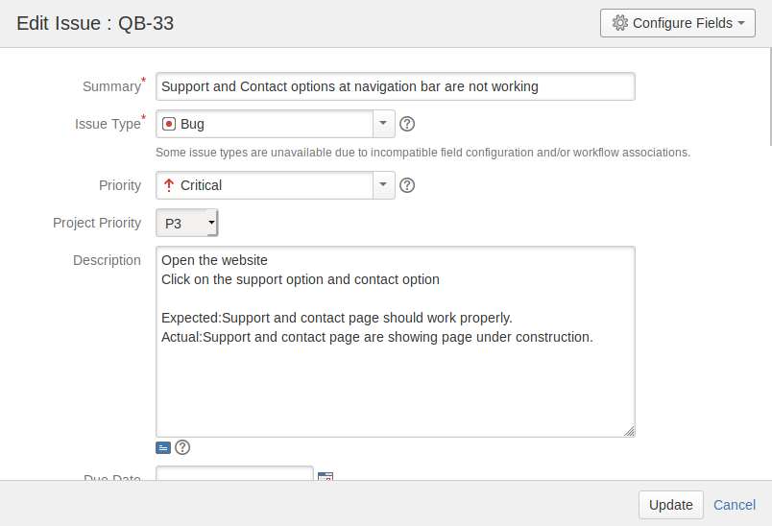
2.Top header navigation options

3.UI bugs for the complete website.
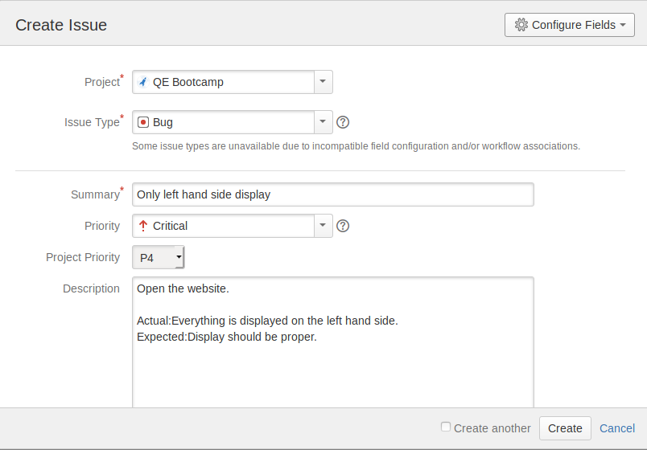
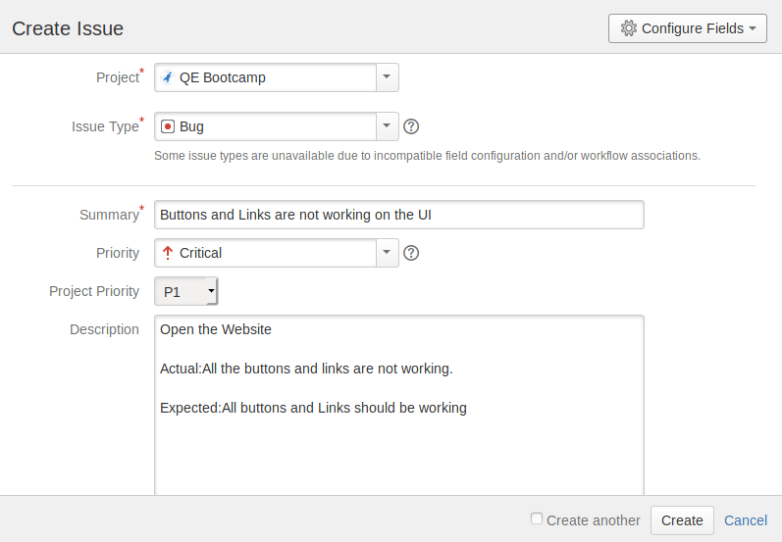

- Write Test Cases for Amazon login, Sign up and Forgot password on TestLink.
Sol:
Amazon login
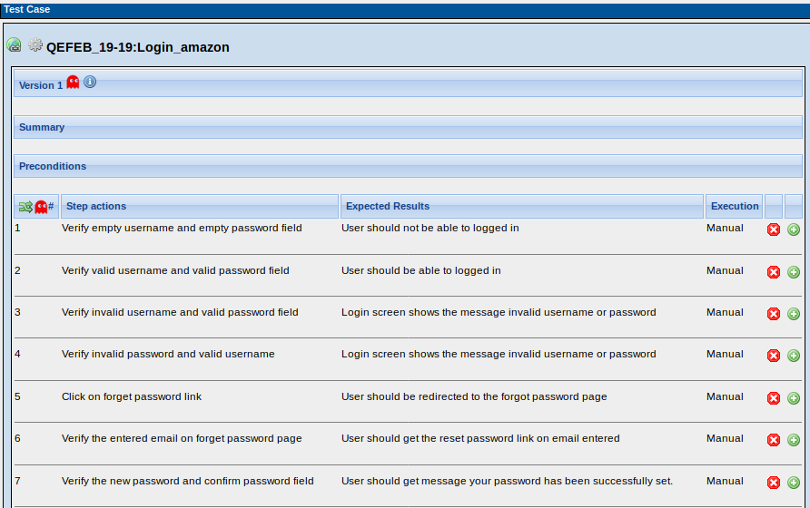
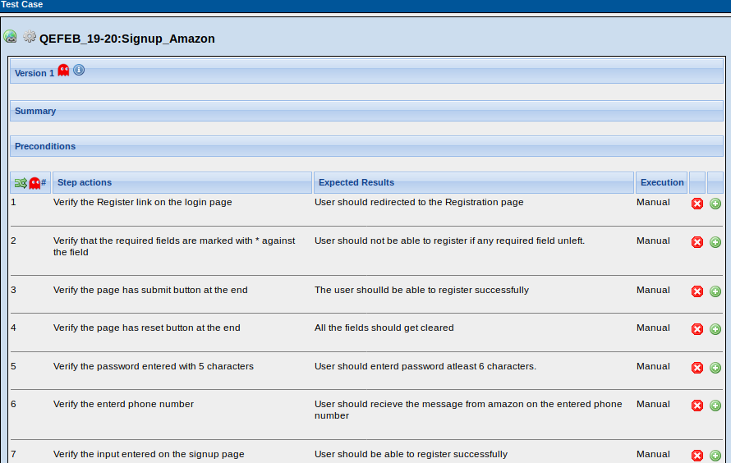
Signup

Forgot password

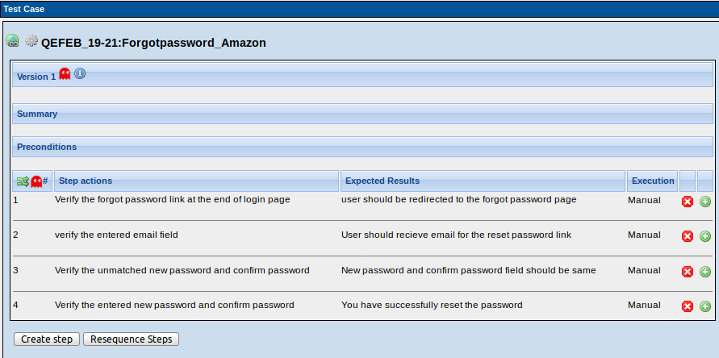

- Write Test Cases for placing an order in Myntra on TestLink.
Sol:
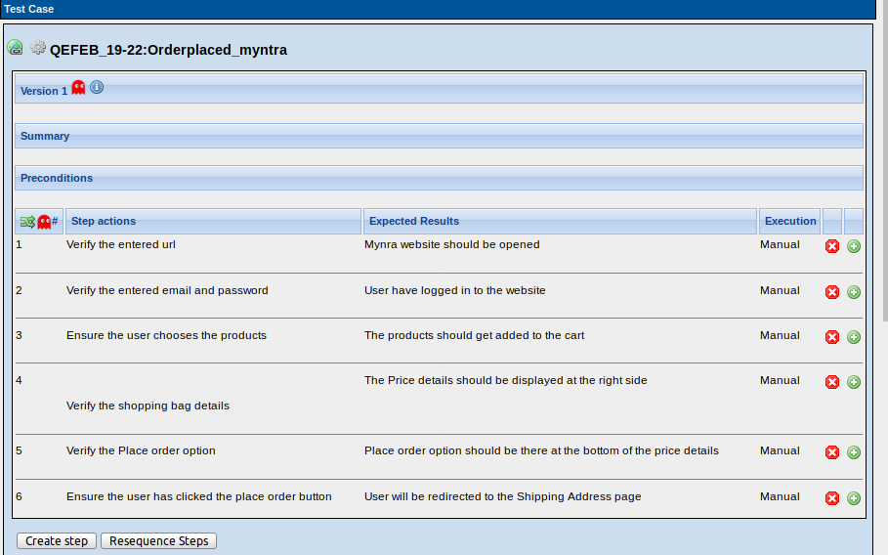

- Write Test Cases for Search functionality on TestLink.
Sol
