1. Difference between retesting and regression testing?

Sol:
Regression Testing | Retesting
Regression testing is a type of software testing that intends to ensure that changes like defect fixes or enhancements to the module or application have not affecting unchanged part. | Retesting is done to make sure that the tests cases which failed in last execution are passing after the defects against those failures are fixed.
In Regression testing, you can include the test cases which passed earlier. We can say that check the functionality which was working earlier. | In Retesting, you can include the test cases which failed earlier. We can say that check the functionality which was failed in earlier build.
Regression testing is not carried out on specific defect fixes. It is planned as specific area or full regression testing. | Retesting is carried out based on the defect fixes.
Defect verification is not comes under Regression testing. | Defect verification is comes under Retesting.
Regression test cases we use are derived from the functional specification, the user manuals, user tutorials, and defect reports in relation to corrected problems. | Test cases for Retesting cannot be prepared before start testing. In Retesting only re-execute the test cases failed in the prior execution.

2. Which of the one are part of functional testing -
a. UAT, Integration, Regression
b. Maintenance, Volume, Performance
c. Sanity, Localization, unit

Sol: c
3. System testing is done before integration testing – True/False

Sol:False

4. Confirmation testing is same as regression testing – True/False

Sol:False

5. Difference between static and dynamic testing.

Sol:
Static Testing | Dynamic Testing
Static Testing is white box testing which is done at early stage if development life cycle. It is more cost effective than dynamic testing | Dynamic Testing on the other hand is done at the later stage of development lifecycle.
Static testing has more statement coverage than dynamic testing in shorter time | Dynamic Testing has less statement stage because it is covers limited area of code
It is done before code deployment | It is done after code deployment
Static testing gives assessment of code as well as documentation. | Dynamic Testing gives bottlenecks of the software system.
It is performed in Verification Stage | It is done in Validation Stage

6. Difference between SDLC &amp; STLC
Sol:

Features | SDLC | STLC
Origin | Development Life Cycle | Testing Life Cycle
Relationship | It is taken as the predecessor | It is defined as the successor
Definition | It includes the development of software including testing and other phases. | It is related to the testing of a software project.
Requirement Gathering | BA will gather requirements and developer will perform the development. | Here, the testing team will check the software from the functional or non-functional point of view.
Testing | Here, the code is tested by peer developers. Here, unit testing, integration testing, and system testing are performed together. | Here, testing and reporting work is done together. Keep in mind unlike code testing, here functional or non-functional behavior is tested.

7. List 3 advantage/disadvantage of Waterfall model.

Sol:
Advantages:
- Process and results are well documented.
- Works well for smaller projects where requirements are very well understood.
- Simple and easy to understand and use.

Disadvantages:
- Cannot accommodate changing requirements.
- Not a good model for complex and object-oriented projects.
- Not suitable for the projects where requirements are at a moderate to high risk of changing. So, risk and uncertainty is high with this process model.

8. What do you understand by the term Functional testing?

Sol:

Functional testing is a kind of black box testing that is performed to confirm that the functionality of an application or system is behaving as expected.It is done to verify all the functionality of an application.
Manual Testing or automation tools can be used for functional testing.
Examples of Functional testing are
- Unit Testing
- Smoke Testing
- Sanity Testing
- Integration Testing
- Black Box testing
- User Acceptance testing
Functional Testing process
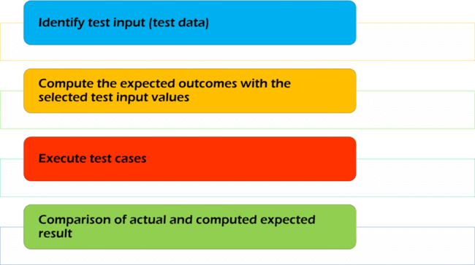

9. Is it true that we can do system testing at any stage?

Sol:No,it is not true.System testing is always done after integration testing.

10. List down difference between validation and verification processes

Sol:

Verification | Validation
Verification is a static practice of verifying documents, design, code and program. | Validation is a dynamic mechanism of validating and testing the actual product.
Verification uses methods like inspections, reviews, walkthroughs, and Desk-checking etc. | Validation uses methods like black box (functional) testing, gray box testing, and white box (structural) testing etc.
Verification is to check whether the software conforms to specifications. | Validation is to check whether software meets the customer expectations and requirements.
Verification is done by QA team to ensure that the software is as per the specifications in the SRS document. | Validation is carried out with the involvement of testing team.
It generally comes first-done before validation. | It generally follows after verification.

11. What are stubs and drivers

Sol:
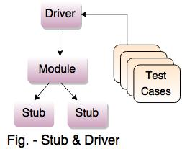
Stubs and drivers both are dummy modules.They are created for test purposes.

Stubs are used in top down testing approach, when you have the major module ready to test, but the sub modules are still not ready yet. So in a simple language stubs are "called" programs, which are called in to test the major module's functionality.

Drivers are the ones, which are the "calling" programs. Drivers are used in bottom up testing approach. Drivers are dummy code, which is used when the sub modules are ready but the main module is still not ready.

For eg. suppose you have three different modules : Login, Home, User. Suppose login module is ready for test, but the two minor modules Home and User, which are called by Login module are not ready yet for testing.At this time, we write a piece of dummy code, which simulates the called methods of Home and User. These dummy pieces of code are the stubs.
On the other hand, the User and Home modules are ready, but the Login module is not ready to test. Now since Home and User return values from Login module, so we write a dummy piece of code, which simulates the Login module. This dummy code is then called Driver.

12. Final product or the software cannot be released without passing through the
STLC process - True/False

Sol:True

13. Choose the correct one
a. Testing should start after development
b. Testing should start as early as possible in software cycle
c. Exhaustive testing is proof of delivering correct product
d. Testing is context independent

Sol:b

14. Maintenance testing deals with retesting to show that the rest of the system has
not been affected by the maintenance work – True/False

Sol:False

15. Maintenance testing deals with regression testing to show that the rest of the
system has not been affected by the maintenance work – True/False

Sol:True

16. Unit testing is performed by developers - True/False

Sol:True

17. In V model testing activities are carried out in parallel with development activities
- True/False

Sol:True

18. Static testing include –
a. Inspection, regression, unit testing
b. Retesting, system, End user
c. Review, inspection, Walkthrough
d. Review, inspection, acceptance

Sol: c

19. Acceptance testing is most often focused on a validation type of testing -
True/False

Sol:

20. Integration testing focuses on testing different modules all together - True/False

Sol: True

