- Create Database
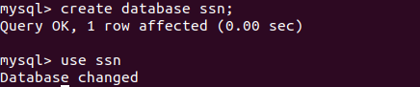
OUTPUT :

- Design Schema
OUTPUT :

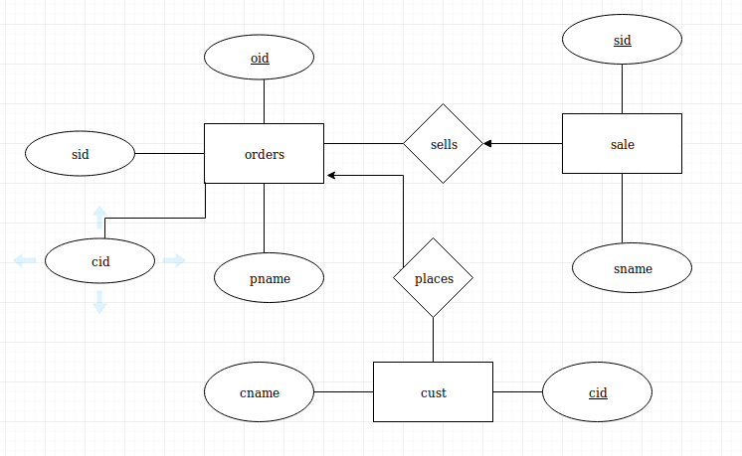

- Create tables
OUTPUT:

- Insert sample data
OUTPUT:
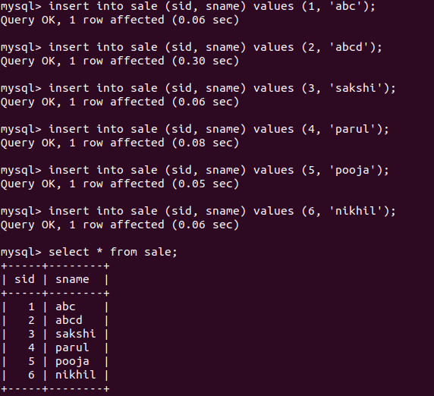

- Find the sales person have multiple orders.
OUTPUT:

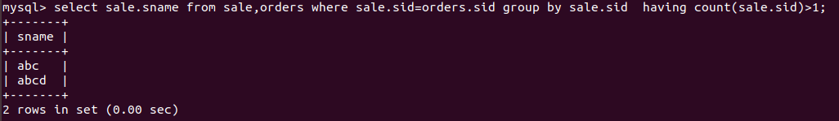

- Find the all sales person details along with order details
OUTPUT:

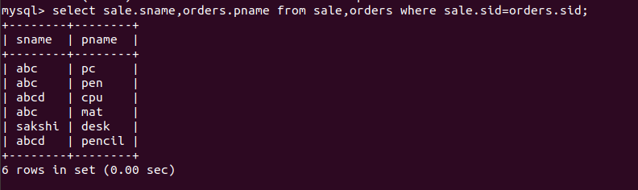
- Create index

OUTPUT:
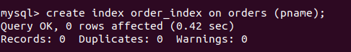

- How to show index on a table

OUTPUT:
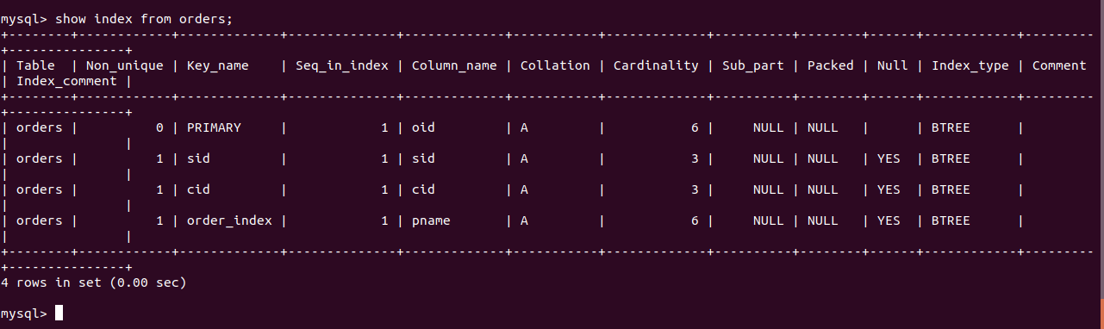

- Find the order number, sale person name, along with the customer to whom that order belongs to
OUTPUT:
