**Movie Ticket Booking System-PHP**

The Movie Ticket Booking System facilitates the users to enquire about the recent movies available movies, booking, and cancellation of movie tickets according to theatre type and class type, enquire about the status of the booked tickets, etc. The aim of this project is to design a website that gives an easy platform for people to get details of trending films and to get movie tickets in the easiest possible way making it simple for all to buy tickets from anytime and anywhere.

**Technologies used:**

* PHP
* HTML
* CSS
* Javascript
* DataBase(Mysql)

**Installation:**

For This Project I used [Xampp](https://www.apachefriends.org/).

1) Open PHPMyAdmin

2) import 'dbmovies.sql'

3) Open Connection.php and update db_name and password.

4) Go to admin Folder and Open config.php and update db_name and password.

**Objectives for a Movie Ticket Booking System**

**Customer can:**

1. Sign up / log in to their account.
2. Search for movies by:
   * Title
   * Genre
   * Language
   * Release date
3. View detailed information about movies, including:
   * Synopsis
   * Cast and crew
   * Show timings
4. Book tickets for a specific showtime, selecting:
   * Number of seats
   * Seat type (e.g., regular, premium, balcony).
5. View their booking history, filtering by:
   * Upcoming bookings
   * Past bookings
   * All bookings
6. Cancel bookings within a specified cancellation period.
7. Check ticket prices before booking.

**Admin can:**

1. Log in to the admin dashboard.
2. Manage movies:
   * Add, update, or delete movies.
   * Filter movies by genre, language, or release date.
3. Manage showtimes:
   * Add, update, or delete showtimes.
   * Assign movies to specific screens and time slots.
4. Manage bookings:
   * View all bookings.
   * Search bookings by customer ID or movie title.
   * Filter bookings by:
     + Movie
     + Show date/time
     + Booking status (e.g., confirmed, canceled).
5. Manage customers:
   * Add, search, modify, or delete customer profiles.
   * Filter customers by membership level (e.g., regular, premium).
   * View all bookings and cancellations associated with a customer.
6. Set and manage ticket pricing:
   * Define prices based on seat type and screen type.
   * Adjust prices dynamically based on demand or time.
7. Generate reports:
   * Daily/weekly revenue reports.
   * Booking trends by genre, language, or customer demographics.
   * Cancellations and refund analysis.

**UI Design for the Movie Ticket Booking System:**

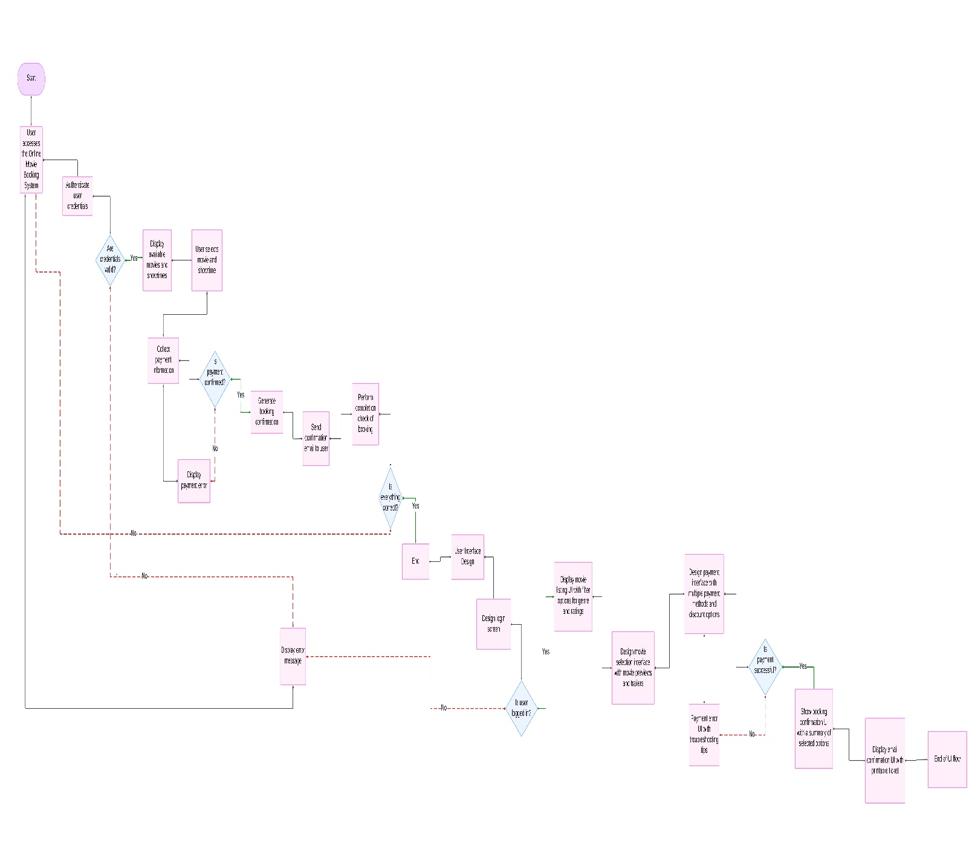

**ER Diagram for Database:**

