WEEK 2 SYSTEM ARCHITECTURE DESIGN
E-Seva Connect – Integrated Citizen Digital Services Platform
Prepared by: Sakshi Jha
Week 2 Deliverable
Estimated effort: 34 hours
Date: 04 October 2026

1. Introduction
This document translates the Week 1 requirements of E-Seva Connect into a detailed system architecture for a citizen-centric e-governance platform. The proposed architecture supports service discovery, eligibility guidance, secure authentication, online applications, document submission, application tracking, grievances, notifications and administration.
The design favors a modular three-tier architecture with clear business boundaries. This keeps the first implementation practical for a student team while preserving a path toward independent services, cloud scaling and authorized government integrations.

2. Architecture Objectives
- Align every major architectural component with Week 1 requirements.
- Protect citizen data through authentication, authorization, encryption, validation and audit logging.
- Provide responsive, accessible and multilingual-ready user interfaces.
- Support reliable application workflows and transparent status tracking.
- Keep the API layer stateless so application capacity can scale horizontally.
- Isolate external integrations behind adapters.
- Use technologies that are practical, maintainable and suitable for future production hardening.

3. Week 1 Requirements Summary
Requirement | Architectural Response
Authentication / RBAC | Auth module, secure sessions/tokens, server-side permission checks.
Service discovery | Searchable service catalogue and indexed service metadata.
Applications | Application workflow module with validation and status state machine.
Documents | Secure object storage plus file type/size validation.
Tracking | Reference numbers and immutable status history.
Grievances | Separate grievance workflow, assignment and resolution history.
Notifications | Notification service with in-app/email/SMS adapters.
Security / privacy | TLS, least privilege, audit logs, data minimization and retention controls.
Accessibility | Semantic UI, keyboard support, contrast, scalable text and localization.
Performance / scalability | Stateless API containers, indexes, caching and load balancing.

4. System Context
The system context identifies citizens and staff as primary actors and government/service, notification, document and identity providers as external systems. External dependencies are isolated behind controlled integration interfaces.
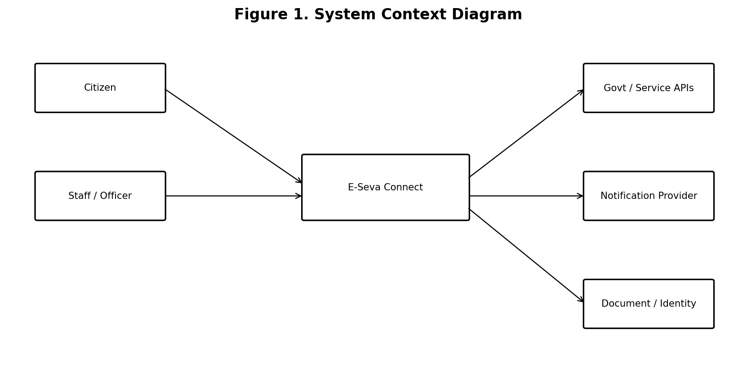
Figure 1. System Context Diagram

5. Architectural Style

5.1 Modular Three-Tier Architecture
The presentation, application and data/integration layers separate user experience from business rules and infrastructure. Within the application layer, modules are organized by business capability.
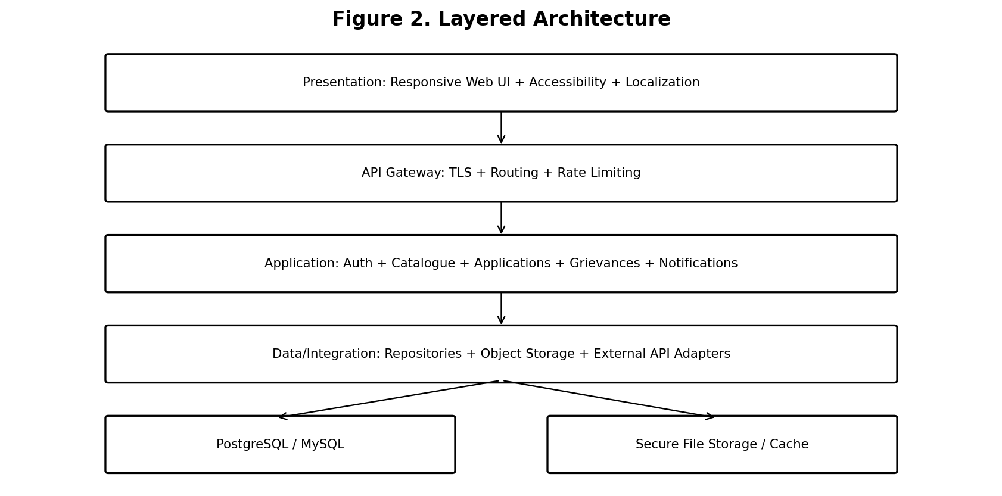
Figure 2. Layered Architecture

5.2 Why a Modular Monolith First?
- Simpler development, testing and deployment for a small team.
- Avoids premature distributed-system complexity.
- Database transactions are easier to manage.
- Module boundaries remain clear, allowing later extraction into services.
- Notification and integration workloads can be separated first if scale requires it.

6. Major Components
Component | Main Responsibility
Responsive Web UI | Citizen portal, staff dashboard, accessibility and localization.
API Gateway / Reverse Proxy | TLS, routing, rate limiting and request filtering.
Authentication / RBAC | Registration, login, sessions/tokens, roles and permissions.
Service Catalogue | Services, categories, eligibility, documents, fees and search.
Application Service | Drafts, validation, submission, reference numbers and status transitions.
Document Service | Secure upload, metadata, authorization and object storage.
Grievance Service | Complaint creation, assignment, status and resolution.
Notification Service | Templates, delivery events and provider adapters.
Admin Module | Service management, users, roles and configuration.
Audit / Reporting | Security events, administrative history and statistics.
Database | Transactional relational data.
External Integration Layer | Government, identity, payment, document and notification APIs.

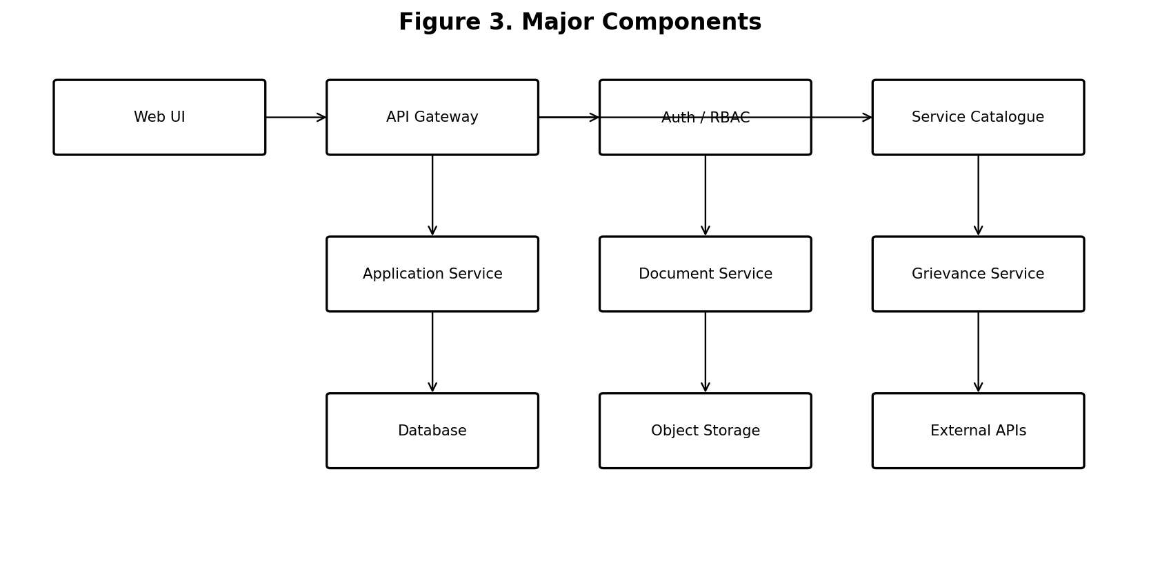
Figure 3. Major Components and Interactions

7. Application Workflow
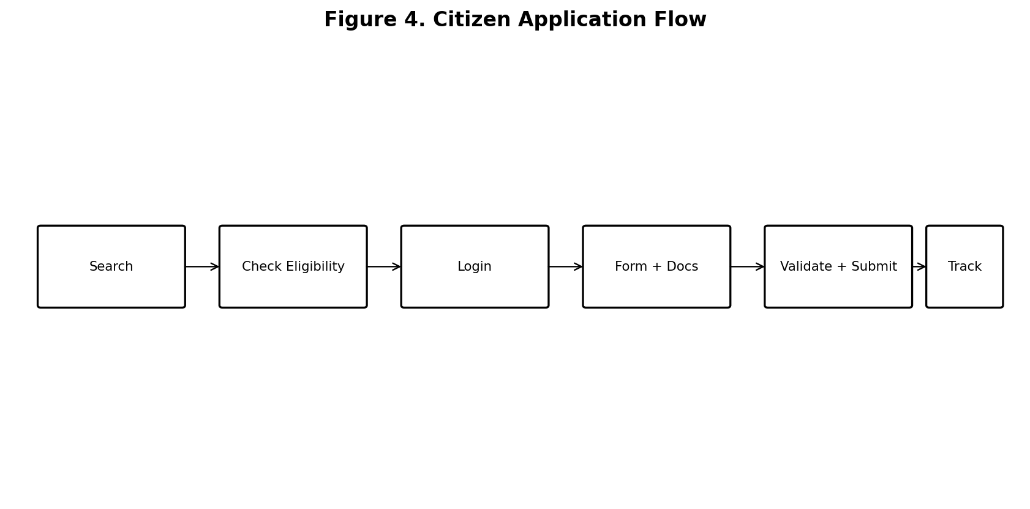
Figure 4. Citizen Application Flow
The workflow minimizes incomplete submissions by presenting eligibility and requirements before the form begins. Validation occurs at both the UI and server/API layers. A successful submission creates the application and initial status history consistently before returning the reference number.

8. Data Architecture
Entity | Purpose
User | Identity, contact, role and account status.
Service | Service metadata, department, category, eligibility and SLA information.
Application | Citizen transaction, reference number, service and current status.
ApplicationDocument | Uploaded document metadata and verification state.
StatusHistory | Complete application status transition history.
Grievance | Citizen complaint, category, assignment and resolution state.
Notification | Delivery channel, message status and timestamp.
AuditLog | Actor, action, resource and timestamp for sensitive events.

PostgreSQL is recommended because the domain has strong relationships and transactional consistency requirements. Indexes should support reference-number lookup, citizen dashboards, service search, status filters and date-based reporting.

9. API Architecture
API Area | Example Endpoints | Access
Auth | POST /auth/register, POST /auth/login, POST /auth/logout | Public / authenticated
Services | GET /services, GET /services/{id} | Public
Applications | POST /applications, GET /applications/{id}, PATCH /applications/{id} | Citizen / Operator
Documents | POST /applications/{id}/documents, GET /documents/{id} | Authorized users
Grievances | POST /grievances, GET /grievances/{id}, PATCH /grievances/{id} | Citizen / Officer
Notifications | GET /notifications, PATCH /notifications/{id}/read | Authenticated
Admin | POST/PATCH /admin/services and role/user operations | Administrator
Reports | GET /reports/applications, GET /reports/grievances | Authorized staff

The API should use consistent HTTP status codes, structured validation errors, request/correlation IDs and pagination for large collections.

10. Technology Stack
Layer | Technology | Reason
Frontend | React + TypeScript | Reusable components, type safety and responsive UI.
Backend | Java + Spring Boot | Mature REST, validation and security ecosystem; aligns with Java development skills.
Database | PostgreSQL | Relational consistency, constraints, indexes and transactions.
ORM | Spring Data JPA / Hibernate | Efficient persistence mapping and maintainable repository code.
Security | Spring Security | Authentication and authorization integration.
API Contract | OpenAPI / Swagger | Clear, testable API documentation.
File Storage | S3-compatible object storage | Separates large documents from transactional data.
Cache | Redis (optional) | Useful for frequently accessed low-risk catalogue data.
Containers | Docker | Consistent development and deployment environments.
Proxy | Nginx / cloud load balancer | TLS, routing and traffic distribution.
CI/CD | GitHub Actions | Automated build, test and deployment workflow.
Testing | JUnit, Spring Boot Test, Postman/Newman | Unit, integration and API testing.

10.1 Technology Selection Justification
Java and Spring Boot are appropriate for an enterprise-style e-governance application because they provide mature security, validation, database and REST capabilities. PostgreSQL matches the relational workflow domain. React supports component-based responsive interfaces, while Docker and GitHub Actions improve deployment consistency and automation.

11. Security Architecture
- HTTPS/TLS for client and API communication.
- Adaptive password hashing; never store plaintext passwords.
- Server-side RBAC on every protected operation.
- MFA-ready design for privileged accounts.
- Rate limiting for authentication and high-risk endpoints.
- Server-side validation, output encoding and protection against common injection/XSS risks.
- CSRF protection where cookie-based authentication is used.
- File upload allowlists, size limits, isolated storage and malware scanning where available.
- Least-privilege database and service credentials.
- Audit logging for authentication, administrative and workflow-sensitive actions.
- Secrets kept outside source control.
- Encrypted backups and tested restoration procedures.

12. Deployment and Scalability
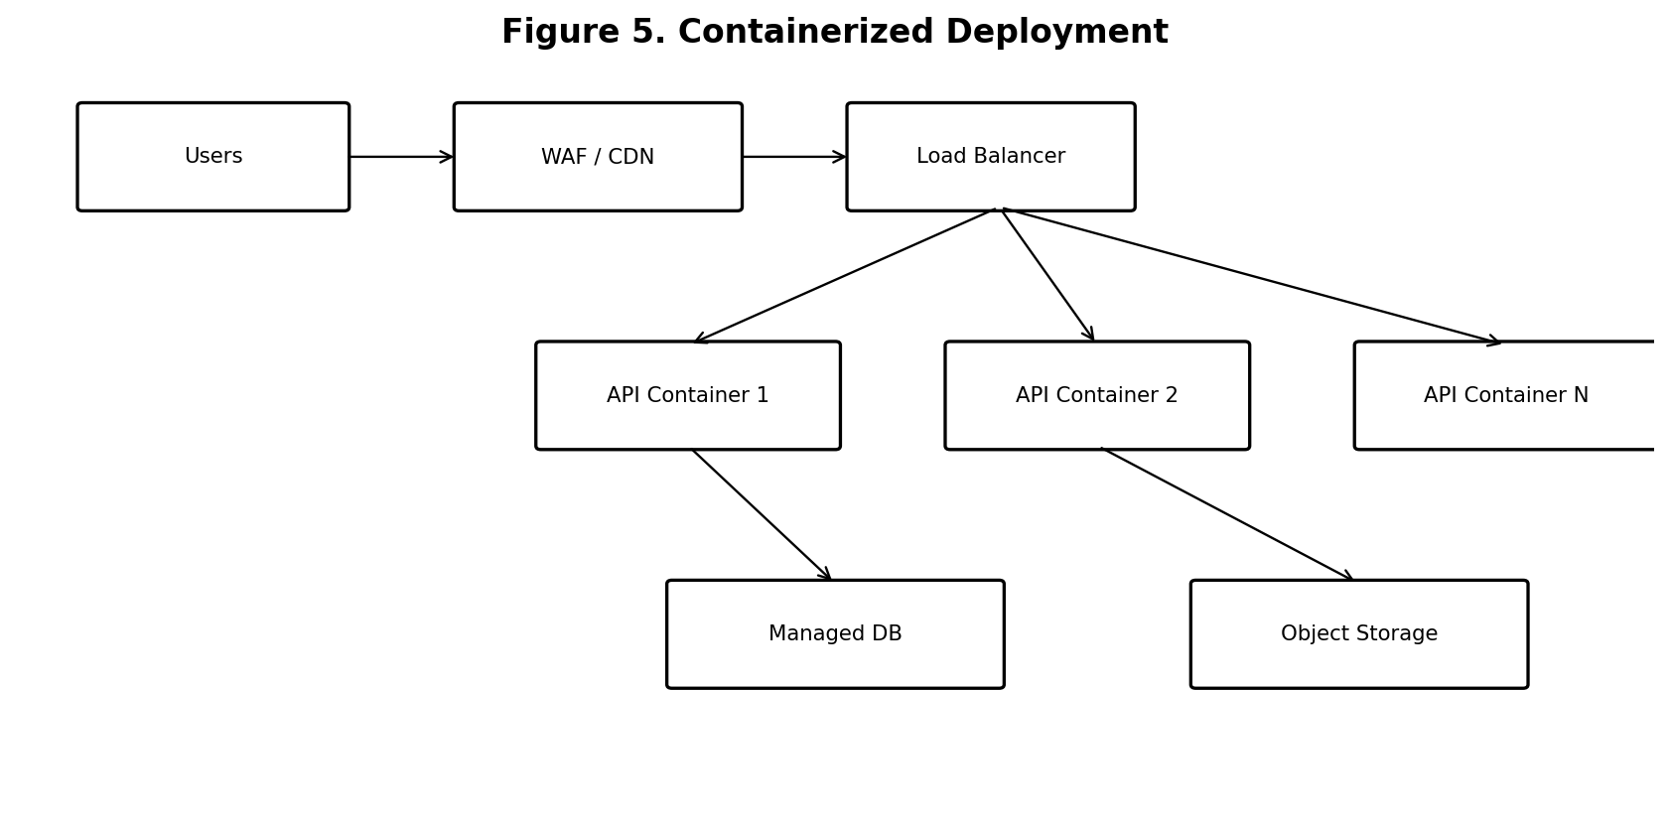
Figure 5. Containerized Cloud Deployment Concept
Application containers are placed behind a load balancer. Persistent state remains in the managed relational database and object storage. Because the API layer is stateless, additional instances can be added during higher demand.
- Development: Docker Compose can run frontend, backend, database and supporting services locally.
- Production: managed container or Kubernetes-style infrastructure can be considered when scale justifies it.
- Use health checks and rolling deployments to reduce downtime.
- Use caching for safe, frequently accessed catalogue data.
- Move high-volume notifications to asynchronous workers/queues.
- Use object storage for documents rather than database blobs.
- Monitor latency, errors, CPU, memory, database load and queue depth.

13. Availability, Backup and Disaster Recovery
- Automated database backups according to the production retention policy.
- At least one recoverable backup independent of the primary environment.
- Periodic restore testing.
- Health checks and automatic removal of unhealthy instances.
- Define RTO and RPO with stakeholders before production.
- Graceful degradation when non-critical notification/integration providers are unavailable.
- Version-controlled infrastructure and deployment configuration.

14. Accessibility Architecture
- Semantic HTML and accessible components.
- Keyboard navigation and visible focus.
- Associated form labels and meaningful validation errors.
- Sufficient contrast and status indicators that do not depend only on color.
- Text resizing and responsive layouts.
- Screen-reader compatible structure.
- Simple instructions and understandable error messages.
- Externalized UI strings for multilingual expansion.
- Accessibility checks included in release testing.

15. Performance Design
Area | Approach | Target / Indicator
API | Efficient queries, indexes, pagination, safe caching | Common operations generally 2–3 seconds under normal load
Database | Indexes and query profiling | Stable response at expected prototype load
Frontend | Compressed assets and lazy loading | Fast initial rendering
Documents | Object storage | Avoid database growth from large files
Notifications | Asynchronous delivery at scale | Do not block application submission
Monitoring | Latency and error metrics | Detect regressions early

16. Testing Strategy
Level | Purpose
Unit | Validate business rules and individual services.
Integration | Validate database, API and module interactions.
API | Verify contracts, validation and authorization.
UI | Validate citizen and staff journeys.
Security | Test authentication, authorization, input and file handling.
Accessibility | Keyboard, focus, labels, contrast and assistive technology checks.
Performance | Concurrent search/application requests and response times.
Recovery | Backup restoration and external-provider failure handling.

17. CI/CD and Version Control
- Create a feature branch.
- Commit meaningful changes and push to GitHub.
- Run automated compilation, unit tests and quality/security checks.
- Review changes through a pull request.
- Build a versioned container image after successful CI.
- Deploy to test/staging environment.
- Run acceptance checks and promote approved builds.
- Keep secrets out of the repository.

18. Architecture Risks and Mitigation
Risk | Mitigation
Overengineering | Start modular; extract services only when justified by scale or ownership.
External API failure | Adapters, timeouts, retries and graceful degradation.
Database bottleneck | Indexes, pagination, profiling and later read scaling.
Document leakage | Private storage, authorization checks, encryption and controlled downloads.
Account takeover | MFA for privileged users, rate limiting and monitoring.
Authorization error | Server-side ownership and role checks.
Accessibility gaps | Make accessibility a requirement and test criterion.
Notification delays | Asynchronous delivery with retries and delivery status.

19. Week 2 Work Plan – 34 Hours
Activity | Hours
Requirements review and traceability | 4
Context and architecture style | 3
Component/module design | 5
Data and API design | 5
Security architecture | 4
Technology research/justification | 3
Deployment/scalability design | 4
Testing/availability planning | 2
Diagrams and final documentation | 4
TOTAL | 34

20. Conclusion
The E-Seva Connect architecture provides a practical bridge from Week 1 requirements to implementation. The modular three-tier design clearly separates presentation, business capabilities, persistence and external integrations. It addresses security, privacy, accessibility, performance and reliability as architectural concerns rather than afterthoughts.
The design is intentionally scalable without being unnecessarily complex. Stateless API instances, relational persistence, object storage, containerization and integration adapters provide a path from academic prototype to a more robust deployment when actual usage and authorized government integrations justify additional infrastructure.

21. References
- National Government Services Portal — https://services.india.gov.in/
- UMANG — https://www.umang.gov.in/landing/
- W3C WCAG 2.2 — https://www.w3.org/TR/WCAG22/
- OWASP Authentication Cheat Sheet — https://cheatsheetseries.owasp.org/cheatsheets/Authentication_Cheat_Sheet.html
- OWASP Authorization Cheat Sheet — https://cheatsheetseries.owasp.org/cheatsheets/Authorization_Cheat_Sheet.html
- OWASP File Upload Cheat Sheet — https://cheatsheetseries.owasp.org/cheatsheets/File_Upload_Cheat_Sheet.html
- Spring Boot Documentation — https://docs.spring.io/spring-boot/
- PostgreSQL Documentation — https://www.postgresql.org/docs/
- Docker Documentation — https://docs.docker.com/

