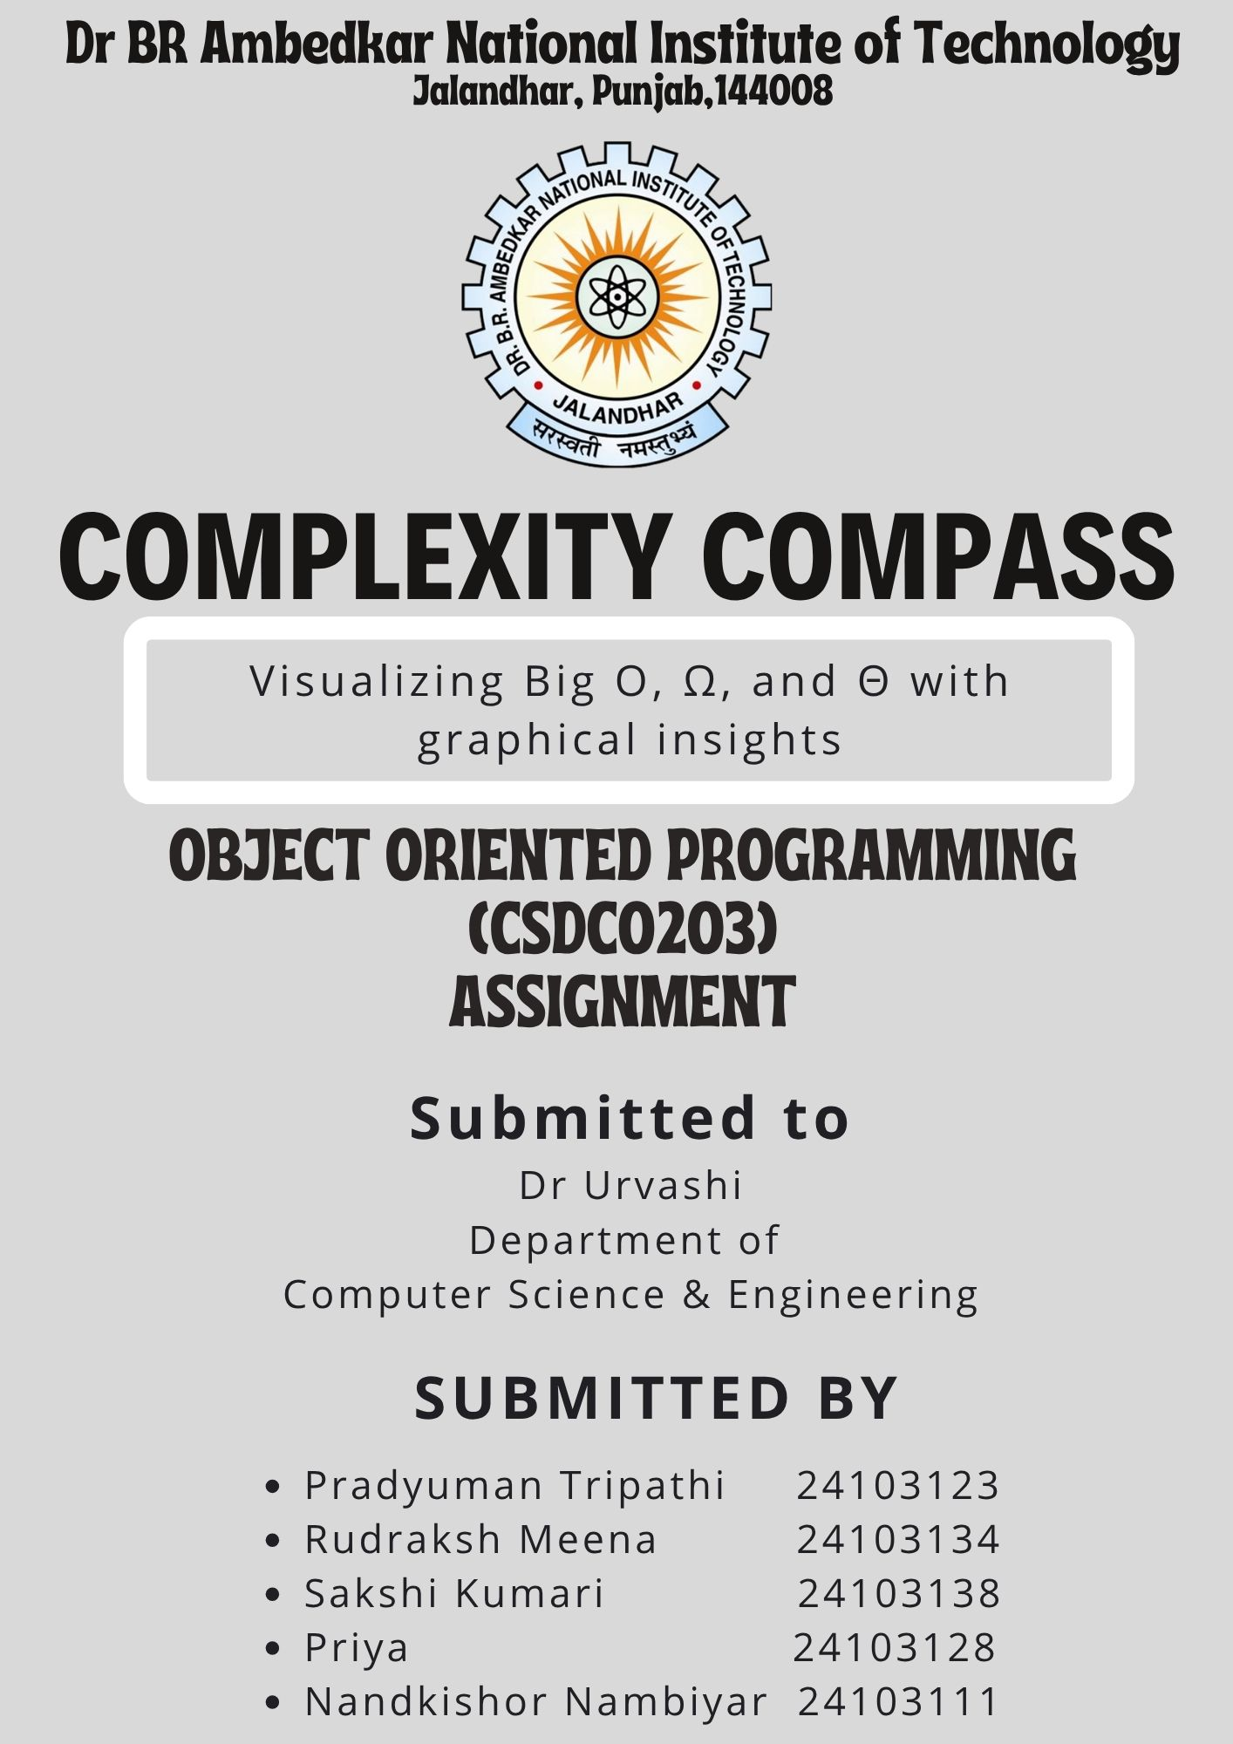
Problem Statement
The goal is to develop an interactive web-based tool, named that enables users—especially computer science students and developers—to analyse the asymptotic behaviour of mathematical functions commonly encountered in algorithm analysis.
Proposed Solution & Design
The proposed solution is the development of an interactive, visualization-based analytical tool named Complexity Compass, aimed at helping users understand the asymptotic behaviour of mathematical functions used in algorithm complexity analysis. The system integrates symbolic mathematics, numerical evaluation, and graphical visualization within an intuitive Streamlit web interface. The design is modular, ensuring clarity, scalability, and robust performance.
System Overview
The application follows a four-layer design:
- Input Layer – Accepts user-defined mathematical functions.
- Computation Layer – Performs symbolic parsing, simplification, dominant-term extraction, and asymptotic classification.
- Visualization Layer – Generates and displays graphs comparing $f(n)$with its asymptotic bounds.
- User Interface Layer – Provides an interactive platform for user input and result exploration.
Functional Workflow
Step 1: User Input
The user enters a function $f(n)$into the Streamlit sidebar.
Valid operations include: +, -, *, /, ^, log, ln, exp, and sqrt.
Step 2: Function Parsing and Validation
The system uses SymPy library to:
- Parse the expression safely using predefined allowed functions.
- Check for syntactic correctness.
- Convert the expression into a symbolic form suitable for computation.
Invalid inputs are handled gracefully with warning messages.
Step 3: Dominant-Term Identification
To determine the asymptotically dominant term $g(n)$, the system:
- Expands and simplifies the function.
- Breaks it into individual terms.
- Compares terms pairwise using:
  - Symbolic limits
  - Numerical evaluations (fallback when symbolic evaluation is not possible)
The term that grows fastest as $n→∞$ is selected as $g(n)$.
3. Asymptotic Relationship Evaluation
The system evaluates whether:
- $f(n)∈O(g(n))$
- $f(n)∈Ω(g(n))$
- $f(n)∈Θ(g(n))$
This is done by computing the symbolic limit:
$$L=\underset{n→∞}{lim⁡}\frac{f(n)}{g(n)}$$
Interpretation:
- $L=0$→ $f(n)∈O(g(n))$
- $L=∞$→ $f(n)∈Ω(g(n))$
- $0<L<∞$→ $f(n)∈Θ(g(n))$
If symbolic evaluation fails (rare cases), the system falls back to numerical approximations.
4. Visualization Design
The plot includes:
- The original function $f(n)$(green curve)
- Scaled upper bound $c⋅g(n)$(orange dashed curve)
- Scaled lower bound $c^{'}⋅g(n)$(green dashed curve)
Design features:
- Smooth curves generated using NumPy
- Clean styling with Seaborn
- Interactive display embedded directly into Streamlit
- Adjustable graph range and labels for clarity
This visualization helps users intuitively compare growth rates.
5. User Interface Design
Streamlit Layout
- Sidebar
  - Function input text box
  - Analyse button
  - Real-time feedback messages
- Main Area
  - Tab: Analysis Result
    - Display the function $f(n)$
    - Display dominant term $g(n)$
    - Big-O, Big-Ω, and Big-Θ metrics in card format
  - Tab: Graph Visualization
    - "Show Graph" button
    - Dynamic asymptotic graph
Colour Scheme
- Green theme for the main function
- Orange for Big-O upper bound
- Dark green for Big-Ω lower bound
- Clean white background grid
The interface is structured to ensure simplicity, clarity, and ease of interaction for users analysing functions.
This intuitive UI foundation leads directly into the broader design goals of the system.
6. Design Goals
The system is designed to be:
Educational
Helps students grasp Big-O, Ω, and Θ visually and intuitively.
Robust
Handles complex expressions without crashing due to symbolic errors.
Interactive
Allows real-time exploration of different functions.
7. Technologies Used
- SymPy – symbolic mathematics and limit evaluation
- NumPy – numerical array computation
- Matplotlib & Seaborn – plotting and styling
- Streamlit – interactive web app framework

The proposed design combines symbolic analysis, numerical evaluation, and clear visualizations to help users understand asymptotic complexity effectively. Its modular structure and interactive interface ensure accurate results while making the tool intuitive and educational.

Code Snippet with Output
Code:
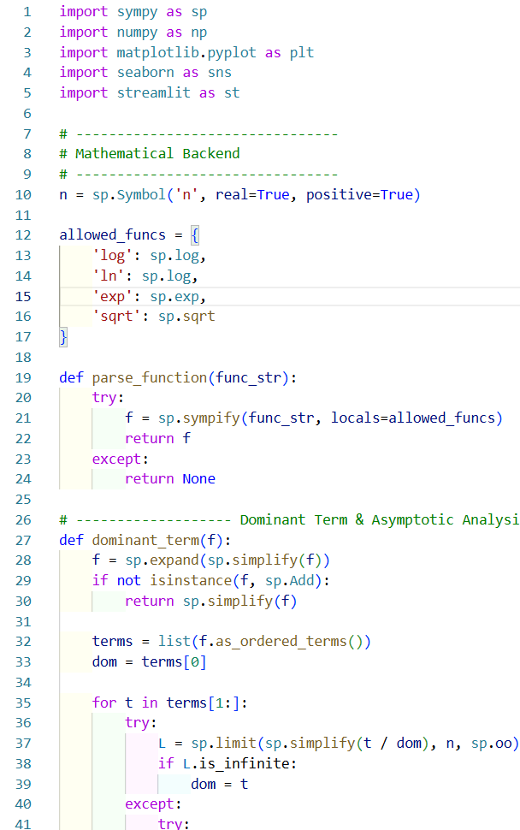
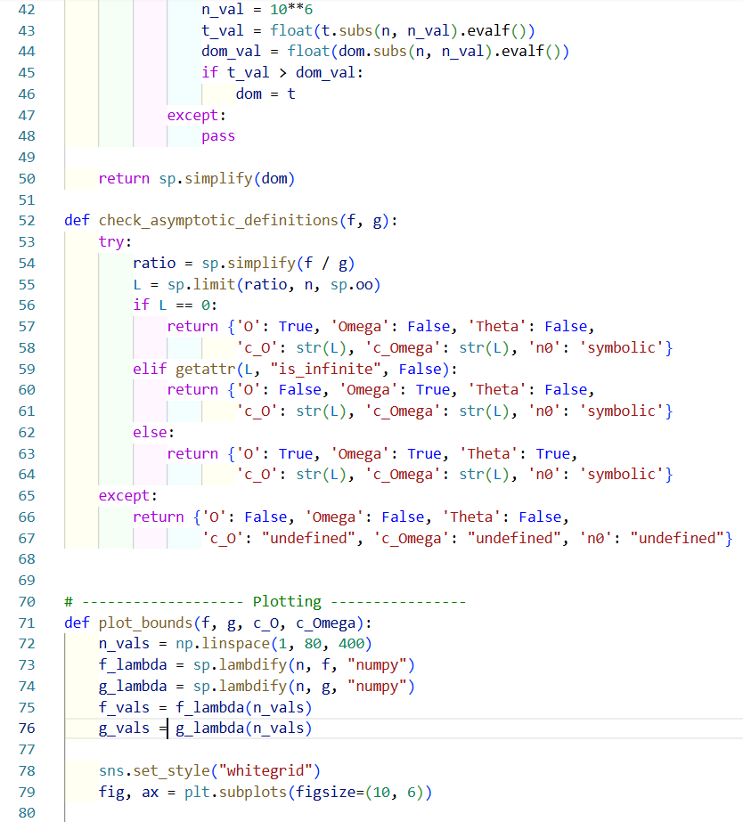
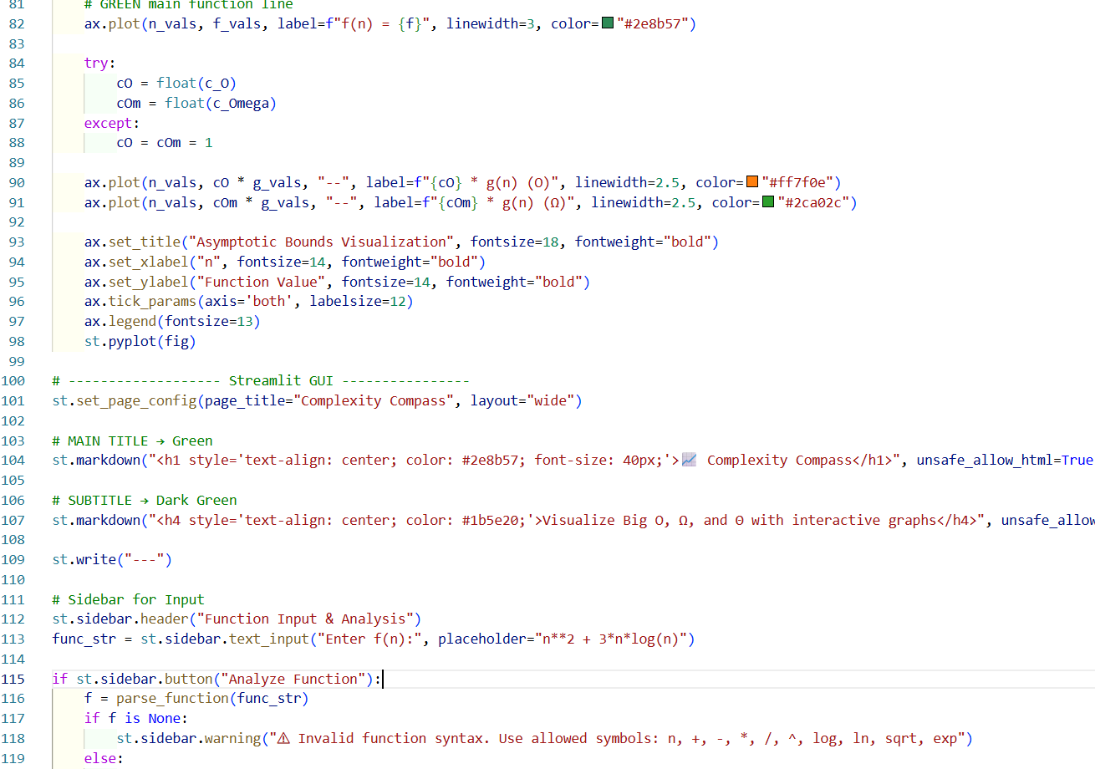
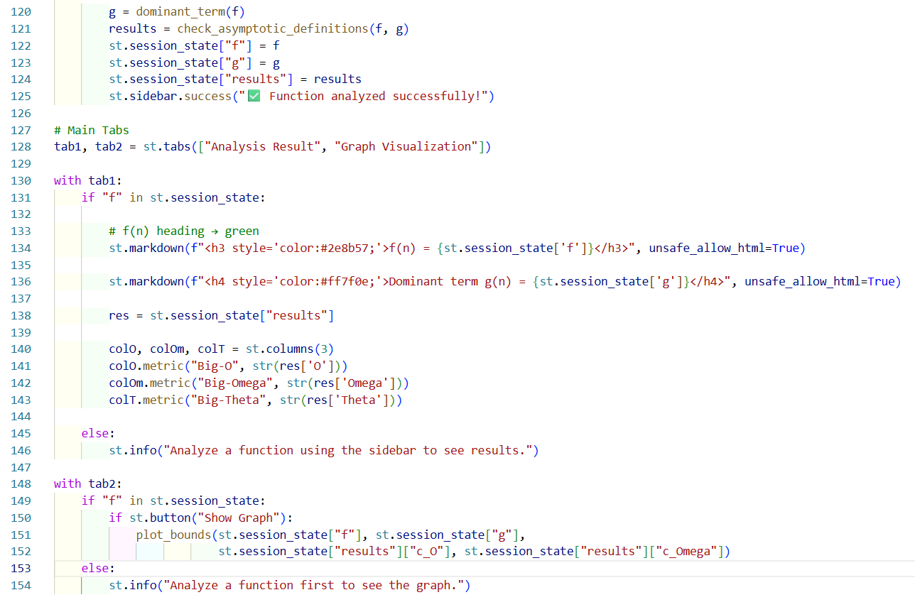

Output:
Simple interface:
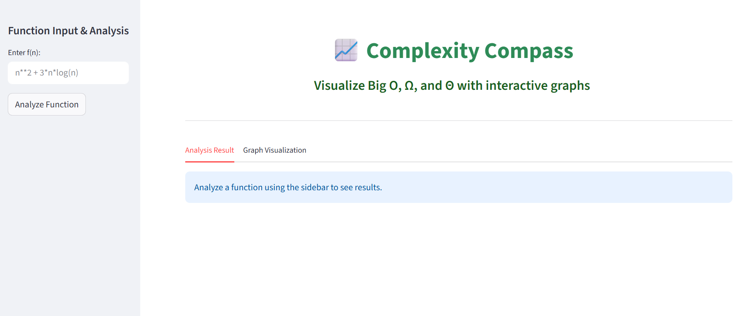
With a user input and Function Analysis Result
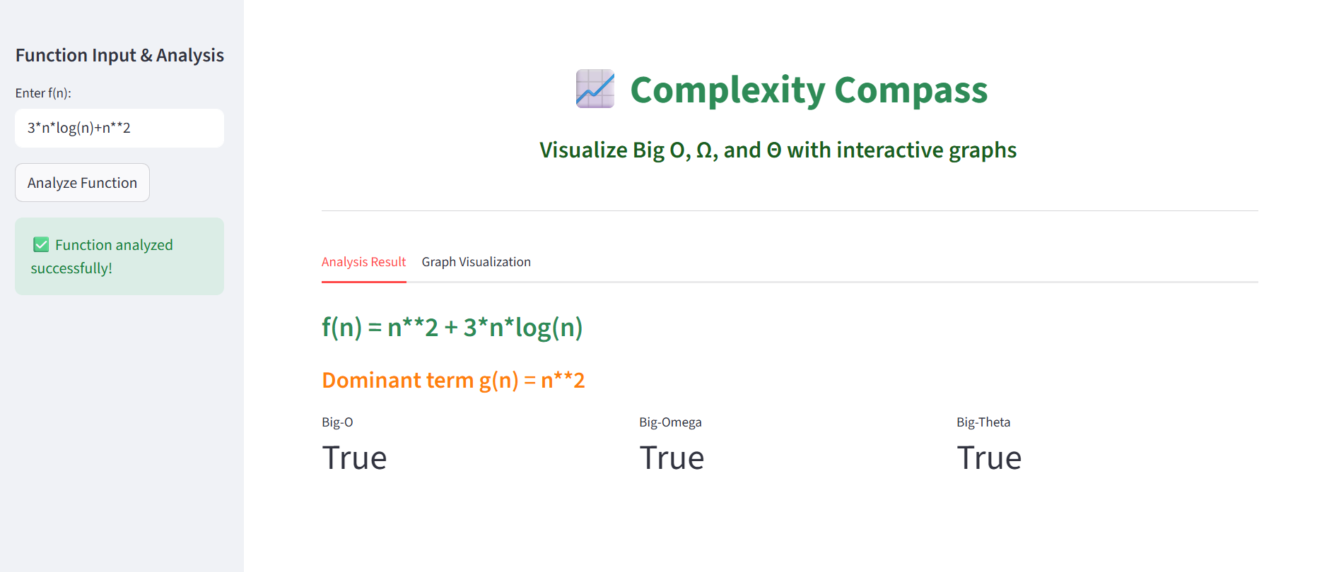
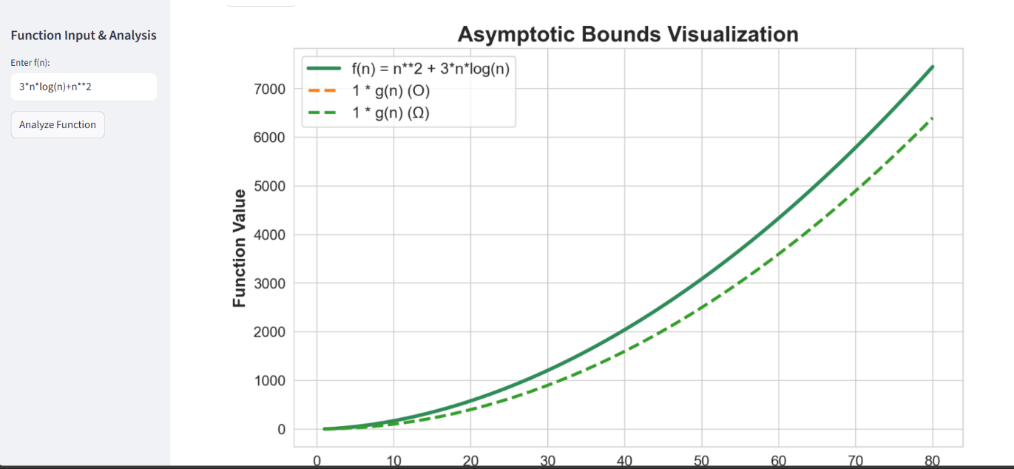
Asymptotic Bounds Visualization

