**Table of Contents**

1. **Introduction**
2. **Historical Background**
3. **Key Concepts in Deep Learning**
4. **Convolutional Neural Networks (CNNs)**
5. **Recurrent Neural Networks (RNNs)**
6. **Transformers**
7. **PyTorch**
8. **Conclusion**

**Comprehensive Report on Deep Learning**

1. **Introduction**

Deep learning is a subset of machine learning in artificial intelligence (AI) that focuses on using neural networks with many layers (hence "deep" learning) to model complex patterns in data. Here’s a brief introduction:

Key Concepts

* Neural Networks: At the heart of deep learning are neural networks, which are inspired by the structure and function of the human brain. A neural network consists of layers of interconnected nodes (neurons), where each node processes input and passes the result to the next layer.
* Layers:
  + Input Layer: The first layer that receives the raw data.
  + Hidden Layers: Layers between the input and output layers where the data undergoes transformations.
  + Output Layer: The final layer that provides the prediction or classification.
* Activation Functions: Functions that introduce non-linearity into the model, allowing it to learn more complex patterns. Common activation functions include ReLU (Rectified Linear Unit), Sigmoid, and Tanh.
* Training: The process of teaching the neural network to make accurate predictions by adjusting its weights based on the error of its predictions. This is typically done using a method called backpropagation, combined with an optimization algorithm like gradient descent.
* Loss Function: A function that measures how well the neural network's predictions match the actual data. Common loss functions include Mean Squared Error (MSE) for regression tasks and Cross-Entropy Loss for classification tasks.
* Optimization: Techniques used to minimize the loss function. Gradient descent is the most commonly used optimization algorithm, which adjusts the weights of the network in the direction that reduces the loss.
* Overfitting and Regularization: Overfitting occurs when a model learns the noise in the training data rather than the actual pattern. Techniques like dropout, L1/L2 regularization, and early stopping are used to prevent overfitting.

Applications

Deep learning has revolutionized many fields due to its ability to handle large amounts of data and its flexibility in modeling complex relationships. Some prominent applications include:

* Computer Vision: Image and video recognition, object detection, facial recognition.
* Natural Language Processing (NLP): Language translation, sentiment analysis, speech recognition.
* Healthcare: Medical image analysis, drug discovery, personalized medicine.
* Autonomous Vehicles: Self-driving cars, traffic prediction, navigation.
* Finance: Fraud detection, algorithmic trading, risk assessment.

**2. Key Concepts in Deep Learning**

**Artificial Neural Networks**

* **Artificial Neurons:** The basic units of neural networks that mimic the behavior of biological neurons. Each neuron receives input, processes it, and passes the output to the next layer.
* **Layers:** Neural networks consist of an input layer, one or more hidden layers, and an output layer. The depth (number of layers) of the network is what makes it "deep."
* **Weights and Biases:** Parameters that the network adjusts during training to minimize error and improve performance.

**Activation Functions**

Activation functions introduce non-linearity into the network, allowing it to model complex patterns. Common activation functions include:

* **ReLU (Rectified Linear Unit):** Outputs zero for negative inputs and the input itself for positive inputs.
* **Sigmoid:** Squashes input values to a range between 0 and 1.
* **Tanh:** Squashes input values to a range between -1 and 1.

**Training Process**

Training a neural network involves:

* **Forward Propagation:** Passing inputs through the network to generate outputs.
* **Loss Function:** Calculating the error between the network's output and the actual target values.
* **Backpropagation:** Adjusting the network's weights and biases based on the error gradient to minimize the loss.

**Optimization Techniques**

Optimization algorithms are used to adjust the weights and biases to minimize the loss function. Common optimizers include:

* **Stochastic Gradient Descent (SGD):** Updates weights incrementally using individual training samples.
* **Adam:** Combines the advantages of two other extensions of SGD, AdaGrad and RMSProp.

**Regularization Methods**

Regularization techniques help prevent overfitting, ensuring the model generalizes well to new data:

* **Dropout:** Randomly drops units from the neural network during training to prevent co-adaptation.
* **L2 Regularization:** Adds a penalty to the loss function based on the squared magnitude of weights.
* **Early Stopping:** Stops training when performance on a validation set starts to degrade.

**Convolutional Neural Networks (CNNs):**

Convolutional Neural Networks (CNNs) are a class of deep neural networks specifically designed to process data with a grid-like topology, such as images. They have proven to be highly effective in various computer vision tasks due to their ability to automatically and adaptively learn spatial hierarchies of features from input images.

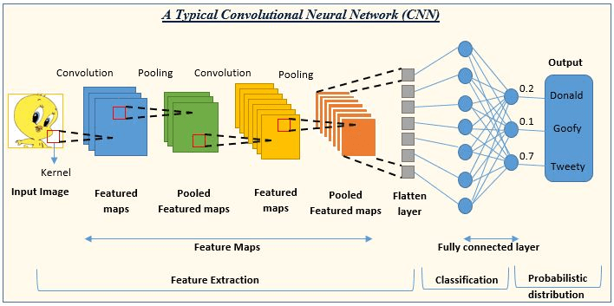

**Key Components of CNNs**

1. **Convolutional Layers:**
   * **Convolution Operation:** The core operation of a CNN involves applying a filter (or kernel) to input data to produce feature maps. This process helps to detect local patterns such as edges, textures, and shapes.
   * **Filters/Kernels:** Small matrices (e.g., 3x3, 5x5) that slide over the input data. The values in these filters are learned during training.
   * **Stride:** The step size by which the filter moves across the input data. A stride of 1 means the filter moves one pixel at a time, while a stride of 2 means it moves two pixels at a time.
   * **Padding:** Adding zeros around the border of the input to ensure that the filter can be applied to the edge pixels. Padding helps maintain the spatial dimensions of the input.
2. **Activation Functions:**
   * **ReLU (Rectified Linear Unit):** The most commonly used activation function in CNNs, which introduces non-linearity by setting all negative values to zero and leaving positive values unchanged.
3. **Pooling Layers:**
   * **Purpose:** To reduce the spatial dimensions (width and height) of the feature maps, thereby decreasing the computational load and memory usage.
   * **Max Pooling:** The most common pooling operation, which takes the maximum value from each patch of the feature map.
   * **Average Pooling:** Computes the average value of each patch in the feature map.
4. **Fully Connected (Dense) Layers:**
   * **Purpose:** To perform high-level reasoning and classification based on the features extracted by the convolutional and pooling layers.
   * **Structure:** Each neuron in a fully connected layer is connected to every neuron in the previous layer.
5. **Output Layer:**
   * **Purpose:** To produce the final classification or prediction.
   * **Activation Function:** Typically uses the Softmax activation function for multi-class classification tasks.

**Recurrent Neural Network (RNN):**

A Recurrent Neural Network (RNN) is a type of neural network designed to handle sequential data by maintaining a form of memory. Unlike traditional feedforward neural networks, which process inputs independently at each layer, RNNs have connections that form a directed cycle, allowing information to persist.

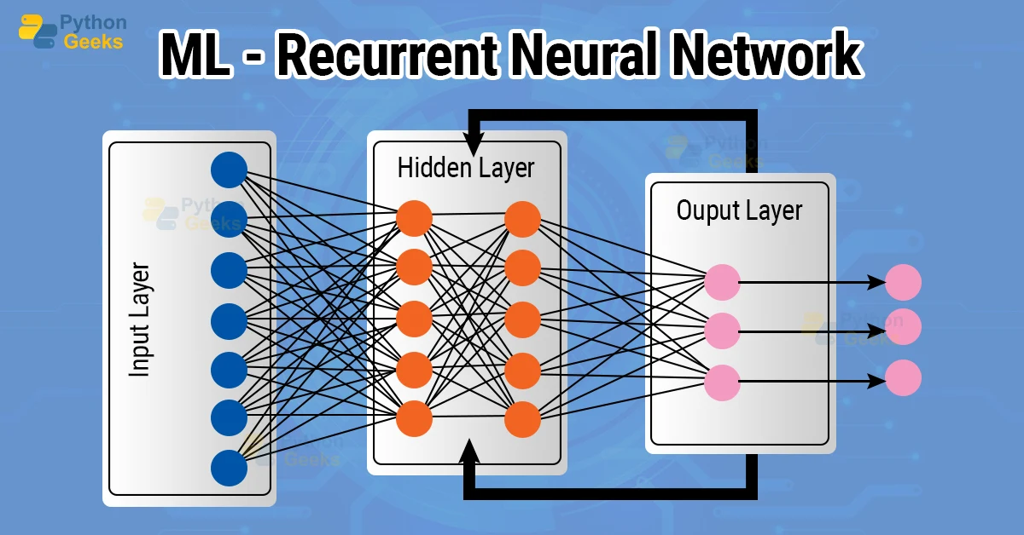

**Key Components of RNNs**

1. **Recurrent Connections:**
   * Each neuron in an RNN is connected to itself through time, enabling it to maintain a state or memory of previous inputs. This cyclic structure allows RNNs to process sequences of inputs.

**Formula**: The output ht ​ of an RNN at time step t is computed as:

**ht​=ϕ(Whh​ht−1​+Wxh​xt​+bh​)**

where:

* ht​ is the hidden state at time t.
* xt is the input at time t.
* Whh and Wxh are weight matrices for the recurrent and input connections, respectively.
* bh ​ is the bias term.
* ϕ is the activation function, typically a hyperbolic tangent tanh or sigmoid function.

1. **Long Short-Term Memory (LSTM):** Standard RNNs can struggle to learn long-term dependencies due to the vanishing gradient problem. LSTM networks introduce a more complex cell structure that includes gates to control the flow of information. LSTM cells maintain a cell state that can carry information over long sequences, controlled by gates that regulate the flow of information.
2. **Bidirectional RNNs**:

• **Idea**: Enhances traditional RNNs by processing sequences in both forward and backward directions.

• **Application**: Useful for tasks where context from both past and future inputs is beneficial, such as speech recognition and named entity recognition.

**Transformers:**

Transformers are a type of deep learning model that has revolutionized natural language processing (NLP) tasks by leveraging self-attention mechanisms. They were introduced in the paper "Attention is All You Need" by Vaswani et al. (2017).

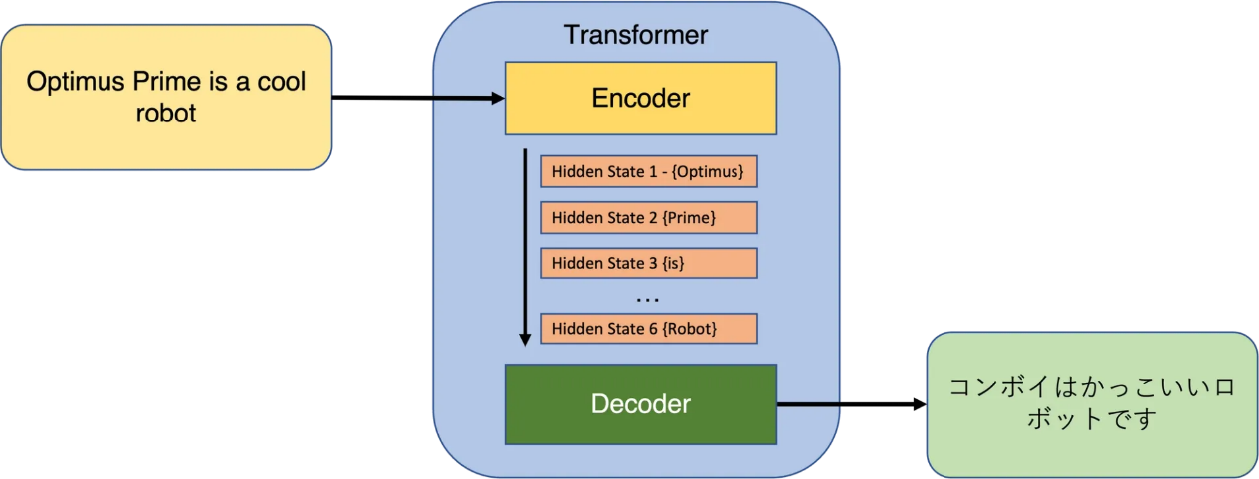

**Key Components:**

1. **Self-Attention Mechanism:**
   * Idea: Allows the model to weigh the significance of each word (or token) in the input sentence by computing attention scores.
   * **Formula**: The attention score Attention(Q,K,V) for a query Q and a set of key-value pairs (K,V)(K, V)(K,V) is computed as:

**Attention(Q,K,V) = softmax(QKT/sqrt(dk)​)V**

where dk is the dimensionality of K and Q.

1. **Transformer Architecture**:

* **Stacked Encoder-Decoder Layers**: Transformers typically consist of multiple layers of encoders and decoders.
* **Encoder**: Processes the input (e.g., words in a sentence) and transforms it into a series of contextualized representations.
* **Decoder**: Takes the encoder's output (or a combination of encoder output and previous decoder outputs) and generates predictions (e.g., translated sentences).

1. **Feedforward Neural Networks**:

* **Idea**: Positioned after each attention mechanism, these networks process the transformed features independently.

**PyTorch:**

PyTorch is an open-source machine learning library developed primarily by Facebook's AI Research lab (FAIR). It is widely used for deep learning applications and provides a flexible framework for building and training neural networks.

**Key Features:**

1. **Tensor Computation**:
   * At its core, PyTorch provides powerful multi-dimensional array operations, similar to NumPy arrays but optimized for GPU acceleration.
   * Tensors in PyTorch can be used to represent and manipulate data at various stages of a machine learning pipeline, from input data to model predictions.
2. **Automatic Differentiation**:
   * One of PyTorch's standout features is its automatic differentiation capability through the autograd package.
   * This feature allows gradients to be computed automatically for tensors, facilitating efficient implementation of gradient-based optimization algorithms like backpropagation.
3. **Dynamic Computation Graphs**:
   * PyTorch uses a dynamic computational graph approach, where the graph is built on-the-fly during runtime.
   * This dynamic nature enables more flexible and intuitive model construction compared to static graph frameworks.
4. **Modular and Extensible**:
   * PyTorch offers a modular and extensible architecture, allowing developers to build complex neural network architectures with ease.
   * It provides a rich set of built-in modules and utilities for defining layers, activation functions, loss functions, and more.
5. **Support for GPU Acceleration**:
   * PyTorch seamlessly integrates with CUDA-capable GPUs to leverage their parallel processing capabilities.
   * This GPU acceleration significantly speeds up computations, making it ideal for training deep neural networks on large datasets.

**Conclusion:**

Deep learning represents a pivotal advancement in machine learning, particularly through the evolution of artificial neural networks and specialized architectures like CNNs, RNNs, and Transformers. PyTorch, with its powerful tensor computation, automatic differentiation capabilities, and GPU acceleration support, has emerged as a leading framework for developing and deploying deep learning models efficiently.

**GitHub links of Implementations of CNN, RNN and Transformers:**

* 1. **RNN :** [**https://colab.research.google.com/drive/1Ryk7zpAkdopxwSs_JPD5iA8EgB9QsnXT?usp=sharing**](https://colab.research.google.com/drive/1Ryk7zpAkdopxwSs_JPD5iA8EgB9QsnXT?usp=sharing) **(wheather prediction )**
  2. **CNN :** [**https://github.com/sakshik2004/FMML/blob/main/Convolutional_Neural_Networks_(CNN).ipynb**](https://github.com/sakshik2004/FMML/blob/main/Convolutional_Neural_Networks_(CNN).ipynb) **(Digit recognizer)**
  3. **Transformer:** [**https://github.com/sakshik2004/FMML/blob/main/Starter_Analyzing_sentiments_related_c0c862fa_f.ipynb**](https://github.com/sakshik2004/FMML/blob/main/Starter_Analyzing_sentiments_related_c0c862fa_f.ipynb) **(Analyzing sentiments)**

**Name : Sakshi Kadu**

**Rollno.: UGMR20230029**