Why Sonarqube-4.5.1?

* Sonarqube-4.5.1 is LTS version.
* LTS stands for Long term support.
* These are the plugins which we are going to use and which is supported by Sonarqube-4.5 version:
  + - PDF Report
    - SCM Activity
    - Issue Assign
    - Issue Report



 

In the current system, we are not able to identify the number of issues which are caused by developers.

By using SonarQube-4.5.1 we will be able to know the number of issues which are caused due to code check-in by developer by using issue report plugin.

Example:

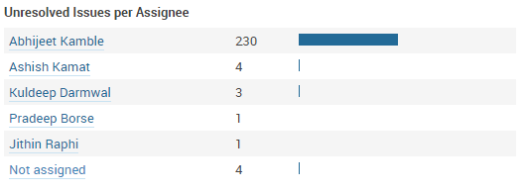

https://upload.wikimedia.org/wikipedia/commons/e/e6/Sonarqube-48x200.png

**Mode**=Analysis

**Work**

F2

F1

C2

C1

**Master**

**Mode**=Preview

**Work-1**

**Mode**=Preview

G2

G1

**Develop**

**Mode**=Preview

D1

D2