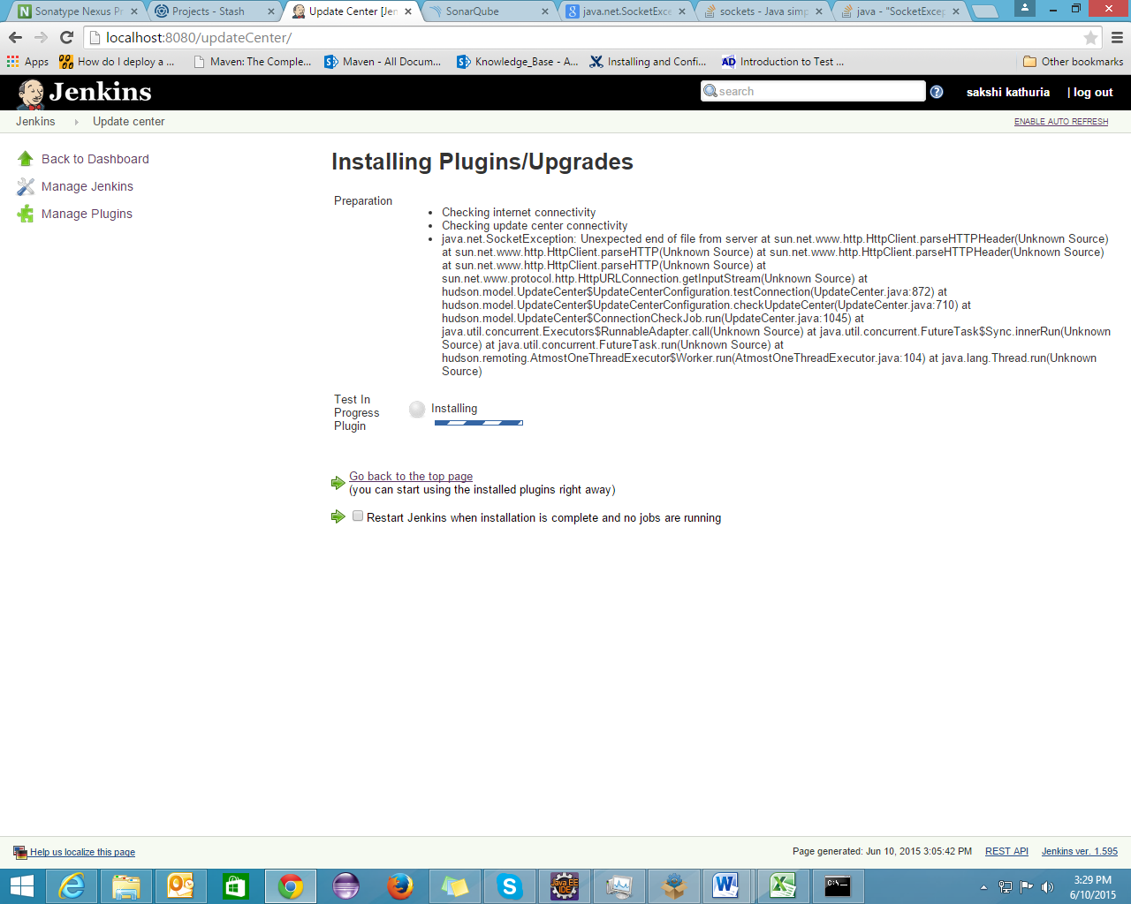

**Could not find artifact org.jenkins-ci.plugins:testInProgress-client:jar:1.0 in nexus (**[**http://localhost:8082/nexus/content/groups/public/**](http://localhost:8082/nexus/content/groups/public/)**)**

