Lab Number: | 1
Student Name: | Sakshi Vadiraj Kaveri
Roll No : | 33

Title:
To Add Two Numbers, Print Number Entered by User, Swap Two Numbers, Check Whether Number is Even or Odd
1.1 Implement using C++
1.2 Implement using Java

Learning Objective:
- Students will be able to write C++ and java program for simple arithmetic operations and take input from user.

Learning Outcome:
- Ability to execute a simple C++ and Java program with and without any inputs to the program.
- Understanding the constructs in C++ and Java.

Course Outcome:
ECL304.1 | Understand object-oriented programming concepts and implement using C++ and Java

Theory:
Difference between procedural and object oriented language
Application of object orientation
Brief introduction to C++ and Java
// to add two numbers
Algorithm:
- Input variables n1,n2 and result
- Assign values to the variables
- Write equation of the sum of the variables and store the sum in result
- Display the sum of two numbers

Program:
C++
#include<iostream>
using namespace std;
int main()

{
int n1,n2,result;
n1=10,n2=15;
result=n1+n2;
cout<<n1<<" + "<<n2<<" = "<<result;
return 0;
}
INPUT GIVEN: n1=10, n2=15
OUTPUT Screenshot:
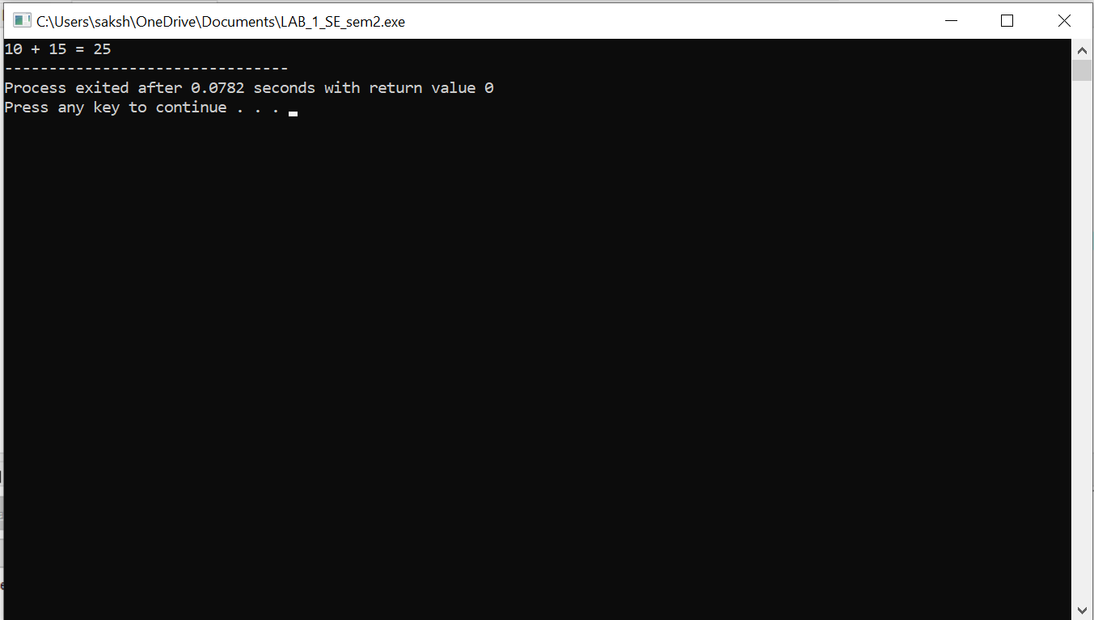

//Print number entered by user
Algorithm:
- Input two variables num1 and num2
- Display message to enter the values of the numbers
- Store the variables
- Print the value of variables entered by user
PROGRAM:
C++
#include<iostream>
using namespace std;
int main()
{
int num1,num2;
cout<<"enter two numbers ";
cin>>num1>>num2;
cout<<"the entered numbers are: "<<num1<<" and "<<num2;
return 0;
}
INPUT GIVEN: num1=10 , num2=15
OUTPUT SCREENSHOT:
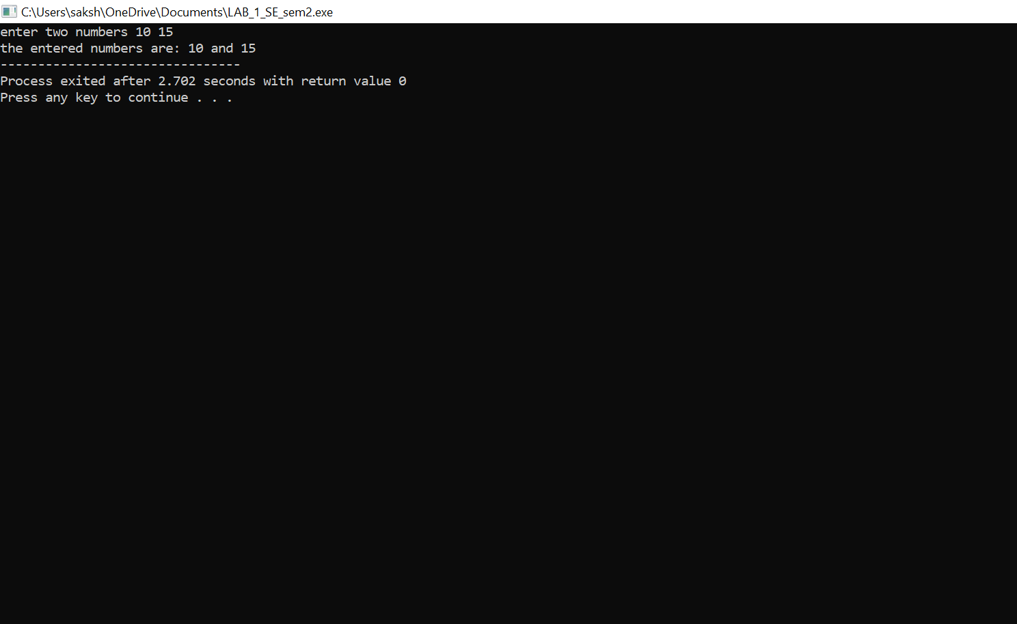
//to swap two numbers
ALGORITHM:
- Input three variables n1,n2 and temp
- Print message to enter the numbers
- Store the numbers input by user in the variables
- Store the value of n1 in temp then store the value of n2 in n1 then finally store the value of temp in n2
- Display the swapped numbers
PROGRAM:
C++
#include<iostream>
using namespace std;
int main()
{
int n1,n2,temp;
cout<<"enter the numbers ";
cin>>n1>>n2;
temp=n1;
n1=n2;
n2=temp;
cout<<"the swapped numbers are: "<<n1<< " and "<<n2;
return 0;
}
INPUT GIVEN: n1=10, n2=15
OUTPUT SCREENSHOT: 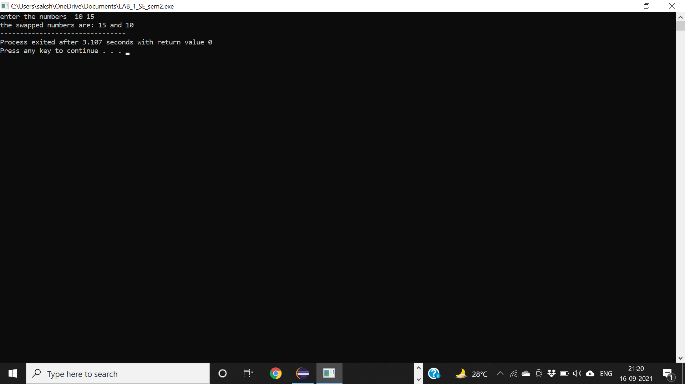
//CHECK WHETHER THE NUMBER IS ODD OR EVEN
ALGORITHM:
- Input variable num1
- Take the input from user
- Store the value input by user in the variable
- If (num1%2==0) then the number is even or else the number is odd
PROGRAM:
C++
#include<iostream>
using namespace std;
int main()
{
int num1;
cout<<"enter the given number";
cin>>num1;
if(num1%2==0)
{
cout<<"the number "<<num1<<" is even";
}
else
{
cout<<"the number "<<num1<<" is odd";
}
return 0;
}
INPUT GIVEN: num1=5
OUTPUT SCREENSHOT: