Lab Number: | 5
Student Name: | Sakshi Vadiraj Kaveri
Roll No : | 33

Title:
To perform Operator Overloading using C++ for
- adding 2 complex numbers
- adding matrices
Learning Objective:
- Students will be able to perform user-defined overloading of built-in operators.
Learning Outcome:
- Understanding the overloading concept on built-in operators.

Course Outcome:
ECL304.2 | Comprehend building blocks of OOPs language, inheritance, package and interfaces

Theory:
Explain about operator overloading with respect to:
- constructor,
- methods and
- operators.
Constructor: - We can overload a constructor by giving the same name as the constructor and classname but with different arguments or parameters and the required constructor is called. While creating the object, arguments must be passed to let compiler know, which constructor needs to be called.
Methods: we can overload a specific method by defining a method with the same method name but with different number of parameters or with a specific sequence of parameters and the specific function is called. It is only through these differences that a compiler can differentiate between functions.
Operators: Operator overloading is one of the features of C++. By overloading the operators, we can give additional meaning to the operators like +-*/=.,= etc., which by default are supposed to work only on standard data types like int, float, char, void etc. It is an essential concept in C++. It’s a type of polymorphism in which an operator is overloaded to give it the user-defined meaning. Conditional [?:], size of, scope(::), Member selector(.), member pointer selector(.*) and the casting operators cannot be overloaded.

Q) Write a C++ program to overload '+' operator to add two matrices

ALGORITHM:

- Declare class matrices
- Take three arrays in class with two arguments of size 2 (for rows and columns)
- Declare methods/functions get_elements(), calc() and display() in the class.
- Using loops take input from the user.
- In main function call get_element(), calc() and display().
- Display the on the screen.

PROGRAM:

#include<iostream>
using namespace std;
class matrices
{
int a[2][2];
int b[2][2];
int c[2][2];
public:
void get_element(void)
{
cout<<"Enter elements "<<endl;
for(int i=0;i<2;i++)
{
for(int j=0;j<2;j++)
{
cin>>a[i][j];
}
}
}
matrices operator+(matrices m2);
void display(void)
{
for(int i=0;i<2;i++)
{
for(int j=0;j<2;j++)
{
cout<<a[i][j]<<" ";

}
cout<<endl;
}
}

};
matrices matrices::operator+(matrices m2)
{
matrices m3;
for(int i=0;i<2;i++)
{
for(int j=0;j<2;j++)
{
m3.a[i][j]=a[i][j]+m2.a[i][j];

}
}
return m3;
}
int main()
{
matrices ob1;
matrices ob2;
ob1.get_element();
cout<<"Matrix 1 "<<endl;
ob1.display();
ob2.get_element();
cout<<"Matrix 2 "<<endl;
ob2.display();
ob1=ob1+ob2;
cout<<"The final matrix obtained is "<<endl;
ob1.display();
return 0;
}

INPUT GIVEN:
Elements of matrix 1 are 1,2,3 and 4.
Elements of matrix 2 are 4,5,6 and 7.

OUTPUT SCREENSHOT:

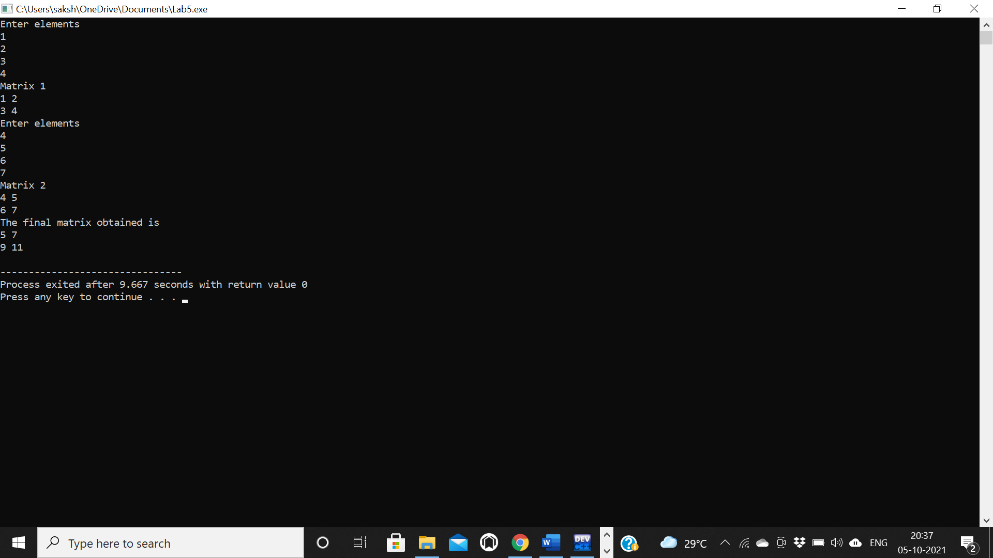

Q2) Write a C++ program to multiply two complex numbers by overloading operator '*'
ALGORITHM:
- Declare class matrices
- Declare two variables real and im in the class.
- Create a constructor complex(int r, int im).
- With the help of formula if z1 = p + iq and z2 = r + is then
z1z2 = (pr - qs) + i(ps + qr) calculate the matrix.
- Display the final matrix on the screen.

PROGRAM:
#include<iostream>
using namespace std;
class complex
{
public:
int real;
int img;
complex()
{
real=0;
img=0;
}
complex(int r,int im)
{
real=r;
img=im;
}
complex operator*(complex c)
{
complex ans;
ans.real=((real*c.real)-(img*c.img));
ans.img=((real*c.img)+(c.real*img));
return (ans);

}
void display(void)
{
cout<<real<<"+"<<img<<"i"<<endl;
}

};
int main()
{
//complex c1,c2;
complex c1(3,4);
cout<<"Complex Number 1: ";
c1.display();
complex c2(6,7);
cout<<"Complex Number 2: ";
c2.display();
c1=c1*c2;
cout<<"The final answer is: ";
c1.display();
return 0;
}
INPUT GIVEN:
Complex number 1= 3+4i
Complex number 2= 6+7i

OUTPUT SCREENSHOT:
