Lab Number: | 2
Student Name: | Sakshi Vadiraj Kaveri
Roll No : | 33

Title:
To Add Two Numbers, Print Number Entered by User, Swap Two Numbers, Check Whether Number is Even or Odd
1.1 Implement using C++
1.2 Implement using Java

Learning Objective:
- Students will be able to write C++ and java program for simple arithmetic operations and take input from user.

Learning Outcome:
- Ability to execute a simple C++ and Java program with and without any inputs to the program.
- Understanding the constructs in C++ and Java.

Course Outcome:
ECL304.1 | Understand object-oriented programming concepts and implement using C++ and Java

Theory:
Difference between procedural and object oriented language
Procedural programming can be defined as a programming model which is derived from structured programming, based upon the concept of calling procedure. Procedures, also known as routines, subroutines or functions, simply consist of a series of computational steps to be carried out. During a program’s execution, any given procedure might be called at any point, including by other procedures or itself.
Object oriented programming can be defined as a programming model which is based upon the concept of objects. Objects contain data in the form of attributes and code in the form of methods. In object oriented programming, computer programs are designed using the concept of objects that interact with real world. Object oriented programming languages are various but the most popular ones are class-based, meaning that objects are instances of classes, which also determine their types.

Application of object orientation
OOP can also be used in manufacturing and design applications, as it allows people to reduce the effort involved. For instance, it can be used while designing blueprints and flowcharts. OOP makes it possible for the designers and engineers to produce these flowcharts and blueprints accurately.

Brief introduction to C++ and Java
Type. Java is only object-oriented programming language. C++ is both a procedural and object-oriented programming language. Input-Output mechanism. Java uses the (System class) System.in for input and System. C++ was designed for systems and applications programming. It was an extension of the C programming language. Java was designed and created as an interpreter for printing systems but later extended as a support network computing. It was designed to be easy to use and accessible to a broader audience.
// to add two numbers
Algorithm:
- Input variables n1,n2 and result
- Assign values to the variables
- Write equation of the sum of the variables and store the sum in result
- Display the sum of two numbers

Program:
import java.util.Scanner;
public class Lab1 {
public static void main (String[] args) {

int n1,n2,result;
n1=10;
n2=15;
result=n1+n2;
System.out.println(n1+" + "+n2+" = "+result);
}
}
INPUT GIVEN: n1=10, n2=15
OUTPUT SCREENSHOT:
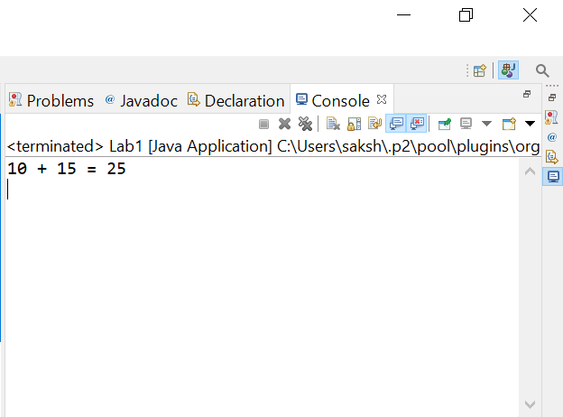

//Print number entered by user
Algorithm:
- Input two variables num1 and num2
- Display message to enter the values of the numbers
- Store the variables
- Print the value of variables entered by user
PROGRAM:
import java.util.Scanner;
public class Lab1 {
public static void main (String[] args) {
int num1,num2;
Scanner sc= new Scanner(System.in);
System.out.println("Enter first number ");
num1=sc.nextInt();
System.out.println("enter second number ");
num2=sc.nextInt();
System.out.println("first number is="+num1);
System.out.println("second number is="+num2);
}
}
INPUT GIVEN: NUM1=10, NUM2=15
OUTPUT SCREENSHOT: 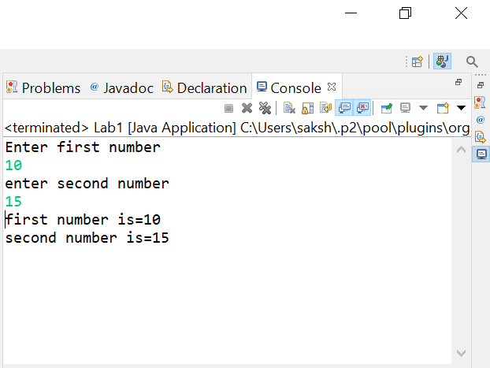
//to swap two numbers
ALGORITHM:
- Input three variables n1,n2 and temp
- Print message to enter the numbers
- Store the numbers input by user in the variables
- Store the value of n1 in temp then store the value of n2 in n1 then finally store the value of temp in n2
- Display the swapped numbers
PROGRAM:

import java.util.Scanner;
public class Lab1 {
public static void main (String[] args) {
int n1,n2,temp;
Scanner sc= new Scanner(System.in);
System.out.println("enter first number");
n1=sc.nextInt();
System.out.println("enter second number");
n2=sc.nextInt();
temp=n1;
n1=n2;
n2=temp;
System.out.println("first number is="+n1);
System.out.println("second number is="+n2);
}
}
INPUT GIVEN: n1=10, n2=15
OUTPUT SCREENSHOT: 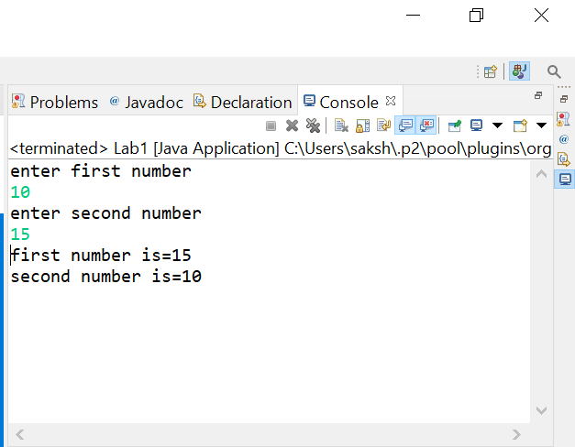

//CHECK WHETHER THE NUMBER IS ODD OR EVEN
ALGORITHM:
- Input variable num1
- Take the input from user
- Store the value input by user in the variable
- If (num1%2==0) then the number is even or else the number is odd
PROGRAM:

import java.util.Scanner;
public class Lab1 {
public static void main (String[] args) {

int a;
Scanner sc= new Scanner(System.in);
System.out.println("enter the number");
a=sc.nextInt();
if(a%2==0)
{
System.out.println("the number "+a+" is even");
}
else
{
System.out.println("the number "+a+" is odd");
}

}
}

INPUT GIVEN: a=5
OUTPUT SCREENSHOT: 