Lab Number: | 4
Student Name: | Sakshi Vadiraj Kaveri
Roll No : | 33

Title:
4.1 Write a Java program to Create a class Student with two method getData() and printData(). getData() to get the value from the user and display the data in printData(). Create the two objects s1 ,s2 to declare and access the values from class StudentTest.
4.2 Write a Java program for Basic bank Management System

Learning Objective:
- Students will be able to write C++ and java program for using classes and objects.

Learning Outcome:
- Ability to execute a simple C++ and Java program by accepting and displaying values using functions
- Understanding the classes and objects concept in C++ and Java.

Course Outcome:
ECL304.1 | Understand object-oriented programming concepts and implement using C++ and Java

Theory:
Explain about Constructor.
A constructor in C++ is a special ‘MEMBER FUNCTION’ having the same name as that of its class which is used to initialize some valid values to the data members of an object. It is executed automatically whenever an object of a class is created. It is always declared in public. It doesn’t have a return value. Constructor can be declared by two ways, first one is without parameters and the second one is by using parameters. There’s no need to call the constructor separately.

Explain about classes and objects in Java.
A class is the blueprint of all the objects that are derived from it. It represents the set of methods and properties that are common to all the objects which are referenced from it. It has the methods, variables which are common to all the objects it projects onto. However, for clean code two classes can be created. One can hold all the methods and variables and the second class can hold the main method. Inside this main method the objects can be created of the first class. The objects are real life entities which are derived from classes, they share the same variables and methods but different values of them.

How to access class attributes and methods? Explain with example.
We can access attributes and methods of the class by creating objects of that class in the main function. We can call the methods present in the class by calling the functions with the help of objects.
For example: -
public class Main {
int x = 5;
public static void main(String[] args) {
Main myObj = new Main();
System.out.println(myObj.x);
}
}
EXPLANATION: - We created a class with the classname Main (same as the file name Main.java) and we declared a variable with the datatype int and we gave a value to that variable. Then in the main function we created an object for the class (objects are always created in the main function) using keyword main. Then we printed the value stored in the variable declared in class by with the help of object created.
Write a Java program to Create a class Student with two method getData() and printData(). getData() to get the value from the user and display the data in printData(). Create the two objects s1 ,s2 to declare and access the values from class StudentTest.
ALGORITHM:
- In class student first declare the attributes to be taken by user, here for e.g., name, roll-no, division and cgpa of the student.
- In method of getdata() input the data of student1(by using non parameter method) given by the user and also input the data for student2(by using parameter method).
- In method printdata() print/display the values given by user and the data given by the parameters.
- Now create a class StudentTest and write the main function inside the class and create the objects for the first class in main function and call the functions to execute the code written in the functions. For printing the data using parameter method, write the values of the variables in parenthesis and then call the function.

PROGRAM:
import java.util.Scanner;
class Student {

Scanner in=new Scanner(System.in);
String name;
int roll_no;
float cgpa;
char div;

/*public Student(String n,int r,float c,char d )
{
name=n;
roll_no=r;
cgpa=c;
div=d;
}*/

//method overloading
void getdata()
{
System.out.println("Enter your name:");
name=in.next(); //string input
System.out.println("Enter your roll number:");
roll_no=in.nextInt();
System.out.println("Enter your CGPA:");
cgpa=in.nextFloat();
System.out.println("Enter your Division:");
div=in.next().charAt(0);

}

void getdata(String n,int r,float c,char d) //with four parameters
{
name=n;
roll_no=r;
cgpa=c;
div=d;

}

/*void getdata(String n,int r,float c) //with three parameters
{
name=n;
roll_no=r;
cgpa=c;
div='C';

}*/

void printdata()
{
System.out.println("Name of the student: "+name);
System.out.println("Roll-no of the student: "+roll_no);
System.out.println("Cgpa of the student: "+cgpa);
System.out.println("Division of the student: "+div);
}

};
public class StudentTest {

public static void main(String[] args) {
// TODO Auto-generated method stub
Student s1=new Student();
Student s2=new Student();
s1.getdata(); //non parameter
s1.printdata();
s2.getdata("Siddharth",03,(float)8.8,'D'); // with parameters
//s2.getdata();
s2.printdata();

}

}

INPUT GIVEN: Name- Sakshi, Roll-no- 33, cgpa= 9.8, Division- B

OUTPUT SCREENSHOT:

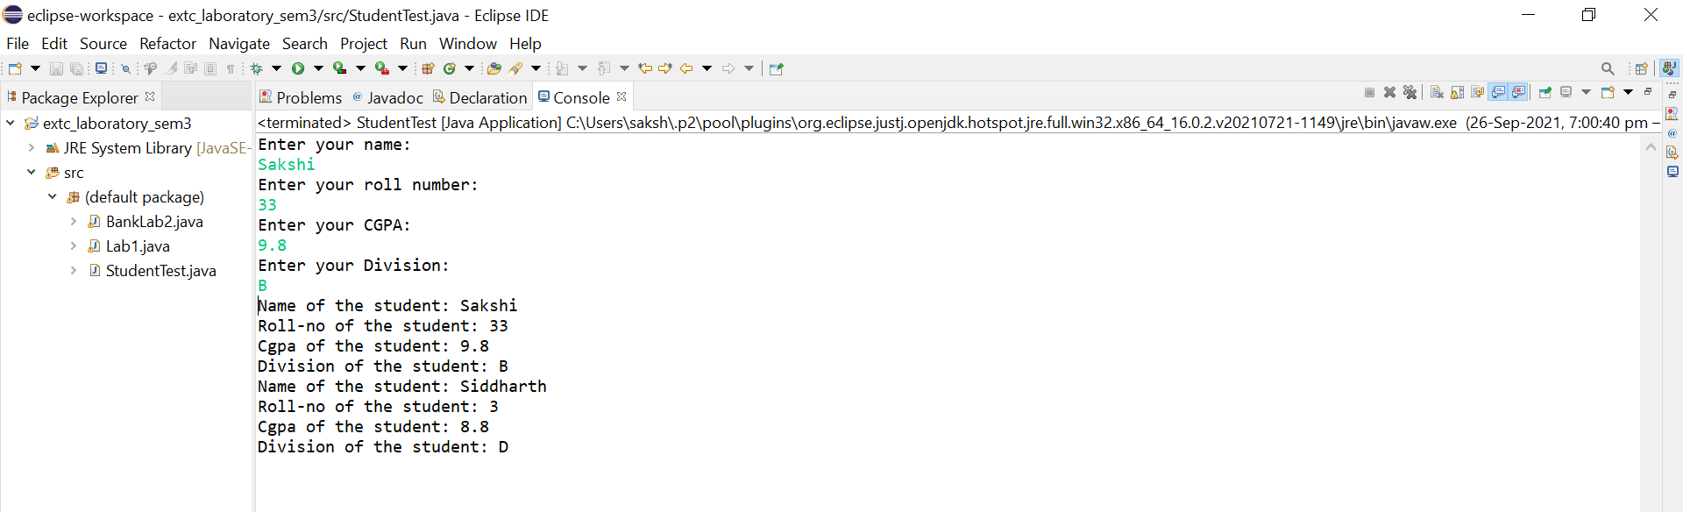

Write a Java program for Basic bank Management System

ALGORITHM:
- Create a class BankLab2 and declare all the variables required for the bank account.
- Create a constructor for class BankLab2 using parameters.
- Create functions for deposit, withdraw, and display for the bank account and write the work or code to be executed in the function with respect to the function name.
- Now in the main function declare two variables ‘ans’ and account number, create objects for class BankLab2 and give the values for the variables(parameters for constructor) in parenthesis,(as we have used constructor there is no separate step to call the constructor as when we create the objects constructor gets automatically called).Display the menu, ask the user to enter an option, declare and store the option value in a variable. Now using do-while loop display the menu to the user and ask for the user’s preferences. By using switch case perform the respective functions according to the user’s choice entered.

PROGRAM:
import java.util.Scanner;
public class BankLab2 {
Scanner in=new Scanner(System.in);

String name;

char account_type;

int account_number,amount;

float balance;

public BankLab2(String n,int a, char t, float b) {

// TODO Auto-generated constructor stub

name = n;

account_number=a;

account_type=t;

balance=b;

}

int deposit()

{
System.out.println("Enter the amount to deposit: ");

int amount=in.nextInt();

if(amount<0)

{
System.out.println("Invalid amount,Enter a valid amount");

return 0;

}

balance=balance+amount;

return 1;

}

int withdraw()

{
System.out.println("Your Balance= " +balance );

System.out.println("Enter amount to withdraw: ");

int amount=in.nextInt();

if (balance<amount)

{
System.out.println("Insufficient Balance: ");

return 0;

}

if(amount<0)

{
System.out.println("Invalid amount" );

return 0;

}

balance=balance-amount;

return 1;

}

void display()

{
System.out.println("Name :"+name);

System.out.println("Account Number:" +account_number);

System.out.println("Account Type:" +account_type);

System.out.println("Balance: " +balance);

}

public static void main(String[] args) {

// TODO Auto-generated method stub

Scanner in=new Scanner(System.in);

BankLab2 b1=new BankLab2("salman",1,'s',2000);

BankLab2 b2=new BankLab2("makarand",2,'s',2000);

BankLab2 b3=new BankLab2("siddharth",3,'s',2000);

System.out.println("Menu");

System.out.println("1.Deposit");

System.out.println("2.Withdraw");

System.out.println("3.Display");

System.out.println("Enter option");

int op=in.nextInt();

char ans;

do

{

System.out.println("Please enter your account number:");

int account_number=in.nextInt();

switch(account_number)

{

case 1: if(op==1)

b1.deposit();

if(op==2)

b1.withdraw();

if(op==3)

b1.display();

break;

case 2: if(op==1)

b2.deposit();

if(op==2)

b2.withdraw();

if(op==3)

b2.display();

break;

case 3: if(op==1)

b3.deposit();

if(op==2)

b3.withdraw();

if(op==3)

b3.display();

break;

default: System.out.println("Enter value between 1 to 3");

break;

}

System.out.println("Do you want to continue?[Y/N]");

ans=in.next().charAt(0); //char input in variable ans

if(ans=='Y' || ans == 'y')

{
System.out.println("Menu");

System.out.println("1.Deposit");

System.out.println("2.Withdraw");

System.out.println("3.Display");

System.out.println("Enter option");

op=in.nextInt();

}

}

while(ans!='N');

}

}

INPUT GIVEN: Account Number=1, Amount deposited=2000

OUTPUT SCREENSHOT: