Lab Number: | 3
Student Name: | Sakshi Vadiraj Kaveri
Roll No : | 33

Title:
3.1 Write a C++ program to Create a class Student with two method getData() and printData(). getData() to get the value from the user and display the data in printData(). Create the two objects s1 ,s2 to declare and access the values from class StudentTest.
3.2 Write a C++ program for Basic bank Management System

Learning Objective:
- Students will be able to write C++ and java program for using classes and objects.

Learning Outcome:
- Ability to execute a simple C++ and Java program by accepting and displaying values using functions
- Understanding the classes and objects concept in C++ and Java.

Course Outcome:
ECL304.1 | Understand object-oriented programming concepts and implement using C++ and Java

Theory:
Difference between procedural and object-oriented language
Procedural programming can be defined as a programming model which is derived from structured programming, based upon the concept of calling procedure. Procedures, also known as routines, subroutines or functions, simply consist of a series of computational steps to be carried out. During a program’s execution, any given procedure might be called at any point, including by other procedures or itself.
Object oriented programming can be defined as a programming model which is based upon the concept of objects. Objects contain data in the form of attributes and code in the form of methods. In object-oriented programming, computer programs are designed using the concept of objects that interact with real world. Object oriented programming languages are various but the most popular ones are class-based, meaning that objects are instances of classes, which also determine their types.
Application of object orientation
OOP can also be used in manufacturing and design applications, as it allows people to reduce the effort involved. For instance, it can be used while designing blueprints and flowcharts. OOP makes it possible for the designers and engineers to produce these flowcharts and blueprints accurately.

Brief introduction to C++ and Java
Type. Java is only object-oriented programming language. C++ is both a procedural and object-oriented programming language. Input-Output mechanism. Java uses the (System class) System.in for input and System. C++ was designed for systems and applications programming. It was an extension of the C programming language. Java was designed and created as an interpreter for printing systems but later extended as a support network computing. It was designed to be easy to use and accessible to a broader audience.

// C++ program to Create a class Student with two method getData() and printData(). getData() to get the value from the user and display the data in printData(). Create the two objects s1 ,s2 to declare and access the values from class StudentTest.
ALGORITHM:
- In class student first declare the attributes to be taken by user, here for e.g., name, roll-no, division and cgpa of the student.
- In method of getdata() input the data of student1(by using non parameter method) given by the user and also input the data for student2(by using parameter method).
- In method printdata() print/display the values given by user and the data given by the parameters.
- Now in main function create the objects of the class Student and call the functions to execute the code written in the functions. For printing the data using parameter method, write the values of the variables in parenthesis and then call the function.
PROGRAM:
#include<iostream>
using namespace std;
class Student
{
public:
string name;
int roll no;
char div;
float cgpa;
void getdata()
{
cout<<"Enter the name of the student: "<<endl;
cin>>name;
cout<<"Enter the roll-no of the student: "<<endl;
cin>>roll_no;
cout<<"Enter the Division of the student: "<<endl;
cin>>div;
cout<<"Enter the cgpa of the student: "<<endl;
cin>>cgpa;

}
int getdata(string n,int r,char d,float c)
{
name=n;
roll_no=r;
div=d;
cgpa=c;
return 0;
}
void printdata()
{

cout<<"Name of the student: "<<name<<endl;
cout<<"Roll-no of the student: "<<roll_no<<endl;
cout<<"Division of the student: "<<div<<endl;
cout<<"The cgpa obtained by the student: "<<cgpa<<endl;

}
};
int main()
{

Student s1;
Student s2;
s1.getdata();
s1.printdata();
s2.getdata("Siddharth",3,'D',8.8);
s2.printdata();
return 0;
}
INPUT GIVEN: Name of the student- Sakshi, Roll-no-33, Div-B, CGPA= 9.8

OUTPUT SCREENSHOT:

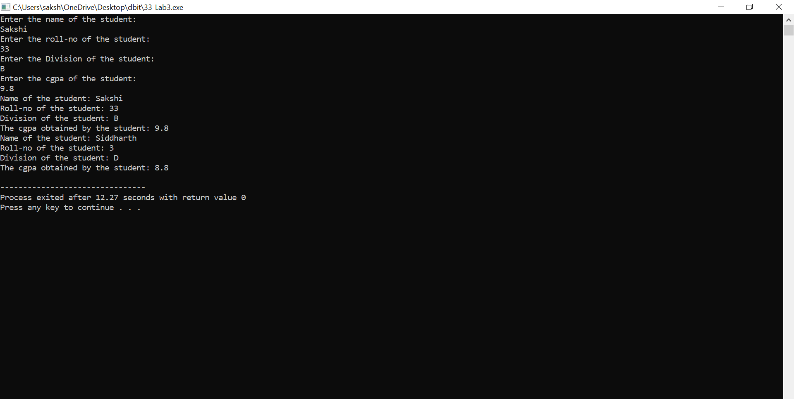

//Write a C++ program for Basic bank Management System
ALGORITHM:
- Create a class BankLab2 and declare all the variables required for the bank account.
- Create a constructor for class BankLab2 using parameters.
- Create functions for deposit, withdraw, and display for the bank account and write the work or code to be executed in the function with respect to the function name.
- Now in the main function declare two variables ‘ans’ and account number, create objects for class BankLab2 and give the values for the variables(parameters for constructor) in parenthesis,(as we have used constructor there is no separate step to call the constructor as when we create the objects constructor gets automatically called).
- Display the menu, ask the user to enter an option, declare and store the option value in a variable. Now using do-while loop display the menu to the user and ask for the user’s preferences. By using switch case perform the respective functions according to the user’s choice entered.
PROGRAM:
#include<iostream>
using namespace std;
class BankLab2 {
public:

string name;

char account_type;

int account_number,amount;

float balance;

BankLab2(string n,int a, char t, float b) {

name = n;

account_number=a;

account_type=t;

balance=b;

}

int deposit()

{

cout<<"Enter the amount to deposit: "<<endl;

cin>>amount;

if(amount<0)

{
cout<<"Invalid amount,Enter a valid amount"<<endl;

return 0;

}

balance=balance+amount;

return 1;

}

int withdraw()

{
cout<<"Your Balance= "<<balance<<endl;

cout<<"Enter amount to withdraw: "<<endl;

cin>>amount;

if (balance<amount)

{
cout<<"Insufficient Balance: "<<endl;

return 0;

}

if(amount<0)

{
cout<<"Invalid amount" <<endl;

return 0;

}

balance=balance-amount;

return 1;

}

void display()

{
cout<<"Name :"<<name<<endl;

cout<<"Account Number:"<<account_number<<endl;

cout<<"Account Type: "<<account_type<<endl;

cout<<"Balance: "<<balance<<endl;

}
};

int main()
{
char ans;
int account_number;

BankLab2 b1("salman",1,'s',2000);

BankLab2 b2("makarand",2,'s',2000);

BankLab2 b3("siddharth",3,'s',2000);

cout<<"Menu"<<endl;

cout<<"1.Deposit"<<endl;

cout<<"2.Withdraw"<<endl;

cout<<"3.Display"<<endl;

cout<<"Enter option"<<endl;

int op;
cin>>op;

do

{

cout<<"Please enter your account number: "<<endl;

cin>>account_number;

switch(account_number)

{

case 1: if(op==1)

b1.deposit();

if(op==2)

b1.withdraw();

if(op==3)

b1.display();

break;

case 2: if(op==1)

b2.deposit();

if(op==2)

b2.withdraw();

if(op==3)

b2.display();

break;

case 3: if(op==1)

b3.deposit();

if(op==2)

b3.withdraw();

if(op==3)

b3.display();

break;

default: cout<<"Enter value between 1 to 3"<<endl;

break;

}

cout<<"Do you want to continue?[Y/N]"<<endl;

cin>>ans;

if(ans=='Y' || ans == 'y')

{

cout<<"Menu"<<endl;

cout<<"1.Deposit"<<endl;

cout<<"2.Withdraw"<<endl;

cout<<"3.Display"<<endl;

cout<<"Enter option";

cin>>op;

}

}

while(ans!='N');

}
INPUT GIVEN: Account number=1, Amount to be deposited=7000

OUTPUT SCREENSHOT:

