Practical - 3

Practical 3: Responsive UI Design using CSS Grid, Flexbox, and Bootstrap/Tailwind
Design responsive layouts for Home, About, Registration, Dashboard, and Events pages using CSS Grid and Flexbox. Optional to use CSS framework such as Bootstrap or Tailwind. Ensure mobile-first responsiveness.

Theory
1. How does the layout adapt for mobile, tablet, and desktop screens?
Answer:

The website uses responsive web design so that it works properly on mobile, tablet, and desktop screens.

Mobile: The layout changes to a single-column design. Images and buttons become smaller, and the navigation menu is arranged for easier tapping on a small screen.

Tablet: The layout uses more screen space than mobile. Sections are spaced comfortably, and images and text are resized to provide a balanced view.

Desktop: The website displays its full layout with multiple sections side by side, larger images, and full navigation, making the best use of the wider screen.

This responsiveness is achieved using CSS media queries, Flexbox, and relative sizing so that the content automatically adjusts to different screen sizes while remaining easy to read and use.

2. Which layout technique is used and why?
Answer:
The website uses CSS Flexbox as the main layout technique.
Why Flexbox is used:
- It arranges elements in rows or columns easily.
- It automatically adjusts the layout for different screen sizes.
- It helps align and center content both horizontally and vertically.
- It provides equal spacing between elements.
- It makes the website responsive with less CSS code.

3. Are typography, spacing, colors, and contrast readable?
Answer:
Yes, the website follows good design principles for readability.
- Typography: A clear and readable font is used with appropriate font sizes for headings and body text.
- Spacing: Proper margins and padding provide enough space between elements, making the content easy to read.
- Colors: A consistent color scheme is used throughout the website to maintain a clean and professional appearance.
- Contrast: There is sufficient contrast between the text and background, ensuring that the content is easy to read and accessible to users.

4. Is the framework used consistently without unnecessary inline CSS?
Answer:
Yes, the framework is used consistently throughout the website. Styling is mainly handled through the external CSS file, which keeps the code organized and easy to maintain. Inline CSS is avoided except where absolutely necessary, ensuring a clean, consistent, and reusable design.

Implementation/ Output/Result
In this practical, we have made StudentHub portal

Evidence of Work (Screenshots)
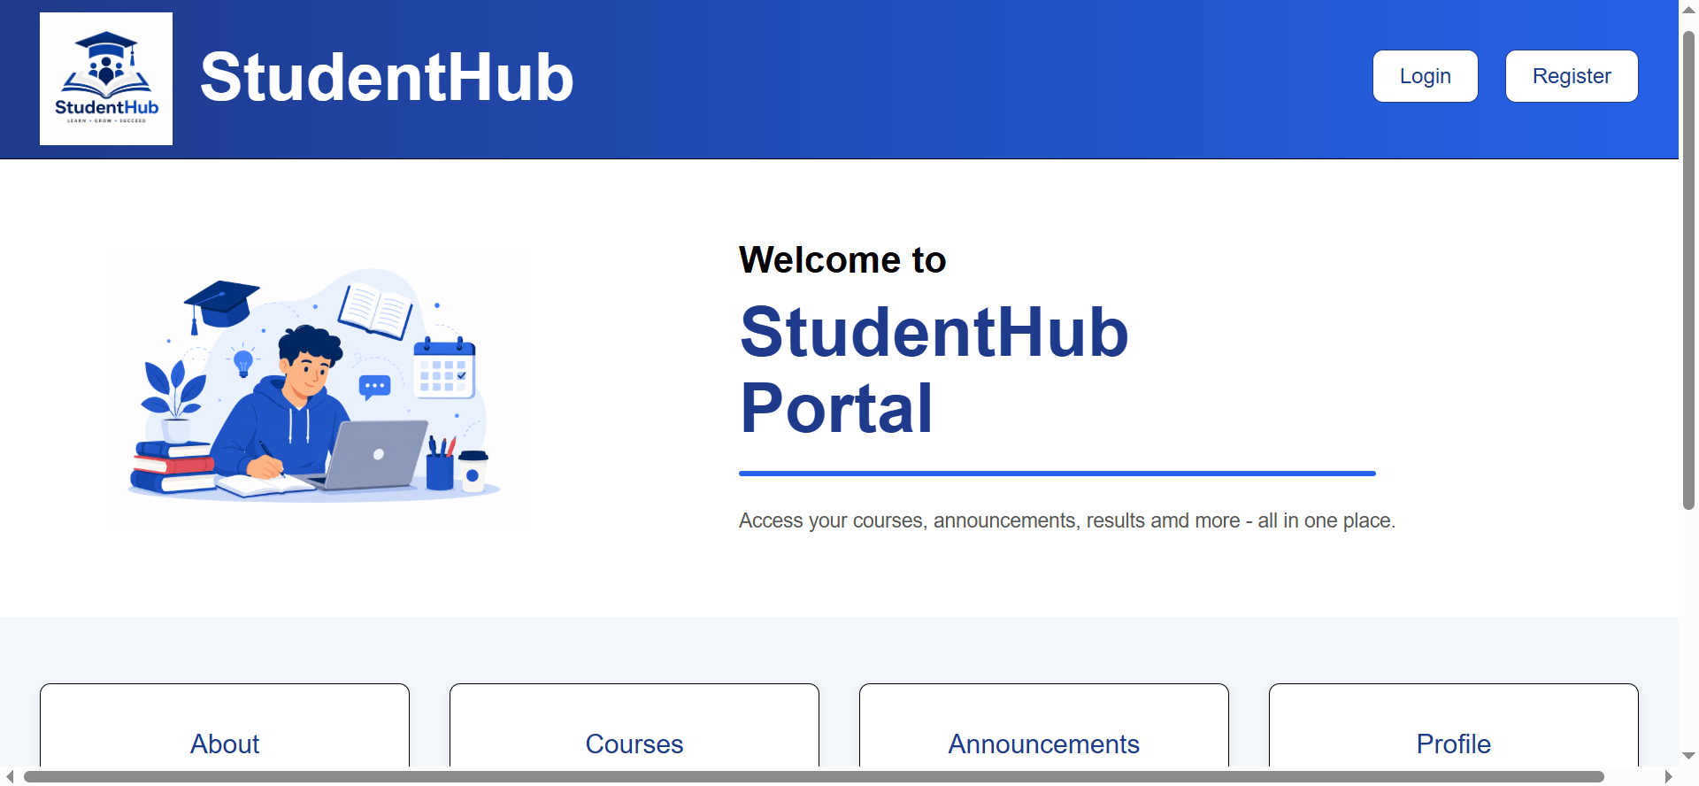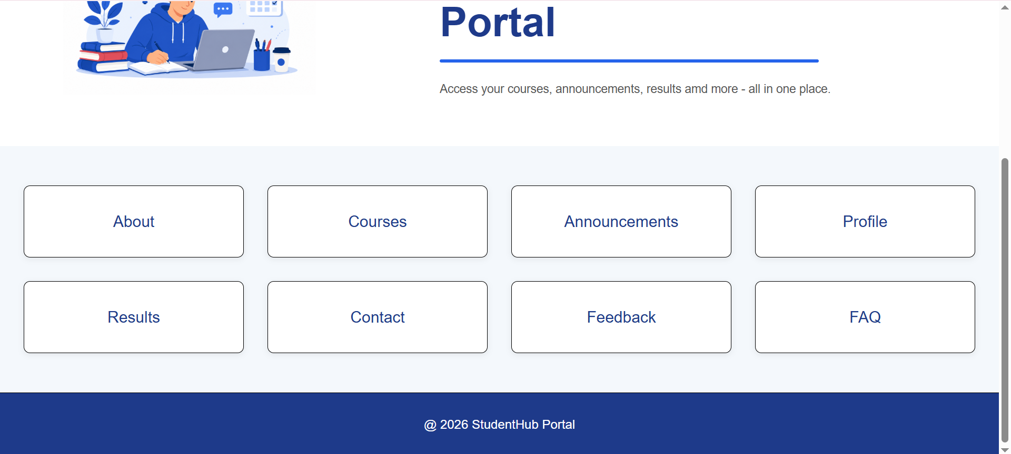
Figure 1.1
Description: Index page

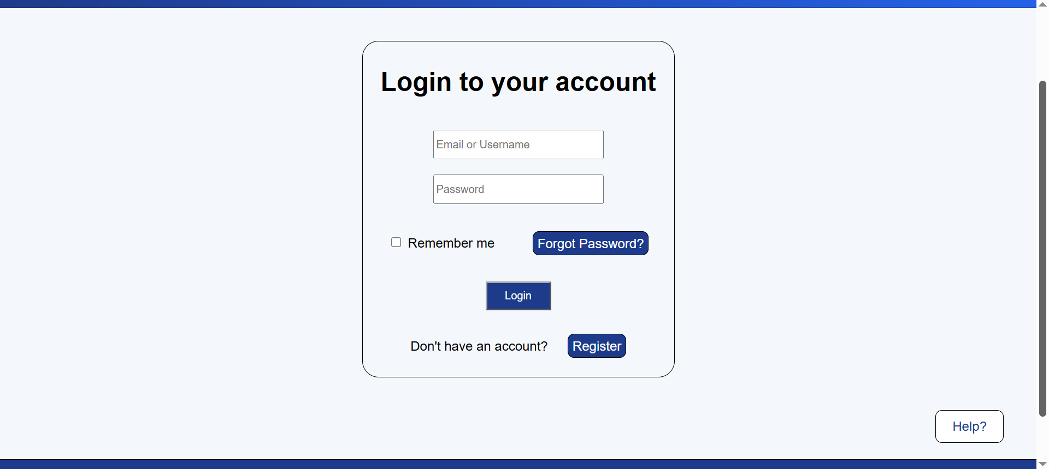
Figure 1.2:
Description: Login page
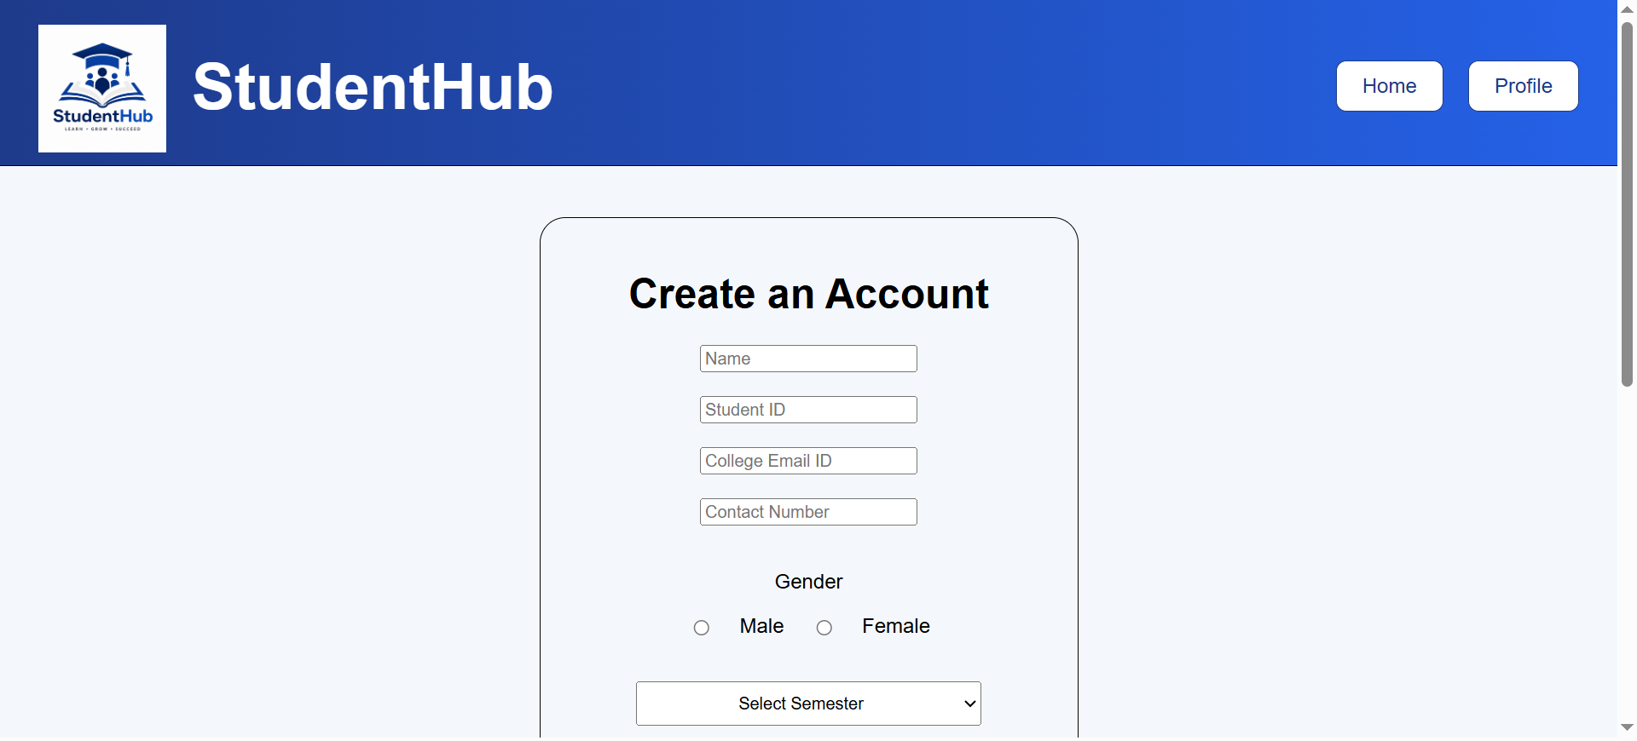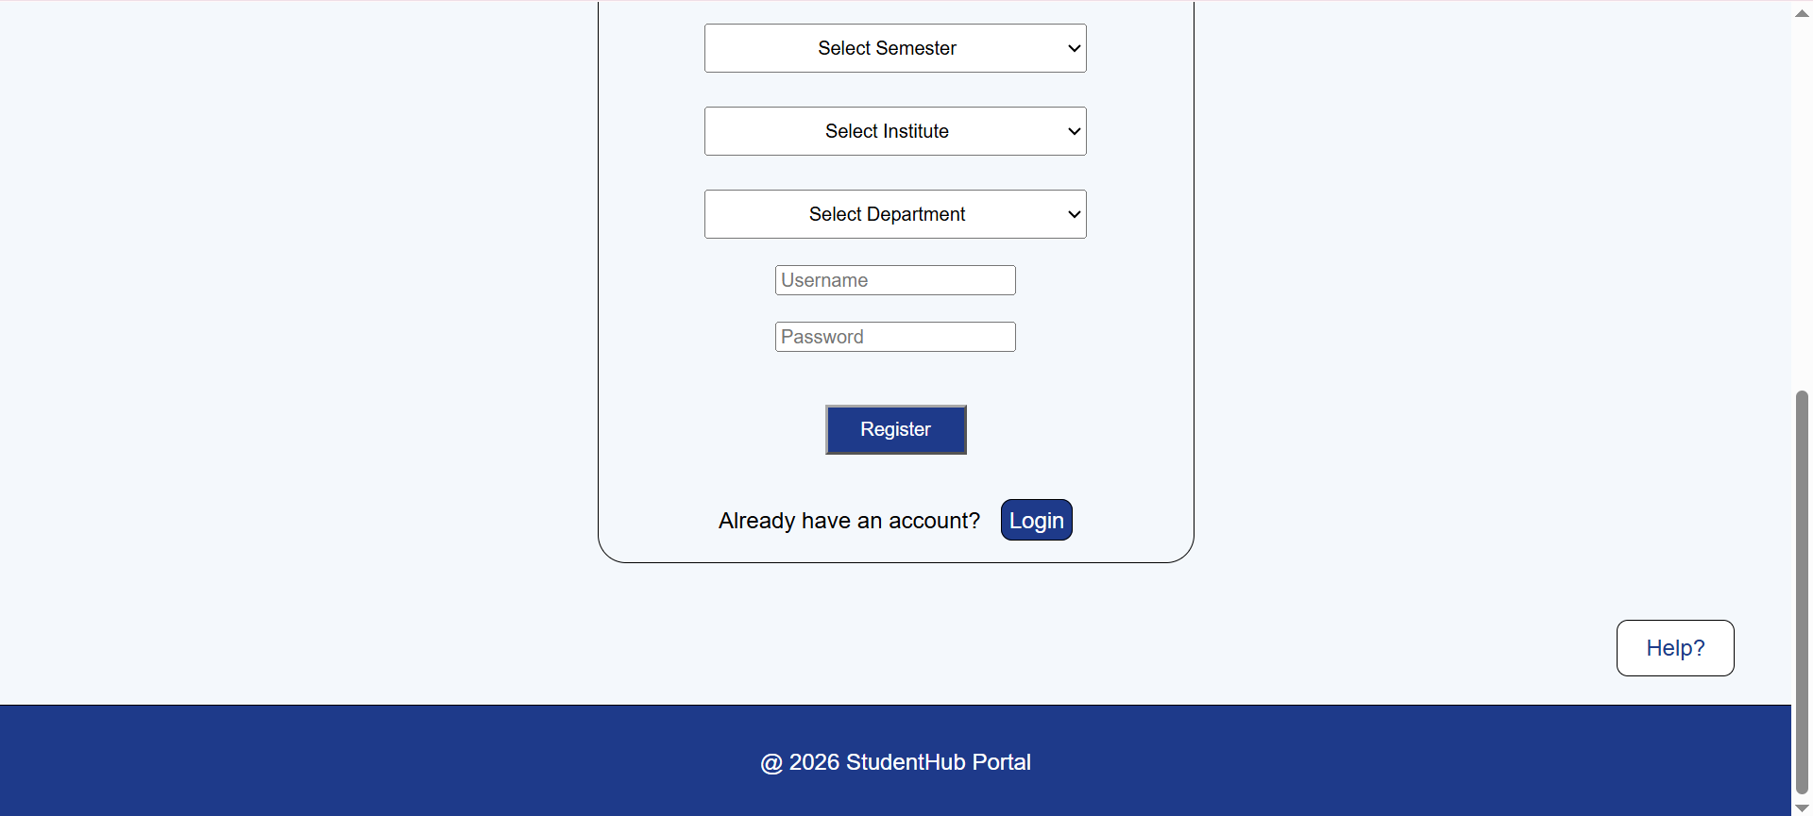
Figure 1.3
Description: Registration page
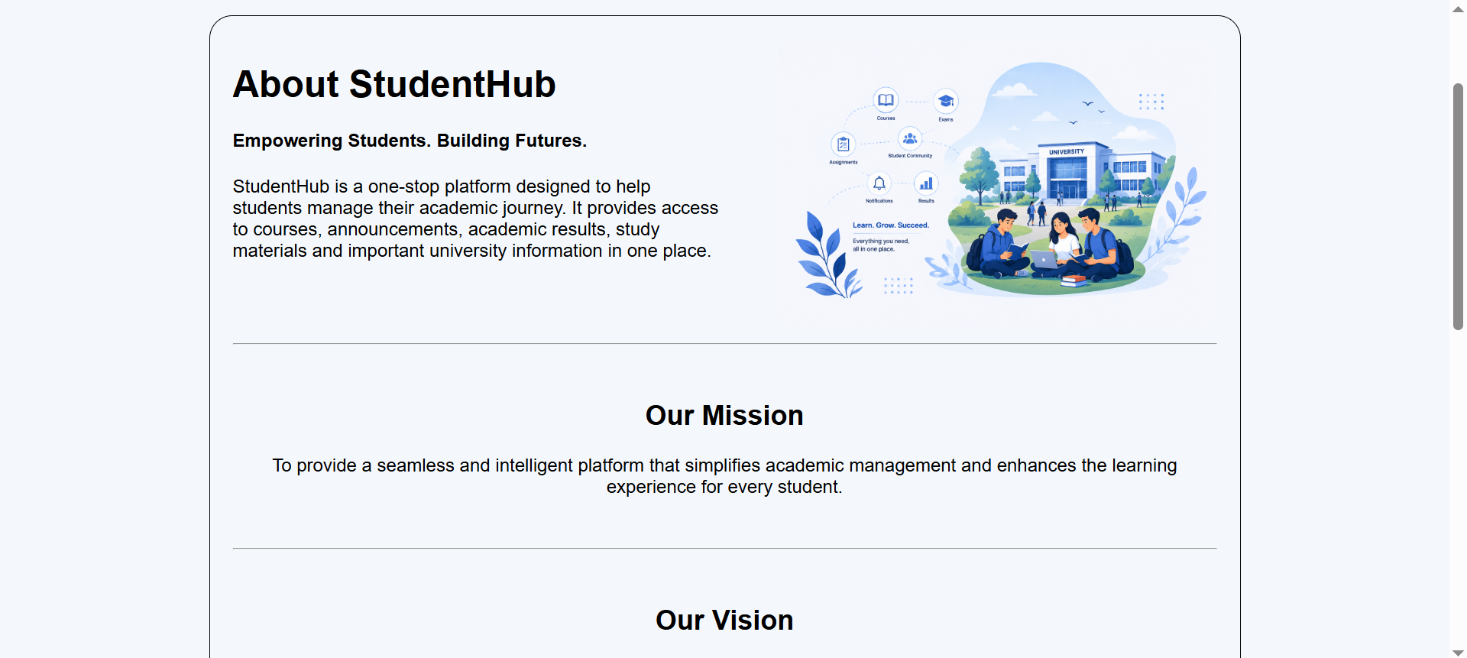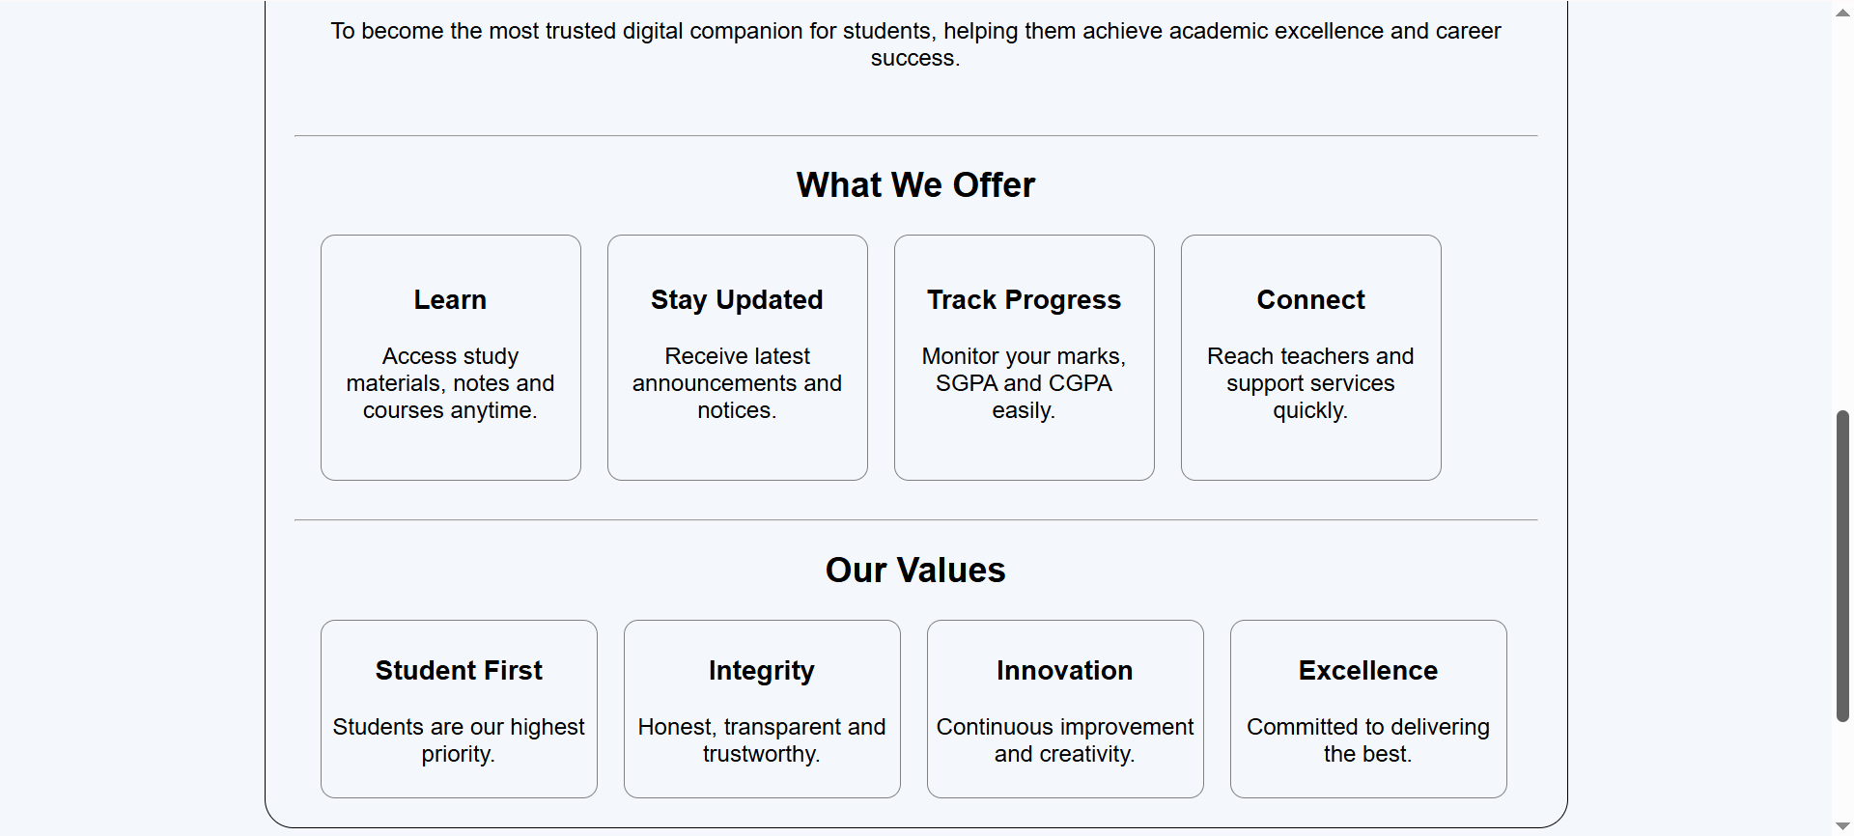
Figure 1.4
Description: About page

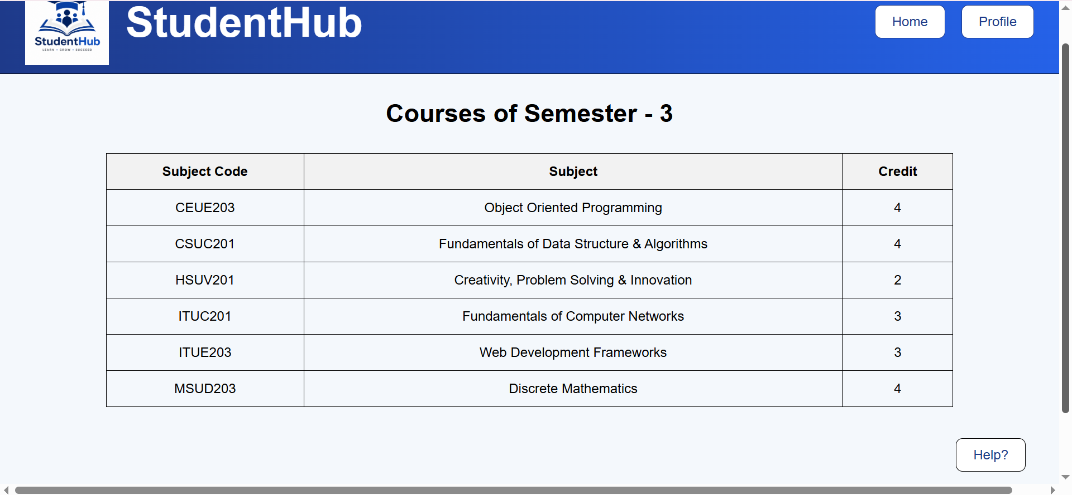
Figure 1.5
Description: Courses page

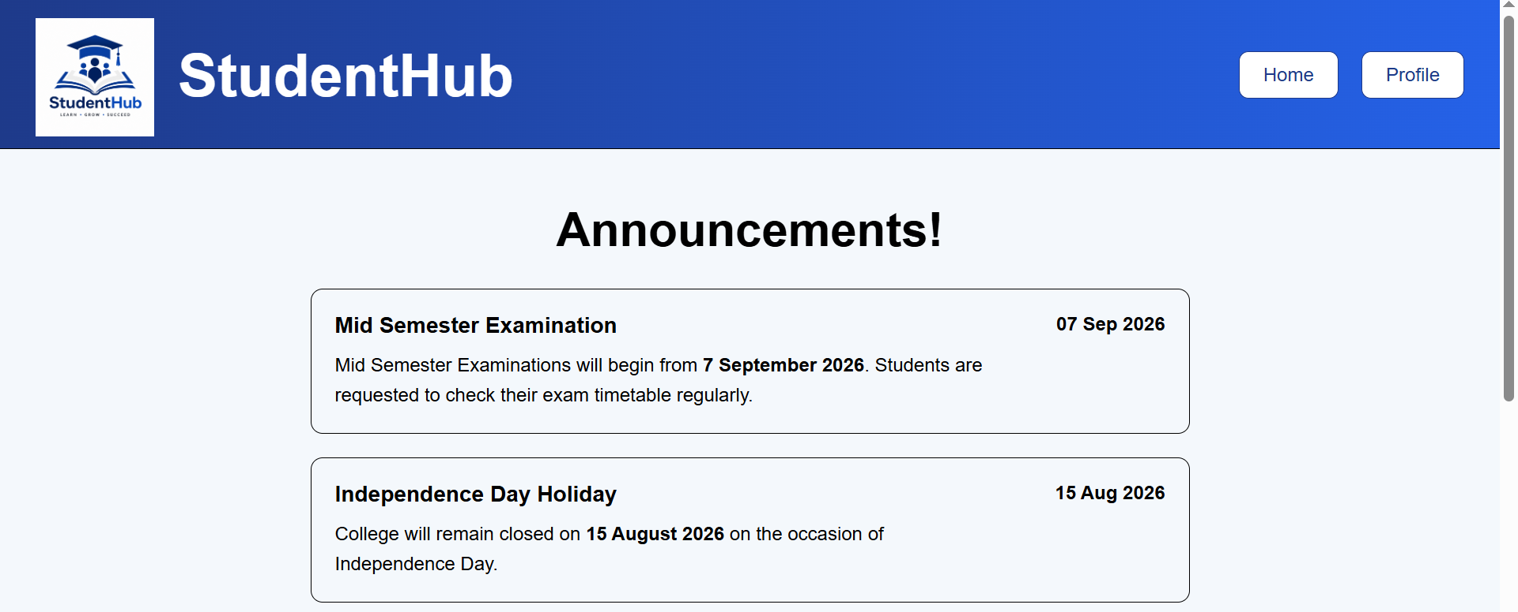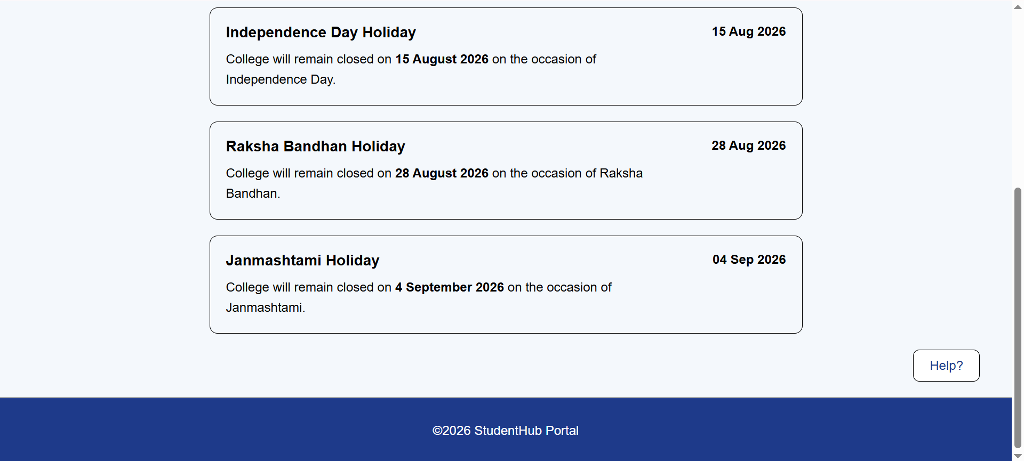
Figure 1.6
Description: Announcement page

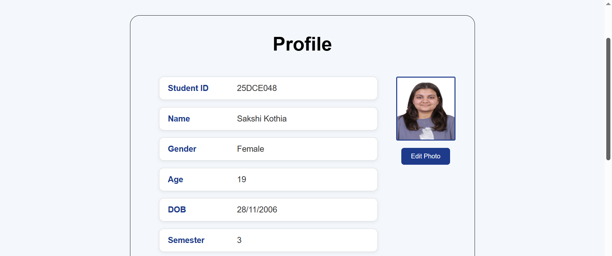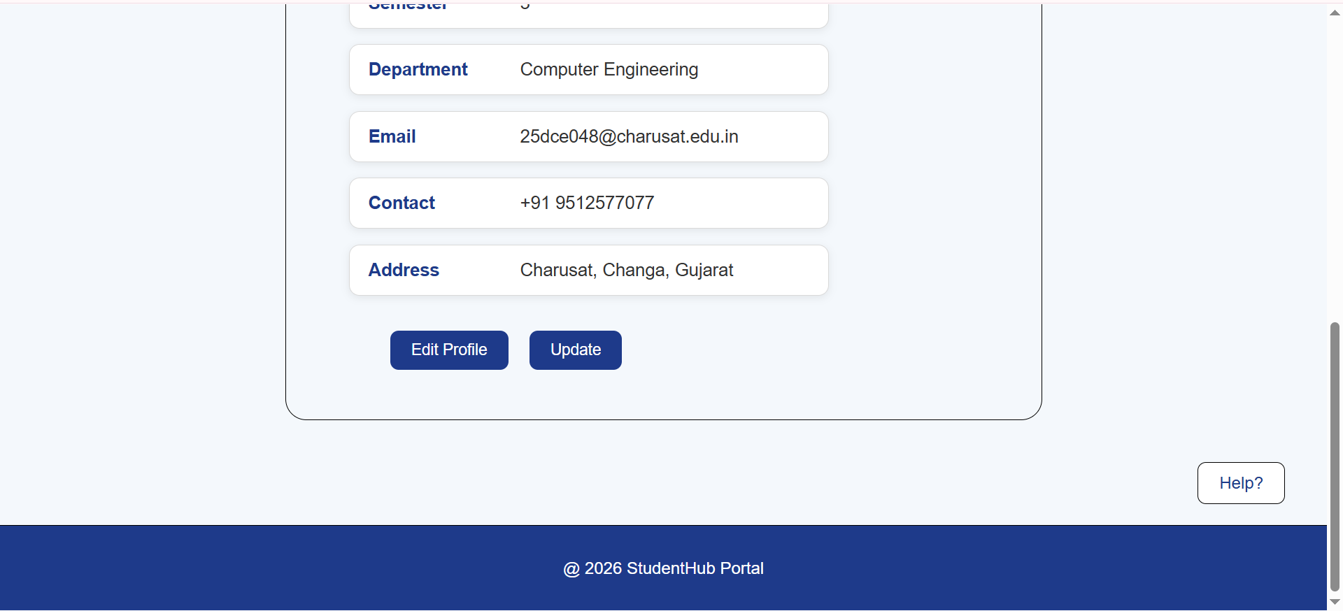
Figure 1.7
Description: Profile page

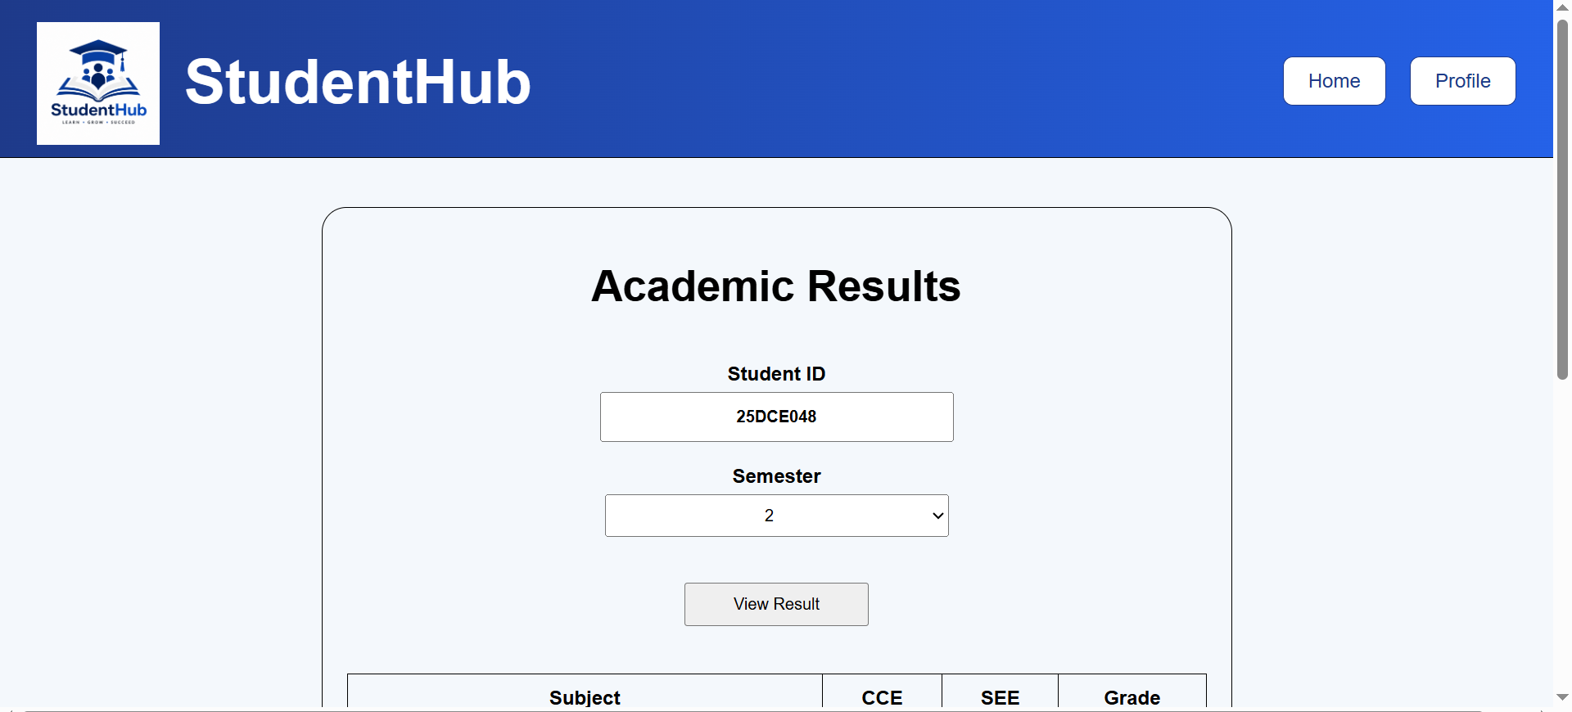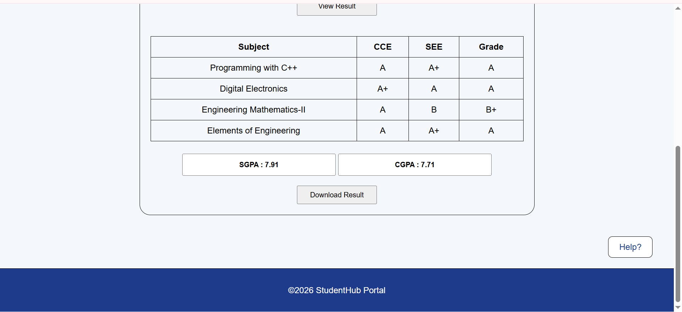
Figure 1.8
Description: Result page

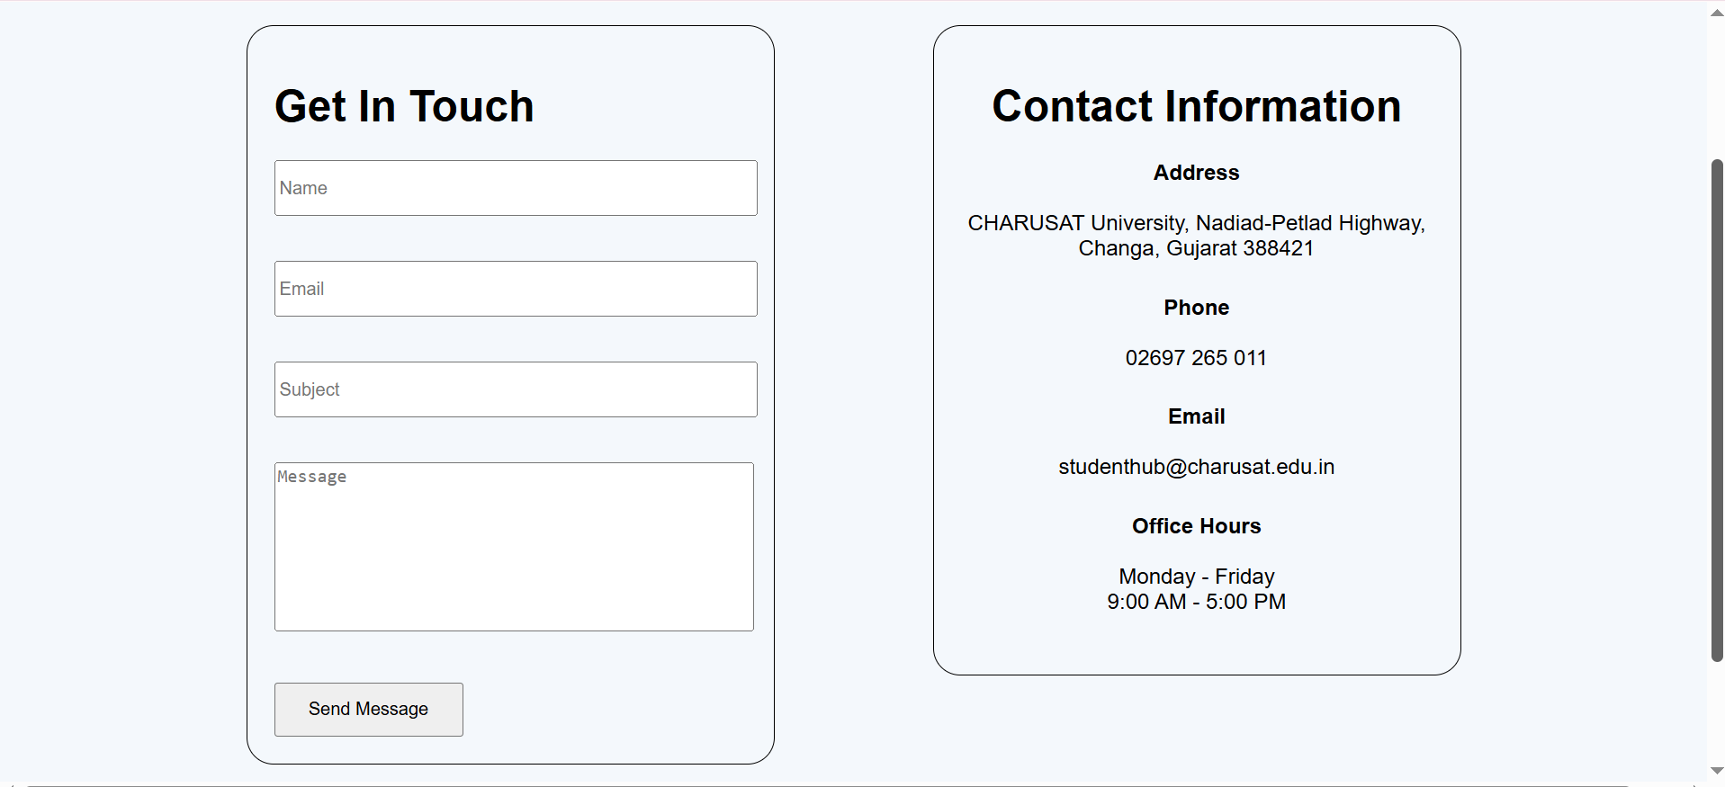
Figure 1.9
Description: Contact page

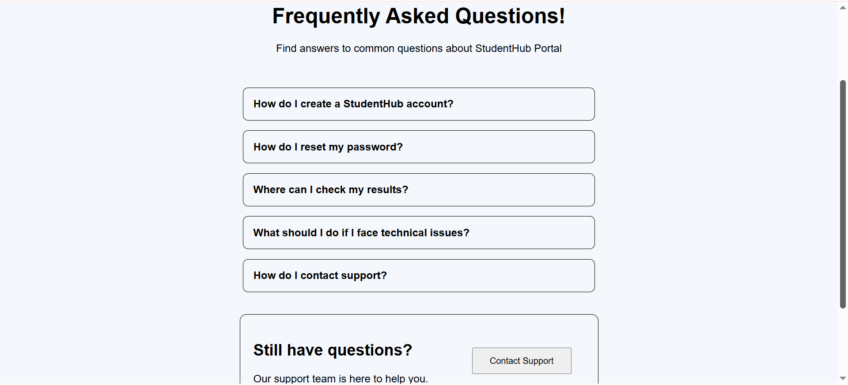
Figure 1.10
Description: FAQ page

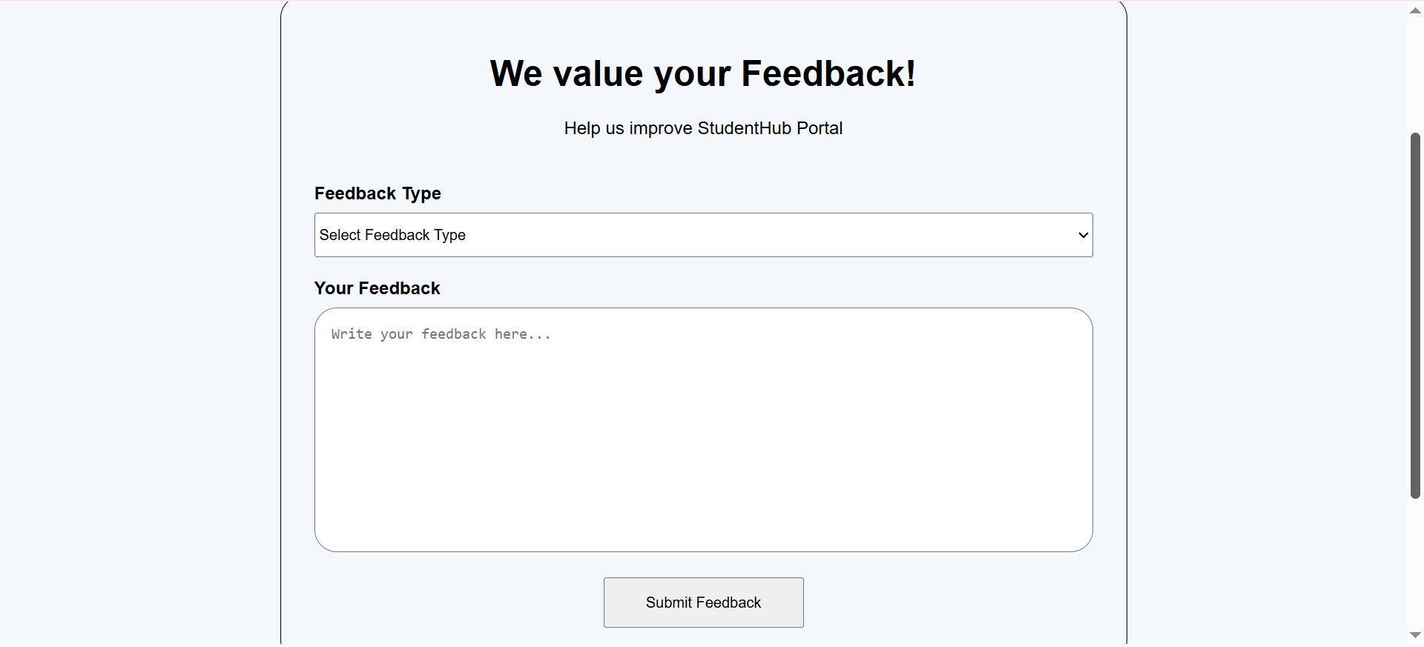
Figure 1.11
Description: Feedback page

GitHub Repository Link:

https://github.com/sakshikothia-28/WDF/tree/387a235c1718d54932832f9a55d81ac757024b7e/Practical-3

Challenges Faced:
- Maintaining proper alignment and spacing.
- Using CSS Grid and Flexbox effectively.
- Ensuring images and content resize correctly.
- Organizing CSS without unnecessary inline styles.

Learning Outcomes:
- Learned to create responsive web layouts using CSS Grid and Flexbox.
- Improved skills in creating clean, organized, and user-friendly web pages.
- Learned to maintain consistent styling using external CSS.

Faculty Remarks:

