Practical - 2

Practical 2: Semantic HTML5 Pages with Accessibility-Ready Structure Develop static HTML5 skeletons for at least 10 StudentHub pages such as Home, About, Register, Login, Dashboard, Events, Profile, Contact, Admin, FAQ, and Feedback. Use semantic tags and accessibility-friendly structure.

Theory

Are semantic tags such as header, nav, main, section, article, aside and footer used properly?
Answer:
Yes, semantic tags of HTML5 are used properly here. They are used to organize the webpages in a meaningful way. The purpose of these are as follows:
- <header> - contains the website title, logo, or page heading.
- <nav> - contains navigation links to other pages such as Home, About, etc.
- <main> - contains the main content of the websites.
- <section> - groups related content into sections, such as announcements, etc.
- <article> - represents independent content.
- <aside> - contains supplementary information.
- <footer> - contains copyright information, contact details, social media links, or other footer content.

Are form labels, headings, image alt text, and navigation links accessible?
Answer:
Yes, the website follows these accessibility features to make it easy for users to navigate.
- Form labels – users can know what information is to be given to that particular content.
- Headings – to differentiate the most important and least important contents.
- Image alt text – descriptive information about the image in case the image is not properly displayed.
- Navigation links – they are clearly labelled so that user can switch pages without getting confused.

Is the page structure consistent across all pages?
Answer:
Yes, all webpages follow the common structure to provide a consistency across all pages and it helps user find information quickly and effectively. It gives user a smooth experience.

Implementation/ Output/Result
In this practical, we have made webpages with the help of ‘HTML’.

Evidence of Work (Screenshots)
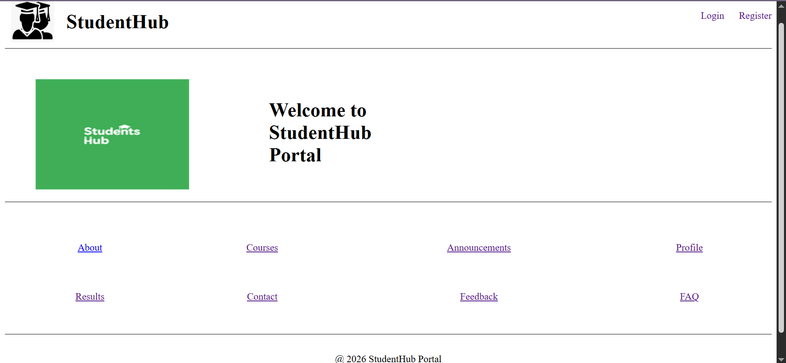
Figure 1.1
Description: Index page

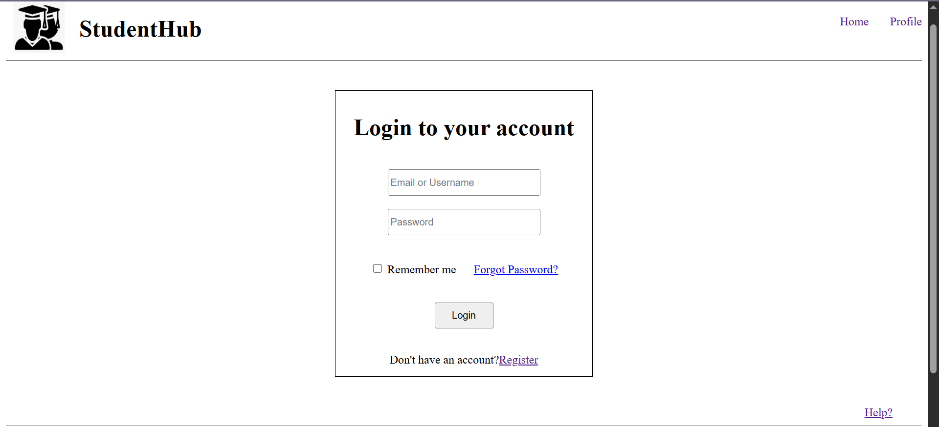
Figure 1.2
Description: Login page
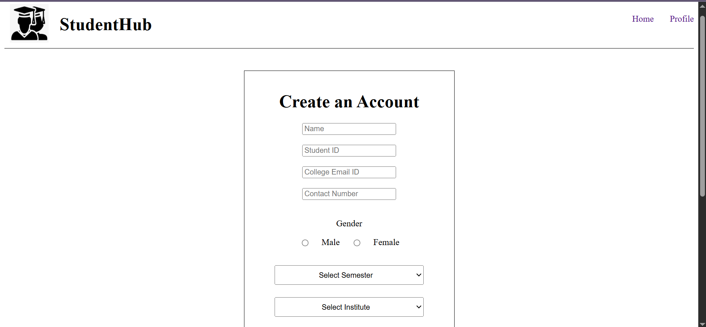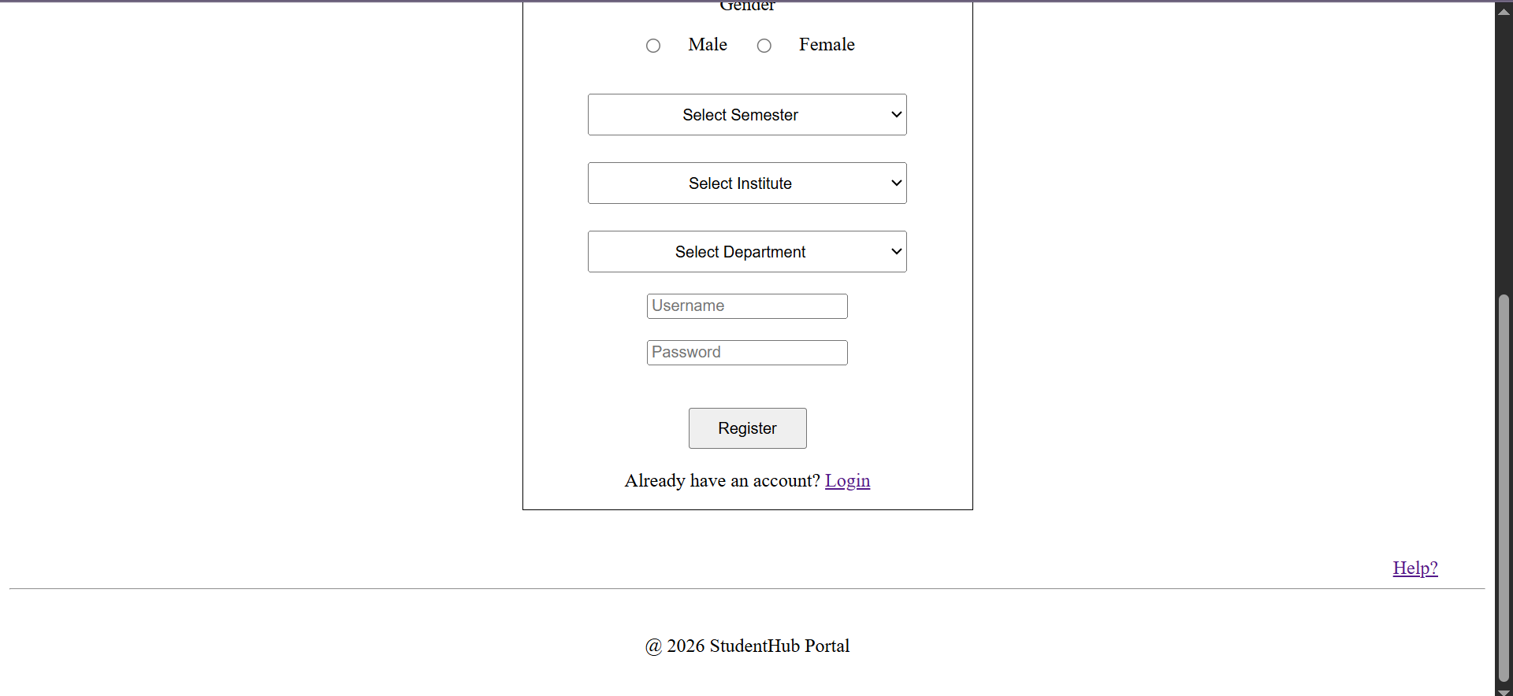
Figure 1.3
Description: Registration page

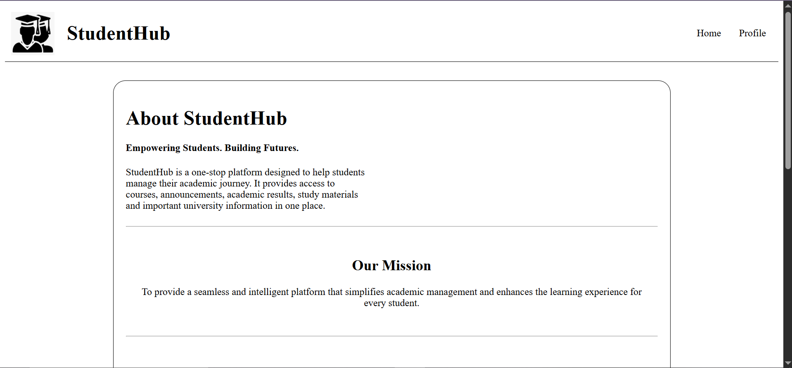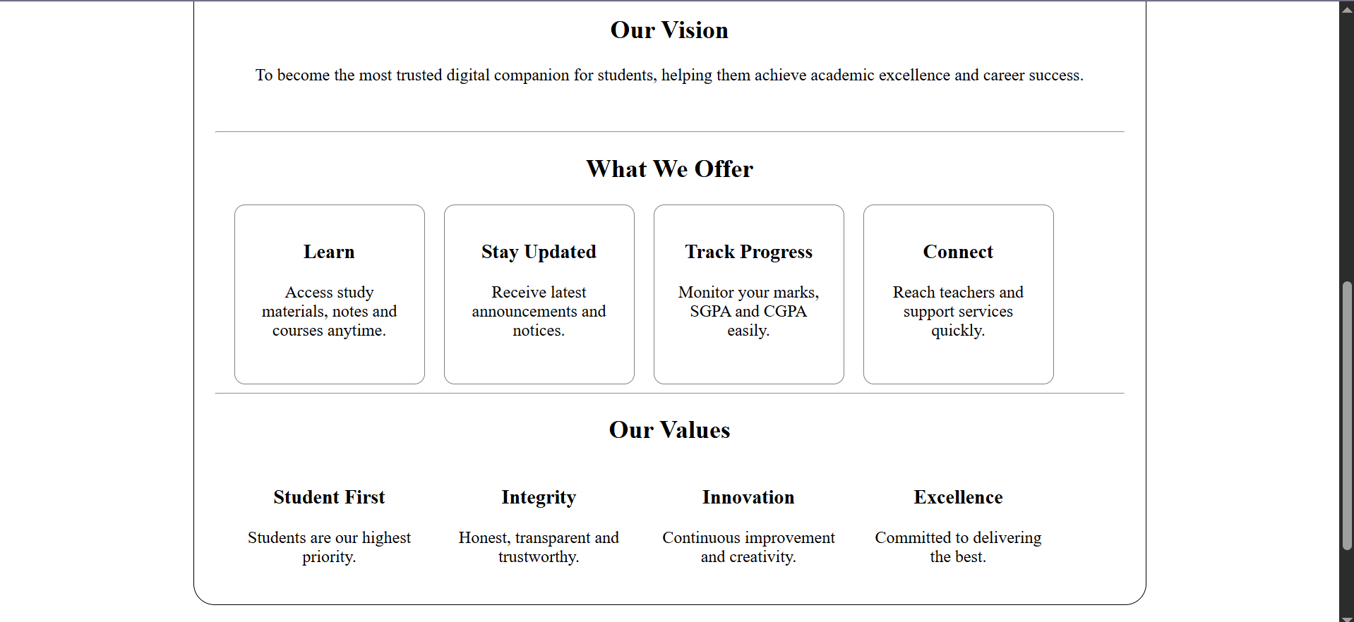
Figure 1.4
Description: About page

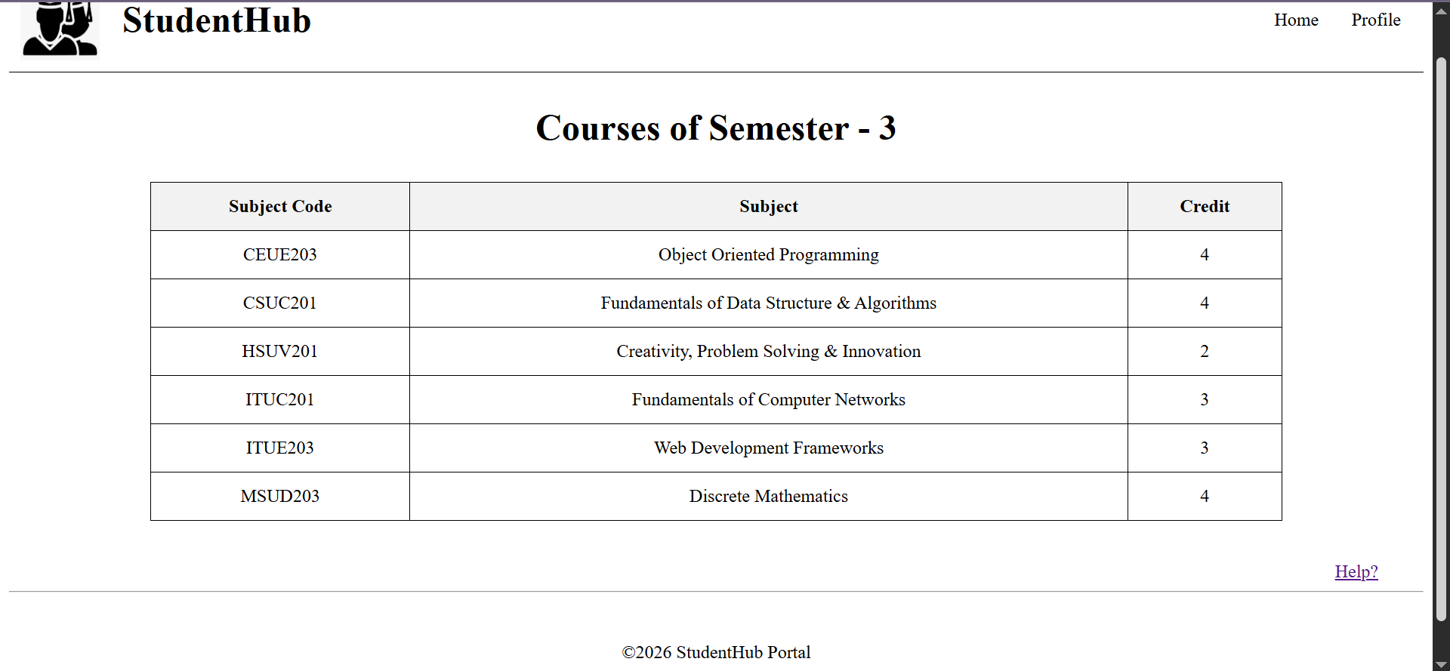
Figure 1.5
Description: Courses page

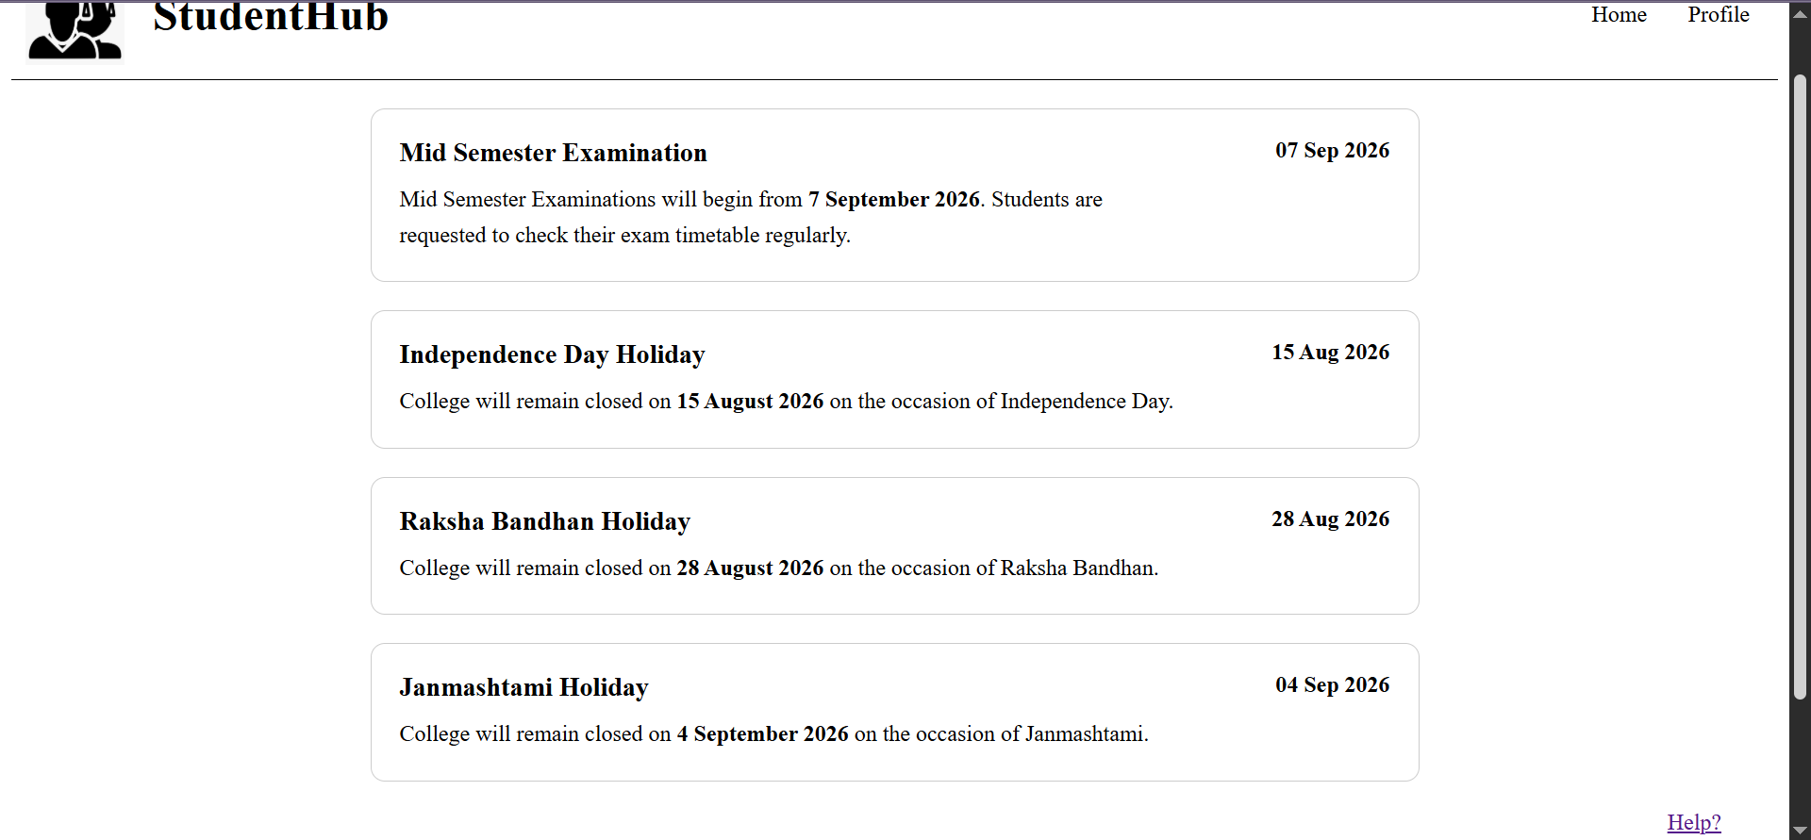
Figure 1.6
Description: Announcement page

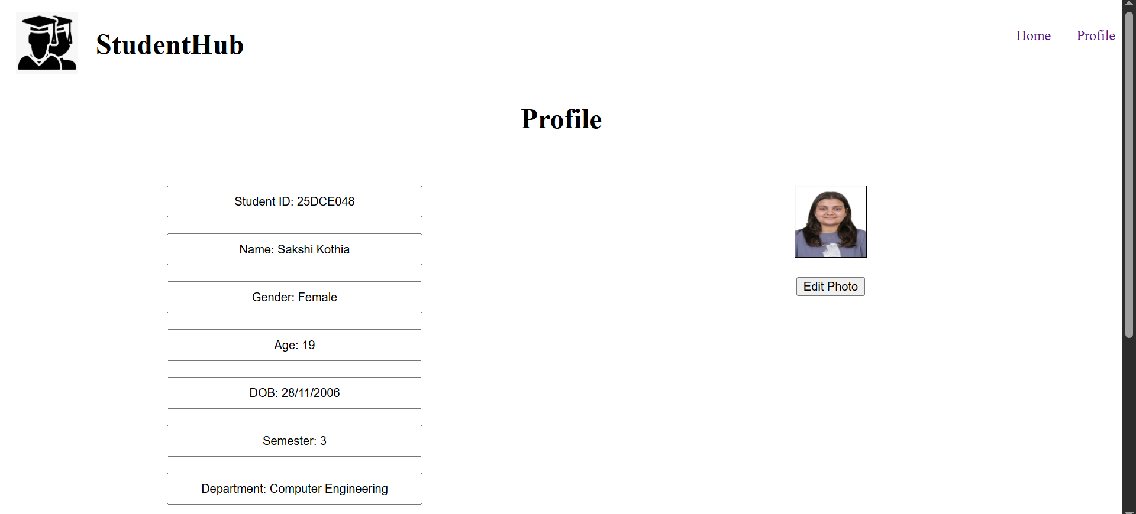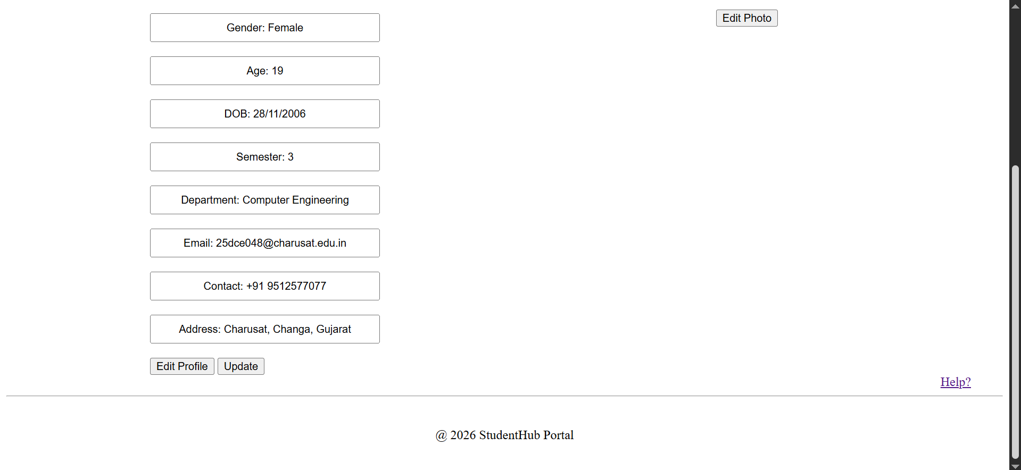
Figure 1.7
Description: Profile page

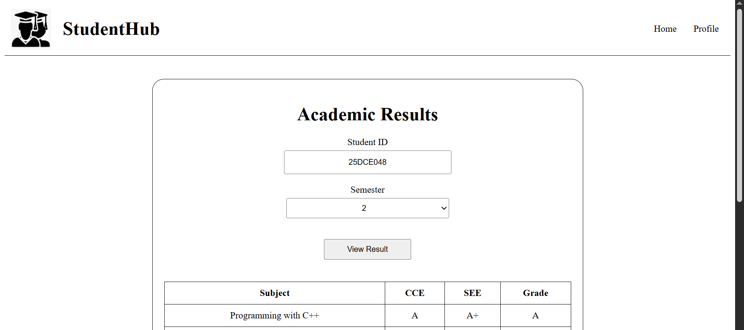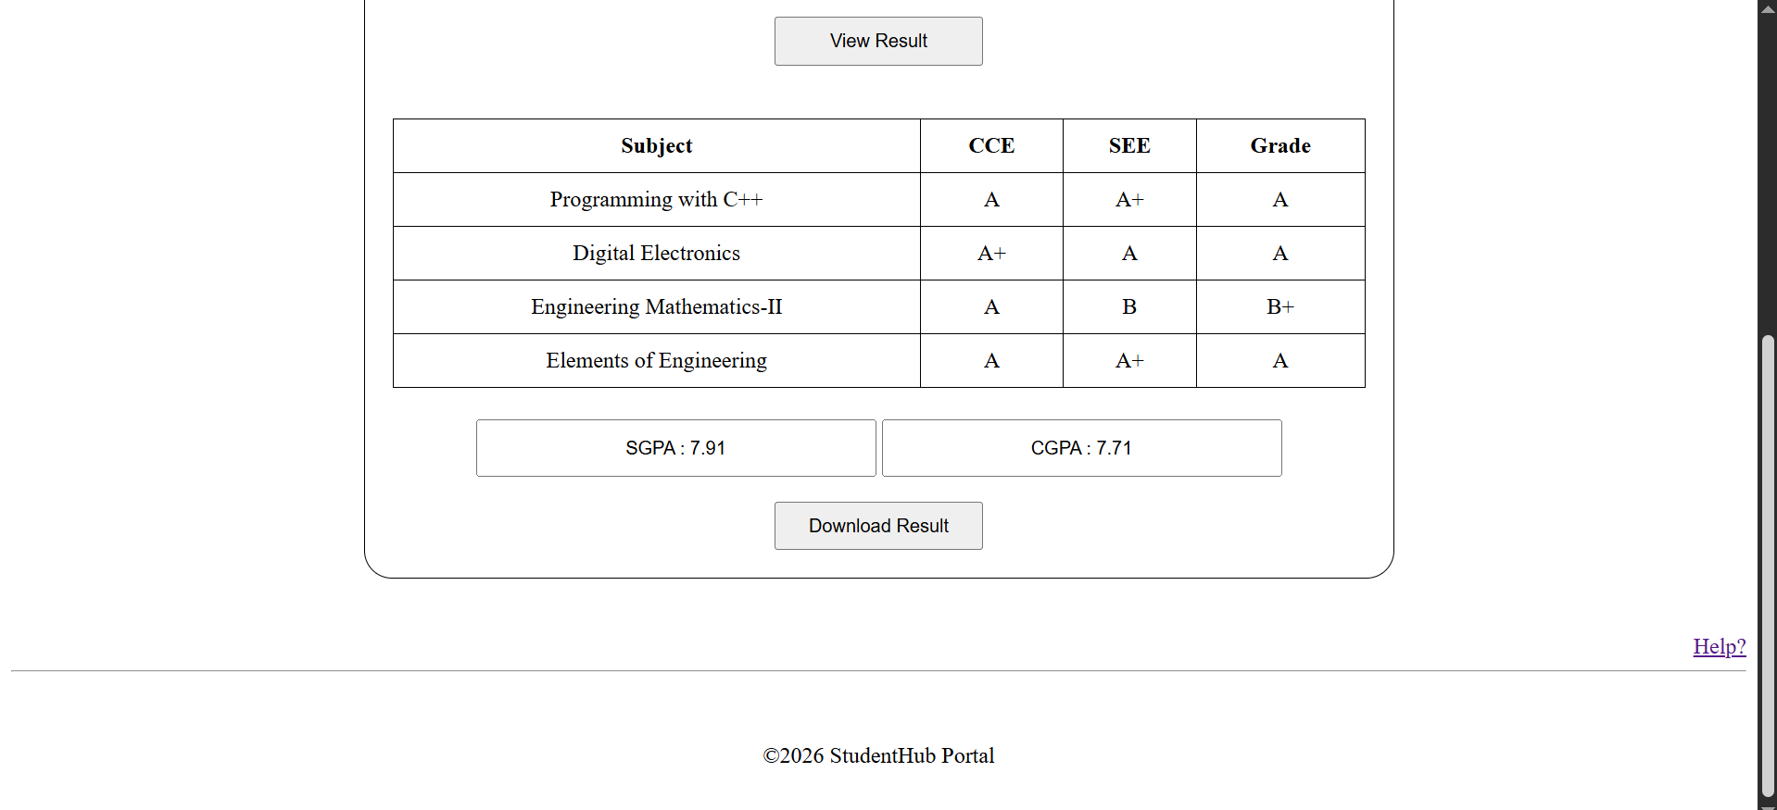
Figure 1.8
Description: Result page

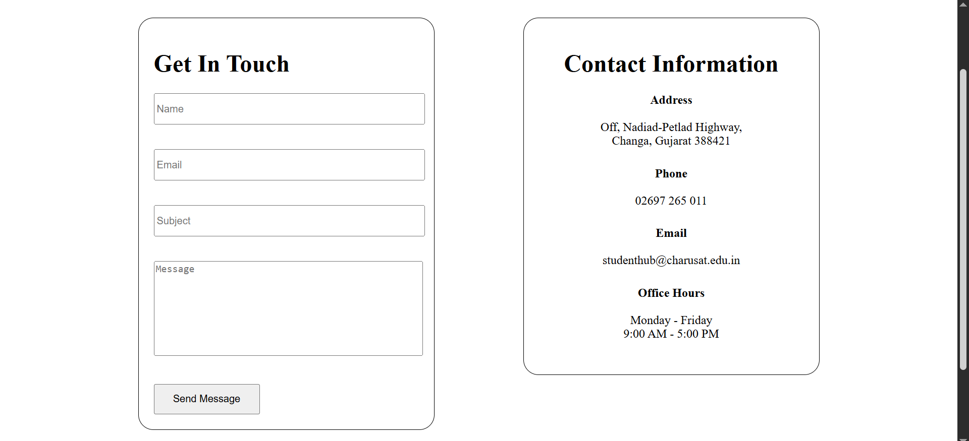
Figure 1.9
Description: Contact page

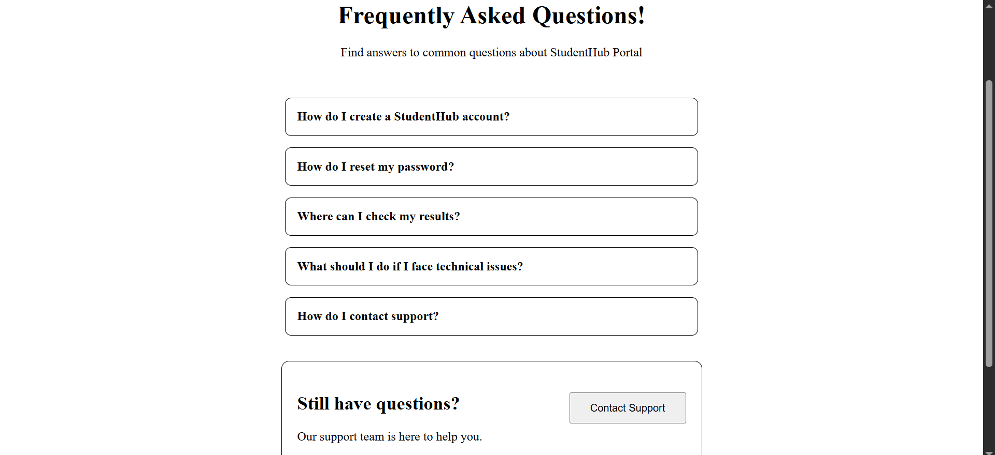
Figure 1.10
Description: FAQ page

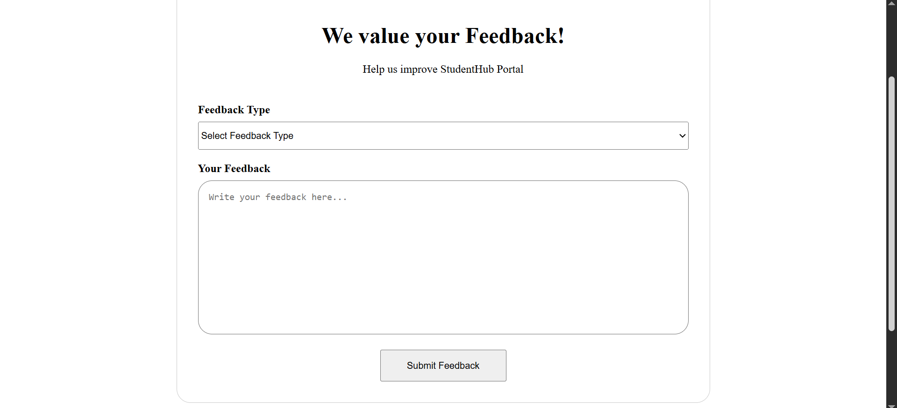
Figure 1.11
Description: Feedback page

GitHub Repository Link:

https://github.com/sakshikothia-28/WDF/tree/bff904b82faadce8f17fa1cecd6614ce93d7adfd/Practical-2

Challenges Faced:
- To ensure that all the pages are properly linked and are properly navigated.
- To ensure that website is smooth to operate and the content is proper for a StudentHub portal.

Learning Outcomes:
- How to create webpages and websites using semantic HTML5 tags.
- How to use certain tags like <nav>, <section>, <article> to make the webpages structured and not complicated.

Faculty Remarks:

