Practical - 4

Practical 4: JavaScript DOM Manipulation, Event Handling, and UI Interactivity
Add dynamic UI components such as collapsible FAQ, modal popup, image/content slider, notification banner, hamburger menu, and light/dark theme switcher using JavaScript.

Theory
1. How are DOM elements selected and modified?
Answer:
DOM elements are selected using methods like:
- document.getElementById()
- document.querySelector()
- document.querySelectorAll()
They can be modified using properties like:
- element.innerHTML
- element.textContent
- element.style
- element.setAttribute()

2. Are event listeners attached correctly?
Answer:
Yes. Event listeners are attached using:

element.addEventListener("click", function() {
// code to execute
});

They listen for an event (such as click) and execute a function when it occurs.

3. Is localStorage used for remembering theme choice?
Answer:
Yes. localStorage can store the user's theme choice so it remains saved even after refreshing or reopening the website.

localStorage.setItem("theme", "dark");

4. Does interactivity improve usability without breaking accessibility?
Answer:
Yes. Interactivity improves usability when it is easy to use, keyboard-accessible, and does not prevent users from accessing content or features.

Implementation/ Output/Result
We have implemented Javascript in this practical to the login and register page.

Evidence of Work (Screenshots)
- Login Page
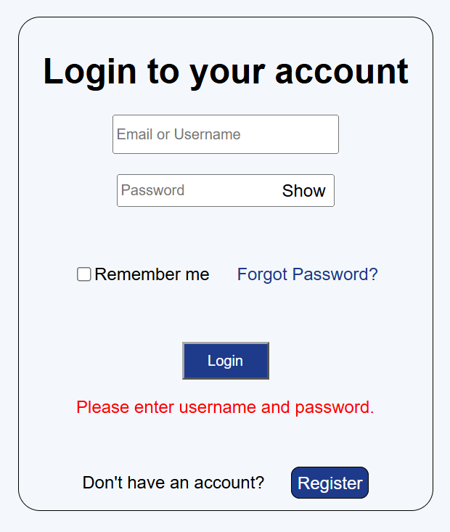
- Register Page
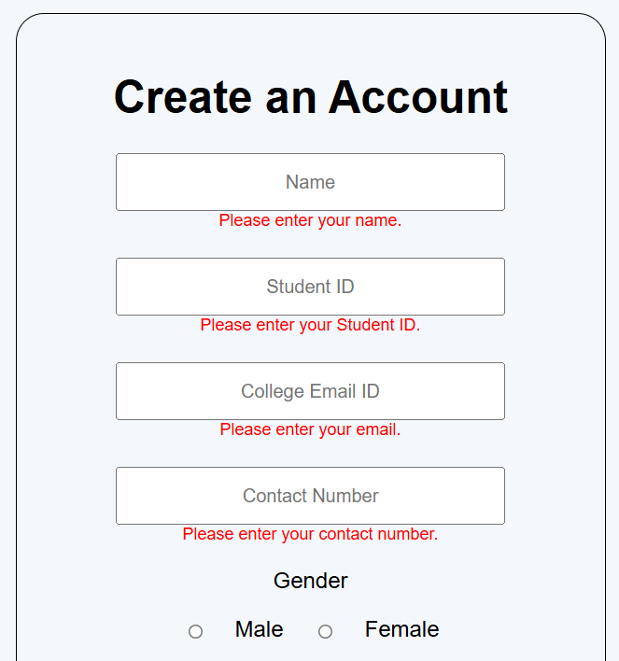
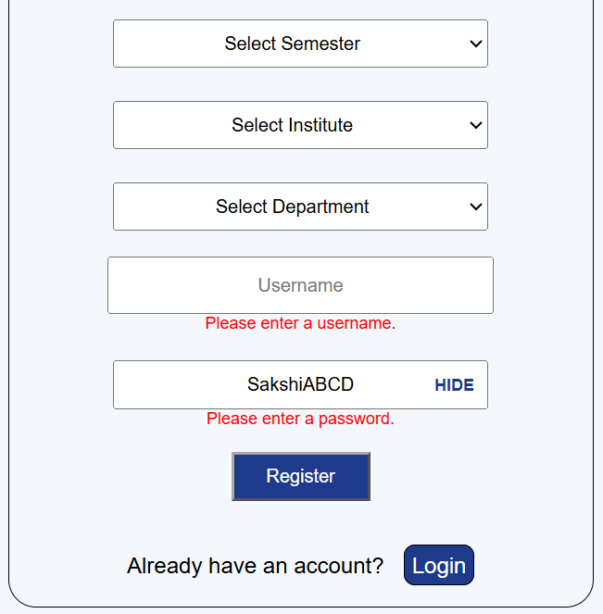

GitHub Repository Link:
https://github.com/sakshikothia-28/WDF/tree/1cc7ea62700f03558d7cb94ec4683ff3ca78856f/Practical-4

Challenges Faced:
- Understanding DOM manipulation and events
- Debugging JavaScript errors
- Managing localStorage data
- Ensuring accessibility and responsiveness

Learning Outcomes:
- Learned to make websites interactive
- Improved DOM and event handling skills
- Learned to store user preferences using localStorage
- Improved problem-solving and debugging skills

Faculty Remarks:

