Practical - 1
Practical Title: Project Initiation, Requirement Analysis, Sitemap, Wireframe, and GitHub Setup

Problem Definition: Initiate the semester-long StudentHub portal by identifying the problem scope, user roles, key modules, navigation flow, and minimum 10 pages. Create a sitemap, low-fidelity wireframe, project folder structure, README file, and GitHub repository.

Theory

What is URL and parts of URL?
Answer:
A URL (Uniform Resource Locator) is a unique address used to locate and access the resources on internet. It is also used to access web pages, files, images and many other online resources.
- Parts of URL
- Scheme
- Subdomain
- Domain
- Top-level domain (TLD)
- Port number
- Path
- Query string separator
- Query string/ parameters
- Fragment

How does HTML file process in web browser?
Answer:
Processing of an HTML file in a web browser:
- Browser requests and receives the HTML file.
- HTML parser reads the document.
- Browser creates the DOM (Document Object Module).
- CSS is loaded and converted into the CSSOM (CSS Object Module).
- DOM and CSSOM are combined to form the Render Tree.
- Browser calculates the layout of elements.
- Browser paints the webpage on the screen.
- JavaScript executes and updates the page if required.

3. How will page navigation flow managed among all HTML pages?
Answer:
Page navigation among HTML pages is managed using hyperlinks (<a> tags). Each link contains an ‘ href ’ attribute that specifies the destination page. When the user clicks a link, the browser loads the corresponding HTML file, allowing users to move from one page to another. Navigation bars, menus, and buttons are commonly used to provide easy access to different pages of a website.

4. How will GitHub commits be maintained after each practical?
Answer:
GitHub commits are maintained by creating a new commit after completing each practical. Each commit includes a meaningful message describing the work done. The changes are then pushed to the GitHub repository, creating a version history that helps track progress, collaborate with others, and restore previous versions if required.

Implementation/ Output/Result
In this practical, we have made wireframes with the help of ‘ draw.io ‘.

Evidence of Work (Screenshots)
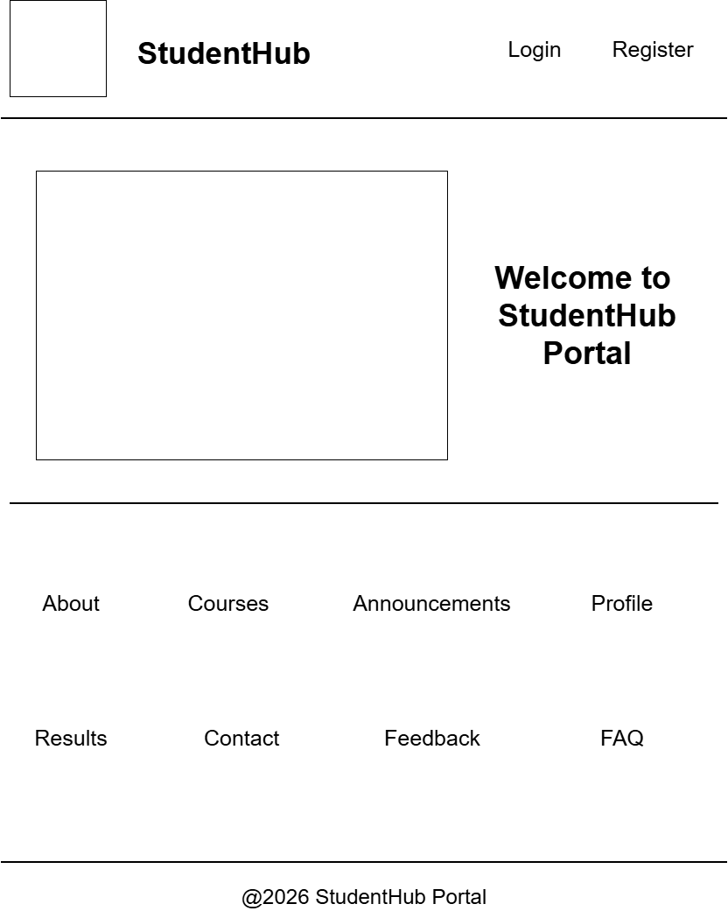
Figure 1.1
Description: Wireframe of Index page

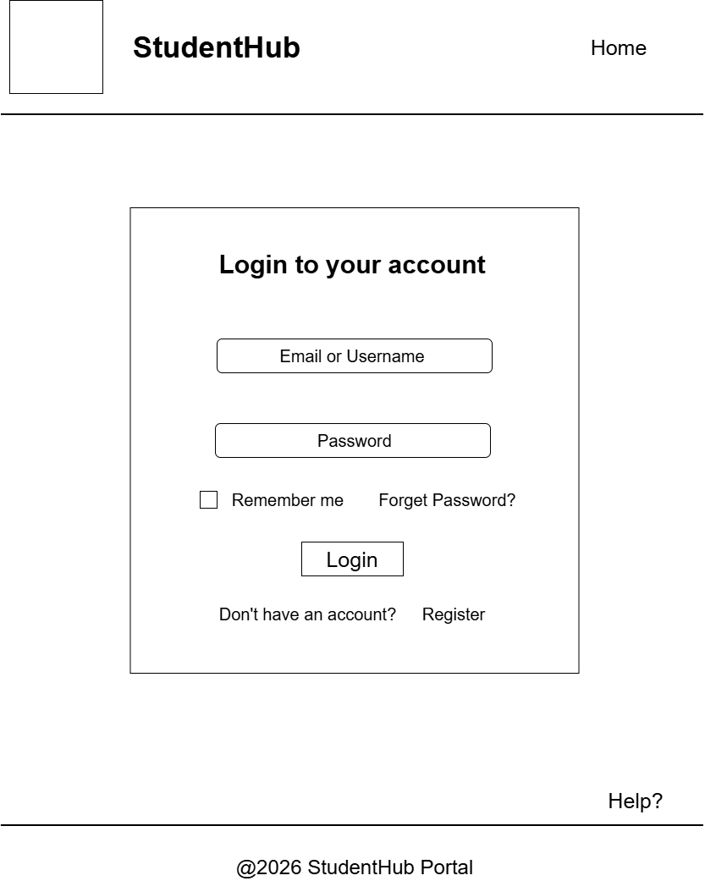
Figure 1.2
Description: Wireframe of Login page

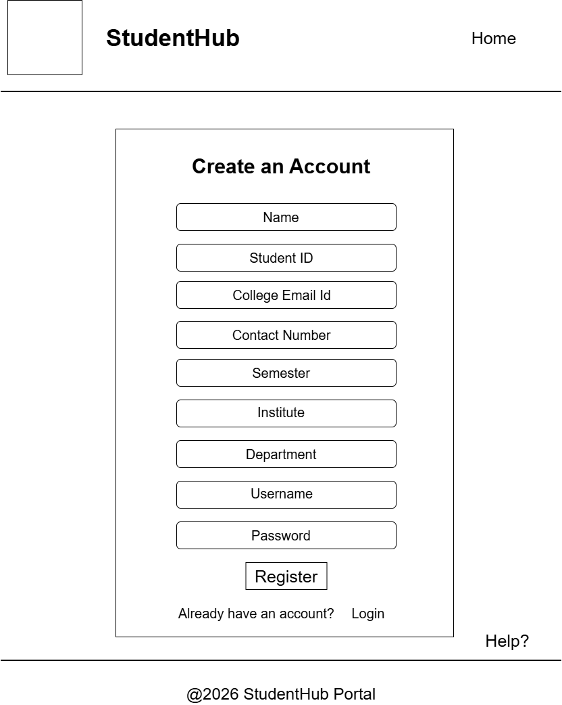
Figure 1.3
Description: Wireframe of Registration page

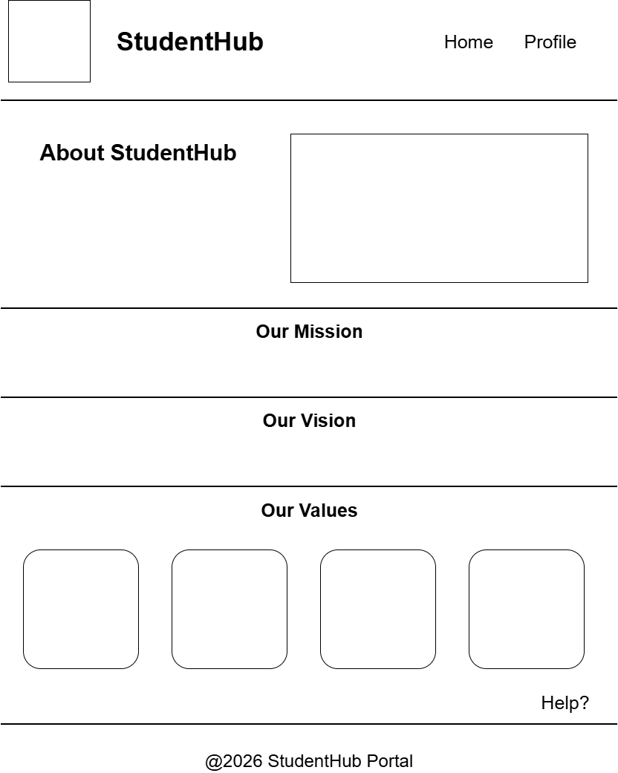
Figure 1.4
Description: Wireframe of About page

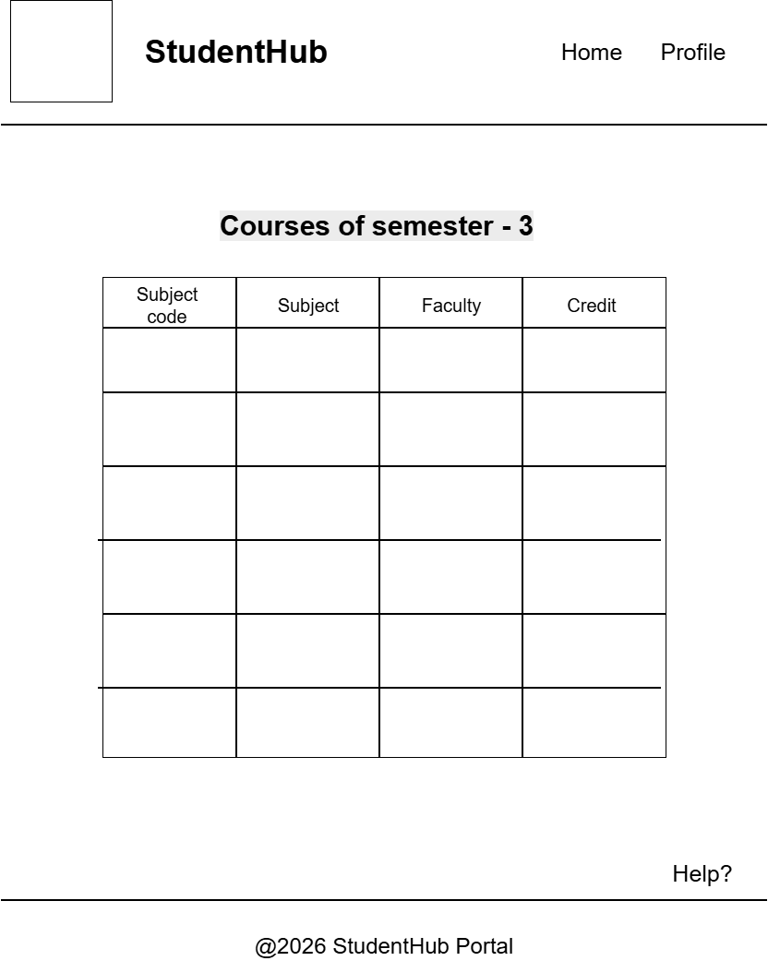
Figure 1.5
Description: Wireframe of Courses page

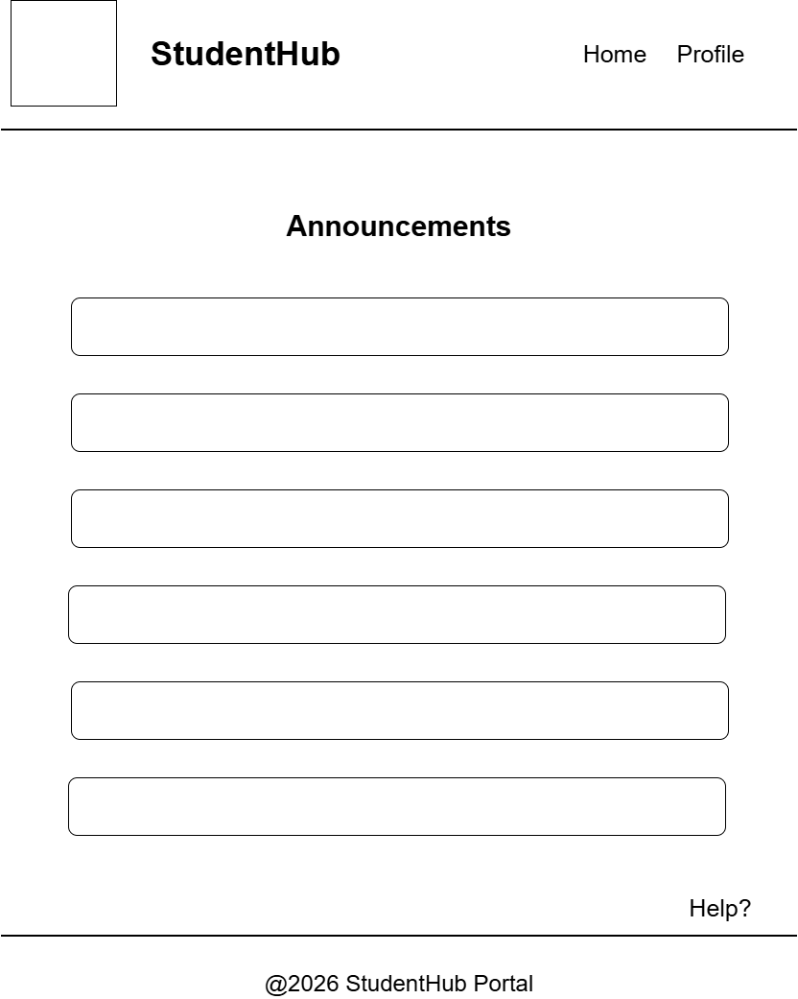
Figure 1.6
Description: Wireframe of Announcement page

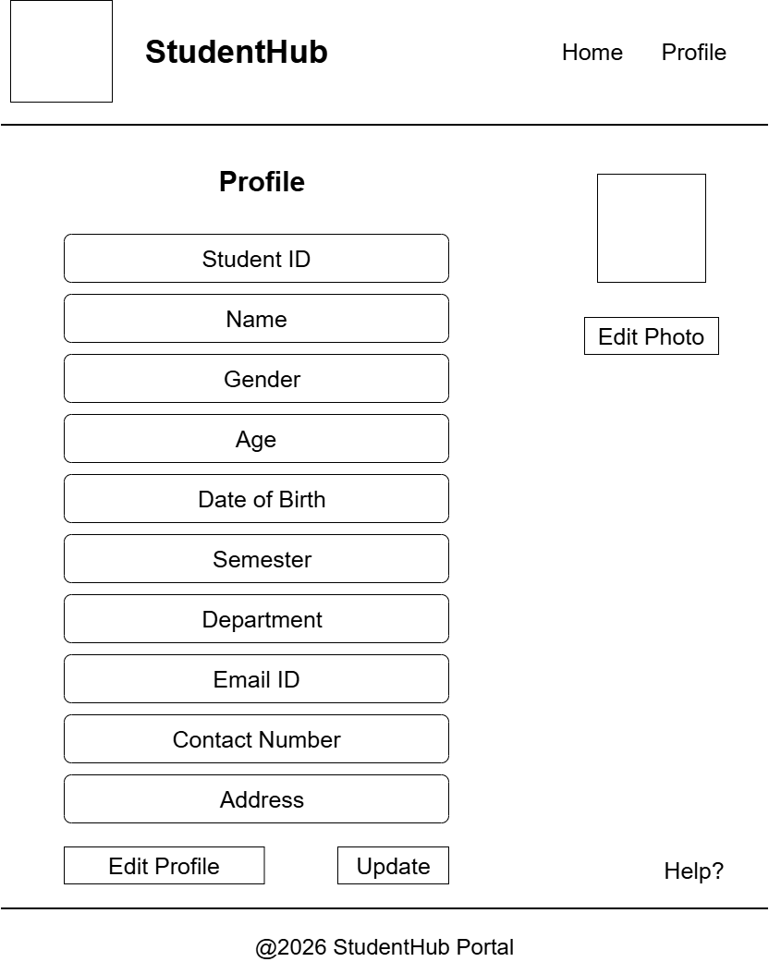
Figure 1.7
Description: Wireframe of Profile page

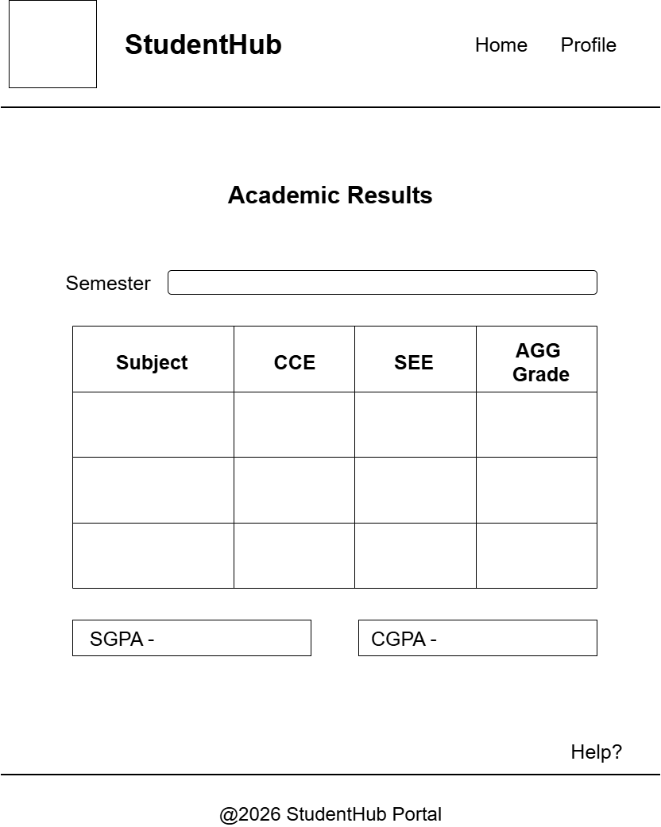
Figure 1.8
Description: Wireframe of Result page

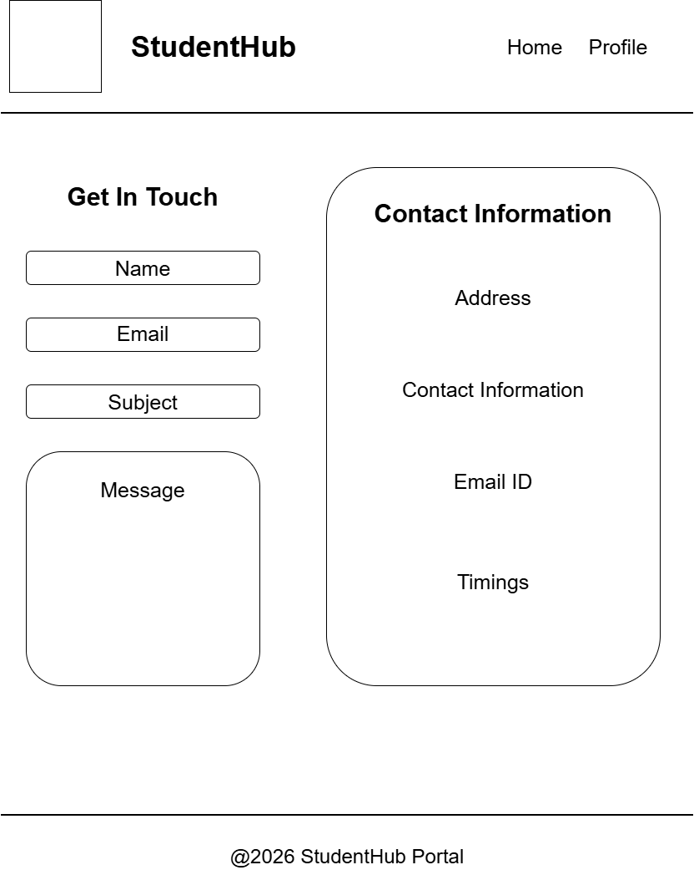
Figure 1.9
Description: Wireframe of Contact page

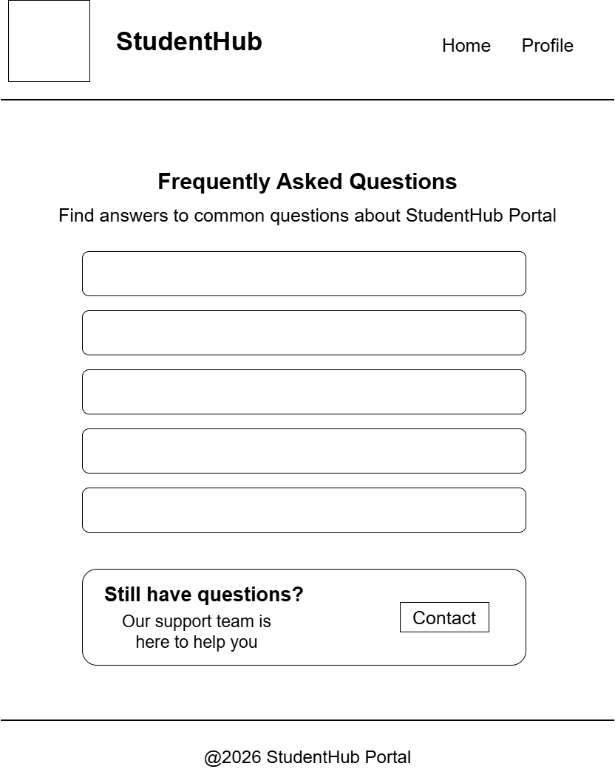
Figure 1.10
Description: Wireframe of FAQ page

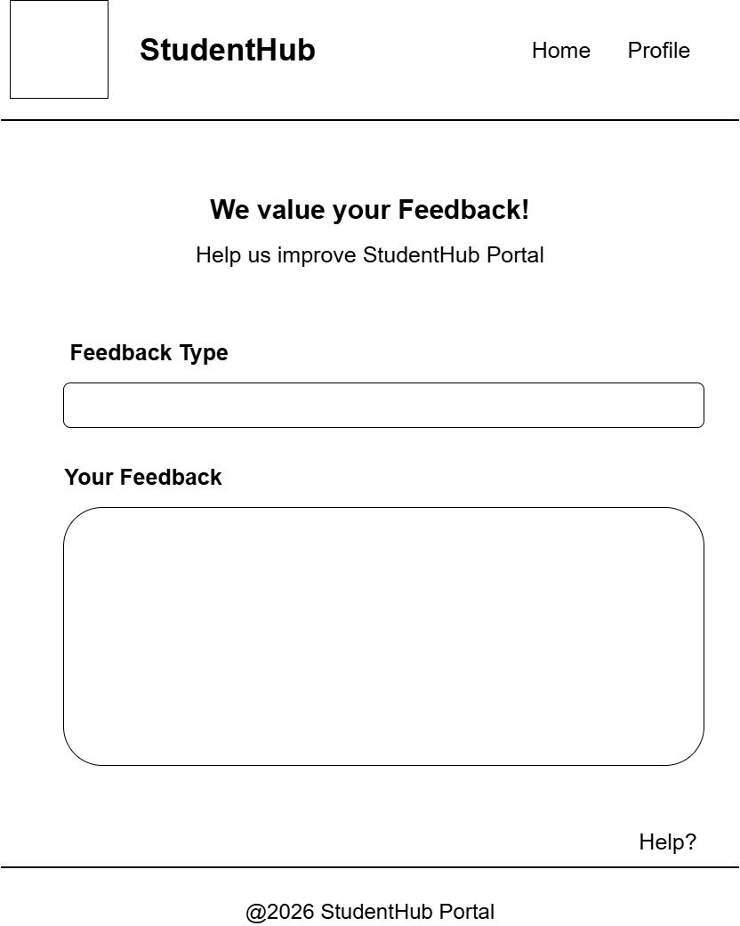
Figure 1.11
Description: Wireframe of Feedback page

GitHub Repository Link:

https://github.com/sakshikothia-28/WDF/tree/168a3ea7eb9ca60349864249cec1212a87de5c56/Practical-1

Challenges Faced:
- Learning how to create wireframes in draw.io
- Learning how to create GitHub repository and upload files.

Learning Outcomes:
- How to identify the problem scope, user roles and project objectives.
- How to analyze the project requirements before starting the development like creating sitemaps and wireframes as per user’s need.

Faculty Remarks:

