Practical - 5

Practical 5: Registration Form with Frontend Validation and User-Friendly Error Handling
Create a student registration form with HTML5 input types and JavaScript validation for name, email, mobile number, password, confirm password, course, year, gender, and terms acceptance. Use Regular Expression for validations.

Theory
1. Are correct input types and attributes used?
Answer:
Yes, Appropriate input types such as text, email, password, and radio are used, along with id, name, and placeholder attributes. Dropdowns are used for selecting Semester, Institute, and Department, while JavaScript Regex provides additional validation.

2. Are validation errors displayed near the relevant fields?
Answer:
Yes, Validation errors are displayed near the relevant fields using <small> elements such as nameError, emailError, contactError, usernameError, and passwordError. The JavaScript displays specific error messages in red below the corresponding input field, making it clear what needs to be corrected.

3. Is password strength checked?
Answer:
Yes, Password strength is checked using a Regular Expression (Regex). The password must contain at least 8 characters, one uppercase letter, one lowercase letter, one number, and one special character. If the password does not meet these requirements, a red validation error is displayed below the password field.

4. Is the form accessible using keyboard and screen-reader-friendly labels?

Answer:
Partially, The form can be accessed using the keyboard because standard HTML form controls such as inputs, radio buttons, and dropdowns are used. However, the current form does not have proper <label> elements for all input fields, which is important for screen-reader accessibility. Labels should be added using the for attribute connected to each input's id.

Implementation/ Output/Result
We have implemented Regex in JavaScript in this practical to the register page.

Evidence of Work (Screenshots)
- Register Page
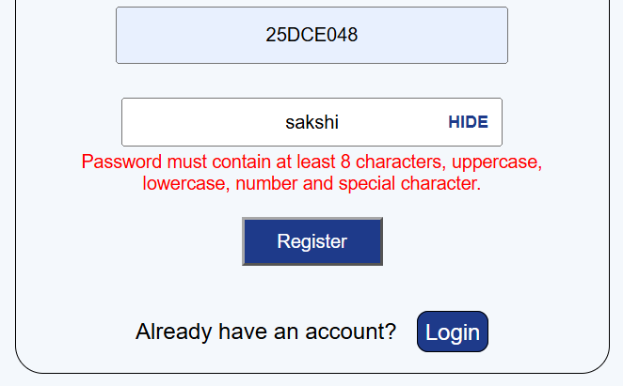
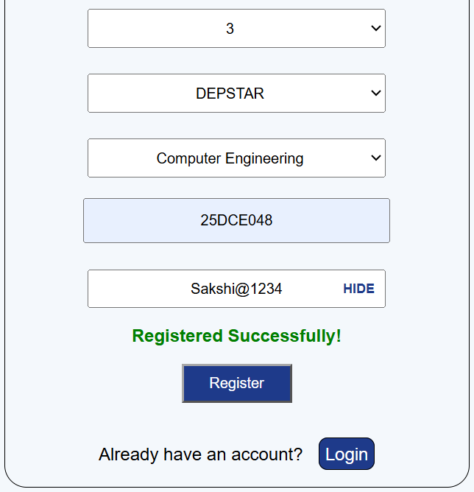
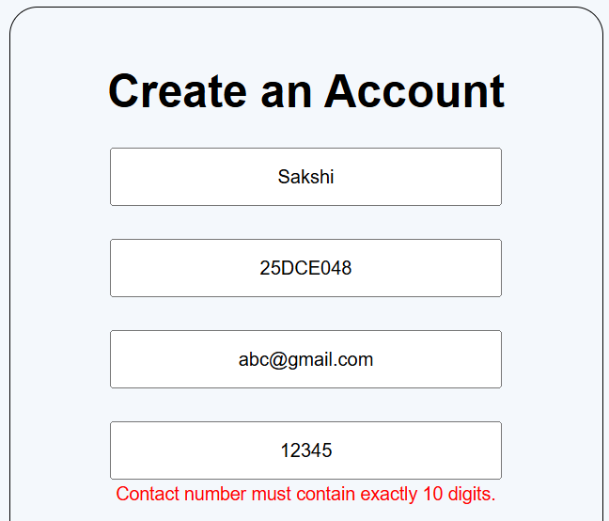
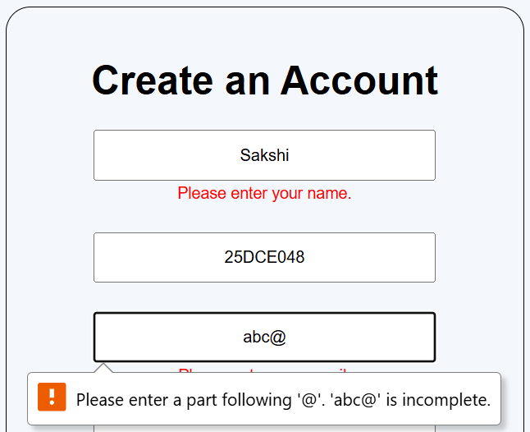

GitHub Repository Link:
https://github.com/sakshikothia-28/WDF/tree/a5079acce87f6d6eacc175e1ee2758fedcbf12f6/Practical-5

Challenges Faced:
- Implementing correct Regex patterns for form validation.
- Handling and displaying validation error messages.
- Debugging JavaScript errors and mismatched IDs.
- Implementing password strength validation.
- Integrating HTML, CSS, and JavaScript properly.

Learning Outcomes:
- Learned to create HTML registration forms.
- Learned client-side validation using JavaScript.
- Learned to use Regex for input validation.
- Learned to display dynamic error and success messages.
- Learned to implement Show/Hide Password functionality.
- Improved debugging and problem-solving skills.
- Understood basic web accessibility concepts.

Faculty Remarks:

