S3 PVT BUCKETS
AWS S3 Bucket Creation Summary
This screenshot shows the Create Bucket page in Amazon S3 (Simple Storage Service). An S3 bucket is a container used to store data and objects in AWS.
- AWS Region: Europe (Stockholm) – eu-north-1
- Bucket Type: General Purpose is selected, which is suitable for most storage use cases.
- Bucket Namespace: Global namespace is selected.
- Bucket Name: sakshi-8
- The bucket name must be 3–63 characters, unique, and can contain letters, numbers, periods, and hyphens.
- The option to copy settings from an existing bucket is also available.
Conclusion: This step is used to configure the basic settings required before creating an Amazon S3 bucket for storing data.
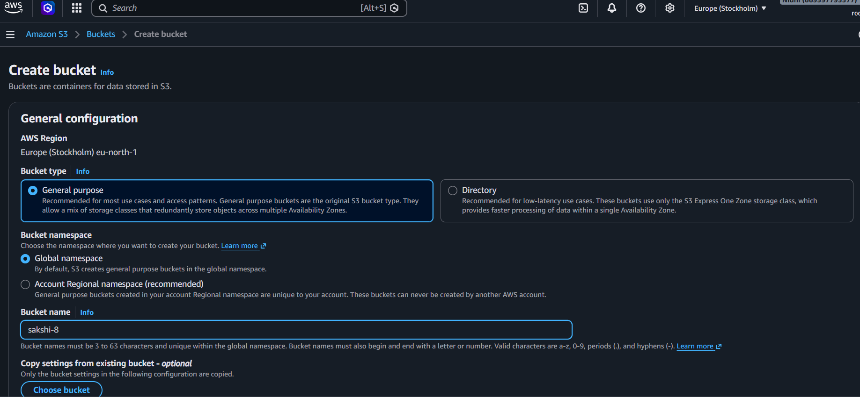

S3 Object Ownership & Public Access Summary
This screenshot shows the Object Ownership and Block Public Access settings while creating an Amazon S3 bucket.
- Object Ownership: ACLs disabled (recommended) is selected.
- This means objects in the bucket are owned by the AWS account, and access is controlled through policies.
- Bucket Owner Enforced is enabled for object ownership.
- Block all public access: Enabled.
- The settings prevent public access through ACLs, bucket policies, and access point policies.
Conclusion: These settings help keep the S3 bucket and its stored objects private and secure by default.
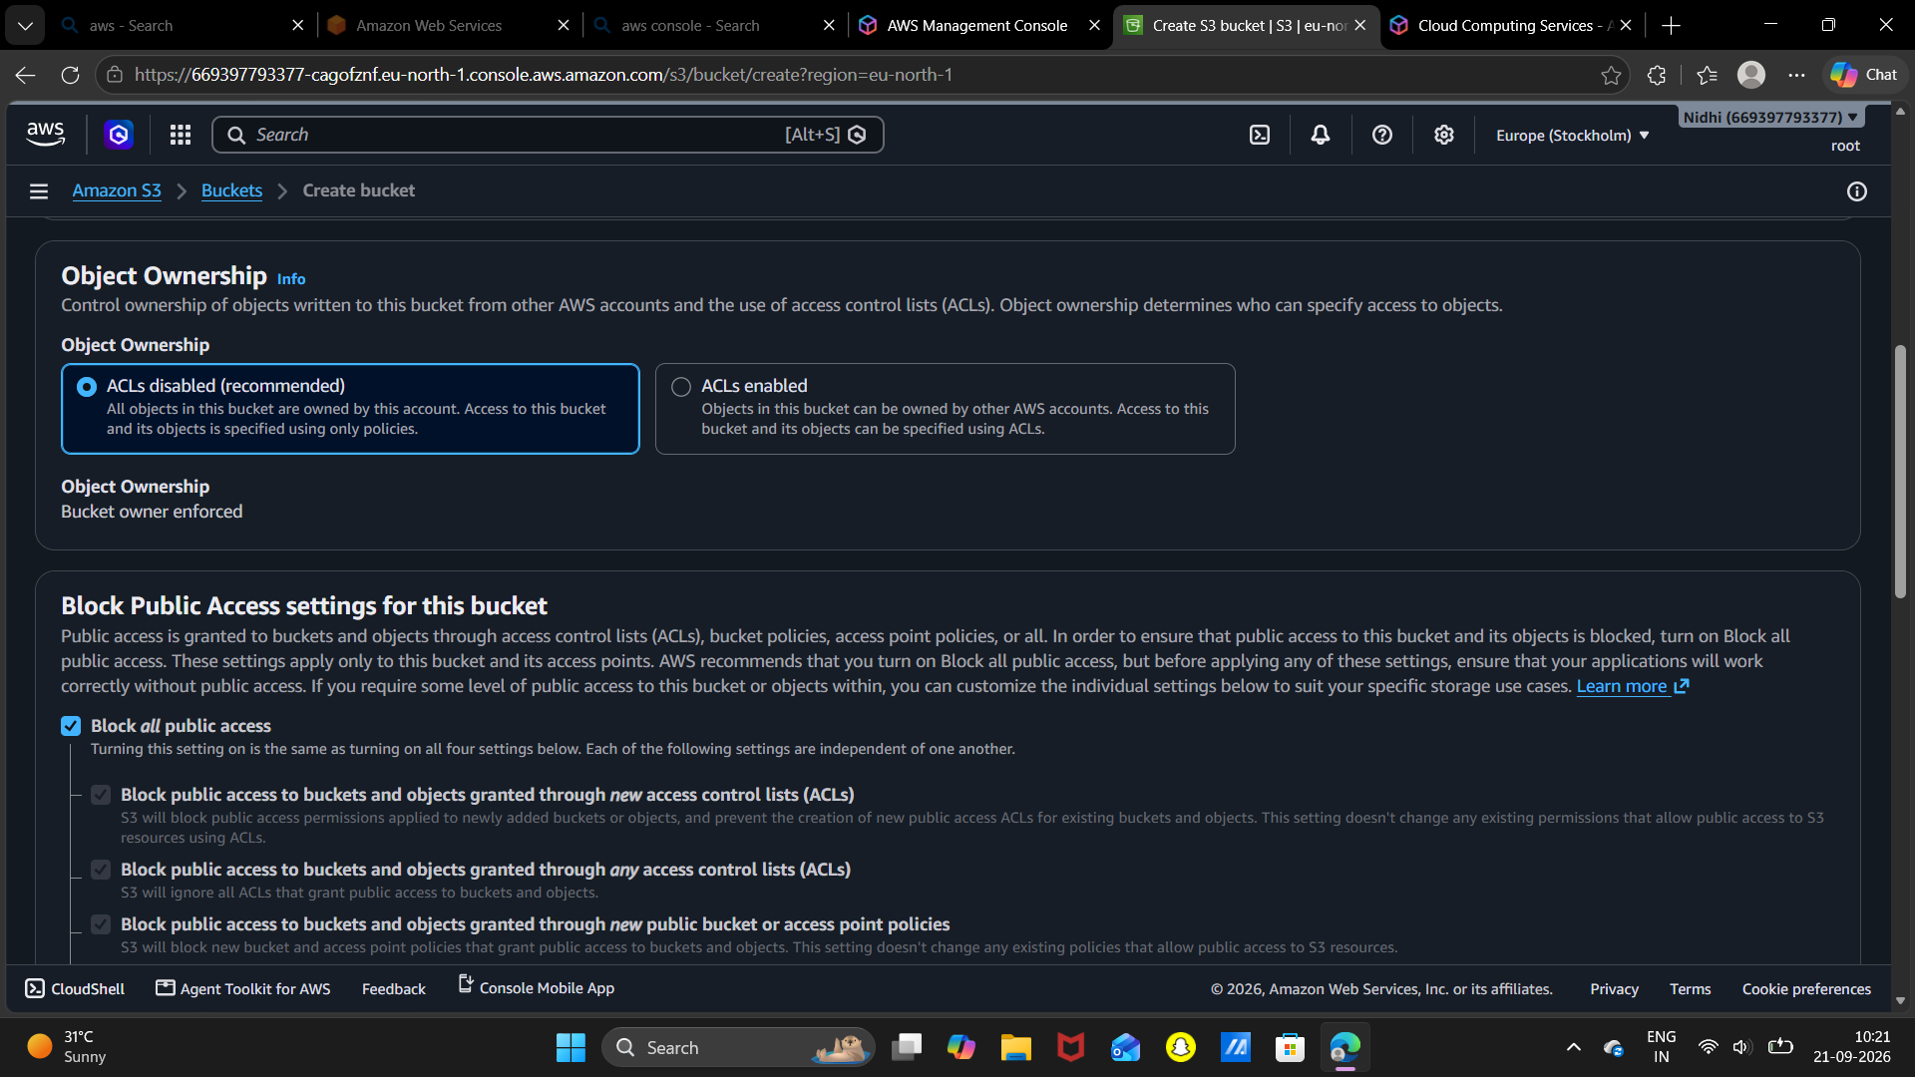

S3 Versioning, Tags & Encryption Summary
This screenshot shows additional configuration options while creating an Amazon S3 bucket.
- Bucket Versioning: Disabled. Versioning can store multiple versions of objects and helps recover previous versions.
- Tags: No tags are added. Tags are optional and can be used for managing and organizing AWS resources.
- Default Encryption: S3 provides server-side encryption for new objects stored in the bucket.
Conclusion: These settings control object version management, resource organization, and data security in the S3 bucket.
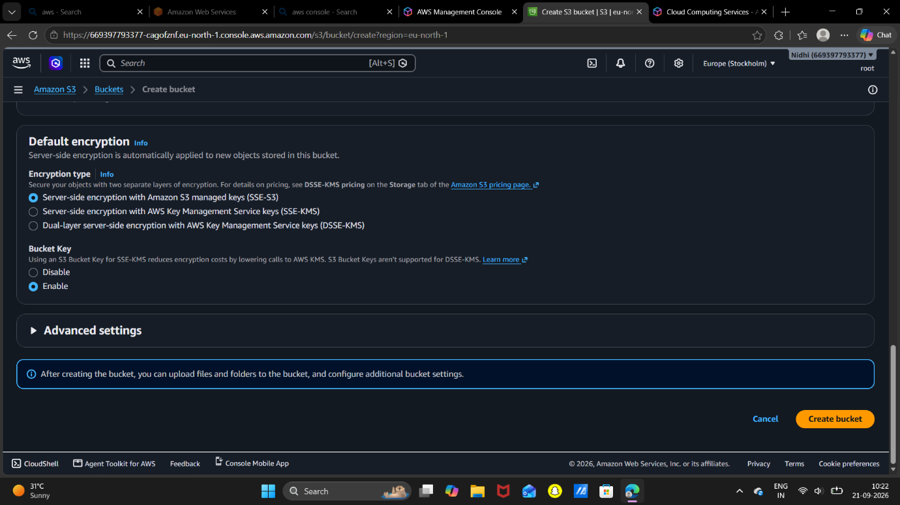
Cloud Assignment – S3 Default Encryption Summary
This screenshot shows the Default Encryption settings while creating an Amazon S3 bucket.
- Encryption Type: Server-side encryption with Amazon S3 managed keys (SSE-S3) is selected.
- This automatically encrypts new objects stored in the bucket.
- S3 Bucket Key: Enabled, which can help reduce AWS KMS requests and related costs when SSE-KMS is used.
- Advanced Settings: Available for additional configuration.
- The Create bucket button is available to complete the bucket creation.
Conclusion: Default encryption provides an additional layer of security for data stored in the S3 bucket.
Cloud Assignment – S3 Bucket Created Summary
The screenshot shows that the Amazon S3 bucket sakshi-8 has been successfully created.
- Bucket Name: sakshi-8
- Status: Successfully created
- The Objects section currently contains 0 objects, meaning no files have been uploaded yet.
- The Upload option is available to add files to the bucket.
- Other sections such as Properties, Permissions, Metrics, Management, and Access Points are also available for managing the bucket.
Conclusion: The S3 bucket has been successfully created and is ready for uploading and storing data.
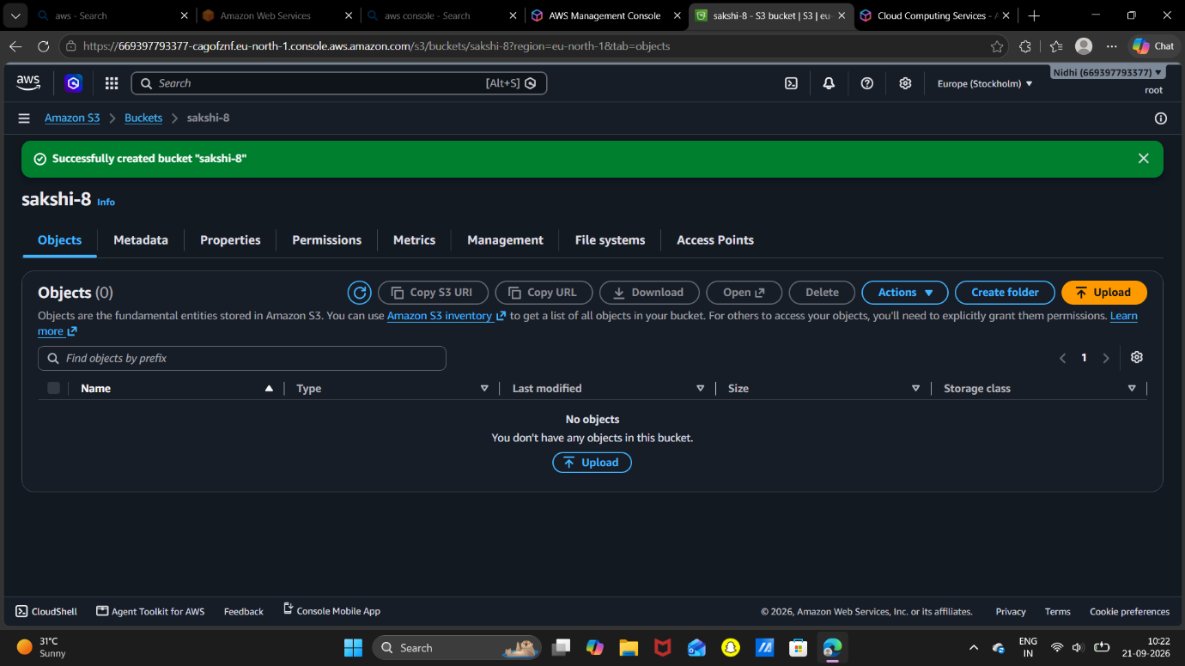
Cloud Assignment – Upload File to S3 Summary
This screenshot shows the Upload page of the Amazon S3 bucket sakshi-8.
- A file named Cloud.docx has been selected for upload.
- File Size: 1.7 MB
- The destination bucket is s3://sakshi-8.
- The Add files and Add folder options are available to select more data.
- Destination details and permissions can also be configured before uploading.
Conclusion: The Cloud.docx file is ready to be uploaded and stored in the Amazon S3 bucket sakshi-8.

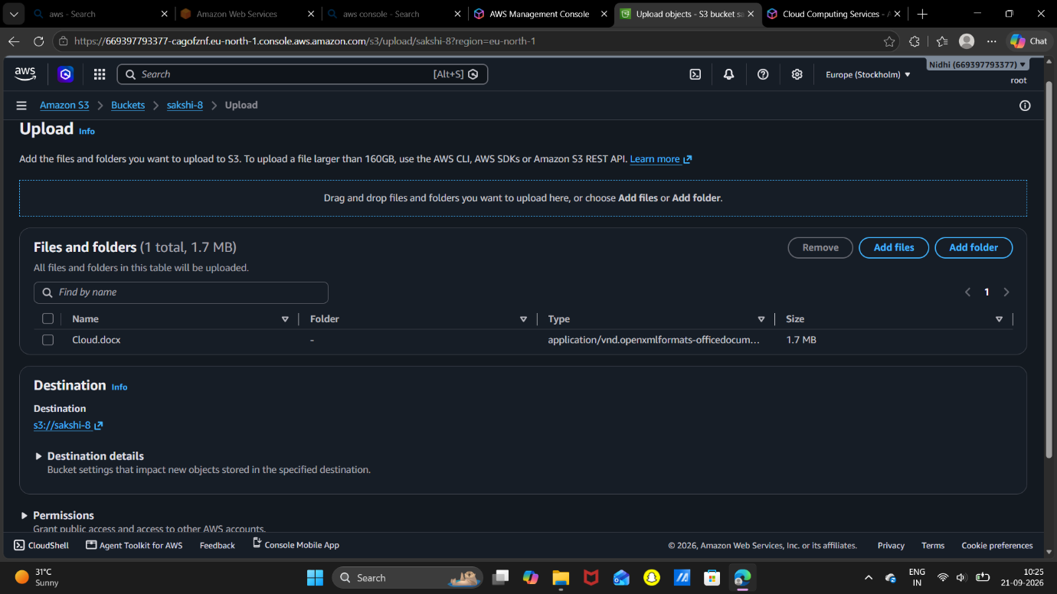
Cloud Assignment – S3 File Upload Success Summary
This screenshot shows that the Cloud.docx file was successfully uploaded to the Amazon S3 bucket.
- Destination: s3://sakshi-8
- File: Cloud.docx
- File Size: 1.7 MB
- Upload Status: Successfully uploaded
- Failed Files: 0
Conclusion: The Cloud.docx file has been successfully stored in the S3 bucket sakshi-8, confirming that the file upload process was completed successfully.

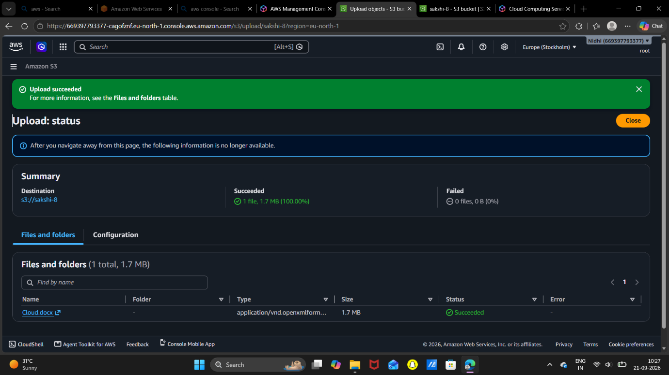
Cloud Assignment – S3 Object Properties Summary
This screenshot shows the properties of the uploaded Cloud.docx object in the S3 bucket sakshi-8.
- Object Name: Cloud.docx
- AWS Region: Europe (Stockholm) – eu-north-1
- File Size: 1.7 MB
- File Type: DOCX
- S3 URI: s3://sakshi-8/Cloud.docx
- Key: Cloud.docx
- The object also has an ARN, ETag, and Object URL for identification and access.
Conclusion: The screenshot confirms that Cloud.docx is successfully stored as an object in the Amazon S3 bucket sakshi-8, along with its storage and identification details.

