Assignment D MongoDB

Q-1: Display all employees who have MongoDB skill ?
Soln: code :- db.employees.find({skills:"MongoDB"})
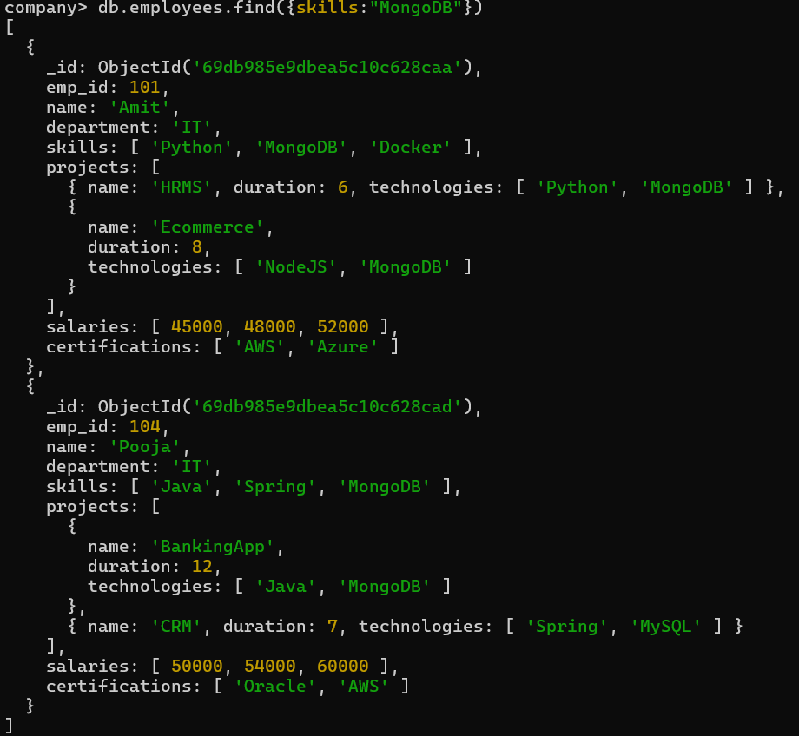
Q-2 Find employees having both Python and MongoDB skills ?
Soln: code:- db.employees.find({skills:{$all:["Python","MongoDB"]}})
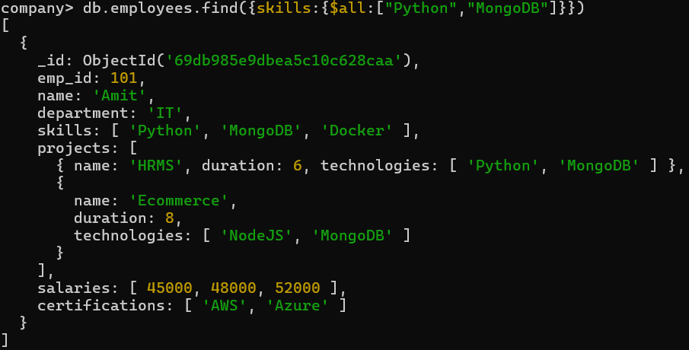
Q-3 Display employees with more than 2 skills ?
Soln: db.employees.find({$expr:{$gt:[{$size:"$skills"},2]}})
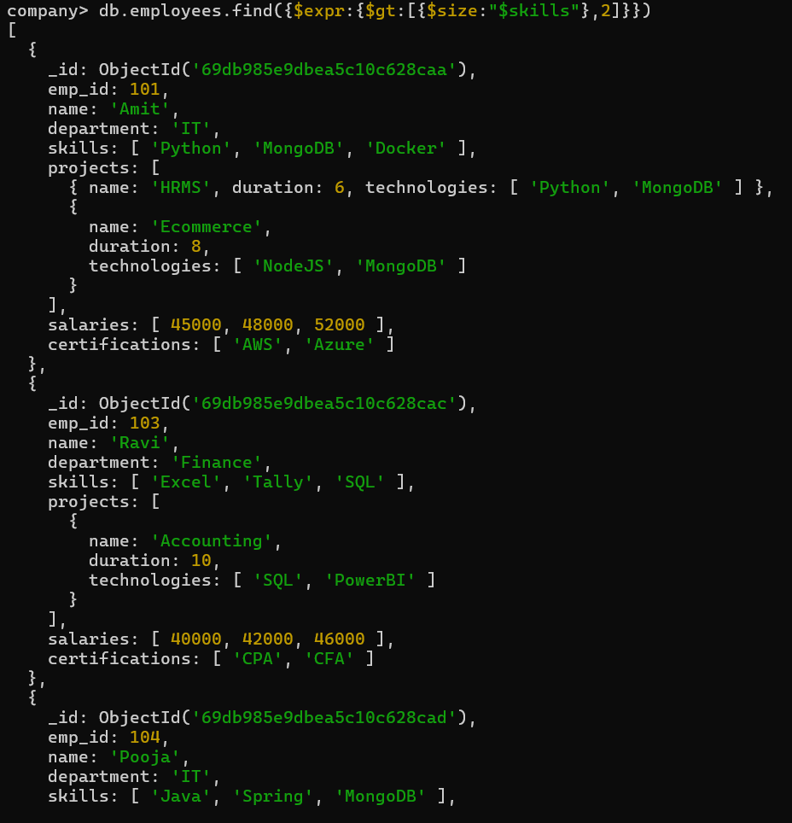
Q-4 Add a new skill "Kubernetes" to Amit ?
Soln: code:- db.employees.updateOne({name:"Amit"},{$push:{skills:"Kubernetes"}})
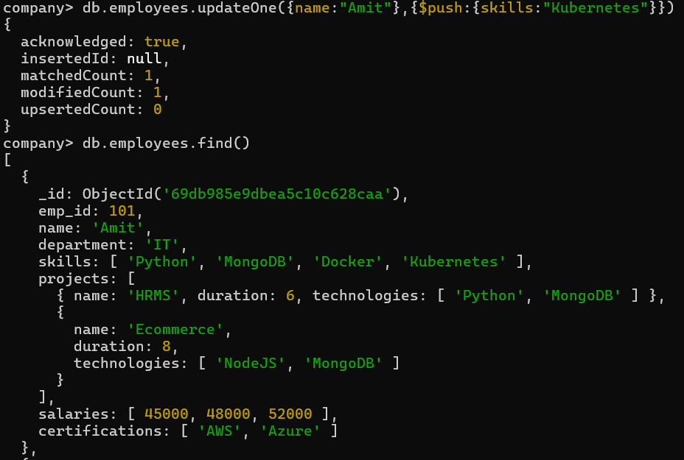
Q-5 Add multiple skills to Pooja ?
Soln: code :- db.employees.updateOne({name:"Pooja"},{$addToSet:{skills:{$each:["AWS","Docker","Git"]}}})
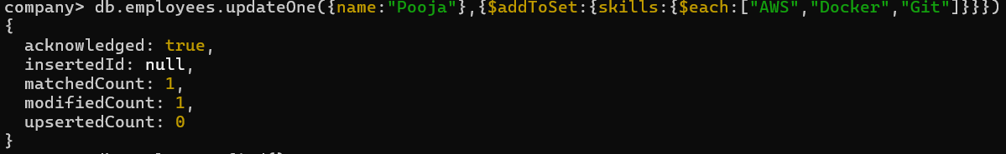
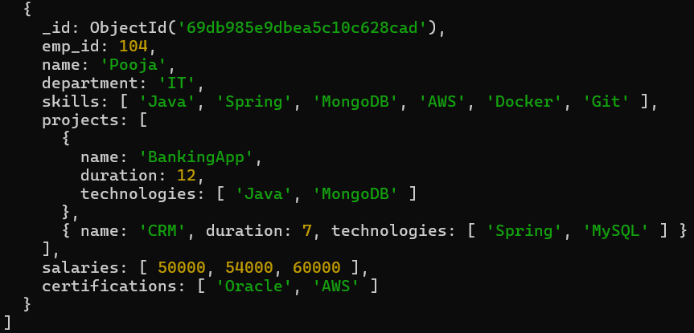
Q-6 Add a certification only if not already present ?
Soln: code :- db.employees.updateOne({name:"Neha"},{$addToSet:{certifications:"PHP"}})
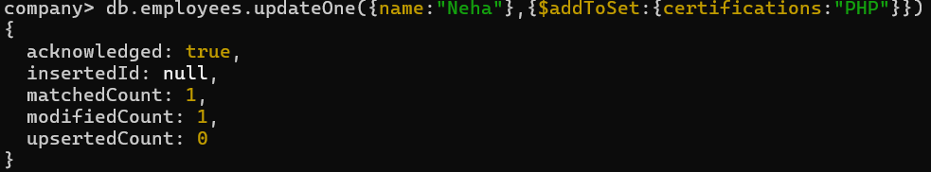
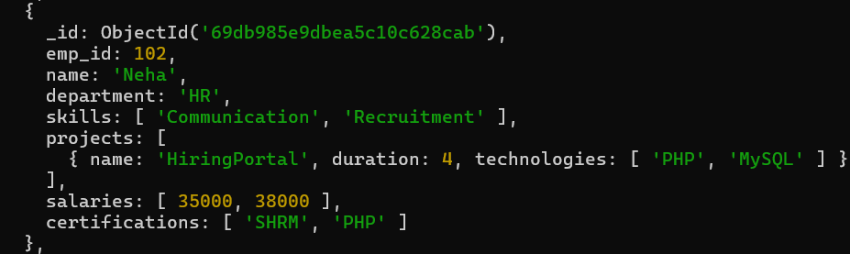
Q-7 Remove "Docker" skill from Amit ?
Soln: code :- db.employees.updateOne({name:"Amit"},{$pull:{skills:"Docker"}})
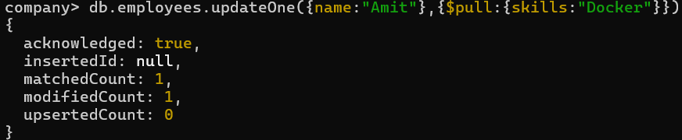
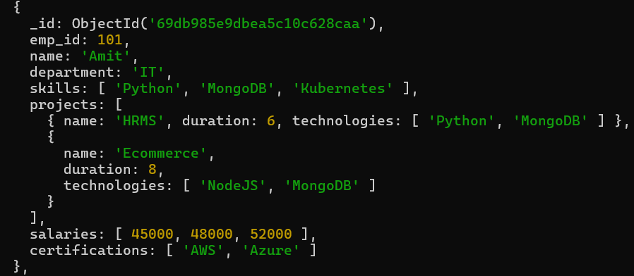
Q-8 Remove multiple salaries less than 45000 ?
Soln: code:- db.employees.updateMany({},{$pull:{salaries:{$lt:45000}}})
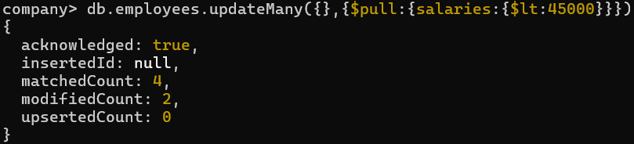
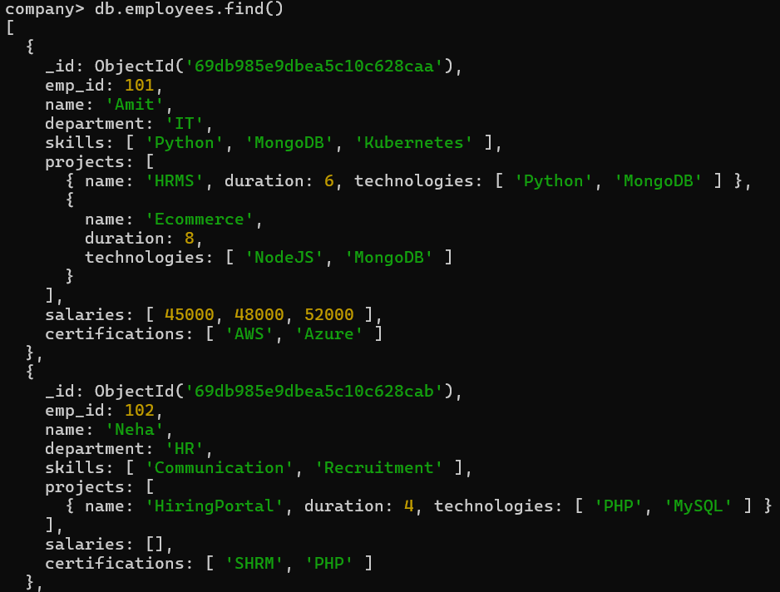
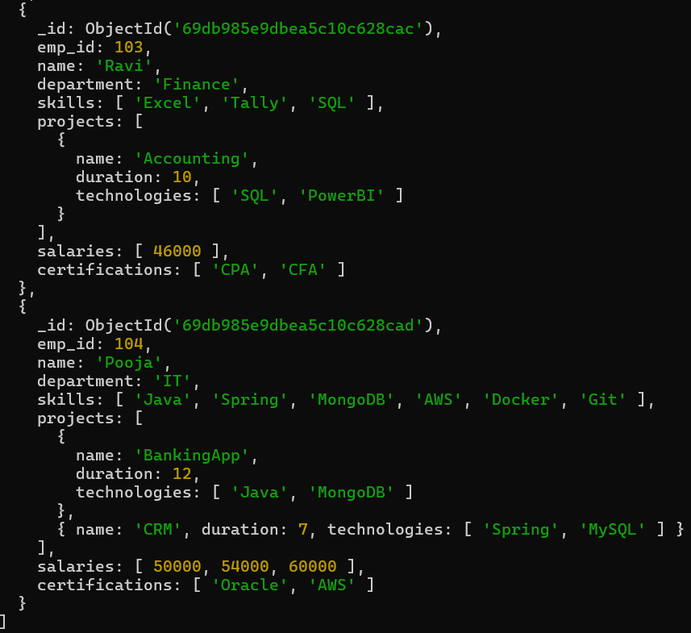
Q-9 Find employees who worked on MongoDB projects ?
Soln: code :- db.employees.find({"projects.technologies":"MongoDB"})
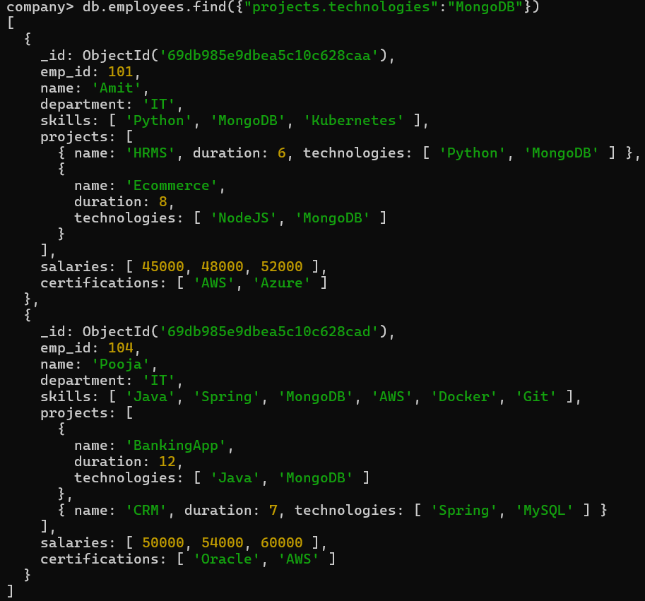
Q-10 Use $elemMatch to find project duration > 6 using MongoDB ?
Soln:code :- db.employees.find({projects:{$elemMatch:{duration:{$gt:6},technologies:"MongoDB"}}})
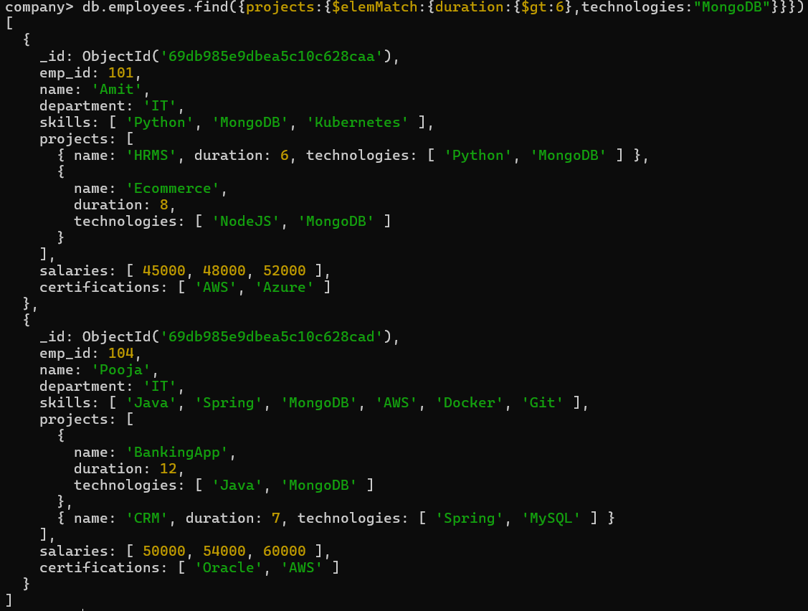
Q-11Count number of projects for each employee ?
Soln:code :- db.employees.aggregate([{$project:{_id:0,emp_id:1,name:1,Total_project:{$size:"$projects"}}}])
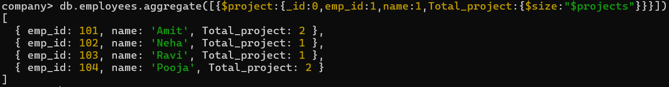
Q-12 Unwind skills array ?
Soln:code :- db.employees.aggregate([{$unwind:"$skills"}])
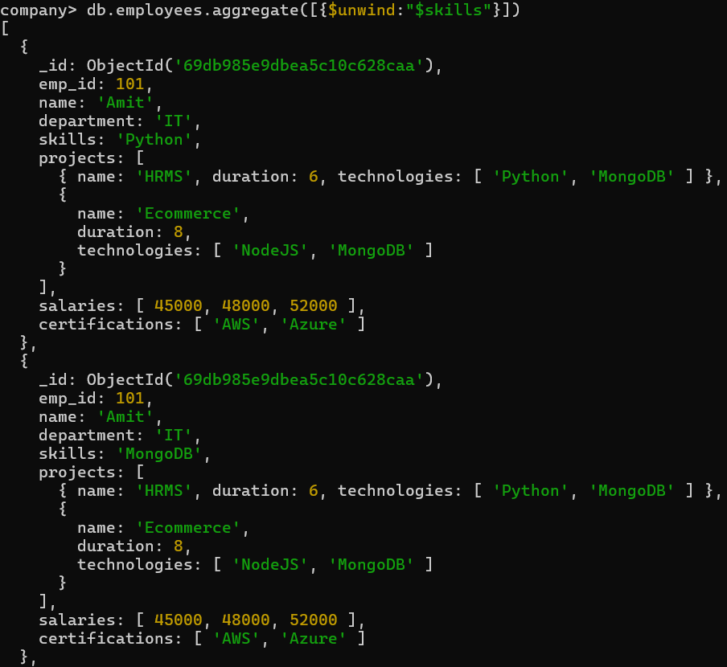
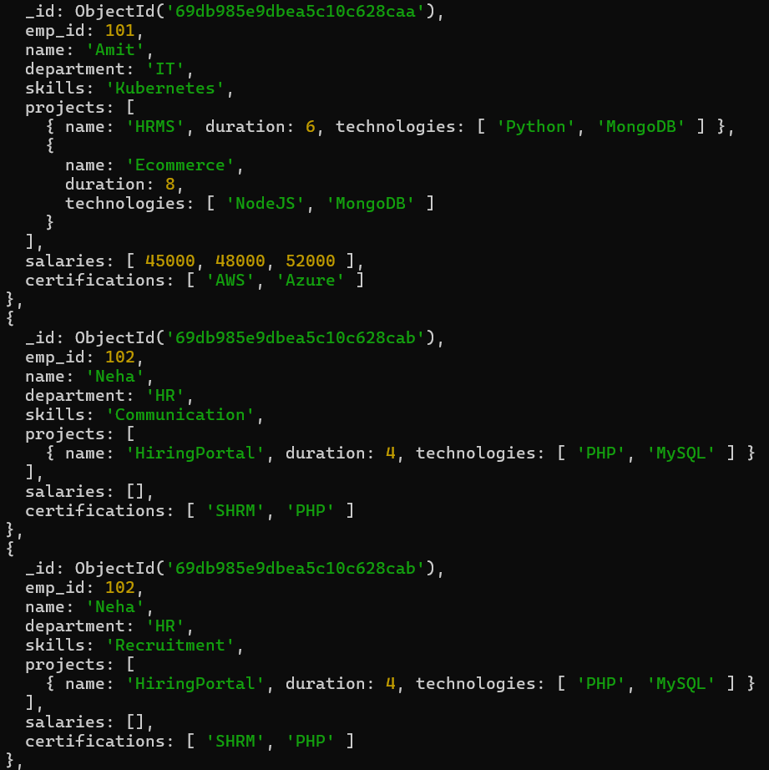
Q-13 List unique skills across company ?
Soln: code :- db.employees.distinct("skills")
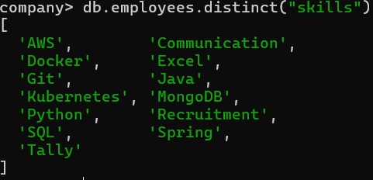
Q-14 Find employees with salary greater than 50000 ?
Soln: db.employees.find({salaries:{$gt:50000}})
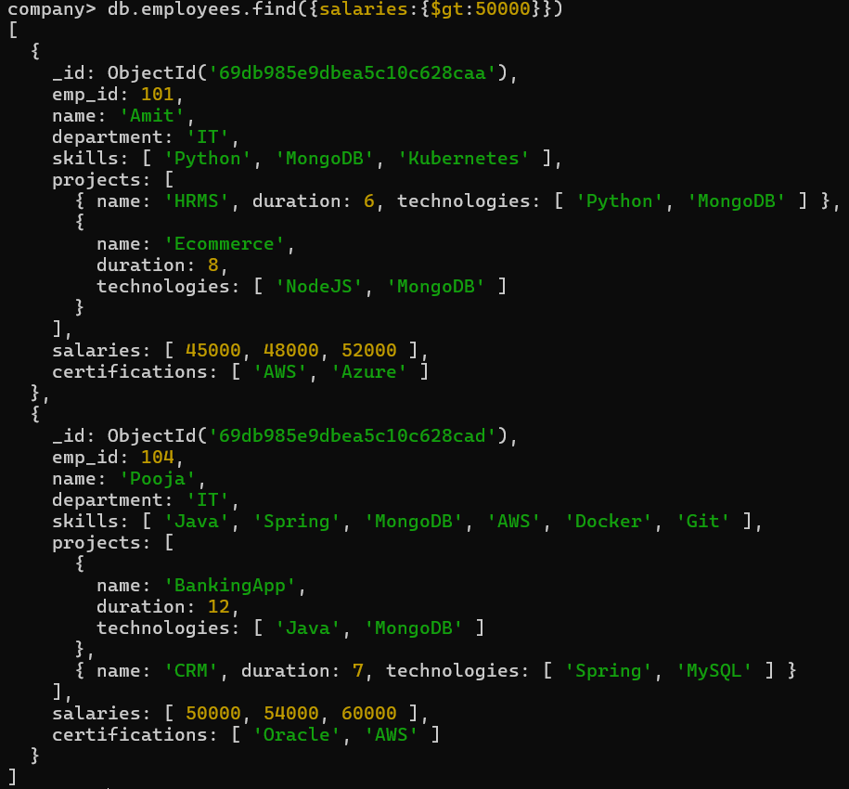
Q-15 Find employees with exactly 2 certifications ?
Soln: code:- db.employees.find({certifications:{$size:2}})
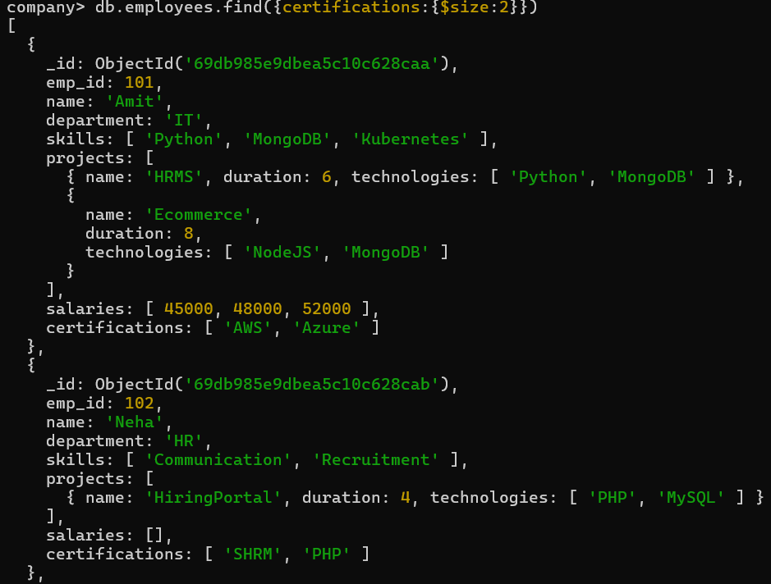
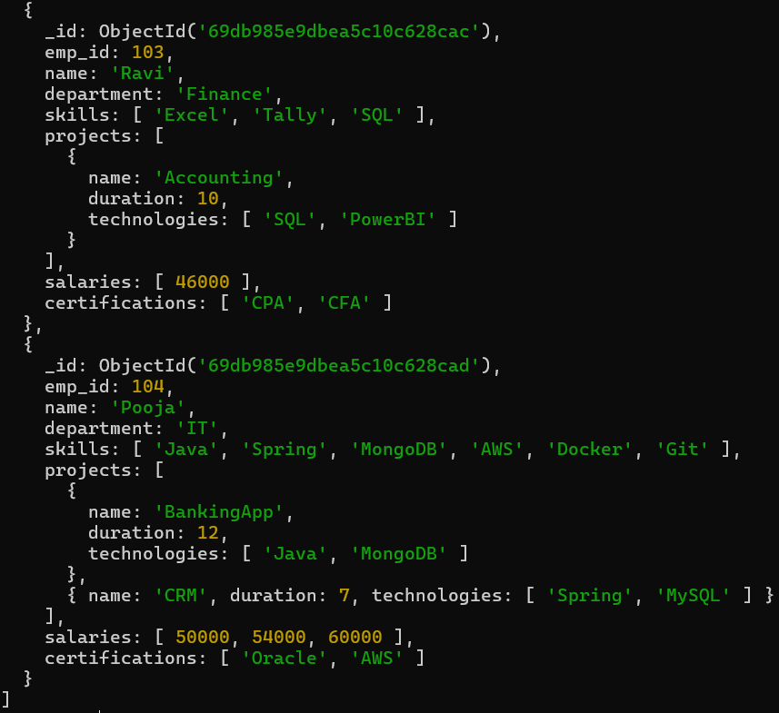
Q-16 Add new project to Ravi ?
Soln: code :- db.employees.updateOne({name:"Ravi"},{$push:{projects:{name:"TextBot",duration:5,technologies:["Excel","SQL"]}}})
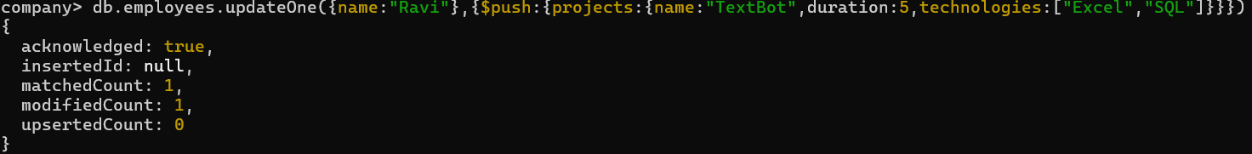
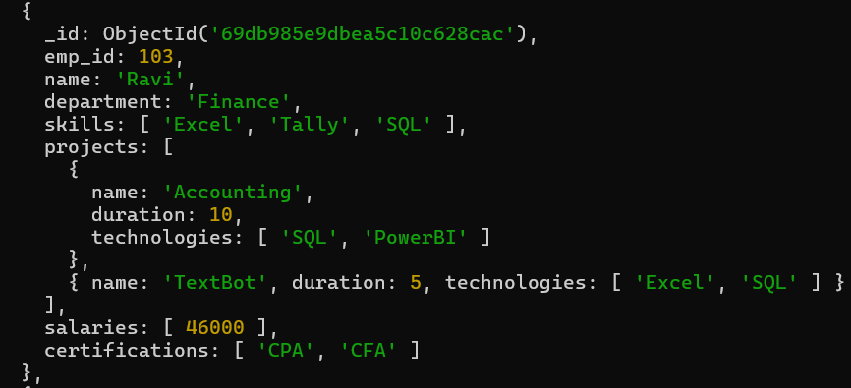
Q-17 Increase all salaries by 10% (array update) ?
Soln: code :- db.employees.updateMany({},{$mul:{"salaries.$[]":1.1}})
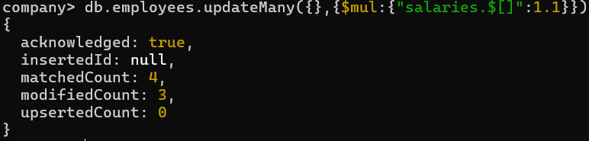
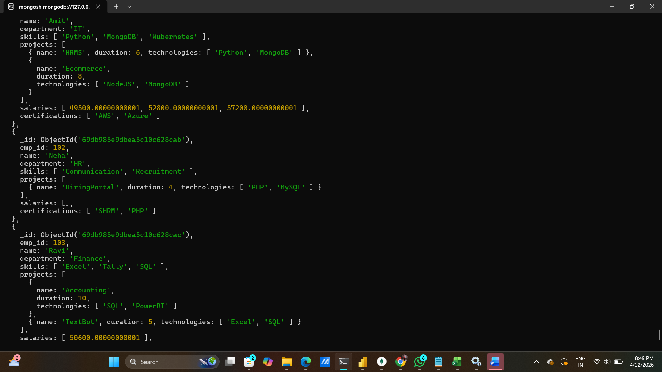
Q-18 Find highest salary of each employee ?
Soln: code :- db.employees.aggregate([{$project:{_id:0,emp_id:1,name:1,Highest_salary:{$max:"$salaries"}}}])
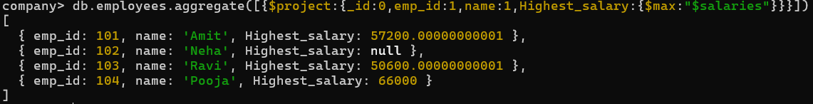
Q-19 Find average salary of employees ?
Soln: code :- db.employees.aggregate([{$project:{_id:0,emp_id:1,name:1,Avg_salary:{$avg:"$salaries"}}}])
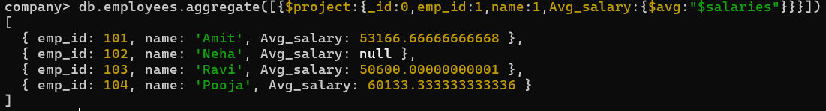
Q-20 Filter projects longer than 6 months ?
Soln: code :- db.employees.aggregate([{$project:{_id:0,emp_id:1,name:1,LongTermProject:{$filter:{input:"$projects",
as:"project",cond:{$gt:["$$project.duration",6]}}}}}])
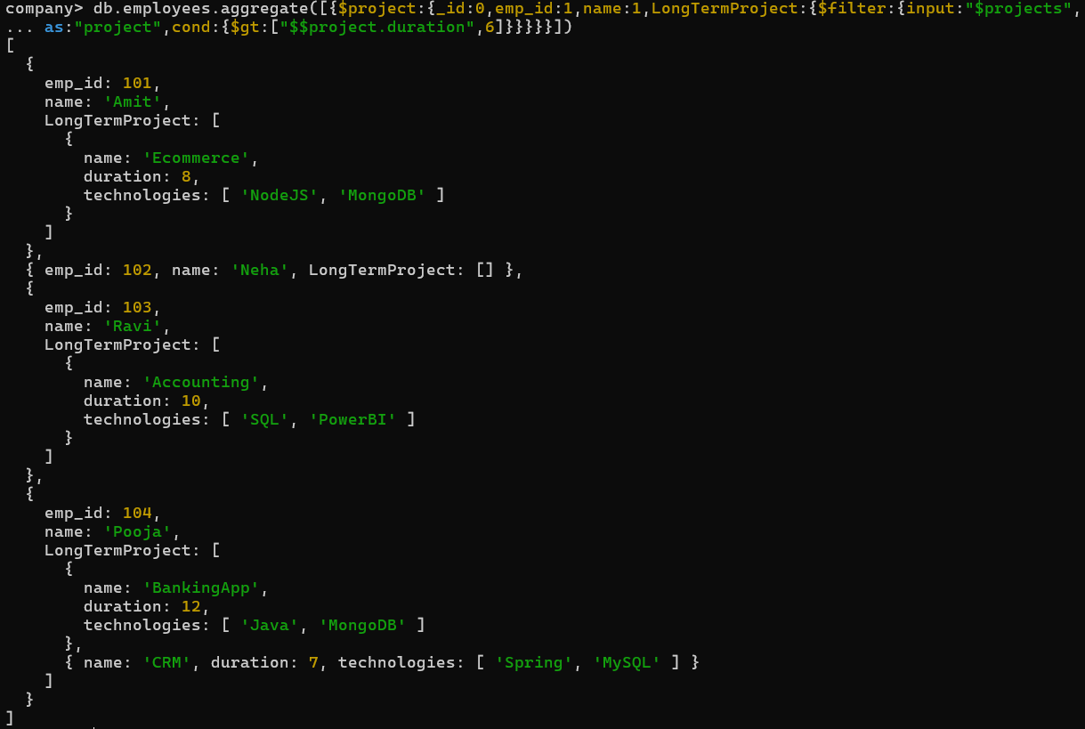
Q-21 Find employees who have any of these skills: Java or Python ?
Soln:code :- db.employees.find({skills:{$in:["Java","Python"]}})
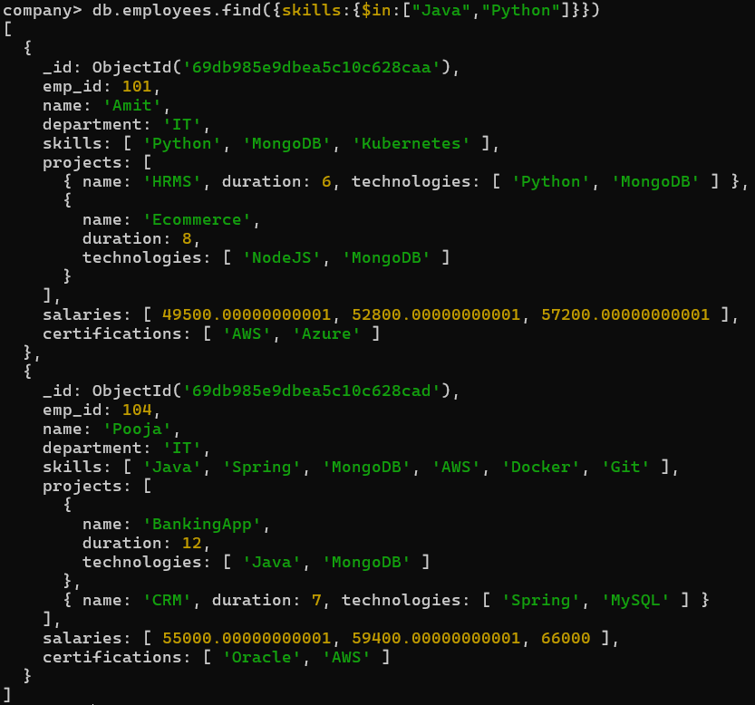
Q-22 Remove last salary entry ?
Soln: code :- db.employees.updateMany({},{$pop:{salaries:1}})
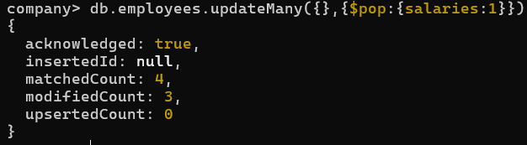
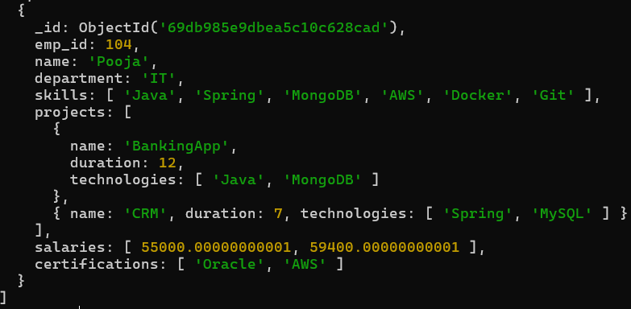
Q-23 Remove first salary entry ?
Soln: code :- db.employees.updateMany({},{$pop:{salaries:-1}})
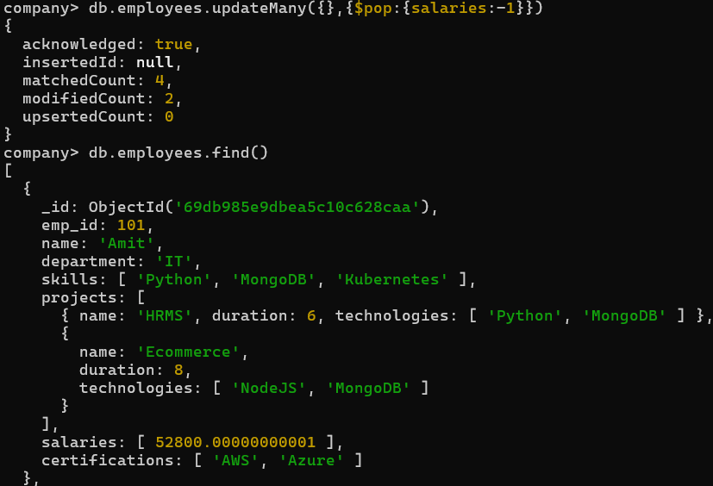
Q-24 Sort salaries array ?
Soln: code :- db.employees.aggregate([{$project:{name:1,sortedSalaries:{$sortArray:{ input:"$salaries",sortBy:1}}}}])
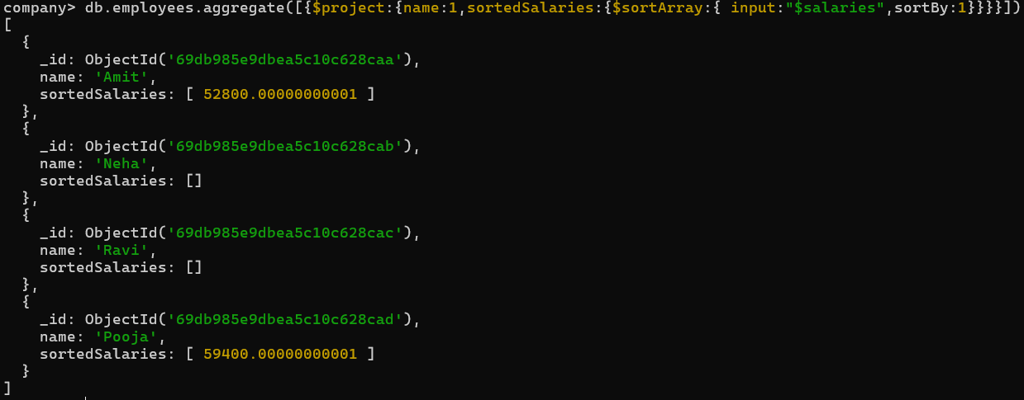
Q-25 Limit salaries array to last 2 entries ?
Soln: code :- db.employees.aggregate([{$project:{name:1,lastTwoSalaries:{$slice:["$salaries",-2]}}}])
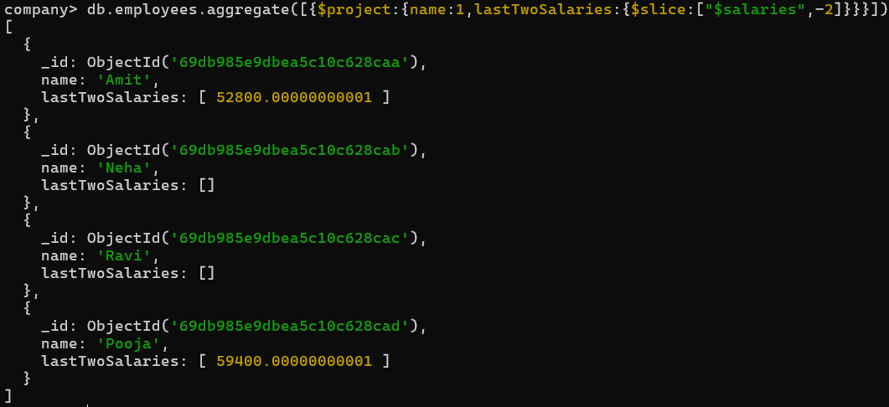
Q-26 Find total salary paid to each employee ?
Soln: code:- db.employees.aggregate([{$project:{_id:0,emp_id:1,name:1,Total_salary:{$sum:["$salaries"]}}}])
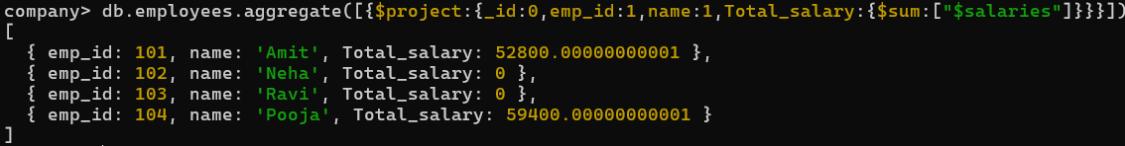
Q-27 Convert skills to uppercase ?
Soln: code :- db.employees.updateMany({},[{$set:{skills:{$map:{input:"$skills",as:"s",in:{$toUpper:"$$s"}}}}}])
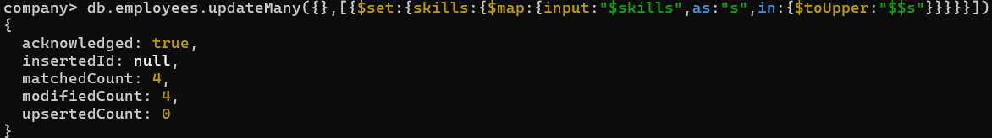
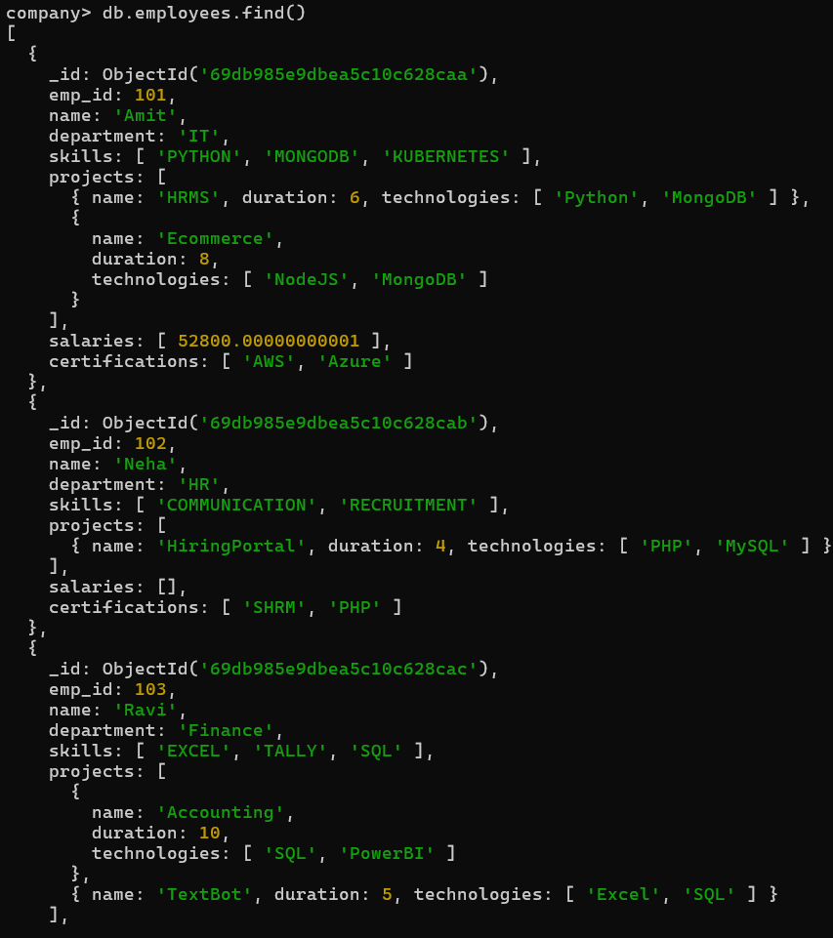
Q-28 Find employees with more than one project ?
Soln: code:- db.employees.find({$expr:{$gt:[{$size:"$projects"},1]}})
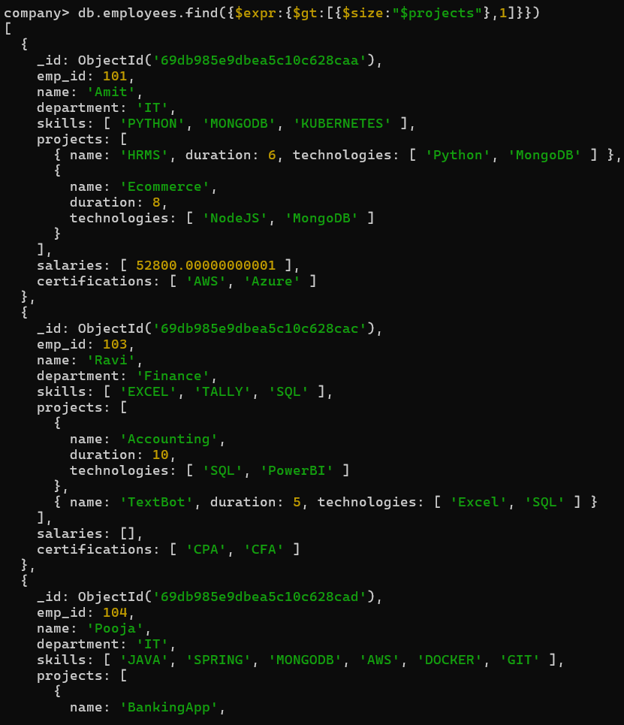
Q-29 Count employees per skill ?
Soln: code :- db.employees.aggregate([{$unwind:"$skills"},{$group:{_id:"$skills",Total_emp:{$sum:1}}},{$sort:{Total_emp:-1}}])
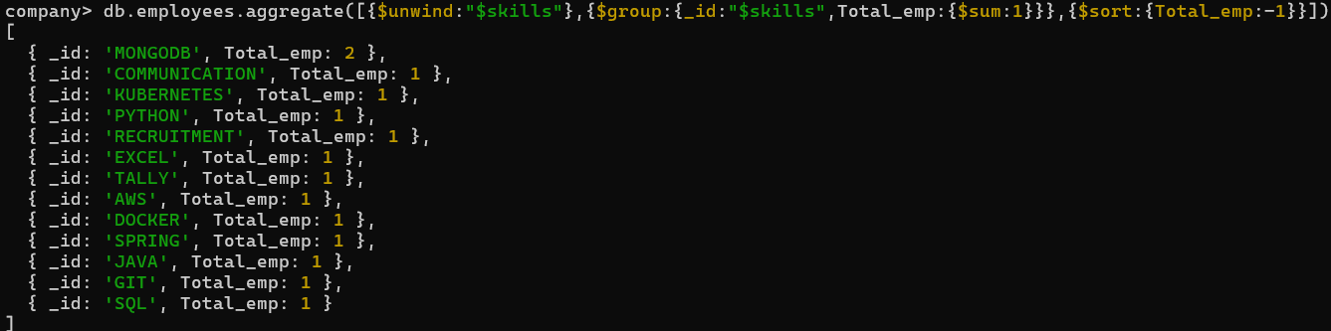
Q-30 Find employees whose all projects use MongoDB ?
Soln: code:- db.employees.find({projects:{$not:{$elemMatch:{technologies:{$ne:"MongoDB"}}}}})
