Practical Assignment – 3

Name : Sakshi Umeshkumar Maisuria

Semester : 7th (MSc-IT)

Roll No. : 026

Subject : Application Development using Full Stack

Code : 705

1) Angular

**Q1. Create Angular application with routing link assigned for following requirements.**

- Display integer, sting, date data in a component.

- Display array values in html list.

- Display array in combo.

- Take a combo with two values (textbox, textarea). Display textbox or textarea

depending on selection of a combo.

-Make another component for user input form with user’s personal details, take input

and display data on submit.

* **Code:**
* **app.module.ts:**
* import { NgModule } from '@angular/core';
* import { BrowserModule } from '@angular/platform-browser';
* import { AppRoutingModule } from './app-routing.module';
* import { AppComponent } from './app.component';
* import { C1Component } from './c1/c1.component';
* import { C2Component } from './c2/c2.component';
* import { ReactiveFormsModule } from '@angular/forms';
* import { FormsModule} from '@angular/forms';
* @NgModule({
* declarations: [
* AppComponent,
* C1Component,
* C2Component
* ],
* imports: [
* BrowserModule,
* AppRoutingModule,
* ReactiveFormsModule,
* FormsModule
* ],
* providers: [],
* bootstrap: [AppComponent]
* })
* export class AppModule { }
* **app.component.html:**

<nav>

  <a routerLink="c1" id="c1">Data as per information </a> |

  <a routerLink="c2" id="c2">User Form </a>

</nav>

<router-outlet></router-outlet>

* **app-routing.module.ts:**
* import { NgModule } from '@angular/core';
* import { RouterModule, Routes } from '@angular/router';
* import { C1Component } from './c1/c1.component';
* import { C2Component } from './c2/c2.component';
* import { AppComponent } from './app.component';
* const routes: Routes = [
* {path:"app",component:AppComponent},
* {path:"c1",component:C1Component},
* {path:"c2",component:C2Component}
* ];
* @NgModule({
* imports: [RouterModule.forRoot(routes)],
* exports: [RouterModule]
* })
* export class AppRoutingModule { }
* **c1.component.html:**

<p style="font-size: 30px;">Create Angular application with routing link assigned for following requirements:.

</p>

<ol>

    <li>

        <strong> - Display integer, sting, date data in a component.</strong>

        <p>Integer: {{var1}}</p>

        <p>String:{{var2}}</p>

        <p>Date:{{var3}}</p>

    </li>

    <li>

        <p> - Display array values in html list.</p>

        <ul>

            <li *ngFor="let a of array1">

                {{a}}

            </li>

        </ul>

    </li>

    <br>

    <li>

        <p> - Display array in combo.

        </p>

        <select>

            <option *ngFor="let a of array1">{{a}}</option>

        </select>

    </li>

    <br>

    <li>

        <p>

            - Take a combo with two values (textbox, textarea). Display textbox or textarea

            depending on selection of a combo.</p>

        <select id="selection" [(ngModel)]="selection" (change)="OnChange()">

            <option *ngFor="let a2 of array2">{{a2}}</option>

        </select><br>

        <br>

        <div *ngIf="selection==='textbox'">

            <input type="text" [(ngModel)]="textbox1">

        </div><br>

        <div *ngIf="selection==='textarea'">

            <textarea name="" id="" cols="30" rows="10" [(ngModel)]="textarea1"></textarea>

        </div>

    </li>

</ol>

* **c1.component.ts:**
* import { Component } from '@angular/core';
* import { FormGroup,FormBuilder } from '@angular/forms';
* @Component({
* selector: 'app-c1',
* templateUrl: './c1.component.html',
* styleUrls: ['./c1.component.css']
* })
* export class C1Component {
* var1:number=270702;
* var2:String="hey, sakshi!";
* var3: Date=new Date(Date.now());
* array1:string[]=['node','asp.net','se','ot'];
* array2:string[]=['select any','textbox','textarea'];
* selection:string='select any';//by default selected
* textbox1:string="";
* textarea1:string="";
* OnChange(){};
* }
* **Output:**

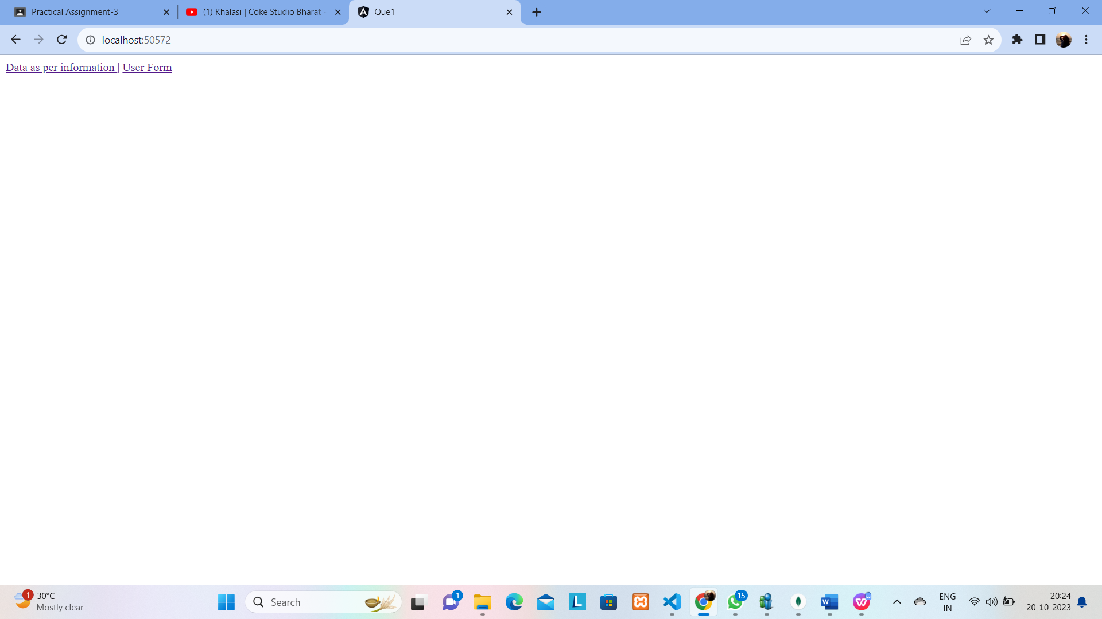

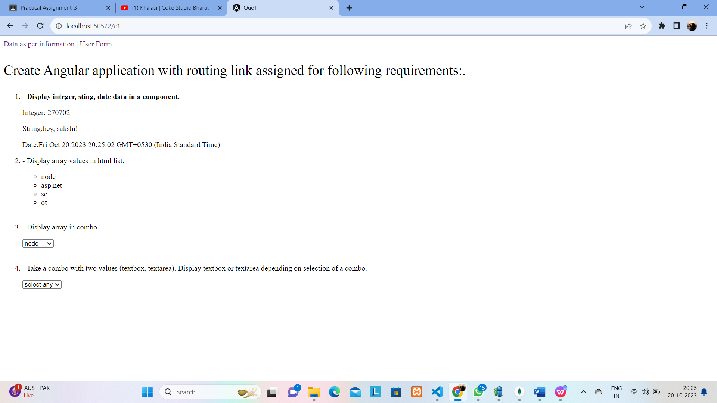

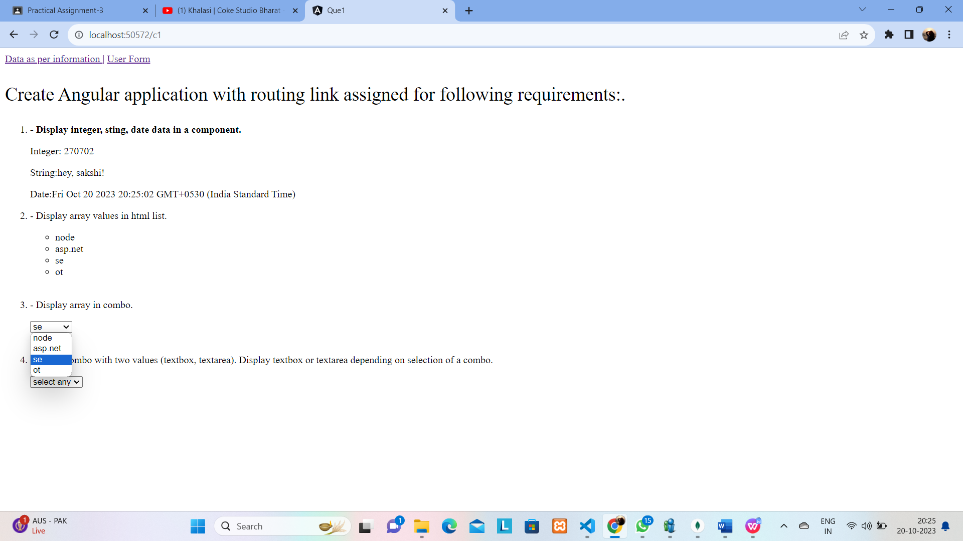

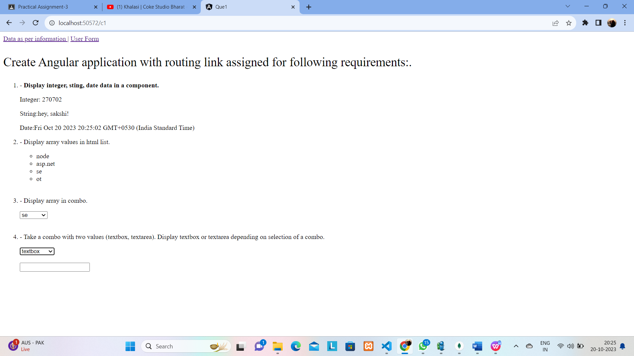

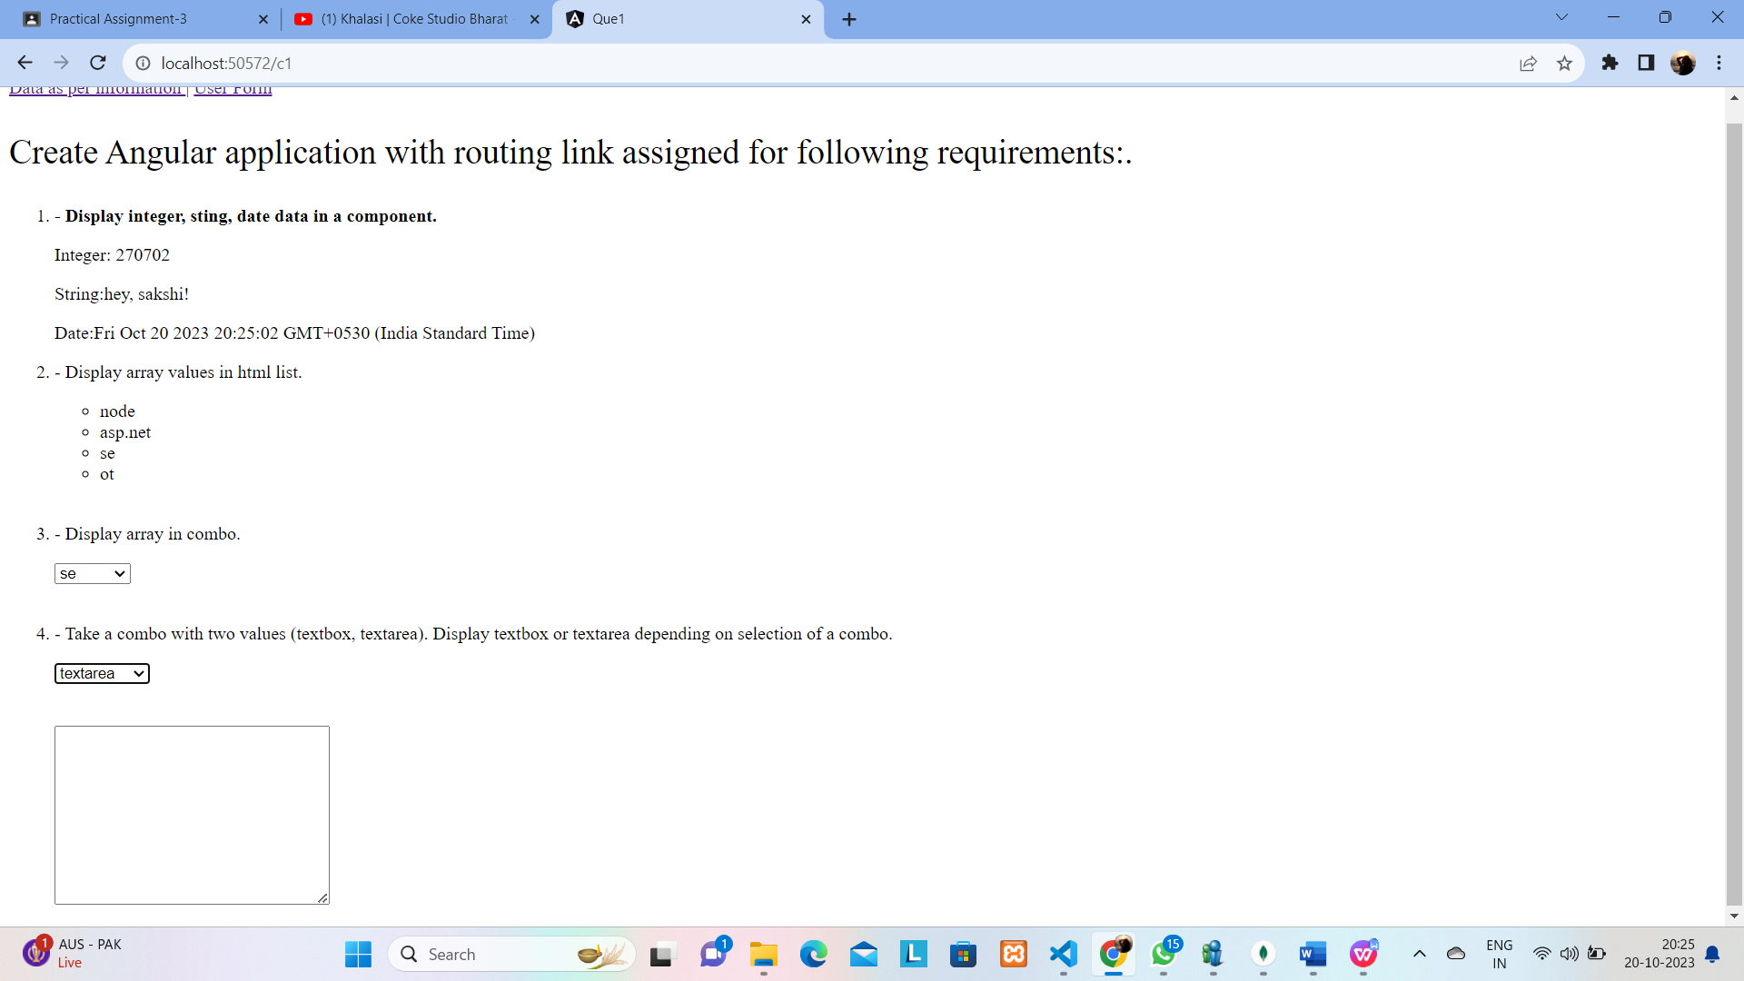

* **c2.component.html:**
* <p style="font-size: 30px;">Make another component for user input form with user’s personal details, take input
* and display data on submit.</p>
* <!DOCTYPE html>
* <html lang="en">
* <head>
* <meta charset="UTF-8">
* <meta name="viewport" content="width=device-width, initial-scale=1.0">
* <title>Document</title>
* </head>
* <body>
* <form (ngSubmit)="onSubmit()">
* Fisrt Name: <input type="text" name="fname" id="" [(ngModel)]="data.fname"><br><br>
* Last Name: <input type="text" name="lname" id="" [(ngModel)]="data.lname"><br><br>
* Address: <textarea name="address" id="" cols="30" rows="6" [(ngModel)]="data.address"></textarea><br><br>
* City: <select name="city" id="" [(ngModel)]="data.city">
* <option value="select" disabled>Select City</option>
* <option value="Surat">Surat</option>
* <option value="Valsad">Valsad</option>
* <option value="Vadodara">Vadodara</option>
* </select> <br><br>
* Gender: <input type="radio" name="gender" id="" value="Male" [(ngModel)]="data.gender">Male
* <input type="radio" name="gender" id="" value="Female" [(ngModel)]="data.gender">Female<br><br>
* Hobbies: <input type="checkbox" name="hobby" value="singing" [(ngModel)]="data.hobby.singing">Singing
* <input type="checkbox" name="hobby" value="travelling" [(ngModel)]="data.hobby.travelling">Travelling
* <input type="checkbox" name="hobby" value="dancing" [(ngModel)]="data.hobby.dancing">Dancing
* <input type="checkbox" name="hobby" value="reading" [(ngModel)]="data.hobby.reading">Reading<br><br>
* <input type="submit" value="Submit">
* </form>
* <br>
* <div *ngIf="submit">
* <h2>User Details</h2>
* <table border="1" width="100%">
* <tr>
* <th>Fisrt Name</th>
* <th>Last Name</th>
* <th>Address</th>
* <th>City</th>
* <th>Gender</th>
* <th>Hobbies</th>
* </tr>
* <tr>
* <td>{{data.fname}}</td>
* <td>{{data.lname}}</td>
* <td>{{data.address}}</td>
* <td>{{data.city}}</td>
* <td>{{data.gender}}</td>
* <td>
* <span *ngIf="data.hobby.singing">Singing,</span>
* <span *ngIf="data.hobby.travelling">&nbsp;Travelling,</span>
* <span *ngIf="data.hobby.dancing">Dancing,</span>
* <span *ngIf="data.hobby.reading">Reading</span>
* </td>
* </tr>
* </table>
* </div>
* </body>
* </html>
* **c2.component.ts:**
* import { Component } from '@angular/core';
* @Component({
* selector: 'app-c2',
* templateUrl: './c2.component.html',
* styleUrls: ['./c2.component.css']
* })
* export class C2Component {
* data={
* fname:'',
* lname:'',
* address:'',
* gender:'',
* hobby:{
* singing:false,
* travelling:false,
* dancing:false,
* reading:false
* },
* city:'Select',
* }
* submit=false
* onSubmit(){
* this.submit=true;
* }
* }
* **Output:**

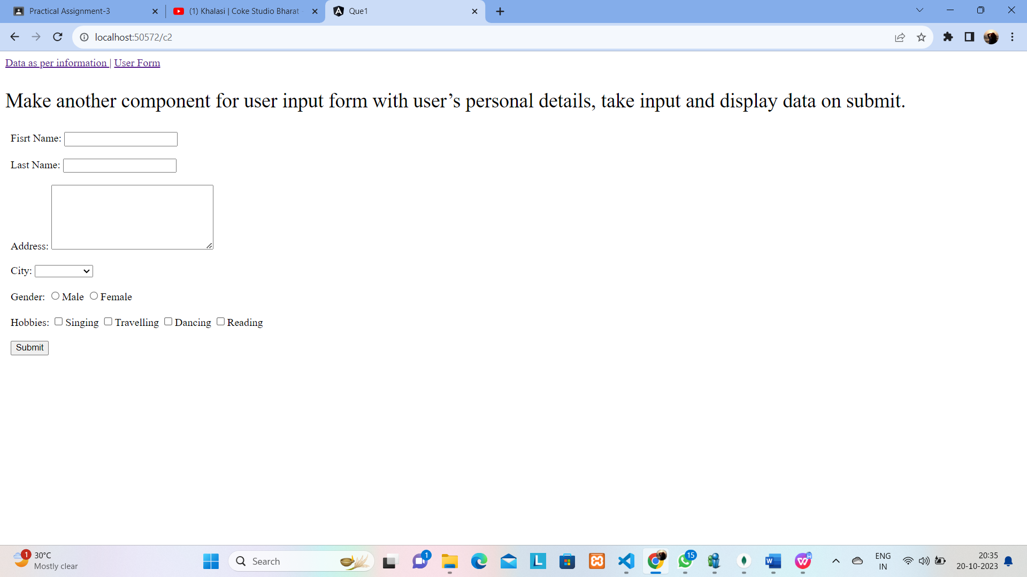

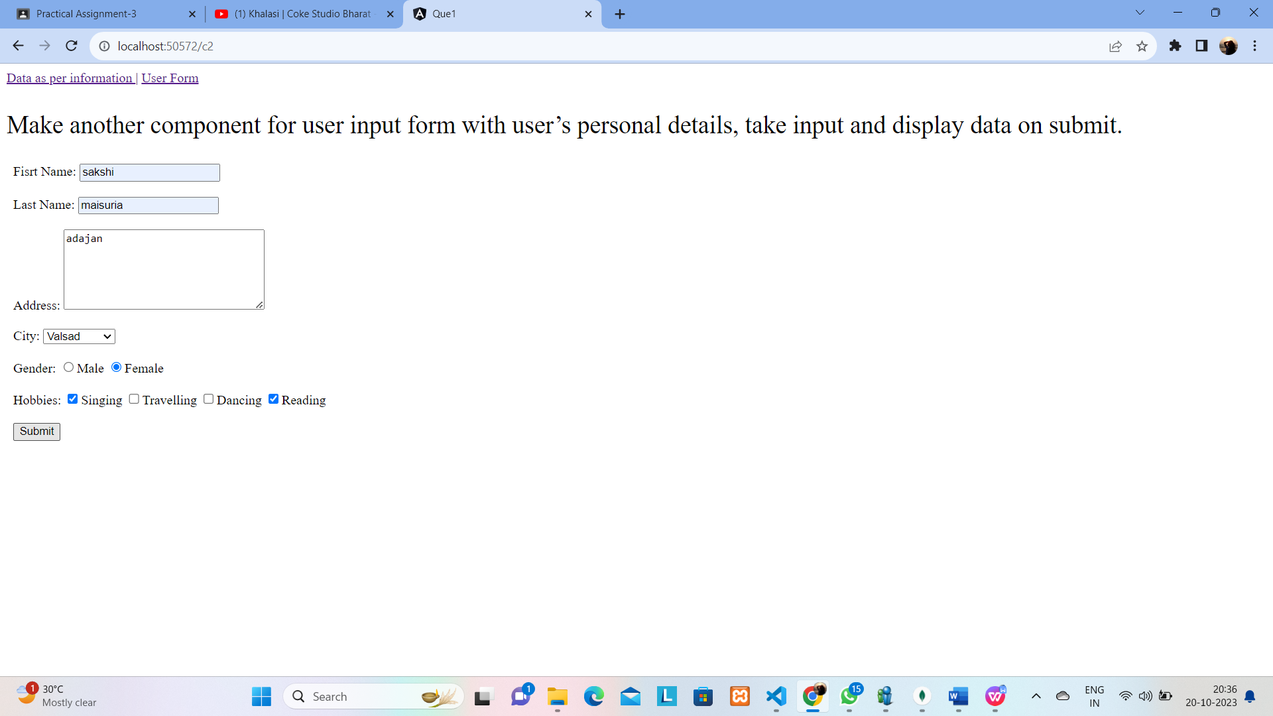

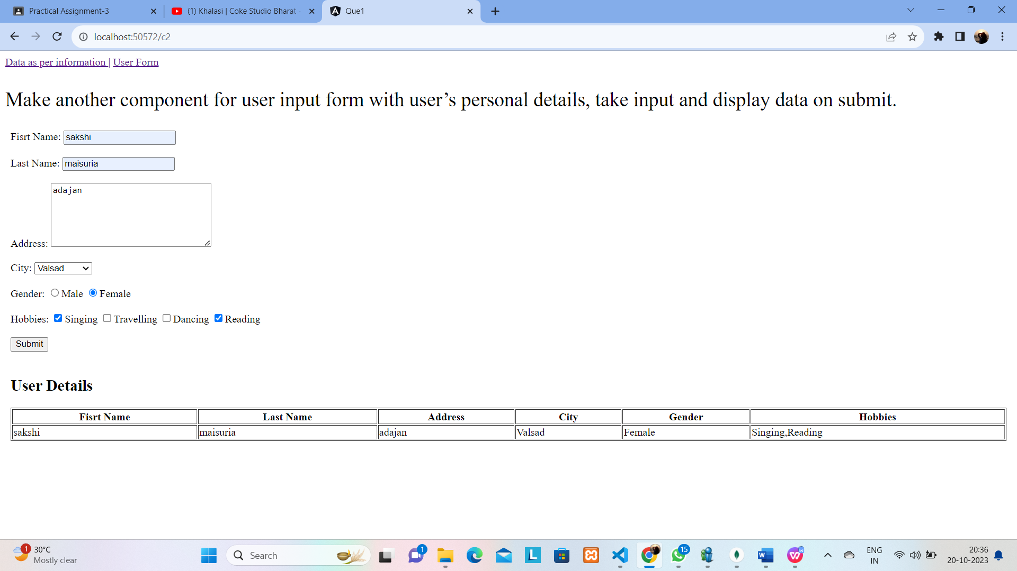

**2) MEAN**

**Q2. Design and develop shopping cart system.**

Backend - Products (CRUD) API in Express.

Frontend

- Call CRUD API

- Display products in grid (3xn)

* **Output:**

