BLUESTOCK FINTECH
Mutual Fund Analytics Platform
End-to-End Data Engineering, ETL Pipeline and Interactive Dashboard

Project | Capstone Project I (individual)
Prepared by | Sakshi Mane, Data Analyst Intern
Company | Bluestock Fintech Pvt. Ltd.
Domain | Mutual Fund / Fintech
Date | October 2026
Repository | See README.md in the GitHub repository
All data comes from publicly available information (AMFI India, NSE, BSE, mfapi.in). Investor transaction data is simulated. This report is for educational purposes only and is not financial advice. Mutual fund investments are subject to market risks.

Contents
1. Executive Summary
2. Business Context and Objectives
3. Data Sources and Quality
4. Architecture, ETL and Database
5. Exploratory Data Analysis
6. Fund Performance Analysis
7. Advanced Analytics and Risk
8. Interactive Dashboard
9. Recommendations
10. Limitations and Data Notes
11. Conclusion and Future Work
Appendix A: How to reproduce
Appendix B: Deliverables map

1. Executive Summary
This project builds a mutual fund analytics platform for Bluestock Fintech: an automated ETL pipeline, a relational SQLite database, exploratory and risk analytics in Python, and a four-page Power BI dashboard. It covers 40 schemes from 10 fund houses, 46,000 daily NAV observations from January 2022 to May 2026, and 32,778 investor transactions from 5,000 investors.
Measure | Result
Top-10 fund house AUM | 30.18 lakh crore (Mar 2022) to 62.74 lakh crore (Dec 2025)
Monthly SIP inflow | Rs 11,517 crore (Jan 2022) to Rs 31,002 crore (Dec 2025)
Active SIP accounts, Dec 2025 | 9.35 crore
Median 3-year CAGR (40 schemes) | 16.6%; best 36.2% (Axis Midcap Fund)
Schemes with Sharpe ratio above 1 | 10 of 40 (9 are below zero)
Deepest drawdown | -53% (SBI Small Cap Fund, Direct)
Highest composite score | Mirae Asset Large Cap Fund - Regular, 84.8/100
Average annual volatility | Equity 17.2% vs Debt 2.2%

Headline findings
- Growth is broad-based. Top-10 AMC AUM roughly doubled (x2.1) and monthly SIP inflow nearly tripled in four years. Industry folios grew from 13.26 to 26.12 crore.
- Cost matters. Direct plans charge 0.78% a year on average against 1.35% for Regular plans, a gap of 0.57 percentage points that compounds every year.
- Raw returns hide risk. Equity funds are about 8 times as volatile as debt funds, and only 10 of 40 schemes earned a Sharpe ratio above 1. A composite scorecard ranks funds on return, risk-adjusted return, alpha, cost and drawdown together.
- Investors are concentrated by age, not by geography. 41% of investors are aged 26-35, while investment value is spread evenly across 12 states and B30 cities contribute 34% of value.
- Data quality is itself a finding. NAV series do not move with their benchmark indices, and some reported metrics disagree with values calculated from NAV. Section 10 explains how this was handled.

2. Business Context and Objectives
India's mutual fund industry manages over Rs 81 lakh crore across 1,908 schemes and 26.12 crore folios (AMFI, December 2025). Investors and advisors still struggle to compare funds because data is scattered across AMFI reports, APIs and exchange files, and because risk-adjusted metrics need transformation of raw NAV data. Bluestock Fintech needs one platform that consolidates the data, computes the metrics and presents them in a dashboard that can be refreshed from the pipeline.
The project addressed five problems: data fragmentation (P1), the performance comparison gap (P2), missing benchmark tracking (P3), the investor behaviour blind spot (P4) and slow static reporting (P5).
# | Objective | What was delivered
O1 | ETL pipeline from raw data | run_pipeline.py and scripts/etl_pipeline.py: one command, logging, error handling, non-zero exit on failure
O2 | Normalised SQL schema | SQLite star schema: 2 dimensions, 4 core facts, 2 further facts and 3 supporting tables
O3 | Exploratory data analysis | Notebook 3: 25 charts and 10 documented findings
O4 | Performance and risk metrics | Notebook 4 and compute_metrics.py: returns, CAGR, Sharpe, Sortino, alpha, beta, drawdown, scorecard
O5 | Interactive BI dashboard | Power BI file with 4 pages, slicers, drill-through and tooltips
O6 | Investor transaction analysis | EDA section 7 and Notebook 5: demographics, geography, cohorts, SIP continuity
O7 | Returns vs benchmark indices | Benchmark chart, tracking error, regression on Nifty 100
O8 | Document and present | This report, a 12-slide deck, README and data dictionary

3. Data Sources and Quality
Ten datasets were provided. Fund names, AMFI codes, fund houses, benchmarks, expense ratios and AUM figures come from public sources (AMFI India, mfapi.in and published news). NAV values are anchored to real values and simulated forward with realistic return and volatility parameters. Investor transactions are synthetic but follow real geographic and demographic patterns.
Dataset | Rows | Content
fund_master | 40 | Scheme master: AMFI code, fund house, category, plan, benchmark, expense ratio, risk category
nav_history | 46,000 | Daily NAV for 40 schemes, 3 Jan 2022 to 29 May 2026 (1,150 trading days each)
aum_by_fund_house | 90 | AUM for 10 fund houses at 9 reporting dates, Mar 2022 to Dec 2025
monthly_sip_inflows | 48 | Industry SIP inflow, accounts and AUM, Jan 2022 to Dec 2025
category_inflows | 144 | Net inflow by 12 categories for FY 2024-25
industry_folio_count | 21 | Industry folios in crore by type
scheme_performance | 40 | Reported returns, Sharpe, Sortino, alpha, beta, drawdown, AUM, rating
investor_transactions | 32,778 | SIP, lumpsum and redemption transactions, 5,000 investors, 12 states, Jan 2024 to May 2025
portfolio_holdings | 322 | Top stock holdings and sector weights for 34 equity schemes
benchmark_indices | 8,050 | Daily closes for 7 indices (Nifty 50, 100, 500, Midcap 150, BSE SmallCap, CRISIL Liquid, Gilt)

3.1 Validation results
- Every AMFI code in the NAV, performance, transaction and holdings tables exists in the fund master (0 unknown codes, 0 duplicate codes).
- No duplicate rows and no missing values in the key columns; all NAV values and transaction amounts are positive.
- Expense ratios range from 0.55% to 1.64%, inside the expected 0.1-2.5% band for all 40 schemes.
- Transaction types were standardised to SIP, Lumpsum and Redemption; KYC status holds only Verified or Pending (about 8% Pending in both city tiers).
- Portfolio holdings cover equity schemes only (34 of 40), as expected for debt funds.

4. Architecture, ETL and Database

4.1 Pipeline layers
Layer | Implementation
Extract | Ten source CSVs in data/raw; live NAV fetch from mfapi.in (live_nav_fetch.py); sources checked before any work starts
Transform | clean_data.py: date parsing, sorting, duplicate removal, validation, forward-fill of weekend and holiday NAVs, standardised names
Load | load_db.py builds the SQLite star schema from sql/schema.sql with SQLAlchemy and loads every table
Analyse | compute_metrics.py and the Jupyter notebooks: returns, risk metrics, scorecard, cohorts
Visualise | Power BI dashboard fed by export_dashboard_data.py

run_pipeline.py runs everything with one command. Each step is logged to logs/etl.log; any failure stops the run with a non-zero exit code and a clear message (tested by removing the source files). After loading, the pipeline verifies that every table's row count equals its source CSV and that there are 0 foreign-key violations.

4.2 Cleaning rules and results
Dataset | Rule | Result
nav_history | Parse dates, sort by fund and date, remove duplicates, check NAV > 0, forward-fill weekends and holidays to a daily calendar | 46,000 rows to 64,320 (+18,320 filled rows flagged is_filled = 1)
investor_transactions | Standardise type, check amount > 0, fix dates, validate KYC values | All 32,778 rows kept
scheme_performance | Numeric checks, outlier flag (3 x IQR within asset class), expense ratio 0.1-2.5% | 0 anomalies, 0 out-of-range
fund_master and others | Parse dates, numeric checks, remove duplicates on the natural key | No rows removed
Forward-filling matters because 9,231 transactions fall on weekends, which have no NAV of their own. After the fill, every transaction can be joined to a NAV (used to estimate units bought). Averages and returns use only the real trading-day NAVs.

4.3 Database design
The schema follows a star design: two dimension tables (dim_fund, dim_date) and fact tables keyed on AMFI code and date. Primary keys, foreign keys and CHECK constraints (for example NAV > 0, amount > 0, valid transaction types) enforce quality inside the database.
Table | Type | Rows | Grain
dim_fund | Dimension | 40 | One row per scheme
dim_date | Dimension | 1,612 | One row per calendar day
fact_nav | Fact | 64,320 | Scheme x day, with daily_return_pct
fact_transactions | Fact | 32,778 | One per investor transaction
fact_performance | Fact | 40 | One per scheme
fact_aum | Fact | 90 | Fund house x reporting date
fact_portfolio | Fact | 322 | Scheme x stock
fact_sip_industry | Fact | 48 | One per month
benchmark_indices, category_inflows, industry_folio_count | Supporting | 8,050 / 144 / 21 | Index closes, category flows, folios

4.4 Analytical SQL queries
Ten queries are saved in sql/queries.sql with their results in sql/query_results.md. Highlights: the five largest schemes by AUM are Mirae Asset Emerging Bluechip (Rs 49,046 crore), Kotak Emerging Equity (Rs 47,469 crore), Nippon India Small Cap (Rs 43,630 crore) and two more; 14 of 40 schemes have an expense ratio below 1%; annual SIP inflow grew 23.6% in 2023, 46% in 2024 and 24.4% in 2025; and the pending-KYC share is almost identical in B30 (8%) and T30 (8.04%) cities.

5. Exploratory Data Analysis
The EDA notebook produces 25 charts. The most important are shown here; all are saved in reports/figures.

5.1 Fund universe and costs
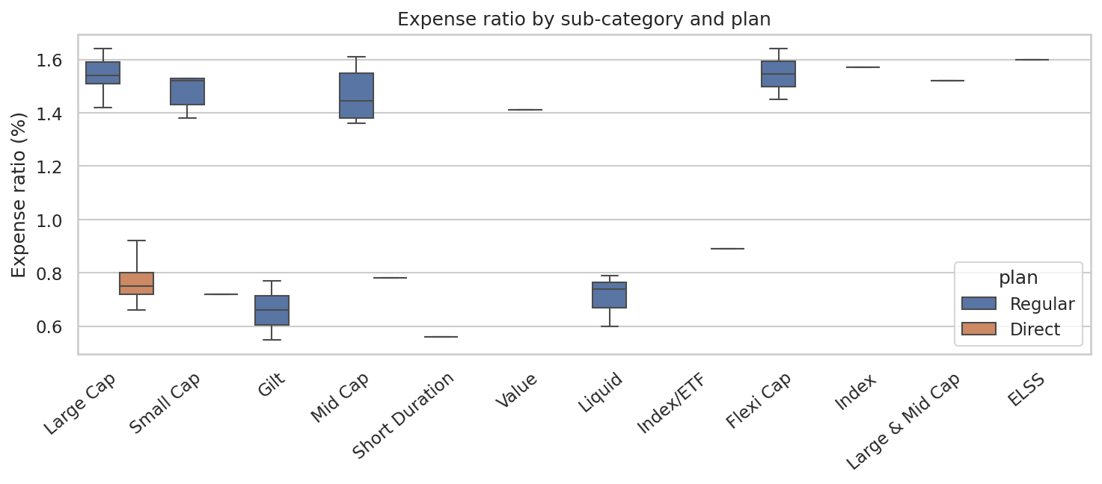
Figure 1. Expense ratio by sub-category and plan
Direct plans (8 of 40 schemes) average 0.78% against 1.35% for Regular plans. The cost gap is the clearest structural difference in the fund universe.

5.2 NAV trends
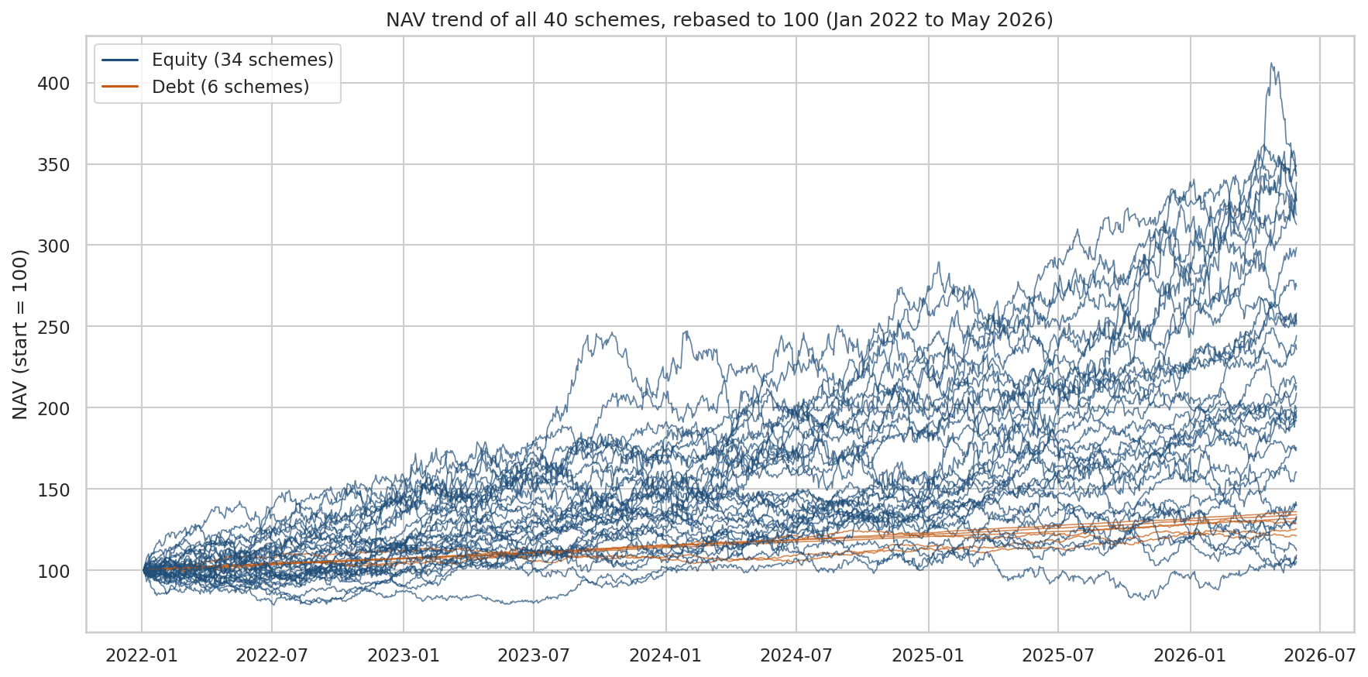
Figure 2. NAV of all 40 schemes rebased to 100 (equity blue, debt orange)
Equity schemes fan out widely: the strongest tripled in value while several ended close to where they started. Debt schemes (orange) rise steadily and stay in a narrow band.

5.3 AUM and industry growth
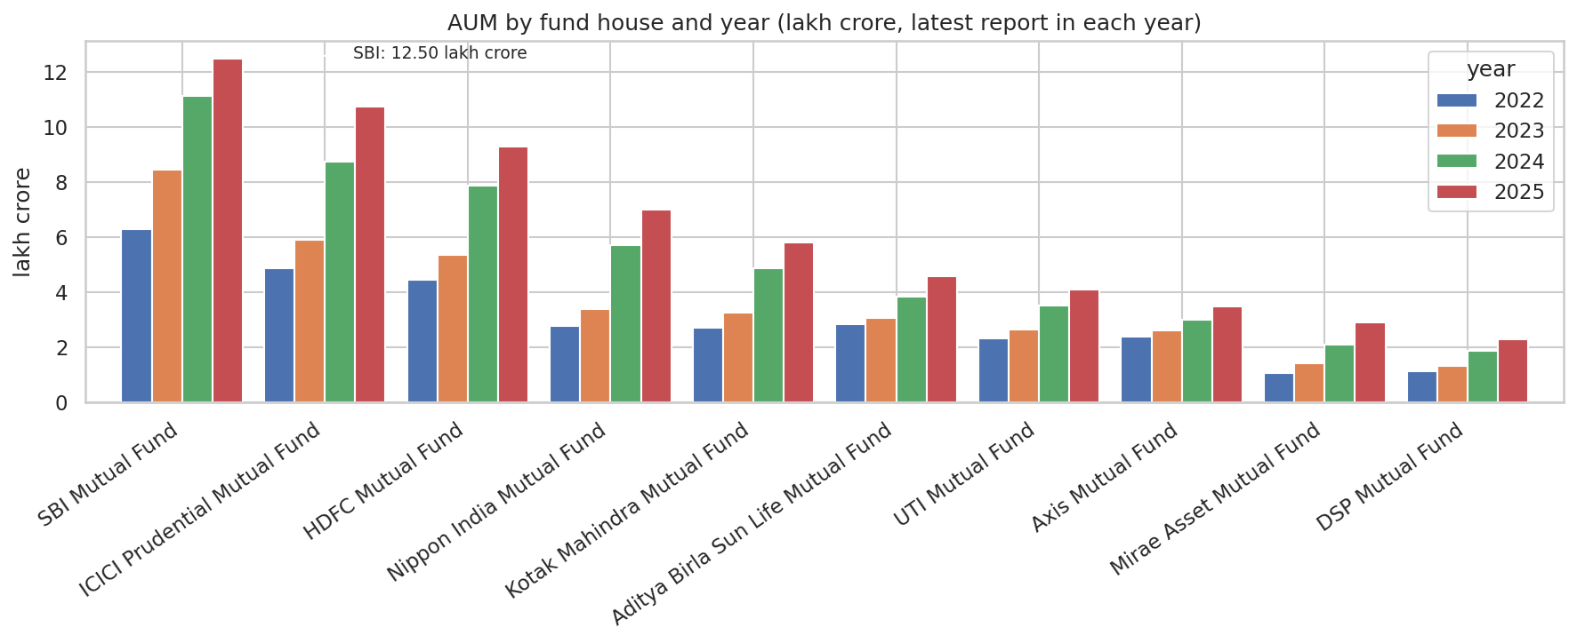
Figure 3. AUM by fund house and year (lakh crore)
SBI Mutual Fund is the largest house at 12.50 lakh crore (20% of the top 10), followed by ICICI Prudential (10.74) and HDFC (9.30). Total AUM of the ten houses grew from 30.18 to 62.74 lakh crore.
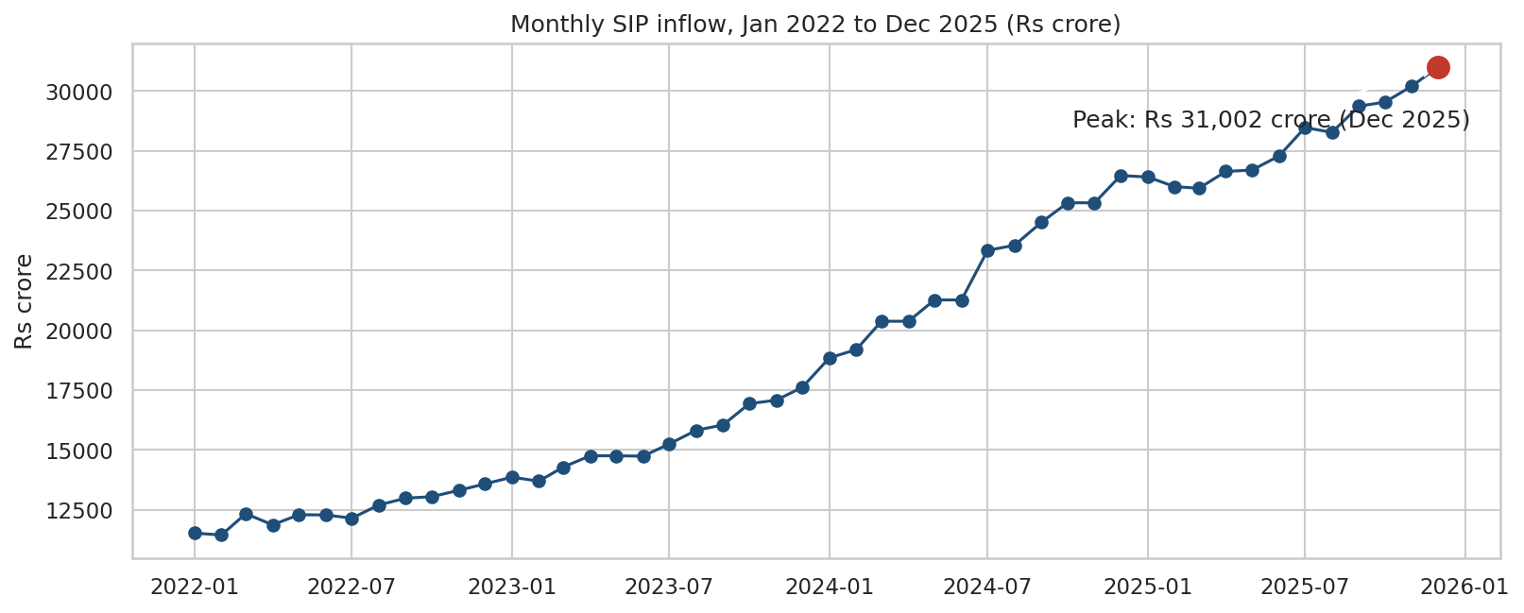
Figure 4. Monthly SIP inflow, with the all-time high marked
Monthly SIP inflow rose from Rs 11,517 crore to a record Rs 31,002 crore in December 2025. Calendar-year totals were Rs 1,49,437 crore (2022), 1,84,763 (2023), 2,69,781 (2024) and 3,35,740 (2025).
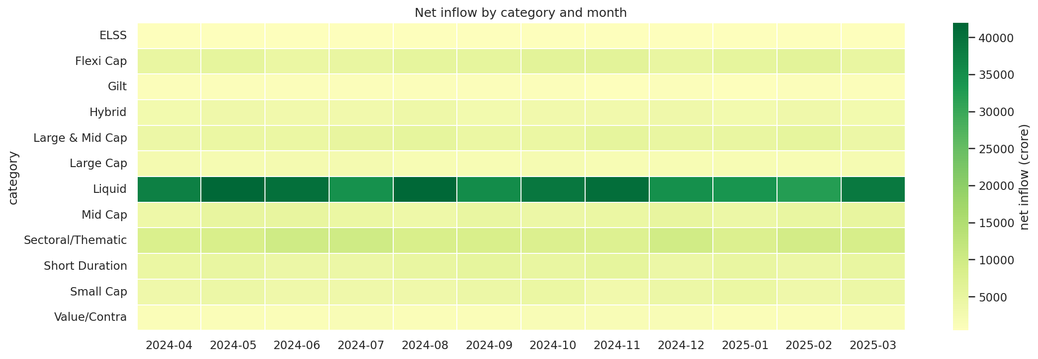
Figure 5. Net inflow by category and month, FY 2024-25 (crore)
Liquid funds took by far the largest net inflow (Rs 4,51,275 crore over the year), then Sectoral/Thematic (1,03,829), Flexi Cap (63,989), Large & Mid Cap (57,752) and Short Duration (55,530). ELSS (6,080) and Gilt (10,395) were the weakest.

5.4 Investor behaviour
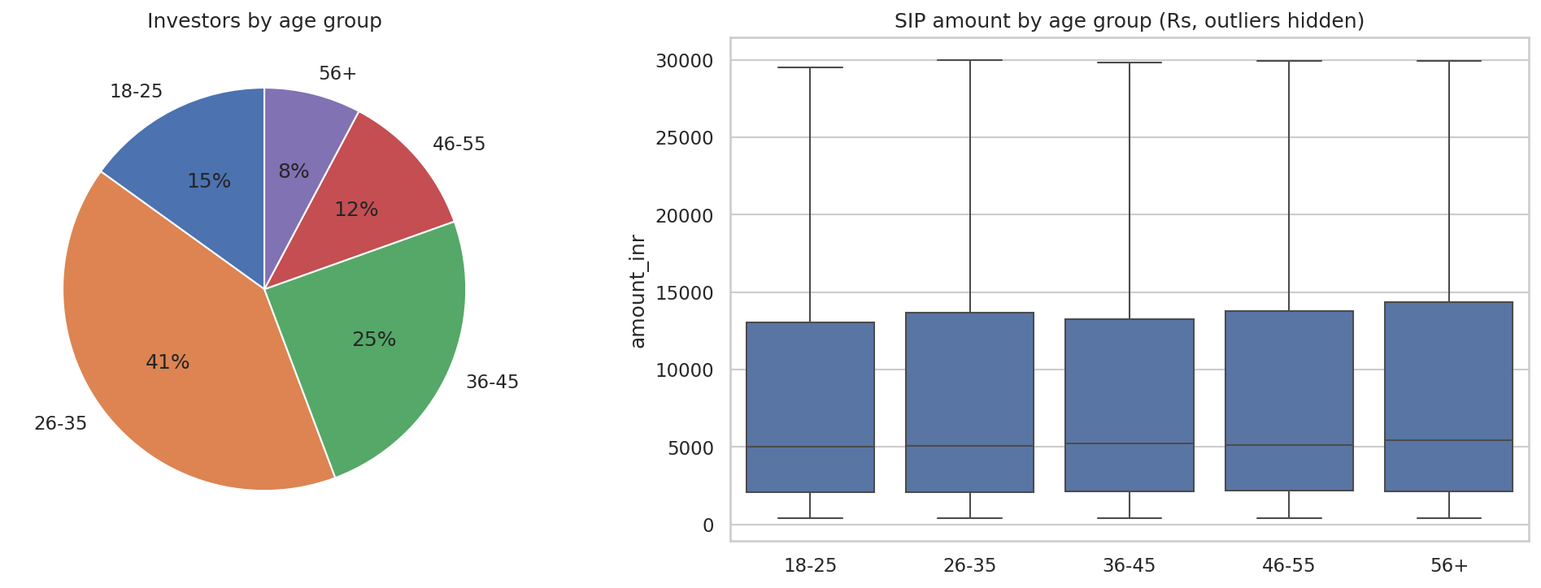
Figure 6. Investors by age group and SIP amount by age group
Investors aged 26-35 are 41% of the base, followed by 36-45 (25%) and 18-25 (15%). Average SIP size is similar across ages (about Rs 10,900-11,600), highest for investors aged 56+.
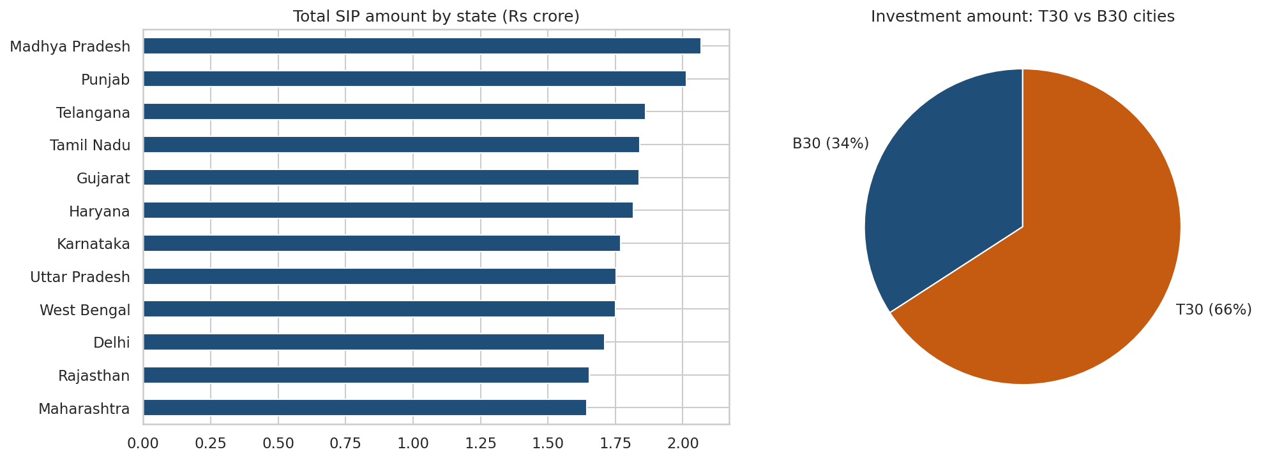
Figure 7. SIP amount by state and T30 vs B30 split
Investment is spread almost evenly across the 12 states (Punjab and Madhya Pradesh about Rs 20.4 crore each, Gujarat 19.9). B30 cities contribute 34% of investment value against 66% for the top-30 cities, a sign of deepening reach beyond metros. By amount, lumpsum accounts for 58.5% of flows, redemptions 35.3% and SIPs 6.2%, although SIPs are the most frequent transaction type (60% of transactions).
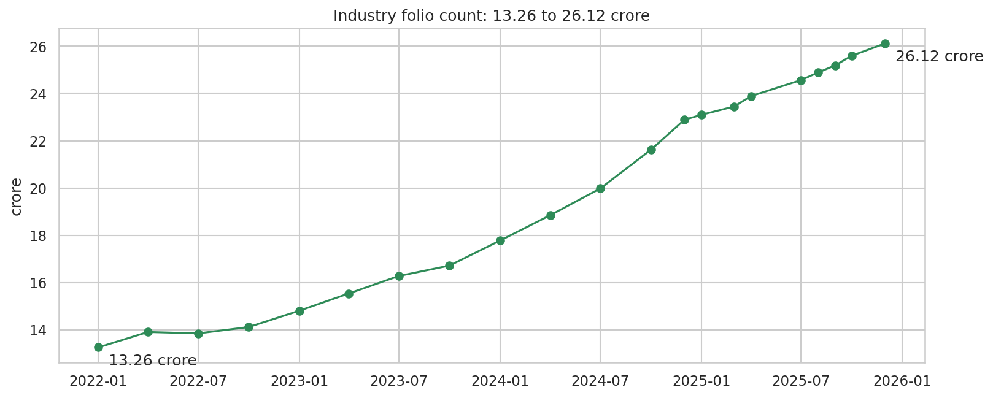
Figure 8. Industry folio count, 13.26 to 26.12 crore
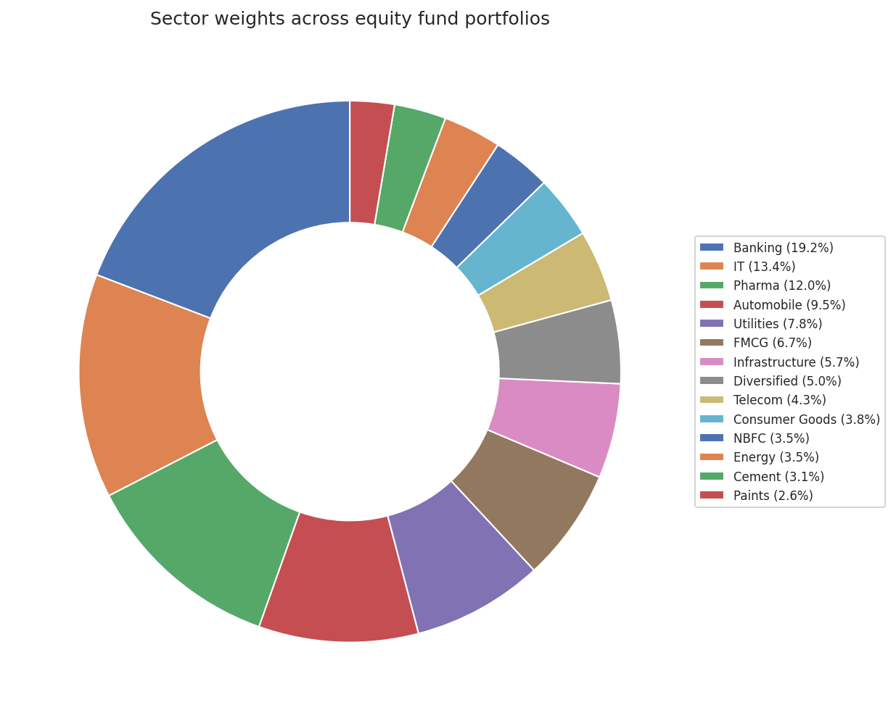
Figure 9. Sector allocation across equity fund portfolios
Banking (19.2%), IT (13.4%) and Pharma (12%) are the largest sector weights.

5.5 Ten key EDA findings
- The universe has 40 schemes from 10 fund houses: 34 equity and 6 debt.
- Direct plans are 0.57 percentage points cheaper than Regular plans.
- SBI Mutual Fund leads with 12.50 lakh crore, 20% of the top-10 total.
- SIPs make up 60% of the 32,778 transactions; net investment is Rs 103 crore.
- State-level investment is evenly spread; no state dominates.
- Monthly SIP inflow rose from Rs 11,517 crore to Rs 31,002 crore.
- Industry folios nearly doubled from 13.26 to 26.12 crore.
- Investors aged 26-35 are the largest group (41%); B30 cities give 34% of value.
- Daily returns of the ten largest schemes are essentially uncorrelated (average -0.00), unlike real funds, which usually move together.
- Banking is the largest sector weight (19.2%); scheme size and 3-year return are only weakly related (Spearman 0.10).

6. Fund Performance Analysis

6.1 Method
All metrics are calculated from daily NAVs on a trading-day basis (252 days a year) using real reported NAVs only. The risk-free rate is 6.5%, a proxy for the repo rate.
Metric | Formula | Note
CAGR | (NAV end / NAV start)^(1/years) - 1 | years = trading days / 252
Sharpe | (Rp - Rf) / Std(Rp) | daily excess return, annualised by sqrt(252)
Sortino | (Rp - Rf) / Downside Std | negative-return days only
Alpha, Beta | OLS of fund returns on Nifty 100 | alpha = intercept x 252
Max drawdown | min(NAV / running max - 1) | with peak, trough and recovery dates
VaR / CVaR (95%) | 5th percentile / mean below it | historical, daily

6.2 Returns
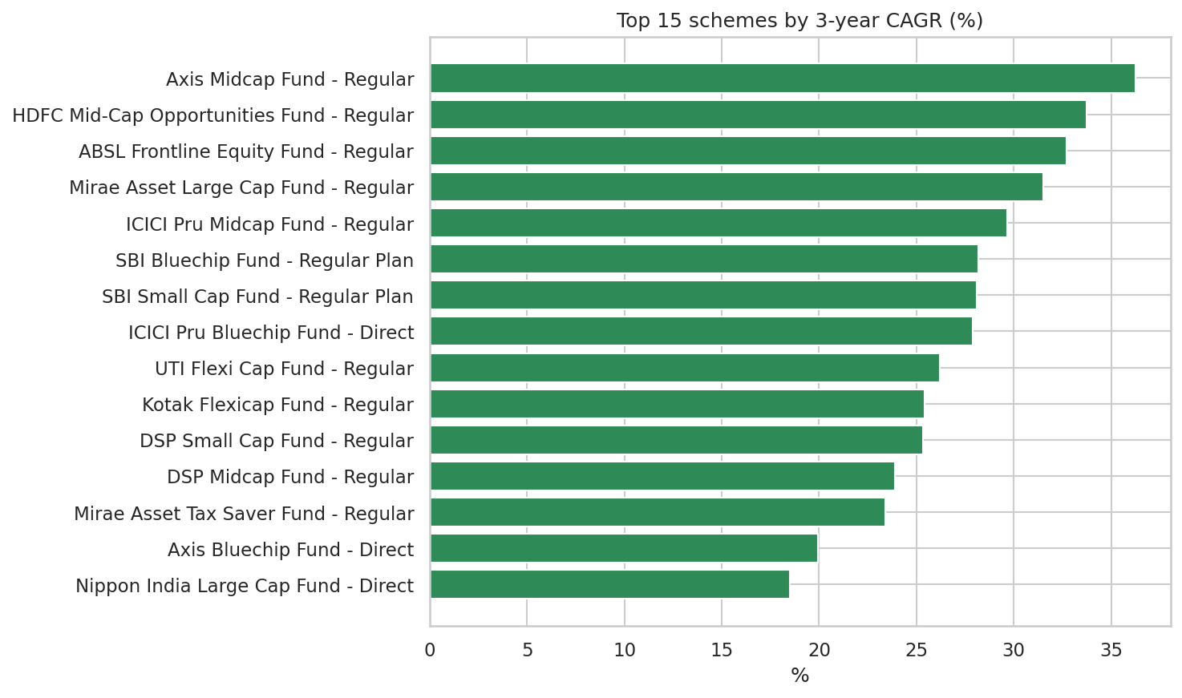
Figure 10. Top 15 schemes by 3-year CAGR
The median 3-year CAGR across the 40 schemes is 16.6%; the best is 36.2% (Axis Midcap Fund). The NAV history is 4.56 years, so a five-year CAGR cannot be calculated; the notebooks report a since-start CAGR instead (median 16.0%).

6.3 Risk-adjusted return and drawdown
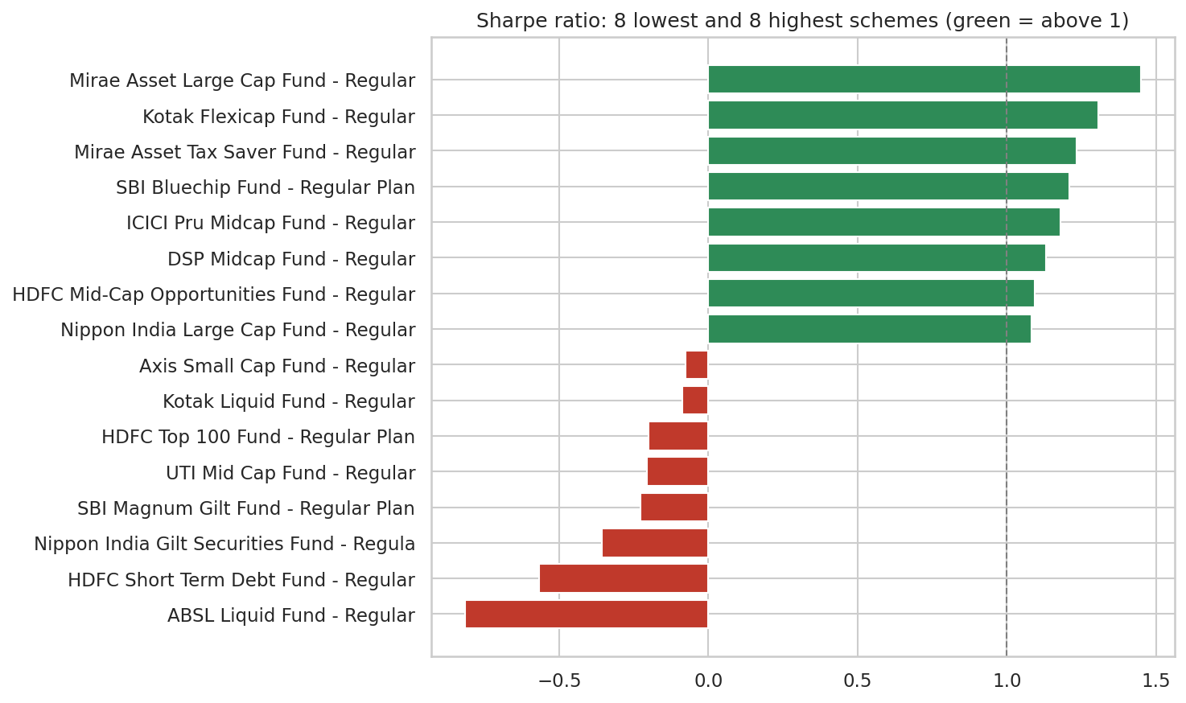
Figure 11. Sharpe ratio: the 8 lowest and 8 highest schemes
10 of 40 schemes have a Sharpe ratio above 1 and 9 are below zero, so more than a fifth of the schemes failed to beat the risk-free rate once volatility is considered.
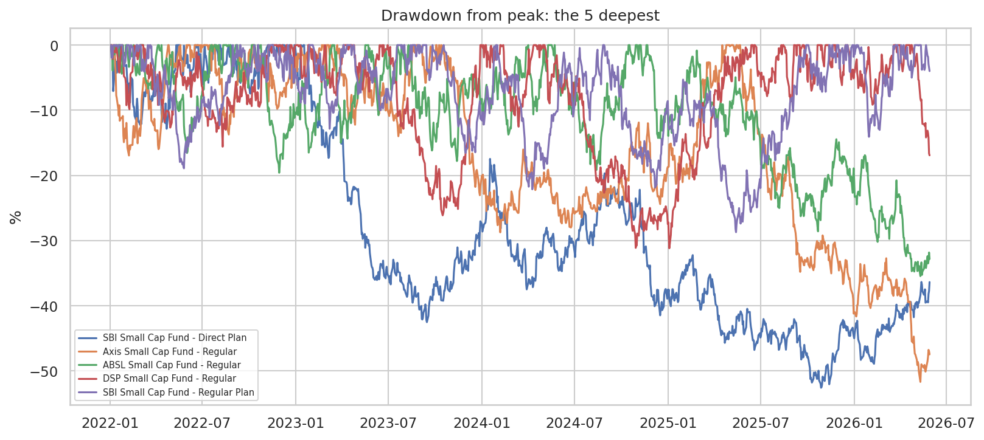
Figure 12. Drawdown from peak: the five deepest
The deepest fall is -53% (SBI Small Cap Fund, Direct). 4 schemes have not yet recovered to their earlier peak. Small-cap schemes lead the drawdown table, which matches their higher volatility.

6.4 Fund scorecard
Each scheme receives a 0-100 score from percentile ranks with the weights below. The ranking is stable: its rank correlation with an equal-weight version is 0.96.
Factor | Weight | Better when
3-year CAGR | 30% | higher
Sharpe ratio | 25% | higher
Alpha | 20% | higher
Expense ratio | 15% | lower
Max drawdown | 10% | smaller fall

Rank | Scheme | Score | 3y CAGR | Sharpe | Max DD | TER %
1 | Mirae Asset Large Cap Fund - Regular | 84.8 | 31.5% | 1.45 | -11% | 1.46
2 | ICICI Pru Midcap Fund - Regular | 82.3 | 29.6% | 1.18 | -18% | 1.36
3 | HDFC Mid-Cap Opportunities Fund - Regular | 82.2 | 33.8% | 1.09 | -16% | 1.38
4 | Kotak Flexicap Fund - Regular | 79.8 | 25.4% | 1.31 | -13% | 1.45
5 | Axis Midcap Fund - Regular | 77.0 | 36.2% | 1.00 | -21% | 1.38
6 | ICICI Pru Bluechip Fund - Direct | 76.2 | 27.9% | 1.03 | -13% | 0.80
7 | SBI Bluechip Fund - Regular Plan | 74.8 | 28.2% | 1.21 | -15% | 1.54
8 | ABSL Frontline Equity Fund - Regular | 72.7 | 32.7% | 1.03 | -11% | 1.60
9 | SBI Small Cap Fund - Regular Plan | 71.1 | 28.1% | 0.94 | -29% | 1.43
10 | Mirae Asset Tax Saver Fund - Regular | 69.9 | 23.4% | 1.24 | -16% | 1.60
Table: the ten highest-scoring schemes. At the bottom are Axis Small Cap Fund - Regular (17), UTI Mid Cap Fund - Regular (14), HDFC Top 100 Fund (13).
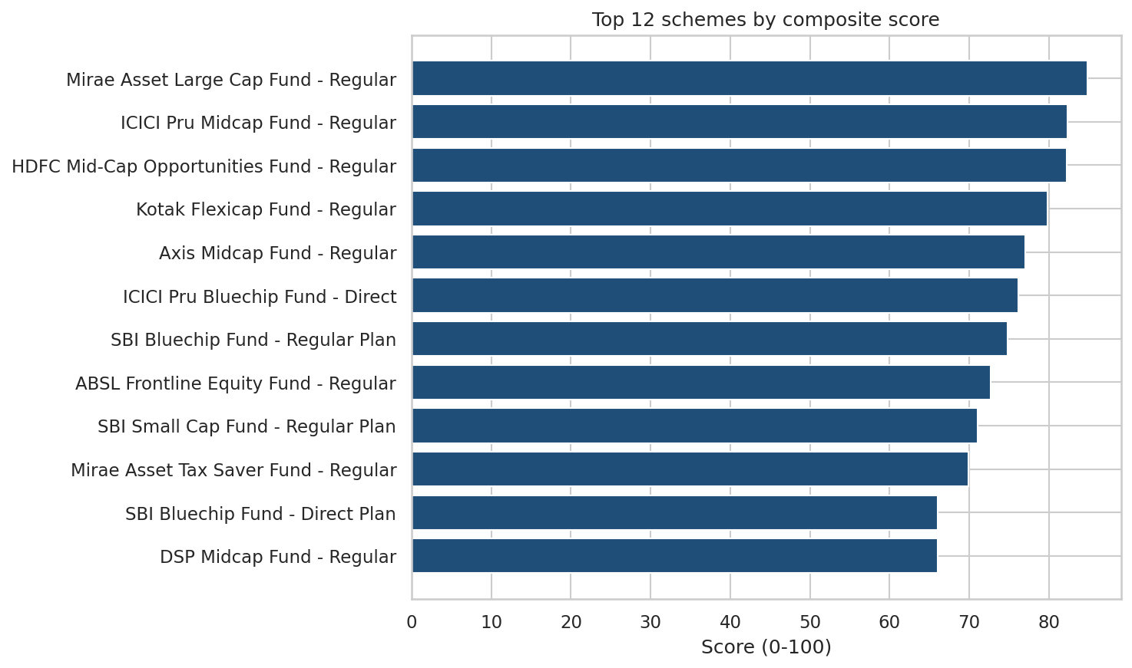
Figure 13. Top 12 schemes by composite score

6.5 Benchmark comparison
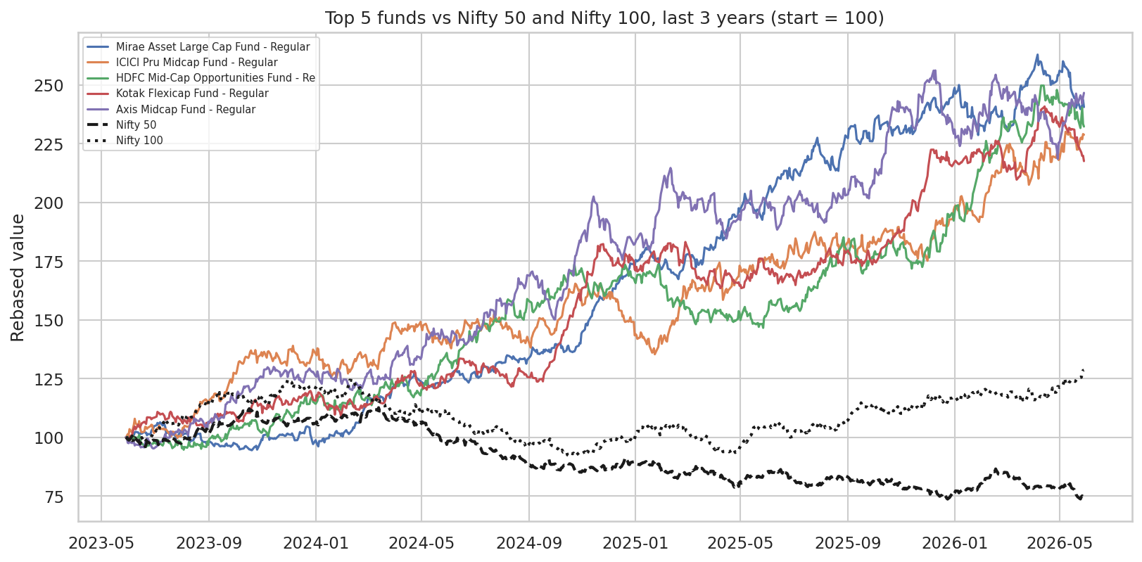
Figure 14. Top 5 schemes against Nifty 50 and Nifty 100, last 3 years (start = 100)
The top five schemes grow faster than both indices over the last three years. However, regressing daily fund returns on Nifty 100 returns gives an average R-squared of only 0.0006: the simulated NAV series do not move with the benchmark. Alpha and beta were calculated exactly as specified, but they are not informative in this dataset (see section 10).

7. Advanced Analytics and Risk

7.1 Value at Risk and CVaR
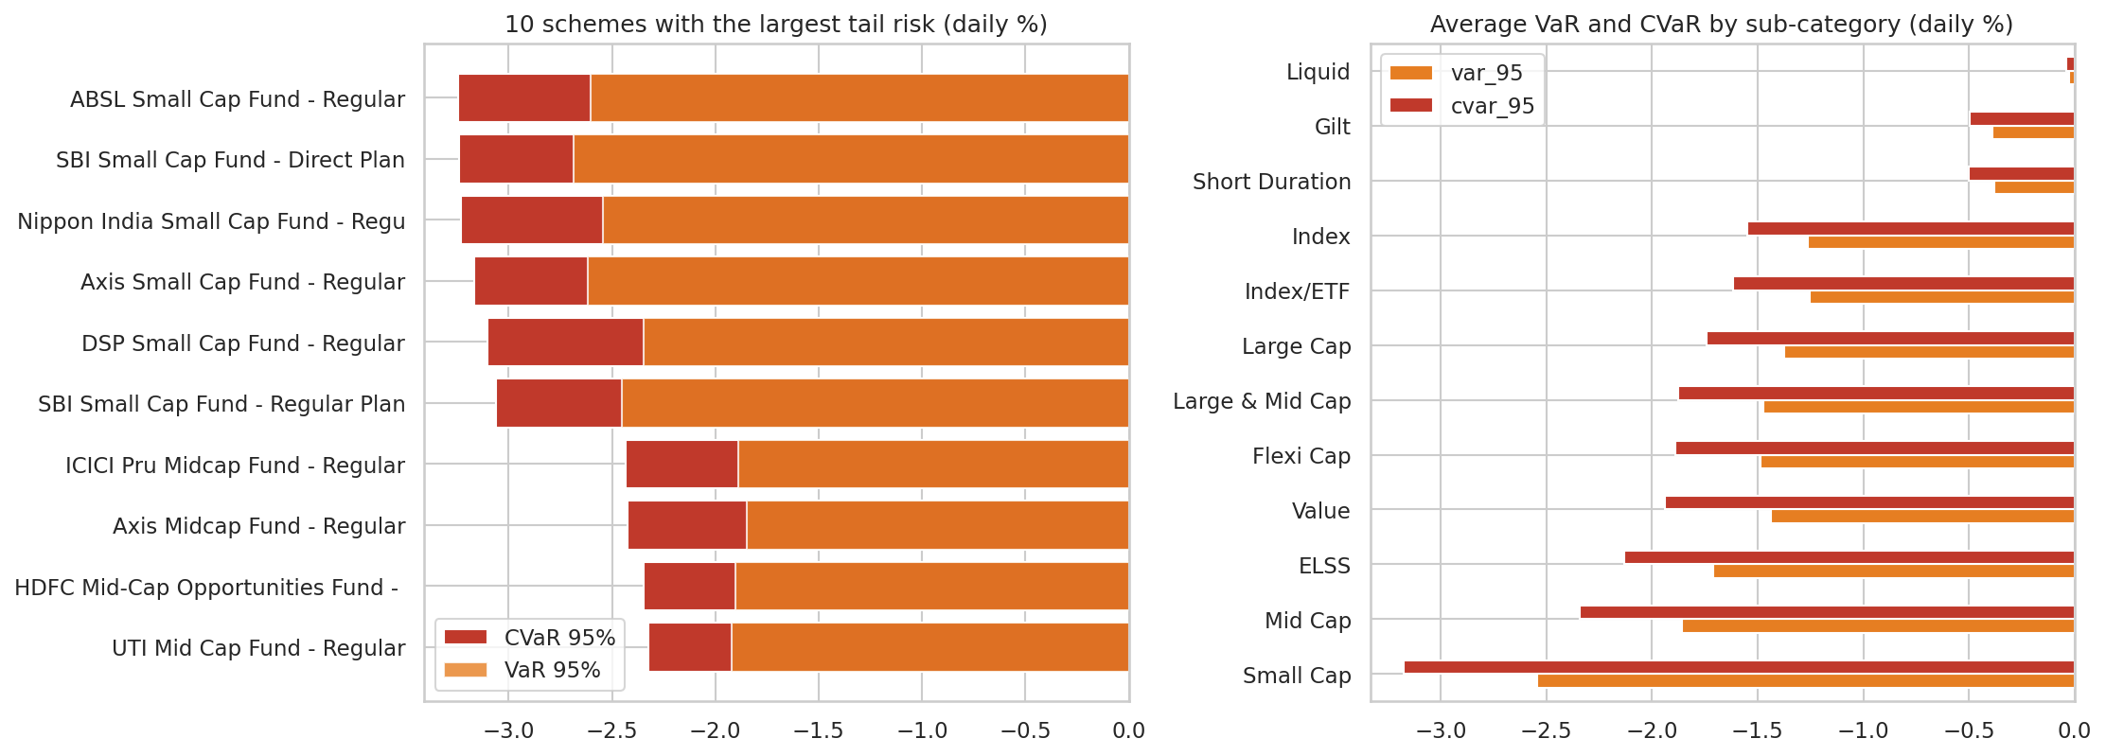
Figure 15. VaR and CVaR (95%) by scheme and sub-category
On 1 trading day in 20, an equity scheme loses at least 1.69% on average, against 0.21% for debt schemes. The highest tail risk is SBI Small Cap Fund (Direct) at -2.69% a day, about Rs 2,686 on a Rs 1 lakh holding.

7.2 Rolling Sharpe ratio
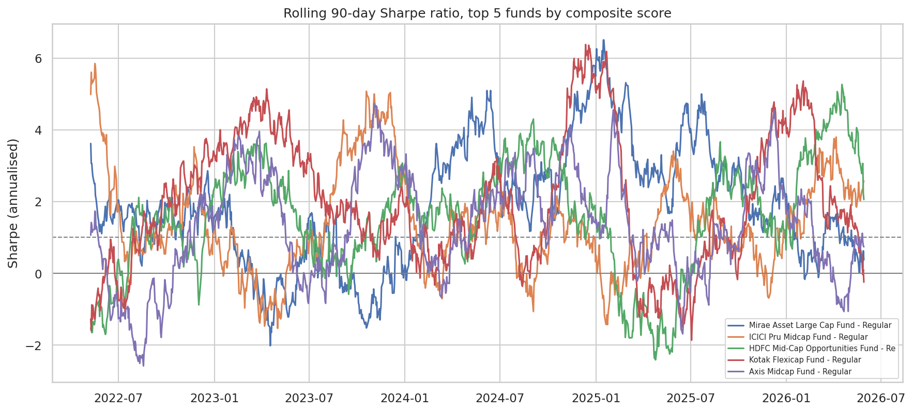
Figure 16. Rolling 90-day Sharpe ratio of the top 5 schemes
Even the best schemes spend about 40% of the time with a rolling Sharpe ratio below 1, so a strong full-period score does not mean a smooth ride.

7.3 Investor cohorts and SIP continuity
Cohort (first transaction) | Investors | Avg SIP (Rs) | Total invested (Rs crore) | Preference
2024 | 4,803 | 10,997 | 225.8 | 85% equity; Large Cap
2025 (Jan-May) | 197 | 13,505 | 1.9 | 84% equity; Large Cap

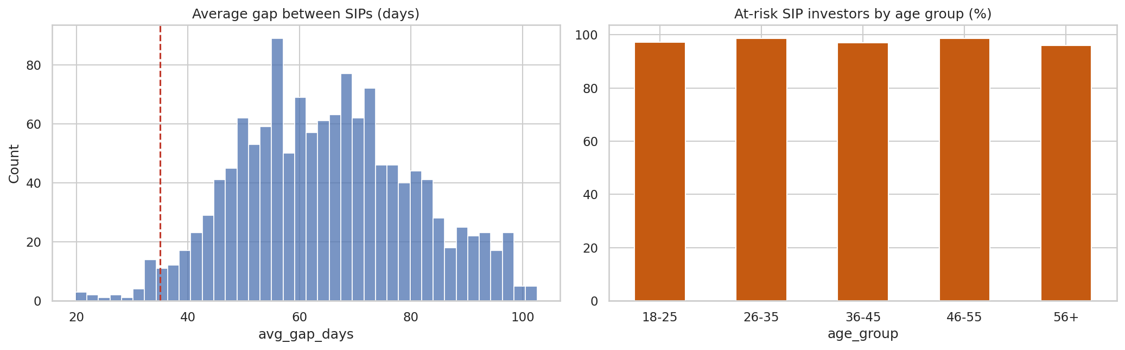
Figure 17. Average gap between SIPs, and at-risk share by age group
1,362 investors made six or more SIPs. Their median average gap is 65 days, so the 35-day rule from the brief flags 98% of them. This reflects the dataset (investors average only about 6.6 transactions over 17 months), not real SIP behaviour. A relative flag was added: the 137 investors with the longest gaps (top 10%) form a practical outreach list.

7.4 Fund recommender
The recommender maps a risk appetite to SEBI risk categories and returns the top three schemes by Sharpe ratio. Output for each appetite:
Appetite | Recommended schemes (Sharpe) | Risk group
Low | ICICI Pru Liquid Fund (0.5); Kotak Liquid Fund (-0.09); SBI Magnum Gilt Fund Plan (-0.23) | Low
Moderate | Mirae Asset Large Cap Fund (1.45); Kotak Flexicap Fund (1.31); SBI Bluechip Fund (1.21) | Moderate, Mod. High
High | Mirae Asset Tax Saver Fund (1.23); ICICI Pru Midcap Fund (1.18); DSP Midcap Fund (1.13) | High, Very High

7.5 Sector concentration
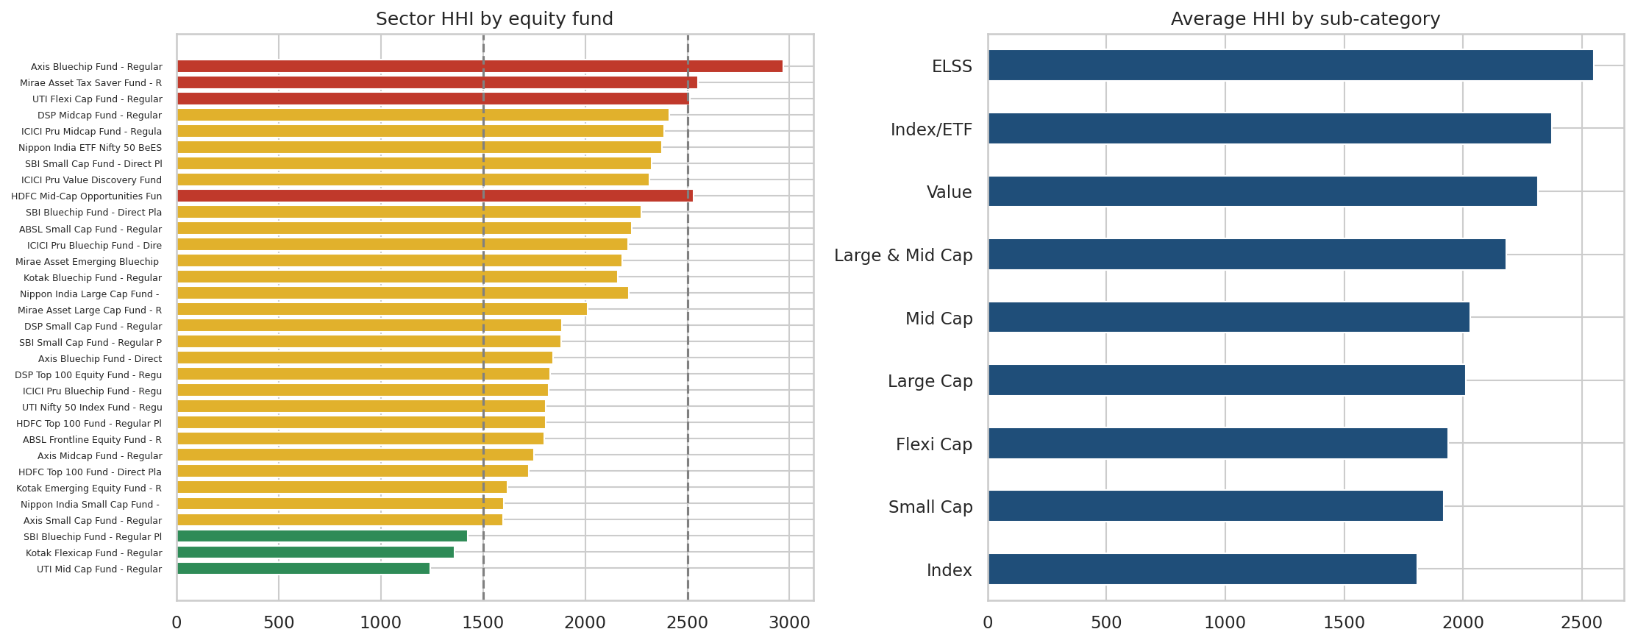
Figure 18. Sector HHI by equity scheme and by sub-category
Using the Herfindahl-Hirschman Index of sector weights, 3 equity schemes are diversified (HHI below 1,500), 27 moderately concentrated and 4 concentrated (above 2,500). The most concentrated is Axis Bluechip Fund (2,968).

8. Interactive Dashboard
The Power BI dashboard connects to the cleaned data and has four report pages with slicers on every page, plus a drill-through page (Fund Detail) and a tooltip page. It uses the Bluestock colour theme and a page navigator. Full build steps are in dashboard/DASHBOARD_GUIDE.md.
Page | Main visuals | Slicers
1. Industry Overview | KPI cards (AUM, SIP inflow, folios, schemes); AUM line; AUM by fund house bar | Fund house, year
2. Fund Performance | Return vs risk scatter (bubble = AUM); sortable scorecard; NAV vs benchmark line | Fund house, category, plan, scheme
3. Investor Analytics | State map; transaction-type donut; SIP by age bar; monthly volume line | State, age group, city tier
4. SIP and Market Trends | SIP inflow vs Nifty 50 combo; category heat map; top 5 categories; folio line | Year, category

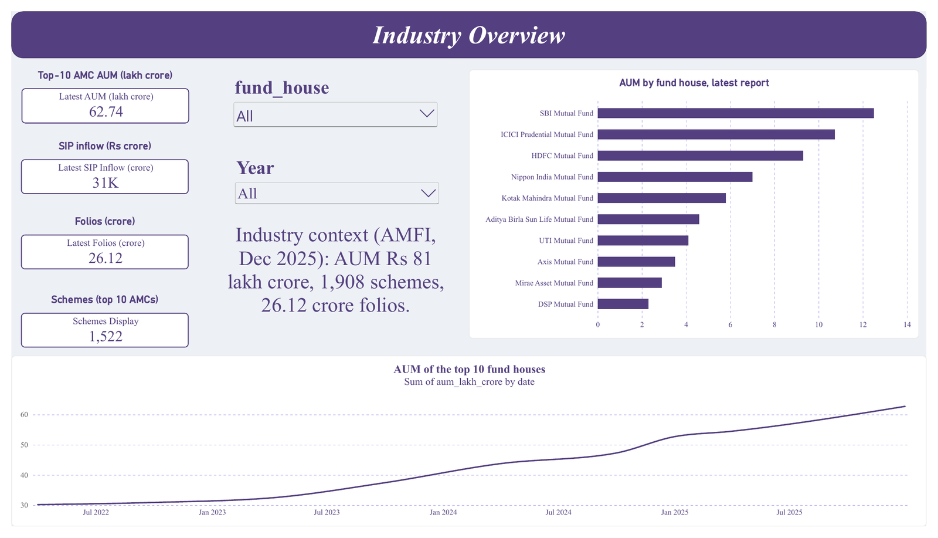
Figure 19. Page 1: Industry Overview
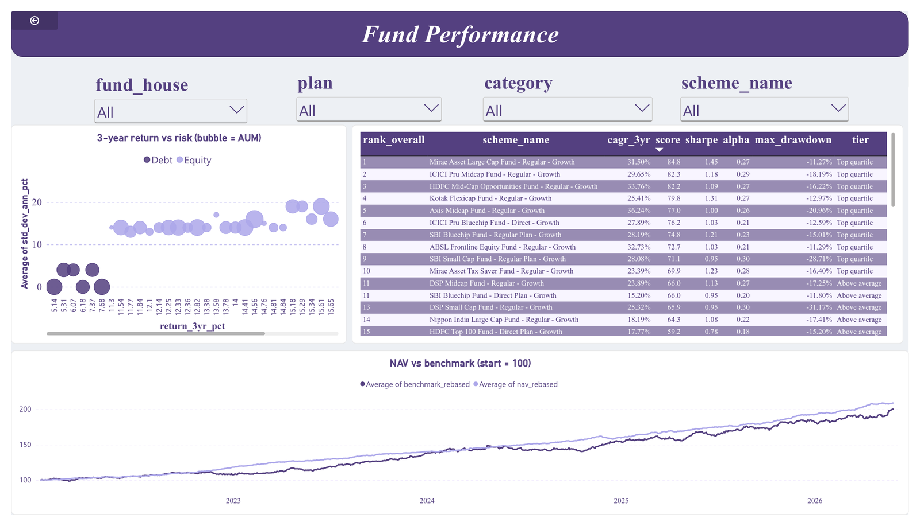
Figure 20. Page 2: Fund Performance
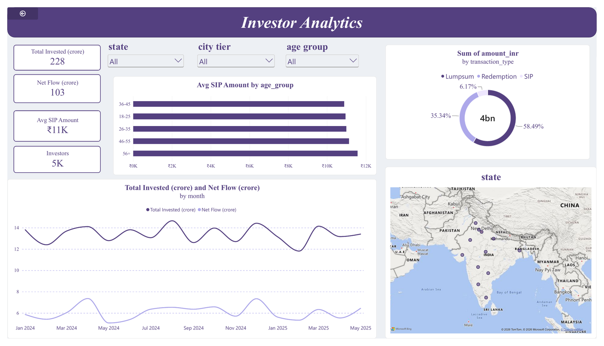
Figure 21. Page 3: Investor Analytics
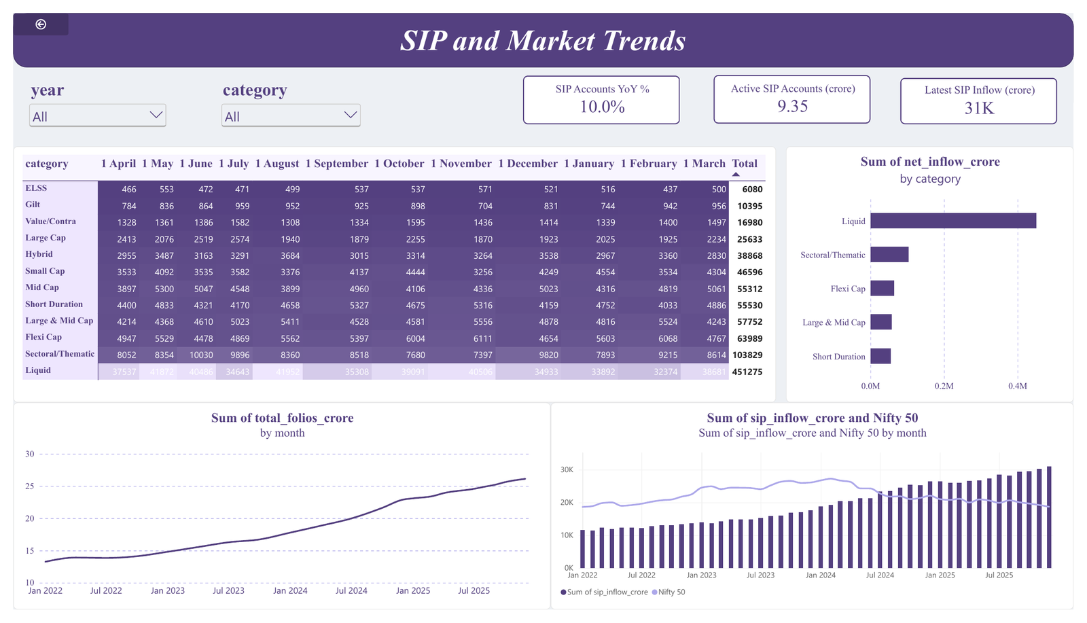
Figure 22. Page 4: SIP and Market Trends

9. Recommendations
These are analytical observations from the data, not investment advice.
- Show cost clearly. Direct plans are 0.57 percentage points cheaper per year. Bluestock products should display expense ratio and plan type next to every return figure.
- Rank funds on risk-adjusted measures. Only 10 of 40 schemes have a Sharpe ratio above 1 and 9 are negative. A composite scorecard (return, Sharpe, alpha, cost, drawdown) is more useful than a raw return table.
- Run a SIP retention programme. SIP continuity is the largest behavioural risk. Start with the 137 investors who have the longest gaps between SIPs and send reminders before an instalment is missed.
- Target B30 growth. B30 cities already provide 34% of investment value and show the same KYC-pending rate as top-30 cities, which suggests onboarding works equally well outside metros.
- Add concentration alerts. Four equity schemes have sector HHI above 2,500; flag these so investors holding several similar schemes understand their overlap.
- Show drawdown history. A -53% fall in a small-cap scheme is a more intuitive risk message than volatility. Show maximum drawdown and recovery time on fund pages.
- Fix the data gaps before production use. Obtain real NAV and benchmark series so alpha, beta and tracking error become meaningful, and add enough investor history to measure SIP continuity properly.

10. Limitations and Data Notes
- Simulated NAVs do not track benchmarks. Average R-squared against Nifty 100 is 0.0006, so OLS alpha, beta, tracking error and capture ratios are computed as specified but cannot be interpreted as skill or market sensitivity.
- Reported and calculated metrics disagree. Correlations between the provider's reported figures and values calculated from NAV are 1.00 for volatility, 0.32 for maximum drawdown, 0.11 for 3-year return and -0.33 for Sharpe. Calculated values are used throughout because they are reproducible.
- No five-year return. The NAV history is 4.56 years, so five-year CAGR is not available; since-start CAGR is reported.
- Short, sparse transaction history. Transactions cover January 2024 to May 2025 with about 6.6 per investor, so cohort and SIP-continuity results are indicative only. The 2025 cohort has only 197 investors.
- Industry totals. AUM data covers the 10 largest fund houses (Rs 62.74 lakh crore), not the full industry figure of Rs 81 lakh crore quoted in the brief.
- Synthetic transactions. Investor-level patterns follow real distributions but are not real behaviour.
- Backward-looking metrics. Past returns and risk do not predict future performance.

11. Conclusion and Future Work
The project delivers a complete, reproducible analytics stack: one command rebuilds the cleaned data, database and metrics; notebooks document every analysis; and the dashboard gives stakeholders self-service access. The analysis shows strong industry growth, a clear cost advantage for Direct plans, wide dispersion in risk-adjusted performance and a need for better SIP retention.
Future work: schedule the NAV fetch to run every weekday evening; add a Streamlit version of the dashboard; add a Monte Carlo projection of NAV growth with uncertainty bands; and add a Markowitz efficient-frontier module for portfolio construction.

Appendix A: How to reproduce
- pip install -r requirements.txt
- Place the 10 source CSVs in data/raw/
- python run_pipeline.py (ETL, metrics, dashboard data, SQL queries, data dictionary)
- Open notebooks/ in Jupyter and run notebooks 01 to 05 with Restart & Run All
- Open dashboard/bluestock_mf_dashboard.pbix in Power BI Desktop

Appendix B: Deliverables map
# | Deliverable | Location
D1 | ETL pipeline script | run_pipeline.py, scripts/etl_pipeline.py, clean_data.py, load_db.py
D2 | SQLite database | data/db/bluestock_mf.db, sql/schema.sql, sql/queries.sql, data_dictionary.md
D3 | EDA notebook | notebooks/03_eda_analysis.ipynb
D4 | Performance metrics | notebooks/04_performance_analytics.ipynb; fund_scorecard.csv, alpha_beta.csv and others in data/processed
D5 | Interactive dashboard | dashboard/bluestock_mf_dashboard.pbix, Dashboard.pdf, page screenshots
D6 | Advanced analytics | notebooks/05_advanced_analytics.ipynb, scripts/recommender.py; var_cvar_report.csv, cohort_analysis.csv
D7 | Final report and slides | reports/Final_Report.pdf, reports/Presentation.pptx

