IBM SkillsBuild National Cybersecurity Bootcamp 2026
Conducted by BharatCares (CSRBOX Group)

FINAL PROJECT REPORT
Explainable ML-Based Network Intrusion Detection System (NIDS)

Submitted by: Sakshi vinod mankar
Bsc forensic science
sandip university nashik
Date: 23 October 2026
GitHub: https://github.com/sakshimankar23/ML-Network-Intrusion-Detector.git

Abstract
Signature-based security tools struggle to detect new and unseen attacks, while machine-learning detectors are often rejected by analysts because they cannot explain their decisions. This project builds an explainable network intrusion detection system (NIDS) on the NSL-KDD benchmark. Four classifiers (Logistic Regression, Decision Tree, Random Forest and XGBoost) were compared with stratified cross-validation, the two strongest were tuned, and the best model, XGBoost (Tuned), was evaluated on the official KDDTest+ set, which contains attack types never seen during training. It reached an accuracy of 80.31%, an attack recall of 67.57%, an F1-score of 79.62% and a ROC-AUC of 0.9723. SHAP is used to explain why each connection is flagged, a threshold analysis quantifies the trade-off between detection and false alarms, and a SOAR-style layer converts predictions into severity levels and recommended response actions. A Streamlit dashboard demonstrates the complete system.

1. Introduction

1.1 Problem Statement
Modern networks face a constant stream of attacks such as denial of service, port scanning, password guessing and privilege escalation. Signature-based tools only recognise attacks they already know. Machine learning can learn the patterns of normal and malicious traffic and generalise to variations, but security teams will not act on alerts from a black box. The problem addressed here is to build a detector that is accurate, honest about its limits and explainable.

1.2 Objectives
- Detect malicious connections (binary classification) with the priority on high recall.
- Classify the attack family: Normal, DoS, Probe, R2L or U2R (multi-class classification).
- Explain each alert using SHAP so an analyst can see which features triggered it.
- Convert predictions into severity levels and recommended actions, similar to a SOAR playbook.
- Evaluate honestly on the official test set, which contains unseen attack types.

1.3 Scope
The project covers data preparation, model development, evaluation, explainability, an alerting layer and a web dashboard. It uses recorded benchmark data and does not capture live network packets.

2. Dataset
The NSL-KDD dataset, created by the Canadian Institute for Cybersecurity (University of New Brunswick), is an improved version of the KDD Cup 1999 data. It removes redundant records so that models are not biased towards frequent records. Each record describes one network connection with 41 features plus a label. The official training file (KDDTrain+) has 125,973 records and the official test file (KDDTest+) has 22,544 records. The test file contains attack types that do not appear in training, which makes it a realistic test of generalisation.
Dataset link: https://www.kaggle.com/datasets/hassan06/nslkdd | https://www.unb.ca/cic/datasets/nsl.html

2.1 Feature groups
Table 1: Feature groups in NSL-KDD
Group | Examples
Basic | duration, protocol_type, service, flag, src_bytes, dst_bytes
Content | num_failed_logins, logged_in, root_shell, num_compromised
Time-based traffic | count, srv_count, serror_rate, rerror_rate, same_srv_rate
Host-based traffic | dst_host_count, dst_host_srv_count, dst_host_serror_rate

2.2 Attack categories
Table 2: Attack categories
Category | Meaning
Normal | Legitimate traffic
DoS | Denial of Service: flooding a target (e.g. neptune, smurf)
Probe | Surveillance and scanning (e.g. satan, portsweep)
R2L | Remote to Local: unauthorised remote access (e.g. guess_passwd)
U2R | User to Root: privilege escalation (e.g. buffer_overflow)

Table 3: Class distribution of the training and test sets
Category | Train records | Test records
Normal | 67343 | 9711
DoS | 45927 | 7460
Probe | 11656 | 2421
R2L | 995 | 2885
U2R | 52 | 67

R2L and U2R are very rare compared with DoS and Probe, so accuracy alone would hide poor performance on them.
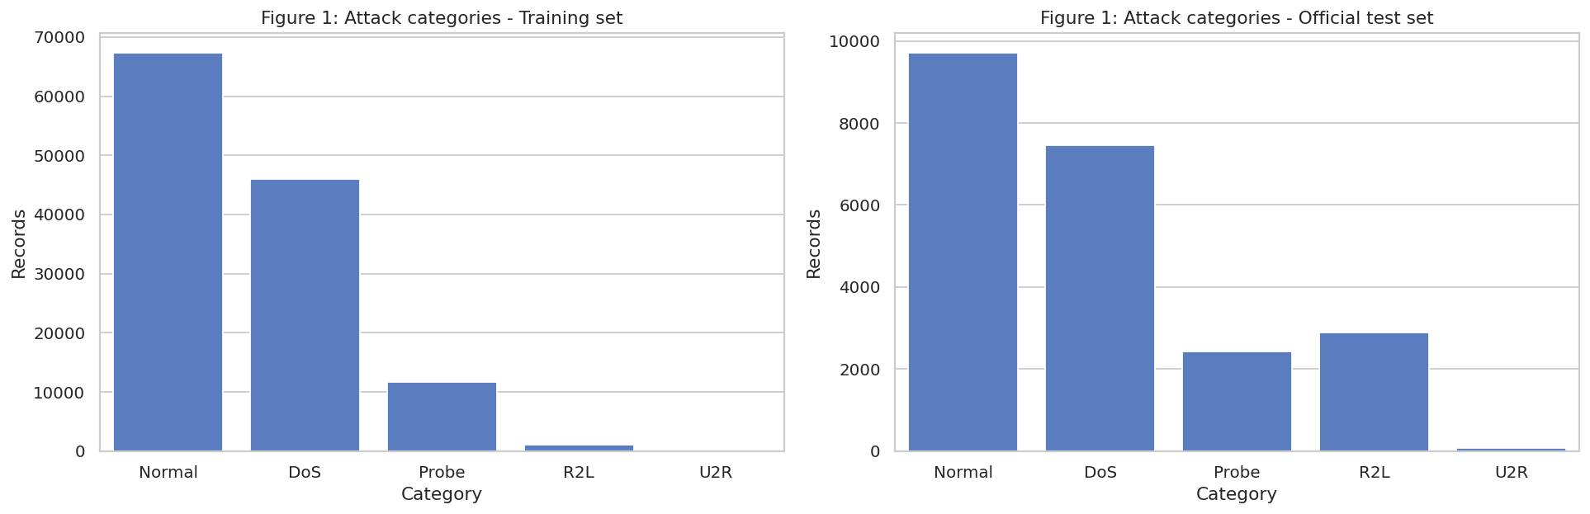
Figure 1: Attack category distribution
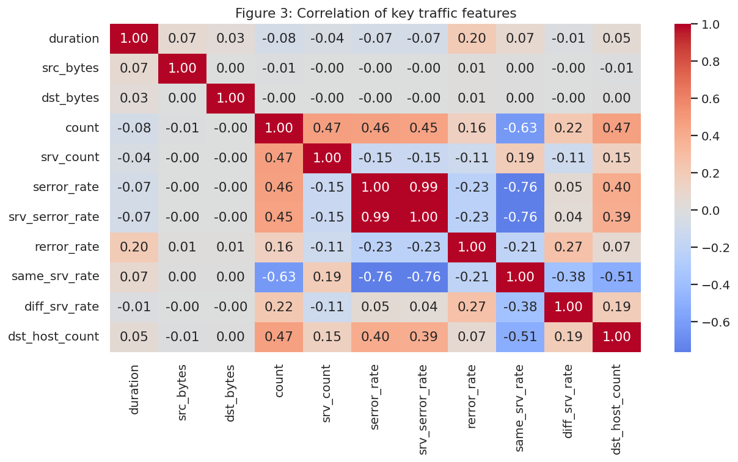
Figure 2: Correlation of key traffic features

3. Methodology

3.1 Technology stack
Table 4: Tools used
Purpose | Tool
Language | Python 3
Data handling | pandas, NumPy
Machine learning | scikit-learn
Gradient boosting | XGBoost
Explainability | SHAP
Visualisation | Matplotlib, Seaborn, Altair
Dashboard | Streamlit
Environment | Google Colab, GitHub

3.2 Data preprocessing
- Labels: the 38 attack names were mapped to 5 categories, and a binary label (Normal or Attack) was created.
- Numeric features were standardised with StandardScaler.
- protocol_type, service and flag were one-hot encoded with unknown categories ignored, because the test set contains services absent from training.
- The difficulty column was dropped because it is a benchmark annotation, not a network feature.
- All preprocessing sits inside a scikit-learn Pipeline, so it is re-fitted on the training part of every cross-validation fold. This prevents data leakage.

3.3 Models and training
Four classifiers were compared: Logistic Regression, Decision Tree, Random Forest and XGBoost. Class imbalance was handled with balanced class weights (scale_pos_weight for XGBoost). Models were compared with stratified cross-validation on the training set using accuracy, precision, recall, F1 and ROC-AUC.

3.4 Hyperparameter tuning
Random Forest and XGBoost were tuned with RandomizedSearchCV optimising F1.
- Best Random Forest parameters: {'clf__n_estimators': 100, 'clf__min_samples_leaf': 2, 'clf__max_depth': 20}
- Best XGBoost parameters: {'clf__n_estimators': 200, 'clf__max_depth': 9, 'clf__learning_rate': 0.05}

3.5 Evaluation strategy
The final models were evaluated on the official KDDTest+ file. In intrusion detection, recall matters more than raw accuracy: a false positive costs an analyst some time, but a false negative is an intruder who went undetected. A threshold analysis measured how detection and false alarms change as the decision threshold is lowered.

3.6 Explainability and alerting
SHAP (SHapley Additive exPlanations) was used to attribute each prediction to the input features, both globally (summary plot) and locally (waterfall plot for a single alert). Prediction probabilities are converted into severity levels with recommended actions:
Table 5: Severity levels and response actions
Severity | Attack probability | Recommended action
Low | below threshold | Log only
Medium | up to 70% | Monitor and flag in SIEM
High | 70% to 90% | Alert SOC, rate-limit source
Critical | above 90% | Block IP, isolate host

4. Results and Discussion

4.1 Cross-validation
Table 6: Stratified cross-validation results on the training set
Model | CV Accuracy | CV Precision | CV Recall | CV F1 | CV ROC-AUC
Logistic Regression | 0.9739 | 0.9764 | 0.9673 | 0.9718 | 0.9964
Decision Tree | 0.9985 | 0.9983 | 0.9984 | 0.9983 | 0.9985
Random Forest | 0.9988 | 0.9995 | 0.9979 | 0.9987 | 1.0000
XGBoost | 0.9991 | 0.9993 | 0.9988 | 0.9990 | 1.0000

Cross-validation folds are drawn from the same distribution as the training data, so these scores are optimistic. The official test set gives the more realistic estimate.

4.2 Performance on the official test set
Table 7: Results on KDDTest+ (threshold 0.5)
Model | Accuracy | Precision | Recall | F1-Score | ROC-AUC
Logistic Regression | 0.7540 | 0.9168 | 0.6246 | 0.7430 | 0.7904
Decision Tree | 0.7976 | 0.9654 | 0.6684 | 0.7899 | 0.8183
Random Forest (Tuned) | 0.7698 | 0.9676 | 0.6162 | 0.7529 | 0.9686
XGBoost (Tuned) | 0.8031 | 0.9690 | 0.6757 | 0.7962 | 0.9723

The selected model, XGBoost (Tuned), reached accuracy 80.31%, precision 96.90%, recall 67.57%, F1-score 79.62% and ROC-AUC 0.9723. Its cross-validated F1 was 0.9990 against 0.7962 on the test set. This gap is expected because KDDTest+ contains attack types that were never seen in training, which mimics zero-day behaviour.
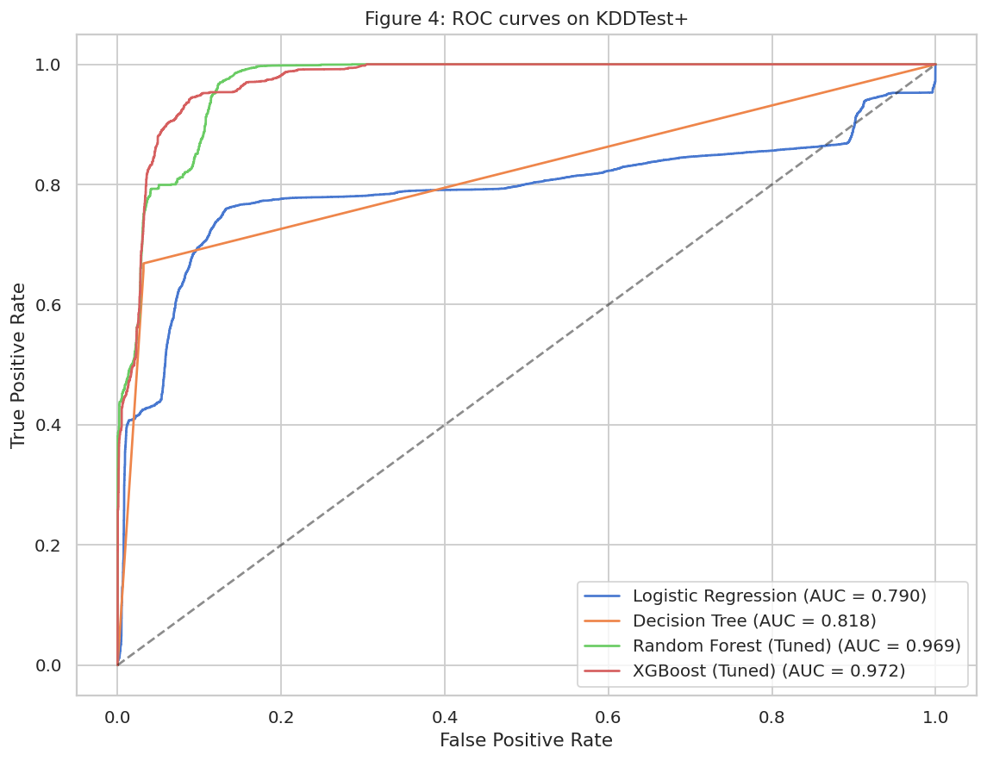
Figure 3: ROC curves of all models on KDDTest+
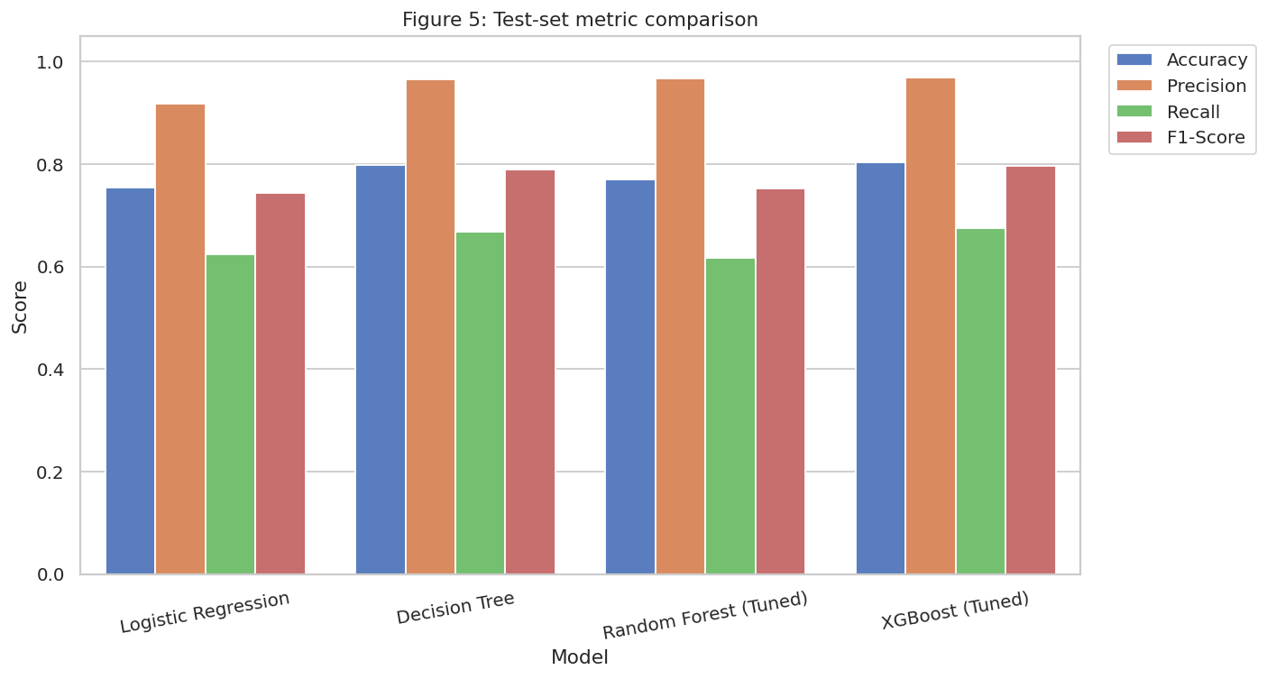
Figure 4: Test metric comparison
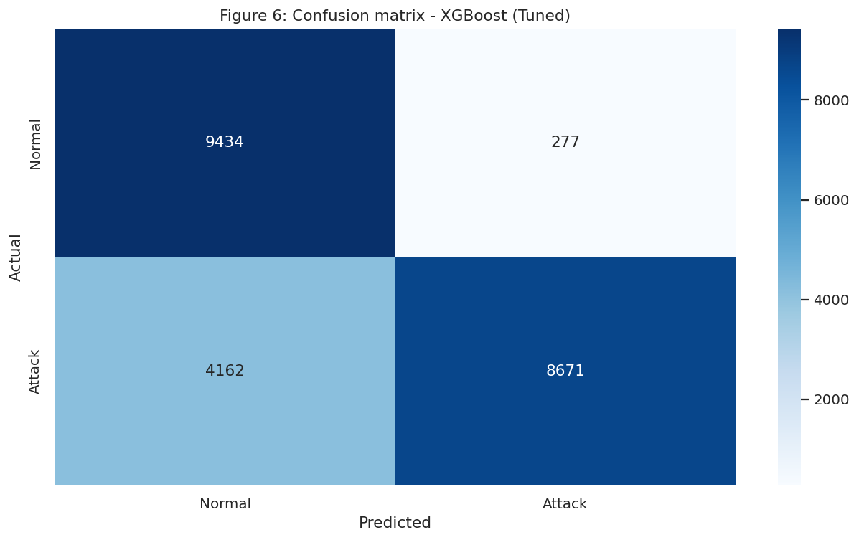
Figure 5: Confusion matrix of XGBoost (Tuned)

4.3 Threshold analysis
Table 8: Effect of the decision threshold on detection and false alarms
Threshold | Attack Recall | Precision | False-Alarm Rate | Missed Attacks (FN)
0.5000 | 0.6757 | 0.9690 | 0.0285 | 4162.0000
0.4000 | 0.6846 | 0.9693 | 0.0286 | 4047.0000
0.3000 | 0.6902 | 0.9688 | 0.0293 | 3976.0000
0.2000 | 0.6958 | 0.9689 | 0.0296 | 3904.0000
0.1000 | 0.7166 | 0.9684 | 0.0309 | 3637.0000

Lowering the threshold from 0.5 to 0.1 raised attack recall from 67.57% to 71.66%, while the false-alarm rate rose from 2.85% to 3.09%. A security team can choose the operating point that matches how costly a missed attack is.
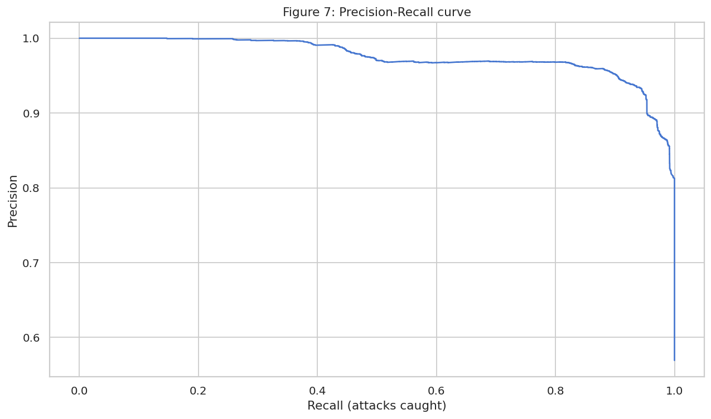
Figure 6: Precision-recall curve

4.4 Multi-class results
Table 9: Per-class results for attack categorisation
Class | Precision | Recall | F1-score | Support
Normal | 0.6497 | 0.9738 | 0.7794 | 9711
DoS | 0.9632 | 0.8094 | 0.8796 | 7460
Probe | 0.8553 | 0.5956 | 0.7022 | 2421
R2L | 0.9310 | 0.0094 | 0.0185 | 2885
U2R | 0.5000 | 0.0299 | 0.0563 | 67

Normal was detected best (recall 97.38%) and R2L worst (recall 0.94%). R2L and U2R attacks target authentication and host-level weaknesses and produce a network footprint close to normal user behaviour. They are also rare in the training data. Reliable detection needs host logs or application-layer inspection.
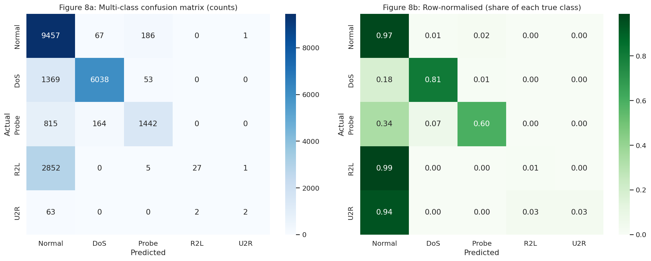
Figure 7: Multi-class confusion matrix

4.5 Explainability with SHAP
The feature-importance and SHAP plots show which traffic features drive the decisions. The local waterfall plot explains one specific alert, showing the features that pushed the connection towards the attack class.
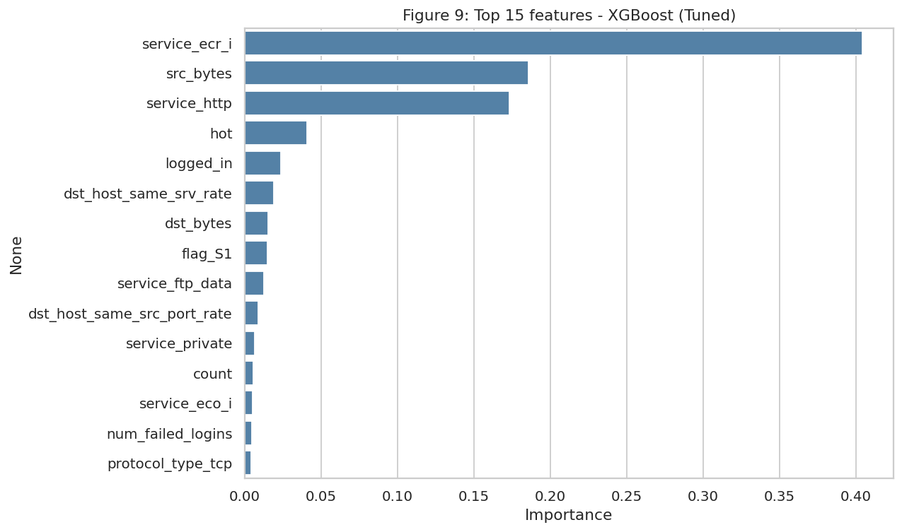
Figure 8: Top 15 features by importance
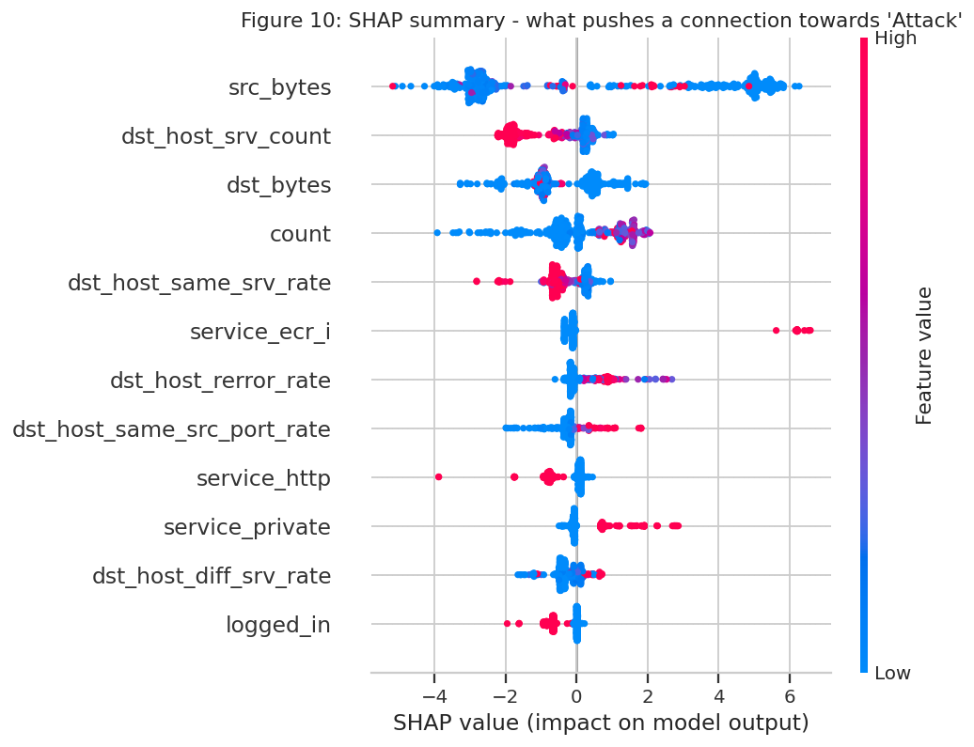
Figure 9: SHAP summary plot
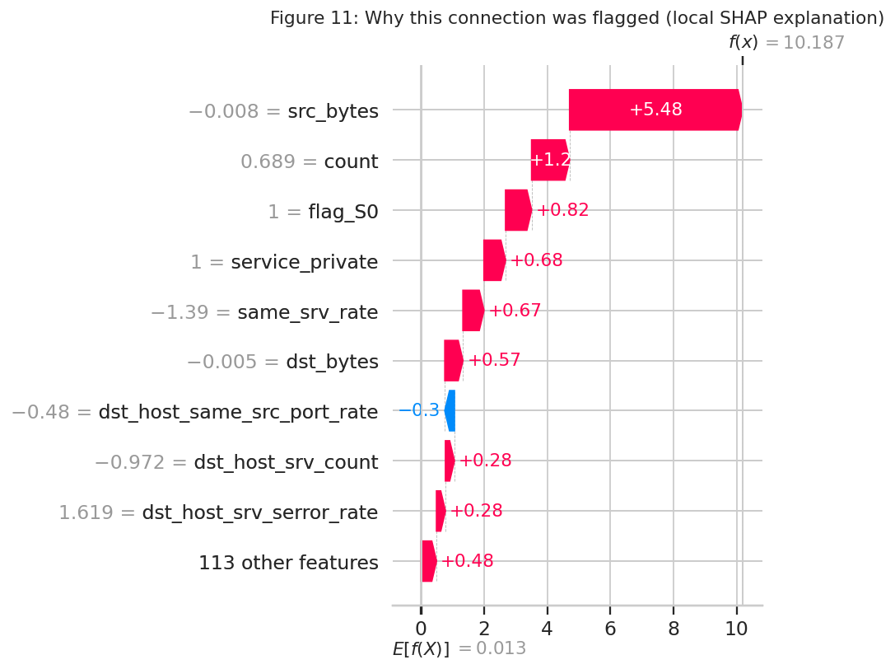
Figure 10: SHAP explanation of one flagged connection

4.6 Error analysis
Table 10: Share of each attack category that was missed
Attack category | Missed (%)
DoS | 11.9705
Probe | 24.3288
R2L | 91.0225
U2R | 80.5970

Attack types that are rare in training or absent from it are the most likely to be missed. This is the main limitation of a supervised detector.
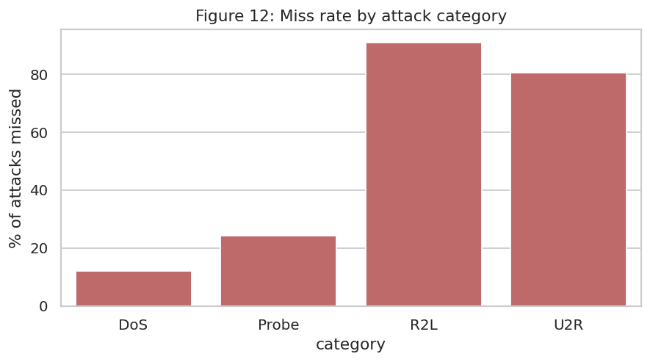
Figure 11: Miss rate by attack category

5. Dashboard (CyberShield NIDS)
A Streamlit web application loads the saved model and provides: a dashboard with summary cards, severity and protocol charts and a downloadable alert list; an explainability tab with SHAP charts for individual alerts; a live traffic simulation; a manual connection tester with attack presets; a model performance tab; and an adjustable detection threshold.
(Add your dashboard screenshots to a folder named 'screenshots' and re-run this cell to include them here.)

6. Limitations
- NSL-KDD is derived from 1999-era traffic; modern threats such as ransomware, encrypted traffic and cloud API abuse are not represented.
- Benchmark traffic is cleaner and less imbalanced than real production traffic.
- A supervised model struggles with attack types it has not seen and with rare classes such as R2L and U2R.
- Even a small false-alarm rate produces many alerts at enterprise scale (alert fatigue).

7. Future Work
- Evaluate on newer datasets such as UNSW-NB15 and CIC-IDS2017.
- Add anomaly-detection methods (autoencoders, isolation forest) for zero-day attacks.
- Capture and score live traffic with Scapy or Zeek.
- Enrich alerts with threat intelligence from VirusTotal or AbuseIPDB.
- Deploy the model behind an API and integrate with a SIEM/SOAR platform.

8. Conclusion
This project delivered an end-to-end, explainable intrusion detection system. On the official test set the XGBoost (Tuned) model reached an F1-score of 79.62% with attack recall of 67.57%. Leak-free pipelines, evaluation on unseen attack types, a threshold analysis, SHAP explanations and a severity-based response layer make the system transparent and practical. The results also show the limits of supervised detection on rare and unseen attacks, which points to the future work above.

References
- Tavallaee, M., Bagheri, E., Lu, W., Ghorbani, A. (2009). A Detailed Analysis of the KDD CUP 99 Data Set. IEEE CISDA.
- Lundberg, S. M., Lee, S.-I. (2017). A Unified Approach to Interpreting Model Predictions. NeurIPS.
- Pedregosa, F. et al. (2011). Scikit-learn: Machine Learning in Python. JMLR 12.
- Chen, T., Guestrin, C. (2016). XGBoost: A Scalable Tree Boosting System. KDD.
- NSL-KDD dataset, Canadian Institute for Cybersecurity, University of New Brunswick: https://www.unb.ca/cic/datasets/nsl.html
- Streamlit documentation: https://docs.streamlit.io

Appendix: Project Files
Table 11: Repository contents
File | Description
SakshiMankar_IntrusionDetector.ipynb | Training, evaluation and explainability notebook
app.py | Streamlit dashboard
requirements.txt | Python dependencies
model.pkl, columns.pkl | Saved model pipeline and metadata
alerts_log.csv | Sample SOC alert log
images/ and results/ | Charts and metric tables

Repository: https://github.com/sakshimankar23/ML-Network-Intrusion-Detector.git

