Jack of all Games
Solution Definition

Authors:
Sterling Commerce
Date Created: 04/29/2009
Version: v0.3
File Name: Jack of all Games_SolutionDefinition_v0.3.doc
Document Revision History
Revision | Date | Description (Changes Made) | Author
01 | 04/29/2009 | Initial Draft | Sterling Team
02 | 06/01/2009 | Add for pre outbound process | Sterling Team
03 | 06/11/2009 | Delete the AS2 perimeter section | Sterling Team
Document Approval History
Name | Signature | Date | Version Approved / Comments
Related or Reference Documents
Document Name | Description | Owner | Location
Discussions, Meetings, Interviews
Date | Discussion / Meeting / Interview | Participants

TABLE OF CONTENTS
1. Introduction 5
1.1 Document Purpose 5
1.2 Document Audience 5
1.3 Related Documents 5
2. Conceptual Solution Architecture 6
2.1 Overview 6
2.1.1 External Trading Partner Communications 6
2.1.2 Jack of all Games Transport Layer 6
2.1.3 Jack of all Games Application Systems 6
2.1.4 Jack of all Games Gentran Integration Suite - GIS 6
2.1.5 Jack of all Games Data Transport 6
2.2 GIS Conceptual Deployment Architecture 7
3. Technical Architecture 9
3.1 Overview 9
3.2 GIS Hardware and Software Requirements 9
3.2.1 Windows Client 9
3.2.2 Windows Host 9
3.2.3 Memory Requirements 10
3.2.4 Database 10
3.2.5 Perimeter Servers 10
3.3 J2EE Architecture 11
3.4 J2EE Scalability and Performance 11
3.5 Environment Requirements 12
3.5.1 Development/Test Environment 12
3.5.2 Production Environment 12
3.6 Environment Diagrams – Logical View 13
3.6.1 Development/Test Environment Physical View 13
3.6.1.1 Development/Test Environment Physical Information 13
3.6.2 Production Environment – Physical View 14
3.6.2.1 Production Environment – Physical Information 14
4. Business Documents 15
4.1 Documents 15
5. Conceptual Functional Solution 16
5.1 Business Functionality 16
5.2 Business Processes 16
5.2.1 EDI Processes 16
5.2.1.1 Outbound Processes 16
5.2.1.2 Outbound Process Functional Flow Diagram 17
5.2.1.3 Inbound Processes 18
5.2.1.4 Inbound Process Functional Flow Diagram 18
5.3 Business Process (BPML) Definition Algorithms 20
5.3.1 File System Business Processes 20
5.3.1.1 BASEEDI_Send_FileSystem 20
5.3.1.2 BASEEDI_AppInt_FileSystem 20
5.3.1.3 BASEEDI_Send_Error 20
5.3.2 De-envelope Business Processes (Inbound EDI) 21
5.3.2.1 BASEEDI_DeenvelopeUnifiedPreProcessor 21
5.3.2.2 BASEEDI_DeenvelopeUnifiedPostProcessor 21
5.3.2.3 BASEEDI_DeenvelopeUnifiedError 22
5.3.2.4 BASEEDI_X12DeenvelopeUnified 22
5.3.2.5 BASEEDI_X12DeenvelopeError 23
5.3.2.6 BASEEDI_EDIFACTDeenvelopeUnified 23
5.3.2.7 BASEEDI_EDIFACTDeenvelopeError 24
5.3.2.8 BASEEDI_TRADACOMDeenvelopeUnified 24
5.3.2.9 BASEEDI_TRADACOMDeenvelopeError 24
5.3.3 Envelope Business Processes (Outbound EDI) 25
5.3.3.1 BASEEDI_DocExtract_Pre1 25
5.3.3.2 BASEEDI_ DocExtractFlat_810_Email 25
5.3.3.3 BaseEDI_DocExtractFlat_Pre2 25
5.3.3.4 BaseEDI_CollectDelayFlatFiles 25
5.3.3.5 BASEEDI_DocExtractFlat 26
5.3.3.6 BASEEDI_DocExtractFlat_Batch_Recovery 26
5.3.3.7 BASEEDI_DocExtractFlatError 27
5.3.3.8 BASEEDI_OutBoundTranslationError 27
5.3.3.9 BASEEDI_OutBoundTranslationError_Redo 27
5.3.3.10 BASEEDI_EnvelopeUnifiedPostProcessor 28
5.3.3.11 BASEEDI_EnvelopeUnifiedPostProcessorError 28
5.3.3.12 BASEEDI_EnvelopeUnified_BadBatch_Handler 29
5.3.3.13 BASEEDI_X12EnvelopeUnified 29
5.3.3.14 BASEEDI_X12EnvelopeError 30
5.3.3.15 BASEEDI_EDIFACTEnvelopeUnified 30
5.3.3.16 BASEEDI_EDIFACTEnvelopeError 31
5.3.3.17 BASEEDI_TRADACOMEnvelopeUnified 31
5.3.3.18 BASEEDI_TRADACOMEnvelopeError 31
5.3.4 Miscellaneous Business Processes 32
5.3.4.1 BASEEDI_RefreshPropertiesCache 32
5.3.4.2 BASEEDI_GenericErrorHandler 32
5.3.5 High Level Business Process Flow 34
5.4 Trading Partners 35
5.5 EDI Standards Requirements and Translation Maps 35
5.5.1 Translation Maps 35
5.5.2 Communications 36
5.5.2.1 Internal Communications 36
5.5.2.2 External Trading Partner Communications 36
5.6 Naming Standards 37
5.7 Archive Strategy and Access 38
5.7.1 Pre and Post Image of EDI Files 38
6. Training Recommendations 39
7. Migration Approach 39
8. GIS Upgrades and Promotion Processes 40
8.1.1 Upgrades 40
8.1.2 Promotion Processes 40
9. Appendix 41
9.1 Appendix A – Acronyms & Definitions 41

Introduction
Jack of all Games contracted with Sterling Commerce to deliver an EDI replacement project from Gentran Server for Windows to Gentran Integration suite™ for the exchange of electronic documents. Sterling’s solution will supply a framework which will provide scalability, reporting capabilities, ease of maintenance and enable Jack of all Games to offer trading partners logical and simple methods of electronic data exchange.

This conceptual architecture is based upon pre-engineered best practices for implementing Gentran Integration Suite for Electronic Data Interchange. Updates to this document will be made as installation and trading partner community conversion data points identify.

Document Purpose
The purpose of this document is to define technical architecture required to enable the Sterling Commerce solution. This includes technical architecture requirements elements that will support a successful deployment of the Sterling Commerce electronic data exchange solution.

This document comprises the results of extensive field experience with implementing Gentran Integration Suite for EDI and is intended as an aid in planning for further EDI community build-out at Jack of all Games. Discussions and analysis contained herein represent a collection point for detailed design specification that prior to onsite engagement and/or conversion for Jack of all Games.

Document Audience

The content of this document is primarily of a conceptual nature and is intended for business and I.T. stakeholders and decision makers associated with this initiative.

Related Documents
The table below lists the key documents reviewed by the project team.

Document Name | Owner / Contact | Date Reviewed

Conceptual Solution Architecture

Overview
This section represents a high level description of the solution architecture and the primary functions the Sterling solution will perform. This provides the “big picture” view of the solution that is detailed further in subsequent sections of this document.

Jack of all Games uses the Windows cluster administration (OS level) to control the operation of GIS. Only one GIS node is active and the other is idle. From view point of GIS, it is standalone setup and both nodes share one database/program folder

External Trading Partner Communications

Jack of all Games will communicate with its trading partners through direct-connects via FTP and AS2 by using the existing communication software. GIS works as EDI translator only and communicates with the external program via file system adapter.

Jack of all Games Transport Layer

N/A

Jack of all Games Application Systems

Jack of all Games’s JDE application system will integrate with GIS EDI implementation by using GIS File System Adapter for both inbound and outbound EDI process. JDE is the primary back-end application that will generate and receive data from GIS and supports batching.
For processing of outbound data, the flat file header records contain identifiers necessary for discovery of a distinct trading partner. These header records in outbound flat files are consistent regardless of transaction type. Inbound data relies on content of envelopes to distinguish one transaction type and/or partner from another.

Jack of all Games Gentran Integration Suite - GIS

GIS is an Enterprise Java-based software product that supports many-to-many translation. In addition to EDI translation and mapping, GIS supports XML and flat file translation, transformation and mapping.

The product also uses Java-based adapters to communicate with JDBC compliant databases, SAP, Siebel and many other backend resources. It uses open source protocols such as HTTP/S, FTP/S and SMTP to transport business-to-business data over the Internet. Of the full suite of features available in the core product, this implementation will leverage File System Adapter and FTP Client Adapter for application integration, EDI-to-Flat File and Flat File-to-EDI mappings, FTP client for trading partner connection, and SMTP for process exception notification.

Jack of all Games Data Transport

Both AS2 and FTP are the transport used by Jack of all Games to send and receive electronic documents to/from trading partners.

GIS Conceptual Deployment Architecture
Note: Direction of arrows indicates direction of data flow, not necessarily source and destination of communications sessions.

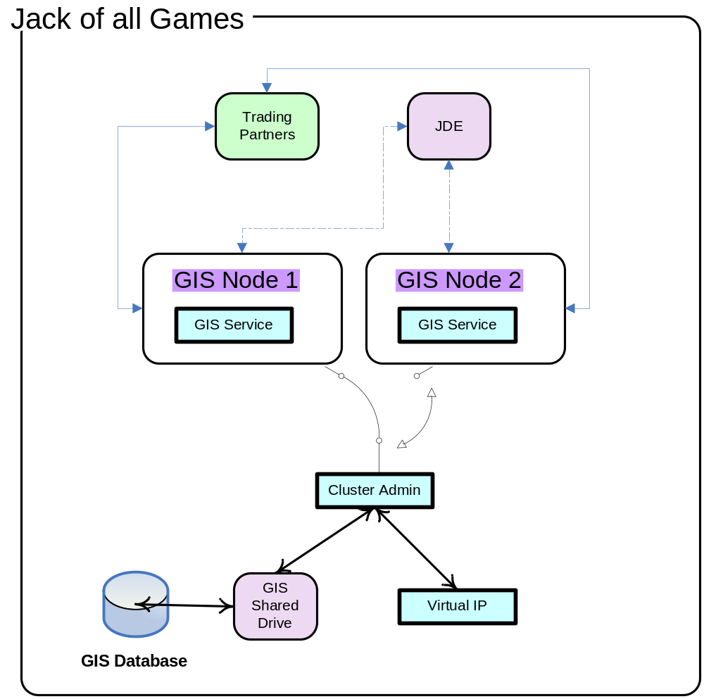

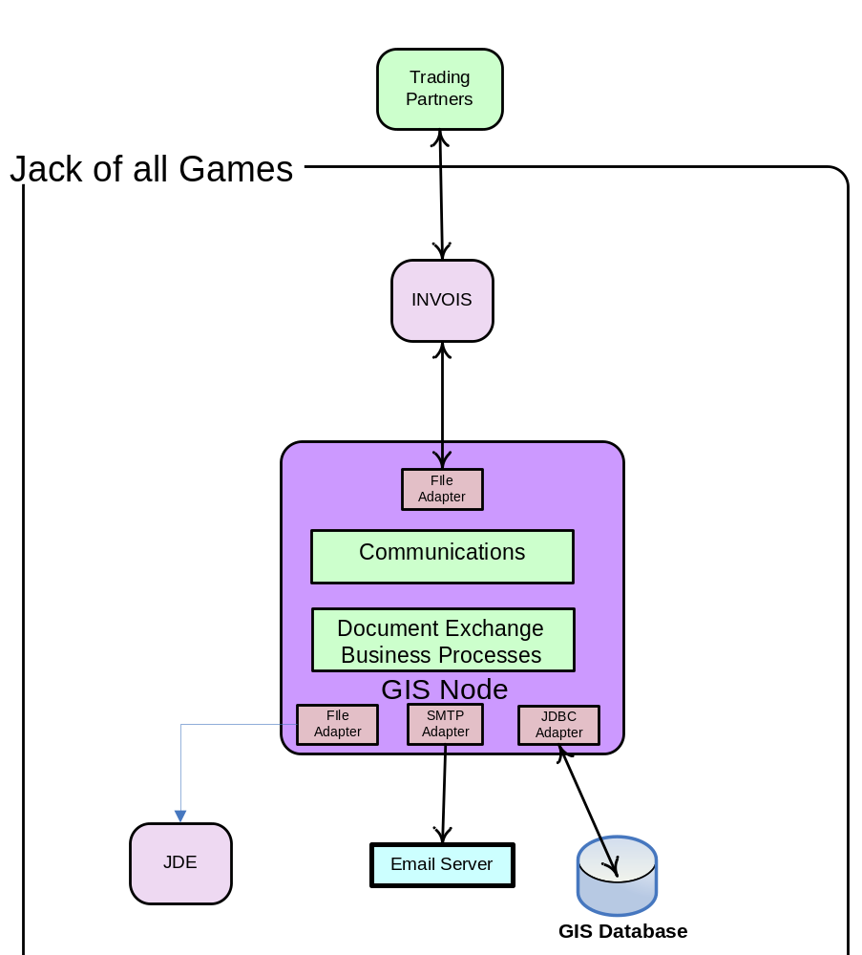

Technical Architecture

This section describes the technical architecture for the Jack of all Games project. It describes GIS architecture and environment. This section provides aid in planning implementation of GIS.

Overview
Document Processing
This installation will handle the processing of Jack of all Games’s mission critical documents. This will include any data transformations required on the inbound and outbound documents as well as specific routings for additional processing or communications. Transaction error notifications via SMTP will deliver from this instance as well.

GIS Hardware and Software Requirements
The following are the minimum requirements for Gentran Integration Suite™. For more information, refer to the Gentran Integration Suite™ Installation Guide.

Windows Client

- CD-ROM drive
- Pentium® or equivalent processor
- 400 MHz processor speed
- Color VGA or SVGA monitor
- Microsoft Internet Explorer 5.5
- 256 MB RAM
- 1 GB disk space

Note: If you are using the Gentran Integration Suite™ Map Editor or Graphical Process Modeler, you also need the Microsoft Windows® 98, Microsoft Windows NT® (SP6), or Microsoft Windows 2000 operating system.

Windows Host

The following items list the minimum hardware and software requirements for implementing Gentran Integration Suite™ on the Windows Server platform.
- 4 GB RAM
- 20 GB free disk space
- OS: Windows 2003 Server
- JDK: Sun JDK 1.5.0_11
- JCE for unrestrict_1.5.0.zip
- JDBC driver version 1.1.1501.101 (download sqljdbc.jar from http://www.microsoft.com/downloads)
- File system space will be needed if you are using the option to store documents on the file system. The amount of space needed will vary depending on the size of the documents to be stored and the length of time you choose to keep documents on the file system.

Memory Requirements

Additional host memory requirements are determined by needs of the operating system and any additional applications. A four-to-one memory to CPU ratio is normally adequate.

Database

Oracle, Microsoft SQL Server and mySQL are supported databases. Since processing of electronic business documents is mission critical to Jack of all Games, the company should carefully consider failover needs when selecting a database for GIS in the Production environment. Gentran Integration Suite requires a database with one logical view. Jack of all Games’s selection of database is Microsoft SQL Server 2005 Enterprise and Standard Editions.

GIS live documents will be stored on the file system, as that is the existing strategy. Lower volume should be able to support this aspect of architecture with no problems.

Perimeter Servers

A perimeter server is communications management software that can be installed in a DMZ and manages communication flows between a perimeter network and Gentran Integration Suite TCP-based transport adapters. A perimeter network is a computer network that is placed between a secure internal network and an unsecured external network to provide an additional layer of security. A perimeter server communicates with Gentran Integration Suite through perimeter services. Perimeter services is the Gentran Integration Suite subsystem supporting multi-homing and secure perimeter network traversing for Gentran Integration Suite B2B communications protocols. Perimeter services consist of the following components:

- Perimeter server you install on your DMZ computer (remote perimeter server).
- Perimeter server pre-installed in Gentran Integration Suite (local perimeter server)
- Perimeter services API that communications adapters in Gentran Integration Suite use to use the perimeter servers (local and remote) to use multi-homing and perimeter network traversal functionality
- Perimeter servers’ configuration management components in Gentran Integration Suite interface

You should use perimeter servers if you want to:
- Secure communications between the DMZ and Gentran Integration Suite.
- Send data to your partners from the perimeter server as the originating IP address.
- Manage security certificates on your secure network and not in a DMZ.
- Enhance performance and scalability of Gentran Integration Suite through session and thread management that includes a large number of connections.
- Use the following adapters or protocols:
  - Options for the scope of this project:
    - FTP Client adapter with related services
    - AS2 protocol
    - HTTP Server adapter
    - HTTP Client adapter with related services
  - Out-of-scope of this project:
    - WebSphere MQ (implemented in future signed SOW)
    - Connect:Direct Server adapter
    - FTP Server adapter
    - Oracle E-Business adapter
    - PeopleSoft adapter
    - Transora adapter
    - SOAP protocol
    - AS1 protocol
    - AS3 protocol

You can install and run perimeter servers in a Windows Server or a UNIX/Linux environment. Perimeter servers:

- Can reside on the same system as Gentran Integration Suite or on a different system.
- Note: The same operating system or JDK version that the perimeter server uses does not need to match the operating system or JDK version used by the copy of Gentran Integration Suite that the perimeter server communicates with.

In addition, each perimeter server requires the following minimum space and memory requirements:

- 100 MB disk space
- 1 GB memory

J2EE Architecture
Gentran Integration Suite™ is built on the Java 2 Enterprise Edition architecture and leverages the J2EE component model. Its business process execution engine component is implemented as an Enterprise Java Bean (EJB) and optionally utilizes the Java Message Service (JMS) as an internal message passing mechanism to support a scalable integration platform with no single point of failure and guaranteed delivery of messages. The J2EE operating environment supports pooled connections for the Activity Engine EJB component and a connection manager to distribute them. A failure in an instance of the Activity Engine EJB component that is servicing the execution of a business process only affects that business process instance.

J2EE Scalability and Performance
The supported hardware environments provide state-of-the-art scalability. Sterling will work with Jack of all Games to specify and deploy a fully-scalable hardware environment for the EDI solution through clustering. Gentran Integration Suite™ supports the leading UNIX and Microsoft® Windows hardware platforms, leading RDBMS systems, and leading J2EE application server products. This will reflect the practices and principles of J2EE at Jack of all Games.

Gentran Integration Suite™ is architected for linear scalability. The product leverages the J2EE application server environment and Java Messaging Service for internal messaging and supports cross-CPU clustering for full scalability. The product implements efficient memory management techniques and process state management to support short and long-lived processes.

Performance of any system will be based on what business processes are implemented and which back-end systems are integrated. Sterling will work with Jack of all Games to implement a framework for scalability planning, testing and benchmarking, starting with the Gentran Integration Suite™ platform in order to ensure that the environment is built and scaled appropriately to meet Jack of all Games’s needs. Again, because of the underlying J2EE platform, the environment can be scaled up as needs change, but it is important to also apply methods and process toward planning and implementing a scalable architecture based on the requirements of a growing business.

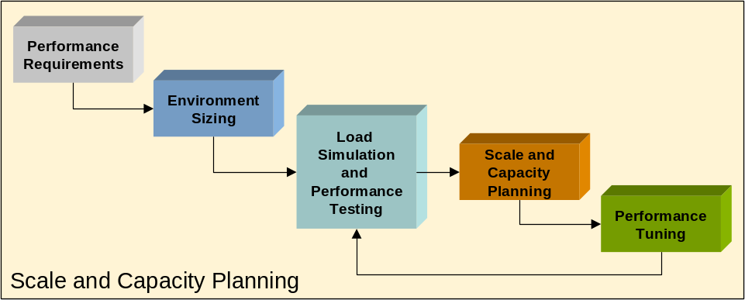

Environment Requirements

Development/Test Environment

User acceptance testing and other systematic testing activities that are required to confirm that developed software meets the requirements of Jack of all Games are conducted in this environment. The tests that are planned and implemented in this environment assure confidence in the integrity of the data throughout the lifecycle of the business processes that are utilized to process electronic business documents. Ideally, this environment is identical to the production environment.

System Testing, which tests the integration of the completely built and configured system, will also take place in the Test environment. This stage of testing demonstrates that the system meets the original objectives and “in-scope” business requirements and that the system is ready for User Acceptance Test.

System Integration Testing is a solution-wide test of all system functionality and includes:
- Interfacing of data to and from external systems
- Processing of data by the appropriate Jack of all Games functional components
- Execution of all down-stream integration and/or processes.

Production Environment

This scalable system is used to process electronic business documents for Jack of all Games 7 days a week. This environment is pristine and only contains those configurations and developed artifacts to support Production-Live trading partners and their data.

Environment Diagrams – Logical View

Development/Test Environment Physical View

This environment is in use for development of GIS artifacts such as maps and business processes and their unit testing. There is no connection with remote partners.

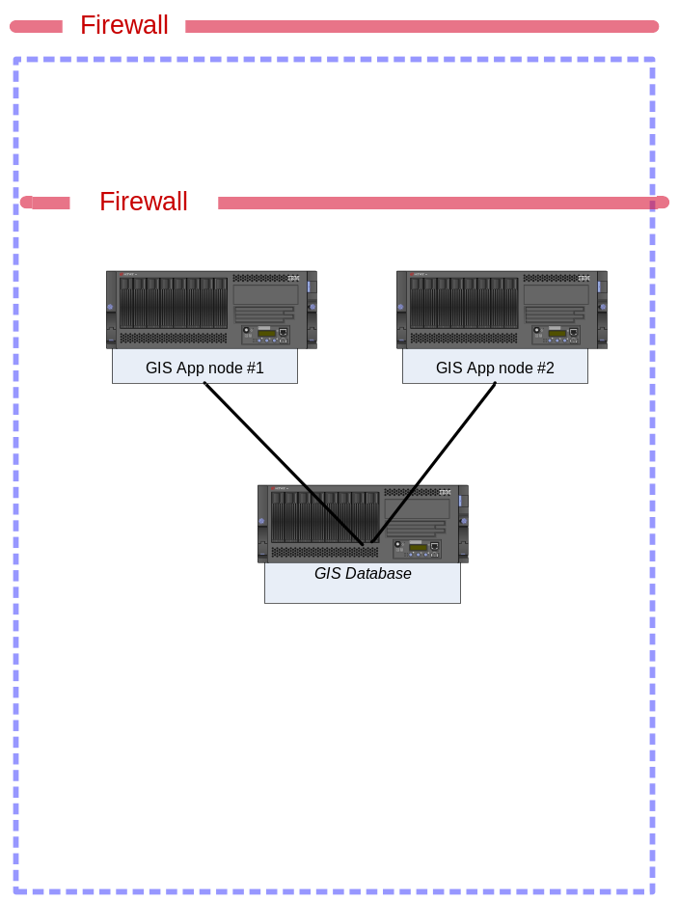

Development/Test Environment Physical Information

Topology Information
System Component | Host Name | IP Address | SPECInt per CPU | Count of CPUs | OS/RAM
Load Balancer | Not Applicable | Not Applicable | N/A | N/A | N/A
GIS Perimeter Server | Not Applicable | Not Applicable | N/A | N/A | N/A
GIS App node #1 | TK2CINGIS2N1 | 10.10.20.109
GIS App node #2 | TK2CINGIS2N2 | 10.10.20.111
GIS Database | TK2CINSQLDV3

Production Environment – Physical View

Production Environment – Physical Information

Topology Information
System Component | Host Name | IP Address | SPECInt per CPU | Count of CPUs | OS/RAM
Load Balancer | Not Applicable | Not Applicable | N/A | N/A | N/A
GIS Perimeter Server | Not Applicable | Not Applicable | N/A | N/A | N/A
GIS App node #1 | TK2CINGIS1N1 | 10.10.20.35
GIS App node #2 | TK2CINGIS1N2 | 10.10.20.37
GIS Database | TK2CINSQLDV3

Business Documents
The following sections define the business documents currently planned at Jack of all Games

Documents

Customer/Standard | Inbound |  |  |  |  | Outbound
 | 850 | ORDERS | 852 | 860 | 940 | 810 | INVOICE | 846 | 856 | 945
Bestbuy (X12) | X |  | X | X |  | X |  |  | X
GSI (X12) | X |  |  |  |  | X |  | X | X
Tesco (EDIFACT) |  | X |  |  |  |  | X
ASDA (TRADACOM) |  | X |  |  |  |  | X
Ditan (X12) |  |  |  |  | X |  |  |  |  | X
 | Outbound |  |  |  |  | Inbound
Supplier/Standard | 850 |  |  |  |  |  |  |  | 856
Nintendo (X12) | X |  |  |  |  |  |  |  | X

In-system retention: 30 days will reside live in GIS with archive each night at 12:01 AM.

Conceptual Functional Solution

Business Functionality
The overall EDI architecture will be based on Gentran Integration Suite™.

Gentran Integration Suite™ provides the following functionality and features that will be employed for this effort.
- Data translation service with graphical mapping tool
- Pre-defined EDI document formats (X12, EDIFACT, TRADACOM)
- Allows mapping any format to any format: EDI, XML, application proprietary (positional or delimited), or directly to a database (JDBC)
  - JDBC mapping is out-of-scope for this project
- B2B adapters and services (EDI, EDIINT)
- Business process automation engine based on BPML standard
- Standards-based architecture (J2EE, BPML, XML)

Business Processes

EDI Processes

This section outlines business processes required to process the inbound and outbound messages that Jack of all Games’s exchanges with its trading partners.

Outbound Processes

- Pick-up outgoing data from the file system.
  - By convention, there will be one directory for application flat files.
- The first process will review the content of the data to determine what trading partner it is for and type of document that is being processed.
  - Flat files will each pass through separate processes that perform identification.
  - These processes will also capture a snap shot of the data and write it to the file system.
  - These pre-processes provide a context for extensibility.
- Once the document and trading partner is identified, and data split by those parameters, the data will route to the appropriate process to translate it to EDI.
- Once data translates/validates it passes to a post-process. The post-process:
  - Captures a snap shot of the data and writes it to the file system.
  - Routes the EDI data to the communications process for delivery to the trading partner.
  - Provides a context for extensibility.
- All processes have error notification functionality built into them. Communication processes have built-in retry mechanisms to gracefully recover from transient network outages.

Outbound Process Functional Flow Diagram

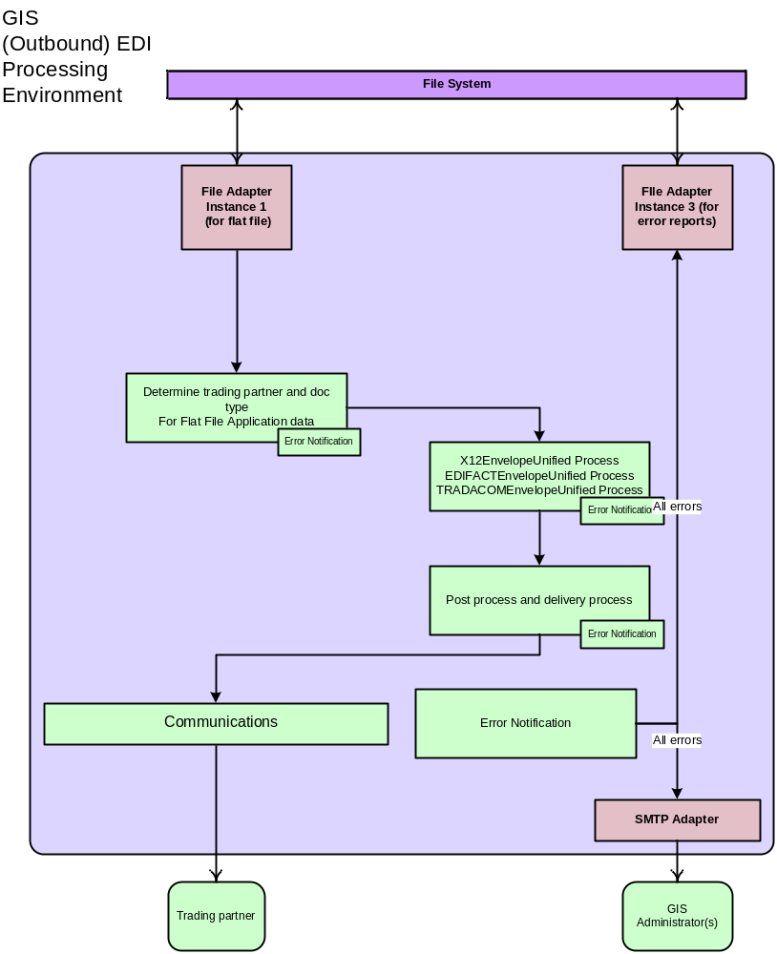

Inbound Processes

These processes will:

- Receive documents from File System Adapter and
- Pass to the EDI pre-processing step which:
  - Captures a snap shot of the data and writes it to the file system.
  - Passes the data on to the standards-specific EDI translation process.
  - Provides a context for extensibility.
- The De-enveloping process will:
  - Parse envelopes to identify sender of the document.
  - Translate X12,EDIFACT,TRADACOM EDI data with assign the key field to a correlation name.
  - Generate a functional acknowledgement and send it back to the trading partner
- Once data translates/validates it passes to a post-process. The post-process:
  - Captures a snap shot of the data and writes it to the file system.
  - Routes the application data to the.
  - Provides a context for extensibility.
- All processes have error notification functionality built into the processes.

Inbound Process Functional Flow Diagram

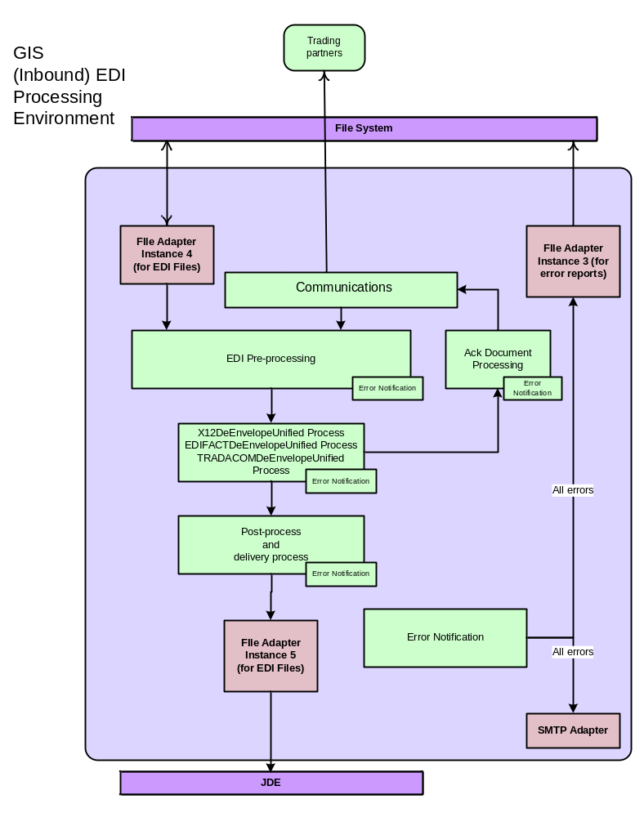

Business Process (BPML) Definition Algorithms
This section describes the function of each GIS Business Process.

File System Business Processes

BaseEDI_Send_FileSystem

- Detailed Description:
  - Used for sending outbound edi files to a file system.
  - Invoked by BASEEDI_EnvelopeUnifiedPostProcessor when it sees the prefix “FS” in the extraction directory.
  - Extracts the file into the extraction directory.
  - If there are any errors then it invokes BASEEDI_Send_Error in ASYNC mode.
- Invoked By: BASEEDI_EnvelopeUnifiedPostProcessor
- Sub BP’s:
  - BASEEDI_Send_Error
- Database:
  - Tables Used: N/A
  - Operation: N/A
- Miscellaneous:
  - Log Files: N/A
  - Property Files: N/A
  - Queue: 8
  - CodeList: N/A
  - Scripts: N/A
  - Services: N/A

BASEEDI_AppInt_FileSystem

- Detailed Description:
  - Invoked by trading partner’s inbound ST envelope setup if Data Extraction Directory is started with FS.
- Invoked By: BASEEDI_DeenvelopeUnifiedPostProcessor
- Sub BP’s: N/A
- Database:
  - Tables Used: CODE_LIST_XREF, CODELIST_XREF_VERS, CODELIST_XREF_ITEM
  - Operation: Select
- Miscellaneous:
  - Log Files: N/A
  - Property Files: N/A
  - Queue: 8
  - CodeList: N/A
  - Scripts: N/A
- Services: N/A

BASEEDI_Send_Error

- Detailed Description:
  - Invokes system BASEEDI_GenericErrorHandler business in Inline mode.
- Invoked By: BASEEDI_AppInt_FTP, BASEEDI_Send_FileSystem
- Sub BP’s:
  - BASEEDI_GenericErrorHandler
- Database:
  - Tables Used: N/A
  - Operation: N/A
- Miscellaneous:
  - Log Files: N/A
  - Property Files: N/A
  - Queue: 3
  - CodeList: N/A
  - Scripts: N/A
  - Services: N/A

De-envelope Business Processes (Inbound EDI)

BASEEDI_DeenvelopeUnifiedPreProcessor
- Detailed Description:
  - It should perform NullCharacter Replacement and the encoding service on the inbound document.
  - Archives the inbound file.
  - Does EDI Deenveloping
  - If there are any errors then it will invoke BASEEDI_DeenvelopeUnifiedError in ASYNC mode.
- Invoked By:
  - BASEEDI_Get_FTP
- Sub BP’s:
  - BASEEDI_DeenvelopeUnifiedError
  - BASEEDI_X12DeenvelopeUnified
  - BASEEDI_EDIFACTDeenvelopeUnified
  - BASEEDI_TRADACOMDeenvelopeUnified
- Database:
  - Tables Used: N/A
  - Operation: N/A
- Miscellaneous:
  - Log Files: N/A
  - Property Files: N/A
  - Queue: 4
  - CodeList: N/A
  - Scripts: N/A
  - Services: N/A

BASEEDI_DeenvelopeUnifiedPostProcessor
- Detailed Description:
  - Archives the post processed inbound file.
  - If there are any errors then it will invoke BASEEDI_DeenvelopeUnifiedError in ASYNC mode.
- Invoked By:
  - BASEEDI_X12DeenvelopeUnified
  - BASEEDI_EDIFACTDeenvelopeUnified
  - BASEEDI_TRADACOMDeenvelopeUnified
- Sub BP’s:
  - BASEEDI_DeenvelopeUnifiedError
- Database:
  - Tables Used: N/A
  - Operation: N/A
- Miscellaneous:
  - Log Files: N/A
  - Property Files: N/A
  - Queue: 6
  - CodeList: N/A
  - Scripts: N/A
  - Services: N/A

BASEEDI_DeenvelopeUnifiedError

- Detailed Description:
  - Invokes system BASEEDI_GenericErrorHandler business in Inline mode.
  - Invoked By:
    - BASEEDI_DeenvelopeUnifiedPreProcessor
    - BASEEDI_DeenvelopeUnifiedPostProcessor
- Sub BP’s:
  - BASEEDI_GenericErrorHandler
- Database:
  - Tables Used: N/A
  - Operation: N/A
- Miscellaneous:
  - Log Files: N/A
  - Property Files: N/A
  - Queue: 3
  - CodeList: N/A
  - Scripts: N/A
  - Services: N/A

BASEEDI_X12DeenvelopeUnified

- Detailed Description:
  - It is similar to X12DeenvelopeUnified
  - Following additions / modifications are done to X12DeenvelopeUnified.
    - Added error logic
  - If there are any errors then it will invoke BASEEDI_X12DeenvelopeError in ASYNC mode.
- Invoked By: Invoked by Deenveloping service in BASEEDI_DeenvelopeUnifiedPreProcessor
- Sub BP’s:
  - BASEEDI_X12DeenvelopeError
  - BASEEDI_DeenvelopeUnifiedPostProcessor
- Database:
  - Tables Used: N/A
  - Operation: N/A
- Miscellaneous:
  - Log Files: N/A
  - Property Files: N/A
  - Queue: 5
  - CodeList: N/A
  - Scripts: N/A
  - Services: N/A

BASEEDI_X12DeenvelopeError

- Detailed Description:
  - Invokes system BASEEDI_GenericErrorHandler business process in Inline mode.
- Invoked By:
  - BASEEDI_X12DeenvelopeUnified
- Sub BP’s:
  - BASEEDI_GenericErrorHandler
- Database:
  - Tables Used: N/A
  - Operation: N/A
- Miscellaneous:
  - Log Files: N/A
  - Property Files: N/A
  - Queue: 3
  - CodeList: N/A
  - Scripts: N/A
  - Services: N/A

BASEEDI_EDIFACTDeenvelopeUnified

- Detailed Description:
  - It is similar to EDIFACTDeenvelopeUnified
  - Following additions / modifications are done to EDIFACTDeenvelopeUnified.
    - Added error logic
        - If there are any errors then it will invoke BASEEDI_EDIFACTDeenvelopeError in ASYNC mode.
- Invoked By: Invoked by Deenveloping service in BASEEDI_DeenvelopeUnifiedPreProcessor
- Sub BP’s:
        - BASEEDI_EDIFACTDeenvelopeError
        - BASEEDI_DeenvelopeUnifiedPostProcessor
- Database:
        - Tables Used: N/A
        - Operation: N/A
- Miscellaneous:
        - Log Files: N/A
        - Property Files: N/A
        - Queue: 5
        - CodeList: N/A
        - Scripts: N/A
        - Services: N/A

BASEEDI_EDIFACTDeenvelopeError

- Detailed Description:
        - Invokes system BASEEDI_GenericErrorHandler business process in Inline mode.
- Invoked By:
        - BASEEDI_EDIFACTDeenvelopeUnified
- Sub BP’s:
        - BASEEDI_GenericErrorHandler
- Database:
        - Tables Used: N/A
        - Operation: N/A
- Miscellaneous:
        - Log Files: N/A
        - Property Files: N/A
        - Queue: 3
        - CodeList: N/A
        - Scripts: N/A
        - Services: N/A

BASEEDI_TRADACOMDeenvelopeUnified

- Detailed Description:
  - It is similar to TRADACOMDeenvelopeUnified
  - Following additions / modifications are done to TRADACOMDeenvelopeUnified.
  - Added error logic
        - If there are any errors then it will invoke BASEEDI_TRADACOMDeenvelopeError in ASYNC mode.
- Invoked By: Invoked by Deenveloping service in BASEEDI_DeenvelopeUnifiedPreProcessor
- Sub BP’s:
        - BASEEDI_TRADACOMDeenvelopeError
        - BASEEDI_DeenvelopeUnifiedPostProcessor
- Database:
        - Tables Used: N/A
        - Operation: N/A
- Miscellaneous:
        - Log Files: N/A
        - Property Files: N/A
        - Queue: 5
        - CodeList: N/A
        - Scripts: N/A
        - Services: N/A

BASEEDI_TRADACOMDeenvelopeError

- Detailed Description:
        - Invokes system BASEEDI_GenericErrorHandler business process in Inline mode.
- Invoked By:
        - BASEEDI_TRADACOMDeenvelopeUnified
- Sub BP’s:
        - BASEEDI_GenericErrorHandler
- Database:
        - Tables Used: N/A
        - Operation: N/A
- Miscellaneous:
        - Log Files: N/A
        - Property Files: N/A
        - Queue: 3
        - CodeList: N/A
        - Scripts: N/A
        - Services: N/A

Envelope Business Processes (Outbound EDI)

BASEEDI_DocExtract_Pre1
- Detailed Description: Used to separate invoice file into groups – non-zero amount and zero amount through the map
- Invoked By: BaseEDI_CollectFlatFiles_Stage1 service
- Sub BP’s: N/A
- Database: N/A
- Miscellaneous: N/A

BASEEDI_ DocExtractFlat_810_Email
- Detailed Description: Used to send out the email notification if there is any zero charge invoice. Te email recipient information is listed in BaseEDI_ZeroInvoice_Notification code list table
- Invoked By: BaseEDI_CollectFlatFiles_810_Email service
- Sub BP’s: N/A
- Database:
  - Tables Used: CODE_LIST_XREF, CODELIST_XREF_ITEM, CODELIST_XREF_VERS
  - Operation: Select
- Miscellaneous: N/A

BaseEDI_DocExtractFlat_Pre2
- Detailed Description: Used to determine whether the outbound invoice should be sent out immediately or delayed for certain days. The information is listed in BaseEDI_ZeroInvoice_Notification code list table
- Invoked By: BaseEDI_CollectFlatFiles_Stage2 service
- Sub BP’s: N/A
- Database:
  - Tables Used: CODE_LIST_XREF, CODELIST_XREF_ITEM, CODELIST_XREF_VERS
  - Operation: Select
- Miscellaneous: N/A

BaseEDI_CollectDelayFlatFiles
- Detailed Description: Used to clooect any delayed invoice file and determine if it should be sent by checking the file name and current date
- Invoked By: Schedule
- Sub BP’s: N/A
- Database: N/A
- Miscellaneous: N/A

BASEEDI_DocExtractFlat

- Detailed Description:
  - This is used for an flat outbound documents and is invoked by a BASEEDI_CollectFlatFiles service
  - Extracts the files to the archive folder
  - Retrieves the map names from the text fields of the BASEEDI_CollectFlatFiles service.
  - For each document
    - Envelopes by invoking BASEEDI_X12EnvelopeUnified in ASYNC mode
  - If there is any unrecognized data
    - Invokes BASEEDI_DocExtractFlat_Batch_Recovery in ASYNC mode for each good group.
  - If the envelope is not found or if the edi encoding failed or if there are any errors then it will invoke BASEEDI_DocExtractFlatError in ASYNC mode.
- Invoked By: BASEEDI_CollectFlatFiles service
- Sub BP’s:
  - BASEEDI_DocExtractFlatError
  - BASEEDI_X12EnvelopeUnified
  - BASEEDI_EDIFACTEnvelopeUnified
  - BASEEDI_TRADACOMEnvelopeUnified
  - BASEEDI_DocExtractFlat_Batch_Recovery
- Database:
  - Tables Used: CODE_LIST_XREF, CODELIST_XREF_ITEM, CODELIST_XREF_VERS
  - Operation: Select
- Miscellaneous:
  - Log Files: N/A
  - Property Files: BASEEDI_cache.properties
  - Queue: 4
  - CodeList: BASEEDI_OBBatchHandlingRegistry
  - Scripts: N/A
  - Services: N/A

BASEEDI_DocExtractFlat_Batch_Recovery

- Detailed Description:
  - It is invoked by BASEEDI_DocExtractFlat
  - It is used to recover all good transactions in the batch of good and bad transactions.
  - If the envelope is not found or if the edi encoding failed or if there are any errors then it will invoke BASEEDI_DocExtractFlatError in ASYNC mode.
- Invoked By: BASEEDI_DocExtractFlat
- Sub BP’s:
  - BASEEDI_DocExtractFlatError
- Database:
  - Tables Used: N/A
  - Operation: N/A
- Miscellaneous:
  - Log Files: N/A
  - Property Files: N/A
  - Queue: 4
  - CodeList: N/A
  - Scripts: N/A
  - Services: N/A

BASEEDI_DocExtractFlatError

- Detailed Description:
  - Invokes system BASEEDI_GenericErrorHandler business in Inline mode.
- Invoked By:
  - BASEEDI_DocExtractFlat
  - BASEEDI_DocExtractFlat_Batch_Recovery
- Sub BP’s:
  - BASEEDI_GenericErrorHandler
- Database:
  - Tables Used: N/A
  - Operation: N/A
- Miscellaneous:
  - Log Files: N/A
  - Property Files: N/A
  - Queue: 3
  - CodeList: N/A
  - Scripts: N/A
  - Services: N/A

BASEEDI_OutBoundTranslationError

- Detailed Description:
  - Invokes system BASEEDI_GenericErrorHandler business in Inline mode.
- Invoked By:
  - BASEEDI_EnvelopeUnified_BadBatch_Handler
- Sub BP’s:
  - BASEEDI_GenericErrorHandler
- Database:
  - Tables Used: N/A
  - Operation: N/A
- Miscellaneous:
  - Log Files: N/A
  - Property Files: N/A
  - Queue: 3
  - CodeList: N/A
  - Scripts: N/A
  - Services: N/A

BASEEDI_OutBoundTranslationError_Redo

- Detailed Description:
  - Reprocess jde outbound application data if the error in the previous run is caused by GIS setup.
- Invoked By:
  - Schedule_BASEEDI_CollectRedoFlatFiles
- Sub BP’s: N/A
- Database:
  - Tables Used: N/A
  - Operation: N/A
- Miscellaneous:
  - Log Files: N/A
  - Property Files: N/A
  - Queue: 8
  - CodeList: N/A
  - Scripts: N/A
  - Services: N/A

BASEEDI_EnvelopeUnifiedPostProcessor

- Detailed Description:
  - Archives the processed outbound file.
  - Routes to the trading partner staging folder based upon the receiver id
  - If there are any errors then it will invoke BASEEDI_EnvelopeUnifiedPostProcessorError in ASYNC mode.
- Invoked By: Triggered during enveloping process
- Sub BP’s:
  - BASEEDI_EnvelopeUnifiedPostProcessorError
  - BASEEDI_Send_FileSystem
- Database:
  - Tables Used: N/A
  - Operation: N/A
- Miscellaneous:
  - Log Files: N/A
  - Property Files: BASEEDI_cache.properties
  - Queue: 4
  - CodeList: N/A
  - Scripts: N/A
  - Services: N/A

BASEEDI_EnvelopeUnifiedPostProcessorError

- Detailed Description:
  - Invokes system BASEEDI_GenericErrorHandler business in Inline mode.
- Invoked By:
  - BASEEDI_EnvelopeUnifiedPostProcessor
- Sub BP’s:
  - BASEEDI_GenericErrorHandler
- Database:
  - Tables Used: N/A
  - Operation: N/A
- Miscellaneous:
  - Log Files: N/A
  - Property Files: N/A
  - Queue: 3
  - CodeList: N/A
  - Scripts: N/A
  - Services: N/A

BASEEDI_EnvelopeUnified_BadBatch_Handler
- Detailed Description:
  - This works through a batch of transactions to identify those transactions that are in error.
  - Splits the batch transactions if it is required
    - Creates smaller sublists and invokes BASEEDI_EnvelopeUnified_BadBatch_Handler in ASYNC mode.
    - Repeats this process until all transactions are split.
  - Works Through SubList Of Transactions against each map and translates
  - Invokes BASEEDI_OutBoundTranslationError in ASYNC mode if there are any errors
- Invoked By:
  - BASEEDI_X12EnvelopeUnified
  - BASEEDI_EDIFACTEnvelopeUnified
  - BASEEDI_TRADACOMEnvelopeUnified
- Sub BP’s:
  - BASEEDI_EnvelopeUnified_BadBatch_Handler
  - BASEEDI_OutBoundTranslationError
- Database:
  - Tables Used: N/A
  - Operation: N/A
- Miscellaneous:
  - Log Files: N/A
  - Property Files: N/A
  - Queue: 2
  - CodeList: N/A
  - Scripts: N/A
  - Services: N/A

BASEEDI_X12EnvelopeUnified
- Detailed Description:
  - It is similar to X12EnvelopeUnified
  - Following additions / modifications are done to X12EnvelopeUnified.
    - Added error logic
    - Modified fault handler for downstream processing by invoking BASEEDI_EnvelopeUnified_BadBatch_Handler in ASYNC mode
    - Modified X12 Envelope to put trans report into Process Data
  - If there are any errors then it will invoke BASEEDI_X12EnvelopeError in ASYNC mode.
- Invoked By: Invoked by Enveloping service in
- Sub BP’s:
  - BASEEDI_X12EnvelopeError
  - BASEEDI_EnvelopeUnifiedPostProcessor
  - BASEEDI_EnvelopeUnified_BadBatch_Handler
- Database:
  - Tables Used: N/A
  - Operation: N/A
- Miscellaneous:
  - Log Files: N/A
  - Property Files: BASEEDI_cache.properties
  - Queue: 5
  - CodeList: N/A
  - Scripts: N/A
  - Services: N/A

BASEEDI_X12EnvelopeError

- Detailed Description:
  - Invokes system BASEEDI_GenericErrorHandler business process in Inline mode.
- Invoked By:
  - BASEEDI_X12EenvelopeUnified
- Sub BP’s:
  - BASEEDI_GenericErrorHandler
- Database:
  - Tables Used: N/A
  - Operation: N/A
- Miscellaneous:
  - Log Files: N/A
  - Property Files: N/A
  - Queue: 3
  - CodeList: N/A
  - Scripts: N/A
  - Services: N/A

BASEEDI_EDIFACTEnvelopeUnified

- Detailed Description:
  - It is similar to EDIFACTEnvelopeUnified
  - Following additions / modifications are done to EDIFACTEnvelopeUnified.
  - Added error logic
  - Modified fault handler for downstream processing by invoking BASEEDI_EnvelopeUnified_BadBatch_Handler in ASYNC mode
  - Modified EDIFACT Envelope to put trans report into Process Data
  - If there are any errors then it will invoke BASEEDI_EDIFACTEnvelopeError in ASYNC mode.
- Invoked By: Invoked by Enveloping service in
- Sub BP’s:
  - BASEEDI_EDIFACTEnvelopeError
  - BASEEDI_EnvelopeUnifiedPostProcessor
  - BASEEDI_EnvelopeUnified_BadBatch_Handler
- Database:
  - Tables Used: N/A
  - Operation: N/A
- Miscellaneous:
  - Log Files: N/A
  - Property Files: BASEEDI_cache.properties
  - Queue: 5
  - CodeList: N/A
  - Scripts: N/A
  - Services: N/A

BASEEDI_EDIFACTEnvelopeError

- Detailed Description:
  - Invokes system BASEEDI_GenericErrorHandler business process in Inline mode.
- Invoked By:
  - BASEEDI_EDIFACTEenvelopeUnified
- Sub BP’s:
  - BASEEDI_GenericErrorHandler
- Database:
  - Tables Used: N/A
  - Operation: N/A
- Miscellaneous:
  - Log Files: N/A
  - Property Files: N/A
  - Queue: 3
  - CodeList: N/A
  - Scripts: N/A
  - Services: N/A

BASEEDI_TRADACOMEnvelopeUnified

- Detailed Description:
  - It is similar to TRADACOMEnvelopeUnified
  - Following additions / modifications are done to TRADACOMEnvelopeUnified.
    - Added error logic
    - Modified fault handler for downstream processing by invoking BASEEDI_EnvelopeUnified_BadBatch_Handler in ASYNC mode
    - Modified TRADACOM Envelope to put trans report into Process Data
  - If there are any errors then it will invoke BASEEDI_TRADACOMEnvelopeError in ASYNC mode.
- Invoked By: Invoked by Enveloping service in
- Sub BP’s:
  - BASEEDI_TRADACOMEnvelopeError
  - BASEEDI_EnvelopeUnifiedPostProcessor
  - BASEEDI_EnvelopeUnified_BadBatch_Handler
- Database:
  - Tables Used: N/A
  - Operation: N/A
- Miscellaneous:
  - Log Files: N/A
  - Property Files: BASEEDI_cache.properties
  - Queue: 5
  - CodeList: N/A
  - Scripts: N/A
  - Services: N/A

BASEEDI_TRADACOMEnvelopeError

- Detailed Description:
  - Invokes system BASEEDI_GenericErrorHandler business process in Inline mode.
- Invoked By:
  - BASEEDI_TRADACOMEenvelopeUnified
- Sub BP’s:
  - BASEEDI_GenericErrorHandler
- Database:
  - Tables Used: N/A
  - Operation: N/A
- Miscellaneous:
  - Log Files: N/A
  - Property Files: N/A
  - Queue: 3
  - CodeList: N/A
  - Scripts: N/A
  - Services: N/A

Miscellaneous Business Processes

BASEEDI_RefreshPropertiesCache

- Detailed Description:
  - Uses cache refresh service to refresh the updates done in BASEEDI_cache.properties.
- Invoked By: Manually
- Sub BP’s: N/A
- Database:
  - Tables Used: N/A
  - Operation: N/A
- Miscellaneous:
  - Log Files: N/A
  - Property Files: BASEEDI_cache.properties
  - Queue: 4
  - CodeList: N/A
  - Scripts: N/A
  - Services: N/A

BASEEDI_GenericErrorHandler

- Detailed Description:
  - Sends email notification to the email-id specified in the BASEEDI_cache.properties file whenever there are errors.
  - Users BASEEDI_EmailFormat to format the email message.
- Invoked By: All error business processes
- Sub BP’s: N/A
- Database:
  - Tables Used: N/A
  - Operation: N/A
- Miscellaneous:
  - Log Files: N/A
  - Property Files: BASEEDI_cache.properties
  - Queue: 3
  - CodeList: N/A
  - Scripts: N/A
  - Services: N/A

High Level Business Process Flow

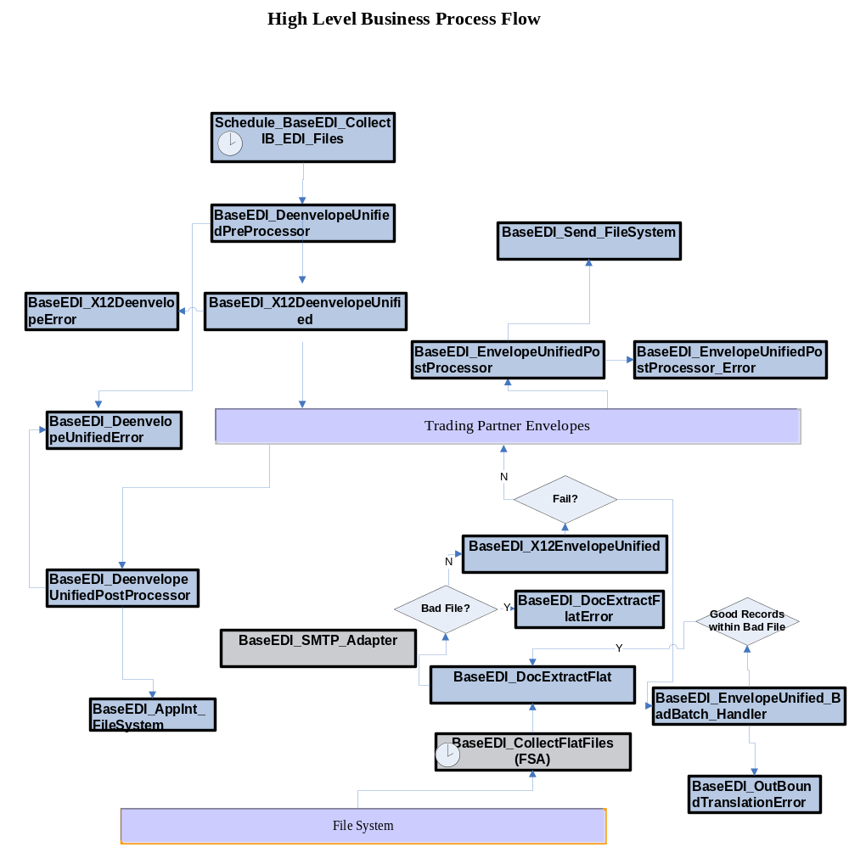

Trading Partners
There are a number of trading partners currently exchanging documents with Jack of all Games. They are listed below, along with pertinent B2B communication information. There are 5 partners identified in this document starting with Section 4.1 Documents. For the communication information, this can be provided later once implementation begins.

# | Trading Partner | Relationship | Test  EDI Qualifier | Test  EDI ID | Production  EDI Qualifier | Production  EDI ID
# | Trading Partner | (Jack of all Games | vendor) | (ex. ZZ) | (ex. SOMMRTPRD) | (ex. ZZ) | (ex. SOMMRTPRD)
1 | Bestbuy | Vendor |  |  | ZZ | 0600603000003
2 | Tesco | Vendor |  |  | 14 | 5000119000006
3 | ASDA | Vendor |  |  |  | 5015715444440
4 | GSI | Vendor |  |  | ZZ | SPSEDIGSI

EDI Standards Requirements and Translation Maps
Jack of all Games uses X12 EDI versions. Gentran Integration Suite™ will support X12 versions 002001 through 005020.

Translation Maps

The following table lists all of the maps that will be developed specifically Jack of all Games’s implementation. Maps are listed in separate documentation. Final names based on naming conventions can prompt population of this table later during implementation.

# | Trading Partner | Direction | EDI  Standard | EDI Transaction Set | EDI Version | Application format
# | Trading Partner | (IB | OB) | (X12 | EDIFACT) | (ex. 810) | (ex. 5010) | (Flat File | XML)
1 | Bestbuy | OB | X12 | 810,856 | 4010 | Flat File
2 | GSI | OB | X12 | 810,846,856 | 4010 | Flat File
3 | Tesco | OB | EDIFACT | INVOICE |  | Flat File
4 | ASDA | OB | TRADACOM | INVOICE |  | Flat File
5 | Ditan | OB | X12 | 945 | 4010 | Flat File
6 | Nintendo | OB | X12 | 856 |  | Flat File
7 | Bestbuy | IB | X12 | 850,852,860 | 4010 | Flat File
8 | GSI | IB | X12 | 850 | 4010 | Flat File
9 | Tesco | IB | EDIFACT | ORDERS |  | Flat File
10 | ASDA | IB | TRADACOM | ORDERS |  | Flat File
11 | Ditan | IB | X12 | 940 | 4010 | Flat File
12 | Nitendo | IB | X12 | 850 | 4010 | Flat File

Communications

Internal Communications
The Jack of all Games’s internal integration with back-end systems will be done using File System Adapter for inbound and outbound. SMTP will be used for error notification.

GIS will be set-up and configured to provide the functionality required. The use of GIS communication adapters will be used in conjunction with business process flows to achieve this.

External Trading Partner Communications

Jack of all Games will communicate with its trading partners using FTP and AS2. Adapters and process flows will be used within GIS to perform these tasks. AS2/FTP IP and Port can be filled in later as necessary but should be discovered early in implementation.

Current breakdown of trading partners and communication type (numbers are approximate):
Grey partners are listed for later migration but not part of the scope of this Professional Services engagement.

# | Trading Partner | Protocol | Production  Queue ID  or  FTP IP : Port | Test  Queue ID  or  FTP IP : Port
# | Trading Partner | (AS2 | VAN via FTP or AS2) | (ex. SOMEMRTPRD)  (ex. svr.somrtPRD.com:21) | (ex. SOMEMRTTST)  (ex. svr.somrtTST.com:21)
1
2
3
4

Naming Standards
With GIS, naming standards are extremely important. GIS has been designed to allow for disabling any objects created as well as deletion of previously created objects. The following table provides suggested naming standards for the objects that will created and configured within GIS.

Item | Naming Convention | Notes
Business Processes | Begins with BASEEDI_<Business Process Name> | Example:  BASEEDI_Send_FTP  BASEEDI_Generic_FTP_to_ORACLE FINANCE
XSLT | Begins with BASEEDI_<XSLT Name> | Example:  BASEEDI_EmailFormat
Service Configurations | Begins with BASEEDI_<Service Name> | Example:  BASEEDI_CollectFlatFiles
Translation Maps | MAP FILENAME:  3 char ID TK2_  2 char direction (IB or OB)_  3 char transaction (810)_  4 char version (with subset if not X12)_  Trading partner_  3 char Jack of all Games division (if applicable)  ex. TK2_IB_850_4010_Fisher | <3 char Jack of all Games ID> ={TK2}  <direction>= {IB, OB}  <transaction> = {850, ORDERS}  <version>= {4010, 3030, etc.}  <TP ID> = {ABS}  <3 char Jack of all Games division> ={FMS}
Interchange Level Envelope | <3 char Jack of all Games ID>_<direction>_  <standard Segment>_<version>_  <Test/Prod>_<TP ID>  Ex. TK2_IB_ISA_v4010_Prod_Fisher | <direction> = {IB,OB}  <standard Segment> = {ISA, UNB}  <version>= {00401, 00303, etc.}  <Test/Prod> = {Test, Prod}  <TP ID> = { Fisher }
Group Level Envelope | <4 char TP ID> _<direction>_<standard segment>_<functional group ID>_<version>_<Test/Prod>_<TP ID>  Ex. TK2_IB_GS_850_v4010_Prod_Fisher | <direction> = {IB,OB}  <standard Segment> = {GS,UNH}  <functional group ID> = {850 ,810, 856}  <version>= {00401, 00303, etc.}  <Test/Prod> = {Test, Prod}  <TP ID> = { Fisher }
Transaction Level Envelope | <TP ID>_<direction> <transaction set>_<version>_<Test/Prod>_<TP ID>  Ex. TK2_IB_ST_850_v4010_Prod_Fisher | <direction> = {IB,OB}  <transaction_set> = {850, 810, etc.}  <version> = {4010, 3030, etc.}  <Test/Prod> = {Test, Prod}  <TP ID> = { Fisher }

Archive Strategy and Access
The archive system will be managed to ensure that the disk space limits available for the Gentran Integration Suite™ system as a whole and the archive storage area in particular are not exceeded. A specific limit on the amount of time the archive data is needed on the system for reference or audit purposes should be determined. Based on this archive retention period, the archive data files can be moved to backup media and removed from the system.

In GIS 4.3, the archive process moves data from live tables to an offline storage area. This includes documents and business process workflow context (persisted data). Once the data has been archived to disk, it can be restored back into a set of restore tables for viewing in the admin console for historic research purposes.

It has yet to be determined how long to keep data in the live tables at Jack of all Games. The longer the retention period the more the performance of the system for research will be impacted and require additional database storage.

Pre and Post Image of EDI Files

Files (raw inbound and translated outbound EDI, Oracle outbound and translated inbound flat files) that will be saved or written to an archive (monthly) directory will not be part of the built-in archive process and it will be up to Jack of all Games to backup and remove these files.

Training Recommendations

For the purposes of supporting this implementation project, Jack of all Games will attend the following education course. The following courses are recommended for Jack of all Games to become familiar enough with GIS to be able to extend this implementation.

- #915 Gentran Integration Suite Fundamentals
- #936 Gentran Integration Suite Data Mapping and EDI Processing

Migration Approach

Jack of all Games has planed to migration the existing trading partners entirely from GT:NT to GIS.

The GIS project can be done in phases or levels to match Jack of all Games’s business requirements. The proposed first phase allows the implementation to be prioritized to focus on an objective. The first phase involves 6 trading partners integrates with back-end applications through a flat file document delivered from/to JDE for outbound/inbound documents.

GIS Upgrades and Promotion Processes

Upgrades

  - Backup GIS node local file systems and the GIS database
  - Any upgrade the alters the DB need be done only once
    - Install a new BP
    - Change a service configurations
  - Any upgrade the alters the file system must be repeated on all nodes (for cluster only)
    - Install a GIS patch
    - Deploy a new custom adapter jar file

Promotion Processes

The principle of the promotion process is the same between Dev/Test and Production.
For the targeted environment:

  - Backup GIS node local file system and the GIS database by the DBA and SA.
  - Import BASEEDI_Assets.xml via GIS import utility
  - Install GIS assets from the export file by using import.sh under ~/tp_import directory
    - Maps
    - Custom BPs
    - XSLTs
    - Services
    - Code Lists
    - Envelopes
    - …
  - Update GIS adapters (services) if necessary
  - Update GIS Code Lists if necessary
  - Update GIS Envelopes if necessary
  - Update GIS Schedules if necessary
  - Update custom property files listed below if necessary, and then execute setupfile.sh after the updates.
    - BASEEDI_cache.properties.in – see an example (TBD)
    - customer_overrides.properties – see an example (TBD)
      - GIS patch installation may replace *.properties.in files, potentially overwriting customer specific changes
      - Allows customer specific changes to ‘product’ properties to be kept in a file that will not be overwritten by patch installation
      - Values will take precedence over values in original properties file
      - Not all ‘product’ properties files are supported in customer_overrides.properties
      - GIS documentation has details:
        - http://www.sterlingcommerce.com/Documentation/GIS43/Content/PropertyFiles/customer_overrides_properties.html

Appendix

Appendix A – Acronyms & Definitions

The following acronyms and terms are used in this document and throughout the project.

Term | Definition
FTP | File Transfer Protocol, used to ‘put’ or ‘get’ data to/from a remote site.
AS2 | A specific protocol that leverages HTTP/S for transfer of encrypted data with receipt acknowledgement.
MDN | Message Disposition Notification, the receipt acknowledgement sent once AS2 EDIINT messages successfully parse and process.
Synchronous | A process that relies on a response from another process before continuing its activities.
Asynchronous | ‘Fire and forget’ where there is no reliance on a child process to finish before continuing a parent process’ actions.
BP / BPML | Business Process / Business Process Modeling Language. This involves a collection of services and logical assignments/decisions that assist in data workflow. Modular in form, these BPs should construct for reuse where possible.
On Fault | This is BPML terminology for error handling where if an error occurs in a business process a decision takes it to the nearest error handling routine for that sequence.
Patch or build | This involves corrections to bugs or enhancements and requires deployment throughout a given GIS node install and may require database updates.
Contract | Not a legally-binding type of contract, often these involve a trading partnership and include all the artifacts necessary to make a connection successful, including which is a producer and which is a consumer of data.
Adapter | A special class of service that communicates outside GIS to file systems, other applications, or through a protocol to another server.
GIS Envelope | An envelope contains metadata such as sender or receiver ID, version of a given document/transaction, and control numbers for uniqueness.
Cache | A cache is a storage area in memory for certain values that require immediate availability without referencing files which can be resource-expensive.
Code List | A code list is often used for cross-reference purposes during translation to convert one value to another based on a key, but another popular use is for cross-references related to routing of data.

