SYSTEM DESIGN

1. Design Constraints & Requirements
This section outlines the functional, non-functional, technical, security, and operational parameters for the Swastik Electronics MERN E-commerce Platform.

1.1 Functional Requirements
The system performs the following core functions:
- User Authentication & Authorization: Sign-up, Login, Admin/User roles, and JWT token-based security.
- Product Management: Add, Edit, Delete products with category, price, and stock details.
- Shopping Cart & Checkout: Add/remove items, update quantity, and place orders.
- Order Management: Track order status, view history, and update from Admin Dashboard.
- Search & Filtering: Search products by name, category, or price range.
- Admin Dashboard: Manage users, products, orders, and view basic analytics.
- Profile Management: Users can view and update their profile and order details.

1.2 Non-Functional Requirements
The system adheres to the following quality attributes:
- Performance: API responses for product fetch, cart, and checkout ≤ 3 seconds.
- Scalability: Designed to support horizontal scaling for multiple concurrent users.
- Availability: Target uptime ≥ 99% during operational hours.
- Reliability: Robust error handling and fallback mechanisms for failed requests.
- Maintainability: Modular codebase separating Frontend, Backend, and Database layers.
- Usability: Responsive design for desktop and mobile access.
1.3 Technical & Design Constraints
The development is bound by the following architectural and technical decisions:
- Architecture Pattern: Decoupled Client-Server model using RESTful APIs.
- Frontend Constraints: Browser-based interface using React.js, Redux, and TailwindCSS.
- Backend Constraints: Node.js with Express.js for API orchestration; MongoDB for data storage.
- Database Constraints: NoSQL database with MongoDB Atlas; structured collections for Users, Products, Orders, Reviews.

1.4 Security Constraints
To ensure system safety and data integrity:
- Authentication & Authorization: JWT-based security with role checks.
- Data Privacy: Secure storage of sensitive user information, including passwords (hashed).
- File Validation: Restrict product images to safe formats and size limits.
1.5 Operational Constraints
- Connectivity: Requires stable internet to access backend APIs and MongoDB Atlas.
- Initialization: Server startup may take time depending on database connection and API readiness.
- Data Quality: Product and user information accuracy depends on proper input formatting.

2. System Architecture
2.1 SYSTEM FLOW
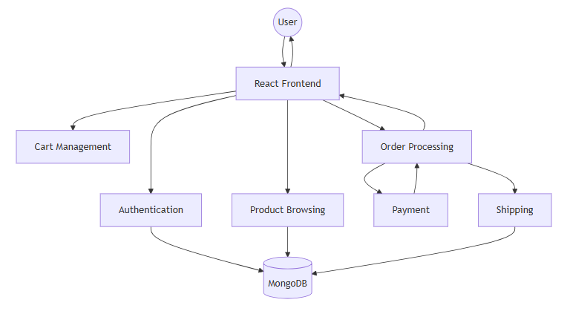
2.2 SEQUENCE FLOW
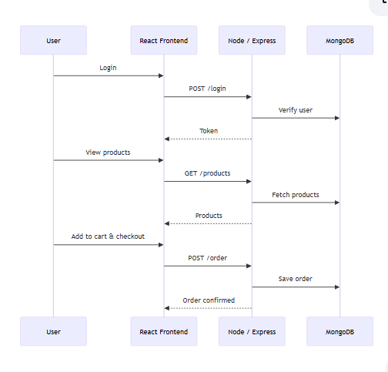
3. User Interface
3.1 Home Page
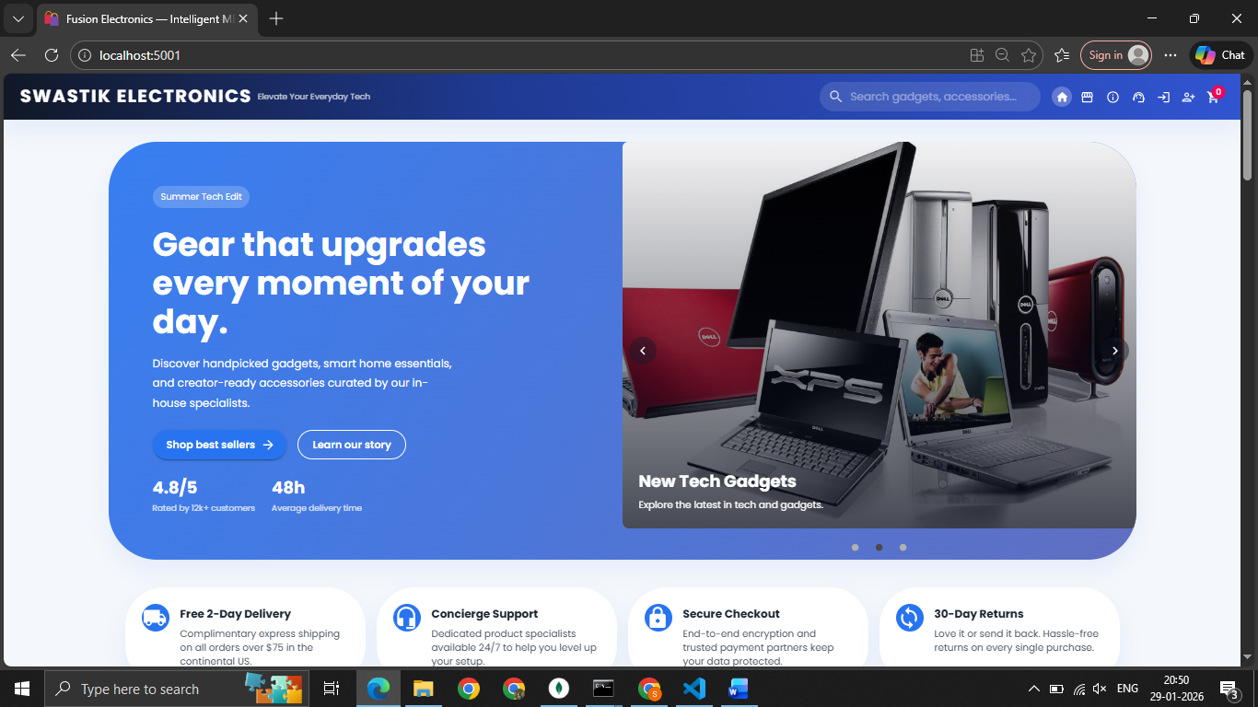
3.2 SIGNUP PAGE
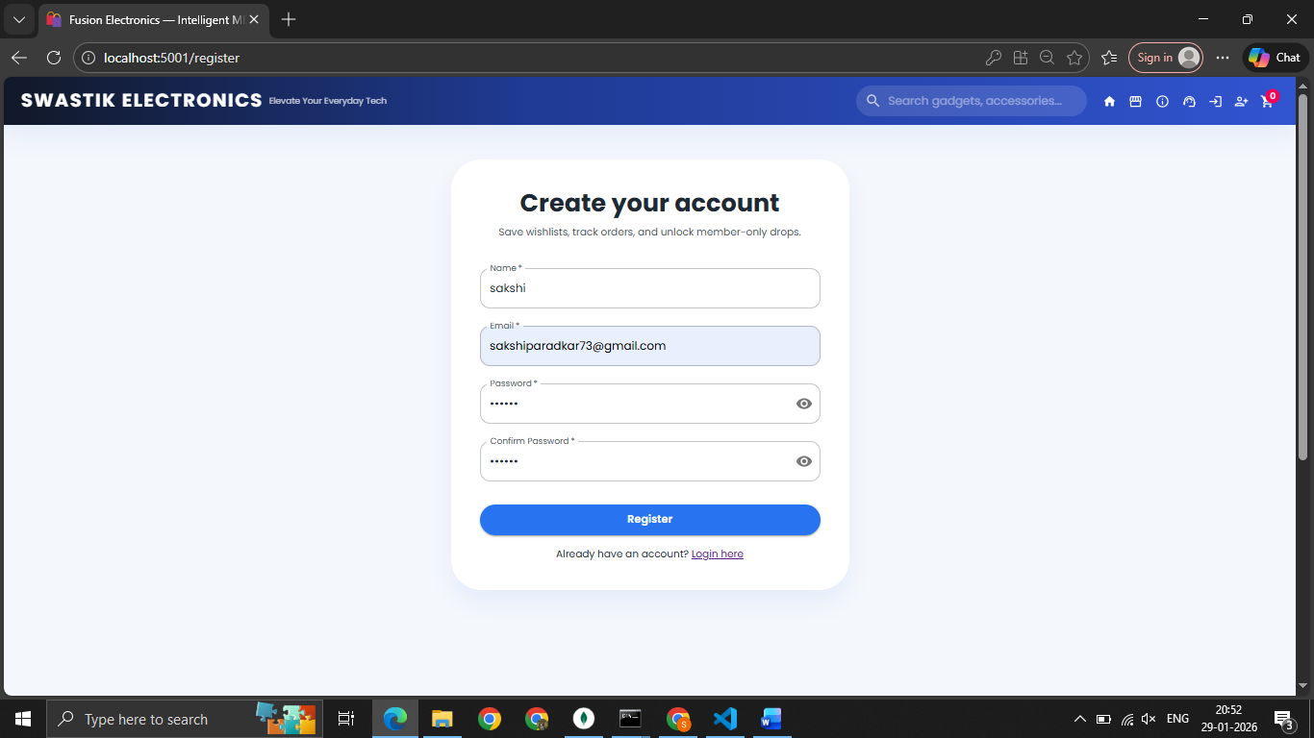
3.3 LOGIN PAGE
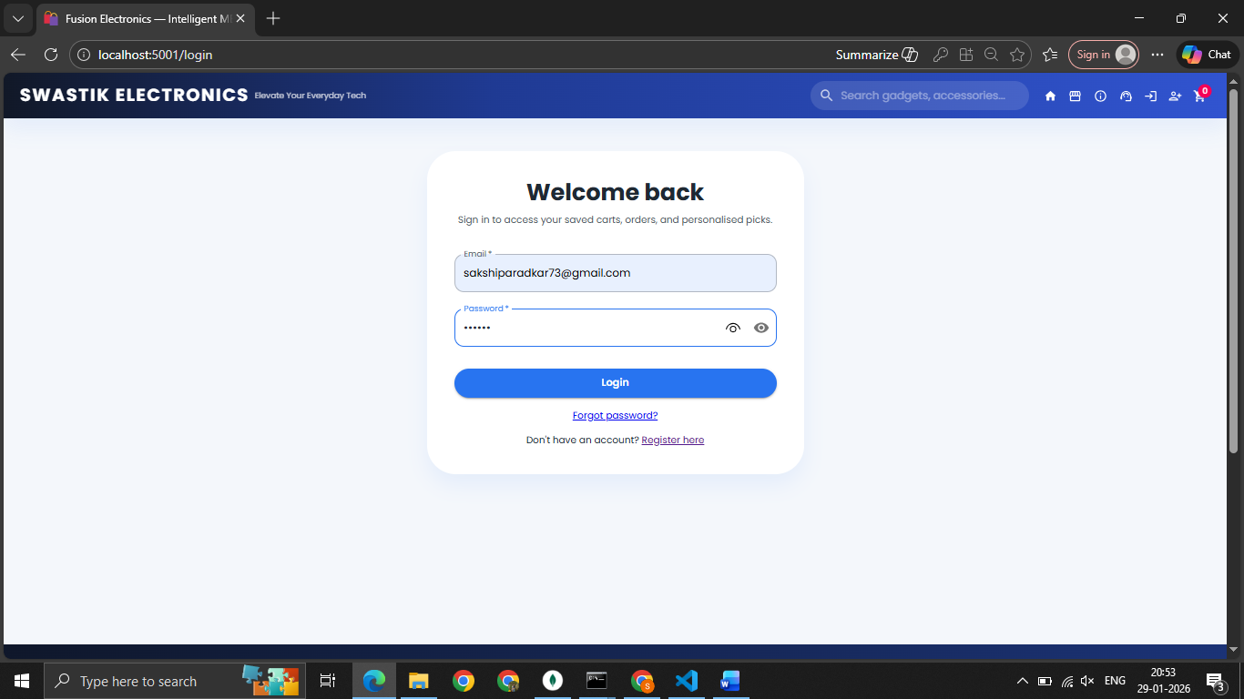

3.4 PRODUCT LIST
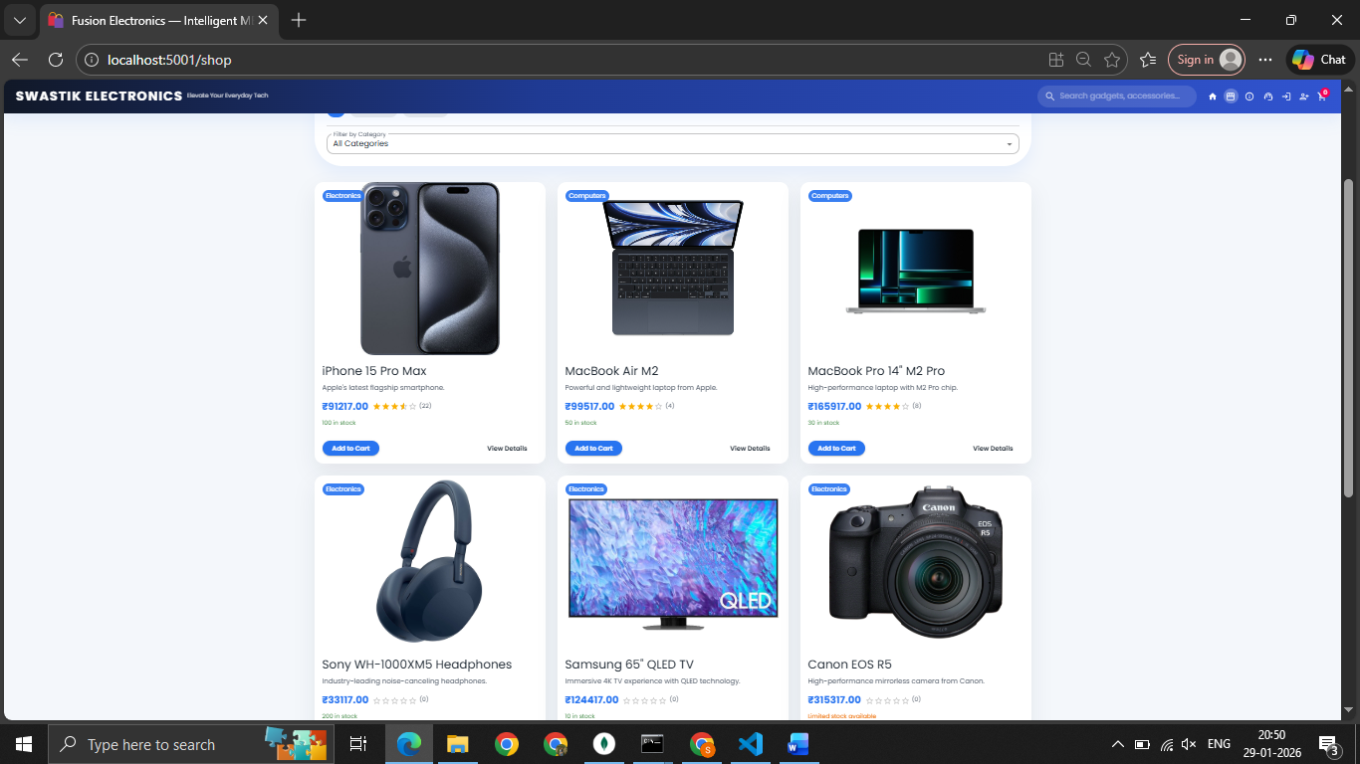

3.5 PRODUCT DETAIL
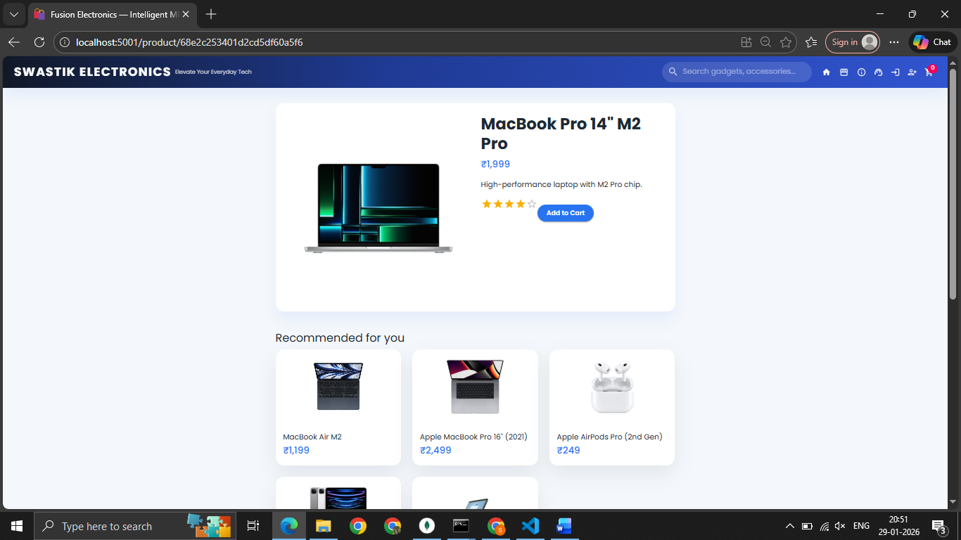

3.5 SHOPPING CART DETAILS
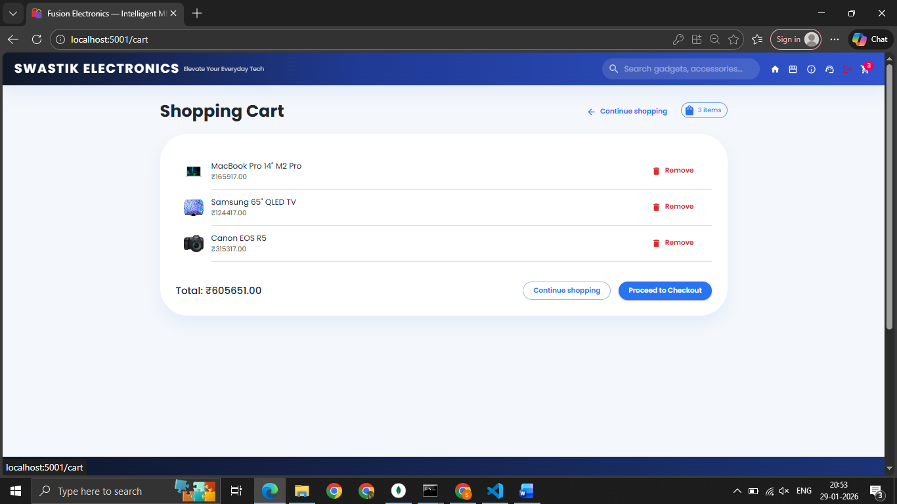
3.6 CHECKOUT /PAYMENT GATEAWAY PAGE
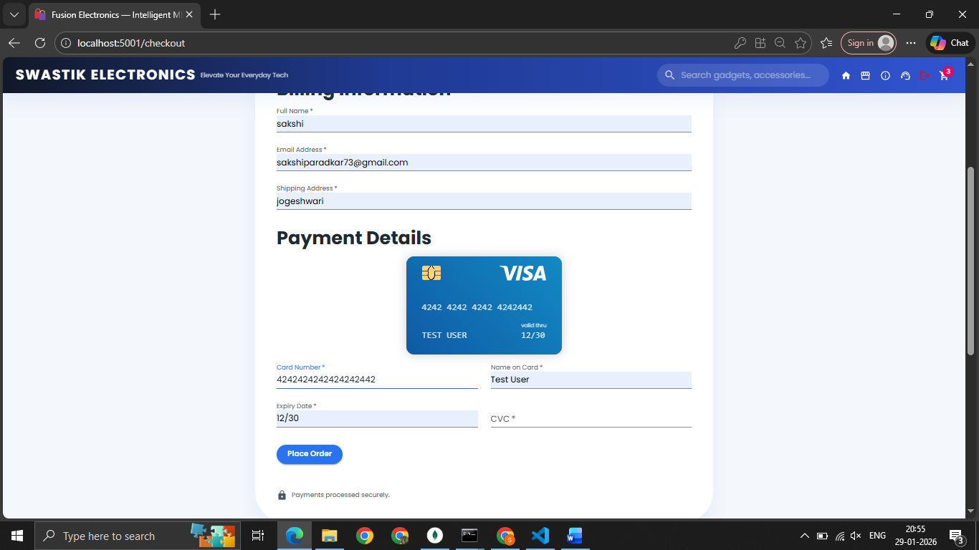

3.7 ORDER CONFIRMATION PAGE
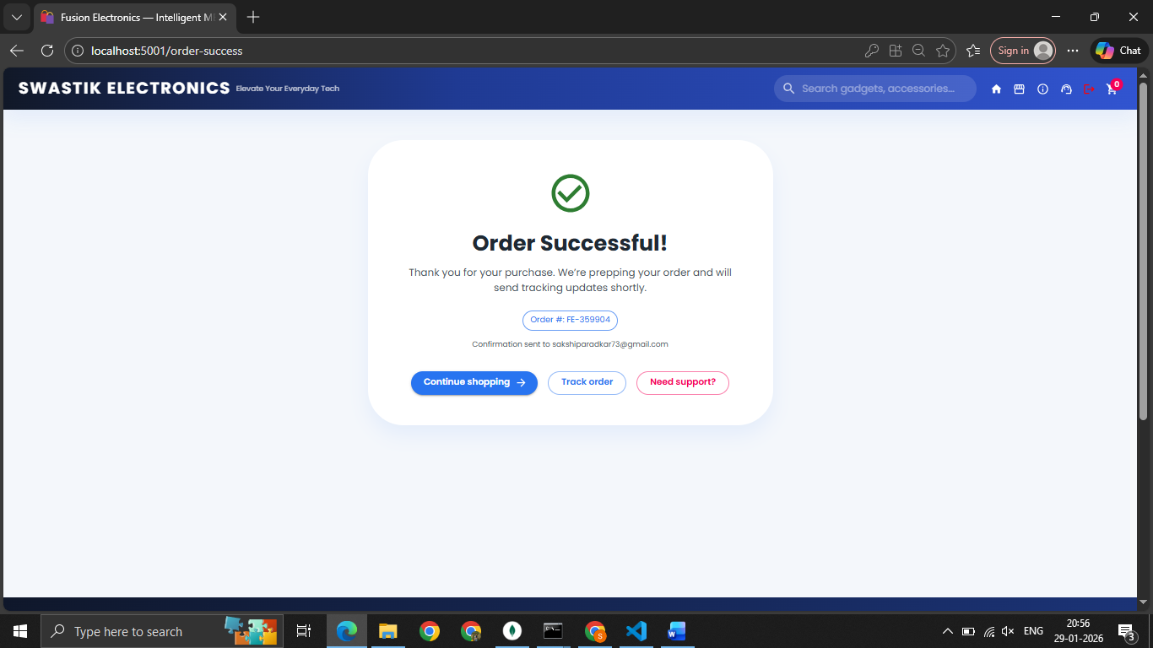

4. Database design
4.1 Database Type
- Database Management System: MongoDB (NoSQL)
- Rationale: MongoDB is chosen for its document-oriented structure, which allows flexible storage of semi-structured product, user, and order data (e.g., nested arrays for cart items, addresses, and product specifications).
4.2 Database Collections (Schema Design)
The database is organized into several primary collections to manage users, products, orders, and carts.
1.Users Collection
Stores authentication details and core identity information.
Field | Type | Constraints | Description
_id | ObjectId | Primary Key | Unique identifier for the user document.
name | String | Required | Full name of the registered user.
email | String | Unique, Required | User's email address used for login and notifications.
password | String | Required | Bcrypt-encrypted hash of the user's password.
createdAt | Date | Default: Date.now | Timestamp indicating when the account was created.

2.Products Collection
Stores product details for the e-commerce platform.
Field | Type | Constraints | Description
_id | ObjectId | Primary Key | Unique identifier for the product.
name | String | Required | Product name.
description | String | — | Detailed product description.
price | Number | Required | Product price.
category | String | — | Product category (Electronics, Apparel, etc.).
images | Array<String> | — | URLs of product images.
stock | Number | Default: 0 | Quantity available in inventory.
createdAt | Date | Default: Date.now | Timestamp when the product was added.

3.Orders Collection
Stores order information linked to users and purchased products.
Field | Type | Constraints | Description
_id | ObjectId | Primary Key | Unique identifier for the order.
userId | ObjectId | Foreign Key (Ref: Users) | Link to the user who placed the order.
products | Array<Object> | — | List of purchased products with quantity and price.
totalPrice | Number | — | Total order amount.
status | String | Default: "Pending" | Order status (Pending, Shipped, Delivered).
orderedAt | Date | Default: Date.now | Timestamp when the order was placed.

4.Cart Collection
Stores shopping cart items before checkout.
Field | Type | Constraints | Description
_id | ObjectId | Primary Key | Unique identifier for the cart.
userId | ObjectId | Foreign Key (Ref: Users) | Link to the cart owner.
items | Array<Object> | — | List of products in the cart with quantity.
updatedAt | Date | Default: Date.now | Last modification timestamp of the cart.

4.2 Database Operation Sequence
- User registers or logs in to the platform.
- Products are fetched from the Products collection and displayed on the frontend.
- User adds products to their cart, stored in the Cart collection.
- Cart updates are saved whenever the user adds/removes items or changes quantity.
- User proceeds to checkout, entering shipping and payment details.
- Order is created and stored in the Orders collection.
- Stock quantity is updated in the Products collection to reflect purchased items.
- Order status is tracked (Pending → Shipped → Delivered).
- Admin or system updates products in the Products collection when adding/editing inventory.

ER Diagram — Database
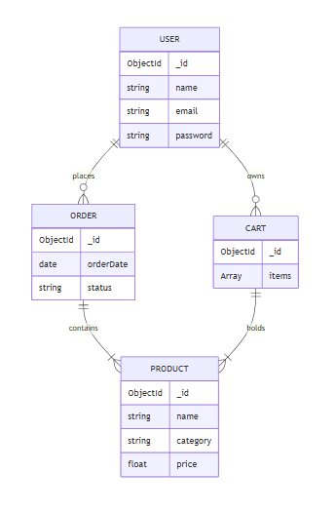

5. Appendix
5.1 Tools & Technologies
- Frontend:
  - React.js – UI library
  - Material-UI (MUI) – Component library
  - Axios – API requests
  - React Router DOM – Navigation
- Backend:
  - Node.js – Server runtime
  - Express.js – Backend framework
  - MongoDB + Mongoose – Database
- Utilities & Deployment:
  - Dotenv – Environment variables
  - Nodemon – Development server reload

