
InAmigos Foundation’s Project Udaan –
Empowering Women for a Better Tomorrow

Women empowerment is one of the most important pillars of social development. When women are provided with education, opportunities, and support, they become capable of transforming not only their own lives but also the lives of their families and communities. Despite the progress made over the years, many women still face barriers such as limited access to education, financial resources, employment opportunities, and awareness regarding health and social welfare. Addressing these challenges requires initiatives that focus on long-term empowerment and sustainable change. One such initiative creating a meaningful impact is Project Udaan by InAmigos Foundation.


InAmigos Foundation is a Section 8 registered non-profit organization founded on 23 September 2020 by Govind Shukla. The foundation works with the vision of creating a better society through various initiatives focused on education, women empowerment, employability, environmental conservation, community welfare, and animal care. Over the years, the organization has established itself as a socially driven institution with certifications and recognitions including 80G, 12A, CSR-1 registration, NITI Aayog registration, and ISO 9001:2015 certification.
Among the foundation’s impactful initiatives, Project Udaan stands as a remarkable step toward women empowerment. The word “Udaan”, meaning flight, represents aspiration, growth, confidence, and the courage to move forward despite challenges. The project was created with the aim of empowering women and helping them become self-reliant through skill development, awareness programs, and entrepreneurial support.
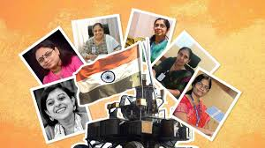
Project Udaan works closely with women and rural self-help groups to provide opportunities that encourage financial independence and personal growth. The initiative focuses on creating an environment where women are able to learn new skills, gain confidence, and contribute actively to society. It emphasizes the idea that empowering women leads to stronger families and more developed communities.
One of the key areas of Project Udaan is skill development and entrepreneurship support. The initiative encourages women to learn practical skills that can improve their livelihoods and open doors to employment or self-employment opportunities. Through various training sessions and workshops, women are guided toward becoming financially independent and capable of building sustainable futures for themselves.
Apart from economic empowerment, Project Udaan also pays attention to social awareness and overall well-being. The initiative actively promotes menstrual hygiene awareness, helping women understand the importance of health, hygiene, and self-care. Such efforts create awareness while breaking social barriers and encouraging open discussions around women’s health.
The impact created by Project Udaan has already been significant. According to InAmigos Foundation, the initiative has successfully empowered more than 900 women, helping them gain confidence, develop skills, and improve their quality of life. The program has positively influenced not only individual women but also their families and communities by promoting participation, self-reliance, and leadership.
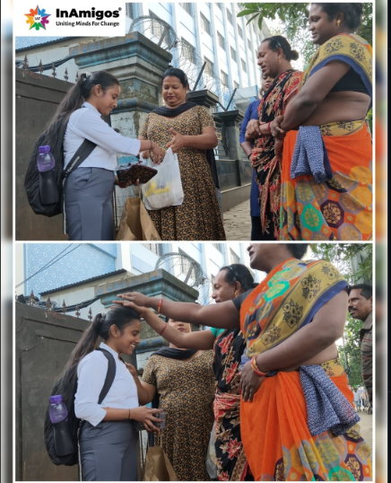
The success of Project Udaan lies in its holistic approach toward empowerment. Rather than focusing only on financial assistance, the project works toward developing confidence, awareness, leadership qualities, and independence among women. This comprehensive approach ensures long-term development and sustainable social impact.
Looking ahead, Project Udaan continues to move forward with the vision of expanding its reach and empowering more women across communities. The initiative aims to create larger opportunities, strengthen support systems, and encourage women to become leaders and change-makers within society.
In conclusion, Project Udaan by InAmigos Foundation is more than just a social initiative—it is a movement that gives women the wings to dream, grow, and achieve. Through skill development, awareness programs, entrepreneurship support, and community engagement, the project is creating positive transformation and inspiring women to rise above limitations. By empowering women today, Project Udaan is helping build a stronger and better tomorrow.

HASHTAGS:
#InAmigosFoundation
#ProjectUdaan
#UdaanByInAmigos
#InAmigosForChange
#WomenWithInAmigos
#EmpowerHer
#RiseWithUdaan
#TransformingLives

