InAmigos Foundation Website Improvement Analysis

Screenshot 1: Causes Page

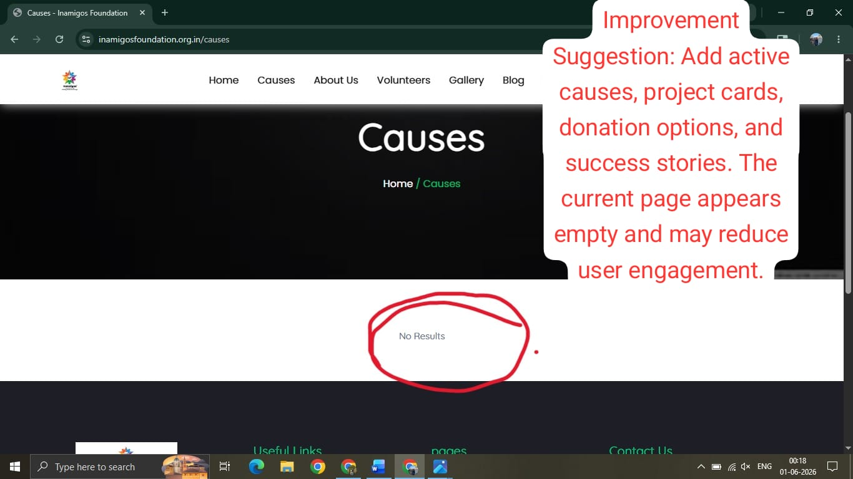

Suggested Improvements

- Add active causes and ongoing projects.
- Display project cards with images and brief descriptions.
- Include donation and volunteer call-to-action buttons.
- Showcase impact stories and success metrics.

Screenshot 2: About Us Page
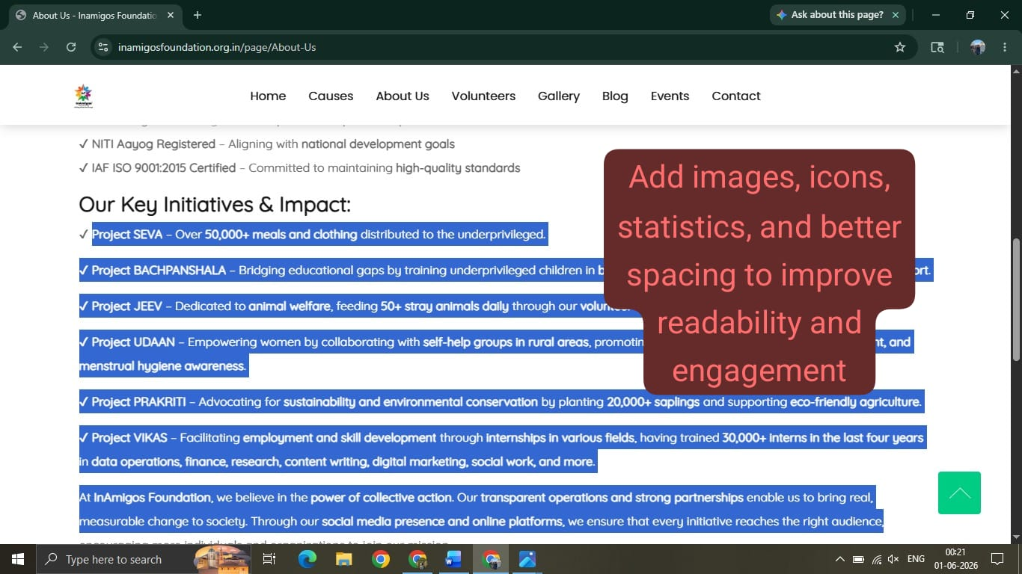

Suggested Improvements
- Add images and icons to support key information.
- Include statistics showing the foundation's impact.
- Improve spacing and visual hierarchy.
- Add a timeline of achievements and milestones.

Screenshot 3: Volunteers Page
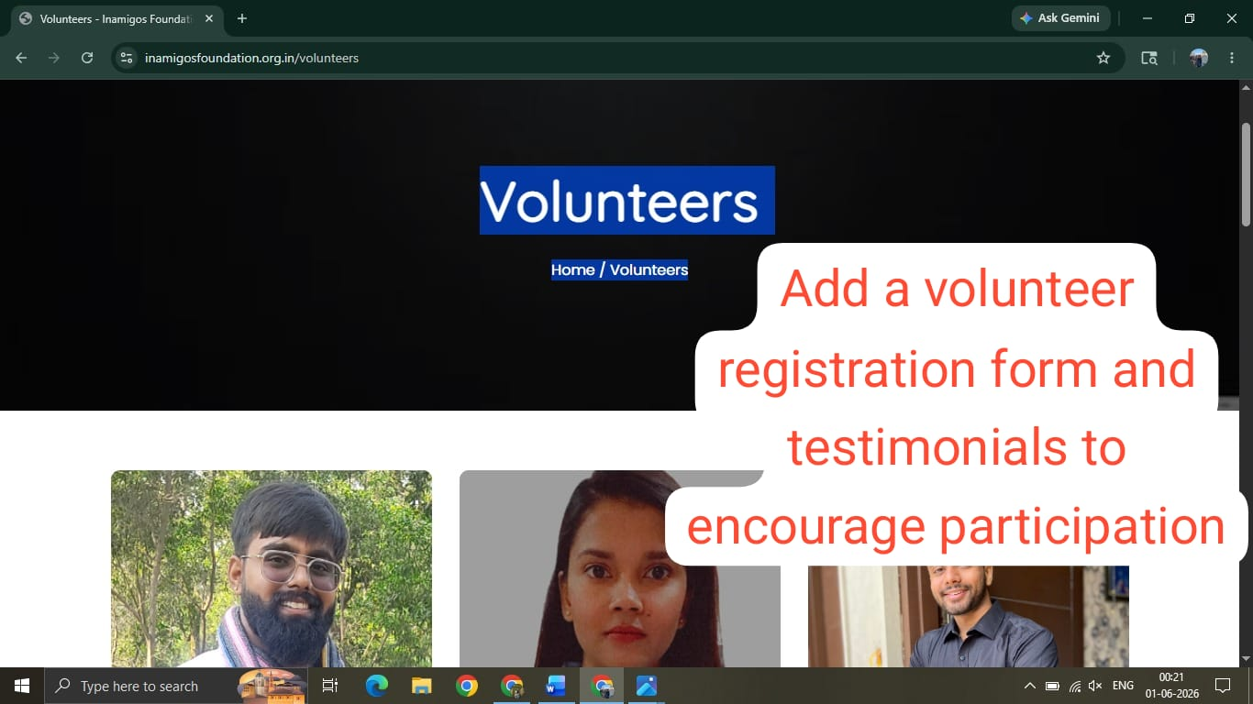

Suggested Improvements
- Add an online volunteer registration form.
- Include volunteer testimonials and success stories.
- Add clear call-to-action buttons such as "Join Now" or "Become a Volunteer."
- Showcase volunteer activities through images.

Screenshot 4: Contact Page
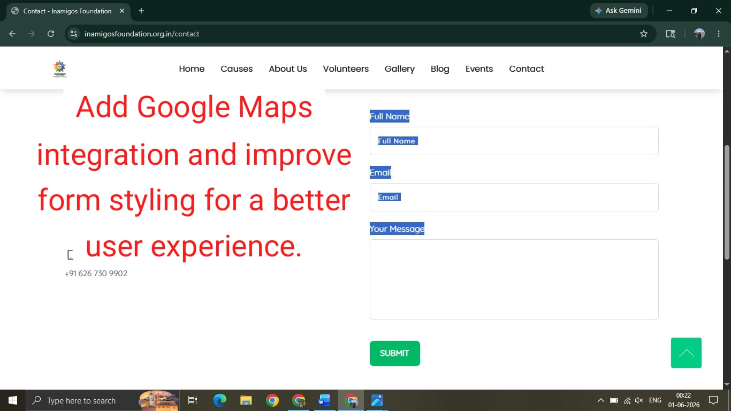

Suggested Improvements
- Integrate Google Maps for easier navigation.
- Improve contact form design and spacing.
- Add social media links and icons.
- Provide additional communication options.

Conclusion
Implementing these improvements can enhance user experience, improve engagement, increase volunteer participation, and strengthen the overall online presence of InAmigos Foundation.

