
S.P. Mandali’s
Ramnarain Ruia Autonomous College
Matunga, Mumbai-400019
Department of Computer Science

Research Project Report
On
NLP-Based Automated Medical Report Processing System for Clinical Data Extraction, Health Trend Analysis and Risk Assessment

Project Guide
Prof. Edith Juni

Project By
Sakshi Moreshwar Paradkar

Seat No: 568
M.Sc. Computer Science 2026-27
ACKNOWLEDGEMENT

Every project, whether academic or practical, is completed successfully with the guidance, support, and encouragement of many individuals.

We take this opportunity to express our sincere gratitude to S. P. Mandali’s Ramnarain Ruia Autonomous College, Matunga, Mumbai, for providing us with the facilities and opportunity to complete this project.
We would like to thank the Department of Computer Science & IT and all the teaching faculty members for their valuable guidance and support throughout the development of our project.
We express our sincere gratitude to our project guide, Mrs. Edith Juni, for her valuable suggestions, encouragement, and guidance during the various stages of the project.

Finally, we would like to thank everyone who directly or indirectly contributed to the successful completion of MedTrack – Medical Report Analyzer.

Thanking you,
SAKSHI M. PARADKAR

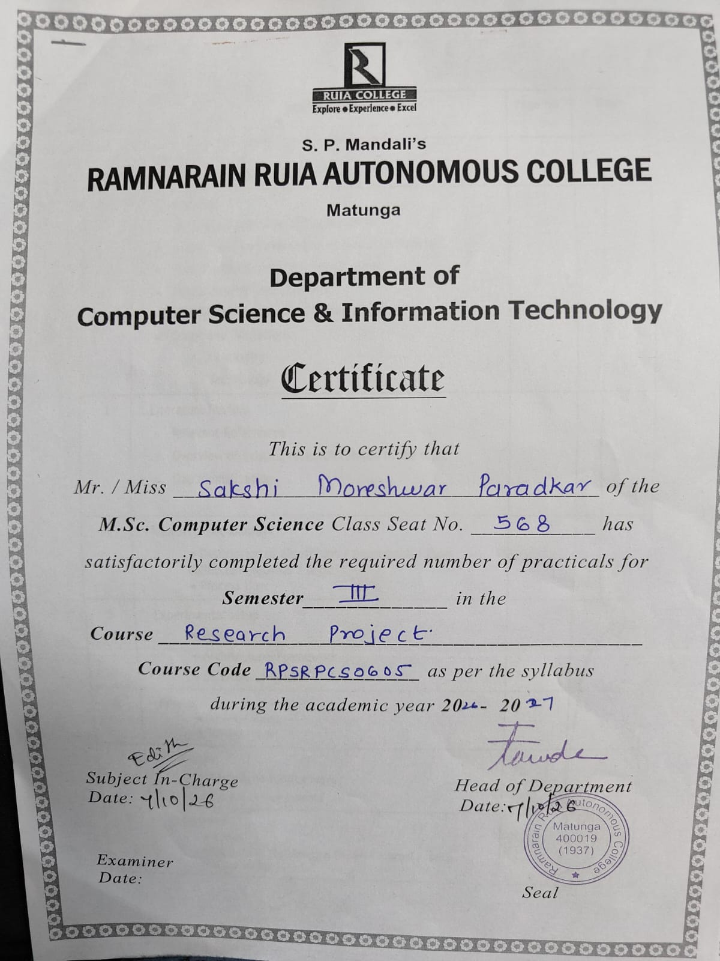

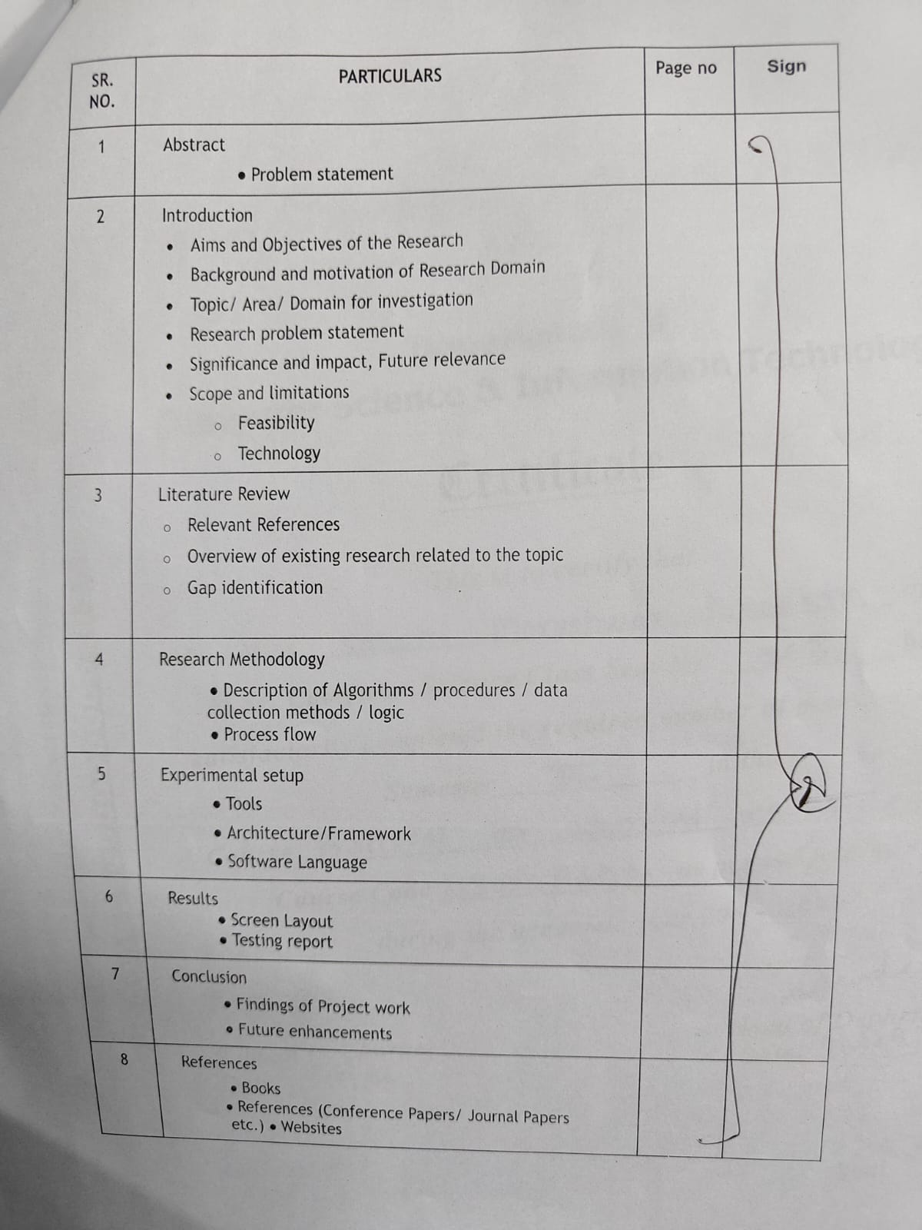

MedTrack:- An NLP-Based System for Medical Report Analysis and Health Monitoring



1.ABSTRACT
1.1 Problem Definition
In medical information management, particularly in handling laboratory reports, extracting, organizing, and monitoring medical test results is a significant challenge. Traditional methods of storing medical reports as separate PDF files or printed documents make it difficult to compare results, identify changes over time, and maintain a clear history of laboratory test values.
The current challenge is to design a system that:
- Automatically extracts laboratory test names, values, units, and reference ranges from digital PDF medical reports.
- Processes and organizes the extracted information using text extraction techniques, regular expressions, and predefined reference data.
- Classifies laboratory test results as Normal, Abnormal, or Needs Review based on the available reference ranges and validation rules.
- Stores medical report information in a database and provides a user-friendly web interface for accessing historical records.
- Compares laboratory reports from different dates and displays changes in test values through interactive charts and trend analysis.
- Generates downloadable PDF summaries to help users maintain and review their medical information.
The goal is to develop a convenient and efficient medical report management system that reduces manual effort, organizes laboratory test results, and helps users monitor changes in their health-related data over time.
2. INTRODUCTION
2.1 Aims and Objectives of the Research
The main aim of MedTrack is to develop a web-based system that automates the extraction, organization, comparison, and visualization of medical laboratory test results.
The objectives are:
- To develop a user-friendly web application for managing laboratory reports.
- To extract text and laboratory test information from digital PDF reports automatically.
- To identify test names, values, units, and reference ranges using rule-based extraction techniques.
- To classify extracted results as Normal, Abnormal, or Needs Review.
- To store medical report information securely in a database associated with the user's account.
- To compare two laboratory reports and identify changes in test values.
- To display health trends using interactive charts and graphical representations.
- To calculate percentage changes and highlight relevant trends in laboratory results.
- To generate downloadable PDF summaries for convenient reference.
- To provide an accessible interface that helps users organize and review their medical information.

2.2 Background and Motivation of the Research Domain

Medical reports are an important part of healthcare because they contain information about a person's health and laboratory test results. These reports are commonly provided in PDF format and include test names, numerical values, measurement units, and reference ranges.
When people undergo laboratory tests repeatedly, they may accumulate several reports from different dates. Comparing these documents manually can be difficult, particularly when the reports contain many test parameters. Important changes may be overlooked when results are stored in separate files or reviewed independently.
Document digitization and information extraction techniques help convert unstructured or semi-structured document content into organized data. Rule-based text processing can identify known patterns, while database systems can store extracted information for future retrieval. Data visualization can then present changes in a more understandable form.
MedTrack was developed to combine these techniques in a single web application. It converts digital laboratory reports into structured records and presents the information through dashboards, comparisons, and trend charts.
The motivation behind this project is to reduce manual effort, improve the organization of medical records, and make it easier for users to review their laboratory results over time.

2.3 Topic / Area / Domain for Investigation
The project falls under the following areas of computer science:
- Web Application Development: Development of a browser-based application using Flask and frontend technologies.
- Document Digitization: Conversion of information contained in PDF laboratory reports into structured digital records.
- Text Processing and Information Extraction: Use of regular expressions and predefined reference data to identify relevant laboratory test information.
- Database Management: Storage and retrieval of user accounts, reports, and test results using SQLite and SQLAlchemy.
- Data Analytics: Calculation of changes in test values and identification of trends across multiple reports.
- Data Visualization: Presentation of laboratory results using interactive Plotly charts.
- Software Testing: Verification of report uploads, data extraction, validation, comparisons, and report generation.

2.4 Research Problem Statement
Traditional medical report management often involves keeping multiple PDF files or printed documents and reviewing their contents manually. This approach does not provide a convenient way to extract laboratory values automatically, compare reports from different dates, or visualize long-term changes.
The research problem is to develop an efficient and user-friendly system that transforms digital laboratory reports into structured data, validates extracted values against reference ranges, and presents the results through interactive visualizations.
MedTrack addresses this problem through a rule-based extraction pipeline, database-backed report management, and graphical health trend analysis.

2.5 Significance and Impact, Future Relevance
Significance
- Reduces the need to enter laboratory test values manually.
- Organizes multiple laboratory reports in one application.
- Helps users identify values outside their reference ranges.
- Makes comparison between reports easier.
- Presents changes in test values through graphical visualizations.
- Provides downloadable summaries for convenient reference.
Impact
The system can improve the convenience of personal medical record management and help users prepare for discussions with healthcare professionals. Its structured data approach also provides a foundation for future medical data analytics applications.
Future Relevance
The project can be extended with optical character recognition for scanned reports, support for additional report formats, more comprehensive reference data, advanced trend analysis, and integration with other health record systems.
MedTrack is designed for informational purposes. Its classifications and visualizations should not be treated as medical diagnoses, and users should consult qualified healthcare professionals for medical decisions.

2.6 Scope and Limitations
A. Scope
The scope of the project includes:
- User registration and login.
- Uploading digital, text-based PDF laboratory reports.
- Extracting laboratory test information automatically.
- Identifying test names, values, units, and reference ranges.
- Classifying extracted values.
- Storing and retrieving report information.
- Comparing reports from different dates.
- Displaying interactive trend charts and percentage changes.
- Exporting laboratory result summaries as PDF files.
- Providing a health quiz and an informational website interface.

B. Limitations
- The current extraction process is designed for digital, text-based PDF reports.
- Scanned reports and photographs require OCR support, which is planned as a future enhancement.
- The extraction process relies on predefined patterns, known test names, and reference data.
- The supported test reference list is limited to the entries configured in the system.
- Differences in report layouts, units, naming conventions, or formatting may affect extraction accuracy.
- An extracted value or its classification may require manual verification.
- The application does not provide a clinical diagnosis or replace consultation with a doctor.
- The system's reliability must be evaluated through testing with appropriate sample reports.

C. Feasibility
Technical Feasibility: The project uses established technologies such as Python, Flask, SQLite, SQLAlchemy, pdfplumber, and Plotly. These technologies provide the functionality required to develop the application without requiring specialized hardware.
Economic Feasibility: The application is developed using open-source software and can run on a standard computer. Hosting and maintenance costs may apply when the application is deployed online.
Operational Feasibility: The browser-based interface allows users to upload reports, view extracted results, and review charts without requiring advanced technical knowledge.

D. Technology Feasibility
The project uses a lightweight web architecture. Flask handles application routes and server-side processing, pdfplumber extracts text from digital PDFs, regular expressions identify structured information, SQLite stores records, and Plotly generates interactive visualizations. These components can be maintained and extended independently.

3.LITERATURE REVIEW
3.1 Relevant References
The development of MedTrack is related to research in medical document digitization, clinical information extraction, rule-based text processing, and healthcare data management.
The following research papers are relevant to the project.

Paper 1: Extracting Laboratory Test Information from Paper-Based Reports
Ming-Wei Ma et al., BMC Medical Informatics and Decision Making, 2023.
Read the research paper
This research presents a pipeline for extracting laboratory test information from paper-based medical reports. It combines optical character recognition with information extraction techniques to identify test names, results, units, and reference ranges. The study demonstrates the importance of converting medical documents into structured data for further processing.
Relevance to MedTrack: The paper supports the need for automatic extraction of laboratory information. MedTrack follows a related objective but currently focuses on digital PDFs and uses pdfplumber, regular expressions, and predefined reference data rather than an OCR-based pipeline.

Paper 2: Clinical Information Extraction Applications — A Literature Review
Research article available through PubMed Central, 2018.
Read the research paper
This review discusses methods used to extract useful clinical information from medical documents. It describes rule-based methods, machine learning techniques, dictionaries, and pattern matching approaches for identifying relevant information from clinical text.
Relevance to MedTrack: The review provides background for the project's rule-based extraction method, which uses regular expressions and a predefined list of test names and aliases to identify laboratory results.

Paper 3: Information Extraction from Electronic Medical Documents: State of the Art and Future Research Directions
Review article, 2022.
Read the research paper
This paper reviews methods for extracting structured information from electronic medical documents. It discusses rule-based methods, information matching, and other approaches used to convert document text into structured data.
Relevance to MedTrack: The review helps explain the technical basis of extracting known information from semi-structured laboratory reports and the limitations of rule-based approaches when document formats vary.

3.2 Overview of Existing Research Related to the Topic
Existing research shows that medical documents can be processed using different approaches, depending on whether the source contains digital text, scanned images, tables, or free-form clinical notes.
Common approaches include:
- Manual Data Entry: Users read medical reports and enter test values into a database or spreadsheet.
- Rule-Based Extraction: Predefined rules and regular expressions identify known patterns in document text.
- Optical Character Recognition: OCR converts text contained in scanned documents or images into machine-readable text.
- Machine Learning-Based Extraction: Trained models identify relevant information from documents with varied structures.
- Database Management: Structured information is stored for retrieval, comparison, and further analysis.
- Data Visualization: Charts and graphs present numerical changes and trends in a more accessible format.

MedTrack implements a lightweight, rule-based approach. It extracts text from digital PDFs, identifies laboratory test information, checks values against reference data, stores results in a database, and displays trends using interactive charts.

3.3 Gap Identification

Based on the reviewed approaches, the following practical gaps are relevant to this project:

- Manual review of multiple reports can be time-consuming.
- Laboratory values stored in separate files are difficult to compare consistently.
- Users may find it difficult to identify changes across reports from different dates.
- Extracted data requires validation because report formatting and units can vary.
- A document extraction process alone does not provide an easy-to-understand historical view of the results.
- Scanned reports require OCR, while rule-based extraction systems require additional rules to support more test names and document formats.

MedTrack addresses several of these needs by combining extraction, validation, storage, comparison, and visualization in one application. Its current scope is limited to digital text-based PDF reports, leaving OCR support and broader document compatibility as future work.

4. RESEARCH METHODOLOGY
4.1 Description of Algorithms, Procedures, Data Collection Methods and Logic
MedTrack follows a document-processing methodology in which laboratory reports are converted into structured records and analyzed over time.
Step 1: User Authentication
The user creates an account or logs in to the application. Flask-Login manages user authentication and supports access to user-associated report records.
Step 2: Report Upload
The user uploads a digital PDF laboratory report and provides the relevant report date through the application interface.
Step 3: PDF Text Extraction
The uploaded PDF is processed using the pdfplumber library. The library extracts machine-readable text from the document.
Step 4: Structured Information Extraction
The extracted text is processed using regular expressions and predefined reference data. The system attempts to identify:
- Laboratory test name.
- Test result or numerical value.
- Measurement unit.
- Reference range.
Aliases and predefined patterns help match variations in test names.
Step 5: Validation and Classification
The extracted values are checked against the reference ranges available in the report or the configured reference list. Results are assigned statuses such as Normal, Abnormal, or Needs Review.
Values that cannot be interpreted confidently are flagged for review rather than automatically assumed to be correct.
Step 6: Database Storage
The report information and extracted test results are stored in an SQLite database using Flask-SQLAlchemy. The records are associated with the relevant user and report date.
Step 7: Trend Analysis
When multiple reports are available, the application calculates changes in test values and identifies selected trends across reports.
Step 8: Data Visualization
Plotly is used to display interactive charts, comparisons, and historical trends. These visualizations help users review changes across report dates.
Step 9: Report Comparison and Export
Users can compare two reports side by side and generate a downloadable PDF summary containing relevant laboratory values and trend information.

4.2 Process Flow
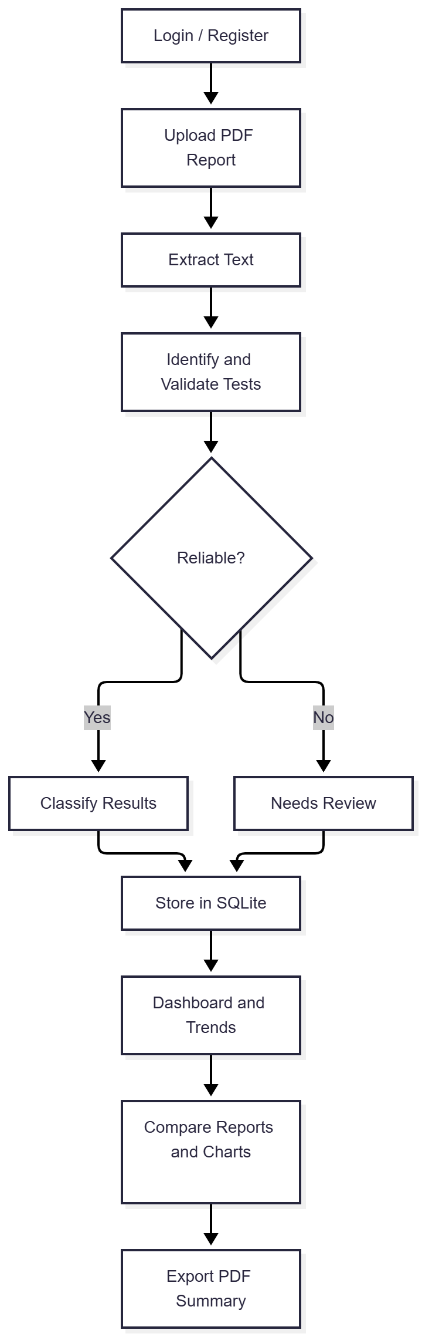
4.3 Data Collection Method

The project processes laboratory information from uploaded digital PDF reports. Sample reports can be used to test the extraction pipeline, including reports containing different test values and edge cases.
The system extracts information directly from the uploaded document rather than requiring users to enter every laboratory value manually.
For project testing, the sample reports should include different report dates, common laboratory parameters, values within and outside reference ranges, and cases where information is missing or cannot be parsed confidently.
Any testing conclusions must be based on the actual test runs and recorded results.

5.EXPERIMENTAL SETUP
5.1 Tools
The project uses the following tools and technologies.

Tool / Technology | Purpose
Python | Main programming language
Flask | Web application framework
Flask-Login | User authentication and session management
SQLite | Persistent database storage
pdfplumber | Text extraction from digital PDF files
Regular Expressions (Regex) | Identification of test names, values, units, and ranges
JSON | Storage of predefined test reference data
Plotly | Interactive charts and data visualization
HTML | Webpage structure
CSS | Styling and layout
JavaScript | Client-side interactions
Bootstrap 5 | Responsive interface components
ReportLab | PDF summary generation
Git and GitHub | Version control and source-code management
Render | Online deployment of the application

5.2 Architecture / Framework
MedTrack follows a layered web application architecture.
1. Presentation Layer
This layer provides the user interface through HTML, CSS, JavaScript, Bootstrap, and Jinja2 templates. It includes the home page, authentication pages, report upload interface, dashboard, and other application pages.

2. Application Layer
The Flask application manages requests, authentication-related routes, file uploads, report processing, validation, database operations, and dashboard functionality.

3. Document Processing Layer
The extraction modules use pdfplumber to read PDF text and regular expressions with predefined reference data to identify laboratory test information.

4. Data Layer
SQLite stores user-associated report records and extracted test results. Flask-SQLAlchemy provides the interface between the application and the database.

5. Analytics and Visualization Layer
This layer calculates percentage changes and selected trends, builds comparisons between reports, and generates interactive Plotly charts.

6. Export Layer
The PDF generation functionality produces downloadable summaries for users to retain or share with healthcare professionals.
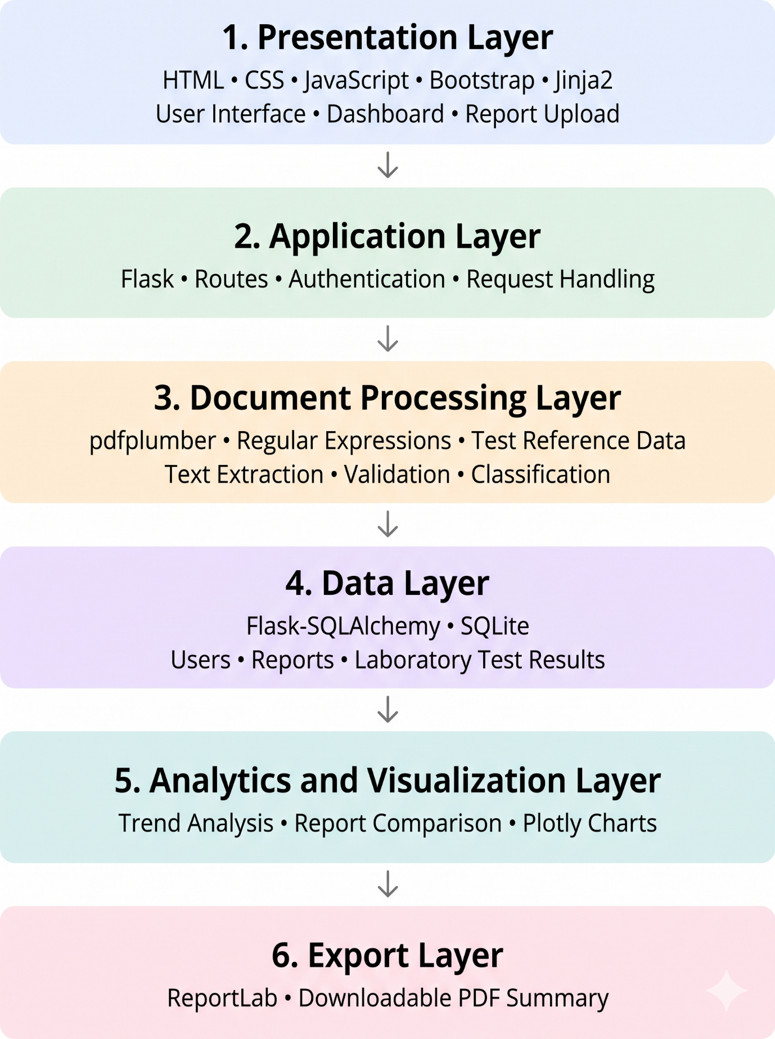

5.3 Software Language
- Python: Used for backend logic, report processing, and data validation.
- HTML: Defines the structure of web pages.
- CSS: Styles the website and manages layouts.
- JavaScript: Adds interactive features to the website.
- SQL: Manages data stored in the SQLite database.
- Jinja2: Displays dynamic content in HTML templates.
- Flask: Handles routing, user requests, and backend operations.
- Bootstrap 5: Creates responsive and mobile-friendly layouts.
- JSON: Stores structured reference data for medical tests.
- Regular Expressions (Regex): Identifies test names, values, and ranges in extracted text.
- pdfplumber: Extracts text from digital PDF medical reports.
- Plotly: Displays interactive charts and health trends.
- ReportLab: Generates downloadable PDF summaries.
- Git and GitHub: Manage and store project source code.
- Render: Hosts the web application online.

6. RESULTS
6.1 Screen Layout
6.1.1 Home Page
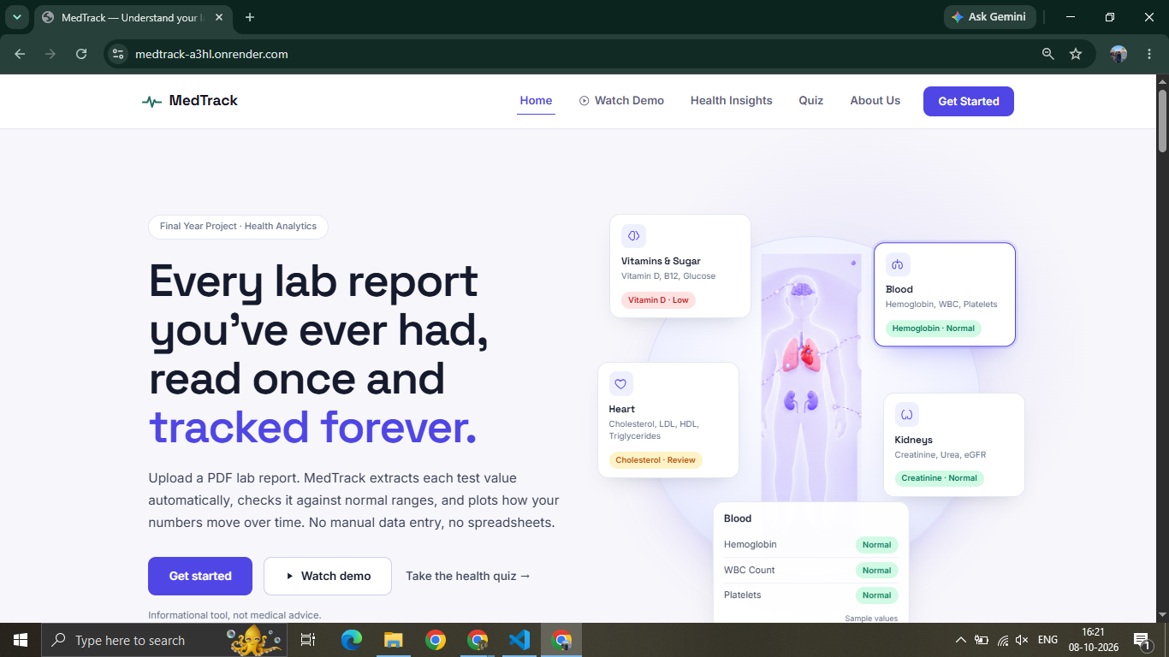

6.1.2 User Registration and Login
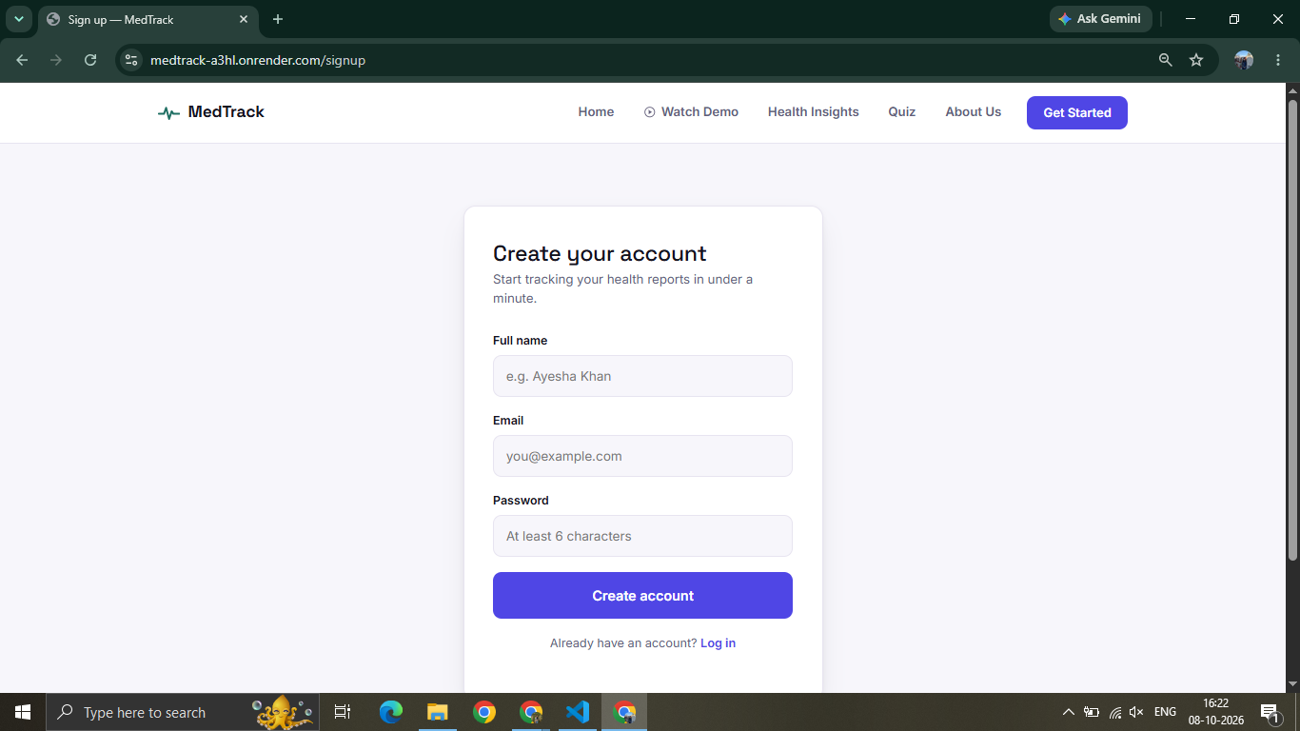

6.1.3 Report Upload Page
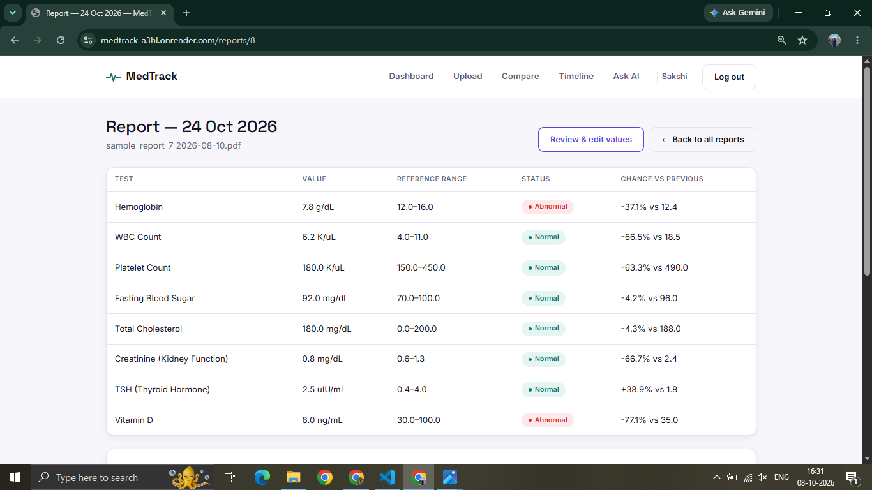

6.1.4 Extracted Test Results
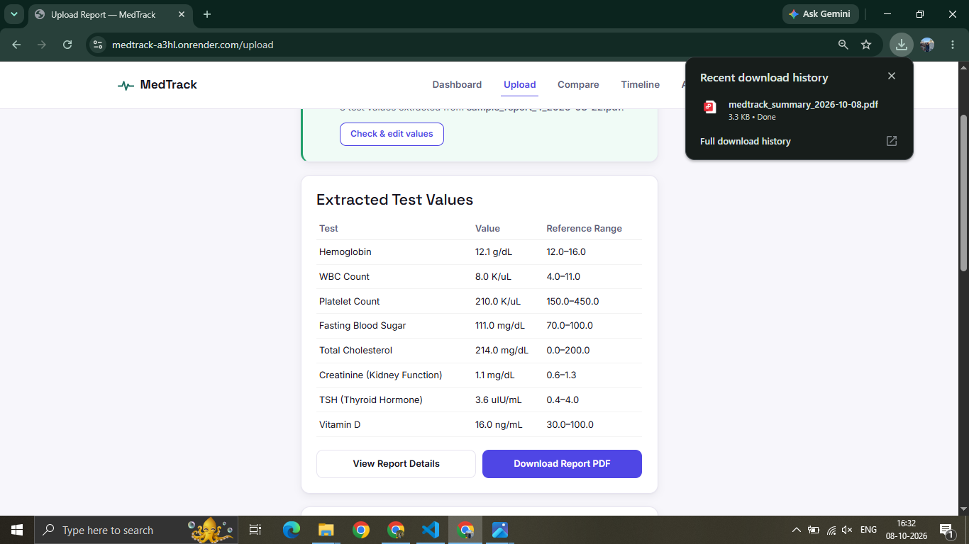

6.1.5 Dashboard and Trend Charts
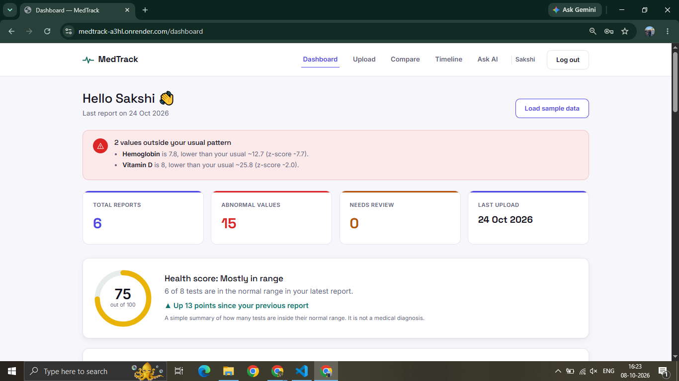

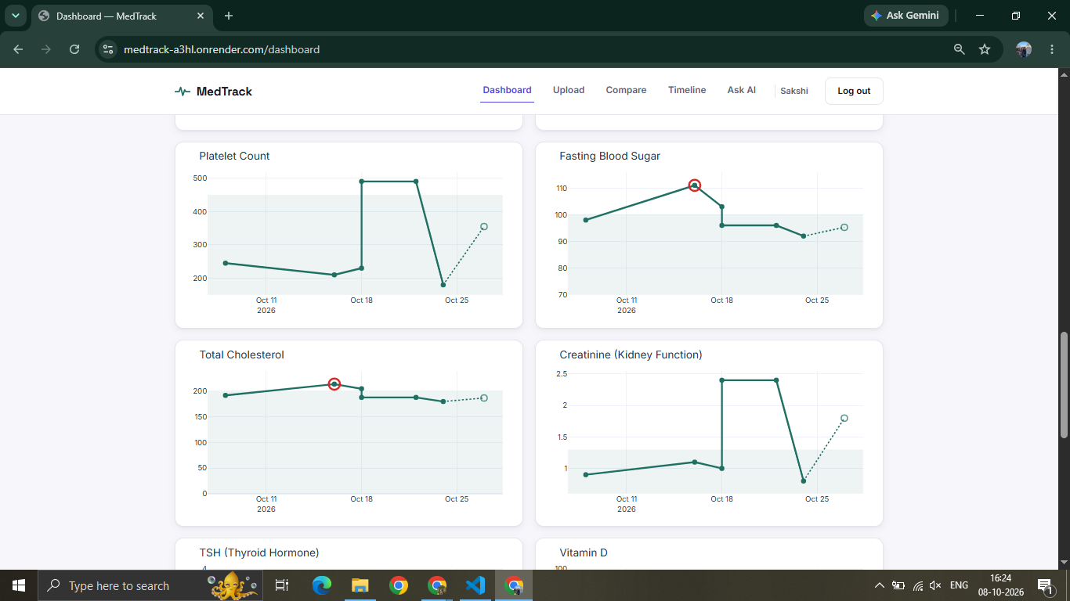

6.1.6 Report Comparison
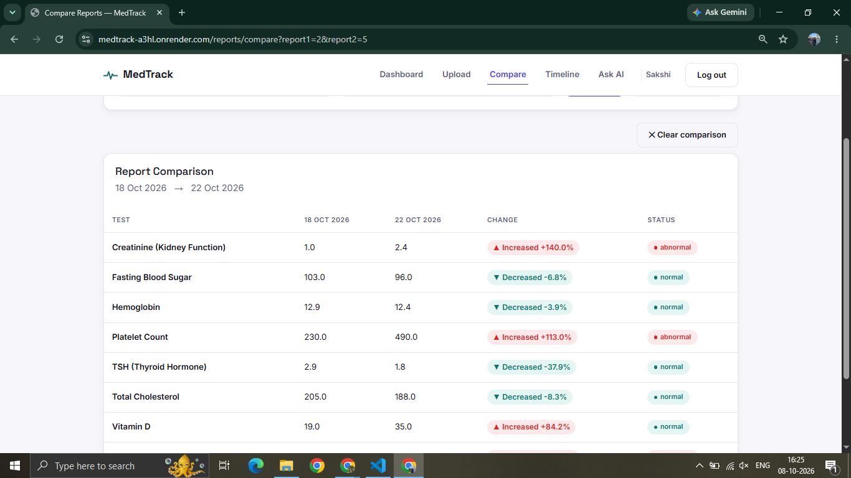

6.1.7 PDF Summary
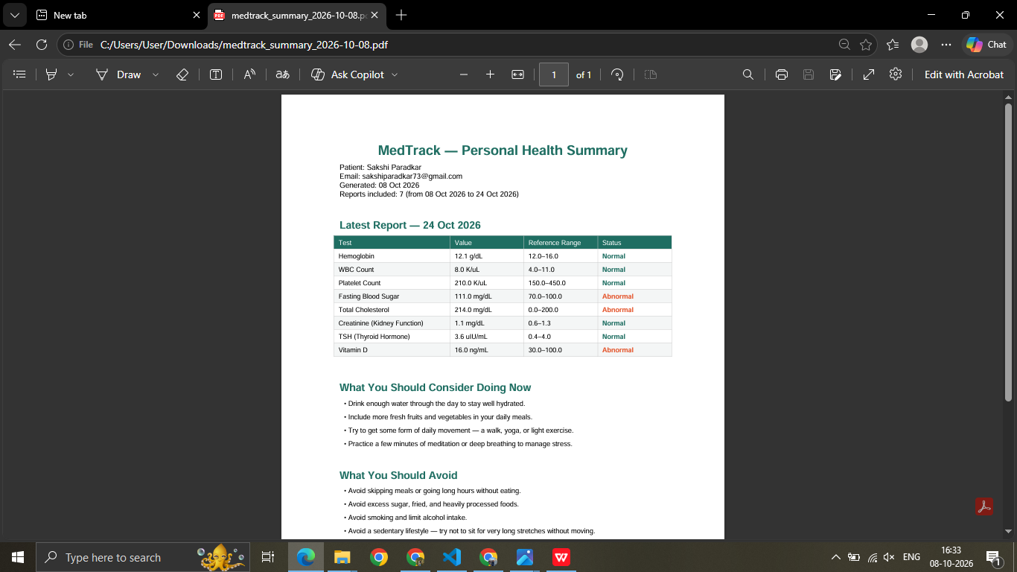
6.2 Testing Report
Testing is required to verify that the application processes laboratory reports correctly and that its main functions operate as expected.
The following table is a proposed test-case template. Fill in the actual observed results after executing each test.
Test Case | Test Description | Expected Result | Actual Result | Status
TC01 | Open the application | Home page loads successfully | To be recorded | Successful
TC02 | Register a new user | User account is created successfully | To be recorded | Successful
TC03 | Log in with valid credentials | User is authenticated | To be recorded | Successful
TC04 | Upload a valid digital PDF | File is accepted for processing | To be recorded | Successful
TC05 | Extract laboratory test information | Test names, values, units, and ranges are extracted where supported | To be recorded | Successful
TC06 | Validate a result within its reference range | Result is classified according to the configured rules | To be recorded | Successful
TC07 | Process an abnormal test value | Result is flagged according to the configured | To be recorded | Successful
TC08 | Process incomplete or ambiguous information | Result is marked for review where applicable | To be recorded | Successful
TC09 | Upload reports from different dates | Reports are stored with their associated dates | To be recorded | Successful
TC10 | Compare two reports | Differences in available test values are displayed | To be recorded | Successful
TC11 | View historical trend charts | Relevant charts are generated when sufficient data exists | To be recorded | Successful
TC12 | Export a PDF summary | A downloadable summary is generated | To be recorded | Successful

7.CONCLUSION
7.1 Findings of Project Work
MedTrack demonstrates how document processing, database management, and data visualization can be combined to simplify the management of medical laboratory reports.
The application extracts structured information from supported digital PDF reports using pdfplumber, regular expressions, and predefined reference data. The extracted information is stored in an SQLite database and made available through a dashboard.
The project provides features for classifying test values, comparing reports from different dates, calculating percentage changes, visualizing trends, and exporting PDF summaries. These functions reduce the effort required to organize and review multiple laboratory reports manually.
The project also demonstrates the practical application of Python-based web development, database integration, rule-based information extraction, and interactive visualization in the healthcare information management domain.
Although the system can help users organize and review their results, extraction errors and limitations in reference data remain possible. The application is intended to support information management and does not replace professional medical evaluation.

7.2 Future Enhancements

The following enhancements can improve the functionality and reliability of MedTrack:
- OCR Integration: Add optical character recognition using tools such as Tesseract to support scanned PDFs and images.
- Improved Extraction: Extend the extraction rules to support more laboratory test names, units, and report formats.
- Advanced Data Validation: Improve validation for missing values, inconsistent units, and ambiguous reference ranges.
- Enhanced Trend Analytics: Introduce additional statistical methods for analyzing long-term changes in laboratory results.
- More Visualization Options: Provide additional chart types, filters, and customizable dashboards.
- Improved PDF Reports: Add configurable summaries with selected charts and report comparisons.
- Additional Export Formats: Support exporting structured results to formats such as CSV.
- Mobile Optimization: Improve usability on mobile devices and smaller screens.

These enhancements can make MedTrack more flexible and reliable while maintaining its primary objective of organizing laboratory information and presenting health trends clearly.

8. REFERENCES
8.1 Research Papers and Journals
1. Ma, M.-W., et al. (2023). “Extracting laboratory test information from paper-based reports.” BMC Medical Informatics and Decision Making, 23, Article 251. Available at: https://doi.org/10.1186/s12911-023-02346-6

2. “Clinical Information Extraction Applications: A Literature Review.” (2018). Available through PubMed Central: https://pmc.ncbi.nlm.nih.gov/articles/PMC5771858/

3. “Information extraction from electronic medical documents: state of the art and future research directions.” (2022). Available through PubMed Central: https://pmc.ncbi.nlm.nih.gov/articles/PMC9640816/

8.2 Technical Documentation
4. Flask Documentation. Available at: https://flask.palletsprojects.com/
5. Flask-SQLAlchemy Documentation. Available at: https://flask-sqlalchemy.palletsprojects.com/
6. SQLite Documentation. Available at: https://www.sqlite.org/docs.html
7. pdfplumber Documentation. Available at: https://github.com/jsvine/pdfplumber
8. Plotly Python Documentation. Available at: https://plotly.com/python/

8.3 Project Resources

9. MedTrack Source Code Repository. Available at: https://github.com/sakshiparadkar/medtrack-medical-report-analyzer
10. MedTrack Live Application. Available at: https://medtrack-a3hl.onrender.com/

