8.WORKFLOW AND PROCESS FLOWS
Project: Planify — Smart Task Scheduler
Field | Details
Prepared By | Sakshi Paradkar
Date | 14 May 2025
Version | 1.0

1. Introduction
Planify is a web-based task reminder and task management application developed to help users organize daily activities efficiently. The system enables users to create tasks, schedule reminders, manage priorities, snooze notifications, and track overdue tasks.
The application focuses on improving productivity and time management by ensuring that users receive timely reminders and can easily manage incomplete tasks.

2. Objectives
The primary objectives of the Planify system are:
- To help users manage daily tasks efficiently
- To provide automated reminder notifications
- To allow users to snooze reminders when necessary
- To detect and manage overdue tasks
- To improve productivity through task scheduling and tracking

3. System Features
The Planify application provides the following major features:
- Task creation with title, time, and priority
- LocalStorage-based task persistence
- Automated reminder notifications
- Snooze functionality
- Overdue task management
- Browser notification support
- User-friendly and responsive interface

4. Functional Requirements
FR-1 Create Task
The system shall allow users to create tasks by entering:
- Task title
- Reminder date and time
- Task priority
FR-2 Save Task
The system shall store task data in LocalStorage to ensure data persistence.
FR-3 Reminder Notification
The system shall trigger a reminder notification when the scheduled time is reached.
FR-4 Complete Task
The user shall be able to mark a task as completed.
FR-5 Snooze Reminder
The user shall be able to snooze reminders for 10 minutes.
FR-6 Overdue Detection
The system shall automatically detect tasks that remain incomplete after the scheduled time.
FR-7 Overdue Status Management
The system shall mark incomplete tasks as OVERDUE.
FR-8 Overdue Highlighting
The system shall display overdue tasks in a highlighted overdue section.
FR-9 Reschedule Task
The user shall be able to reschedule overdue tasks.

5. Workflow Diagrams
5.1 task lifecycle Workflow
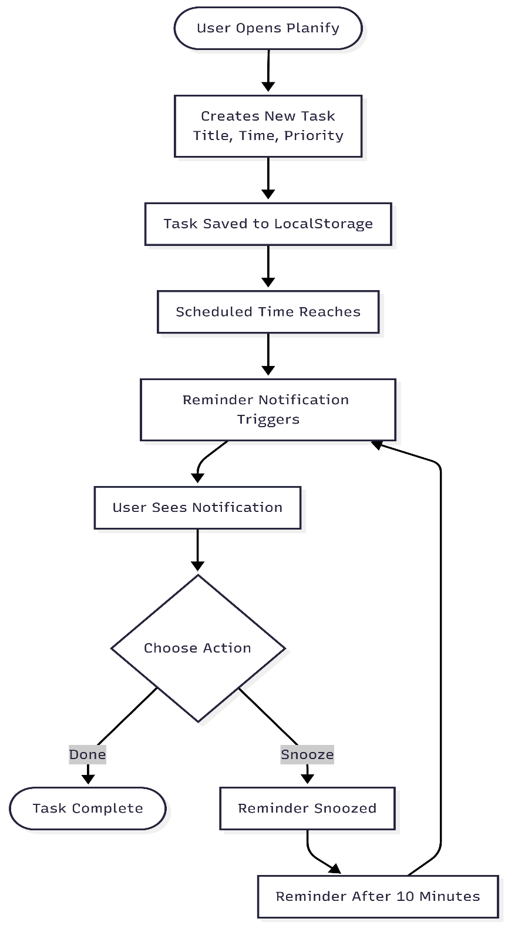

Process Explanation
User creates a task with a title, reminder time, and priority, and the system saves it in LocalStorage. When the scheduled time is reached, a reminder notification appears. The user can either mark the task as complete or snooze the reminder for 10 minutes.
5.2 Overdue Task Workflow
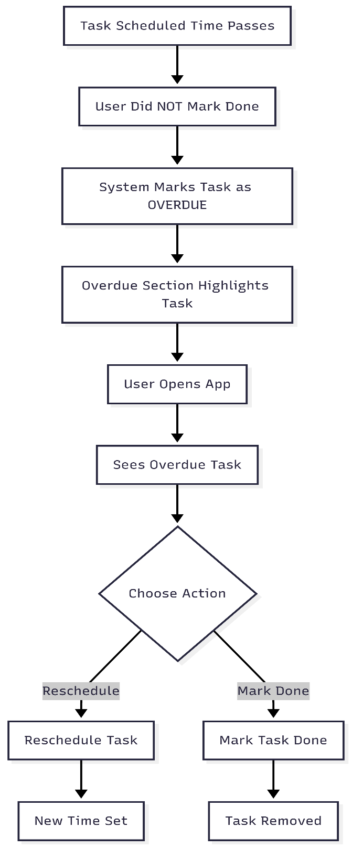

Process Explanation
When the scheduled task time passes and the user does not complete the task, the system marks it as OVERDUE and highlights it in the overdue section. When the user opens the app, they can either reschedule the task or mark it as completed.

5.3 Browser Notification Workflow
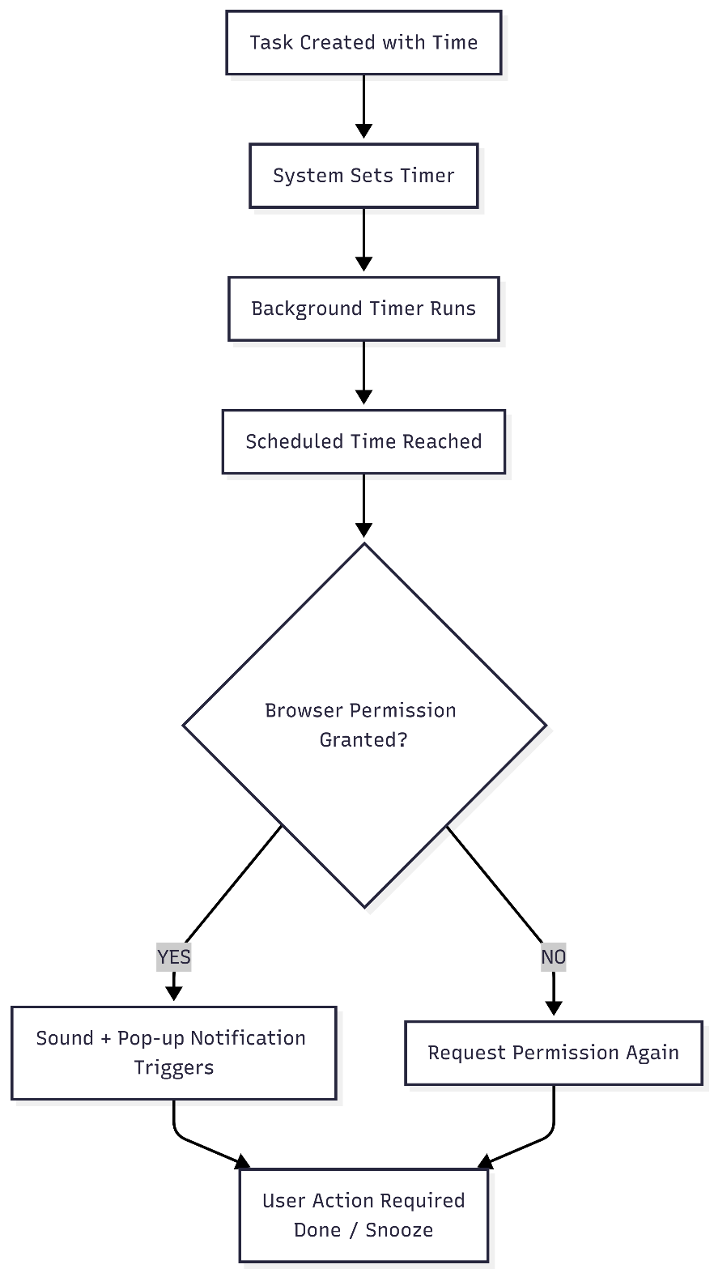

Process Explanation
The user creates a task with a reminder time, and the system starts a background timer. When the scheduled time is reached, the system checks browser notification permission and triggers a sound and popup notification if permission is granted. The user can then mark the task as done or snooze the reminder.

6. Non-Functional Requirements
The system shall satisfy the following non-functional requirements:
- Fast reminder triggering
- Reliable data persistence
- Responsive user interface
- Cross-browser compatibility
- Efficient background timer execution
- User-friendly interface design
- Minimal notification delay

7. Technologies Used
Component | Technology
Frontend | HTML, CSS, JavaScript
Storage | LocalStorage
Notifications | Browser Notification API
Diagrams | Mermaid.js

8. Future Enhancements
Future versions of Planify may include:
- Cloud synchronization
- Email notifications
- Mobile application support
- AI-based task prioritization
- Voice reminders
- Recurring task scheduling
- Calendar integration
- Multi-user collaboration
9. Conclusion
Planify is an efficient task reminder and management system designed to help users organize tasks, receive timely reminders, and manage overdue activities effectively. The system improves productivity through automation, notification management, and simple task tracking features.

