Product Catalog with Similar Products

Apple iPhone 14
Category: Smartphones
Price: $799
Latest Apple iPhone with A15 Bionic chip, dual-camera system, and 5G support.
Image:
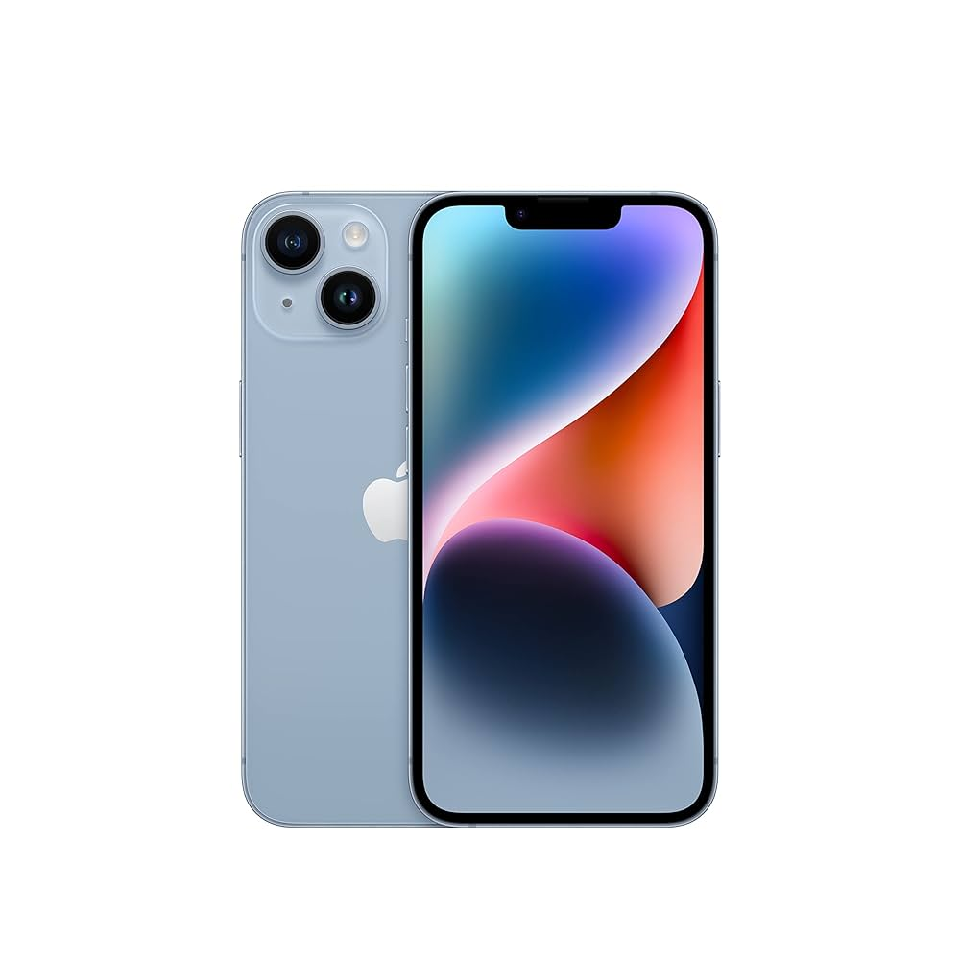

Similar Products:
- Samsung Galaxy S23
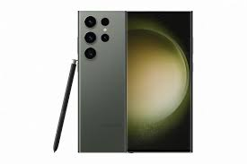

- Dell XPS 13


Samsung Galaxy S23
Category: Smartphones
Price: $749
Flagship Samsung smartphone with Snapdragon 8 Gen 2, triple-camera, and AMOLED display.
Image:

Similar Products:
- Apple iPhone 14
- Sony WH-1000XM5
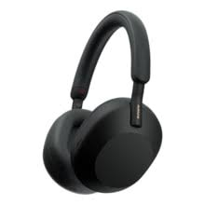

Sony WH-1000XM5
Category: Headphones
Price: $399
Premium noise-cancelling wireless headphones with superior sound quality.
Image:

Similar Products:
- Samsung Galaxy S23

Dell XPS 13
Category: Laptops
Price: $1299
Ultra-thin laptop with Intel i7, 16GB RAM, and 512GB SSD.
Image:

Similar Products:
- Apple iPhone

