An IS, on the other hand, focuses on how people use IT and data to manage and make decisions within an organization.

IS supports knowledge management and communication. IT allows data sharing to take place between different departments, providing consistent data for analysis by a variety of teams. An IS supports various business functions such as accounting, finance, marketing, human resources, operations and supply chain management. It can also enable new business models and opportunities, such as e-commerce, social media and artificial intelligence (AI).

The basic process an IS follows includes the following steps:

1. Input. The system collects data and information from various sources, such as sensors, keyboards, scanners or databases.
2. Processing. The system transforms the raw data into meaningful information by applying various operations, such as sorting, classifying, calculating, analyzing or synthesizing.
3. Storage. The system stores the processed information in a structured and secure way, such as in a database, a file system or in cloud storage.
4. Output. The system presents the information to the users in a usable format, such as reports, graphs, charts or dashboards.
5. Feedback. The system collects feedback from users and other stakeholders to evaluate its performance and improve its design and functionality.

Elements of an IS:

1. Hardware:
2. Software:
3. Database
4. People
5. Telecommunications

Objectives of IS:

1. Improving decision making

2. Establishing regular contact with customers and suppliers

3. Getting competitive advantages

4. Identifying and designing new products and business models

5. Achieving business excellence

Types of IS:

1. Operations Support System

2. Management Support system

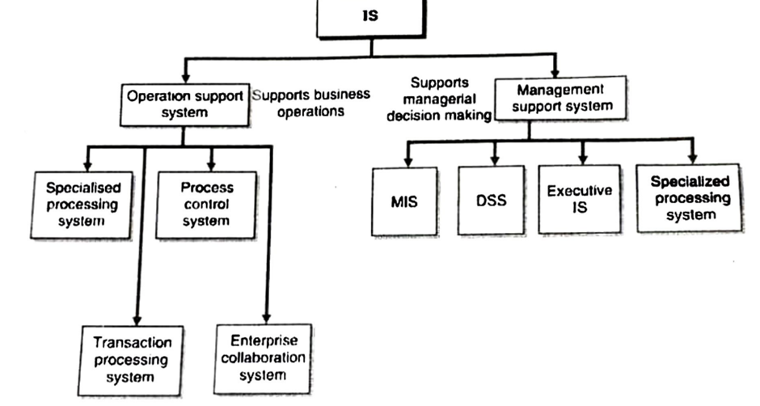

Activities of IS:

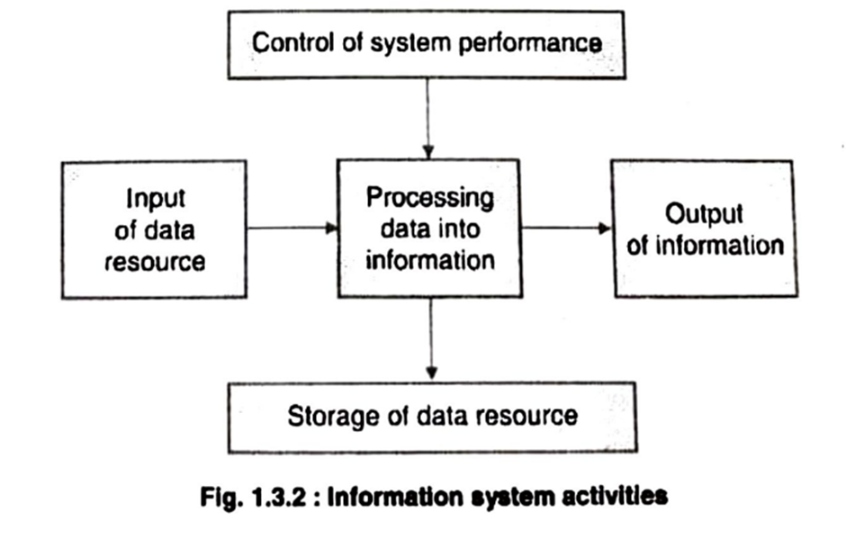

Impact of IS on organizations:

1. Better flow of information
2. Improves transaction processing
3. Supports decision making
4. Supports workgroups and team activity
5. Improves quality of goods and services
6. Provides effective data management

Impact of IS on society:

POSITIVE:

1. Effective communication system
2. Availability of information
3. Improving globalization and reducing cultural gap
4. Getting better services
5. Getting a range of online services

NEGATIVE:

1. Increasing fraud
2. Lack of job security
3. availability of too much information
4. Security threat

Characteristics of good is:

1. Usefulness of information
2. Relevance of information
3. Accuracy and reliability
4. Completeness of information
5. Timeliness

Competitive advantages:

Competitive advantage achieved through Information Systems (IS) is often referred to as "Information Technology (IT) competitive advantage" or "IT-enabled competitive advantage." It occurs when an organization effectively and strategically uses information technology and information systems to outperform its competitors in various aspects of its business. Here are some ways in which competitive advantage can be achieved through IS:

1. \*\*Cost Leadership:\*\* Efficient use of IS can lead to cost savings through automation, streamlining of processes, and reducing operational expenses. Organizations that leverage IT to minimize costs can offer products or services at lower prices, which can be a significant competitive advantage.

2. \*\*Product Differentiation:\*\* IS can support innovation and product development, leading to the creation of unique and differentiated products or services. For example, companies like Apple and Tesla have used IS to create innovative products (iPhone, electric cars) that set them apart from competitors.

3. \*\*Improved Customer Service:\*\* Information systems can enhance the customer experience through personalized interactions, faster response times, and better service quality. Companies that excel in customer service through IS, such as Amazon with its recommendation algorithms and efficient order fulfillment systems, can gain a competitive edge.

4. \*\*Supply Chain Management:\*\* Efficient supply chain management powered by IS can result in reduced inventory costs, faster delivery times, and better coordination with suppliers. Companies like Walmart have used IS to optimize their supply chains, giving them a competitive advantage in terms of cost and availability.

5. \*\*Data Analytics and Insights:\*\* Advanced analytics and big data technologies can provide organizations with valuable insights into customer behavior, market trends, and operational efficiency. Companies that can turn data into actionable insights can make more informed decisions and gain a competitive edge.

6. \*\*E-commerce and Online Presence:\*\* Companies that have a strong online presence and robust e-commerce platforms can reach a wider audience and conduct business more efficiently. Online retailers like Amazon and Alibaba have leveraged IS to dominate their respective markets.

7. \*\*Agility and Flexibility:\*\* IS can make organizations more agile and responsive to changes in the business environment. Cloud computing, for example, allows companies to scale resources up or down quickly, enabling them to adapt to changing market conditions faster than competitors with traditional IT infrastructures.

8. \*\*Strategic Decision-Making:\*\* IS can provide executives and managers with real-time access to critical data and analytics, which can support more strategic and informed decision-making. Companies that use IS for strategic decision support can respond to market dynamics more effectively.

9. \*\*Customer Relationship Management (CRM):\*\* Effective use of CRM systems can help organizations build stronger customer relationships, improve customer retention rates, and cross-sell or upsell products and services.

10. \*\*Security and Risk Management:\*\* A robust IS security strategy can protect an organization's data and assets from cyber threats. Companies that prioritize cybersecurity and data protection can gain a competitive advantage by ensuring the trust and confidence of their customers.

In summary, competitive advantage achieved through Information Systems involves leveraging technology and data strategically to excel in various aspects of business operations, from cost management and product differentiation to customer service and market insights. It requires a combination of technology investments, skilled personnel, and a clear understanding of how IS can support and align with the organization's overall strategic goals.

Module 2

Characteristics of Big Data:

1. Volume
2. Variety
3. Veracity
4. Value
5. Velocity
6. Variability

Data warehouse

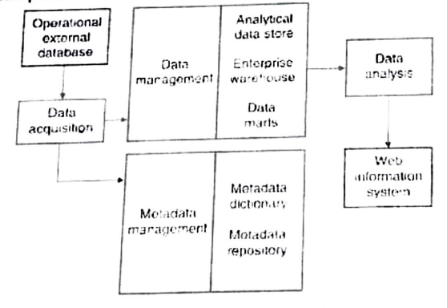

basic characteristics of data warehouses and data marts:

Data Warehouses:

Organized by Business Dimension:

Data warehouses are structured databases that are organized around key business dimensions, such as time, geography, product, customer, and more. This organization allows for the efficient storage and retrieval of data for analytical purposes. Data is stored in a way that supports complex queries and reporting based on these dimensions.

Use Online Analytical Processing (OLAP):

Data warehouses are optimized for Online Analytical Processing (OLAP), which means they are designed to handle complex queries and data analysis tasks. OLAP allows users to perform multidimensional analysis, drill-down, and slice-and-dice operations to gain insights from data.

Integrated:

Data warehouses integrate data from multiple sources within an organization. This integration process involves cleansing, transforming, and consolidating data to ensure consistency and accuracy. The goal is to provide a unified view of data for reporting and analysis.

Time Variant:

Data warehouses are time variant, meaning they store historical data over time. This historical data allows organizations to analyze trends, track changes, and make comparisons over different time periods. It supports both current and historical reporting and analysis.

Nonvolatile:

Data warehouses are nonvolatile, meaning that once data is loaded into the warehouse, it is not typically modified or deleted. Instead, new data is added to the warehouse to maintain a complete historical record. This ensures data integrity and traceability.

Multidimensional:

Data warehouses use a multidimensional data model, which is well-suited for complex analysis. This model represents data in a way that allows users to view it from various dimensions simultaneously, making it easier to explore relationships and patterns in the data.